Unit 1 Section D: Legislation, IRS and Corporate Culture
Impact of Political Systems
Germany 1884 passes the 1st compulsory Workers’ Compensation legislation. Austria:1887, Norway: 1894
USA 1962 Pres. Kennedy’s message to Congress 4 Rights of Consumers: safety, informed, choose, be heard. Kennedy, 50 yrs ago, tried to put legislation in place similar to what we are still trying to put in place today ie. Putting in laws to put warning on our asbestos that we sell to other countries.
Europe – expect gov’t involvement, Economic decision making largely carried out by gov’t
USA – expect self determination Reaganomics: restrain growth of gov’t regulation, Gov’t is the problem. USA- tend to Deregulate laws, Reagan did this a lot and same with Bush… deregulate, leads to putting the power back into the big businesses. USA expects self-determination and not regulation from the government.
Canada – accept gov’t involvement Regulation often seen as cure for problems
Ronald Reagan “Gov’t is not the solution to our problems…Gov’t is the problem” 1981
What will Obama’s legacy be. In the ILO clip we here Obama saying there is nothing more fundamental to Americans than a good paying job.
Canadian Legislation
FEDERAL –applies to ALL provinces
->Codes: -Canada Labour Code -Rights & Duties of Federal Employees, -Criminal Code
->Statutes (written laws passed by the Federal or Provincial Parliaments) (Acts): Transportation of Dangerous Goods Act
->Regulations

PROVINCIAL
->Statutes (Acts) (GENERAL): Occupational Health and Safety Act, Workplace Safety & Insurance Act
->Regulations (SPECIFIC): In Industrial Establishments
->Codes: Building Code, Fire Code

MUNICIPAL –City level
->Bi-laws
->Codes

Non Regulatory Guidance

Standards developed by:
-Canadian Standards Association (CSA), - CSA triangle on safety boots is a standard not a regulation and not a law (it just helps u comply with the legislation) and it means u can drop 50 lb weight and u wont get hurt
-American Conference of Governmental Hygienists (ACGIH, USA), -Chemical Safety Board (CSB, USA)

Industry Standards: -Developed by associations of employers

Company Codes of Practice: -Developed by individual companies of groups of companies

FEDERAL CRIMINAL CODE

*The Westray Mine Disaster (they blocked methane detectors bc was annoying n kept goin off)
-All 26 miners die in explosion
-52 Provincial OHS charges laid then withdrawn
Criminal charges laid but stayed -Lack of disclosure (CEO)
Public Inquiry ordered, halted, then re-instated
74 recommendations
-#73 legislation to ensure corporate executives and directors are held properly accountable for workplace safety
Bill C-45 (this law came intact 12 yrs after the fact!)

->Enforced by: --Police Services*
S.217.1, says anyone directing/has authority over another to perform a task is under legal duty to prevent bodily harm to that person from that task
--Protection of workers, students, public
--Reasonable steps to prevent bodily harm

Implications
Higher individual/organizational OHS legal risk
No insurance for OHS criminal negligence
Increased importance of Accidents/Incidents (A/I) prevention
Due Diligence not a defense in criminal charges -It is a defense for the provincial statute (OHSA)
Lawyers suggest it is mandatory to develop OHS management system -Defense for both OHSA and Criminal Code

Criminal Code Penalties
->Based on severity of outcome
-Injury – 10 years imprisonment
-Fatality – life imprisonment
->Unlimited $$$ -Based on company & other factors
->Non-tax deductible
->Probationary terms for organization
-Publicize conviction, sentence & system
-Restitution to victim
-Comply with other reasonable conditions (includes policies, procedures, training, public service announcements, Criminal code penalties diff than OHSA)

Federal Statutes
->Enacted by: Federal Parliament
->Federal Statute
-Hazardous Products Act:
Establishes a national standard for chemical classification, hazard communication and workers’ right to know
-Canada Labour Code (3 parts)
(1)Enforced by Human Resource and Skills Development Canada
(2)Establishes framework for employment standards and safety requirements (ex. Ventilation, lighting, temperature, sound vibrations in accordance w/ standards), duties and rights
(3)Applies to Federal Workplaces
__________ - ___________
__________ - ___________

Federal Regulations
->Enacted by Cabinet
->Canada Occupational Health and Safety Regulations
-Establishes more specific requirements for workplace hazards:
Confined spaces, Diving operations, Lighting levels, Violence
** 125 ppl in canada enforcing Canada labour code (FEDERAL) but for the Ontario PROVINCIAL legislation there is 400. (Note the difference)

Provincial Statutes
Enacted by Provincial Parliament
->Occupational Health & Safety Act
-Enforced by: MOL*(Ontario Ministry of Labour)
-Establishes rights, responsibilities & liabilities
-Establishes framework upon which regulations are made
->Workplace Safety & Insurance Act
-Enforced by: Workplace Safety and Insurance Board*
-Establishes responsibilities for safety promotion, prevention workplace injury & illness and compensation for affected workers covered by Act

PROVINCIAL REGULATIONS
Enacted by Cabinet
-On advise of Ministry of Labour, or other Minister with Portfolio
“Written in blood”
-Most are performance based (eg. On a machine, the pinch point must have a guard)
--Ensure access to moving parts is guarded
Few are prescriptive (meaning few are unflexible)
-Procedures for a Type III asbestos removal
Examples of Regulations:
-Regulations are reactive; result from social amplification
Performance based regulations- the regulation sets the expected outcome but does not specify the method used to reach the outcome
Prescriptive regulations specify the method of achieving a desired outcome

Ontario Timeline
1900 –Ministry of Labour formed in Ontario
1973 –Farm Safety Association Inc. ...Uranium miners go on strike –concerned about rising # of lung cancer, silicosis
1975 –Ham Commision Report recommends JHSC, Internal Responsibility System (IRS) is Described
1978- ON passes OHSA, based on IRS
1998 -Royal Commission Report on Westray Mine Disaster completed
2004 -MOL begins to hire 200 new inspectors, Criminal Code revised (Westray)
2006 -Provincial Smoking in Public Places Legislation

OHSA (occ health n safety act)
->Philosophy
-Workplace safety is a shared responsibility
->Structure
-Interlocking responsibilities are assigned to employer / constructor, supervisors and workers (all interrelated)
-to ensure workplace hazards are identified, and
-control measures are implemented to prevent injury and illness
->Internal Responsibility System (IRS)
-Elements enshrined in law (but not defined by law)

Safe at Work Ontario
Compliance = workers following laws in OHSA
-------“Make me” –these employees choose not to do something until theyre forced to do so (tend to have lots of accidents)
--------------------“Show me” –they don’t know how, you show them a little bit and they make big strides to make things better
-----------------------------------------“Watch me” –follow all the regulations and go over n above
The goal is self reliance and sharing of best practices.
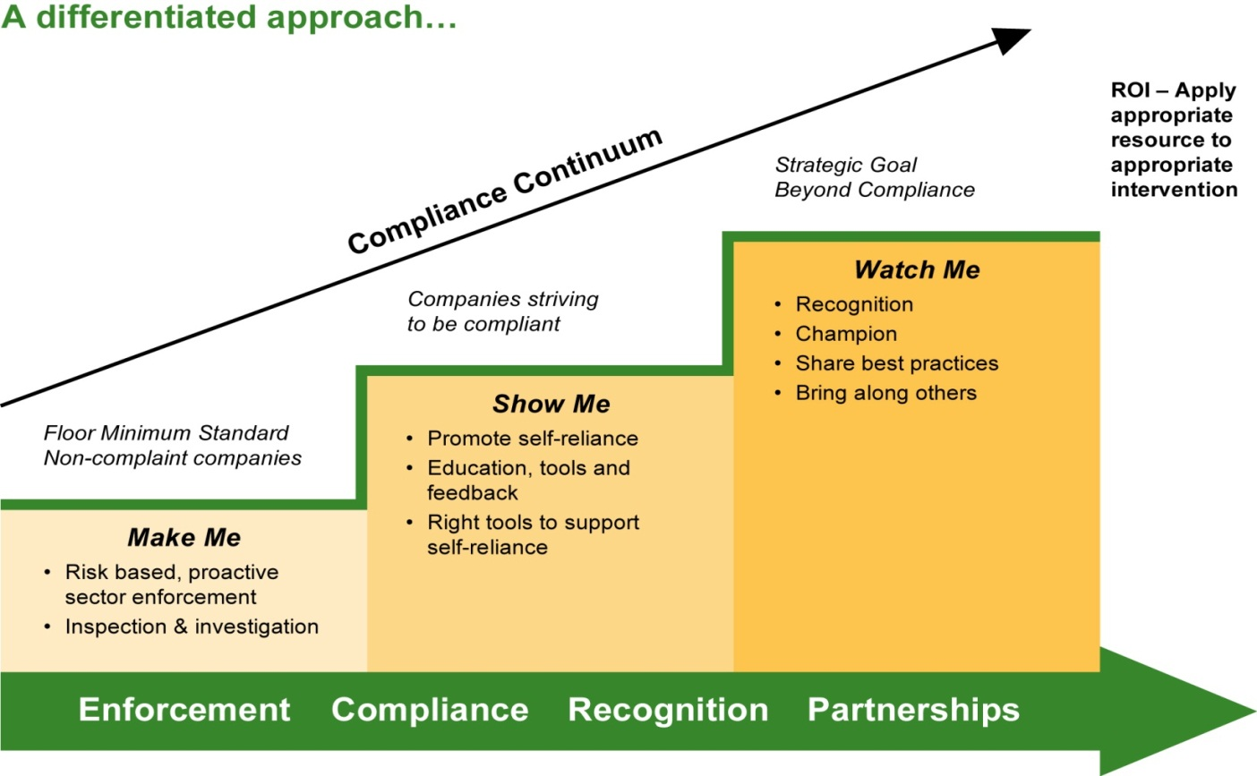
Expert Panel in Ontario
->Minister of Labour Appointed Tony Dean to Chair an Expert Advisory Panel of Ontario’s H&S (Health and Safety) System
-Role & responsibility of parties
-Impact of underground economy
-Protection of vulnerable workers
-Incentives to motivate performance
-Impact of technology & advancements
-Mandatory entry-level H&S training
->Interjurisdictional Review
-Ontario, Quebec, British Columbia, Germany, United Kingdom, New Zealand, Australia
->Consultation with
Labour, business, workers, professionals, H&S organizations

Legislation in other Jurisdictions
-a lot more workers covered in Germany and UK (also have higher populations so really the ratio is similar)
Approx 8% of Canadian workers are employed in Federal workplaces
>1,000,000 workers
Legislation enforced by 128 Officers spread across Canada. Ontario has 450 officers for approx 580,000 workers covered

MOL Prosecutions
->Penalties: p.62 of OHSA book
->Purpose
-Specific deterrence: (makes individual/owner accountable so they wont make mistake again)
-General deterrence: (other employers will here of that incident and that employer will work harder to prevent accidents)
->Where does the $$ go?
-Provincial Offences Penalty
$ goes to victim compensation, federal govt, but mainly MUNICIPALITY where court case was held, also 25% Victim Surcharge -the 25% victim surcharge goes to police to give to victims of crime

Written in Blood
->Public Service Workers exempt from OSHA (occupational safety and health administration)
->CSB (Chemical Safety Board) video of workers exempt from Florida State OSHA; the outcome of an injury investigation; and response from Florida Gov’t
Florida: 4 years later …. As of 2011, Florida has still NOT introduced legislation recommended by CBS in 2007 following the death of workers while welding above a tank of methane
-THEY FUCKED UP not being covered by OSHA regulations

OHSA 1979
The philosophy behind the law is known as the 'internal responsibility system'.
-government expects employers and workers to cooperate to control occupational health and safety hazards.
Evolution of the Internal Responsibility System 1975 The Ham Commission Report recommends joint committees.

Reading the OHSA
Top left –section of law that appears first on page followed by the name of the Act or Regulation
Top right –Part of law u are currently looking at, followed by section of law that appears at bottom of page

OHSA Key Elements
-Definitions
-Application - tells u who this act or regulation applies to
-Administration (HSR & JHSC) –part u look to for health a safety committee
-Duties of Workplace Parties –whos job is it, who trains
-Codes of Practice
-Toxic Substances
-Rights to Refuse or to Stop Work
-Reprisals by Employers (reprisals = retaliations... E.g. Boss punishing worker for saying to fix dangerous part on machine)
-Notices –any reporting requirements will be found under notices
-Enforcement –is abt MOL, they have more rights than police
-Offences and Penalties
-Regulations
INTERNAL RESPONSIBILITY SYSTEM
->History
-Saskatchewan Law 1972
-British Law 1974
-Ham Royal Commission 1976
Elliott Lake Miners Strike
-Ontario OHSA 1979 -Based on IRS concept
-Mackenzie-Laskin Report 1987 -Supported continuance of IRS in legislation
-WHMIS 1987 -Based on key IRS element; right to know
-Ontario OHSA 1990 -Expanded role of IRS
Nova Scotia -Added definition of IRS to its OHSA

INTERNAL
-To workplace
-To the job
-Motivators to perform
RESPONSIBILITY
-Defines specific roles for each level of the organization
SYSTEM
-A support mechanism to delegate responsibility and authority for completion of roles
-An accountability system to ensure completion of roles

Pyramid of IRS (ppl framework within the management system)
Directors President Vice President Managers Supervisors Workers

-Responsibility & Authority delegated DOWN through structure
-Accountability –reporting UP through structure

IRS 4 Key Principles
1. Visible, demonstrated commitment
2. Unbroken chain of direct responsibility and accountability
3. Consultation and Communication
4. Effective Contributory Participation

Visbile & Demonstrated Commitment
-Written policy signed by CEO
-Information available in language of workers
-Job hazards identified
-Competent Supervisors
-JHSC/HSR established & supported (joint health and safety committee, health and safety rep.)
-H&S included in Company plans, exec meetings, reports, etc
H&S programs developed

Direct Chain of Responsibility
-Workers told of hazards
-Workers know to whom and how to report concerns
-Workers know rights
-Supervisors conduct regular inspections
-Supervisors performance to promote safety is measured and rewarded
-Safety performance is measured and rewarded similar to productivity

Consultation and Communication (2 way communication asking, sharing, & seeking understanding)
-Employer provides info to supervisors & workers on hazards
-Employer seeks input of workers on development of new systems or changes to procedures
-Supervisors ensure workers know of hazards and prevention methods
-Workers report defects to supervisor
-Employer communicates H&S policy to workers

Effective Contributory Participation
-JHSC meetings are held and minutes distributed to CEO
-JHSR/HSR monthly inspections conducted and findings addressed
-JHSC makes recommendation for improvements
-Purchasing and engineering depts actively participate in decisions that affect safety
-Preventative maintenance for equipment is conducted

MOL Roles in ERS (external resp. sys.) –Underpinning Support
SET
Through Minister and Legislature
COMMUNICATE
Promote the IRS,
Provide compliance feedback
ENFORCE
• Legislation
Monitor the effectiveness of the IRS during:
Inspections; Investigations; and Dispute resolution; Issue compliance orders

Simple concept = dimensions of consideration in planning and budgeting, whole enterprise functions from top to bottom to be profitable, productive, safe… integrated system (profitability, productivity, planning and operations integrated)
Role of MOL = expressing public interest thru law, is it committed to public law to make sure of public health safety (no matter how mny inspectors u have ur not gonna have healthy and safe workplace if u don’t have an internal repsonibiilty system, ministry of labor audits and enforces the public law, a workplace complying w/ everything in green book may still be unsafe –the law is written in blood)
Role of JHSC = workers and management are audited by inspector can discuss how theyre doing in the workplace, form of consultive auditing of whether enterprise is living up to internal responsibility system. (workers and management discuss how they are doing)
Whose responsible for health and safety = enterprise, management, owners, employers of company. Human sense of responsibility, workers have integral concern for their safety as well as public. (EVERYBODY)
Safety and health is integral part of everything… With profit, the way work its carried out etc..

Workplace Injury Compensation
->History
1910 -1913 Meredith Royal Commission
-Study WB systems in England, Germany and USA.
1914
-Workmen’s Compensation Act (Ontario)
-The Compromise
>Protect Employers from Law Suits
>Guarantee Workers compensation for approved claims
-WCB had 56 employees and managed 17,000 claims
1998
Workplace Safety & Insurance Act
4,500 employees, 340,000 claims
(know scope of #’s)

Meredith’s Principles
-Public, compulsory system
-No fault compensation
-Collective Liability system
-Security of payment for duration of injury
-Independent board control
-Compensation tied to earning power
-Divert some funds to prevention activities
-Exclusive jurisdiction

Public, compulsory – it was intended to be run by the public sector and not private insurance companies. It was intended that employer had to register with the system
No fault – no blame is assigned and comp is paid without either party being able to sue the other
Collective liability- money from employer goes into a centralized fund that is paid out by the Board. This protects workers against companies that go out of business and protects a company from a few catastrophic events.
Payment security – worker is paid if company goes under. Worker is paid for duration of disability.
Independent board – set up to remove employer employee disputes from the courts. The board was to develop policies and principles over time to ensure consistent treatment of workers.
Compensation tied to earning power – a % of pre-injury earning is paid up to a maximum regardless of the injury; therefore removing the old “meat chart” systems of a broken leg = $xx
Divert funds for prevention- used to fund Safe Work Associations.
Exclusive jurisdiction- WCB or now WSIB (workplace safety & insurance board) have final say in decisions.

Workers’ Compensation Coverage in Canada

Ontario has 73.1% of workers covered and 226, 000 employer accounts

Graph - More claims in 1960 vs 1915… doesn’t mean more injuries in 1960 just more ppl reported it.

Entitlement: who
->Any employee who suffers from:
-an accidental personal injury arising out of & in course of employment
-is impaired by an occupational disease based on prescribed restrictions
->Survivors of a deceased worker

WSIB Emphasis
Vision
To eliminate all workplace injuries and illnesses in Ontario
Philosophical Change
1. Promote workplace safety
2. Facilitate early & safety return to work (ESRTW)
3. Facilitate labour market re-entry (LMR)
4. Provide compensation

How is WSIB Funded?
100% funded by EMPLOYERS (impt to know)
2 systems –Schedule 1 (Assessment, $/$100 payroll) -Schedule 2 ($$ distribution, most $ went to administration)
Unfunded Liability -the difference between the total cost of claims in the system and the funds in the system to pay for them.
$ 10,347,000,000 at end of 1991 (10 bil)
$ 5,600,000,000 at end of 2001
$ 9,300,000,000 at end of 2007
$+12, 000,000 as of Jan 2011 (12 mil)
Goal was $0 by end of 2014
-Must raise rates or lower benefits to get rid of unfunded liability…
-2% rise in premiums in 2011, 2012

Workplace Party Duties
COMMUNICATE
With each other and WSIB
-Recovery status
-Availability of and for work
-Status changes
COOPERATE
-With each other and WSIB
PARTICIPATE
-In recovery programs, prevention activities, reporting

WSIB Claims
STARTED
Form 6
-Worker’s Report of Injury/Disease
Form 7
-Employer’s Report of Injury/Disease
Form 8
-Physician’s First Treatment

SUSPENDED
-IW (injured worker) fails to co-operate following written warning
-Form 6 is not received by WSIB
-Form 8 is not received by WSIB
-Fraud is uncovered
-Disability and/or Health Care ends
-Loss of earnings ends
-IW becomes 65 yrs old

