Last Name:_____________KEY_____________________

First Name:_____________________________________

BIOLOGY 112
Mid-term

Feb 26, 2013

SHOW ALL YOUR CALCULATIONS, REASONING and UNITS
Also, if I ask for “one” reason then provide only one reason.

#1 (2 marks) Identify two structures that all cells possess but viruses lack?

- ribosomes or any other enzymes at all
- cell membrane
- cytoplasm

#2 (3 marks) What are the three primary functions of the cell membrane of prokaryotes.

- Selective permeability barrier..this might be considered as protection against certain compounds (toxins), but just answering “protection” is far too vague.
- A site for anchoring proteins
- Establishment of a ion concentration gradient for energy generation
In prokaryotes, the cell wall holds things in, and protects against lysis…this is not a mark worthy answer for prokaryotes, especially considering all the other important functions of prokaryotic cells.

#3 (1 mark) Some Archaea live in extremely hot environments? What feature of their cell membrane allows them to do so?

They lipids of the cell membrane are isoprenes not fatty acids. Due to cross-membrane bonds and intramolecular rings, isoprenes are more stable at high temperatures than fatty acids

#4 (2 marks) Which of the following molecules are able to diffuse easily through a cell membrane:
O₂, glucose, H⁺, CO₂, OH⁻.

O₂ and CO₂

#5 (1 mark) A new prokaryotic cell was discovered that contained no peptidoglycan. Is this organism likely from Domain Bacteria or Domain Archaea?

Archaea

#6 A Gram negative (Gm –‘ve) rod containing 10 mM concentration of glucose in its cytoplasm is placed in a 0.15% solution of glucose. Note: 1M=molecular weight/L. Glucose weighs 180 g/mole. 1%=1g/100mL.

a) (2 marks) Is the cell likely to lyse? Why?

No, even though the cell is hypertonic to the environment and water will move into the cell, the cell wall should prevent lysis

#6 ^{cont.}. b) (1 mark) What if the Gm –‘ve rod is placed in a 0.15% glucose solution that also contains lysozyme? Explain.
Lysozyme breaks down the peptidoglycan layer, and so, if the cell is in a hypotonic environment the cell will lyse. However, in the lysozyme has to reach the peptidoglycan.
In our case there will probably no effect because the outer membrane (the LPS) of the Gram –‘ve cell provides protection against the action of lysozyme.

#7 (2 marks) Would a cell with a membrane surface area to cytoplasm volume ratio of 2.5 um²:1 um³ be more efficient or less efficient than a cell with a ratio of 3.1 um² :1 um³? Why?

It would be less efficient because there is less membrane surface area (less area for diffusion, area to anchor proteins) to service the metabolic demand of each unit of cytoplasm volume.
Avoid re-stating the terms of the ration…everyone knows that 2.5<3.1, say why it’s important.

#8 (4 marks) Name two cytoplasmic inclusions found in prokaryotic cells and identify the primary function of each.
Inorganic and organic are categories…easy to get an incorrect function if you answer with broad categories.
PHB (PHA)---carbon and energy storage Glycogen---carbon and energy storage
Polyphosphate granules---energy storage
Sulfur granules are actually in the periplasm not the cytoplasm---energy storage (O.5 marks)
Magnetosomes---no known purpose
Gas vesicles are not actually inclusions-(0.5)--buoyancy

#9 a) (1 marks) Why do Gram –‘ve cells tend to be more resistant to penicillin that Gram +’ve cells?

Once again, they have an outer membrane (the LPS layer) to the cell wall which affords greater protection to the peptidoglycan layer. Not an outer “layer”…the PG in Gram +’ve is an outer layer.

b) (1 mark) How does penicillin actually work? Be as specific as you can with your terminology.

It prevents the formation of the peptide cross bridges in the synthesis of new peptidoglycan, as a result cell growth and division is blocked
Note; saying that it blocks cell division isn’t providing detail at the level of that presented in class

#10 a) (1 mark) What is the purpose of the bacterial endospore?

Endurance of unfavourable environmental conditions

b) (4 marks) What compounds can be found in the core of the endospore but not in the cytoplasm of the vegetative cell? What is the purpose of these compounds?

Ca²⁺ +dipicolinic acid---helps to stabilize the DNA)
SASPS---also help to stabilize the DNA and provide energy for re-growth of the vegetative cell.

#11 a) (2 marks) Which of the following are not found on a strand of prokaryotic mRNA:
Shine-Dalgarno sequence, start codon, stop codon, promoter region, terminator region, reading frame, operator.

Promoter and operator

b) (2 marks) What is the function of each of your answers in a)?

promoter is the site where RNA polymerase binds
operator is where a repressor molecule can bind

#12 The two following sequences (Loop A and Loop B) show the stem-loop structure from two different mRNA's.
Loop A
Loop B
GCU
U A
A C
GC
CG
UA
CG
AU
CG
CG
CG
5'-UAUCACGAGCAAAA-3'
UGG
C U
G G
G A
A C
UA
CG
AU
UA
AU
CG
5'-UAUCACGAGCAAAA-3'

a) (1 mark) What is the primary purpose of the stem-loop structure in mRNA?
Stops transcription

b) (1 mark) Which one (Loop A or Loop B) is likely to better withstand 3' to 5' RNA exonucleases and why?

Loop A, because there are more GC bonds which are stronger, and/or there is a longer sequence of binding thus a longer ½ life

c) (1 mark) Why is rRNA so resistant to RNAses?
Note: the question is not asking, why does rRNA need to be resistant.
The proteins of the ribosome protects the rRNA of the ribosome.
It not “the ribosome” because rRNA is part of the ribosome, and the rRNA is not necessarily particularly folded.

#13 (2 marks) How does the stop codon actually cause translation to stop?

No tRNA enters the ribosome, instead, specific proteins called release factors come into place and split the polypeptide from the final tRNA. The ribosomal sub-units then fall apart

#14 (3 marks) What is an operon?

An operon is a series of related genes transcribed as a single mRNA but translated as separate proteins.
One(??this doesn’t seem right but the text has this in the glossery..but in main text it says a cluster) or more genes transcribed into a single RNA and under the control of a single regulatory site.

#15 (1 mark) Identify one molecular feature of transcription or translation that Archaea have in common with Bacteria, but which does not exist in Eukarya.
Polycistronic DNA (operons) Repressors binding directly to DNA in promoter
70S ribosomes Shine-Dalgarno sequences
16S and 23S rRNA Single RNA polymerase
Genes that code for proteins are continuous…no introns and exons

#16 (3 marks) Signal transduction is when a signal external to the cell causes receptors on the cell’s surface to trigger a change in a series of molecules within the cell. This domino effect eventually causes a response in some intracellular target.
How is the direction of bacterial flagellar rotation affected by the presence of a repellent? Explain in terms of signal transduction.

The repellent binds to a receptor protein on the surface of the cell, this causes a change in shape of the receptor protein which in turn causes a protein CheA to be phosphorylated. CheA in turn phosphorylates CheY. CheY interacts with the flagella motor causing the flagella (-um) to rotate clockwise.

#17 (1 mark) Which of the following diagrams shows gene regulation by repression. In the diagrams, the little circles (or balls) represent compounds brought into the cell from the external environment. #2

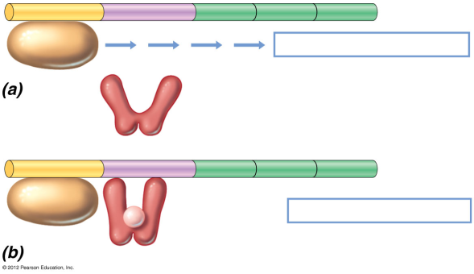
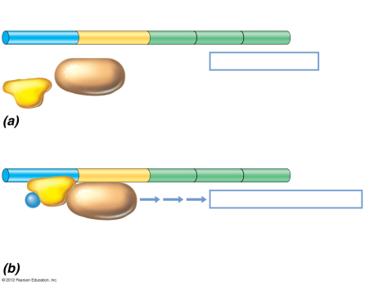
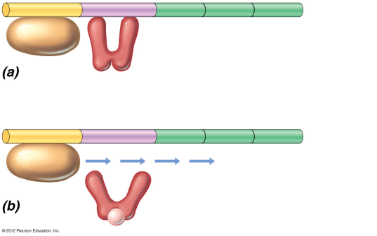

#21
#31
#11

#18 (2 marks) With reference to quorum sensing, how do cells assess population density?

By the concentration of signal molecules, the concentration increases because there are more cells producing the signal (make sure you don’t state this backwards..that the population increases along with an increase in signal molecules) it rises to a specific threshold and signals the bacteria that the population density has reached a critical level or quorum. The signal molecules diffuse across the cell membrane and build up in the cytoplasm. When concentrations build-up sufficiently an activator protein is able to trigger transcription (this is the mechanism your text speaks of, but I have also read that: chemicals produced by cells bind to chemoreceptors on the surface of cells.)

#19 a) (1 mark) Ethylmethane sulfonate (EMS) is a mutagen which reacts with DNA by adding a methyl (-CH₃) group to the base guanine (G). During DNA replication, faulty base pairing to T occurs instead of to C. What type of mutagen is EMS?
Base modifyer

b) (4 marks) Below is a single codon on a piece of double stranded DNA. Diagram (fill in the blanks) each single strand of DNA through replication as mutated by EMS, then transcribe each of these single strands to mRNA, and then translate each to an amino acid and identify the mutant amino acid. Genetic code is located at the back of the exam.
Transcription (RNA polymerase reads the DNA strand 3’ to 5”
translation

5'- G G A - 3' mRNA 5'-U C C - 3' amino acid=Ser_
replication
3'- T* T* T - 5' mRNA 5'- A A A - 3' amino acidLys^{mutant}
5'- G G A - 3'
3'- C C T - 5'
3'- C C T - 5' mRNA 5'-G G A- 3' amino acid=_gly
replication

5'-G G A- 3' mRNA 5'-U C C- 3' amino acid=_Ser

#19 ^{cont} c) (2 marks) Fully describe the type of mutation that has occurred.

It is a point mutation leading to a base substitution leading to a missense mutation.

#20 (2 marks) What is the difference between transduction and transposons?

Transduction is a process in which a recipient cell receives new DNA from a donor cell via a virus..once again, not “from” a virus, that sounds like the cell is getting viral DNA…which wouldn’t be added to the cell’s chromosome because it wouldn’t be sufficiently homologous
Transposons are objects, they are discrete units of DNA that can move integrate from one strand of DNA in a cell to another strand of DNA in a cell. They are not a plasmid.

#21 (1 mark) Which of the following cells represents a F+ cell. Chromosomal DNA is shown as a dashed line, plasmid DNA as a solid line. #4

#21
#31
#41
#11

#22 a) (3 marks) Explain, with diagrams, one way a virus can end up carrying bacterial genes from one cell to another cell.
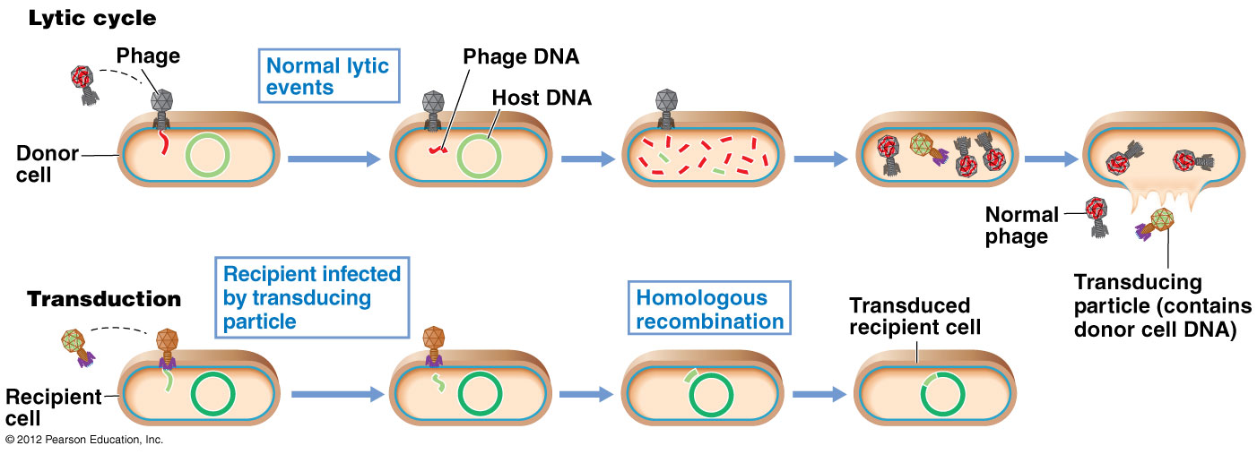
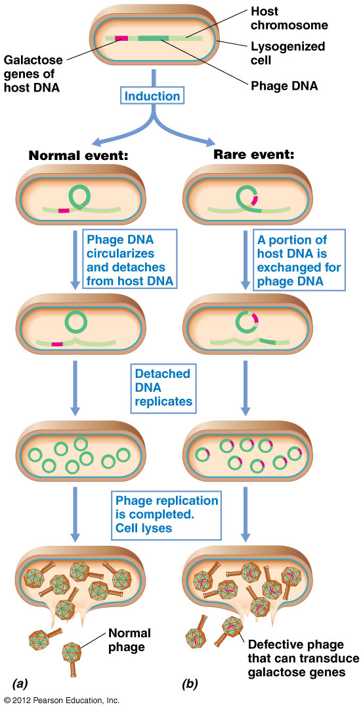

#22^{cont.} b) (1 mark) After a virus has transferred bacterial DNA to another bacterial cell, what is the name of the step that actually inserts the new DNA into the recipient bacterial chromosome?

Homologous recombination

c) (2 marks) Name two other processes that occur, in any Domain, that use the step you’ve identified in b)?

transformation, conjugation, or synapses (crossing over) in Eukaryotes

#23 (4 marks) A conjugation experiment is performed between a strain of bacteria that is sensitive to the antibiotics penicillin, tetracycline and rifampicin (tet- pen-rif-) and a Hfr bacterial donor strain that is resistant to all three. (pen+ tet+rif+). Screening yields two transconjugants (pen+ tet -rif-and pen+ tet+rif-).
Explain with diagrams how this could have occurred.

Replace lac in the diagram pen, pro with tet and add rif just past the tet site.
I went over this diagram with you, your text doesn’t have exactly this, the info however is on Pg 236t…
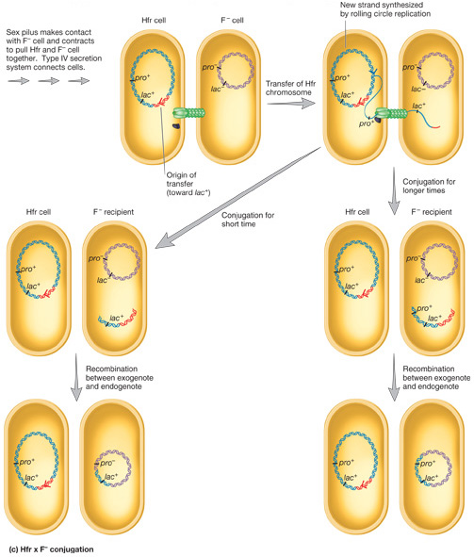

Strand breaks after pen+ and tet+ is transferred and before rif+ is transferred
Strand breaks after pen+ is transferred and before tet+ is transferred

Bonus question! What recombination process is being cartooned below?

Transformation…incorporation of “free” DNA


