Human Memory and Information Processing

Memory and Information Processing
- Acquisition of Information
- Serial Anticipation Learning
- Paired Associate Learning
- Mediating Strategies – meaningfulness, frequency, formation of images, schema, pronouncibility, rhyming etc.
- Encoding specificity and distinctiveness
- Transfer – positive, zero, negative
- Verbal Learning and Associated Variables
- Verbal Mediators – commonalities
- Rehearsal – maintenance, elaborative
- Natural Language mediators – stimulus equivalent, response equivalent
- Retrieval
- Forgetting
- Measuring Retention – recall, recognition, relearning (savings)
- Theories of Forgetting – decay, interference, repression
- Types of Interference – proactive, retroactive
- Ways to improve Retrieval – over learning, organization, chunking
- Models of Memory and Info Processing
- The theories and processes applies: an examination of the serial position curve

Acquisition of Information
- Materials and methods
- The bulk of research on memory has employed verbal materials
- They range from nonsense syllables to words to sentences to paragraphs
- This range of materials allows for manipulation of the amount of meaning in a stimuli

Herrmann Ebbinghaus
- First published study of memory in 1885
- Invented the nonsense syllable
- Two major types – CVC & CCC
- CVC – consonant-vowel-consonant
- CCC- consonant CVC – consonant-vowel-consonant
- CCC- consonant-consonant-consonant
- Purpose was to attempt to eliminate the effects of prior knowledge on learning of materials
- Procedure - Serial Anticipation Learning
- Read a list of nonsense syllables to the beat of a metronome to insure each item received the same exposure for study
- On all exposures following the initial exposure he attempted to form an association between the current stimuli and the next stimuli on the list

Serial Anticipation Learning
- Items are shown individually
- All items on a list are shown once to constitute a single trial
- On each subsequent trial the subject attempts to anticipate what the next item will be from viewing the current item (i.e. each item is thus both a stimulus and response)
- Learning is declared complete when the subject is able to reach a specified Criterion (i.e. make 2 completely correct asses through the list)
- Measurement
- What is measured is the number of trials until criterion is reached
- Also the number of errors per item is measured
- The latter measure is taken to insure items are of approximately equal difficulty
- Results
- Items at the beginning and end of lists are more easily learned
- Words are more easily learned with this method than either CVC and CCC stimuli
- The method also provides for a measure of retention called Savings

Paired Associate Learning
- Main principle is to establish and association between two items
- One item serves as the stimuli for the recall of the other item (i.e., an item is either a stimulus item or a response item never both as in serial anticipation learning)
- The major employer of this technique, using words, has been Dr. Allan Paivia, at UWO currently holding the position of Professor Emeritus, and one of the top cognitive psychologists in the world
- He and his associates utilize this procedure to examine the differences between concrete and abstract words
- Procedure
- For learning Pairs of items are presented for an equal amount of time per pair
- Pairs consist of CC (concrete-concrete); CA (concrete-abstract); AC(abstract-concrete); AA (abstract-abstract)
- An example of a Concrete item would be Chair
- An example of an Abstract item would be Justice
- During Retention testing the first item of each pair (the stimulus) is presented and subjects attempt to recall the second item (the response). For example:

Pair Type Stimuli Response
CC Chair Broom
CA Door Justice
AC Truth Dog
AA Belief Honesty
•Results
- In order of recall accuracy Concrete items are recalled better than Abstract items
- The ranking of all possible pairs is as follows: CC pairs; CA pairs; AC pairs; AA pairs
- This indicates that Concrete items are better as Stimulus items than Abstract items
- Paivio explained this as a consequence of representational differences for the two stimulus types
- The theory is known as DUAL-CODING
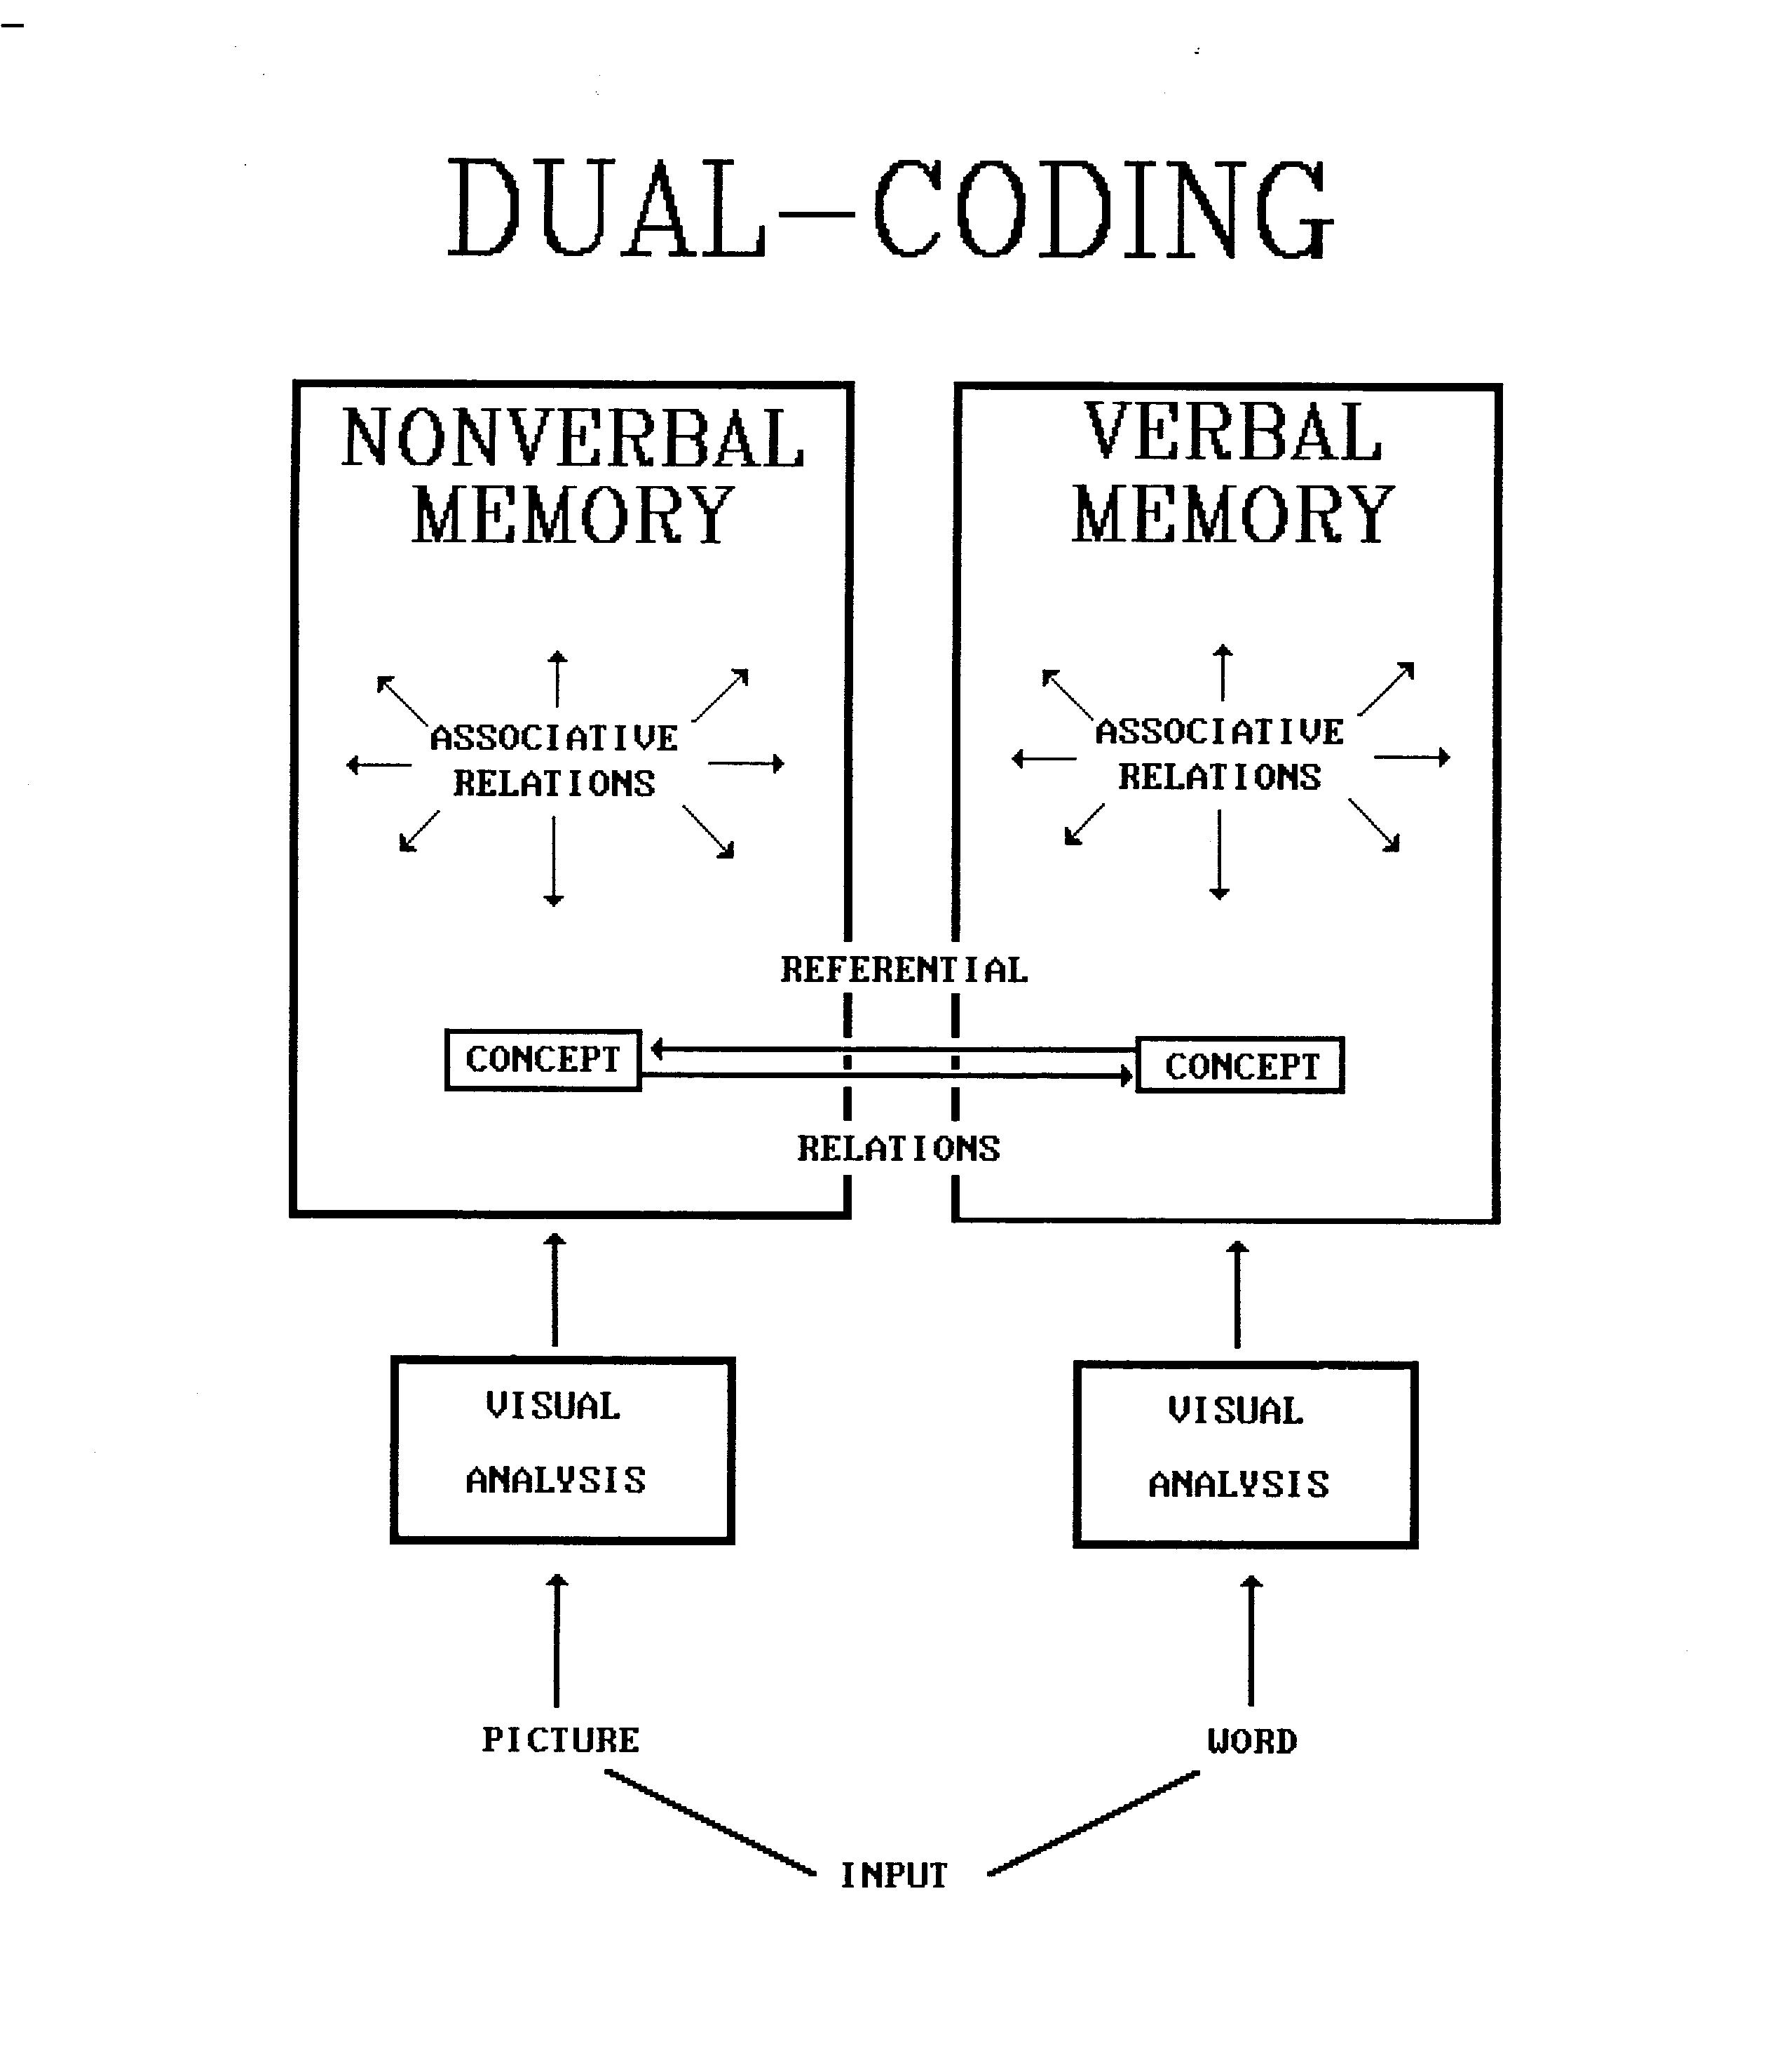
- This theory postulates two representational systems exist independently although they are referentially linked

SAL & PA Review
- SAL – Words learned easier & remembered better than Nonsense syllables (CVC & CCC)
- Items at beginning & end of lists learned easier & remembered better than mid list
- PA – Within words Concrete response items recalled better than Abstract & Concrete make better anchors
- Although Ebbinghaus intended to eliminate the type of complications that words add to obtaining a pure measure of learning by using nonsense syllables later studies have shown that even nonsense syllables can contain meaning.
- Thus the advantage for words is not because nonsense syllables have no meaning, as Ebbinghaus believed, but because words have more meaning

Meaningfulness
- Meaningfulness can be measured in several ways:
- Procedure - Show item and ask for subjects to report any items that come to mind
- Measure – Speed of 1st Association (RT)
-Percentage of subjects who offer an association
-Mean number of associations offered
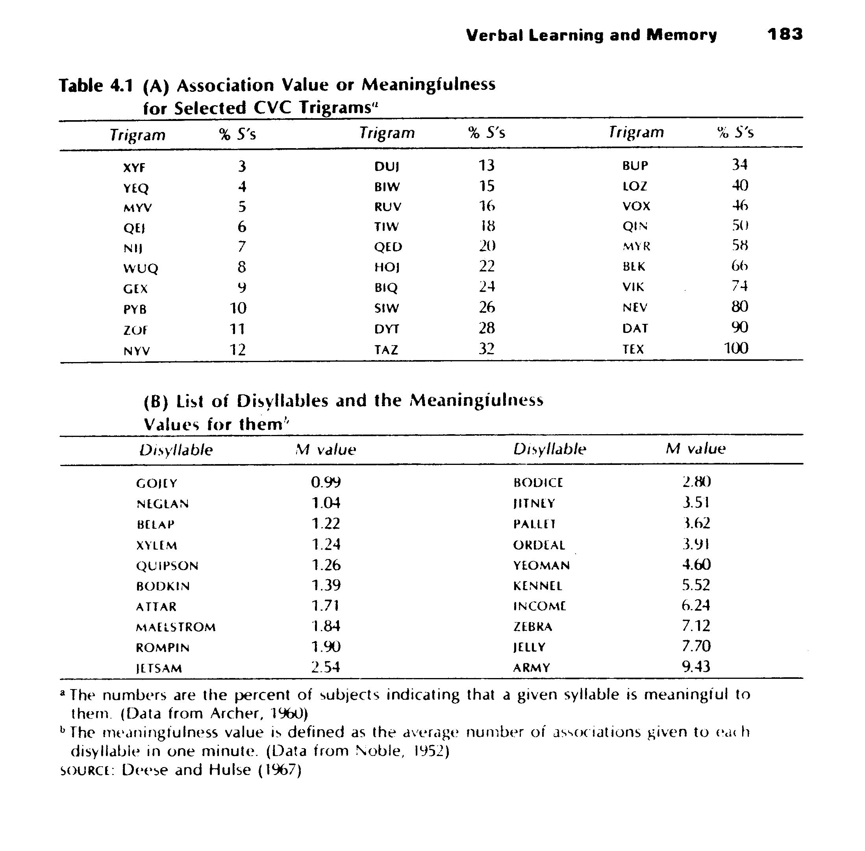
- Meaningfulness ratings are good predictors of:
- Rate of Learning (both SAL & PA)
- Increase probability of recall in Free Recall
- However Similarity of Meaning for items in a list or between S & R items in the PA task decrease performance

Encoding Specificity & Distinctiveness
- Importance of these factors was discovered and researched by Endel Tulving
- Basic finding is that the more distinctive an encoding is the easier it will be to recall the encoded information.
- Also the more the situation at test is similar to the situation of learning the better will be recall

Other factors affecting Retention
- Frequency of Occurrence
- The more often an item is encountered the greater it is recalled and the faster it is recalled
- Phonemic Effects
- Pronouncibility is correlated .46 with ability to recall an item or provide a correct response in a PA task.

Transfer
- The investigation of Transfer is important to an understanding of how prior learning affects current learning
- Three types of Transfer:
  - Positive Transfer – when earlier learning aids current or future learning
  - Zero Transfer – when earlier learning aids current or future learning
  - Negative Transfer – when prior learning inhibits current learning

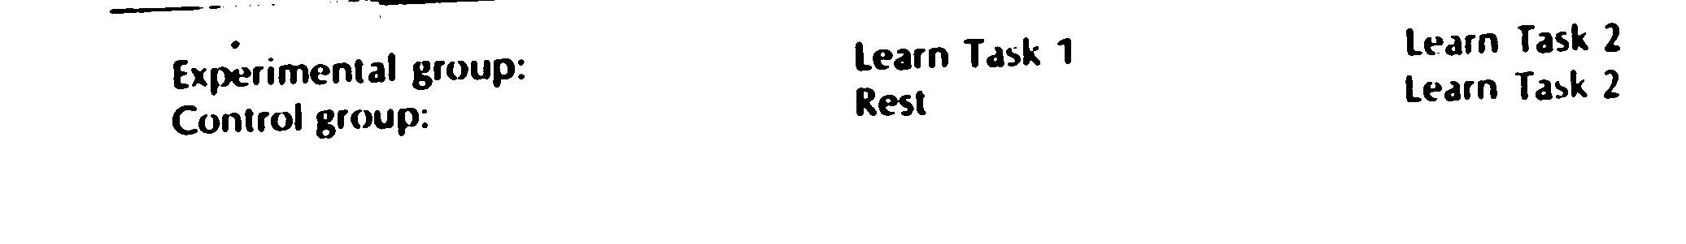
The Transfer Experiment: Procedure

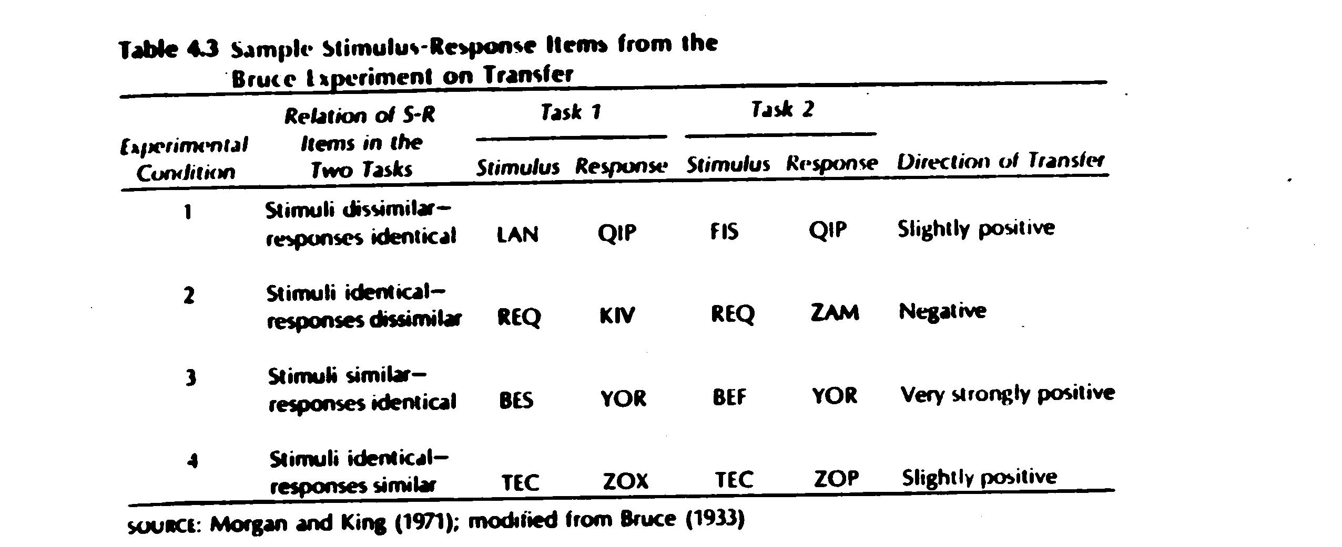

Important Generalizations of Transfer
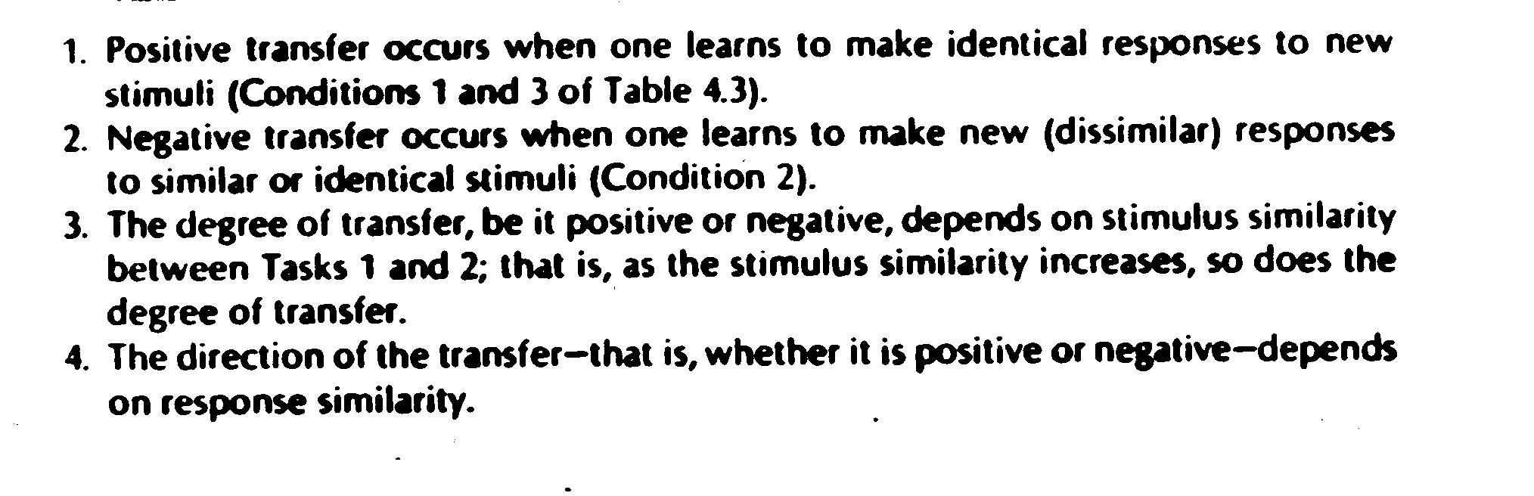

Recap
- Learning Verbal material is easier if it is:
- Meaningful
- Distinct from other new material
- Frequently presented
- Concretized
- Can be related to prior material
- Testing situation is similar to Learning

Processes in Information Processing
- Rehearsal and Mediating processes
- Rehearsal has Two major Types
- Maintenance & Elaborative
  - Maintenance – consists largely of silent repetitive speech
  - Elaborative - will involve mediating procedures

Rehearsal: Peter & Peterson (1959)
- Classic Experiment
- Subjects presented with list of Trigrams and at end of list a number with instructions to count backwards by three’s
- Counting task was to prevent rehearsal
- Subjects would recall list after 3, 6, 9, 12, 15, 18 seconds of counting task
- Results - Relatively Linear decrease in recall scores as time spent in counting task increased
- This is based upon the assumption that the counting task prevents rehearsal as the trigrams are displaced in memory by the counting task due to memory limitations

Memory Limits
- George Miller (1956) – Research indicated that working or Short-Term Memory(STM) is limited to a capacity of 7+/- 2 items or Chunks of information
- If Rehearsal is what is important (it could be a retrieval failure) then rehearsal serves two functions – Maintenance in STM and transfer to Long Term Memory (LTM)

A Model of Memory to Explain Peter & Peterson (1959)
- One model which is compatible with the results is the Duplex Model of Memory
- Divides Memory into STM and LTM where rehearsal is the process to transfer information from STM to LTM
- Either a number of rote rehearsals or some Elaborative rehearsal serves as the transfer mechanism
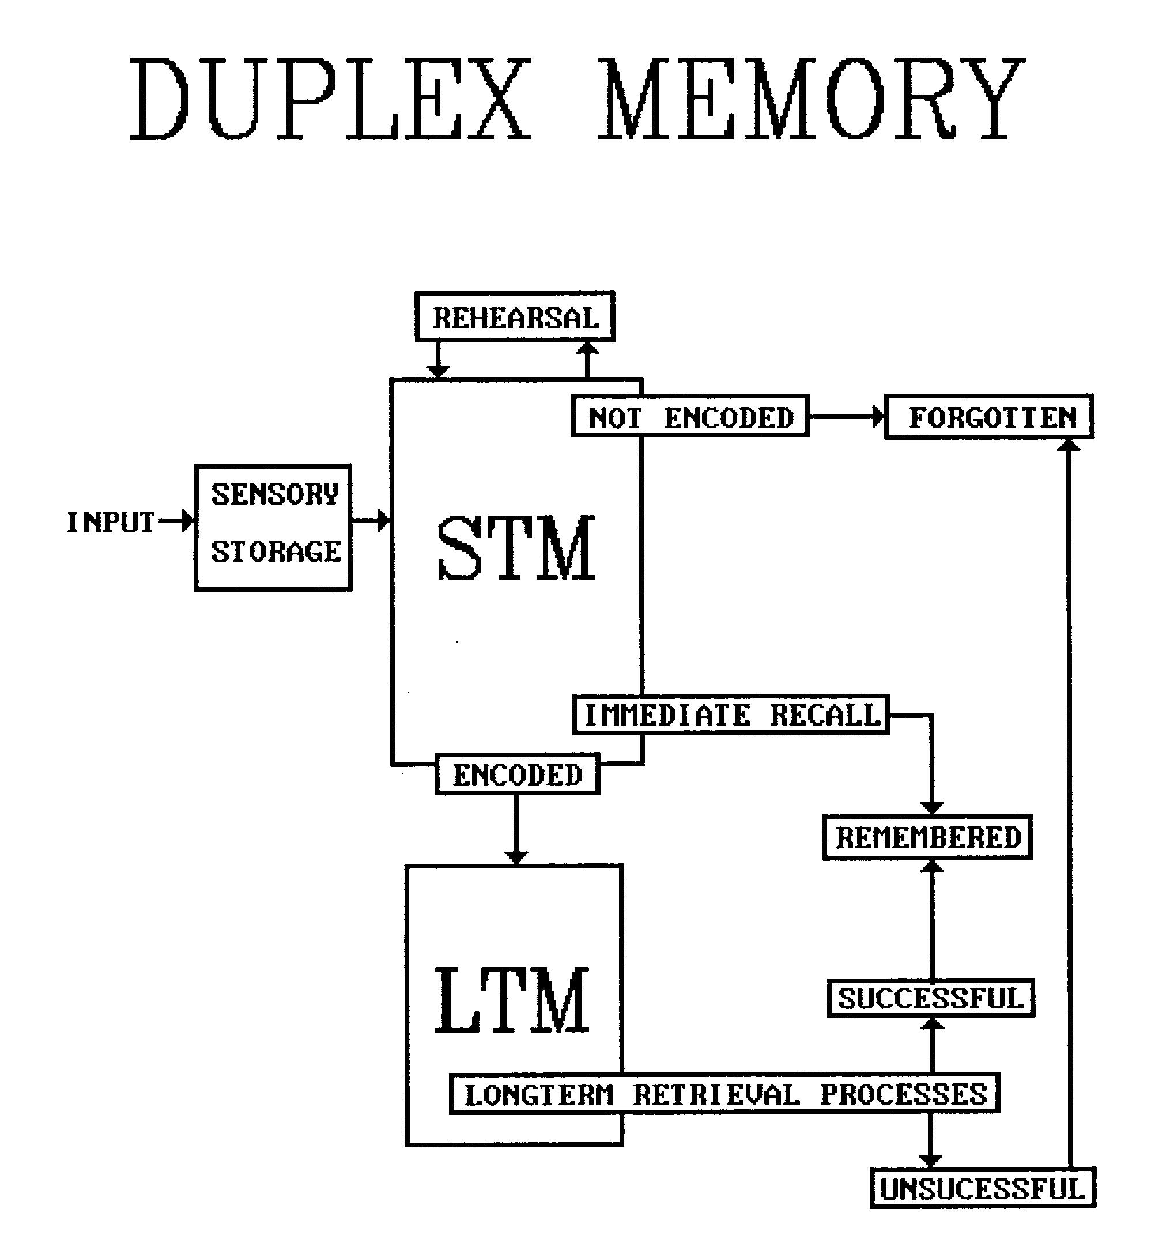

Rehearsal cont’
- Is it better to rehearse 3sec on a single item at one time or 1 sec on the item 3 times
- Frequency effects suggest the latter
- Bugelski (1962) investigated this in a PA task where subjects were presented pairs for 6, 8, 10, 12, or 19 sec. The Criterion for learning was 2 passes through the items with no errors
- Results: Bugelski – Note: Primary implication of results is that Total Time is the determining factor for list learning.
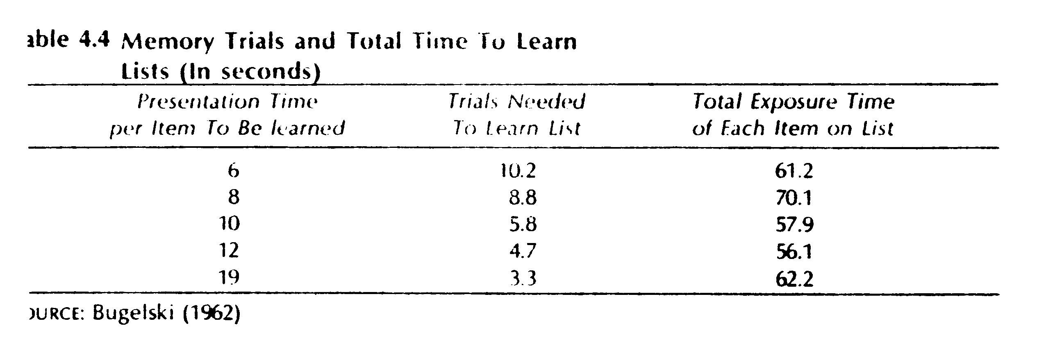
- Further research by Rundus & Atkinson (1970) which investigated overt rehearsal.
- Subjects received 20 items 1 every 5 sec
- Subjects were instructed to rehearse aloud
- Recall was a linear function of how many times an item was rehearsed as opposed to how long it was presented.

Mediation
- In list or PA learning terms are often not related in meaning
- In order to facilitate learning subjects have reported employing mediating strategies
- They report generating a word which has some relationship with each of the words in a pair (e.g., given DOG and NINE subjects may generate CAT –[raining cats & dogs / cats have nine lives])
- This type of mediator is known as a Natural Language Mediator
- Natural Language Mediators may be placed into TWO Classes
  - 1 Stimulus equivalent – Both Democratic & Birthday elicit Party
  - 2 Response equivalent – mediator elicits both stimulus & response terms – Record might elicit Store and Time
- Another form of mediation relevant when stimuli consist of CCC’s or CVC’s is Transformational Mediation Prytulak (1971)
- In this instance subjects transform the nonsense syllable into a real word – e.g., PYN is transformed into PIN (sub y for i) or FET into PET (sub f for p) or LYV into LIVE (sub y for i, minus e)
- Recall is a function of the No. of transformations

Retrieval & Forgetting
- Forgetting can be explained in Two possible ways:
  - 1 it was never encoded and thus was not learned
  - 2 it was learned and is therefore available but you have experienced a retrieval failure
- This indicates Three necessary components to memory: a) Encoding, b) Storage, c)Retrieval

Measuring Retention
- Three primary measures of retention:
1) Recall – either Verbatim (a list)or Reconstructive (story telling)
2) Recognition – (e.g., multiple choice)
3) Relearning – upon discovering a deficit in performance one can relearn the material to an original level of competence
- Savings
- Retention is measured by comparing the number of trials taken in the relearning situation to reach the specified criterion to the original number of trials taken to reach the specified criterion.
- Savings = 100 ((OT – RT) / OT)
- Where OT = original trials to criterion &
- RT = relearning trials to criterion

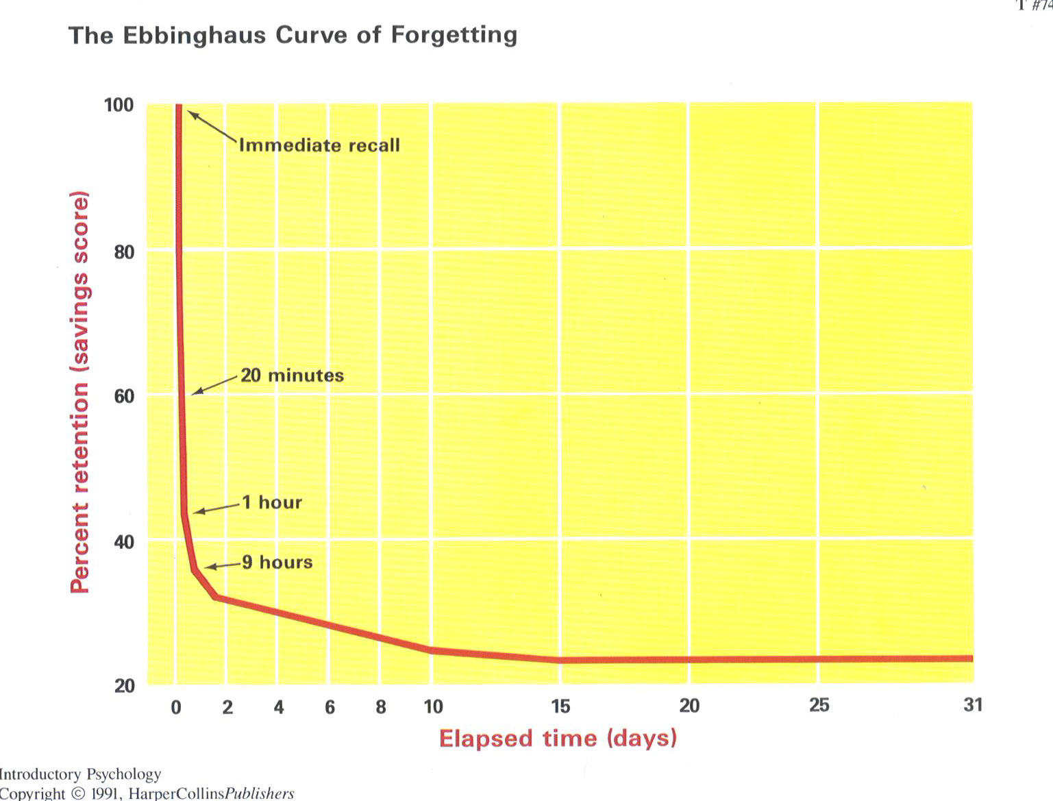

Theories of Forgetting
- Decay & Interference
- Decay: Forgetting is a consequence of disuse –
  - a) The knowledge itself fades
  - b) The route to the information is lost.
- This theory assumes that the information was initially learned.
- Decay Theory is supported by research into Iconic and Echoic memory.
- Sperlings research into Iconic memory showed that in a 4 column 3 row display subjects could accurately report approximately 33% of the display in a Whole report condition and that what was reported was typically the first row
- Sperling developed the technique of Partial Report
- Subjects were shown the display and signaled with a tone (high, medium, low) to report either the top, middle, or bottom row.
- The number of items reported was similar regardless of the row signaled
- Sperling argued that this indicated the entire display had been processed to the level of Iconic memory but that the act of reporting took longer that Iconic memory could preserve the information
- This finding provides support for the Decay theory of Forgetting
- Although Decay theory is supported by studies such as Sperling’s for more durable memories it should be treated with suspicion as time is often invoked as an explanation when the actual processes have not yet been discovered.
- A better Theory for longer lived memory systems is Interference Theory
- Interference Theory - Two types of Interference:
  - 1 Proactive: from things which precede the to be learned material
  - 2 Retroactive: from things which follow the to be learned material
- These types of interference effects hamper Rehearsal
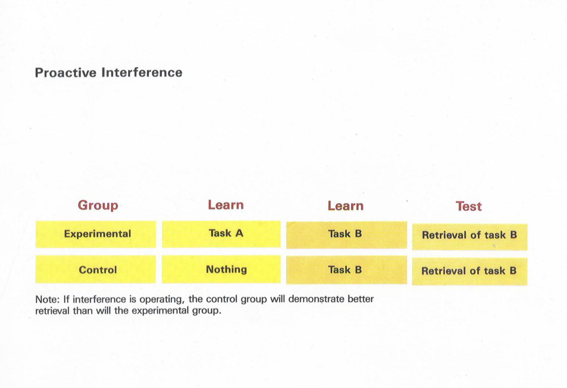
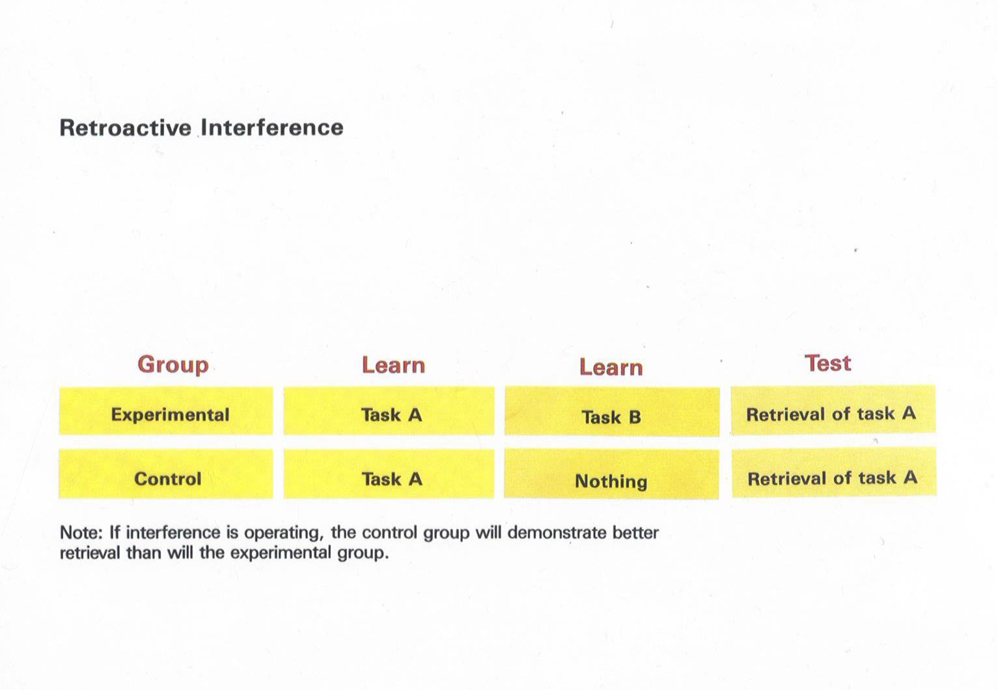

- Repression
- This type of forgetting is active
- That is to say it is motivated forgetting
- It was first proposed by Freud when he discovered that persons with emotional instability would avoid bringing certain lines of thought to a conclusion during therapy
- Specific memories were repressed because they would cause the individual emotional distress or anxiety if and when they were brought into consciousness.
- The memories were subjected to a Retrieval Block as an Ego defense mechanism.

Improving Retention
- 3 Major Approaches
  - Over Learning – the better something is learned the less susceptible it is to interference
  - Organization – put material in a form which is meaningful to you and distinctive
  - Chunking – Group related concepts together under a heading so if you recall the heading you can “UNPACK” the information

Another Model of Memory
- Levels of Processing (Craik & Lockhart, 1972)
- Levels of processing is based upon the notion that items are initially processed at a shallow level (Feature analysis)
- They continue processing at a deeper level of Pattern Analysis
- And are finally processed for their Semantic relevance
- Retention is both a function of how deeply an item is processed and at what level of processing it is tested
- This becomes clearer with examination of the model
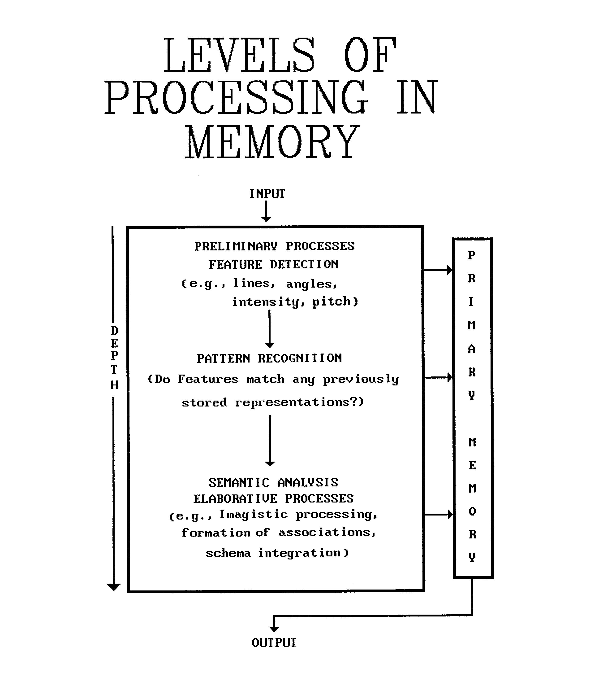

AN APPLICATION
- The Serial Position Curve
- This is a well known empirical result when people attempt to learn a list of items
- Basically, regardless of list length, items at the beginnings and ends of lists are remembered better than those in the middle
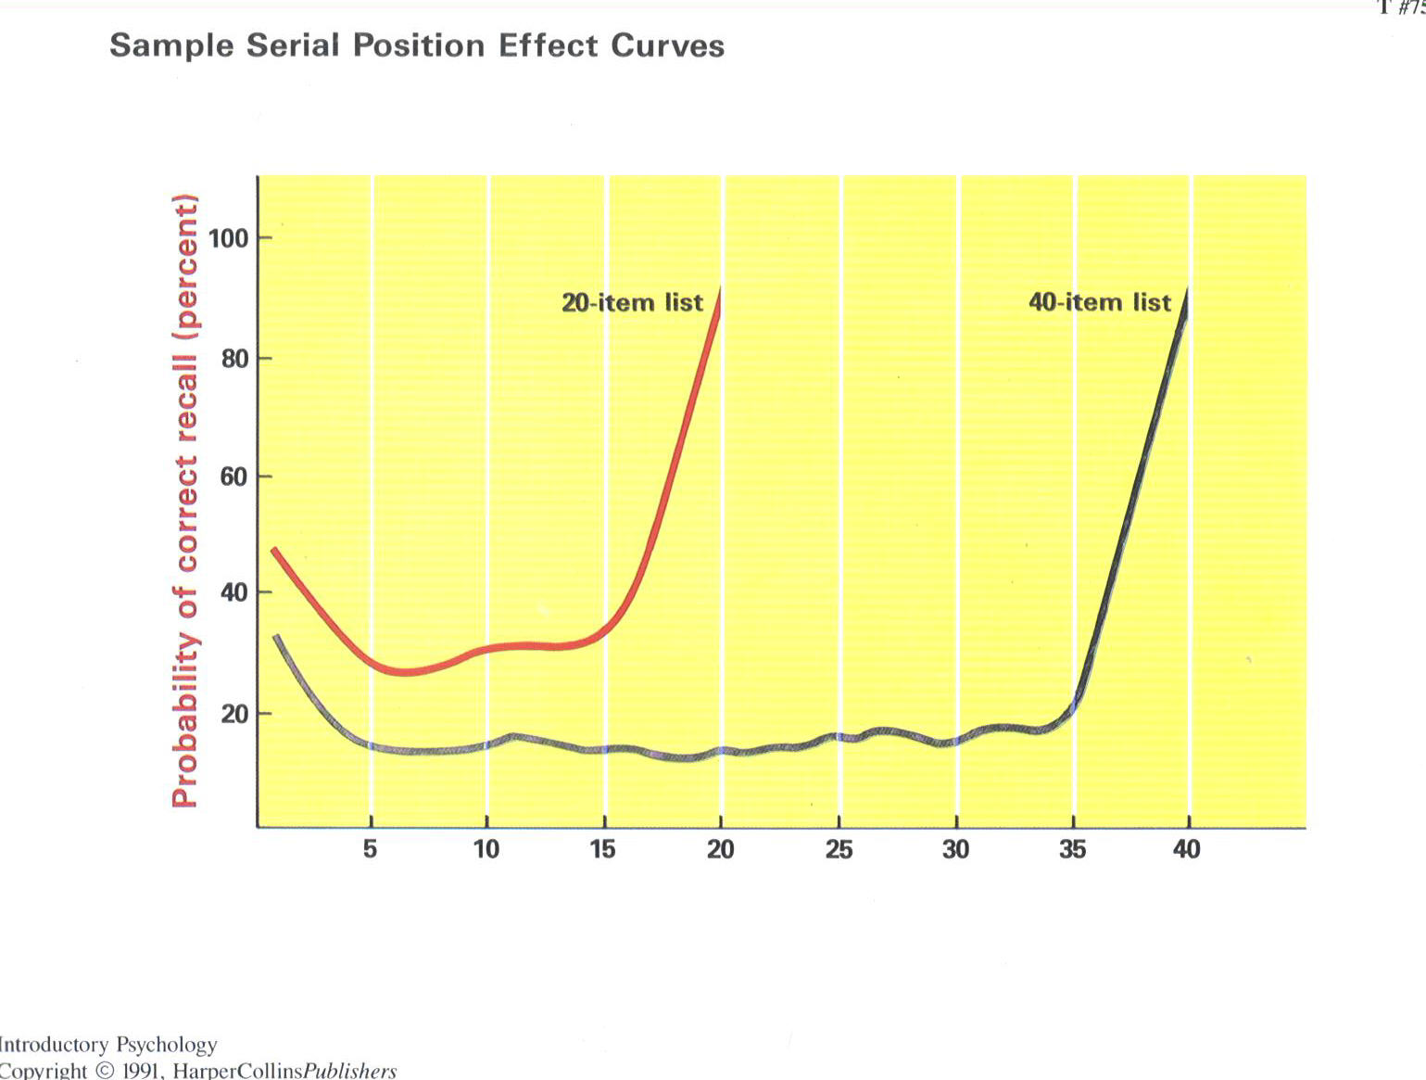

Serial Position Curve
- However this pattern changes if the recall of items is delayed with an interpolated task such as counting backwards by threes for 30 sec after the presentation of the last list item.
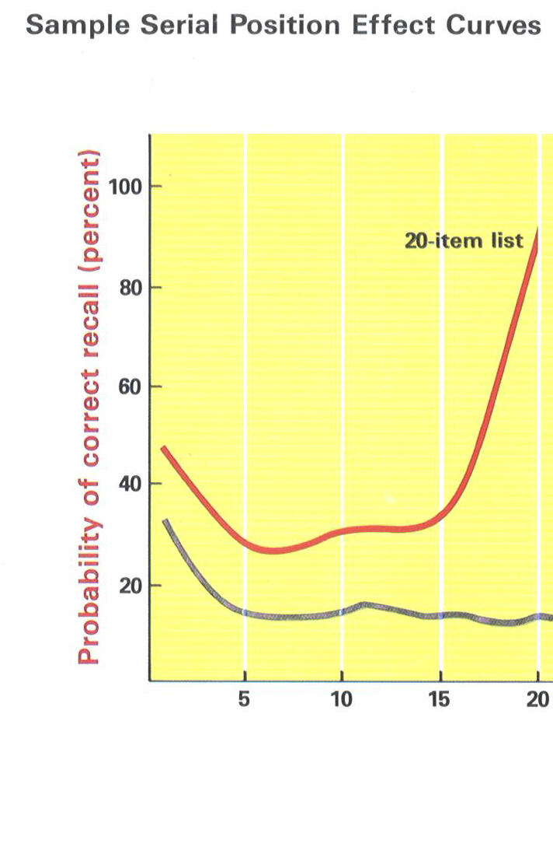
The Application
- How can what you have learned about Human Memory and Information processing explain the Serial Position Curve?
- What processes are operating and how?
- What Models of Memory are compatible with the results and processes which explain them?

