Winter 2013 | The Respiratory System
Year 2- University of Ottawa |  | APA 2312

Transportation of Oxygen and Carbon Dioxide
- Pulmonary ventilation (breathing) – movement of air into and out of the lungs
- Pulmonary diffusion – the exchange of O₂ and CO₂ via the blood
- Capillary diffusion – the exchange of O₂ and CO₂ between the capillary blood and the metabolically active tissue

anatomy of the Respiratory system
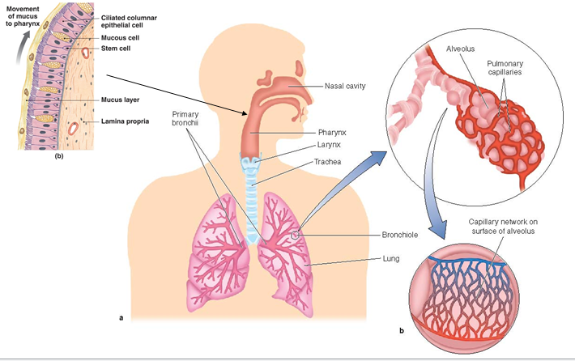

PUlmonary Ventilation

Inspiration
- Active process involving the diaphragm and the external intercostal muscles
- Pressure in the lung is less than the air pressure outside the body, air following the pressure gradient coming into the lung

Expiration
- Usually a passive process involving relaxation of the inspiratory muscles; pressure increases in the lungs and air is forced out
- Active process during forced breathing

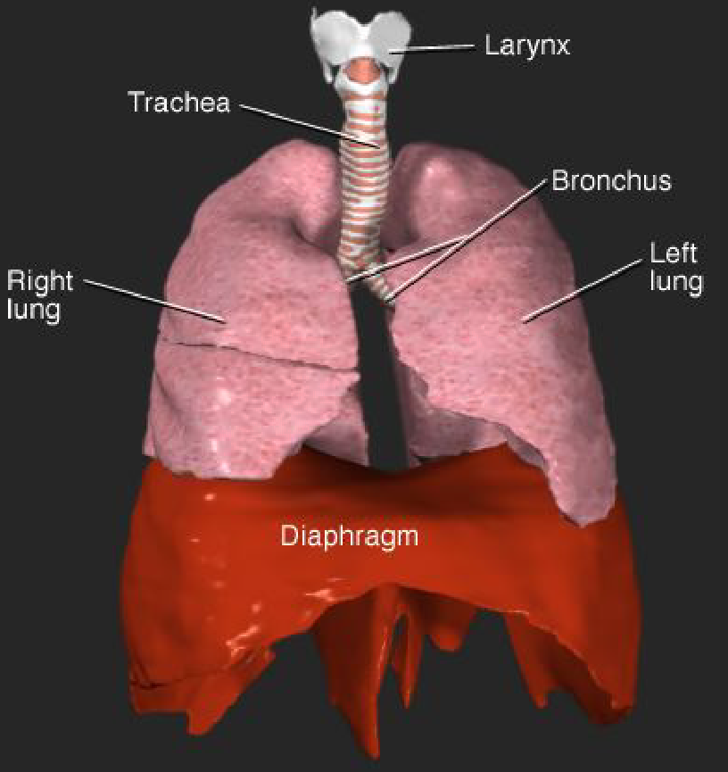

Boyle’s Law
- For a given quantity of any gas (such as air) in an air-tight container; the pressure is inversely related to the volume of the container
  - Ex. If atm=1 then the container = 100L but if atm=2 then the container=50L

Mechanics of Breathing
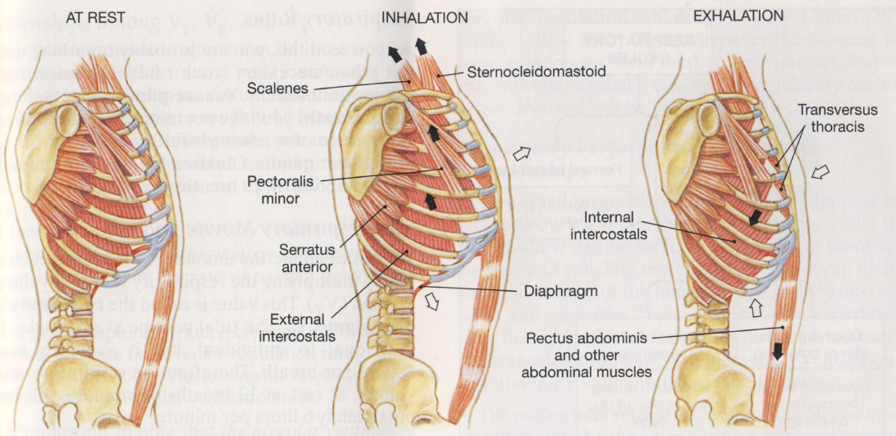
Lung volume Measured by Spirometry
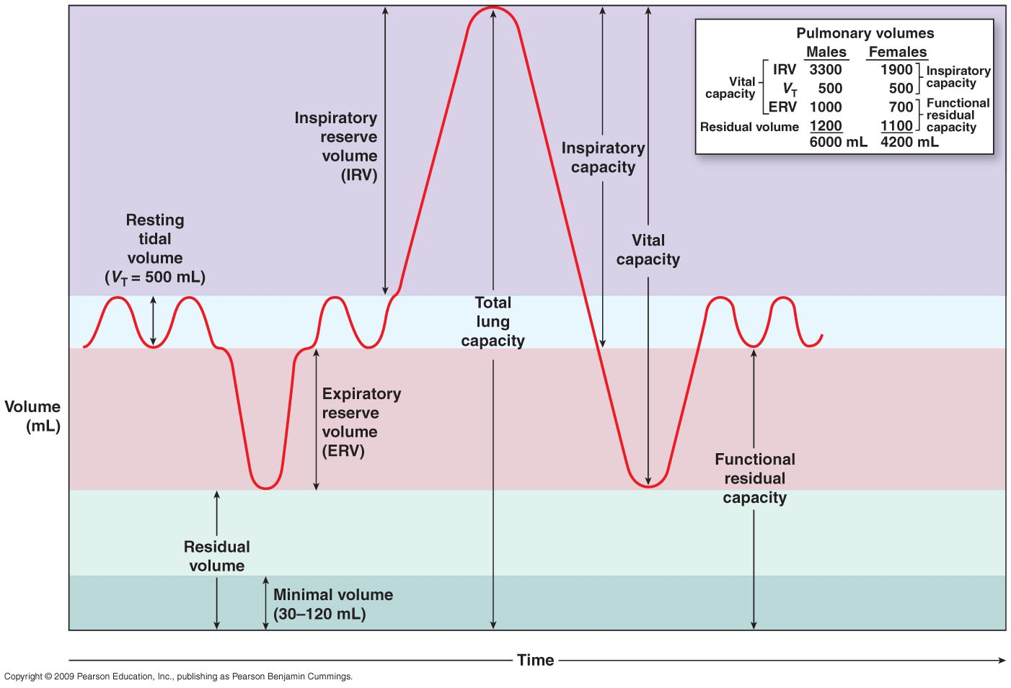

Pulmonary Ventilation
- Respiratory Rates and volumes
  - Respiratory system adapts to changing oxygen demands by varying:
    - The number of breaths per minute (respiratory frequency f_{r})
    - The volume of air moved per breath (tidal volume V_{r})
- The Respiratory minute Ventilation (V_{E})
  - Amount of air moved per minute
  - Calculated by
    - Respiratory rate X tidal volume
  - Measures pulmonary ventilation
- Anatomical Dead Space
  - Only a part of the respiratory minute volume reaches alveolar exchange surfaces
  - Volume of air remaining in conducting passages is anatomic dead space
- Alveolar ventilation
  - Amount of air reaching alveoli each minute
  - Calculated as:
    - (Tidal volume – anatomical dead space) X respiratory rate
  - A higher gas exchange rate is achieved if you raise the tidal volume and lower the respiratory rate

anatomy of the respiratory Membrane

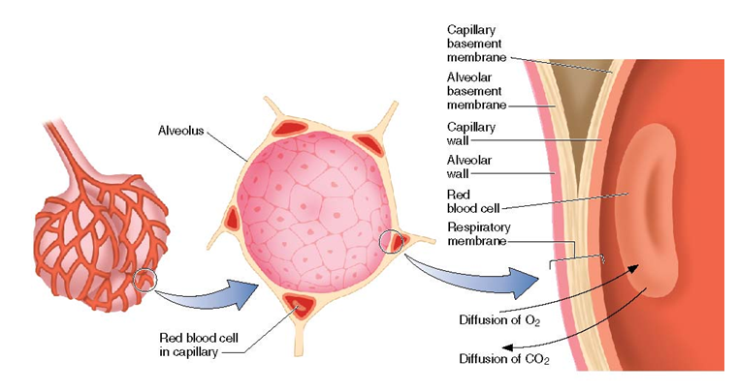

Pulmonary Diffusion
- Why are the lungs so good at diffusion?
  - The thickness (T) of alveolar walls are very thin
  - The area (A) is 50-100m² total

Gas exchange in the Alveoli
- Occurs by passive diffusion across the alveolar wall
- Volume of diffused gas (V_{gas}) is described by Fick’s law
- Inversely proportional to T
- Directly proportional to A and P₁ – P₂
  - Difference in concentration of gas between each side of the alveolar wall
- Directly proportional to solubility
- Indirectly proportional to MW (molecular weight)

Concentration of Gasses in the Air

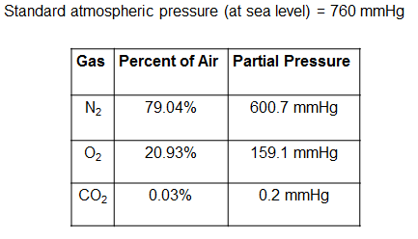

Oxygen Transport

Dissolved O₂ in blood plasma
- For each mmHg of PO₂ 0.003ml of O₂ is dissolved per 100ml of blood
- Therefore for PO₂ of 100mmHg = 0.30ml of O₂ dissolved/100ml blood
- Therefore for cardiac output (Q) of 5 L/min = 15ml of O₂ dissolved/100ml blood (~1-2%)

O₂ bound to Hemoglobin
- HbO₂ (100% sat) contains 1.34ml/O₂ of Hb
  - [Hb] blood = 16g/100ml
- SaO₂=100%
- Therefore 21.4ml O₂/100ml of blood
- Therefore for cardiac output (Q) of 5L/min = 1070ml (98%bound to Hb)

Carbon Dioxide Transfer
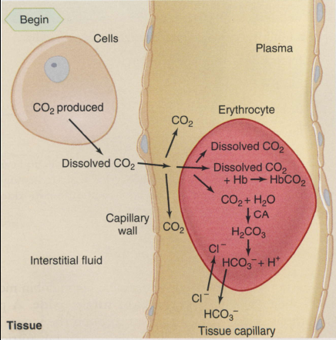
- 10% dissolved in plasma
- 30% bound to Hb
- 60% carried as bicarbonate

Respiratory Exchange Ratio
- The ratio between CO₂ released (VCO₂max) and oxygen consumed (VO₂max)
- RER = VCO₂max/VO₂max
- The RER value at rest is usually 0.78 to 0.80

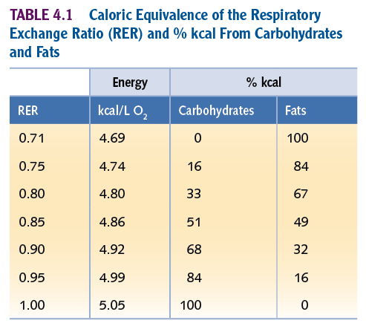

Resting Metabolic rate (RMR)
- RMR is the minimum amount of energy required by the body to sustain basic cellular function
  - Fat-free mass
  - Body surface area
  - Ranges from 1100-2500 Kcal/day
  - When activity is added, daily caloric expenditure is 1700-3100 kcal/day

Factors that afect Resting metabolic Rate
- Age – RMR gradually decreases with age, generally because of a decrease in fat-free mass
- Body temperature – RMR increases with increasing temperature
- Psychological stress – stress increases activity of the sympathetic nervous system

Metabolic Rate during submaximal Exercise
- Metabolism increases in direct proportion to the increase in exercise intensity
- During exercise at a constant power output (work rate) VO₂ increases from its resting value to a steady-state value within 1-2 minutes
- There is a linear increase in the VO₂ with increases in power output (work rate)

