Winter 2013 | The Cardiovascular System
Year2-University of Ottawa |  | APA 2312

The Heart and Cardiac Muscles

Introduction to Cardiovascular System
- The pulmonary circuit
  - carries blood to and from gas exchange surfaces of lungs
- The systemic circuit
  - Carries blood to and from the body

Anatomy of the Heart
- Atriums
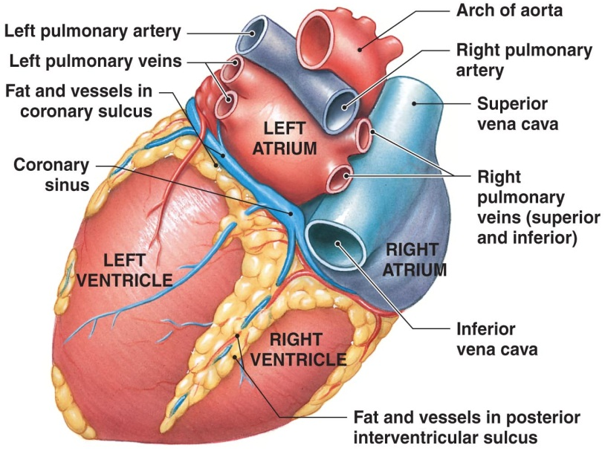
  - Receives blood from veins
- Ventricles
  - Pumps blood to arteries
- Right side of heart
  - Deals with pulmonary circuit
- Left side of heart
  - Deals with systemic circuit

The Right Atrium
- Receives blood from
  - Superior vena cava
    - Receives blood from head, neck, upper limbs, and chest
  - Inferior vena cava
    - Receives blood from truck, viscera, and lower limbs
  - Coronary sinus
    - Cardiac veins return blood to coronary sinus
    - Coronary sinus opens into right atrium

The right Ventricle
- The right ventricle
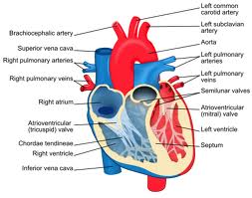
  - Connected to the right atrium by the right atrioventricular (AV) valve, or tricuspid valve
  - Receives blood from the right atria and pumps I through the pulmonary circulation

The left atrium
- Blood from the pulmonary veins is delivered to the left atrium
- Blood from left atrium passes to the left ventricle through the left atrioventricular (AV) valve
  - A two-cusped bicuspid valve or mitral valve

The Left Ventricle
- Holds same volume as right ventricle
- Is larger; muscle is thicker and more powerful
- Systemic circulation
  - Blood leaves left ventricle through aortic valve into ascending aorta
  - Ascending aorta turns (aortic arch) and becomes descending aorta

Coronary Circulation
- The blood supply to the heart
- The coronary arteries
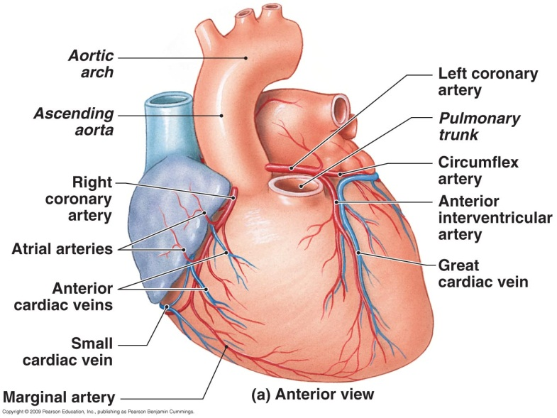
  - Originate at the aortic sinuses
- The coronary veins
  - Drain into the right atrium

Walls of the Heart
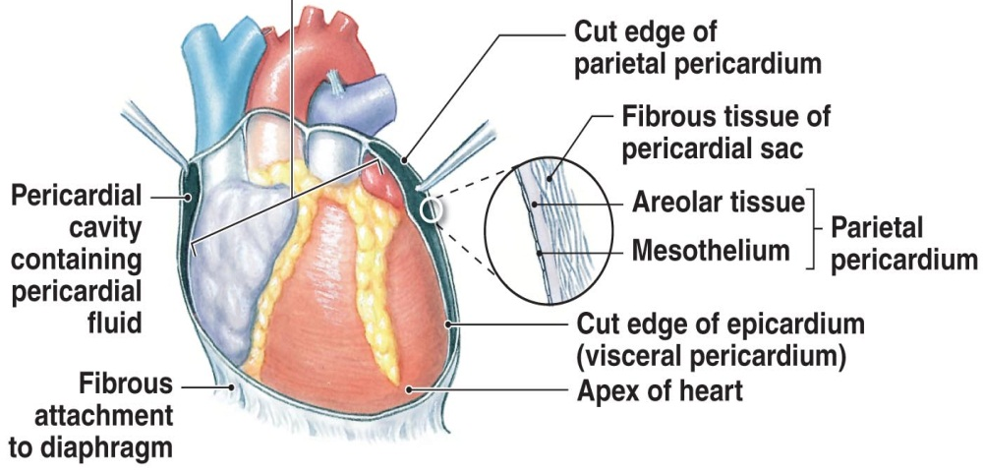
- The pericardium
  - Double-layered fluid-filled sac
- Epicardium
  - Outer layer
- Myocardium
  - Middle layer
- Endocardium
  - Inner layer

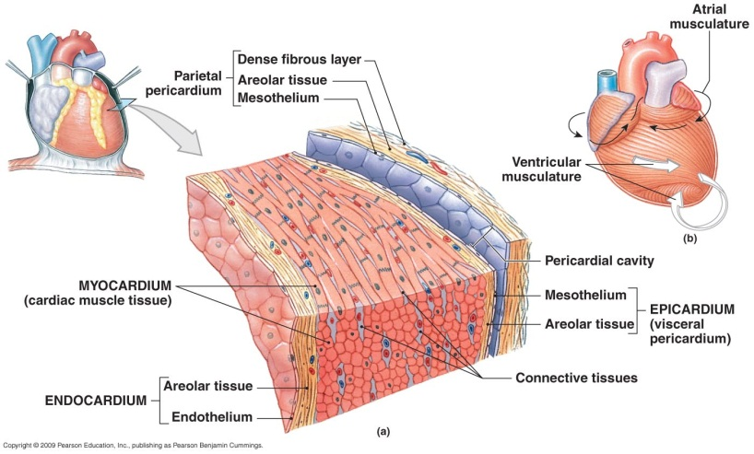

Muscles of the Heart
Cardiac muscle vs. Skeletal muscle
- Cardiac Muscle
  - Actin and myosin
  - Self-innervated
  - Contain intercalated discs
  - Branched
  - Highly oxidative
- Skeletal Muscle
  - Actin and myosin
  - Requires innervation
  - No intercalated discs
  - Linear
  - Depends upon fiber type

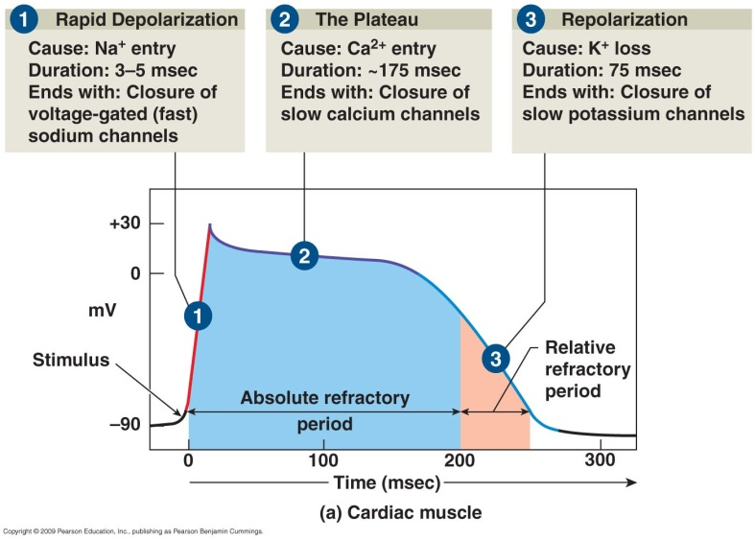
Action Potentials
- Cardiac Muscles
  - Self-potentiating
  - Continuous (no resting potential)
  - Threshold: -40mV
  - Pea polarization: +20 - +30mV
  - Lowest polarization: -60 - -80mV
- Skeletal Muscle
  - Requires innervation
  - Rests
  - Threshold: -55mV
  - Peak polarization: +30mV
  - Resting potential: -70mV
  - Lowest polarization: -80mV

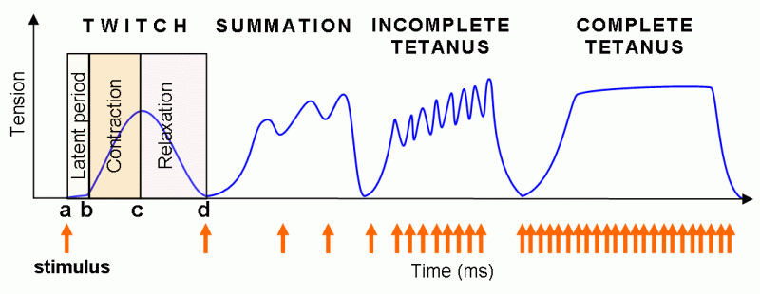
Cardiac Muscle Cells
- Conducting system
  - Controls and coordinates heartbeat
- Contractile cells
  - Produce contractions that propel blood

Intercalated discs
- Interconnect cardiac muscle cells
- Linked by gap junctions
- Convey force of contraction
- Propagate action potentials

Valves of the Heart
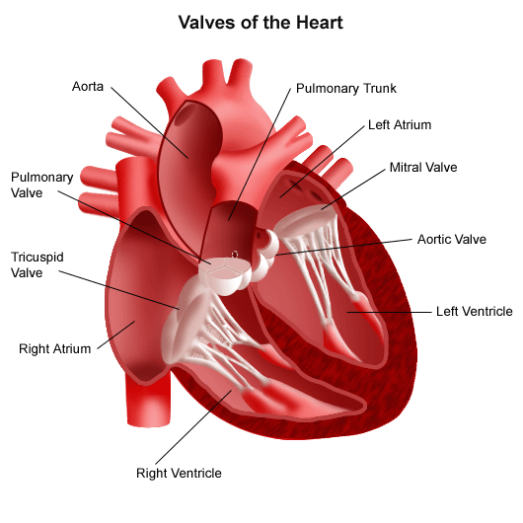
- Septum
- AV valves
  - Bicuspid
  - Tricuspid
- Pulmonary valve
- Aortic valve
- Subvalvular apparatus
  - Papillary muscles
  - Chordae tendinae
- Why no atrial valves?

Structural Differences between the left and right ventricles
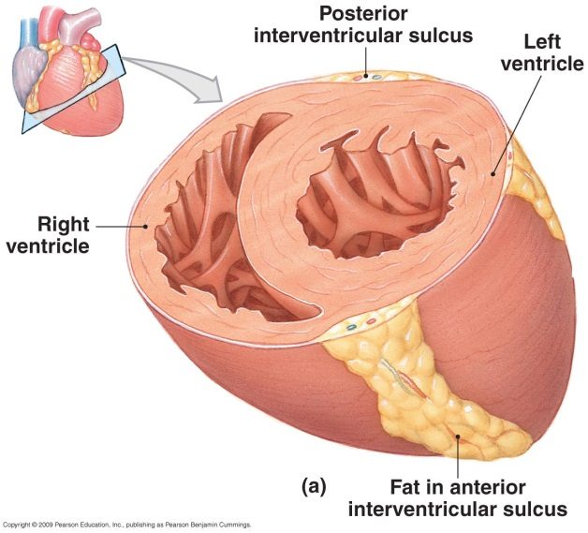

Good vs. Bad Hypertrophy
- In athletes:
  - Increase of up to 60% in V-mass
  - Increase in performance
- In hypertensive
  - Increase of up to 150% in V-mass
  - No increase in performance

Heartbeat and Cardiac Cycle

The conducting System
- Heart Rate
  - SA node generates 80-100 action potentials per minute
  - AV node generates 40-60 action potentials per minute
  - Regulated by central nervous system innervation during normal rest and exercise

Structure of the conducting system
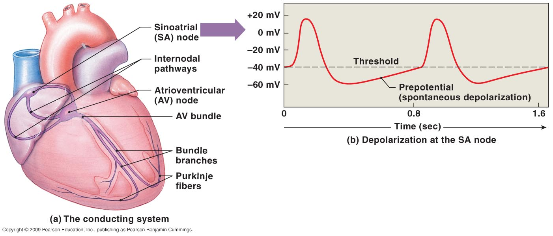
- Sinoatrial (SA) node
- Atrioventricular (AV) node
- AV bundle
- Purkinje fibers
- Pacemaker cells
- Conduction cells

Process
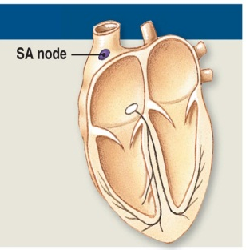
Step One
- SA node full of modified cardiac muscle cells creates an action potential

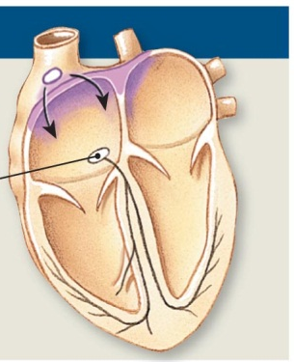
Step Two
- Action potential generated at the SA node spreads to both atria by cell to cell contact
- Stimulus only affects the atria because they are isolated from the ventricles
- Action potential spreads fast enough that both atria contact at the same time

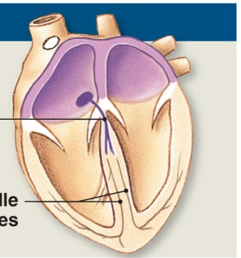
Step Three
- Delay through the AV node is due to:
  - Nodal cells are smaller in diameter than the conducting cells
  - Connection between conducting and nodal cells is less efficient than between conducting cells
- Importance: allows sufficient time to the atria to contract before the ventricles do, which would close the AV valves

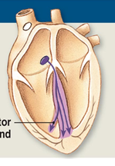

Step Four
- The impulse travels along the interventricular septum within the AV bundle and the bundle branches to the Purkinje fibers and , via the moderator bands, to the papillary muscles of the right ventricle

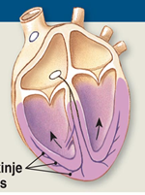

Step Five
- The impulse is distributed by Purkinje fibers and relayed throughout the ventricular myocardium. Atrial contraction is completes, and ventricular contraction begins.

The Contractile Cells

The Refractory period
- Rapid depolarization
- The Plateau
- Repolarization

Skeletal Muscle

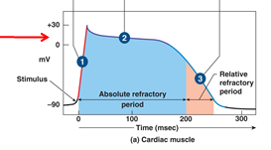

Cardiac Muscle

Cardiac Cycle
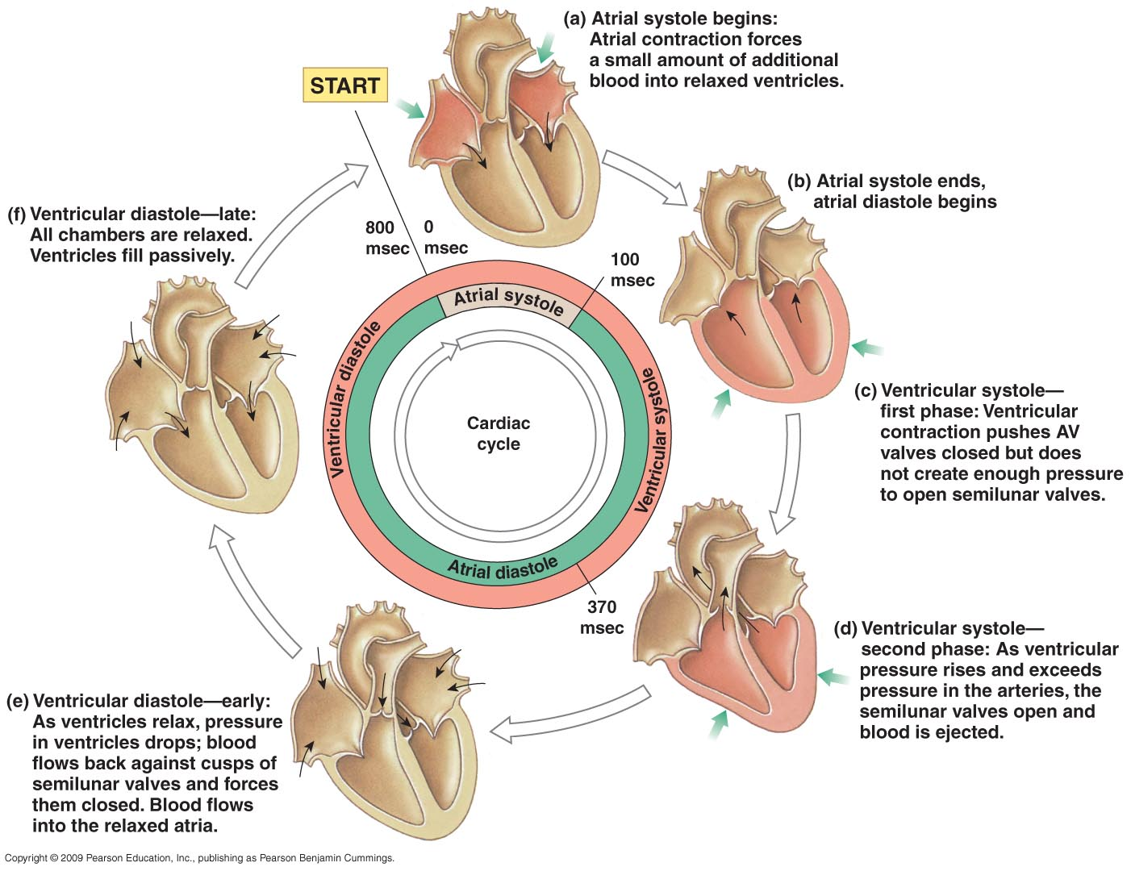

Phases of he Cardiac Cycle
- The cycle can be divided into two major stages:
  - Systole – the period of contraction
    - Artial systole – the period in which the atria contracts
    - Ventricular systole – the period in which the ventricles contract
  - Diastole – the period of relaxation
    - Atrial diastole – the period in which the atria relaxes
    - Ventricular diastole – the period in which the ventricles relax

Stage 1: Ventricular filling
- Blood returning to the heart via the systematic and pulmonary veins enter the relaxed atria and pass through the AV valves into the ventricles under its own pressure
- The atria contract, driving blood into the ventricles. When the atria relaxes systole begins

Stage 2: Isovolumetric contraction
- The ventricles contract raising the pressure within them. When ventricular pressure exceeds atrial pressure the AV valves close
- This phase ends when the ventricular pressure is great enough to open the semilunar valves

Stage 3: Ventricular ejection
- Blood is injected into the aorta and pulmonary arteries through the open semilunar valves causing the ventricular volume to fall.
- When the ventricular pressure falls below the aortic pressure the semilunar valves close ending the ejection and systole

Stage 4: Isocolumetric relaxation
- The onset of early diastole relaxes the ventricles
- At this point ventricular pressure is too low to open the semilunar valves to open but still too high the open the AV valves

Blood

Blood

Functions of Blood
- Transport nutrients
- Transport waste
- Transport hormones
- Transport heat
- Acid-base balance
- Immune function
- Tissue repair
- Maintain oncotic pressure

Physical Characteristics of Blood
- Blood volume (L) = 8% of body weight (kg)
  - Adult male: 5-6 L
  - Adult female: 4-5L
  - Circulation time: ~1min
- Three general characteristics of blood
  - Temperature ~38°C
  - High viscosity (2x water)
  - pH of ~7.35-7.45

Make up of Blood
- Plasma (55-60%)
  - Fluid consisting of:
    - Water (90%)
    - Dissolved plasma proteins (7%)
    - Other solutes (3%)
- Formed elements (40-45%)
  - All cells and solids
- Everything in blood plasma is dissolved
- Dissolved solutes include:
  - Nutrients
  - Electrolytes
  - Respiratory gases
  - Hormones
Plasma
- Makes up 50-60% of blood volume
- More than 90% of plasma is water
- Materials plasma and IF exchange across capillary walls
  - Water
  - Electrolytes
  - Small solutes

Plasma Protein
- Albumins (60%) – Liver
  - Transport fatty substances
  - Major osmotic protein
- Globulins (35%) – Liver (antibodies from plasma cells)
  - Antibodies, also called immunoglobulin
  - Transport globulins: hormone-binding proteins, mealloproteins, apolipoproteins, and steroid binding proteins
- Fibrinogen (4%)
  - Molecules that form clots and produce long, insoluble strands of fibrin
- Other plasma proteins (1%)
  - Enzymes and hormones
Formed Elements
- Three types of formed elements:
  - Red blood cells or erythrocytes
    - Transport oxygen
  - White blood cells or leukocytes
    - Part of the immune system
  - Platelets
    - Cell fragments involved in clotting

Red Blood Cells
- Abundance of red blood cells
- Red blood cells make up 99.9% of blood’s formed elements
- Red blood cell count: the number of red blood cells in 1 microliter of whole blood
  - Male: 4.6-6.3 million
  - Female: 4.2-5.5 million
- Hematocrit: percentage of red blood cells in blood
  - Male: 40-54
  - Female: 37-47
- Erythropoiesis
  - Occurs only in myeloid tissue ( red bone marrow
  - Stem cells mature to become red blood cells
- Hemocytoblasts
  - Stem cells in myeloid tissue divide to produce
    - Myeloid stem cells – become red blood cells, some white blood cells
    - Lymphoid stem cells – become lymphocytes
- Stimulating Hormone
  - Erythropoietin (EPO)
    - Also called erythropoiesis-stimulating hormone
    - Secreted by the kidneys when their oxygen concentration is low (hypoxia)
  - Stimulates red blood cell production in red bone marrow by:
    - Increased cell division rates
    - Speeds up the maturation of red blood cells

Structure
- Red blood cell shape and size
  - High surface-to-volume ratio
    - Quickly absorbs and releases oxygen
  - Discs form stacks called rouleaux
    - Smooth the flow through narrow blood vessels
  - Discs bend and flex entering small capillaries
    - 7.8 µm red blood cells pass through 4µm capillary

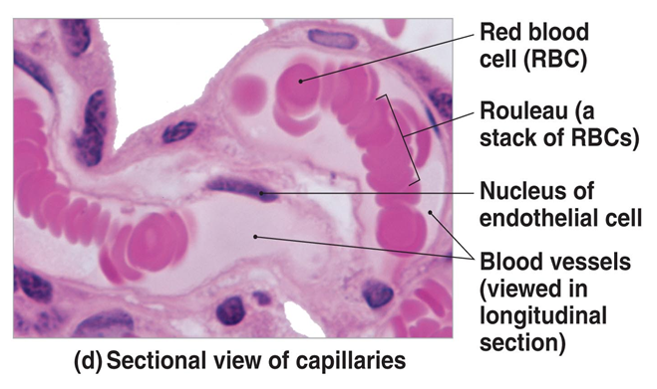

Hemoglobin
- Each red blood cell contains 280 million molecules
- Hemoglobin is a protein molecule that transports respiratory gases
- Normal hemoglobin
  - Male: 14-18 g/dL blood
  - Female: 12-16 g/dL blood
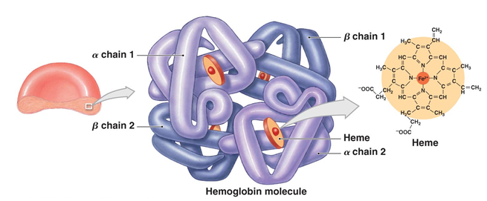

Hemoglobin Function
- Carries oxygen
- With low oxygen (peripheral capillaries)
  - Hemoglobin releases oxygen
  - Binds carbon dioxide and carries it to lungs
    - Forms carbaminohemoglobin

Death of a Red Blood Cell
- In circulation for 100-120 days
- Becomes inflexible and fractures
  - Primarily occurs in the spleen
- Iron from heme is salvaged
- Heme bilirubinbile urobilinogen feces
- Globin is broken down into amino acids

White Blood Cells
- Also called leukocytes
- 5 types:
  - Neutrophils (50-70%)
  - Lymphocytes (25-45%)
  - Monocytes (3-8%)
  - Eosinophils (2-4%)
  - Basophils (0.5-1%)
- What are the differences between white and red blood cells?
  - Presence of organelles
  - Role (immune vs. metabolic)
  - Residence
Neutrophils
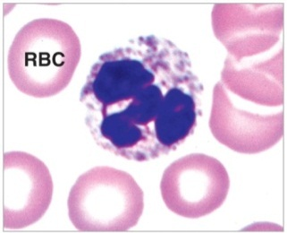
- 50-70% of circulating white blood cells
- Involved in the body’s nonspecific defenses
- Capable of phagocytosis
- Contain lysosomal enzymes and bactericides
- Highly mobile, first to arrive at the site of an injury and/or attack bacteria
- High count may indicate
  - Bacterial infections
  - Burns
  - Stress
  - Inflammation
- Low count may indicate
  - Radiation exposure
  - Drug toxicity
  - Vitamin B12 deficiency
  - Systematic lupus erythematous

Lymphocytes
- T-Cells – Helper and memory cells
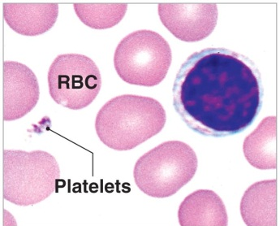
- B-Cells – antibody makers
- Natural killer cells
- 20-30% of circulating white blood cells
- Migrate in and out of blood
- Mostly in connective tissues and lymphoid organs
- High count may indicate
  - Viral infection
  - Some leukemias
- Low count may indicate
  - Prolonged illness
  - Immunosuppression
  - Treatment with cortisol

Monocytes
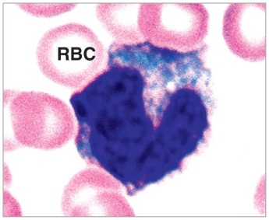
- 2-8% of circulating white blood cells
- Half are stored in the spleen
- Enter peripheral tissues and become macrophages
- Engulf large particles and pathogens
- Secrete substances that attract immune system cells and fibrocytes to injured area
- High count may indicate
  - Viaral or fungal infections
  - Tuberculosis
  - Some leukemias
  - Chronic diseases
- Low count may indicate
  - Bone marrow suppression
  - Treatment with cortisol

Eosinophils
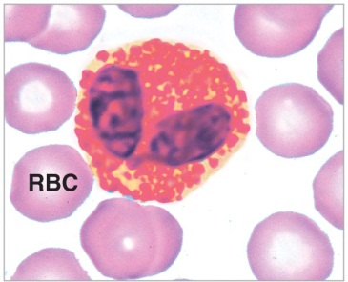
- 2-4% of circulating white blood cells
- Attack large parasites
- Excrete toxic compounds
- Are sensitive to allergens
- Control inflammation with enzymes that counteract inflammatory effects of neutrophils
- High count may indicate
  - Allergic reactions
  - Parasitic infections
  - Autoimmune diseases
- Low count may indicate
  - Drug toxicity
  - Stress

Basophils
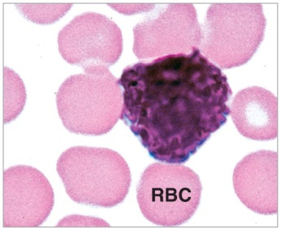
- Less than 1% of circulating white blood cells
- Accumulate in damaged tissue
  - Release histamine
    - Dilates blood vessels
    - Enhances inflammation

  - Release heparin
    - Prevents blood clotting
- High count may indicate
  - Allergic reactions
  - Leukemias
  - Cancers
  - Hypothyroidism
- Low count may indicate
  - Pregnancy
  - Ovulation
  - Stress
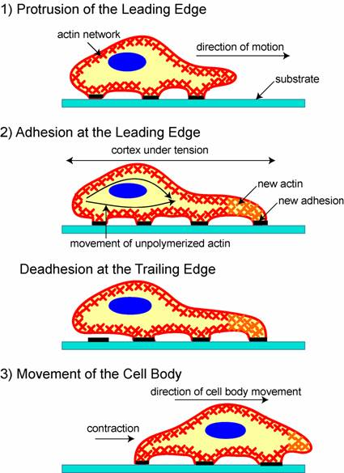
  - Hyperthyroidism

White blood cell functions
- Defend against pathogens (disease-causing organism)
- Remove toxins and wastes
- Attack/remove abnormal or damaged cells

Characteristics of White Blood Cells
- Diapedesis - all can migrate out of the bloodstream
- Amoeboid movement
- Positive chemotaxins – all are attracted to chemical stimuli
- Granulocytes are capable of phagocytosis

White Blood Cell Production
- Myeloid stem cells
  - Differentiate into progenitor cells, which produce all white blood cells except lymphocytes
- Lymphoid stem cells
  - Lymphopoiesis: the production of lymphocytes
- All cells except monocytes develop in bone marrow

Platelets
- Cell fragments
- Circulate for 9-12 days
- Are removed in the spleen by phagocytes
- 1/3 are held in the spleen for emergencies

Functions
- Three functions of platelets
  - Release chemicals that cause clotting
  - Bind to injured area
  - Bind to each other and fibrin

Production
- Occurs in bone marrow
- Megakaryocytes
  - Giant cells in bone marrow
  - Manufacture platelets

Blood Types
- 30 different blood groups
- Two main groups
  - ABO
  - Rh(+/-)

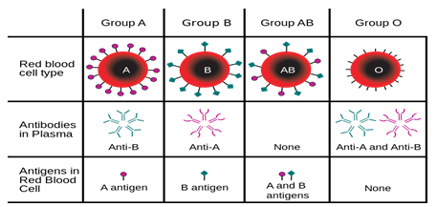

Exercise Training and Blood Volume
- Training increases blood volume
- Physical training
  - 7% increase in blood volume
- Heat acclimation
  - 5% increase in blood volume
- Physical training in the heat
  - 12% increase in blood volume

- What are the physiological advantages of hypervolemia?
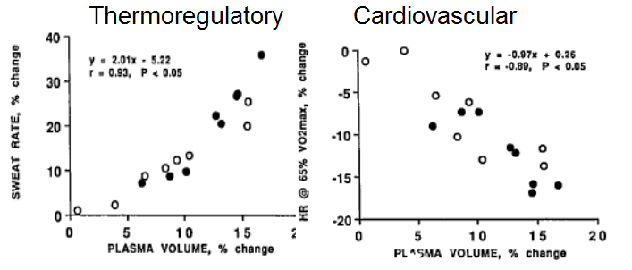

Anemia
- What is anemia?
  - Abnormally low oxygen-carrying capacity of blood
  - A sign/symptom but not a disease disorder itself
- Can be due to:
  - Reduced number of erythrocytes, each with normal concentration of Hb
  - Reduced concentration of Hb per erythrocyte
  - Abnormal Hb production
- Causes:
  - Dietary deficiencies
  - Inadequate production of red blood cells
  - Excessive blood loss
  - Excessive destruction of red blood cells
  - Diseases/disorders

Autoimmune disorders
- Type 1 diabetes
- Rheumatic arthritis
- Multiple sclerosis
- Narcolepsy

Inflammatory Response
- COPD

Arterial Plaque

Blood Doping
- Some athletes use EPO to increase their performance, Why?
  - In circulation for 100-120 days
  - Becomes inflexible and fractures
    - Primarily occurs in the spleen
  - Iron from heme is salvaged
  - Heme bilirubin bile urobilinogen feces
  - Globin broken down to amino acids
- Homologous blood doping involves taking blood from a different donor
- Analogous blood doping involves reusing your own blood but can cause a state of anemia
- EPO doping involves the injection of a hormone which signals production of red blood cells within bone morrow

Blood Vessels
Feature | Typical Artery | Typical Vein
General appearance in sectional view | Usually round, with relatively thick wall | Usually flattened or collapses, with relatively thin wall
Tunica intima
Endothelium | Usually rippled, due to vessel constriction | Often smooth
Internal elastic membrane | Present | Absent
Tunica media | Thick, dominated by smooth muscle cells and elastic fibers | Thin, dominated by smooth muscle cells and collagen fibers
External elastic membrane | Present | Absent
Tunica Externa | Collagen and elastic fibers | Collagen and elastic fibers and smooth muscle cells

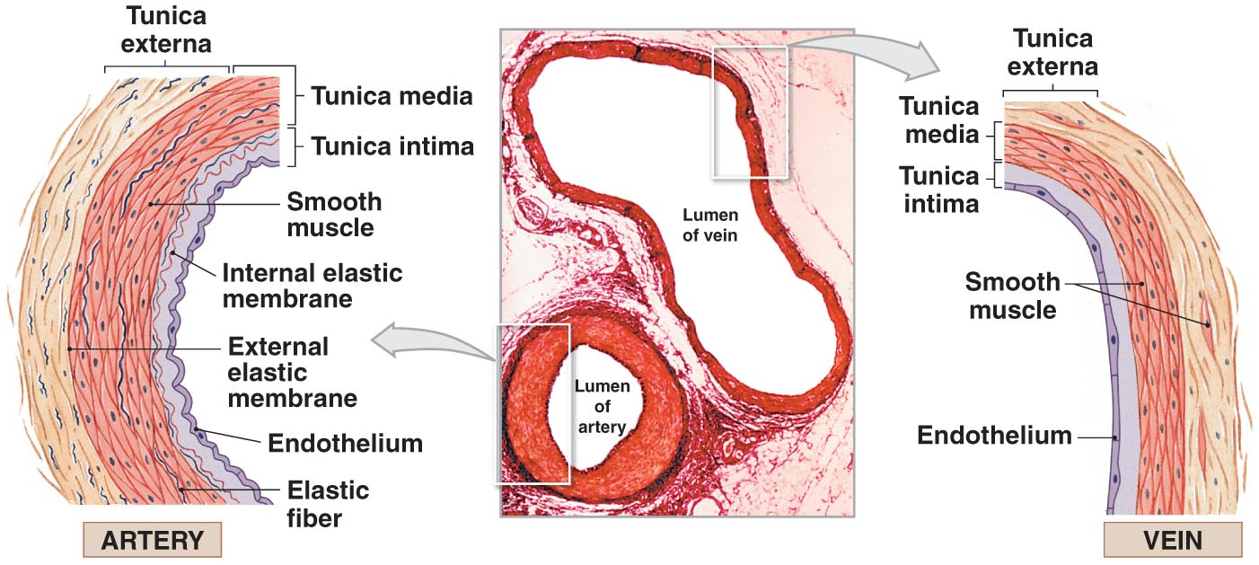

Structure and Function of Arteries

Arterial System
- From heart to capillaries, arteries change from:
  - Elastic arteries muscular arteries arterioles capillaries

Elastic Artery
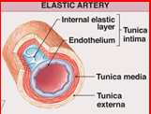
- Large vessels (aorta, pulmonary trunk)
- Tunica media = elastic fibres, few muscle cells
- Elasticity helps absorb pulse waves
- Aneurysm
  - Failure in elastic wall of artery
  - Resultant bulge resembles a bubble in the wall of a tear
  - Bursting of bubble can result in catastrophic blowout

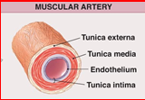
Muscular Artery
- Medium size
- Tunica media = few elastic fibres, many muscle cells
- Provide structural integrity to vessels that are the primary distributor to organs and tissues

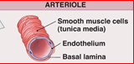
Arteriole
- Small size
- No tunica externa
- Tunica media = couple of layers of smooth muscle cells
- Change diameter in response to sympathetic or endocrine stimulation
  - Vasoconstriction
  - Vasodialation

Continous Capillary
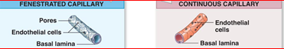
- Smallest size
- Only blood vessels that allow exchange across vessel walls
- No tunica media
- No tunica externa
- Two types
  - Continuous
  - Fenestrated

Capillaries
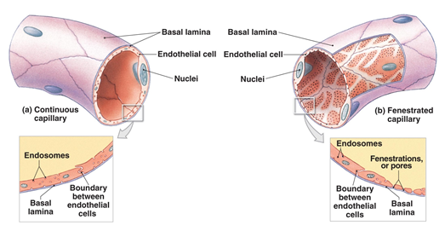

Capillary Beds
- Connect one arteriole and one venule
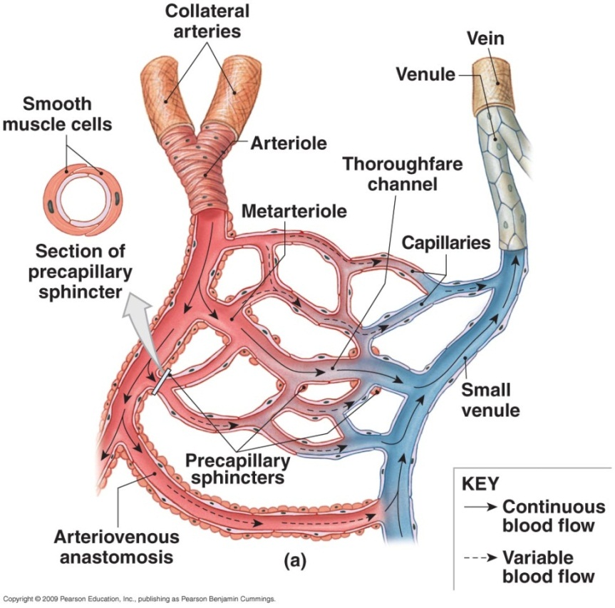
- Theroughfare channels
  - Direct capillary connections between arterioles and venules
  - Controlled by smooth muscle segments (metarterioles)

Anteriovenous Anatomeses
- In the hand, blood flow is regulated by the AVA’s
- Body is warm AVA’s open
  - Blood flows in large quantities from the arteries through the AVA’s to the superficial veins
- Body cools AVA’s close
  - Blood flow is drastically reduced due to increased sympathetic activity
- The remaining flow will return to the body core through deep veins, which are located close to the arteries

Structure and Functioon of Veins

Venous System
- Collect blood from capillaries in tissues and organs
- Return blood to heart
- Are larger in diameter than arteries
- Have thinner walls than arteries
- Have lower blood pressure

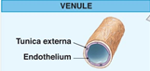
Venules
- Very small
- Collect blood from capillaries

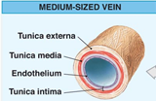
Medium-sized veins
- Thin tunica media and few smooth muscle cells
- Tunica externa with longitudinal bundles of elastic fibers

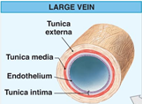
Large Veins
- Have all three tunica layers
- Thick tunica externa
- Thin tunica media

Venous Blood Flow
- Venous valves
  - Folds of tunica intima
  - Prevent blood from flowing backward
  - Compression pushes blood toward heart
- Muscle pump
- Vericose Veins

Distribution of Blood
- Heart, arteries, and capillaries
  - 30-50% of blood volume
- Venous system
  - 60-65%
    - 1/3 venous blood I in the large venous network of the liver, bone marrow, and skin
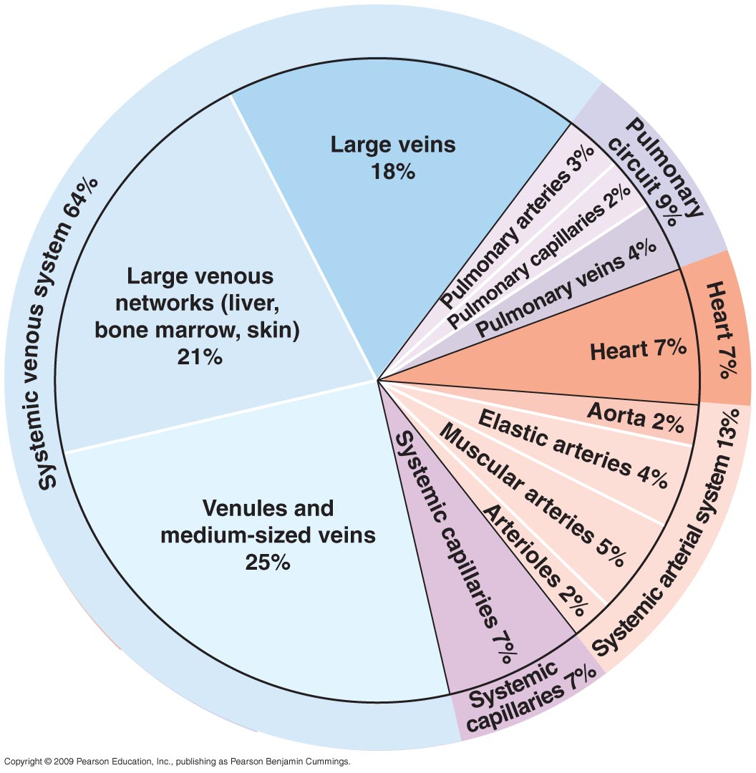

Blood flow and Resistance

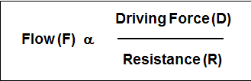

- Driving force (D) = pressure gradient (ΔP) or P1-P2)
- Larger length (l) = lower flow due to more resistance
- Larger radium ® = higher flow due to less resistance
- Higher viscosity (μ) = lower flow due to more resistance

Blood Pressure
- Because of pulsatile nature of blood pressure in the arterial system, blood pressure is expressed as mean arterial pressure (MAP)

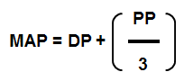

- DP = Diastolic Pressure
- PP = Pulse Pressure (Systolic – Diastolic)

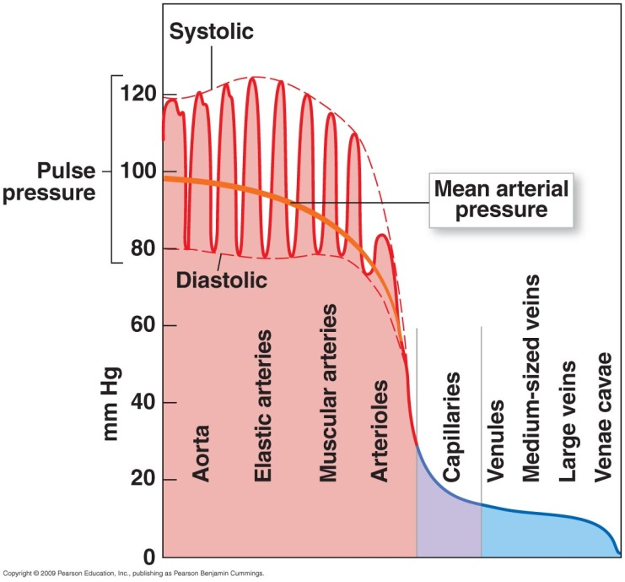

Normal Blood Pressure
- Physicians typically express systolic and diastolic blood pressure (SP/DP)
- “Normal” = 120/80 or lower
- “Pre-hypertensive” = 121//81 to 139/89
- “Clinically hypertensive” = 140/90 or greater

Hemodynamics
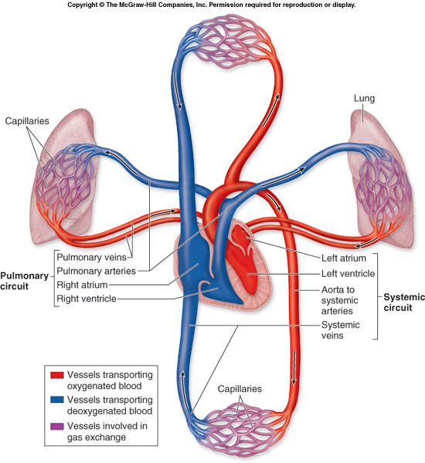

Cardiodynamics
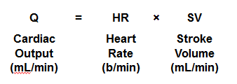

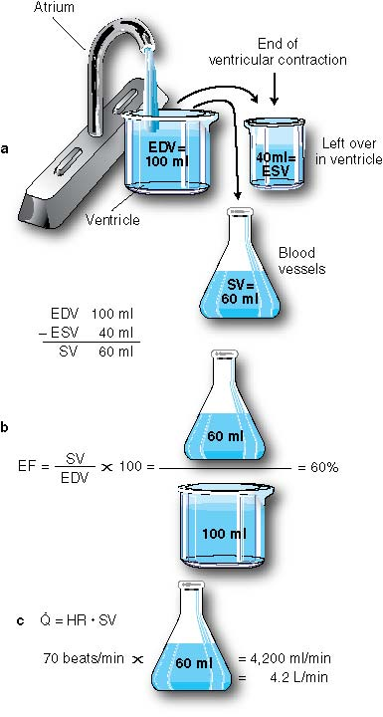

- EDV = end-diastolic volume
  - Volume of blood in the ventricle prior to the beat
- ESV = end-systolic volume
  - Volume of blood in the ventricle at the end of a beat
- SV = Stroke volume
  - The volume of blood pumped from the ventricle of the heart with each beat
  - At rest the stroke volume is Q=5L/min
- EF=ejection fraction
  - Stroke volume divided by end-diastolic volume
- Q= Cardiac Output
  - Production of stroke volume and heart rate
- HR= heart rate

Cardiac Output
- The ability of the cardiovascular system to deliver blood to organs ultimately depends on the rate at which the heart’s ventricles are able to pump blood
- There are ~ 5L of blood in the body and it takes the ventricles ~ 1min to pump 5L of blood
- Therfore the cardiac output is determined by multiplying the heart rate by the stroke volume

Oxygen Consumption: Fitness & Fuel

Oxygen Content of Blood
- Dissolved O₂ in blood plasma
  - For each mmHg of PO₂ 0.03ml of O₂ is dissolved per litre of blood
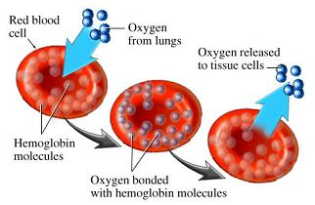
  - Therefore for PO₂ of 10mmHg (sea-level) = 3.0ml of O₂ dissolved per 1L of blood
- O₂ bound to Hemoglobin
  - HbO₂ (100% saturated) contains 1.34ml O2/g oh Hb
    - [Hb]blood = 160g/1L of blood
  - SaO₂= 100% (sea-level)
    - Therefore 214ml O₂/L of blood
- Total amount of O₂ per L of arterial blood = 217mL or 0.217L

Oxygen Consumption (VO₂)
- Oxygen consumption is the amount of oxygen used up by the tissues for oxidative phosphorylation (to create ATP) per minute
- Fick’s Principle measures the amount of oxygen that is used when blood travels through the body.

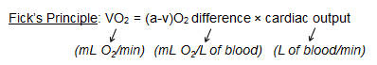

Maximal Oxygen Uptake
- VO_{2max} – the maximal capacity or oxygen consumption by the body during maximal exertion
- This is the single best measurement of cardiorespiratory endurance and aerobic fitness
- Increases with physical training
- Generally expressed relative to body weight (ml X kg⁻¹ X min⁻¹)
- VO_{2max} declines in active people after age 25-30 by ~ 1% per year

Increasing VO₂max
- By increasing the amount of O₂ in arterial blood more oxygen is utilized by tissue cells
- If we decrease the amount of O₂ left in venous blood by increasing mitochondrial count the O₂ difference will increase
- By increasing the maximal heart rate the heart is able to increase the amount of blood it oxygenates which in turn increases the amount of O₂ available
- By increasing the maximum stroke volume the amount of blood that is able to pass through the heart is increased which allows more O₂ to become available
- Increasing the Lactate threshold allows one to get closer to achieving VO₂max

Cardiovascular Adaption

Cardiovascular response to exercise
- Light exercise
  - Extensive vasodilation occurs in the tissue
    - Increasing circulation
  - To maintain blood pressure we must increase cardiac output
    - Increase heart rate
    - Increase stoke volume
- Heavy exercise
  - High levels of blood flow needed by skeletal muscles, lungs, and heart
  - Cardiac output increases to maximum
    - About 4X resting level
  - Restricts blood flow to “nonessential” organs
  - Blood supply to the brain is affected
- The goal of the body is to maintain blood pressure

