Digestive system PART I: oral cavity
Digestive system back ground:
Digestive tract:
-> Oral cavity
-> pharinge (not covered)
->oesophagu0073
-> stomach
->large intestine
->rectum
Associated glands: salivary glands, pancreas, liver.
-> Can be used or stored
-> but need to be digested to minimal unit.
First Step in digestion:
- In mouth, food is moistened by saliva
- Grinded by teeth into smaller pieces
- Saliva contains AMYLASE = initiate diegestion of carbohydrage.
  - Also other enzymes (lipase) secreted by salivary gland, but not active until stomach

Epithelium of lips – oral mucosa (a lining of wet surface)
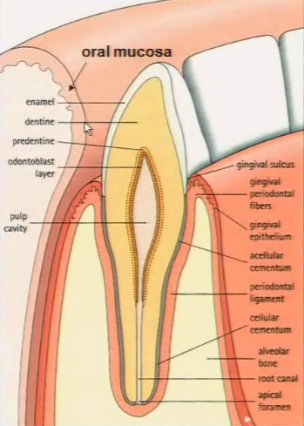
- Inner aspect of lips = oral mucosa
- Outter aspect = SKIN (ORTHOKERATINIZED)
- In lips = transition of keratin->non k.
Oral cavity is lined by mucosa:
- First layer = epithelial lining
  - Nonkeratinized stratified squamous epi.
- Immediately under = Lamina propria
  - Loose CT
- Under, we have submucosa:
  - Sometimes not present
  - It is dense CT
  - May contain small salivary glands
There is also a gingival:
- It is the area around the teeth
- Parakeratinized, not same keratin as skin.
  - Not produced by stratum granulosum
Let’s look at some histological slides: inner aspect of lips
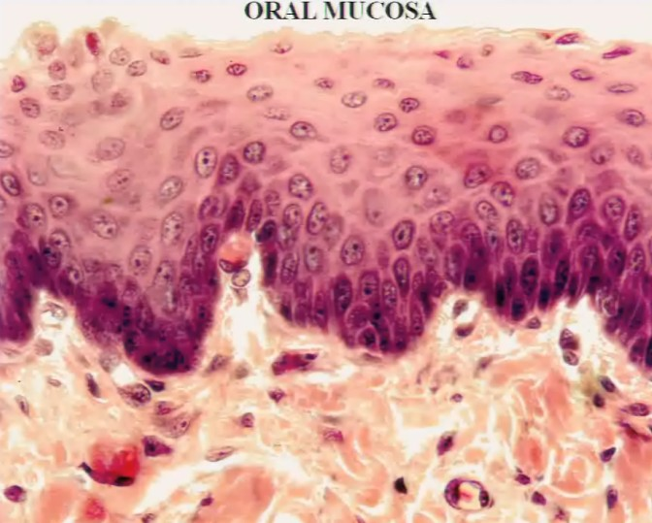
Squamous stratified epithelium.
Layer of squamous cells (no keratohyalins)-> do not die! (non keratinized)

Stratum spinolosum replaced by layer of polygonal cell (less desmosome than in skin)

Stratum germinativum

Lamina propria: fibrocyte+capillary
Submucosa: denst CT.

Next, let’s see the PALATE (上颚)
Also have parakeratinized epithelium like GINGIVA (rest of oral cavity = non keratinized)
The tongue
Mass of striated skeletal muscle covered by oral mucosa:
- Muscle goes in different directions – 3 planes of sections: longitudinal/ transverse/oblique
Mucosa = nonkeratinized stratified squamous epithelium and lamina propria strongly attached to muscle layer.
- There will be a little bit of keratin in “philiform papillae” of tongue
Dorsal side of tongue: irregular surface: due to small eminencies called papillae
Anatomy of tongue:we are responsible for the 3 papilla
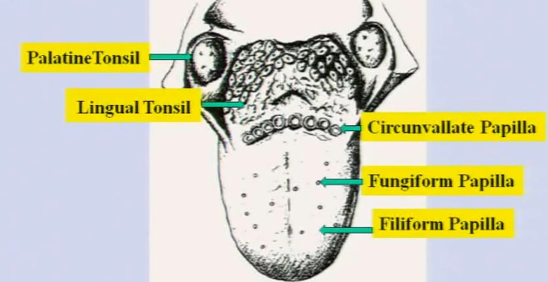
Insertion of tongue: palatine tonsil (lymphoid tissue)
Back of tongue : lingual tonsil

A lingual bead in posterial side of tongue: circumvallate papilla

Fungiform papilla: little redish, in dorsal side of tongue.
Filliform papilla: give rough form of tongue at back of tongue, pointy.

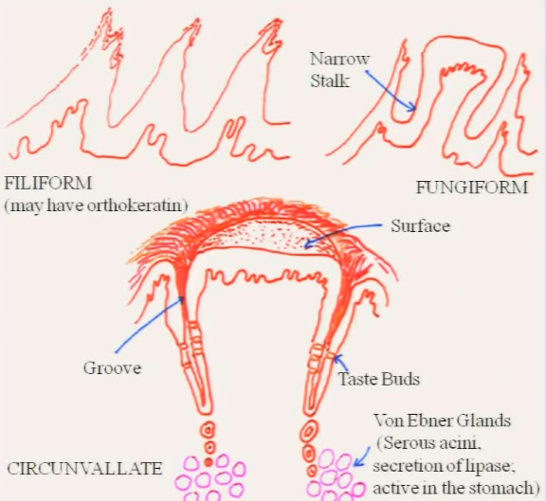
Filiform papilla:
Pointy
Contain a little bit of orthokeratin, so at tip of tissue, we may have squamous stratified KERATINIZED epithelium. We may have stratum granulosum.
- Granule more red (like tricohyalin granules), not blue (keratohyaline granule)
- Very similar to stratum granulosum.
Fungiform papilla:
Like a mushroom, at bottom, we have a narrow stalk
May contain some taste buds, BUT WE DO NOT SEE THEM IN OUR SECTIONS!!!
- In humans we have that.

Circumvallate papilla:
Largest, plunged in mucosa, have grooves around it, at base of groove, we have salivary glands (VON EDNER’S GLAND )
Von Edner’s gland:
- Responsible for secretion of light base -> 30% digestion of lipid
- Serous secretion
- Secrete fluid to wash food out of the tasting grooves.
We are going to find taste buds here
- Abundant on side of papilla, few on the other side.

Taste buds:
Embedded in epithelium (non keratinized) that rests on BM(blue line in bottom)
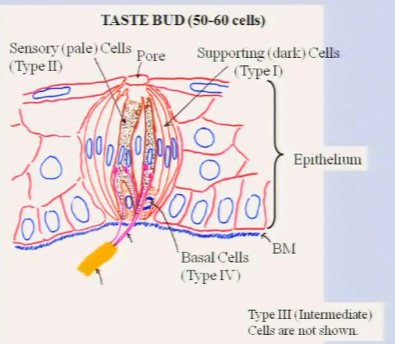
On top we have squamous cells
- If on top of taste bud, not join each other
- Become pore of taste bud.
In group of 50-60 cells.

Surpporting cells:
- Type I cells, dark stain
Sensory cells:
- Type II cells, pale stained
- Have microvili that capture taste sensation
- When capture chemical, pass to neurone
Intermediate cells:
- Type III, not shown
- Precursors of type II
Basal cells:
- Type IV
- Short
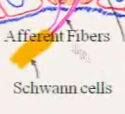
- Stem cells
- Nuclei close to bottom
There are also some afferent fibers that synapse with sensory cells.
Disease: Familial Dysautomia:
If mutation affects the expression of SENSORY cells = non taster baby
- How do we know that?
- Use phenyl thiocarbamide (PTC) – if no reaction from baby = diseased.
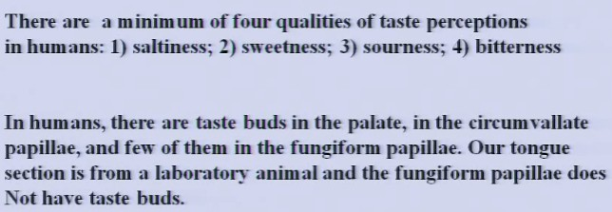

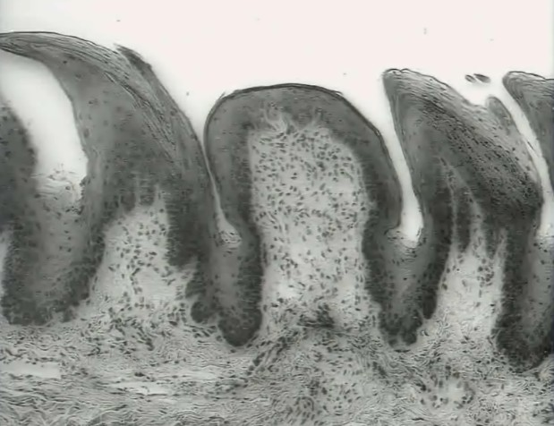
FILIFORM FUNGIFORM FILIFORM

Digestive system PART II: salivary glands
Glandular epithelial (differs from covering epithelial): cells specialized in secretion function.
Classified according to # of cells:
- Unicellular : like goblet cells producing mucous
- Multicellular: like sweat glands, salivary glands.
According to the fate of secretion:
- If goes to surface of skin or cavity : exocrine (sweat gland, salivary gland, sebaceous gland)
- If product goes to bloodstream (like hormones) : endocrine (pancrease)
According to the way product leave the cell:
- When gland does not undergo structural modification: merocrine (sweat gland)
- When gland does change shape, cell dies and goes out: holocrine (sebaceaous gland)
- Apocrine: mammary gland -- not covered. (cell loose SOME cytoplasm) – intermediate
According to the duct:
- Simple: duct does not branch (sweat gland, gastric gland)
- Compound: duct divides a lot (salivary gland)

According to secretory portion:
- Spherical secretary portion = acinar
  - Mucous
  - Serous
- Long structure = tubular (sweat gland)
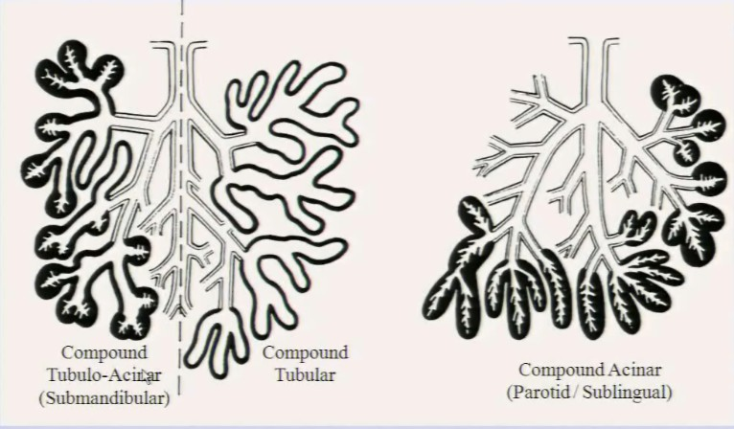
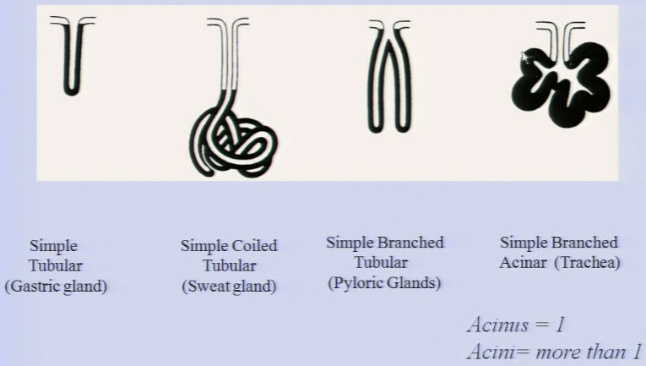
Salivary glands:

Function:
- wet and lubricate oral cavity
- Initiate digestion of carbohydrates (just initiate, real digestion start later)
- Secrete amylase/lysozyme/IgA/lactoferrin.
  - Lysozyme destroys wall of bacteria
  - IgA = immunoglobin
  - Lactoferrin = binds to iron, remove all iron, make DNA of bacterial unable to grow.
Three pairs of large salivary glands:
- Parotid – mainly serous
- Submandibular – Serous and serous mucous (combination)
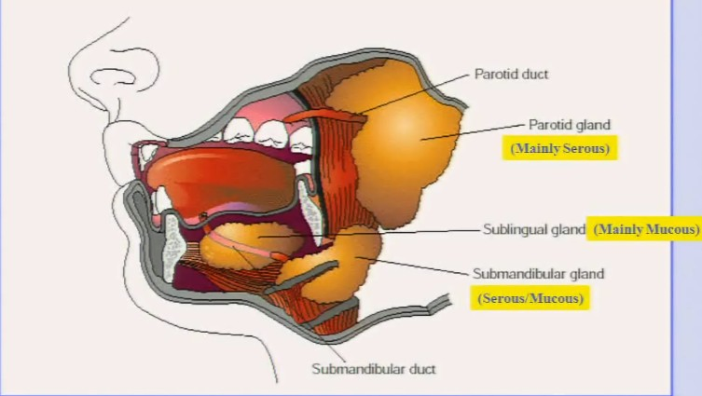
- Sublingual – mainly mucous

Submandibular gland:
You have a combination of everything : serous/mucous and acinar
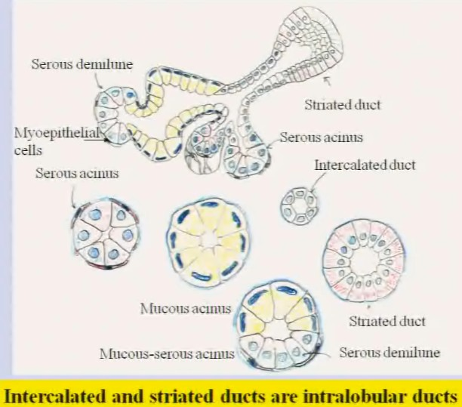
Serous acini:
- Located at end of glands’s duct system
- Has myoepithelial cells that squeeze (located INSIDE BM and below secretory cells)
- Look like grapes
- Serous acini has following features:
  - Pyramidal cells
  - Lumen of gland has zymogenic granules ----- SMALL
  - Base of cell = a lot ER
  - Nucleus centrally located
Mucous acini:
- Located in the tubular portion of gland (mucous part) --- not DUCT
- Has following features:
  - Cells much taller, still pyramidal
  - Chromatin of nuclei stay in bottom of cell
  - Lumen = larger
  - Gland = larger
Mucous-serous acini:
- Combination of both structures:
  - Like a lot of mucous, and a serous demilune. (usually smaller)
- Myoepithelial cell associated with SEROUS portion, NEVER mucous.
First order of tubules: intercalated duct:
- Narrow duct that connects Acinus or secretory portion to the rest of gland
  - Much smaller than glands and ducts
  - Cuboidal cell/or squamous
Then we have STRIATED DUCTS – EXCLUSIVE for salivary gland:
- Follow intercalated duct
- Much larger than intercalated duct
- A lot of striations – caused by mitochondria – stain very pink
- Nucleus located midway in cell = very round and well stained.
NOTE: intercalated + striated duct = INTRALOBULAR DUCT

Serous VS mucous in EM:
Serous:
- On the top of cells: have zymogenic granules
  - Secretory vesicles
  - Secreted upon to the lumen, watery material
- Secretion use exocytosis: thiner proteinaceous secretion
  - Amylase
  - Lysozyme
  - Lactoferrin
  - H2O
Mucous:
- On top: Vicious carbohydrate rich protein mucin (DOES NOT STAIN PINK!!!)
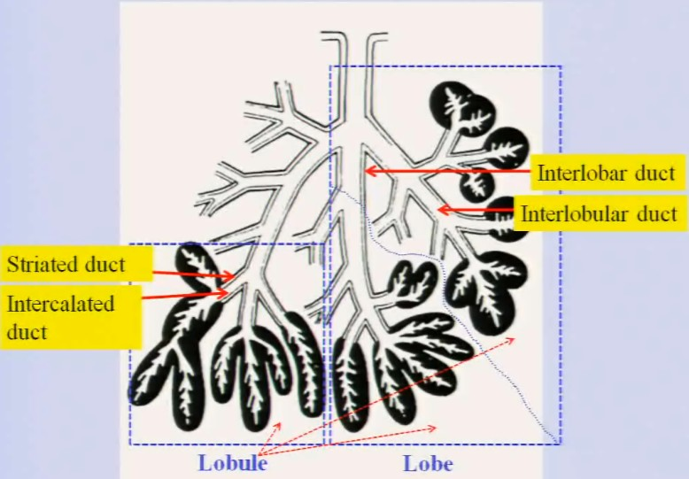
Duct system:
Duct goes in -> diverge into a group of acinus = LOBULE (Separate from other by small CT)
A group of lobules = LOBE (separate from other LOBE by huge CT)
If ducts…:
- Duct located inside CT between 2 lobules: interlobular duct
- Located inside CT that is between 2 LOBES: interLOBAR duct
- WITHIN lobule = striated duct -> intercalated duct.(not much CT around)

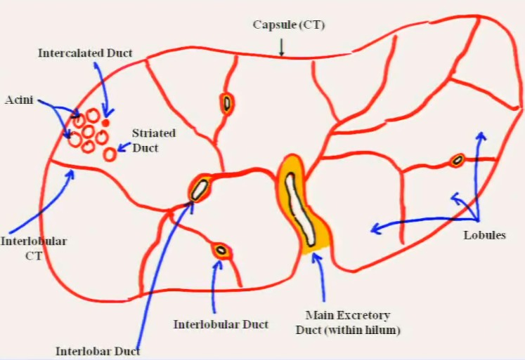
CT in salivary gland:
We have a capsul of CT = around
This capsule invaginate -> form lobes and lobules.

If we magnify :
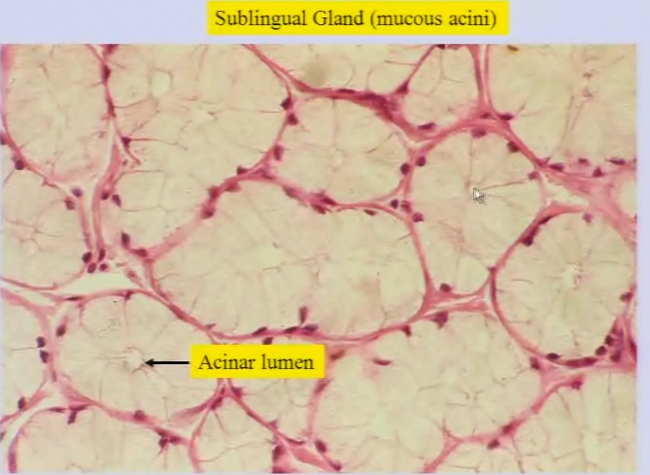
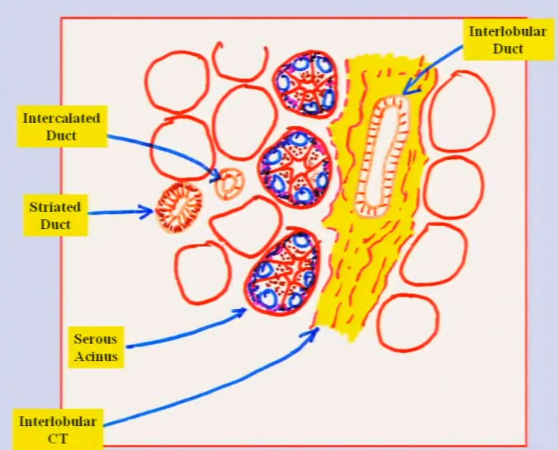
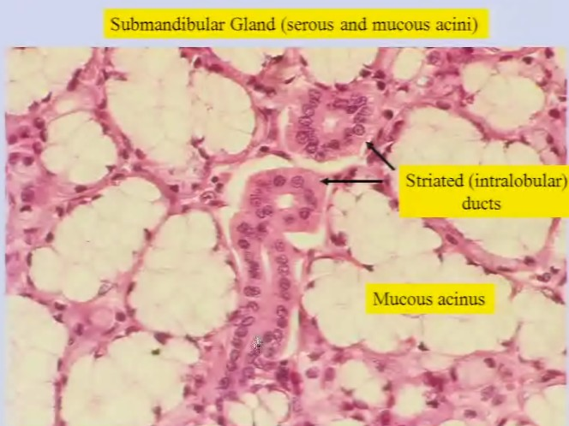
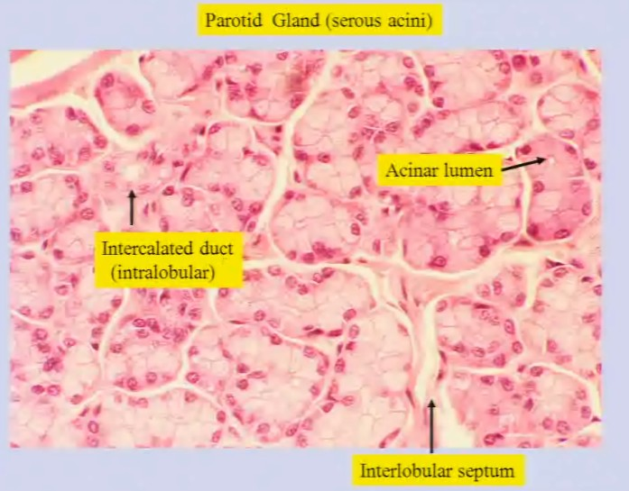

Intercalated duct in horizontal section

Digestive system PART IIIA: tooth structure
Remember: oral cavity covered by oral mucosa => BM=>lamina propria => submucosa (small salivary glands)
Outer aspect of lips, stratified squamous epithelium with orthokeratin.
Today we see new epithelium: parakeratin.
- Present in Gingiva and your palate
  - Gingiva will extend to enamel
Teeth:
Human have 2 sets of teeth (dihyodonty)
- Baby or deciduous = 20 teeth
- Permanent dentition = 32 teeth + wisdom
- Symmetrically distributed : upper maxillary and lower mandibular archs
  - Each arch is divided into 2 quadrants
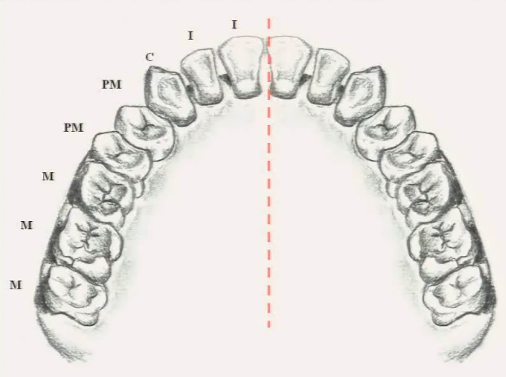
This is an upper maxillary arch, red line divides quadrants.

NOTE: last M on the left side: wisdom teeth

Right quadrants left quadrants
If we want to know the difference between baby and permanent: (per quadrants)
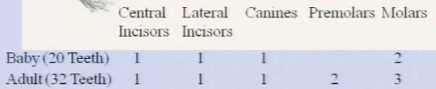

Let’s look more detail into tooth (canine in this case)
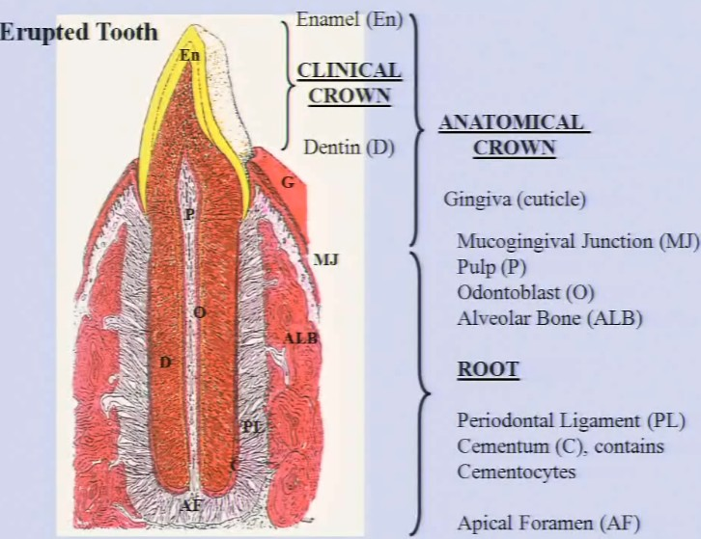
If we look in mirror = clinical crown.
What you see usually: enamel (right above line of gingival) -> NEVER going to see enamel in histological slides (it is too hard…)
- Unless, we can decalcify it (because it is made of calcium phosphate)
But the real crown = anatomical crown
- The line of crown goes below the level of gingiva..
- As the epithelium approach to bottom of enamel -> become hemidesmosome -> join epithelial to enamel.
  - Seal completely the gingival and enamel
  - To protect PL.
- Also include a part of dentine (D) ---stains really pink.
  - Main constituent of root. = present in crown AND root.
Inside the root (and dentine) = pulp
- Made of CT – quite look like immature fibroblast
- Contain blood vessel.
Pulp is limited inside by odontalblast (O)
- Line the pulp
- Main contributor to the formation of dentine.
- Goes down until Apical foramen (AF)
Out side the Dentine, the layer become thicker and thicker = Cementum (C)
- Start from enamel in the root and goes deeper (get thicker)
- Resembles like bone.
  - Has small cavities that traps cells.
  - These cells = cementocytes trapped in EC matrix
Outside Periodontal ligaments, we have alveolar bone (ALB)
- Forms a socket to fit in the root of the teeth
- Have osteocytes
- Have tendency to make haversian system, but not really do it
Between the ALB and C = Periodontal ligaments:
- Dense CT rich in collagen fiber -> projects from AF to top
- Tooth is suspended in this
So if we have plaque accumulating at the bottom of enamel -> destroys binding of hemidesmosomes, lead to infection of PL. If bacteria damage this part, it compromise the PL -> tooth fall out because no socket.
Openning at end of root is Apical framen (AF)
- We might not see this depend on section
===================================
Tooth composition:
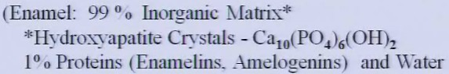
- The 2 proteins attract calcium, and make them precipitate here ->harden it
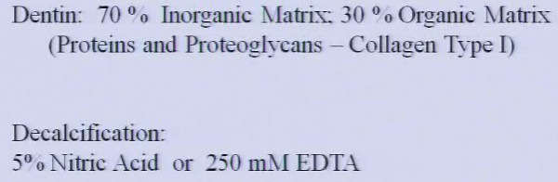
- Organic matrix made by proteins and proteoglycans – large amount of COLLAGE TYPE 1 like in bone.

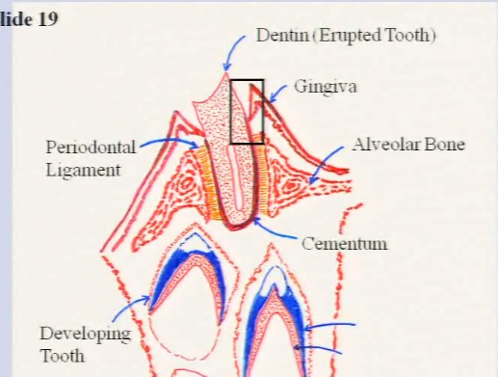
Difference between developing VS mature tooth:
Erupted tooth:
- Dentine, without enamel(decalcified)
- Gingiva = parallel to area of interdigitation of L.M. and gingival
- Alveolar bone = landmark to identify PL
- PL will help you localize cementum

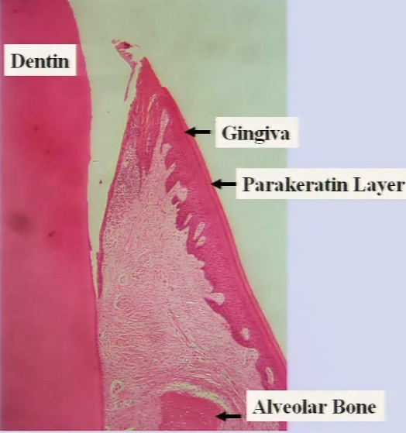
A magnificationof the square gives this: (this is crown + a bit of root)
Dentine:
- From the junction up -> crown, below = root
Gingiva :
- That pale layer = parakeratin
- Very parallel
- There will be a transition of parakeratin -> oral mucosa
  - Called: muco-gingival region
  - You see parakeratin fade, and begin oral mucosa

The DARK LINE that separate dentine / PL
- Cementum
- That pale region = PL

Deeper in, we have root: (end of root)
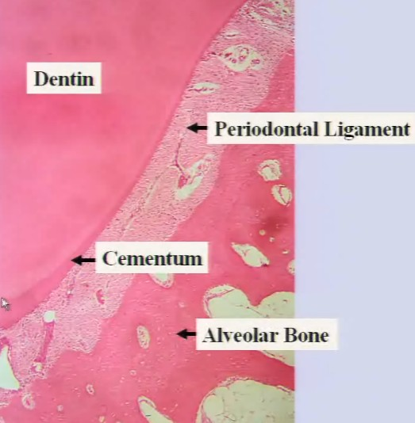
Cementum:
- Cementum gets thicker and thicker as you go in.
- That darker line is cementum
- At this magnification = CANT SEE CEMENTOCYTE
Alveolar bones:
- You can see some bits of bones

If we magnify on the pulp: (cross section here)
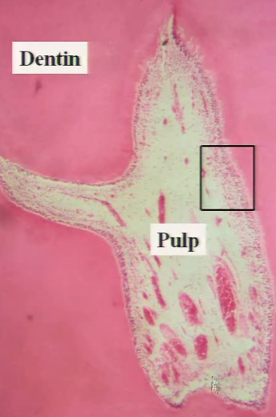
cannot see the Apical framen here

The outer layer of cells = odontoblast

Inside, we have loose CT + lot of blood vessel
- Even nerve terminal

If we magnify the square on odontoblast:
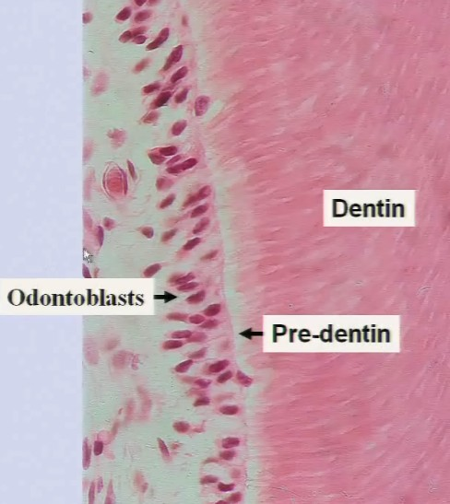
Odontoblasts are epithelial cells:
- Long process projecting all the way to cementum(in root) or enamel (in crown)
- Each odontoblast has one long process that is trapped in EC matrix.
- Odontoblast synthesizes collagen fibers + proteoglycans + glycoprotein + EC matrix
- As dentin gorws, it goes LEFT here.
  - Therefore the pulp will be smaller and smaller
- Predentine : syntehsized dentine, but no calcium here yet.

Odontoblasts can also sense stimulus

Digestive system PART IIIB: tooth formation
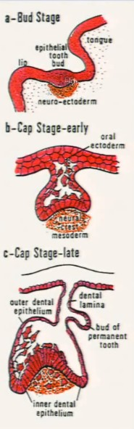
- Neuroectorderm cells migrate from neural crest
- Neuro ectoderm cell induce the formation of epithelial tooth buds -> form 10 future baby tooth.

Bud stage = enlarging of ectoderm at level of future tooth
---------------------------------------------------------------
- Epithelial structure (oral ectoderm) -> will become future enamel organ (organ that synthesis enamel)
- Neuro-ectoderm cells mix with mesoderm cells and form the neural crest mesoderm.
- REMEMBER: neuro ectoderm cells will form future odontoblastes

- Future enamel organ remain connected to the ectoderm by dental lamina and originate a second bud for permanent tooth
- This second bud will remain until you are 4,5 years old.
- Cells of enamel organs start differenciate into concrete layers.
  - We distinguish into inner dental epithelium (columnar cells)
  - Outer dental epithelium (squamous cells)
    - Connected to dental lamina ->ectoderm
- Some cells of the neural crest mesoderm start differenciate into odontoblasts (in drawing = those acidophilic cells in the orange area)
  - They are lined in the inner dental epithelium.

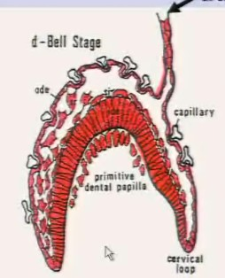
- In addition to the outer dental epithelium and inner dental epithelium (ode and ide), the enamel organ differentiate into stratum intermedium (si) and stellate reticulum (sr)
  - The cuboidal cells attach to ide and form si (the flat ones)
  - Then we have some stellate cells (the polygonal ones ) forming sr
- The inner dental epithelium formed by ameloblasts which synthesized enamel (En) (STAIN IN BLUE IF IMMATURE). The crown shapes at the Bell Stage.
- The cervical loop marks the position of neck of tooth (future crown root junction)
- Odontoblasts become aligned at bottom, primitive dental papilla formed here
The inner and outer epithelium will grow down at cervical loop. But inner epithelium will not be ameloblast anymore (NO MORE SYNTHESIS OF ENAMEL by ide!!!)
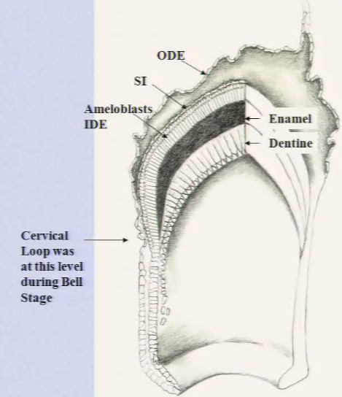
==========================
Why do we need ide?? ->recruit odontoblastes -> which lay down dentine.
- The odontoblastes grow deeper and deeper, producing collagen fibers, proteiglycans, glycoproteins,
- Facilitate precipitation of calcium phosphate
- The processes of these odontoblasts trapped in dentine
- So we have little cannaliculae here.
The ameloblasts keep synthesis enamel.

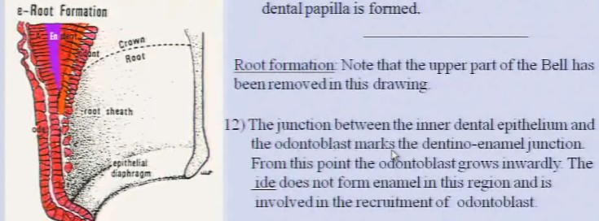

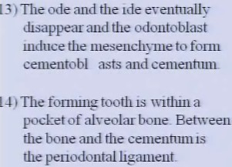
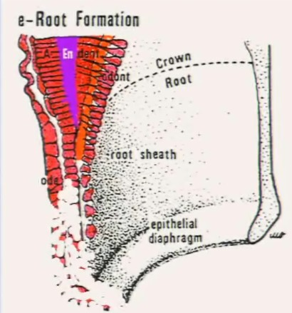
form from mesoderm

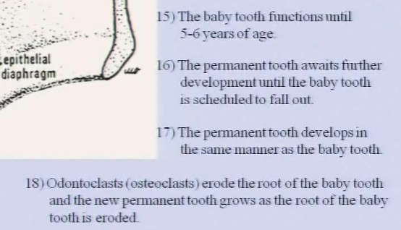

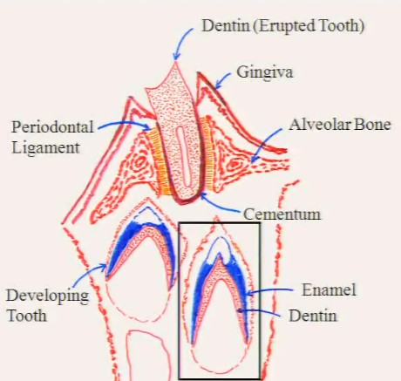
After this erosion, all the organs synthesizing enamel is gone.
We look at the square region:

This is a late bell stage tooth:
On top we have the future alveolar bone.
We will localize the enamel organ based on the blue immature enamels
- Beside the immature enamels, we have ameloblasts
Also beside enamel, we have the forming dentine belonging to the crown
The huge cavity = forming pulp, deliminated by odontoblasts.
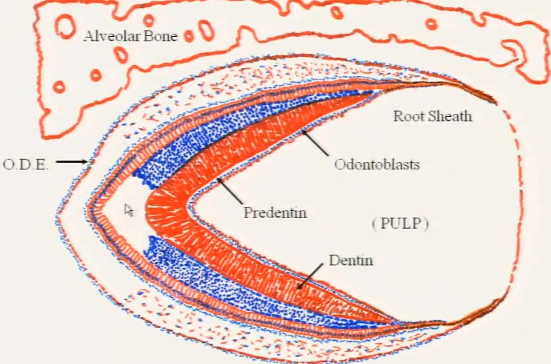
Root sheath: area where ide doesn’t produce enamel (does not transform into odontoblastes.)
Engaged in formation of root.

This is a mature enamel, so we don’t see blue.

Things in square = need identify in lab.
Left squre (enamel organ) from top to bottom:
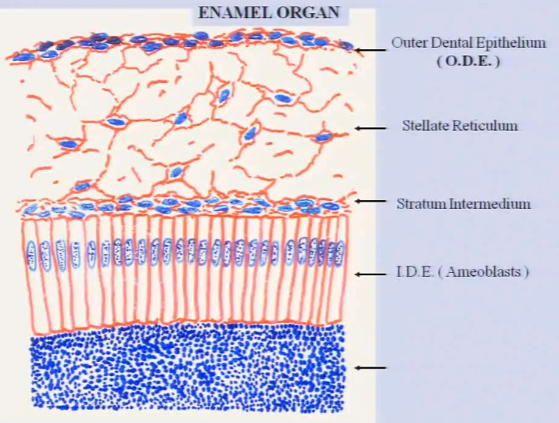
If only asked to describe enamel organ , just describe this.
If ask origin, then all the above (buds etc.)

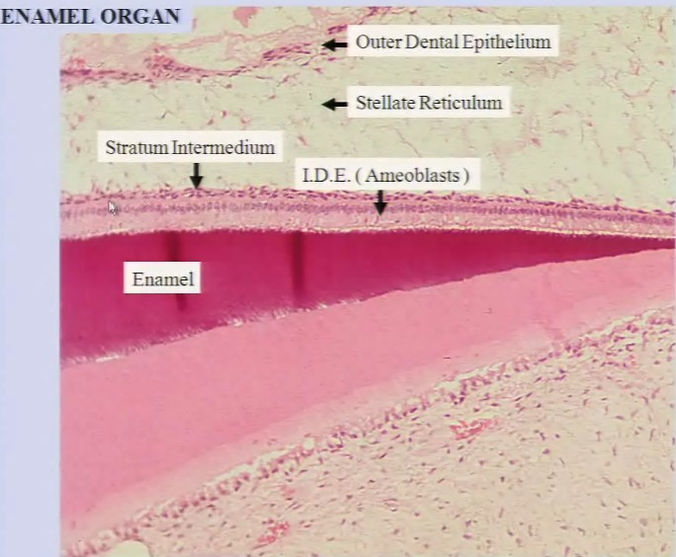

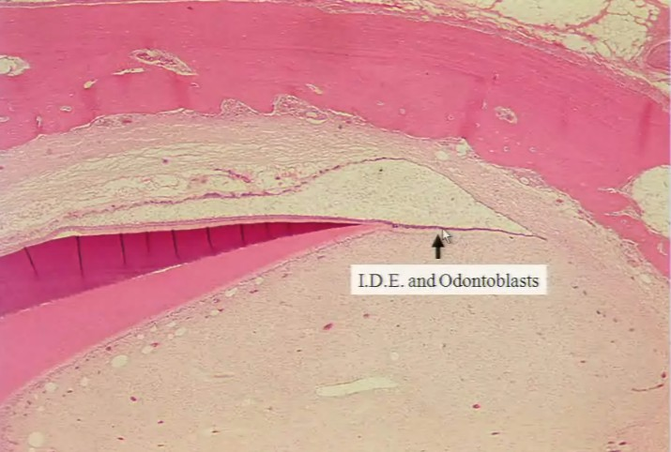
Note the black line = odontoblasts

Digestive system PART IV: oesophagus, stomach.
Oesophagus
So we did oral cavity + tooth, now move lower in digestive tract.
Function of digestive tract: Food injest -> get energy via the digested (small molecules) food.
general plan: for oesophagus
Mucosa:
- Epithelium
- L.M
  - Few glands here as well
- Musclaris mucosae
  - Circular
- As you get further futher -> mucosa gets smaller and smaller
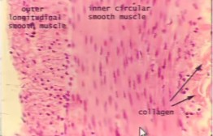
Submucosa:
- Loose or dense CT depending on where you are
  - In stomach = dense
  - Oesophagus = loose
  - Finds glands here
    - Mucousa glands: Oesophageal glands
Muscularis:
- 2 sublayers of smooth muscle ( in rectum), 3 in stomach
- Internal circular , external longitudinal
Serousa/adventitia
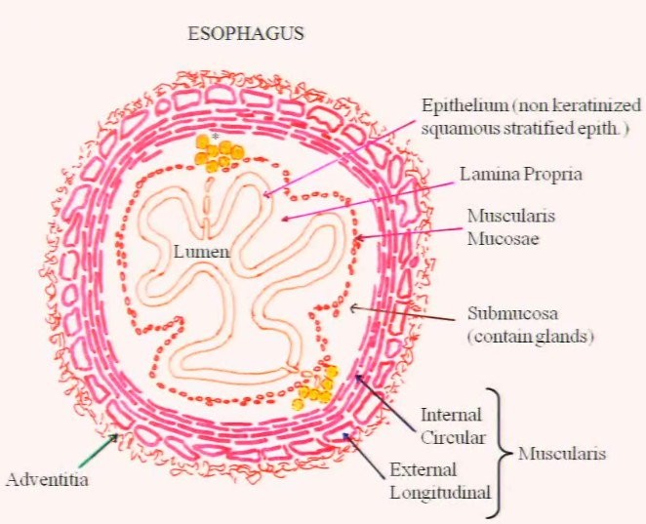

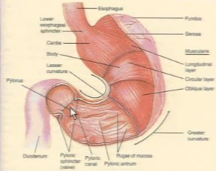
Stomach
Anatomy of stomach:
From end of oesophagus -> start of intestine = stomach
Upper region, near oesophagus entry = cardia.
Top right region = fundus
4 cm end of stomach = pyloric region
Rest of stomach = body of stomach

Alingment of muscle:
inner most = oblique
Middle = around stomach
outer = longitudinal to stomach
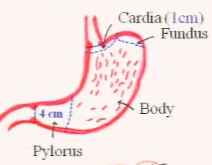
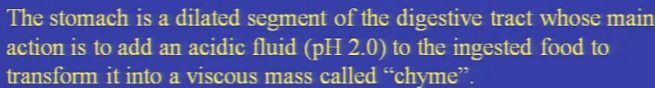
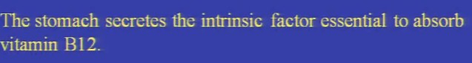
Knowing the general plan, we can start dissecting gastric tissue: RED = different from oesophagus
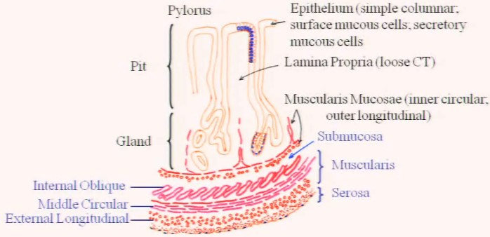
- We describe epithelium via:
  - Pits
  - Gland
- 1st layer inner most = epithelium (simple columnar)
  - Pits: simple surface mucous MAKE mucous that has bicarbonate in it = natural buffer.
    - Reason to have mucous: so acid don’t eat away your stomach
  - Gland: secretory mucous cells also secrete mucous, but NOT AS THICK
    - Same effect, protects gland.
    - NOTE: THIS IS NOT a secretory gland.
- Below = 2 layers of muscularis mucosa (inner circular, outer longitudinal)
- Submucosa
- Muscularis
  - Internal oblique, medium circular, outer longitudinal
- Serosa

You can determine region of stomach (pyloric/cardia/body) by looking pit VS gland
Cardia : 1pit: 1gland
Pyloric : 2 pit : 1 gland
Body/fundus: 1pit: 3glands (GASTRIC GLANDS)
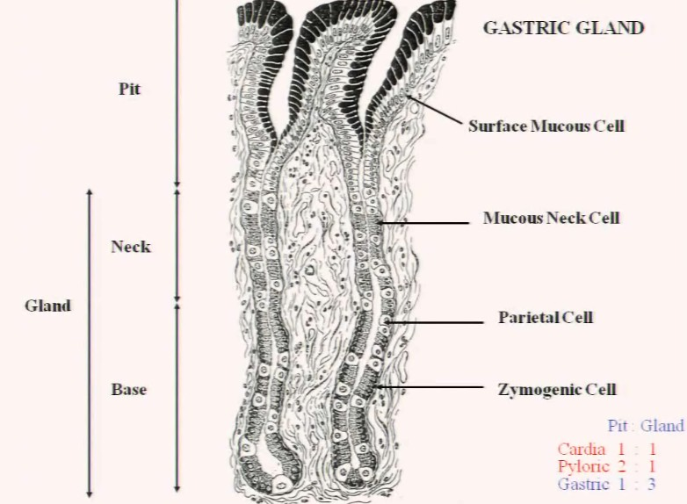
You stop seeing pits when you stop seeing surface mucous cells.
Gland portion divided:
- Neck
  - Mucous neck cell
- Base
  - Parietal cells
  - Look like omelette
  - Make intrinsic factors for B12
  - Also make HCl
  - BOTH NECK AND BASE
- Base of gland = Zymogenic cells
  - Make zymogenic granules
  - Proenzymes.
Cell descriptions:
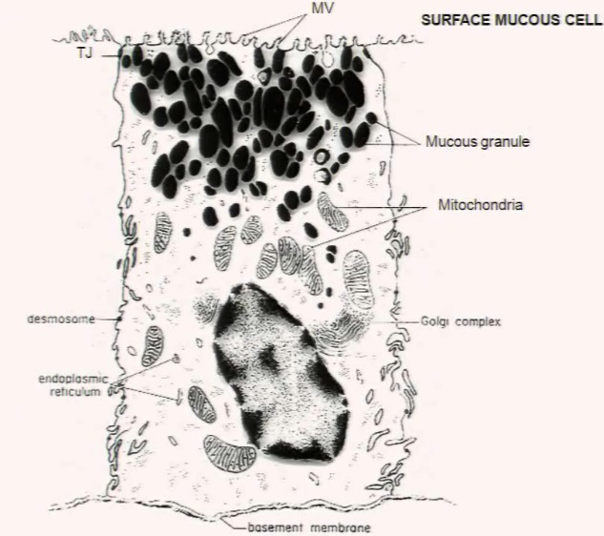
Surface mucous cells
TJ = tight junction = prevent acid fills in your cell
Packed with mucous granules
Carbohydrage rich glycoprotein described as the visible mucus because of its cloudy appearance.

Forms a thick vicscous gel like coat that adhere to the epithelial surface

Contain high [c] of bicarbonate (to mitigate acid effect)

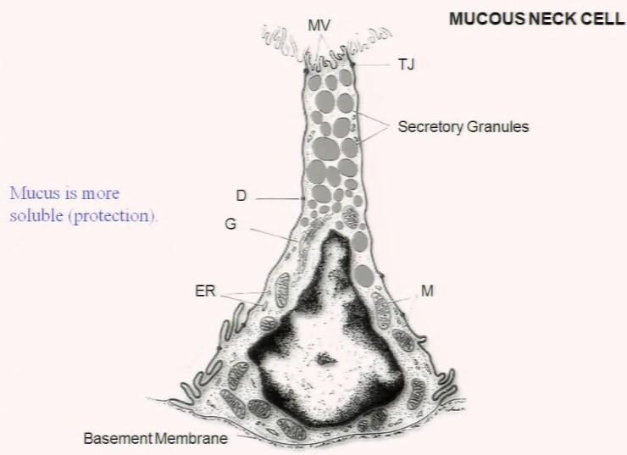
Mucous neck cells
Mucous much fluidly, don’t want to cram the pits up with thick mucous.

Nucleus at bottom

You have food come in and enzyme (from zymogenic cell) goes out.

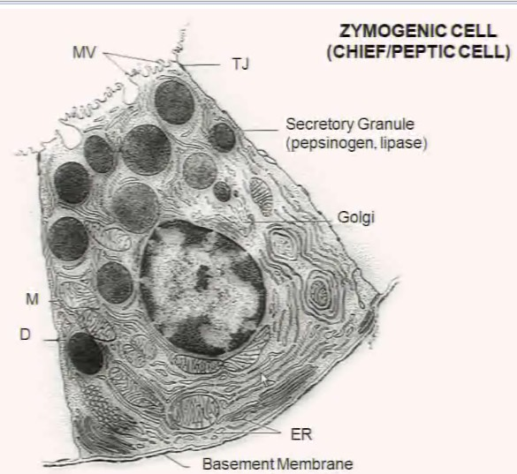
Zymogenic cells

Lot’s of ERs and organelles

Proteins made from secretory granules: like pepsinogen and lipase
- Pepsinogen: proenzyme, goes out of gland, get cleaved into pepsin -> break down protein
- Lipase = Brek down fats

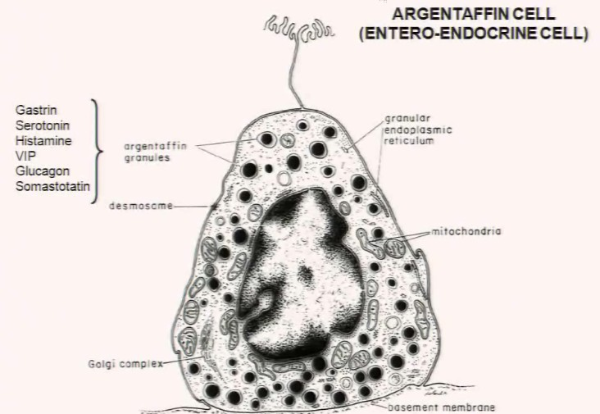
Argen Taffin cell: can’t see in LM
If stained with silver = light up
- Contain agentaffin granules
Contain hormones:
- Gastrin
- Serotonin
Secretes hormones DOWN BM:
- Affect mobility and contraction of the muscles (endocrine)
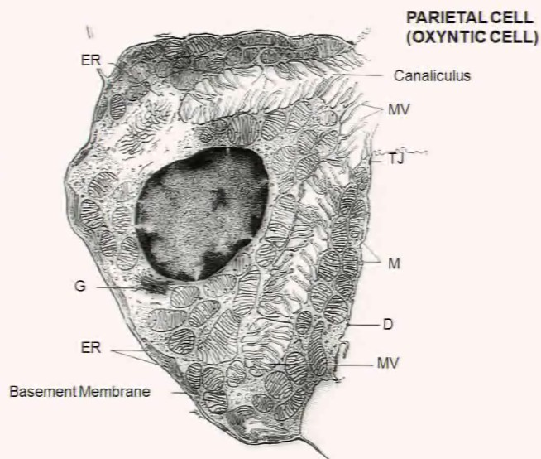
Parietal cells:
Present in neck/ base of glands.

There are indentations/canaliculus inside cell (with microvilli).
- Form lumen + increase surface area.
- Packed with Mitochondria + ribosome.

Make:
- Intrinsic factor for VB12 for blood cell production
- No VB 12 -> Atrophic Gastritis -> pernicieous anemia

Production of HCl in gland:
Use carbonic anhydrase to produce HCl and bicarbonate
The GASTRIC REGION:
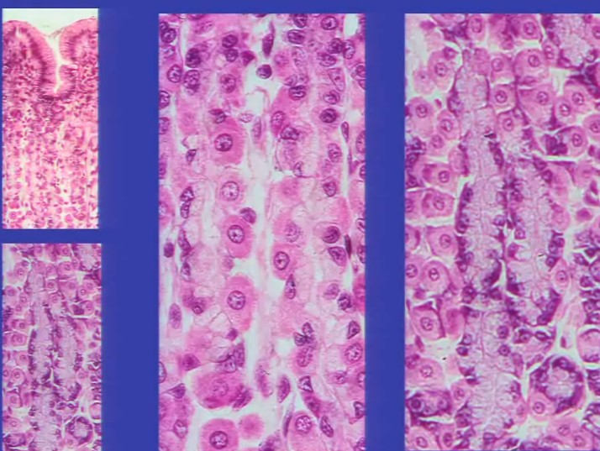
Neck cell

Parietal cell

Digestive system PART V: intestine (small)
Macromolecules that are partially digested in stomach, get digested in lumen of small intestine by the action of pancrease enzymes
Terminal digestion: proteins +carbohydrate occurs at mucosal surface of intestinal origin, tuning into amino acids, monosaccharides, fatty acids,and monoglycerides ----- absorbed along the vast absorptive surface of small intestine
Small intestine = 3 segments:
- Duodenum
- Jejunum
- Ileum
Disguishable at level of submucosa.
Duodenum:
Mucosa
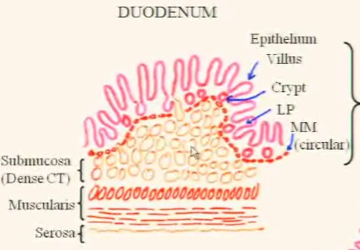
- Epithelium
  - Have villi and crypts instead of pits an d glands
  - Villi = invagination and form crypt (of lieberkuhn)
- Lamina propria
- Muscularis mucosa
Submucosa (dense CT)
- Packed with Bruner’s glands, only present here.
  - Secretes alkali fluid = pH 9 (rich in bicarbonate)
  - Used to pH of 2 in stomach -> neutral 7 to make all glands work
Muscularis (2 layers of smooth muscle) \
Serosa

Jujenum:
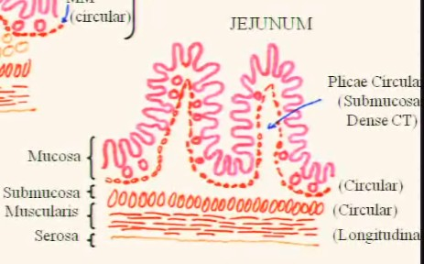
Mucosa
- Muscularis mucosa = circular
Submucosa (dense CT)
- Pushes up
  - Form plicae circularis (eruptions of submucosa pushing mucosa up)
  - Used to increase surface area -> more opportunity to absorb nutrient = (X3 surface )
Muscularis
- Inner circular, longitudinal outside
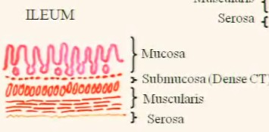
Serosa
Ileum: not have picture in lab
Know it if asked to describe small intestin
Mucosa
Submucosa (dense CT)
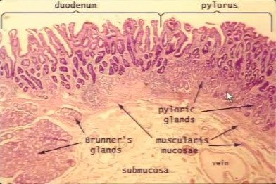
- thin
Muscularis
Serosa
- AKA visceral paratine

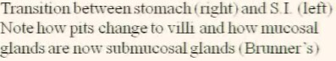
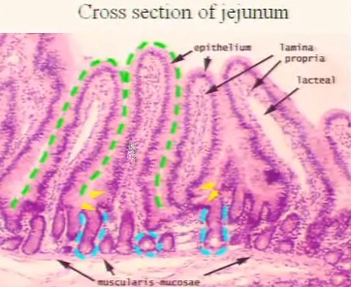
Green line: submucosa invagination

Cells that make up Vili and crypts
START FROM BOTTOM: CRYPT
Stem cells:
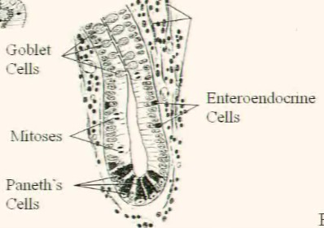
- Lining of epithelium turnover = 3 days
  - Lot of mitotic structures
- Constant renovation
- Can’t see with LM
Paneth cells:
- Columnar
- Dark, nucleus at bottom
- At bottom of crypts
- Secretes lysozymes (kill bacteria)
Enteroendocrine cells:
- Exocytose their secretion DOWN into muscle to control contraction
Goblet cells:
- Produce mucus -> lubrificate surface.

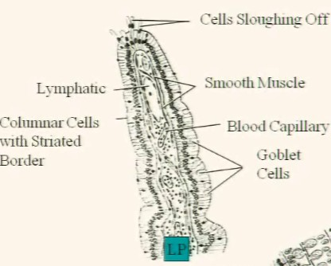
In vili:
Goblet cells: also present
Columnar cells with striated border = main cells of villi.
Cells sloughing off at top of vili
Inside, under epithelium = L.P.

Also need to identify blood vessels

Will identify smooth muscle, popped off from Muscularis mucosa
- Give vili movement to push down food

General plan of small Intestine mucosa:
- Villi (simple columnar epithelium) Cells:
  - columnar cells with BRUSH BORDER (absorptive cells or enterocytes)
    - Brush = microvilli
  - Goblet cells
    - Secrete mucus
  - M cells
    - Immunological response in digestive tract, see later.
    - Part of peyer’s patch REMEMBER this
- Crypts cells: (simple columnar epithelium)
  - Columnar cells with brush border (also absorptive cells)
  - Goblet cells
  - Enteroendocrine cells
    - Secretes hormone into B.M.
    - Secretes cholecystokinin(CKK) to control gall blader and pancrease secretion
  - Produce Lysozymes
    - Kill bacterial by breaking their cell wall
  - Stem cells
- L.P.
- Muscularis mucosa

Enterocytes:
Have the following:
- Zona acclurence = tight junction = terminal web of actin
- Desmosomes
- Hemidesmosomes at bottom
- Rest on BM
Try to increase surface area = have microvilli = NOT CILIA
- Parallel bundles of actin,
- Connected by VILIN -> hold parallel bundles of actin up -> push plasma membrane up -> increase surface of cell.
- Coating microvilli = enzyme protein and transmembrane proteins.

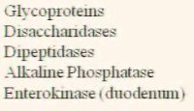
This is the point where we absorb food.

Digest sugar
Digest protein
Digest phosphate
Activate Trypsinogen -> trypsin

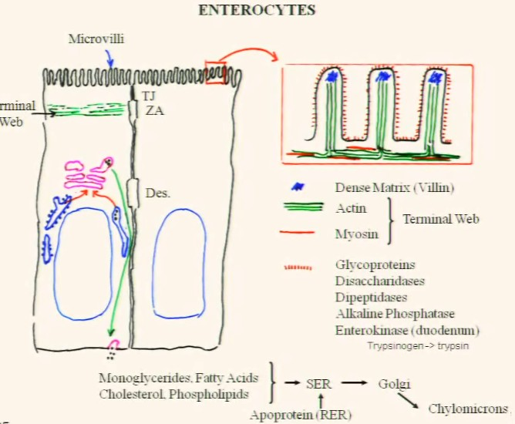
Monomer sugars pass through membranes easily, and gets down to the ER. Proteins work the same way.

Fat not so easy: hydrophobic
- Sit on entry site and stays as a chunk of fat
- You need it to make membrane + myelin
- Chunks of fats are ground up, get in via enterocyte via endocytosis.
- Get to golgi -> packaged with lipoprotein (made in rough ER)
- We made apolipoprotein
- These apolipoprotein are then exocytosed into the bottom -> chylomicrons (in golgi) -> taken by blood stream -> fine digested in liver.

How antibodies are made through digestive tract:

Goblet cell make lubrificant for mucus layer -> which traps antigen
Lymphocytes can goes up between mucus, but cannot go upper than tight junction

When you have antigen stuck in mucus, M cell, look like anterocytes, but with LONGER microvili come (lines the digestive tract)
Endocytose those bacteria and mix it with the lymphocytes (later become plasma cells, and make antibodies) that migrated up.

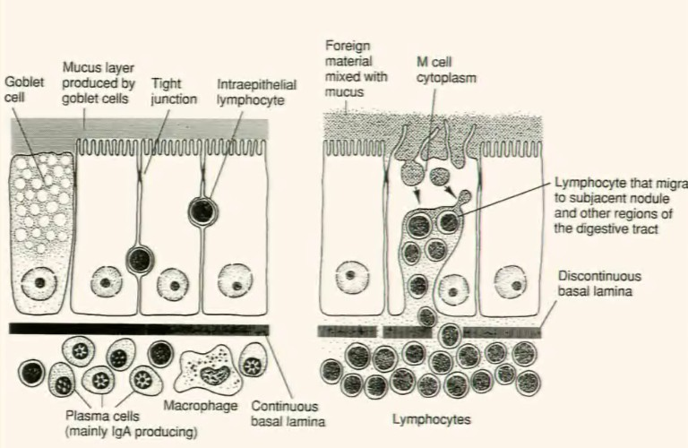
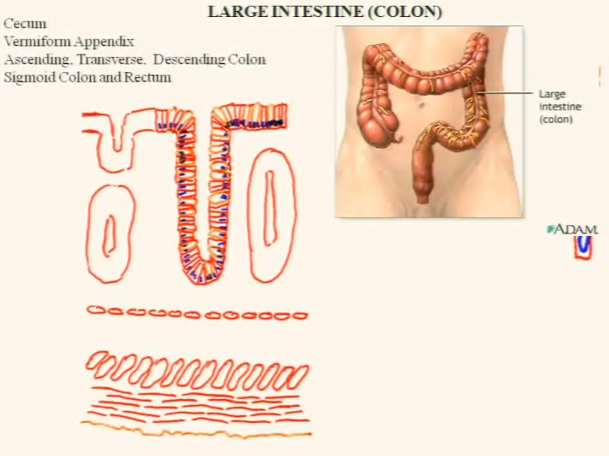
Digestive system PART V: large intestine/ colon
Appendix = connect to secum (blind pouch that sits there)

Large intestine = 3 parts:
- Ascending
- Transcerse
- Descending
With sigmoidal bind on it

General plan:

Mucosa:
- Just crypts, no villi
  - We only see invaginations
- Epithelium: columnar + goblet cells (lubricate)
  - Main absorption = water
  - Has goblet cells + absorptive cells.
  - Also find entero-endocrine cells (secrete down BM)
  - Stem cells of course.
- L.M.
- M.Mucosae
  - Circular
Submucosa
Teniae-muscularis (inner circular + outer longitudinal)
- 2 layers of smooth muscle.
- Longitudinal does not wrap all way round, just BANDS! ELSE WHERE = run the length
Serosa

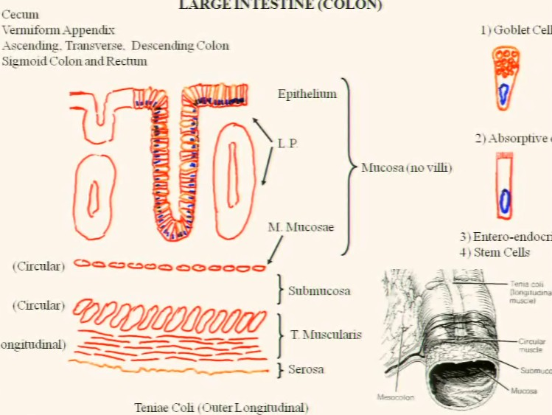
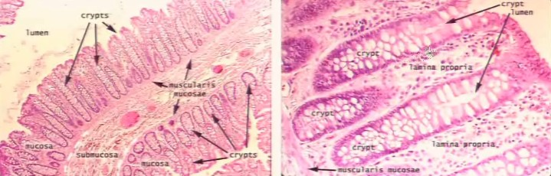

Digestive system PART VI: pancrease
Only exo-endo crine organs we can see.

How a exocrine gland / endocrine gland (2 path ways) differenciate
Both originated from epithelium tissue
- Come from ectoderm + endoderm
  - Eventually mesoderm
- As the tissue divides -> penetrate into mesoderm -> exocrine
  - Eventually form a duct
  - End of duct become secretary portion
  - Exocrine will have duct, leading to lead product out of endoderm(surface)
- The cells also may detach -> 2 fates -> endocrine:
  - Organize into small vesicle
    - Produce protein (pro hormones – inactive)
    - Cell pick up these proteins (endocytose) and release into capillaries
    - EG: thyroid gland.
  - Some cells may organize into cords
    - Align near capillaries (no reservoirs)
    - The hormones are immediately released into capillary as produced.
      - Like insulin
  - These glands do not have duct, secrete into blood stream.
Pancreas:
- Mix of exocrine and endocrine portion:
  - Endocrine = made of islets of langerhans
  - Exocrine = compound acinar glands (identical to salivary glands)
    - Similar to parotid glands
- Exocrine pancrease produce: alkaline fluid +
- proteins
  - Proteins = 15+ enzyme/pro-enzymes(AKA zymogens)
    - Used to digest ALL foods.
- Both pancrease and salivary glands derived from evaginations of endodermal lining of embryo (of primitive intestine)
Baisc embryology :
- In a transverse section, lower = endoderm
- The endoderm will form a small vesicle = primitive intestine
- This is where pancreas come from (the lining of endoderm)
In primitive intestine, cells grow from the walls of intestine, gradually forming branching.
- At end of acinus, a group of cell differentiate
- Will be completely detached
- Will later form islet of langerhans.
The cells at bottom further differentiate into lobes and lobules

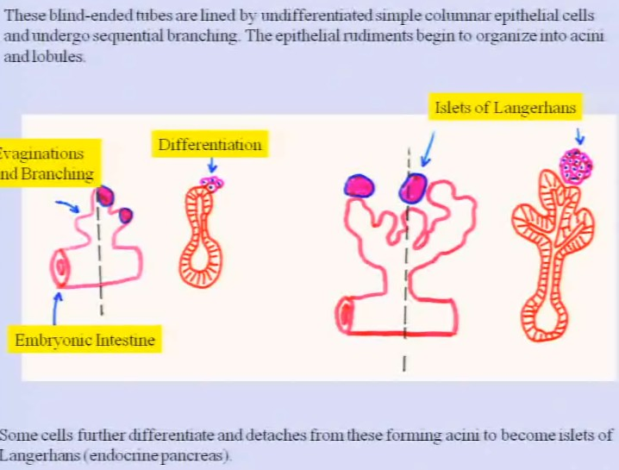

Let’s jump to a more differentiated stage of glands:
In the case of salivary gland, itralobular duct = STRIATED duct.

In pancrease, we DO NOT have striated duct. Instead, you have Collecting Duct!
- Doesn’t have striation.

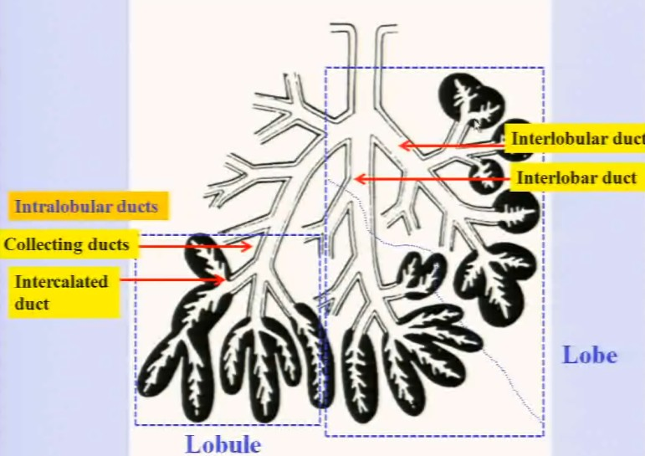
Pancreas = compound gland = a lot of branching.

Larger duct emerging from main pancreatic duct = INTERLOBAR DUCT
- Surrounded by a lot of CT
Diverge into INTERLOBULAR DUCT

Diverge into INTRALOBULAR DUCT = collecting duct

Diverge into small ducts (intercalated duct) like in salivary gland.

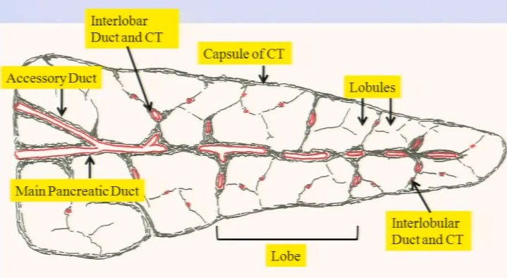
The pancrease is surrounded by a thick capsule of dense CT.

The CT will penetrate at level of duct system.

Follow the duct system and separate the organ.

When have THICK layer of CT = INTERLOBAR

As it divides, it becomes thinner and thinner -> become interlobular CT.

Man pancreatic duct -> interlobar duct -> interlobular duct -> intralobular duct
THICKest CT ------------------------------------------------------------- small CT

Note: there will be area of transition = don’t worry.

If we enlarge an area with interlobular duct with thin CT:
We will see blood vessels, nerves, and lymphatics.
We will see the following structure INSIDE LOBULES:
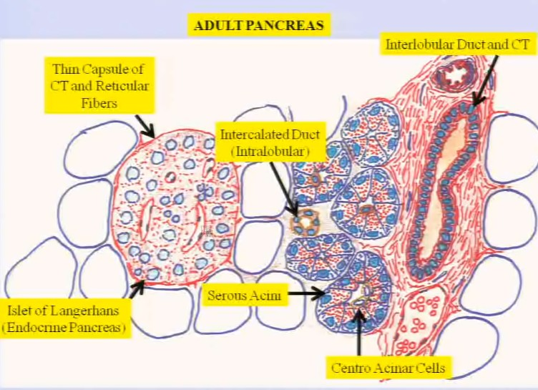
- Serous acinus
  - Secretory unit of the pancreas (similar to parotid gland)
  - THESE ones in PANCREAS do not have myoepithelial cells (Can’t see in LM)
  - But pancreas do have CENTRO ACINAR CELLS.
- Intercalated duct (intralobular)
  - Later converge into collecting duct
  - Drain directly into interlobular duct
- Islets of langeran (distinctive feature)
  - Endocrine pancreas
  - 200um in diameter
  - Many epithelial cells + capillaries inside (hormones entry)

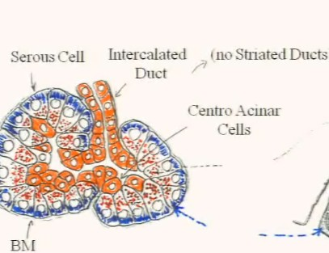
Serous acinus
Serous cell:
- Reset on basement membrane
  - No myoepithelial
- Has intercalated duct in it (paler than acinus)
  - Cuboidal / squamous
  - Central nuclei
  - NO STRIATED DUCTS
- Presence of central acinar cells.
  - Does not look like intercalated duct
  - Rather like squamous cell on serous cells.
  - Some time completely separated from intercalated duct.

You have tight junctions that joins adjacent mucous cells. Below = individual cell.

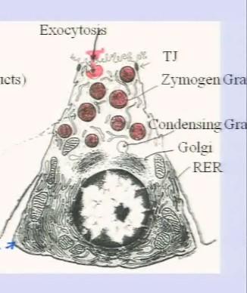
- If TJ fail, pancreatisis happens.
- This is because harmful substance made inside leaked out.

Why is these cells such basophilic? Because developed ER and nucleus (basophilic) (blue) + numerous ribosomes.

When having secretory cell: extensive ER and golgi -> pack the product into granules -> condensing granule (paler) -> make zymogenic granules (acidophilic, darker)

Also when granules fuse with apical plasma membrane upon proper stimulation, you want them to FUSE ABOVE TJ, not in lateral space -> highly polarized.
- Extensive alcohol = change polarity of granules (goes into lateral space)
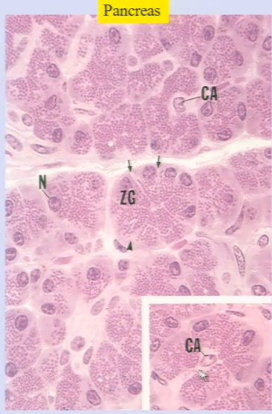
Real thing of this:

Note that CA cell has PALER color than normal cells.

Regulation of the exocrine pancreas:

2 main hormones:
Secretin :
- Secretion of H2O and bicarbonate
- Neutralize pH of stomach -> duodenum
  - If not neutralize = harm duodenum.
Cholecystokinin (CCK):
- Produced by endocrine cells of duodenum, promote exocytosis.

When pancreas secret zymogens, a bunch of product (powerful) = proenzyme (activated in intestine by ENTEROKINASE) -> remove small AA to activate enzyme
- Enterokinase produced in microvili that covers the duodenum’s columnar cell covering the intestine (particular the level of jejunum)
- You have peptidases that break down A.A.
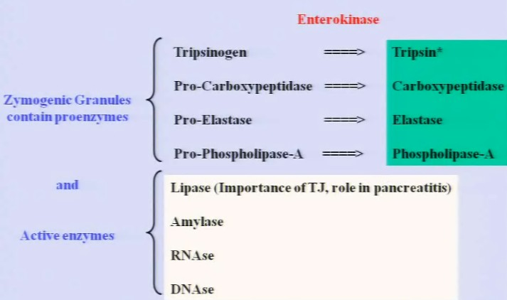
- In the same MICROVILLI, you have ENTEROKINASE that activates these pro enzymes from pancreas.

(this one is bad), don't want them in intercellular space. Of TJ
Destroy glycogen

The central acinar cells also produce tripsin inhibitors
- You do not want these enzyme to active in the lumen.

Islets of Langerhans (endocrine pancreas)
- We usually put low magnification, that resembles parotid gland -> and in little corner + put an islet of langerhans. -- distinctive for pancreas
Big structure surrounded by thin layer of reticular fiber.
Multitude of cells.

Entire structure = paler
Filled by capillaries.

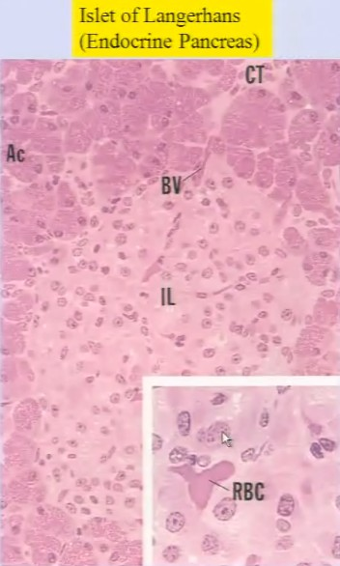
We have central acinar cells.
We see a lot of capillaries, full of RBC.

If at high magnification.
- Some cell = large + loose chromatin
- Some cell = small + dense chromatin
- = 5-6 different cell types.
  - No need to identify = because need immunological chemistry. SHOULD KNOW CELLS EXIST!

Cells in Islet of Langerhans:
In human: 500k -1mil islets, 2% of pancreas = endocrine. DIAMETER = 200um
- Each islet = microunit.

Cell type | % | Size | Location | Hormone | Function | Note:
A(alpha cell) | 15-20% of islet | Large | Periphery | Produce Glucagon | Glycogen breakdown, gluconeogenesis  (produce sugar that release into blood stream) -> increase glucemia | 2nd most important cell  Secreted in night (produce energy because we don’t have food)
B(beta cell) | 70% of islet | Smaller | center | Produce insulin | Uptake of glucose after meals, lower glucemia in blood. | Most important
D cell | 5% | Large | Both | Somatostatin | Inhibit release of glucagon OR exocrine pancreas
F cell | 1% | Large | Both | Pancreatic peptide | Unkown function
G cell | 1% | Large | Both | Produce Gastrin (pancreatic?!) | But gastrin in pancreas? | Gastrin is used to stimulate parietal cell to produce HCL…

Two endocrine cells belonging to islet of langerhan associated with a capillary

- Fenestrated capillary (lined by fenestrated epithelium) --- 2 types in kidney + pancreas
  - In all endocrine organs
  - Need hormones to go freely into capillaries.

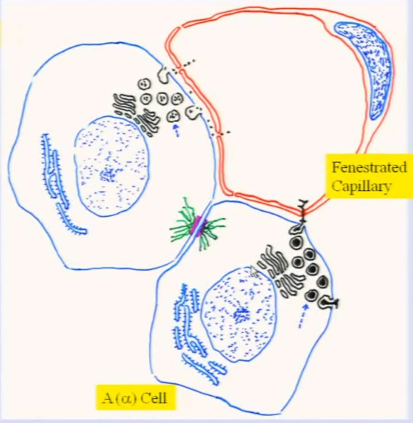
Alpha cell:
- Condensed granules of 250nm
- Extensive ER and golgi
Beta cell: (the one on left)
- Same ER and golgi
- Granules a little larger > contain small granulations

Adjacent cells will be joined by DESMOSOMES

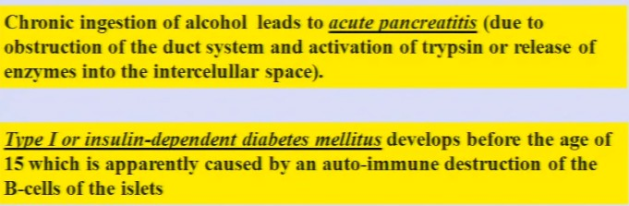

Digestive system PART VI: liver

The liver is the Largest gland in the body, a vital organ.
It is under diaphragm and located on the right side
It is lobulated.

- It is surrounded by a capsul of CT – thin, but hard (dense irregular CT)
  - If these capsule break -> massive bleeding.
- At level of porta hepatis, the CT goes inside and divide the liver into hepatic lobules
- At level of porta hepatis -> 2 portal veins : bring nutrient from intestine.
  - Goes CT inside, and divide into capillaries to nutrient lobules.
- We also have hepatic arteries -> divide into arteriole later.
- Coming out, in reverse direction, we have hepatic duct.
  - We have the duct draining into gall bladder
  - Also a common bile duct
- We also have a hepatic vein
  - Coming out of liver, drains into inferior vena cava -> goes to heart.

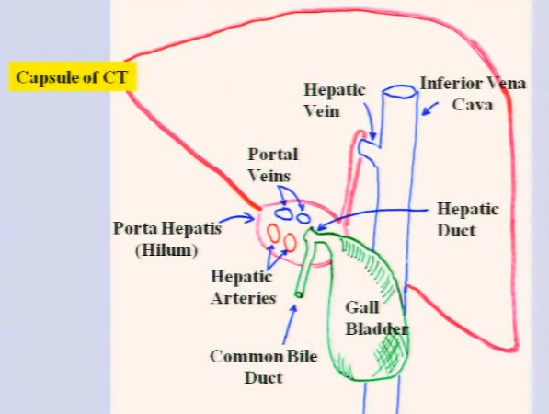

Functions：
Endocrine: secrete serum protein
- Albumin, fibrinogen, prothrombin(coagulating protein), transferring (transfer of iron, used to produce DNA)
- VLDL/LDL: low density lipoprotein (carry cholesterol to peripheral to tissue to synthesize plasma membrane)
- All these = secreted directly into circulation
Exocrine : produce bile -> secreted out to external milieu (to intestine)
- Bile acid, bilirubin (also phospholipid and cholesterol)
Inactivation/elimination of substances:
- Glucuronyl transferase:congjugate glucuronic acid to billirubun/barbiturate/anthihistaminics/anticonvulsants/insecticides and other drugs
Convertion of substances: thyroid hormone -> more powerful hormone
- Transform thyrosine tri-idothyrosine
Hemopoeisis during FETAL life
- Formation of RBC – transcient process
Storage : of lipid (cholesterol and glycogen)

Histological slides:

Hepatic lobules are more or less polygone shaped.
CT divides lobules
Each lobule has beginning and end.
Each hepatic lobule has a CENTRAL VEIN – responsible for all blood circulation in lobule.

At each CONER = CT enlarged.
- That place = portal space.
  - Contain branches of hepatic artery (like arteriole) and portal vein.
- We also have BILE DUCT
  - That merges together with venules and artery.\

So all central veins will go through lobule and JOIN INTO SUBLOBULAR VEIN
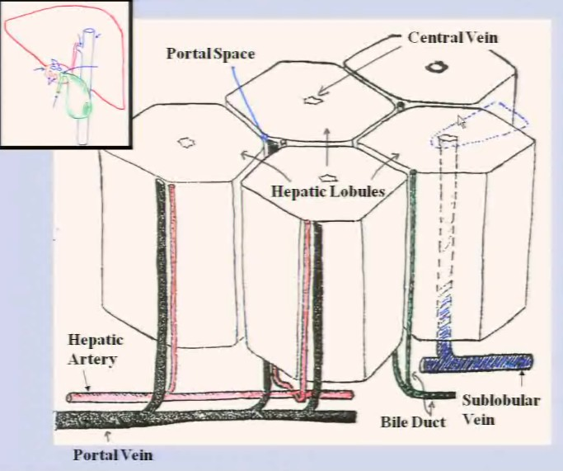

Now if we ENLARGE THE BLUE SLICE:

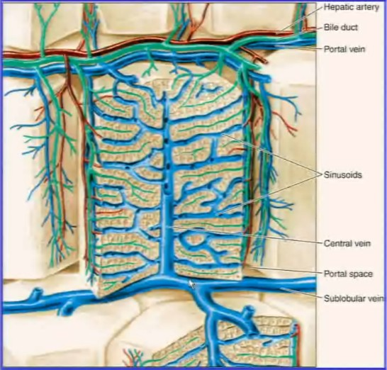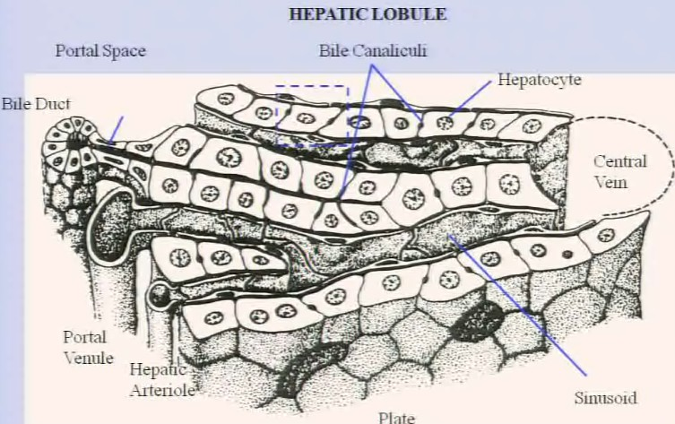
- Bile duct:
  - You could see : lined by columnar SIMPLE epithelium
  - Could be cuboidal as well.
  - Located in CT between lobule (represent interlobular duct in interlobular CT)
- Portal venule:
  - Opens directly in the structure called SINUSOID
    - Bring nutrient here from intestine
- Hepatic arteriole:
  - The arteriole also open to sinusoid
    - Bring oxygen here from heart
- In sinusoid: BOTH artery+venule BLOOD MIX, UNIQUE for liver.
  - This is an example of sinusoid capillary.
  - Irregular capillary
  - Covered by endothelial cells
    - Discontinue, simple squamous
    - Doesn’t have tight junction.
    - Rest on BM: faced inside, ALSO DISCONTINUE.
- Hepatocytes:
  - Cells that do all the functions of liver.
  - Epithelial ORIGIN, but NO BM!
  - 2 different areas:
    - One portion facing undothelium lining (outer and inner)- there is a space here.
    - One portion facing adjacent hepatocyte: SMALL CANALICULLI
      - Called biled canaliculli, a space between 2 haptocytes, sealed by TJ.
  - Forming plates -> same direction as lobules
    - Has “window” in the plate -> use to transfer blood flow.
  - Bile Canaliculli can go vertically or horizontally (but always between adjacent heptatocytes -> end at bile duct.
- Cholangioles
  - There is a squamous duct around bile duct
  - Equivalent to intercalated duct
  - Lead to INTRALOBULAR DUCT OR BILE DUCT -> go hepatic duct -> gal bladder.
Space of Disse:
Endothelial cells form a space at level of plasma membrane with hepatocyte.
SPACE BETWEEN BM and PLASMA MEMBRANE of hepatocyte
- Appear as MC question, remember to mention it during description

The hepatocyte: enlarge the BLUE RECTANGLE in previous pic:
You have central heptocyte (blue) + 2 lateral ones (green), with 2 canaliculi.

The side of heptocyte facing space of Disse = have numerous microvili.
- Because we have a discontinuous epithelial membrane = free communication between SINUSOID + space of DISSE.
- Same stuff happen on the opposite side.

The side of hepatocyte facing lateral plasma membrane:
- Find desmosome/TJ = focal point of contact between membranes.
  - Sealing the bile canaliculli (perpendicularly.
  - Prevent bile to reach circulation = JAUNDICE if otherwise.

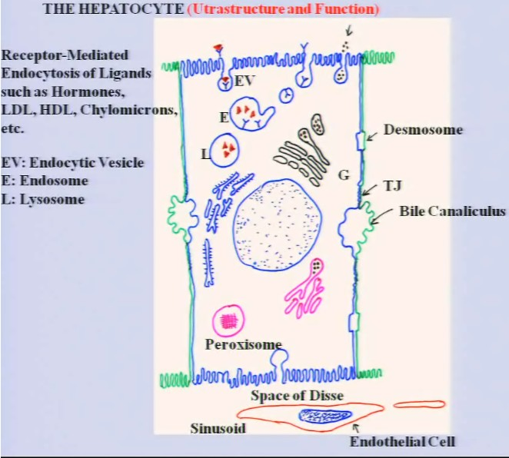
During receptor mediated endocytosis:
- Frequent at level of liver, used to transfer hormones, because they cannot be circulated forever.
- There are receptors of liver on surface, that has high affinity to these hormones -> bind to them + endocytose.
Form endocytic vesicles -> endosome (the receptors dissociate and goes back to surface, leaving the ligands) -> become lysozome and destroy hormones.

EG: endocytosis of low density lipoproteins (LDL):
LDL binds to exterior surface, inner surface of plasma membrane get coated with clathrin (vesicle detach)

Ultra structure and function:
The liver has endocrine function

VLDL apolipoprotein complex.
- Lipoprotein = lipid and protein
- Lipid synthesized in SER, while protein synthesized in RER and sent to golgi.
- All lipids are then sent to golgi = conjugate both things together. -> VLDL (very low density lipoprotein)
- The VLDL are then wrapped by golgi
- Release via exocytose.
RER: blue
SER:pink,
Golgi

Also exocrine function: secretion of bile.
- Cholesterol used with taurine to produce taurocholic acid = elimination of cholesterol
- Cholesterold + glycine = glycocholic acid
- Bilirubin is also changed to glucuronic acid by GLUCURONIC TRANSFERASE
Above = released into bile duct.

Peroxisome: unique in liver/kidney
- Membrane bound organelles.
- Distinguished from lysosome by the presence of crystalloid.
- Function: break down Hydrogen peroxide to Oxygen and Water
  - The peroxide is byproduct of beta chain oxidation of fatty acid.
  - Also participate in breakdown of PURINE AND ALCOHOOL
  - Also in bile synthesise of cholesterol
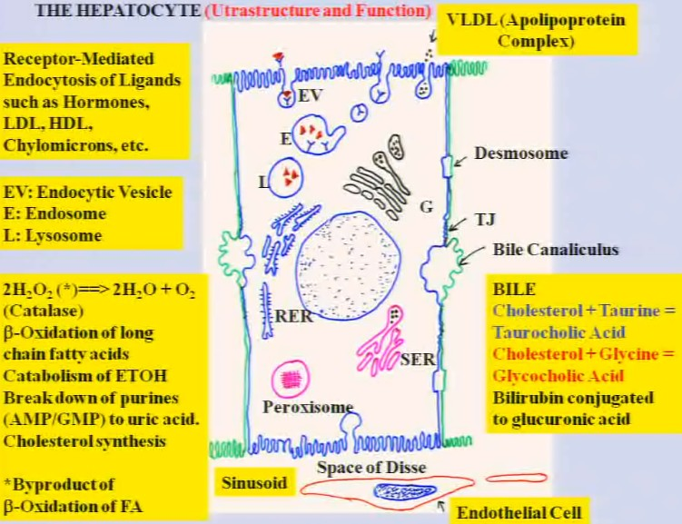

Circulation of Blood VS of Bile:

Blood:
Portal venule + portal arteriole -> sinusoid -> central vein ->sublobular vein -> fuse into hepatic vein -> drain into inferior vasa cava.
So from the portal space to -> central vein

Bile:
Center of hepatic lobule -> bile duct in the portal space
Central ->periphery.

NOTE: central vein is a SPACE, not lined by endothelial

Few facts to remember:
- Turn over of hepatocyte = 150 days +
  - Expanding population of epithelial cells
- Mitotic index: 1 mitosis every 20k cells
  - Low mitotic index
- Surgical excision: cell divide actively until the organ restore normal number
- However, repetitive injury of liver = hepatocyte die
  - And CT will proliferate -> hepatocyte no longer coming back
  - Cirrhosis: 酒精肝

Hepatic lobule:
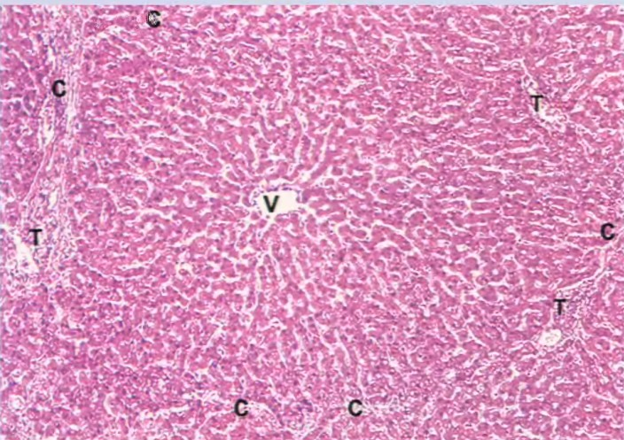
C = connective tissue (pork will have a lot of CT, but not others)
T = portal space.
V = central vein = characteristic of hepatic lobule
- You will see many sinusoids, and therefore the course of hepatocytes and endothelials
- You might see macrophage, but it’s ok.

If we enlarge a portal space:
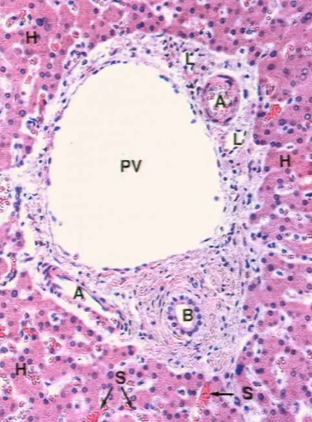
PV: portal veinule
A = hepatic arteriole (based on smooth muscle)
L = lymphatics, or veins.
B = bile duct: distinguished by single cuboidal epithelial

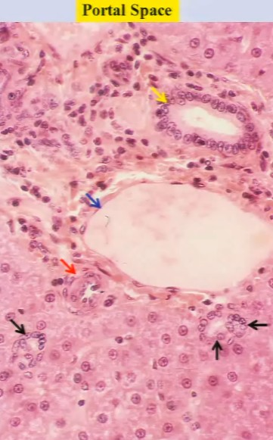
Blue arrow: portal veinule

Yellow = bile duct

Red = hepatic arteriole

Black = collangioles

Urinary system
Kidney, ureter, urinary bladder and urethra -> cover kidney and bladder IN LAB

Function:
- Excretion of metabolic waste (urea)
- Regulation of body water%
- Regulation of electrolyte balance
- Participate in endocrine secretion of Renin (enzyme regulating blood pressure) and Erithropoietin (hormone stimulating production of )

The kidney:
- Located in the back of abdomnal
- Shape
  - Like half of bean
- Convex border in external
- Concave border in internal
  - Hilum
    - Presence of renal artery and veins penetrating into organ
  - Mainly occupied by pelvis
- Renal pelvis
  - Expanded portion of ureter
- Human kidney = lobes and lobules

Kidney anatomy
- Capsul of dense CT surround kidney, penetrate at level of hilum = interlobar CT
- Kidney has 2 areas:
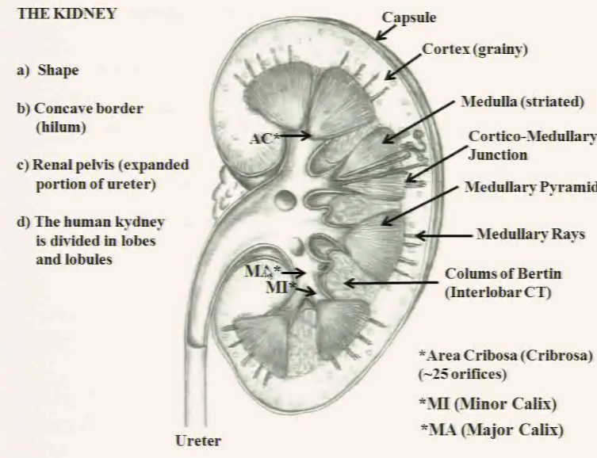
  - Cortex
    - Grainy
  - Medulla
    - Striated due to ducts
- Landmark: cortico- medullary junction
  - Artificial line between cortex and medulla
- Medulla in LOBULATED KIDNEY will form medullary pyramids (renal pyramids)
  - Separated by CT
- Pieces of medulla penetrating cortex = medullary rays
  - Important
- Renal pyramid’s ducts will open at apex of pyramid: Area Cribosa
  - Means: perforated area
- CT separating pyramids: column of Bertin
- MiC minor calyx
  - Space where ducts of renal pyrmid empty their content
- MiC converge to MaC
  - Major calyx
- MaC will form pelvis.
The nephron: Area of ONE pyramidal medulla + its cortex + renal corpuscle
ALL PINK+RED = nephron
PART OF BROWN = NOT NEPHRON
In each human kidney = 1-4million nephrons (functional and structural)

Parts of nephron:

Renal corpuscle:
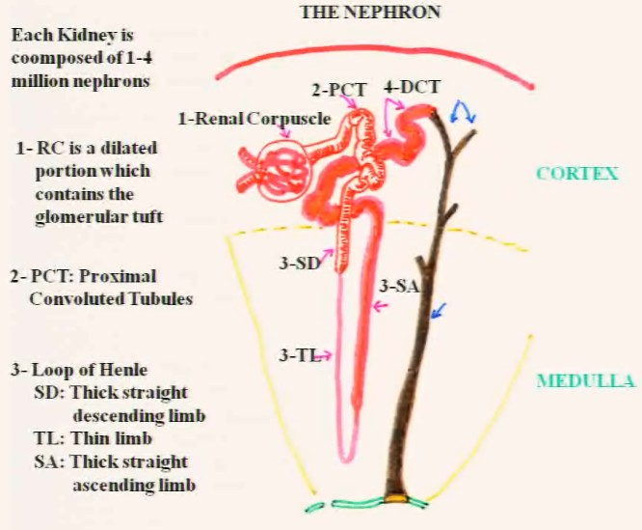
- Has 2 horns of arterioles, one of them = afferent arteriole
- Form capillaries
- Capillaries converge = efferent arteriole
- RC contains glomerular tuft
PCT (proximal convoluted tubule)
- Continues with the huge loop, which has 3 portions (most located in medulla)
Loop of henle:
First portion: SD: THICK straight descending limb
- Continuation of PCT, RESEMBLE PCT
Second:TL: thin limb of loop of henle
3rd portion: thin limb become larger again: SA : thick straight ASCENDING limb
- Looks like DCT
- In both medulla and rays/a bit in cortex

When loop of henle enters cortex again: DCT: distal convoluted duct
Similar to Thick ascending limb (in medulla), while DCT in cortex.

The nephron end at the end of DCT, the following is a new system made by collecting tubules.

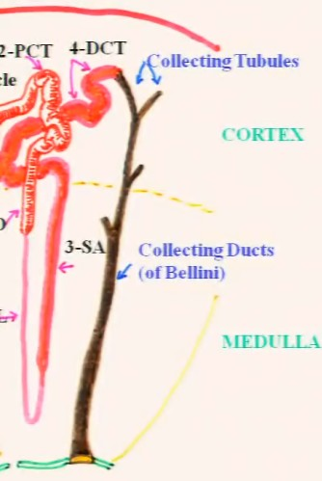
Collecting tubules will join to each other, and merge into a larger duct at the medulla.
Collecting tubule -> collecting duct of Bellini 2 types:
- Lorenzo Bellini
  - He’s the one
- Vincenzo Bellini

Duct of Bellini will open at Area of Cribosa, collecting duct open, and facing minor calyx.\

Renal Corpuscle:
Bowman’s capsule:
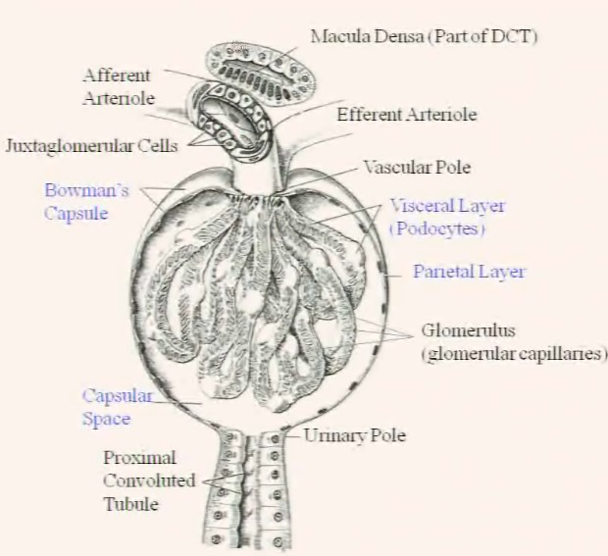
- Flat cells surrounding the renal corpuscle
- There is 2 layers:
  - Parietal layer
    - Made of squamous cells
  - Visceral layer
    - Made of podocytes that surround capillaries
- Also have Capsular space
  - Collection of ultrafiltrate
  - Hydrostatic pressure in arteriole is high, liquid in capillary goes in to capsular space -> ULTRAFILTRATE
  - Ultrafiltrate will then circulate via the PCT

2 Poles: Vascular/Urinary
- At URINARY POLE = PCT originate
- At VASCULAR POLE = entrance of Afferent arteriole

Inside:
- Glomerular capillaries emerged from afferent arteriole
Return by efferent arteriole

Cell in the media of arteriole:
- Usually SMOOTH MUSCLE cell
- But in afferent arteriole = > smooth muscle cells acquire shape of epithelial cells + contain secretory granules -> JUXTAGLOMERULAR CELLS

In are where DCT become close to JUXTAGLOMERULAR CELLS -> cuboidal cells become COLUMNAR -> cells become tightly bound together = MACULA DENSA = regional differentiation of DCT due to contact with juxtaglomerular cellx

Problem: differentiate afferent VS efferent??
- If see macula densa close to renal corpuscle, Then it is the vascular pole.
- The urinary pole will be on the opposite side

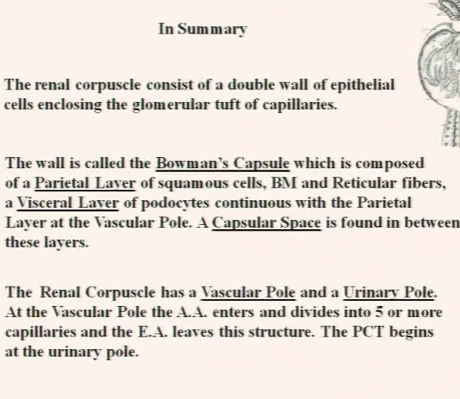
Next, we go to a 3D picture.
- Podocyte:
  - Has long primary processes
  - Also has secondary processes, AKA pedicels
    - LINED BENETH by DIAPHRAGM
    - Diaphragm separate 2 adjacent pedicels
  - Pedicels interdigit other pedicels.
  - Leave space between 2 adjascnet pedicels = FILTRATION SLIT
- Capilarry:
  - Fenestrated capillary = small opening on wall of capillary
The epithelial of the capillaries will rest on BM
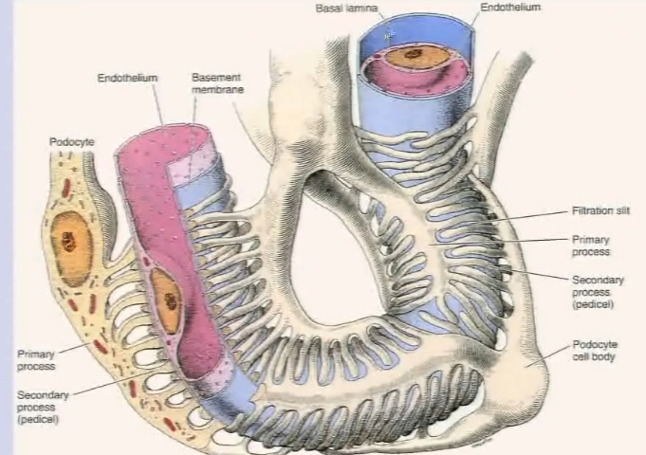

Mesengial cells: cells located between blood vessels.
Two types:
- Located WITHIN renal corpuscle = intramesangial cells
- Located outside renal corpuscle = extramesangial cells
- No identifiable in lab.

Intraglomerular mesangial cells:
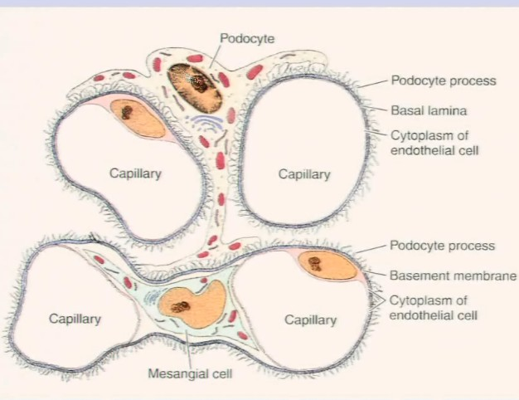
Primary process of podocyte reach to the capillaries at bottom (in between, we have mesangial cells)

Function of mesangial cells.
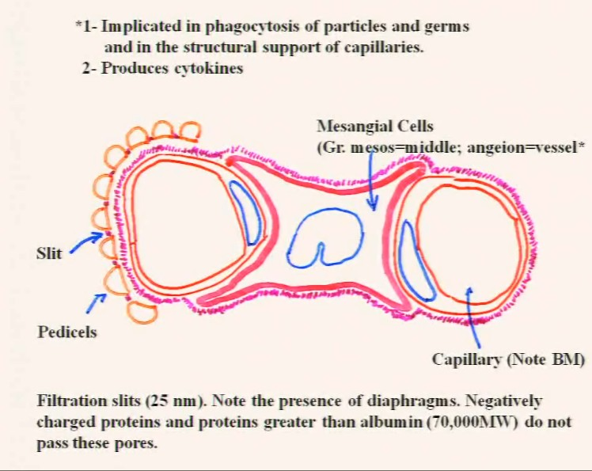

EM picture:
P = podocytes
P1 = primary process
P2 = pedicels, resting on BM (same one as the ENDOTHELIAL CELL)
- Shared BM also present in alveoli (between pneumocyte I and endothelial)
- In this case it is podocyte share with endothelial
F = fenestration
C = capillary lumen
FS = filtration slit.
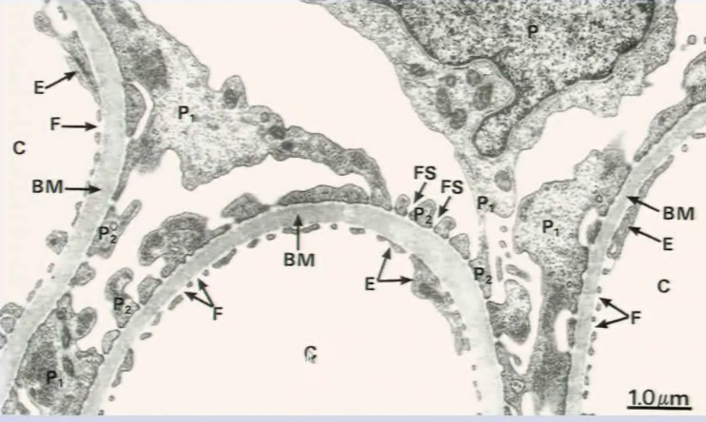
In summary:

PCT: highly aicidophilic, diameter 60um
- CANNOT DISTINGUISH CELL’S LATERAL MEMBRANE
- Facing lumen = brush border = increase surface area
- Central nuclei
- Columnar cells
Each cell :
- A lot of microvili -> call BRUSH BORDER
  - Large absorption mechanism
- Large number of endocytic vesicles
- Basal membrane enfolded, inside which we find MITOCHONDRIA
  - At their base = sodium potassium ATPase (move against gradient)

PCT continues with Straight Thick descending limb of loop of Henle,
- Same as PCT, but distinguishable by:
  - PCT in cortex, thick limb in medulla
  - PCT is more spherical shaped, while Thick limb = usually longitudinal.

-> goes into THIN LIMB
- Diameter 12um thick= little bigger than capillary
- Has free diffusion of Na in two directions
How do we know if thin limb is descending or ascending? (NO WAY!)

Straight Thick ascending potion:
- Found in medulla and medullary rays
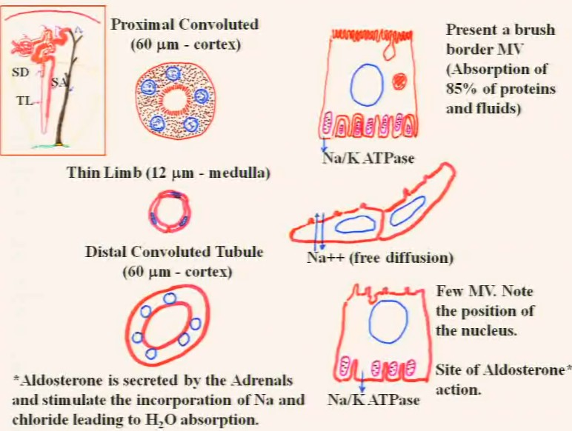
DCT = last part of nephron
- In cortex, 60um diameter (same in size with proximal)
- DISTINCTIONS: DCT = not as acidophilic
- DISTINCTIONS: DCT = cuboidal cells
- DISTINCTIONS: DCT = much larger lumen than PCT
- DISTINCTIONS: DCT = clearer lumen , because PCT has MV that disintegrate
- You will see nuclei of cells touching the apical membrane (kissing membrane)
- Few MV
- In the basal area = similar, also have Na K ATPase = pull solutes against gradient
  - Pump Cl- also
- ATPase REGULATED BY HORMONE: Aldosterone, secreted by adrenal gland
  - Stimulating absorption of Na and Cl to create gradient to pull water in

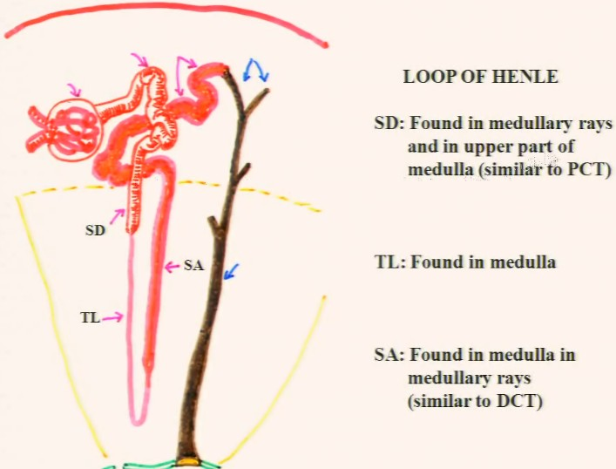
After the DCT, we have the collecting tubules and ducts (not part of nephron)

Collecting tubules:
- Some in cortex, most in modularly rays
- 50um diameter
- YOU COULD SEE LATERAL PLASMA MEMBRANE
- Lumen smaller than DCT
- Nuclei in center
Collecting duct of Bellini:
- When collecting tubules merge together -> form duct of Bellini
- Diameter 200um in diameter
- Found deep in medulla
Site of ADH action: antidiuretic hormone (AKA vasopressin) – make collecting duct PERMEABLE to water
- Usually, duct = not permeable to conduct urin to excrete
- But if in case of excessive water loss
  - ADH secreted
  - The collecting tubules permeable to water -> water goes out (because interstitial space has a lot of solute)

What exactly is macula densa?
In following drawing, the nuclei should kiss the plasma membrane + we should not see the lateral membranes

The Afferent arteriole will have their smooth muscle cells MODIFIED = bulky + look like epithelial + contain large amount of granules. = AKA JUXTAGLOMERULAR CELL
The efferent arteriole will have it the normal smooth muscle.

The DCT cells that are close to arterioles = cells become taller, and thinner= cells appear close to each other AKA macula densa.

Do not forget those cells in between afferent + efferent arterioles: extraglomerular mesangial cells.

THE ABOVE = JUXTAGLOMERULAR APPARATUS
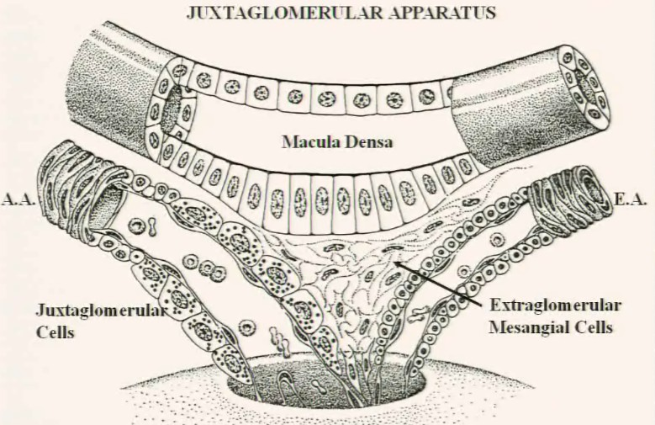
Juxtaglomerular cells:
- Modified SM cells of afferent arteriole
- Secretes RENIN, acts on plasma angiotensinogen
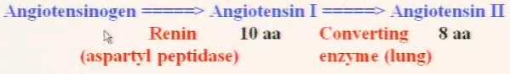
- Which stimulate DCT
- Stimulates bone marrow to produce RBC
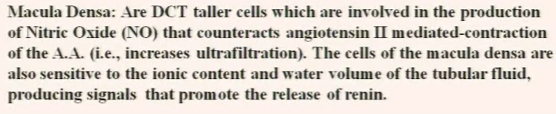
- If we use Angiotensin II ->contraction of arterioles (including afferent arteriole here)
- But we do not want to do it, because less blood going in to renal corpuscle
- No filtration occur = start retain urea
- We need locally relax these arterioles, NO will be able to do this.

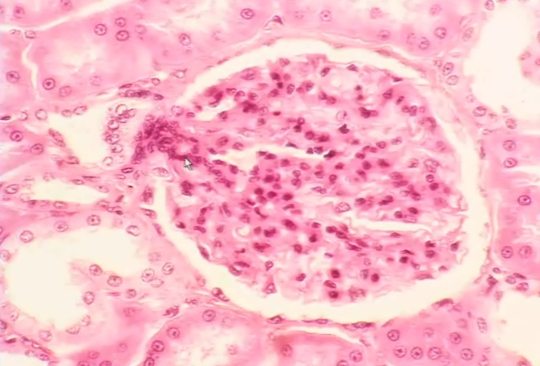

Dark nuclei = extraglomerular mesangial cell
Same dark nuclei = intraglomerular mesangial cell
Big nuclei, inside, = podocyte?
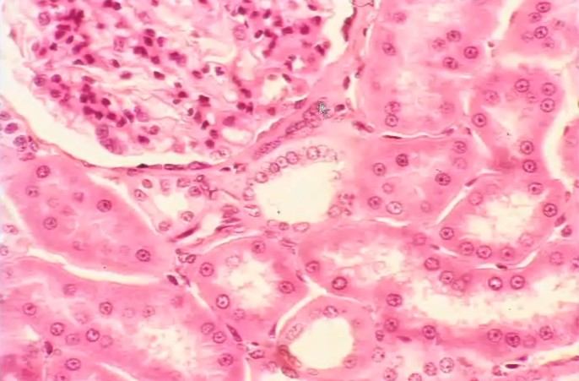 Sub capsule space
Macula densa
Dista convoluted tubule
Extraglomerular mesangial cell
Flat cells of the capsule of Vodman
PCT Collecting tubule
Medullary rays:

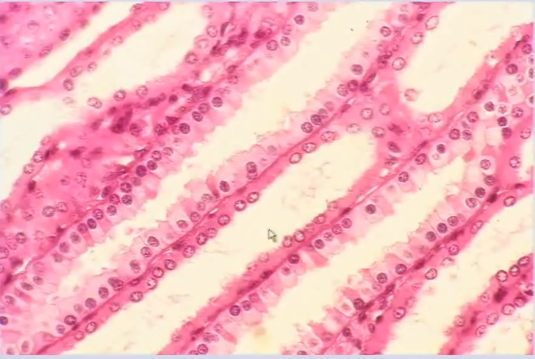
Straight Thick Ascending

Straight thick descending

Collecting tubule (lateral membrane)

Area of Cribosa:
- Occurs at tip of renal papilla
- All the collecting duct of Bellini empty at the area cribosa
- The space after = minor calyx

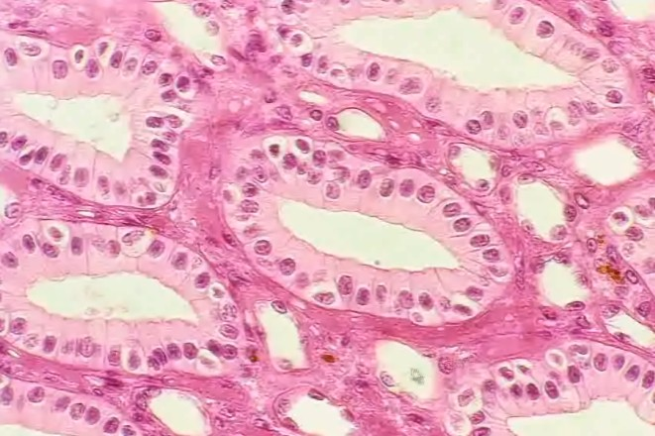
Collecting duct of Bellini
Thin limb of Henle’s loop
Capillary, vasa recta with endothelial cell around (always associated with a little bit of PLASMA) – EMPTY + BIGGER = thin limb.

Circulation in Renal system:
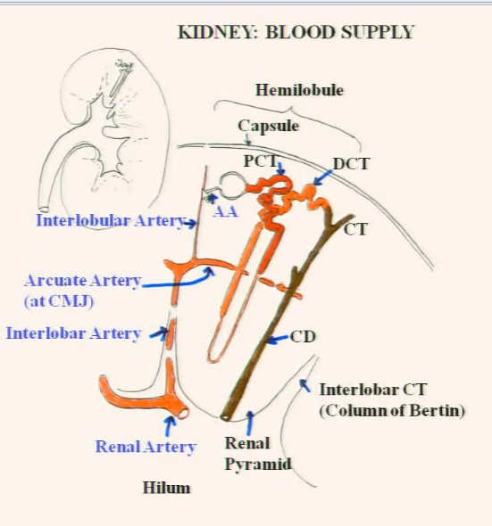
Here’s a renal pyramid + without pelvis:
At level of Hilum, we have PENETRATION OF RENAL ARTERY (branch of abdonminal aoerta

Renal artery split into various interlobar artery
Which divide again into Arcuate artery (AT LEVEL OF CORTICAL MEDULARY JUNCTION)

At this junction: Interlobular artery goes up (deliminates the boundary between 2 lobules)
Then branch into intralobular artery -> diverge into Afferent arteriole

From afferent arteriole:

For all those arteries, we will have veins with the same name.
In following drawing, arcuat artery is present in white, vein in black.
A.A. will branch inside renal corpuscle, forming later efferent arteriole.
- By a network of INTERTUBULAR CAPILARIES
- Also produce erythropoietin
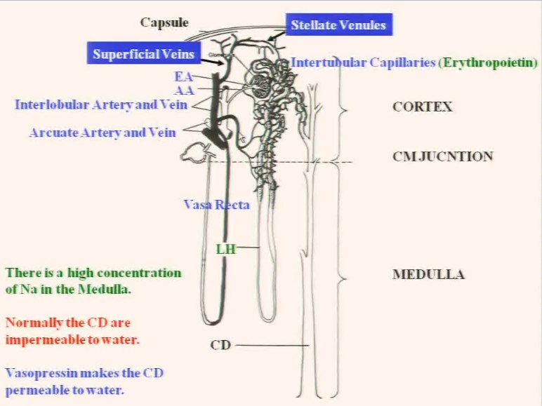
The interlobular capillaries will then merge into ESTALATE VENULES -> SUPERFICIAL VEIN -> drain into INTERLOBULAR VEIN -> ARCUATE VEIN -> INTERLOBAR VEIN -> RENAL VEIN.

Note Vasa Recta: long capillaries originating from E.A. of renal corpuscles that are located close to CMJ
Goes a loop, and drain into the junction of interlobular vein and arcuate vein, divided into:
- Arteriole system
- Venous system

Urinary Bladder:
Up = lumen,
Mucosa:
- Transitional epithelium
- L.P.
- No submucosa
Muscularis:
- Organized into 3 layers ONLY AT ENTRANCE of URETER:
  - Inner longitudinal
  - Middle circular
  - Outer longitudinal
If we concentrate on the epithelium:
Transitional epithelium:
- Basal columnar cell
  - Active dividing, STEM cell
- Middle cell
  - Polygonal
  - Contains a lot of secretory vesicles
- Bulky Superficial Facet cells
  - This is why we have transitional epithelium
  - Sometime binuclei
  - Bladder dilate = 5 layers, extended = 2 layers
  - Placed in such away that it diminishes layers.
  - DO NOT CONFUSE WITH STRATIFIED SQUAMOUS EPITHELIUM NON KERATINIZED- look for facet cells.

Nervous system:

Dr.Penfield accidently discovered the functionality of brain.
Created MNI, mapped the human brain

Nervous tissue:
- Composed of 10 billion neurones, nerves tissue distributed throughout the body as a network.
- Classified into:
  - CNS
    - Brain, cerebellum,spinal cord
      - White/gray matter
  - PNS
    - Nerve fibers
    - Nerve ganglions
- Histologically:
  - Neurones (nerve cells)
  - Neuroglial (glial cells equivalent to CT)
    - Surpport, defense, nutrition, protection
- Gray matter: cell body, neuroglial
- White matter: neural processes, wrapped in myelin (neuroglia)
Function of nervous system:
- Detect, analyze + transmit info generated by stimulus (heat, light, mechanical sensory)
- Organize and coordinate directly most body’s functional parts
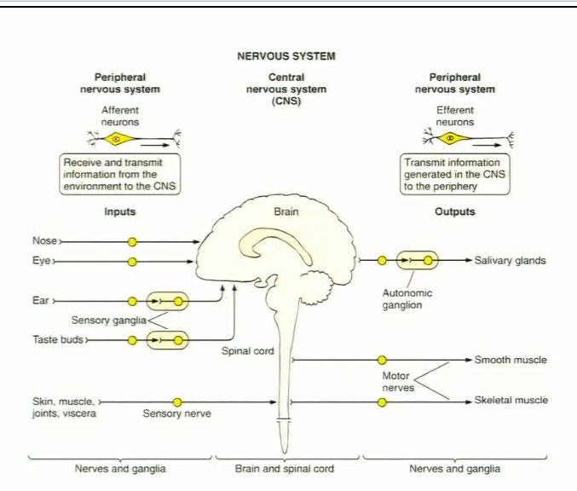
- Respond + transmit info via alternating electrical differences between the in/out surface of cell

Divided into CNS/ PNS:
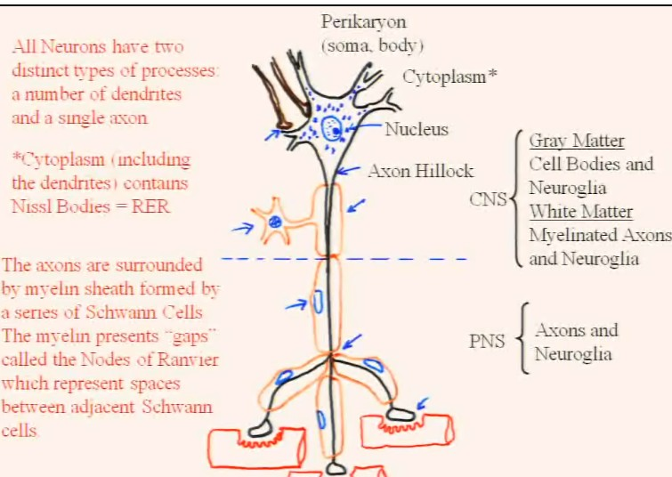
- Body called SOMA/PERIKARYON
- Axon hillock:
  - Determines which processes is axon
  - AXON DOES NOT HAVE BLUE DOTTY GRANULES
    - Nissel bodies
- Cytoplasm of neurone is usually stained blue (nissel bodies)
- CNS:
  - Gray: cell bodies and neuroganglia
  - White: myelinated axons
- Schuan cells: make myelin
- Node of ranvier = space between schuan cells.
  - IN CNS: we have OLIGODENDROCYTES to produce myelin
ANS = subdivision of PNS = innervates other organs
When one axon touches an dendrites, we call it an SYNAPSES:
- Can be inhibitory or excitatory
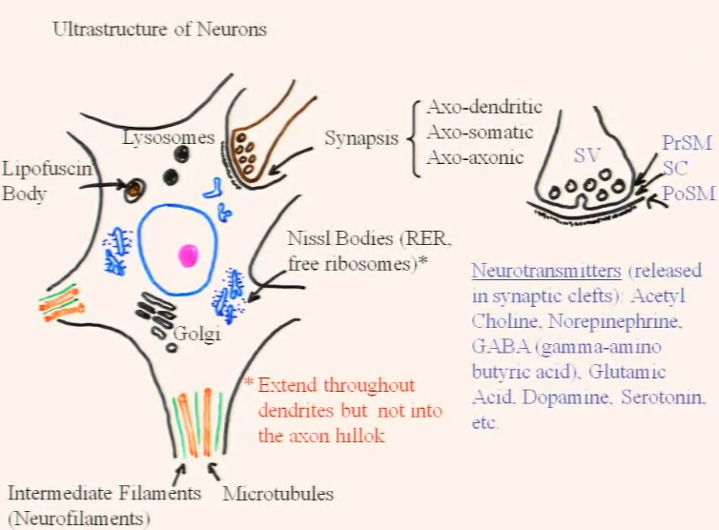
- Axons ends in terminal arborizations and end bulb called TERMINAL BOUTONS (motor end plate) which are parts of synapses
- Could be:
  - Axo dendritic
  - Axo somatic
  - Axo axonic
- Has
  - Presynaptic membrane
  - Synaptic cleft
  - Post synaptic membrane
- Neurotransmitters vesicle sin synaptic cleft fuse with Post synaptic membrane (endocytosis) and release content
  - Ach
  - Glutamate
  - GABA etc.
  - NEUROPEPTIDE NOT RELEASED HERE

Structure of neurone body:
- Has nissel bodies (Free Ribosome) all over its body, extend to dendrite, not axon
- Axon has neurofilaments and microtubules
  - This is why nissel bodies cannot get into axons.
- Also find lysosome
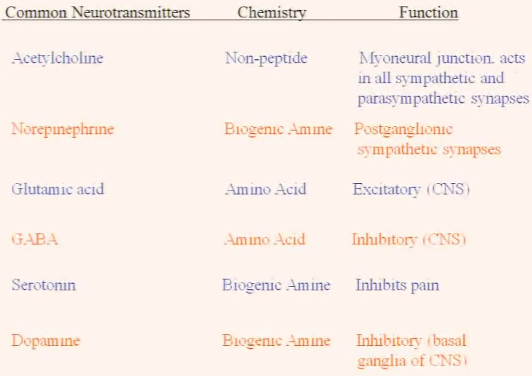
- Lipofusion bodies, lysosomes that cannot be degraded.

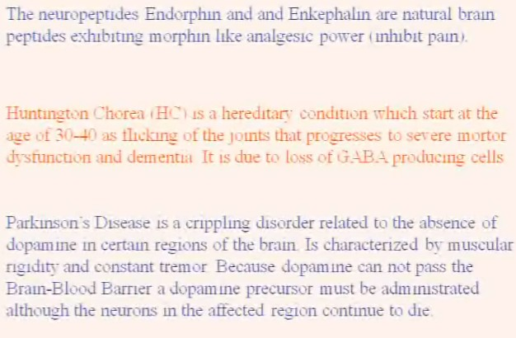

3 types of neurones we are going to see:
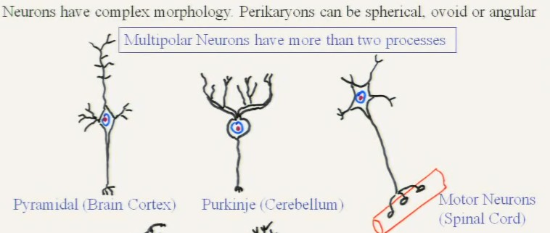
Histologically speaking:
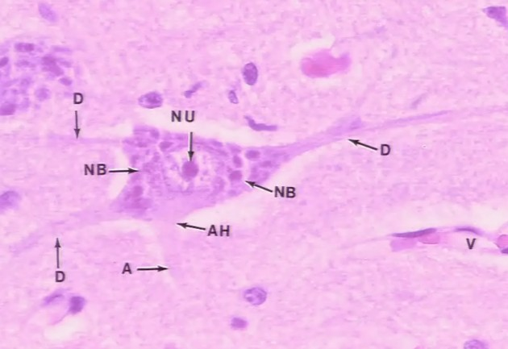
Nu = nucleus
As long as you see nissel bodies around the hillock = NOT AXON = Dendrites (D)
AH = axon hillock

Surpporting cells of CNS:neuroglial cells
Astrocytes:
- Biggest neuroglial cells
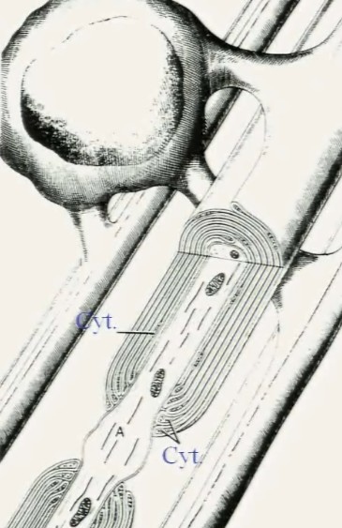
- Found in white matter of CNS
- Set out pedicles or vascular feets
- Form blood brain barrier.
- Bring nutrient into neurones
Responsible in removing neurotransmitters
Oligodendrocytes: ---------------------------------------------
- Found in both gray/white matter
- Produce myelin
- Satelites cells aroundneurones in CNS
- Wrapps their membrane AROUND axon
  - Modified cell membranes

Microglia:
- Scattered throughout CNS
- Smallest neuroglial cells
- Darkly stained, derived from monocytes
- Functions as phagocytes -> remove debris + damaged neurones
NOTE: myelin = phospholipids, Myelin basic protein
- Thicker myelin = faster impulse.\
- Autoimmune disease can result demyelination (MS.)

In PNS = Schawnn cells make myelin:
- Axon lies inside, with Schawann cell winds around it
- As time passes, Schawann cell wraps around it
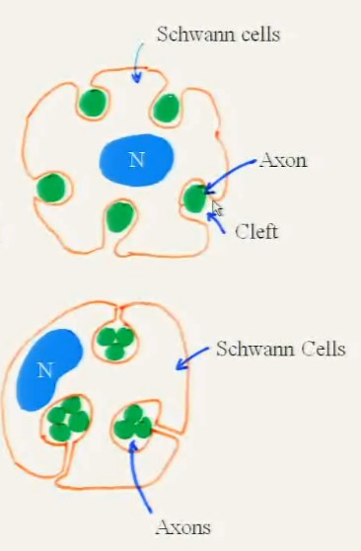
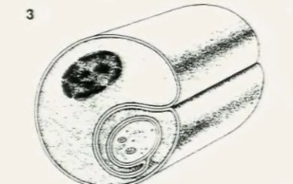

In both PNS and CNS: not all axons are enveloped in myelin:
In PNS = unwrapped axons found within clefts of Schawnn cells

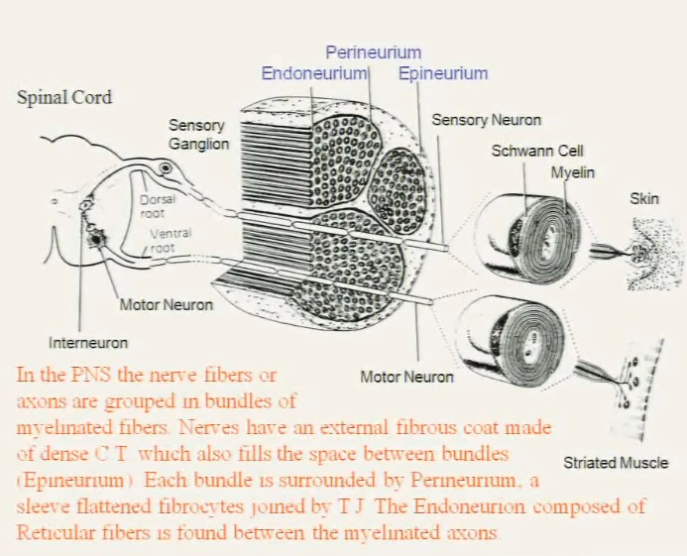
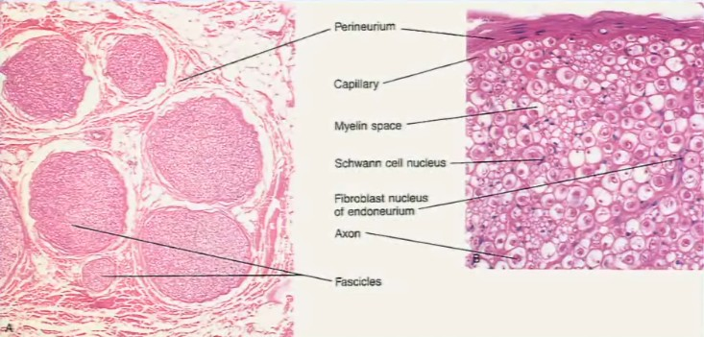
Note: myelin space: the myelin is taken away due to tissue preparation. (because it is lipid)

