Chapter 8 social influence, socialization and culture

Learning objectives
- Understand the difference between information dependence and effect dependence.
- Differentiate compliance, identification, and internalization as motives for social conformity
- Describes the socialization process and the stages of organization socialization
- Describe the implications of unrealistic expectations and the psychological control for socialization

Social influence in organization
- In many social settings, and especially in groups, people are highly dependent on others.
- This dependence sets the stage for influence to occur
- Two kinds of dependence are information dependence and effect dependence.

Motives for social conformity
- The motives for social conformity vary across situations and can be classified as follows:
  - Compliance
  - Identification
  - Internalization

Organizational socialization
- Socialization is the process by which people learn the attitudes, knowledge, and behaviour that are necessary to function in a group or organization.
- It is a learning process in which new members must acquire knowledge, change their attitudes, and perform new behaviour.
- It is the primary means by which organizations communicate the organization’s culture and values to new members.
- Organizational socialization is dependent on a good “fit.”
  - Person-job (P-J) fit: the match between an employee’s knowledge, skills, and abilities and the requirements of a job
  - Person-organization (P-O) fit: the match between an employee’s personal values and the values of an organization

Three Stages of Organizational Socialization
- Anticipatory socialization: in advance of entry (e.g., formal education, summer jobs)
- Encounter: day-to-day reality at organization (e.g., orientations, getting to know boss & coworkers)
- Role management: employees actively manage their role in the organization
  - Work–life balance
  - Internalizing organizational norms & values

The socialization process
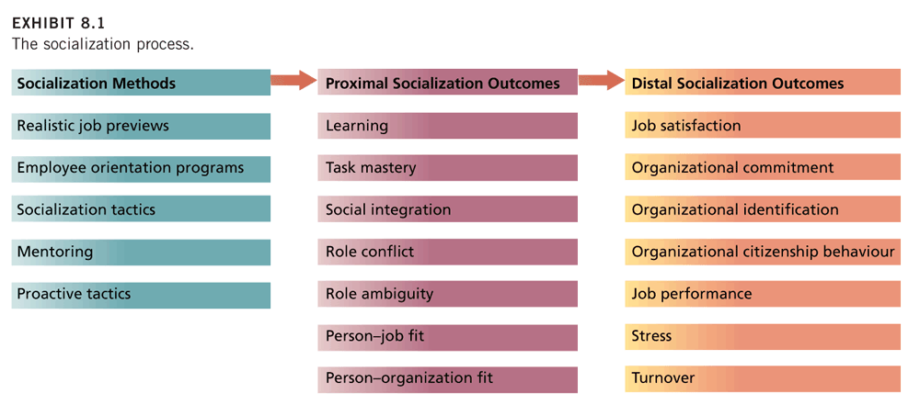
Unrealistic expectations
- People entering organizations hold many expectations that are inaccurate and often unrealistically high.
- When they enter an organization they experience a reality shock and their expectations are mot met.
- Newcomers who have higher met expectations have higher job satisfaction, organizational commitment, job performance, and job survival and lower intentions to quit.

Psychological contract
- Beliefs held by employees regarding the reciprocal obligations and promises between them and their organization
- An employee might expect to receive bonuses and promotions in return for hard work and loyalty.

Methods of socialization
- Organizations differ in terms of who does the socializing, how it is done, and how much is done.
- Most organizations make use of the following methods of socializations:
  - Realistic job previews
  - Employee orientation programs
  - Socialization tactics

Realistic job previews
- The provision of a balanced realistic picture of the positive and negative aspects of the job to job applicants
- The provide “corrective action” to expectations at the anticipatory socialization stage
- The realistic job preview process can be compared to the traditional preview process that often sets expectations too high by ignoring the negative aspects of the job.

Traditional and Realistic Job Previews Compared

Realistic job previews: research evidence
- Realistic job previews are effective in reducing inflated expectations and turnover and improving job performance.
- Turnover reduction is due in part to lower expectations and increased job satisfaction.
- They cause those not cut out for the job or who have low P-J and P-O fit perceptions to withdraw from the application process, process known as self-selection.

Employee orientation programs
- Orientation programs are designed to introduce new employees to their job, the people they will be working with, and the organization.
- They also teach newcomers how to cope with stressful work situations.
- Employees who attend orientation are more socialized in terms of their knowledge and understanding of the organization and report higher organizational commitment.
- Evidence of a reduction in the rate of turnover.

Socialization tactics
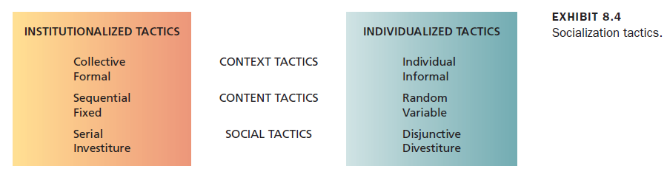
- Institutionalization socialization reflects a more formalized and structured program of socialization that reduces uncertainty and encourages new hires to accept organizational norms and maintain the status quo.
- Individualized socialization reflects a relative absence of structure that creates ambiguity and encourages new hires to question the status quo and develop their own approach to their role.
- Institutionalization socialization tactics are effective in promoting uniformity of behaviour.
- When socialization is individualized, new members are more likely to take on the particular characteristics and style of those who are socializing them – uniformity is less likely.
- Institutionalized socialization is always followed up by some individualized socialization as the member joins his or her regular work unit.

What is organizational culture?
- An organization’s style, atmosphere, or personality.
- Consists of the shared beliefs, values, and assumptions that exist in an organization.
- These shared beliefs, values, and assumptions determine the norms that develop and the patterns of behaviour that emerge from these norms.
CULTURE → NORMS → BEHAVIOUR
- Subcultures are smaller cultures that develop within a larger organizational culture that are based on differences in training, occupation, or departmental goals.

The “strong culture” concept
- A strong culture is an organizational culture with intense and pervasive beliefs, values, and assumptions.
- A strong culture provides great consensus concerning “what the organization is about” or what is stands for.
- Weak cultures are fragmented and have less impact on organizational members.
- An organization does not have to be big to have a strong culture
- Strong cultures do not necessarily result in blind conformity.
- Strong cultures are associated with greater success an effectiveness.

Assets of strong culture
- Coordination
  - The overarching values and assumptions of strong cultures can facilitate communication and coordination.
- Conflict Resolution
  - Sharing core values is a powerful mechanism for resolving conflicts.
- Financial Success
  - Strong cultures contribute to financial success and organizational effectiveness when the culture supports the mission, strategy, and goals of the organization.

Liabilities of strong cultures
- Resistance to Change
  - A strong culture can prove very resistant to change and can damage a firm’s ability to innovate
- Culture clash
  - Strong cultures can mix badly when a merger or acquisition pushes two of them together under the same corporate banner.

Contributors to the culture
- How are cultures built, maintained, and changed?
- Two key factors that contribute to the foundation and continuation of organizational cultures:
  - The founder’s role
- Passed on through stories
- Top management also has strong, sometimes conflicting impact on culture
  - Socialization process: socialization steps in strong culture
- Selecting Employees
- Debasement & Hazing
- Training “in the trenches”
- Reward & Promotion
- Exposure to Core Culture
- Organizational Folklore
- Role Models

