Herzberg: How do you motivate employees?

Concepts on how to motivate employees

Negative KITA:

-Physical punishment (not practiced in North America)

-Reprimanding employees

Positive KITA:

-Less working hours

-Spiraling wages

-Fringe benefits (medical coverage, stock options, etc.)

-Human relations training of managers

-Sensitivity training

-Communications

-Two-way communication

-Job participation (“feeling of achievement”)

-Employee counseling

Hygiene (KITA) factors vs. Motivation factors

Herzberg’s main point Hygiene (KITA) factors may get an employee to do what you want them to do at the moment, but they do not create continuous motivation. Motivation factors do.

Motivation factors:
-Ability (to do something)

-Achievement

-Recognition

-Work itself

-Responsibility

-Opportunities for advancement

-Growth

Motivators lead to job satisfaction, absence of hygiene factors lead to job dissatisfaction

How can management create satisfying jobs for employees?

Not through job enlargement (achieved by horizontal job loading)

Examples of job enlargement:

-Increasing amount of production expected

-Adding routine clerical tasks that do not provide sense of achievement

-Rotating jobs that do not provide increased responsibility

-Removing difficult tasks from the job in order to obtain more results on easy tasks

Through job enrichment (achieved by vertical job loading)

Principles of job enrichment:

-Removing some controls while retaining accountability

-Increasing individual accountability

-Putting a person in charge of a complete natural unit of work

-Granting additional authority (job freedom)

-Introducing new and more difficult tasks

-Assigning specific tasks enabling individuals to become experts (and grow)

Casual claims:

- Post Hoc Ergo Propter Hoc
After Something Therefore Because Something
Meaning we should do the same as last time (not always necessarily true).

Kaplan & Norton’s balanced scorecard: Measures that drive performance

• The “bottom line”(financial performance) is not enough
• Four perspectives for a balanced scorecard- a set of measures that gives top managers a fast but comprehensive view of the business.
• Need to be able to measure

– Customer perspective: How do customers see us?
• What matters most to customers? (Specific measures that reflect the factors that really matter to customers) To achieve our vision, how should we appear to customers? Measuring customers’ satisfaction.

– Internal business perspective (operational effectiveness): What must we excel at?
• How can we produce to meet customer expectations? (Internal operations that enable them to satisfy customer needs) To satisfy our shareholders and customers, what business processes must we excel at? Measuring our delivery time.

– Innovation & learning perspective: Can we continue to improve and create value?
• How can we make continual improvements? (improve existing products, launch new ones, create more value for customers.....)To achieve our vision, how will we sustain our ability to change and improve?

– Financial perspective: How do we look to shareholders?
• How can we ensure profitability for shareholders? How do we look to them? To succeed financially, how should we appear to our shareholders? Measuring profit.

Kenya Balanced Scorecard Red Cross example:
- Financial Stewardship :
- Innovation(learning capacity): Increasing capacities.
- Business Process: number of people who were beneficiaries of the red cross program
- Beneficiary/ Stakeholder: how long does it take a project to get up and running?

JMSB Balanced Scorecard (example of measures):
- Measure of innovation: number of doctoral students, research recognition, publication recognition, number of research grants
- Measure of operational effectiveness: percentage of graduates (5000 students start in xxxx year, how many graduate?), cost per student
- Customer-related measure (students, companies, employers and government= customers): Government is interested to raise employment rate
- Financial, bottom-line: Deficit, budget, cost per student

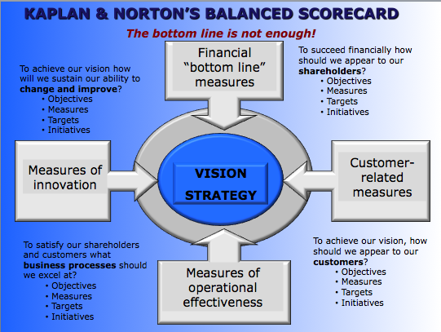
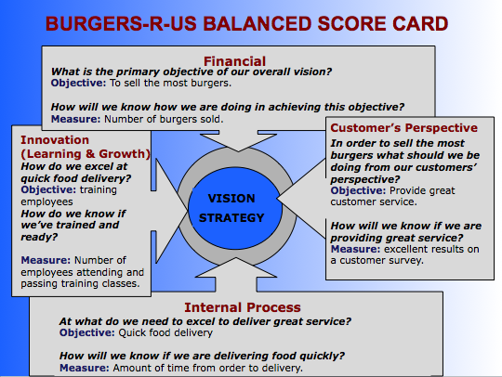

ECI 's Balanced Scorecard
Perspectives | Questions | Goals | Measurements
Customer | How do customers see us? | New products. | Percent of sales from new products.
Customer | How do customers see us? | Responsive supply. | On-time delivery as defined by the customer.
Customer | How do customers see us? | Preferred supplier. | Share of key account's purchases.
Customer | How do customers see us? | Customer partnership. | Number of cooperative engineering efforts.
Internal business | What must we excel at? | Technology capability. | Manufacturing geometry versus the competition.
Internal business | What must we excel at? | Manufacturing excellence. | Cycle time, Unit cost and Yield.
Internal business | What must we excel at? | Design productivity. | Silicon efficiency and Engineering efficiency.
Internal business | What must we excel at? | New product introduction. | Actual introduction schedule versus planned introduction.
Innovation & learning | Can we continue to improve & create value? | Technology leadership. | Time to develop the next generation.
Innovation & learning | Can we continue to improve & create value? | Manufacturing learning. | Process time to maturity.
Innovation & learning | Can we continue to improve & create value? | Product focus. | Percent of products that equal 80% of sales.
Innovation & learning | Can we continue to improve & create value? | Time to market. | New product introduction versus the competition.
Financial | How do we look to shareholders? | Survive. | Cash flow.
Financial | How do we look to shareholders? | Succeed. | Quarterly sales growth and operating income by division.
Financial | How do we look to shareholders? | Prosper. | Increased market share and Return on Equity.

Definitions:
- Stakeholder: somebody who may have a vested (continuing) interest in a business

BOOK:
-Golfing
Casual claim: Golfers live 5 years longer than others.
Rival claim: Golf is a sport for the wealthy and they usually can afford medical care and afford better nutrition. There is less stress in Sweden, therefore you live longer.

- Collin & Porras
Casual claim: Companies who have a core ideology will last.
Rival claim: The opposite could be true; companies that last will eventually have a core ideology.
Handy Charles: The Sigmoid Curve

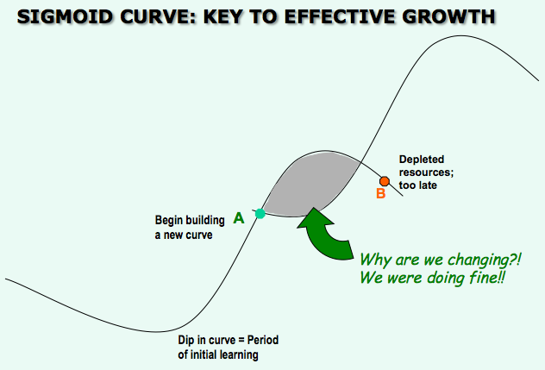

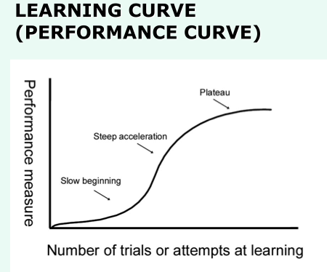

Managing Change- Curvilinear Logic

Think of a time when you had a significant change of mind or had to consider making an important move. Model your thought process, and predictors of your successful (or failed) change using the sigmoid curve

- The secret to constant growth is to start a new sigmoid curve before the first one peters out. The right time to start the second curve is at point A where there is the time as well as the resources and the energy to get the new curve. Point A is the time to start thinking about change and to change.

- It is the way to build a new future while maintaining the present.

- The second curve can be a new product, a new way of operating, a new strategy or a new culture noticeably different from the old.

- Usually new people need to operate the second curve, while the older employees need to help shape the future.

- Shaded area between point A and B: Struggle to keep what is best from the past while experimenting with the new. Confusion, uncertainty and fear. Might be the time to train people for new skills for the new curve.

- There is no scientific way to know where a company stands on the curve. Must proceed by guess and assumption.

- The discipline of the first curve is to always assume that you are near the peak of the curve (Point A) and should start preparing for the second curve. Always assume that present strategies need to be replaced within two or three years.

- The discipline of the second curve is to give up some stuff not needed to be done anymore from the first curve.

-Initial dip in curve

- Other authors that have a theory about managing change: Greiner (stages of evolution and revolution), Collins & Porras (certain things need to stay the same the core values, purpose and ideology... but we can change everything else like products and services )

- Are their ideas consistent with the sigmoid curve? In what way do they refer? I lay out an image: an envisioned future, BHAGS

- Causal claim of Gore’s success: The reason for Gore’s success is private ownership.

- Rival claim: The culture is what caused its success. Or the management structure. (type: Alternate rival claim)

Mintzberg- The manager’s job: myth and reality

Myths: (managers plan, organize, coordinate & control)

-The manager is a reflective, systematic planner

-The effective manager has no regular duties to perform

-The senior manager needs aggregated information, which a formal management information system best provides

-Management is a science and a profession

Realities:

-Managers’ activities are characterized by brevity, variety, and discontinuity. They are strongly oriented to action and dislike reflective activities

-Management works involves performing a number of regular duties, including ritual and ceremony, negotiations and processing of soft information

-Managers strongly favor verbal media, telephone calls, and meeting over documents

-The managers’ programs- to process information and make decisions are not formalized in any computer system, but are located in their brains

Three categories of managerial roles

Interpersonal roles:

-Figurehead: a true representative of the image of the firm, represents credibility (ex: the dean of jmsb to represent jmsb), the person that we associate with the firm o

-Leader: showing the direction in which we should be doing, and motivating through feedback

-Liaison: represent the needs of my people, of my area of responsibility

Informational roles:

-Monitor: monitor what is going on outside and inside of the place, collects information – constant activity

-Disseminator: make sure to give the information to the people that need it, manager passes information

-Spokesperson: speak on behalf of the company and the employees, represents,

Decision roles:

-Entrepreneur: sniffs out and sees opportunities and seizes them, capitalize on opportunities

-Disturbance-handler: discipline, create a solution for any disturbance coming from inside or outside the company, handles and remedies, fixes

-Resource-allocator: who gets the budget, distributes the budget, classifies, assesses the priorities and needs

-Negotiator: interfere, negotiate the best solutions and terms from the organization’s pont of view

Educating managers: the business case method is the most effective way

Liker & Choi: Supply Chain Thinking

- Companies should build long lasting mutually beneficial relationships with suppliers bases on :
- Collaboration
- Respect: trust, something in it for both parties
- Coprosperity:

-The underlying values are:
- Discipline: have to be dedicated to continue to improve, to help you improve, give you feedback, helping relationship
- Trust
- Improvement
- Empathy: have a grasp of what issues both sides are experiencing

- The supplier-partnering hierarchy:
- Conduct joint improvement activities:
- Share information intensively but selectively: no need to have all your company’s secrets disclosed
- Develop suppliers’ technical capabilities: perhaps there is the opportunity to share expertise and arrange encounters to talk about each side’s needs
- Supervise your suppliers: example of giving feedback
- Turn supplier rivalry into opportunity: there’s always many suppliers available, to encourage your suppliers to up their game, you compare them and then feedback that information to them, this way you are getting more consistent supply and of better quality, suppliers will help you choose which supplier to create a relationship with.
- Understand how you suppliers work: your though about the cost, quality…

