EC 223 Chapter 5 Notes
The Behaviour of Interest Rates
Four Determinants of Asset Demand
- Wealth - the total resources owned by the individual, including all assets
- Holding everything else constant, an increase in wealth raises the quantity demanded of an asset.
- Expected Return - the return expected over the next period on one asset relative to alternative assets
- an increase in an asset’s expected return relative to that of an alternative asset, holding everything else unchanged, raises the quantity demanded of the asset.
- Risk - the degree of uncertainty associated with the return on one asset relative to alternative assets
- holding everything else constant, if an asset’s risk rises relative to that of alternative assets, its quantity demanded will fall.
- Liquidity - the ease and speed with which an asset can be turned into cash relative to alternative assets
- The more liquid an asset is relative to alternative assets, holding everything else unchanged, the more desirable it is, and the greater will be the quantity demanded.
Theory of Asset Demand
- The quantity demanded of an asset is positively related to wealth.+
- The quantity demanded of an asset is positively related to its expected return relative to alternative assets.+
- The quantity demanded of an asset is negatively related to the risk of its returns relative to alternative assets.-
- The quantity demanded of an asset is positively related to its liquidity relative to alternative assets.+
Bond Demand
- shows the relationship between the quantity demanded and the price when all other economic variables are held constant (ceteris paribus).
- At lower bond prices (higher interest rates), ceteris paribus, the quantity demanded of bonds is higher
- an inverse relationship between the price of the bond and the quantity demanded.
Derivation of Bond Demand Curve
consider the demand for one- year discount bonds,
- no coupon payments but pay the owner the $ 1000 face value in a year.
- If the holding period is one year, then, as we saw in Chapter 4, the return on the bond is known absolutely and is equal to the interest rate as measured by the yield to maturity.
- This means that the expected return on this bond is equal to i. If the bond sells for $950,
i = RET^{e} = (F-P)/P
P=$950
i=($1000 - $950)/$950 = 0.053 = 5.3%

Demand is determined by lenders
At this 5.3% interest rate and expected return corresponding to a bond price of $ 950, let us assume that the quantity of bonds demanded is $ 100 billion, which is plotted as point A in Figure 5- 1.

At a price of $ 900, the interest rate and expected return are
i=($1000 - $900)/$900 = 0.111 = 11.1%

Because the expected return on these bonds is higher, with all other economic variables held constant, the quantity demanded of bonds will be higher.

Point B in Figure 5- 1 shows that the quantity of bonds demanded at the price of $ 900 has risen to $ 200 billion.

Continuing with this reasoning we derive the bond demand curve.
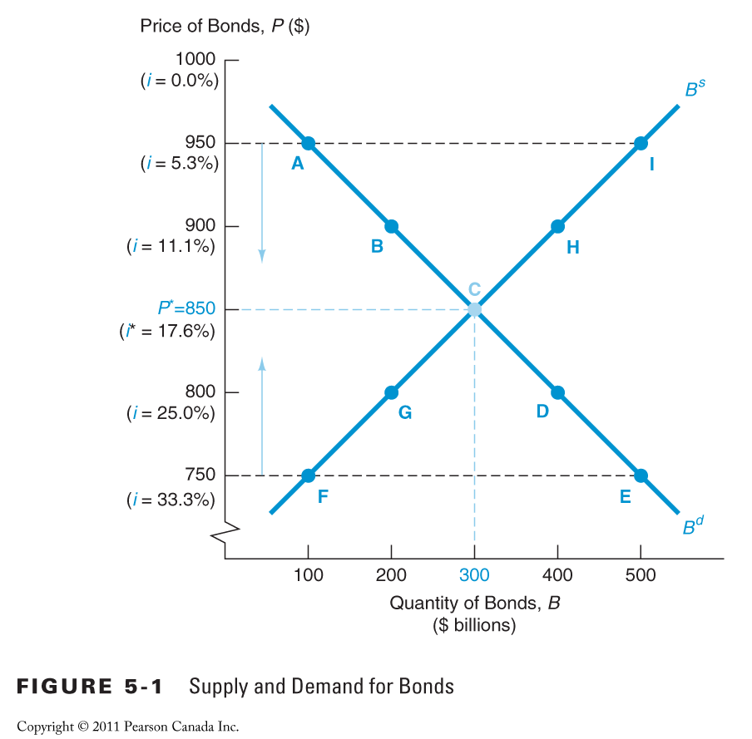

Bond Supply
- shows the relationship between the quantity supplied and the price when all other economic variables are held constant.
- At lower prices (higher interest rates), ceteris paribus, the quantity supplied of bonds is lower
- a positive relationship between the price of the bond and the quantity supplied.

Supply is Determined by Borrowers
- When the price of the bonds is $ 750 ( interest rate 33.3%), point F shows that the quantity of bonds supplied is $ 100 billion.
- If the price is $ 800, the interest rate is the lower rate of 25%.
- Because at this interest rate it is now less costly to borrow by issuing bonds, firms will be willing to borrow more through bond issues, and the quantity of bonds supplied is at the higher level of $ 200 billion ( point G).
- An even higher price of $ 850, corresponding to a lower interest rate of 17.6%, results in a larger quantity of bonds supplied of $300 billion (point C).
- Continuing with this reasoning we derive the bond supply curve.

Market Equilibrium
- Occurs when the amount that people are willing to buy (demand) equals the amount that people are willing to sell (supply) at a given price.
- Bd = Bs determines the equilibrium (or market clearing) price and interest rate
- When Bd > Bs : excess demand - price will rise and interest rate will fall
- When Bd < Bs : excess supply - price will fall and interest rate will rise

Movement vs Shift
- A movement along the demand ( or supply) curve: When quantity demanded ( or supplied) changes as a result of a change in the price of the bond ( or, equivalently, a change in the interest rate).
- A shift in the demand ( or supply) curve: When the quantity demanded ( or supplied) changes at each given price ( or interest rate) of the bond in response to a change in some other factor besides the bond’s price or interest rate.
- When one of these factors changes, causing a shift in the demand or supply curve, there will be a new equilibrium value for the interest rate.

Shifts in the Demand for Bonds
- Wealth - in an expansion with growing wealth, the demand curve for bonds shifts to the right +
- Expected Interest rates - higher expected interest rates in the future lower the return for long-term bonds, shifting the demand curve to the left -
- Expected Inflation - an increase in the expected rate of inflations lowers the expected return for bonds, causing the demand curve to shift to the left -
- Risk - an increase in the riskiness of bonds causes the demand curve to shift to the left -
- Liquidity - increased liquidity of bonds results in the demand curve shifting right +
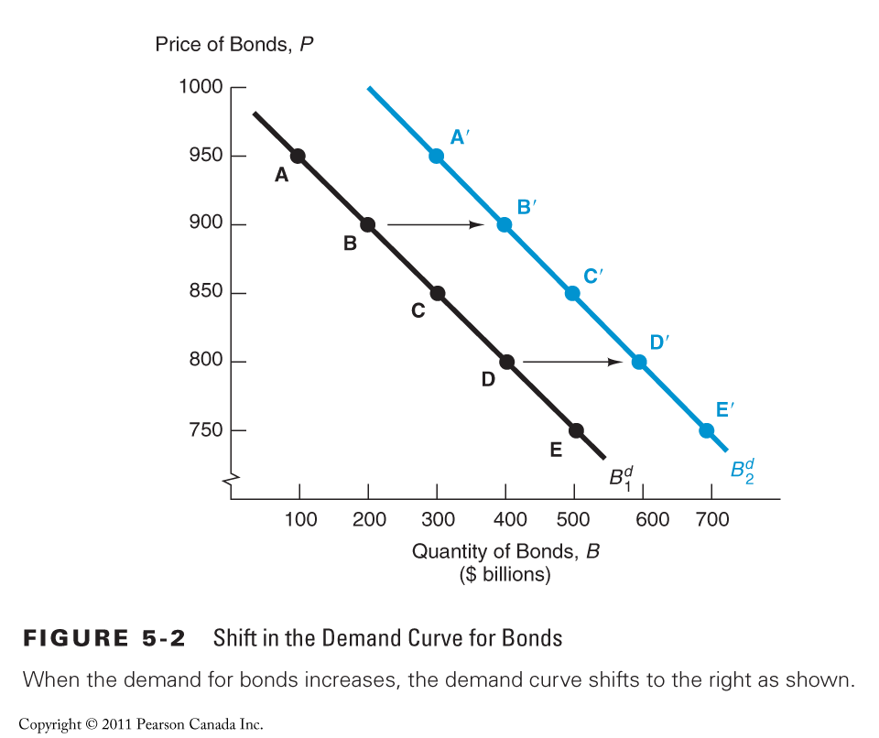

Wealth
- in a business cycle expansion with growing wealth, the demand for bonds rises and the demand curve for bonds shifts to the right.
- in a recession, when income and wealth are falling, the demand for bonds falls, and the demand curve shifts to the left.
- Another factor that affects wealth is the public’s propensity to save.
- If households save more, wealth increases and, as we have seen, the demand for bonds rises and the demand curve for bonds shifts to the right.
- If people save less, wealth and the demand for bonds will fall and the demand curve shifts to the left.

Expected Interest Rates, Expected Returns
- For a one- year discount bond and a one- year holding period, the expected return and the interest rate are identical
- In other words, nothing besides today’s interest rate affects the expected return.
- For other bonds with a variety of maturities, the expected return may differ from the interest rate.
- if people begin to think that interest rates will be higher next year than they had originally anticipated, the expected return today on long- term bonds will fall, and the quantity demanded will fall at each interest rate.
- On contrast, lower expected interest rates in the future increase the demand for long- term bonds and shift the demand curve to the right

Expected Returns on other Assets
- Changes in expected returns on other assets can also shift the demand curve for bonds.
- If people suddenly began to expect higher stock prices in the future, both expected capital gains and expected returns on stocks would rise.
- With the expected return on bonds held constant, the expected return on bonds today relative to stocks would fall, lowering the demand for bonds and shifting the demand curve to the left.

Expected Inflation
- Changes in expected inflation is likely to alter expected returns on physical (real) assets such as automobiles and houses, which affects the demand for bonds.
- An increase in expected inflation will lead to
- higher prices on real assets in the future and hence higher nominal capital gains.
- a fall in the expected return on bonds relative to the expected return on real assets today and thus cause the demand for bonds to fall.
- Alternatively, an increase in the expected rate of inflation lowers the expected return for bonds, causing their demand to decline and the demand curve to shift to the left.

Risk
- If prices in the bond market become more volatile, the risk associated with bonds increases, and bonds become a less attractive asset
- the demand curve to shift to the left.
- Conversely, an increase in the volatility of prices in another asset market, such as the stock market, would make bonds more attractive.
- An increase in the riskiness of alternative assets causes the demand for bonds to rise
- the demand curve to shift to the right

Liquidity
- If more people started trading in the bond market and as a result it became easier to sell bonds quickly, the increase in their liquidity would cause the quantity of bonds demanded at each interest rate to rise
- The demand curve shifts to the right
- Similarly, increased liquidity of alternative assets lowers the demand for bonds
- shifts the demand curve to the left.

Shifts in the Supply of Bonds
- Expected profitability of investment opportunities - in an expansion, the supply curve shifts to the right +
- Expected inflation - an increase in expected inflation shifts the supply curve for bonds to the right +
- Government activities - increased budget deficits/surpluses shift the supply curve to the right/left
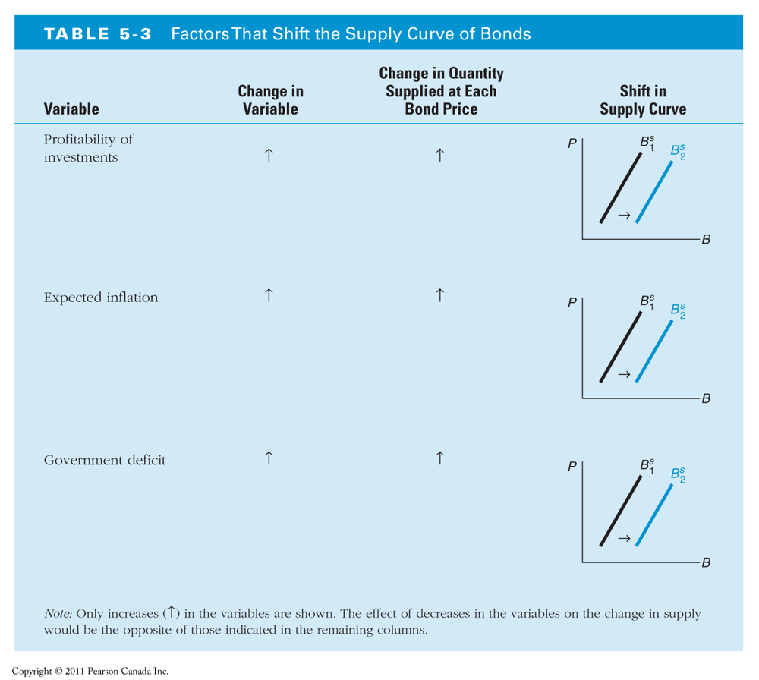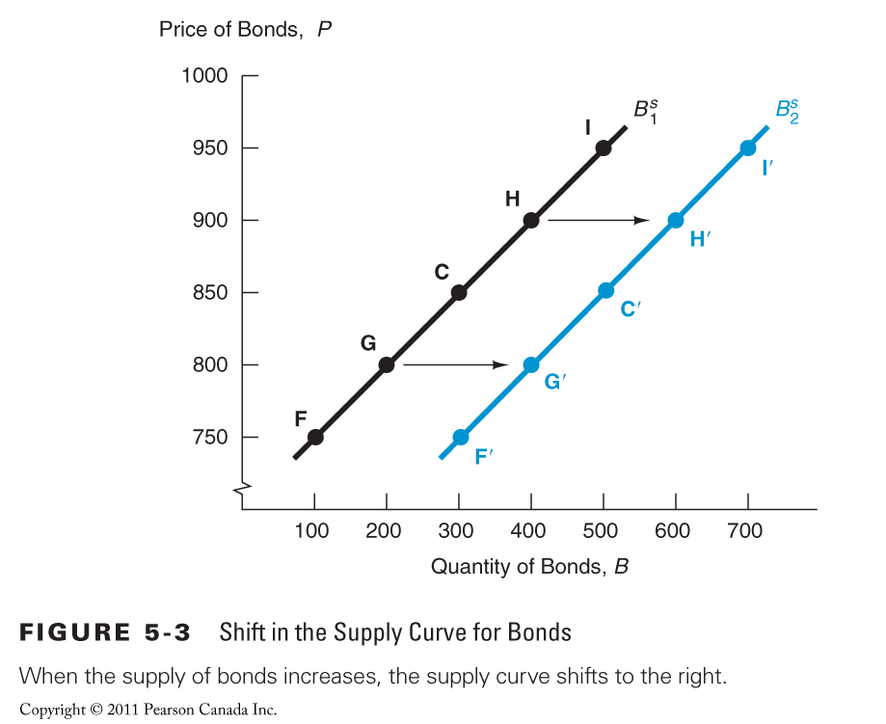

Expected Profitability of investment opportunities
- The more profitable plant and equipment investments that a firm expects it can make, the more willing it will be to borrow in order to finance these investments.
- When the economy is growing rapidly investment opportunities that are expected to be profitable increase, and the quantity of bonds supplied at any given bond price will increase
- In a business cycle expansion, the supply of bonds increases, and the supply curve shifts to the right.
Likewise, in a recession, when there are far fewer expected profitable investment opportunities, the supply of bonds falls and the supply curve shifts to the left.

Expected Inflation
- For a given interest rate ( and bond price), when expected inflation increases,
- the real cost of borrowing falls;
- hence the quantity of bonds supplied increases at any given bond price.
- An increase in expected inflation causes the supply of bonds to increase and the supply curve to shift to the right

Government Activities
- When government deficits are large, the government sells more bonds,
- the quantity of bonds supplied at each bond price increases.
- Higher government deficits increase the supply of bonds and shift the supply curve to the right
- On the other hand, government surpluses, decrease the supply of bonds and shift the supply curve to the left.

- When you examine the effect of a variable change, remember that we are assuming that all other variables are unchanged
- Remember that the interest rate is negatively related to the bond price, so when the equilibrium bond price rises, the equilibrium interest rate falls. Conversely, if the equilibrium bond price moves downward, the equilibrium interest rate rises.
Interest Rate Changes from Expected Inflation

The Fisher Effect:
- Suppose that expected inflation is initially 5% and the initial supply and demand curves intersect at point 1
- If expected inflation rises to 10%, the expected return on bonds relative to real assets falls for any given bond price and interest rate.
- As a result, the demand for bonds falls, and the demand curve shifts to the left.
- The rise in expected inflation also shifts the supply curve:
- At any given bond price and interest rate, the real cost of borrowing has declined, causing the quantity of bonds supplied to increase, and the supply curve shifts to the right.
- At the new equilibrium, bond prices have fallen and the interest rate has increased.
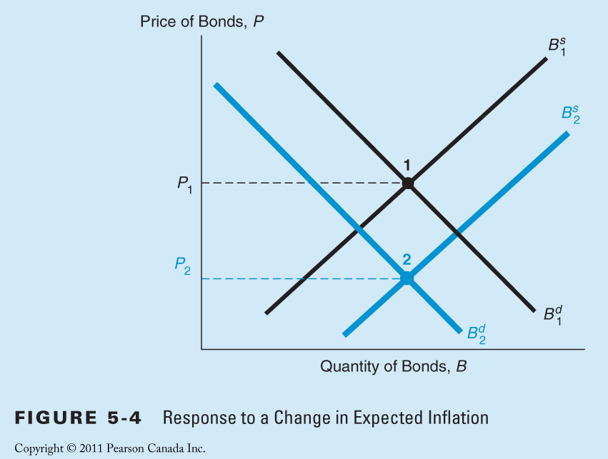

Interest Rate Changes from Expected Inflation
- Note that in Figure 5- 4, the equilibrium quantity of bonds remains the same for both point 1 and point 2.
- However, depending on the size of the shifts in the supply and demand curves, the equilibrium quantity of bonds could either rise or fall when expected inflation rises.
- important observation: when expected inflation rises, interest rates will rise(Fisher effect). The effect on the quantity of bonds is undetermined.

Response to a Business Cycle Expansion
- In a business cycle expansion, the amount of goods and services being produced in the economy rises, so national income increases.
- Businesses will be more willing to borrow because they are likely to have many profitable investment opportunities.
- Hence at a given bond price, the quantity of bonds that firms want to sell ( that is, the supply of bonds) will increase.
The supply curve for bonds shifts to the right
- Expansion in the economy will also affect the demand for bonds.
- As the business cycle expands, wealth is likely to increase,
- the demand for bonds will rise as well. The demand curve shifts to the right.
- As a result of both supply and demand shifting to the right, equilibrium quantity of bonds increases.
- Depending on whether the supply curve shifts more than the demand curve or vice versa, the new equilibrium interest rate can either rise or fall. 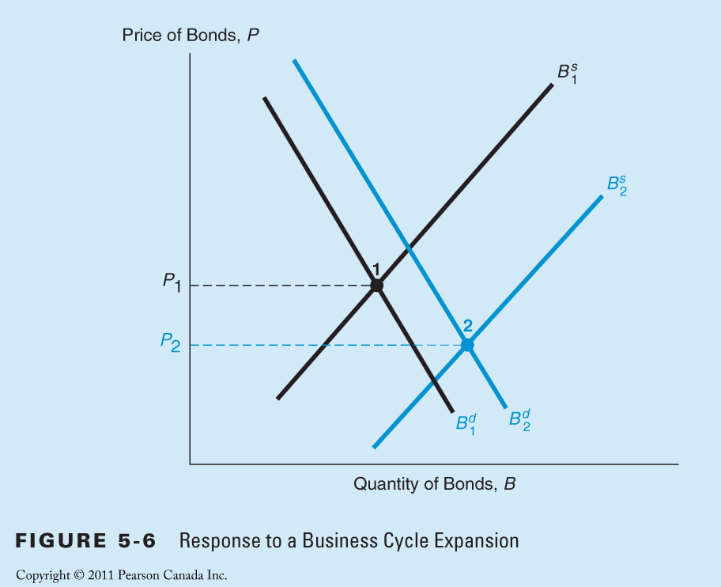
- Figure 5-6 has been drawn so that the shift in the supply curve is greater than the shift in the demand curve,
- The equilibrium bond price to falls leading to a rise in the equilibrium interest rate.
- Why?
- Because that is the outcome we actually see in the data: A business cycle expansion and a rise in income lead to a higher interest rate.
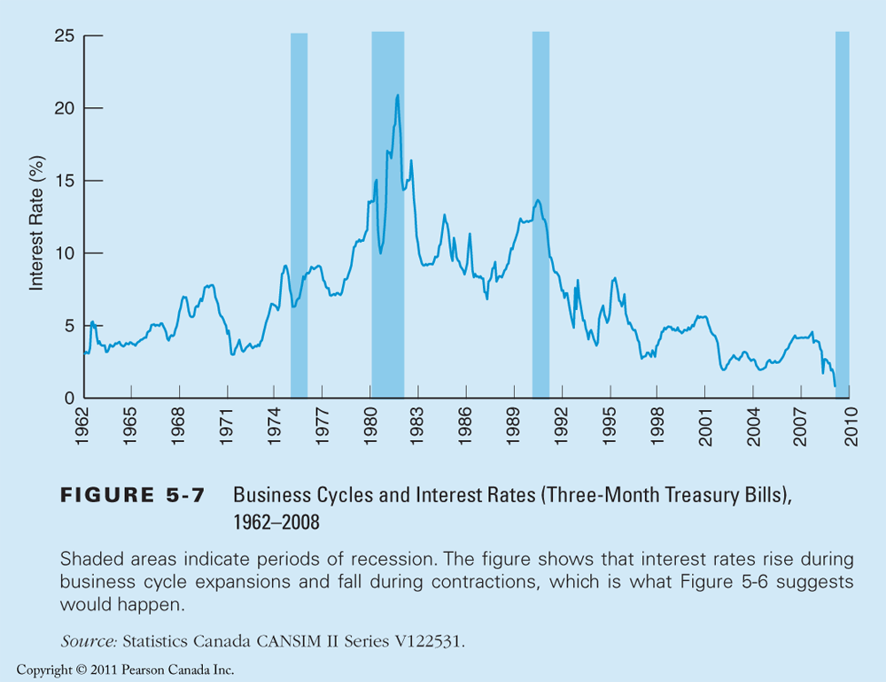
the interest rate tends to rise during business cycle expansions and fall during recessions

Response to a Lower Savings Rate
- Since 1980, Canada has experienced a sharp drop in personal savings rates,
- The decline in savings means that the wealth of Canadian households is lower than would otherwise be the case.
- It decreases the demand for bonds and shifts the demand curve to the left
- The result is that the equilibrium bond price drops and the interest rate rises.
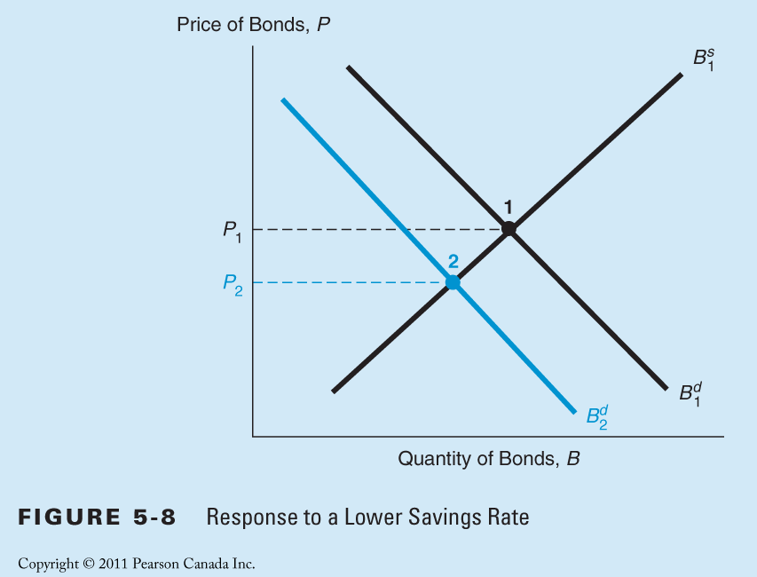
- Low savings can raise interest rates, and the higher rates may retard investment in capital goods.
- The low savings may lead to a less- productive economy.
- What to do? Policy suggestions:
- changing the tax laws to encourage saving
- forcing Canadians to save more by mandating increased contributions into retirement plans.
Liquidity Preference Framework
- Equilibrium interest rates are determined by the supply and demand for money
- Closely related to the loanable funds framework of the bond market.
- Two ways to store wealth: money and bonds
- Total wealth equals total amount of money (money supply) and total quantity of bonds (bond supply).
- Bs + Ms = Bd +Md
- People cannot purchase more assets than their available resources allow. As a result, quantity of bonds and money demanded equal the quantity supplied.
- Rearrange terms:
- Bs - Bd = Md – Ms
- If the bond market is in equilibrium (Bs=Bd)then the money market must also be in equilibrium (Ms=Md)
- Thus it is the same to think about determining the equilibrium interest rate by
- equating the supply and demand for bonds (loanable funds approach) or
- by equating the supply and demand for money (liquidity preference approach)
- In practice, the approaches differ
- because by assuming that there are only two kinds of assets, money and bonds, the liquidity preference approach implicitly ignores any effects on interest rates that arise from changes in the expected returns on real assets.
- On most cases however the both frameworks yield the same predictions.

Liquidity Preference Framework vs Bond Market
- the bond supply and demand framework (loanable funds approach) is easier to use when analyzing the effects from changes in expected inflation,
- whereas the liquidity preference framework provides a simpler analysis of the effects from changes in income, the price level, and the supply of money.

Liquidity Preference Framework
- the demand for money and the interest rate should be negatively related:
  - opportunity cost of holding money: the amount of interest ( expected return) sacrificed by not holding the alternative asset— in this case, a bond.
  - As the interest rate on bonds, i, rises, the opportunity cost of holding money rises,
  - so money is less desirable and the quantity of money demanded must fall.
- assume that a central bank controls the amount of money supplied at a fixed quantity.
- The equilibrium where the quantity of money demanded equals the quantity of money supplied occurs at the point C with the resulting equilibrium interest rate of 15%.
- When the interest rate is above the equilibrium interest rate:
  - The quantity of money supplied exceeds the quantity demanded
  - The excess supply of money means that people are holding more money than they desire,
  - They will try to get rid of their excess money balances by trying to buy bonds.
  - Accordingly, they will bid up the price of bonds,
  - As the bond price rises, the interest rate will fall toward the equilibrium interest rate of 15%.
- Only when the interest rate is at its equilibrium value will there be no tendency for it to move further, and the interest rate will settle to its equilibrium value.
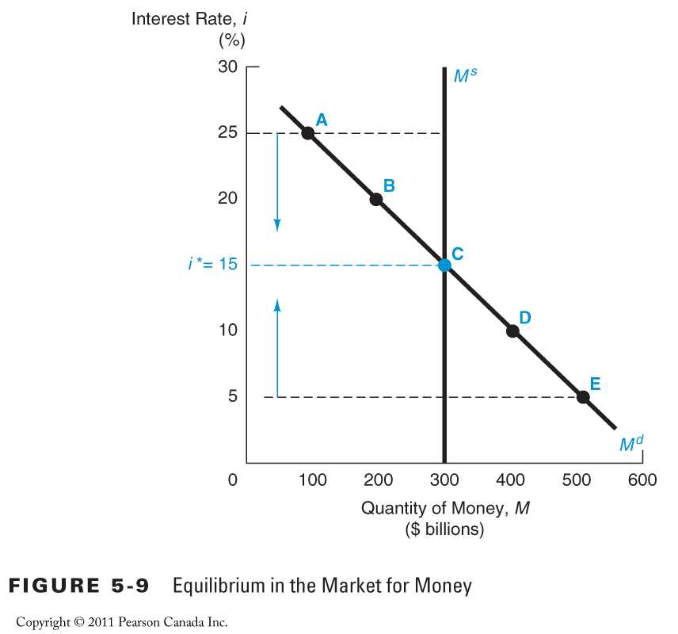
Shifts in the Demand for Money
- two factors cause the demand curve for money to shift: income and the price level.
- Income Effect + In Keynes’s view, there were two reasons why income would affect the demand for money.
- As an economy expands and income rises, wealth increases and people will want to hold more money as a store of value.
- As the economy expands and income rises, people will want to carry out more transactions using money, with the result that they will also want to hold more money.
The conclusion: a higher level of income causes the demand for money at each interest rate to increase and the demand curve to shift to the right. Interest rates will rise.

- Price-Level Effect + people care about the amount of money they hold in real terms, that is, in terms of the goods and services that it can buy.
- When the price level rises, the same quantity of money cannot be used to purchase as many real goods or services.
- To restore their holdings of money in real terms to their former level, people will want to hold a greater nominal quantity of money,
- so a rise in the price level causes the demand for money at each interest rate to increase
- the demand curve to shift to the right.
- Interest rates will rise.
Shifts in the Supply of Money
- Assume that the supply of money is controlled by the central bank.
- An increase in the money supply engineered by the Bank of Canada will shift the supply curve for money to the right.
- Interest rates will decline. 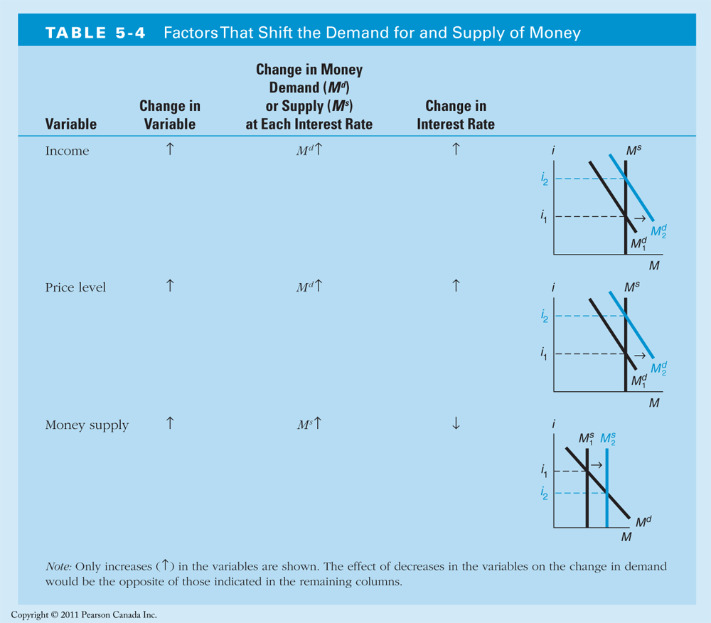
Response to a Change in Income or the Price Level
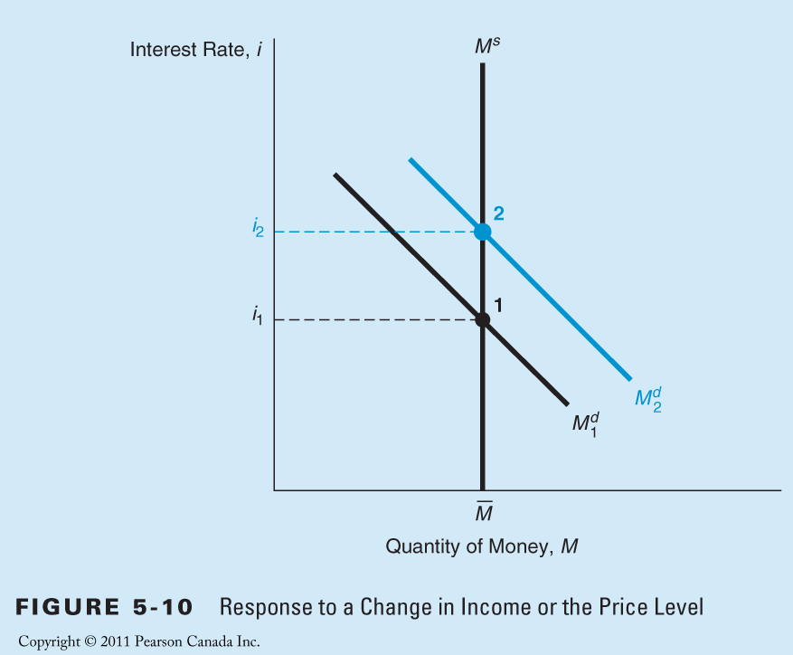
In a business cycle expansion, when income is rising, or when the price level rises, the demand curve shifts to the right. The supply curve is fixed. The equilibrium interest rate rises.
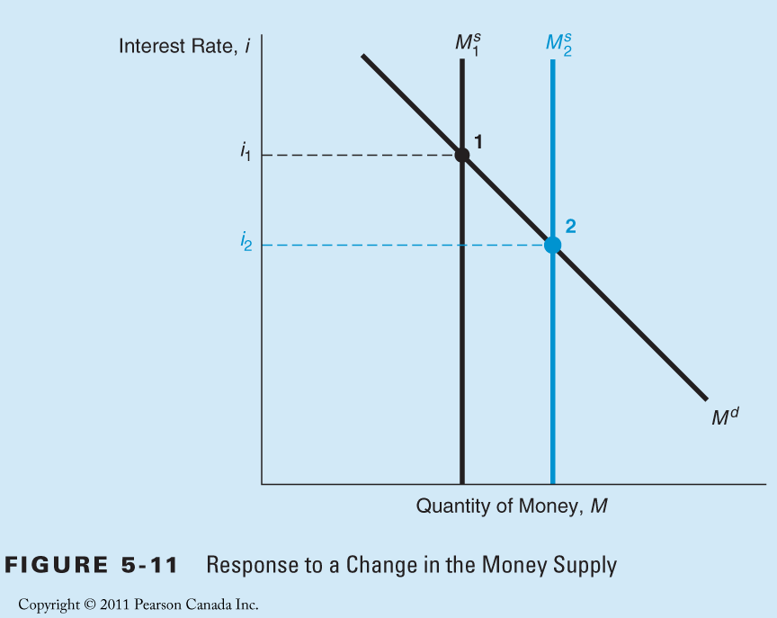
- When the money supply increases, the supply curve shifts to the right and the equilibrium interest rate falls.

Response to a change in the money supply
- The liquidity preference analysis in Figure 5- 11 seems to lead to the conclusion that an increase in the money supply will lower interest rates. (namely liquidity effect, see next slide)
- Might there be other important factors left out of the liquidity preference analysis in Figure 5- 11 that would reverse this conclusion?

The liquidity effect
- the liquidity effect: an increase in the money supply (everything else remaining equal) lowers interest rates
- Milton Friedman acknowledges that the liquidity preference analysis is correct and accepts the liquidity effect
- He also has raised an important criticism of the liquidity effect:
  - an increase in the money supply might not leave “ everything else equal”
  - will have other effects on the economy that may make interest rates rise.
  - If these effects are substantial, it is entirely possible that when the money supply rises, interest rates too may rise.

Other Effects related to Supply of Money
- Income effect of an increase in the money supply is a rise in the interest rate in response to a higher level of income.
  - Because an increasing money supply is an expansionary influence on the economy, it should raise national income and wealth.
  - Both the liquidity preference and bond supply and demand (loanable funds) frameworks point out that interest rates will then rise:
- Refer to Figure 5-6 on loanable funds framework: Interest rates rise in the case of expansion period in the economy
- Refer to Figure 5-10 on liquidity preference framework

Price-Level effect of an increase in the money supply is a rise in interest rates in response to the rise in the price level.
- An increase in the money supply can also cause the overall price level in the economy to rise.
- The liquidity preference framework: this will lead to a rise in interest rates. (Figure 5-10)
The expected-inflation effect of an increase in the money supply is a rise in interest rates in response to the rise in the expected inflation rate.
- The higher inflation rate that results from an increase in the money supply affects the expected inflation rate.
- An increase in the money supply may lead people to expect a higher price level in the future.
- The supply and demand for bonds framework: this increase in expected inflation will lead to a higher level of interest rates. (Figure 5-4)
The Difference Between Price Level Effect and the Expected Inflation Effect
- Suppose that there is a onetime increase in the money supply today that leads to a rise in prices to a permanently higher level by next year.
- The interest rate will rise via the price- level effect.
- Only at the end of the year, when the price level has risen to its peak, will the price- level effect be at a maximum. The rising price level will also raise interest rates via the expected- inflation effect because people will expect that inflation will be higher over the course of the year.
- However, when the price level stops rising next year, the expected inflation rate will return back to zero.
- Any rise in interest rates as a result of the earlier rise in expected inflation will then be reversed.
- The price- level effect reaches its greatest impact next year,
- The expected- inflation effect will have its smallest impact ( zero impact) next year.
- The basic difference between the two effects:
- the price- level effect remains even after prices have stopped rising, whereas the expected- inflation effect disappears. The expected- inflation effect will persist only as long as the price level continues to rise.
- A onetime increase in the money supply will not produce a continually rising price level; only a higher rate of money supply growth will.
- Thus a higher rate of money supply growth is needed if the expected- inflation effect is to persist.

Does a Higher Rate of Growth of the Money Supply Lower Interest Rates
- only the liquidity effect indicates that a higher rate of money growth will cause a decline in interest rates.
- In contrast, the income, price- level, and expected- inflation effects indicate that interest rates will rise when money growth is higher.
Which of these effects are the largest?
- Generally, the liquidity effect from the greater money growth takes effect immediately
- because the rising money supply leads to an immediate decline in the equilibrium interest rate.
- The income and price- level effects take time to work
- because it takes time for the increasing money supply to raise the price level and income.
- The expected- inflation effect can be slow or fast, depending on whether people adjust their expectations of inflation slowly or quickly.

Does a Higher Rate of Growth of the Money Supply Lower Interest Rates
- Figure 5-12 (a): the liquidity effect dominates the other effects so that the interest rate falls from i1 to a final level of i2.
- The liquidity effect operates quickly to lower the interest rate, but as time goes by the other effects start to reverse some of the decline.
- Because the liquidity effect is larger than the others, the interest rate never rises back to its initial level.
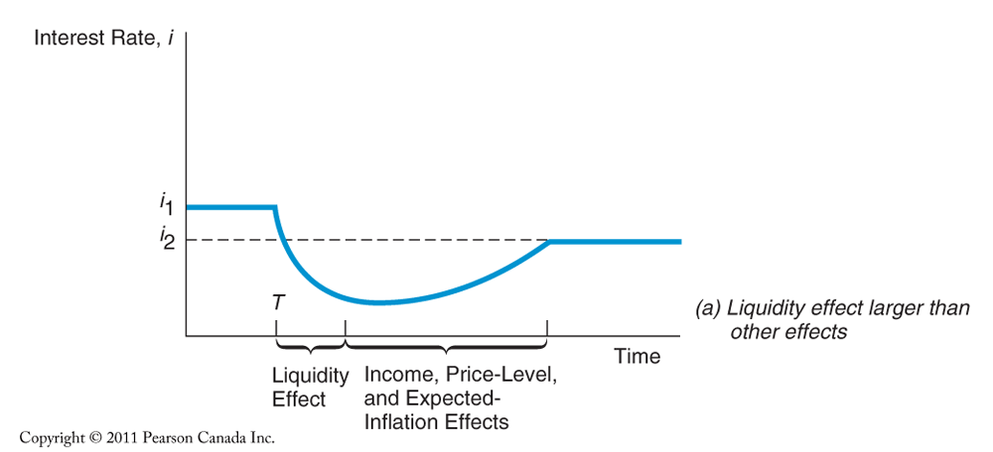
- Figure 5-12 (b): Initially, the liquidity effect drives down the interest rate.
- Then the income, price- level, and expected- inflation effects begin to raise it.
- Because these effects are dominant, the interest rate eventually rises above its initial level i1 to its final level of i2.
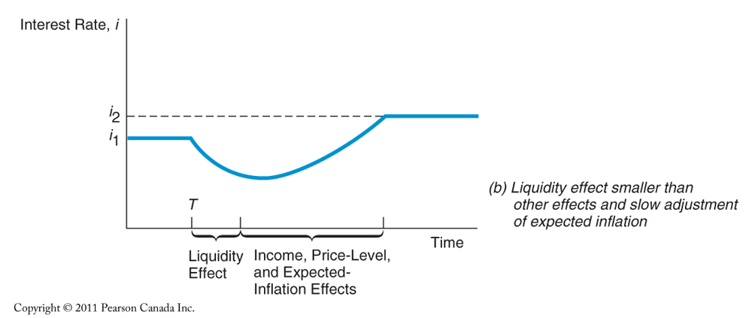
- Figure 5-12 (c): the expected- inflation effect dominating as well as operating rapidly
  - because people quickly raise their expectations of inflation when the rate of money growth increases.
- The expected- inflation effect begins immediately to over-power the liquidity effect
- Over time, as the income and price- level effects start to take hold, the interest rate rises even higher
- increasing money supply growth is not the answer to reducing interest rates; rather, money growth should be reduced in order to lower interest rates!
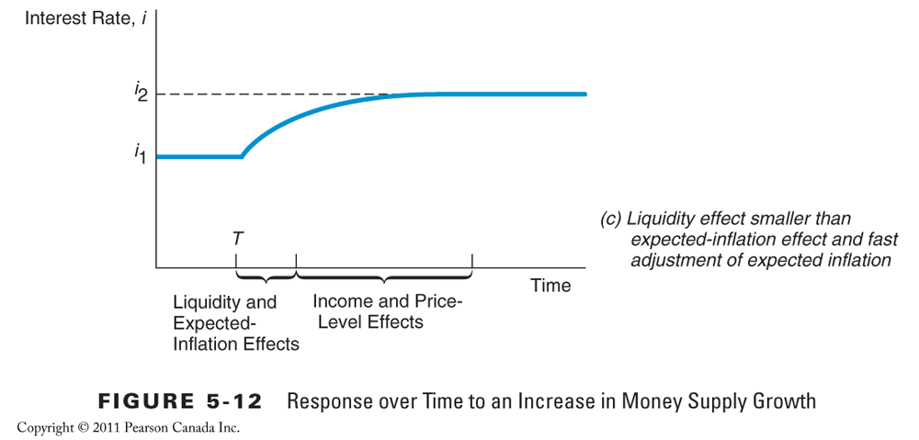
- which of these three scenarios is closest to reality?
- Look at the evidence
Figure 5- 13
- When the rate of money supply growth began to climb in the late- 1970s, interest rates rose,
the price- level, income, and expected- inflation effects dominated the liquidity effect.
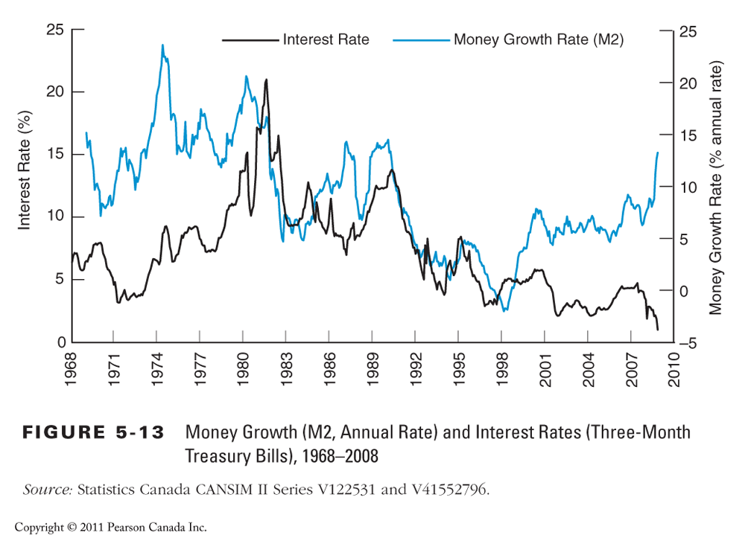
- The rise in the rate of money supply growth in the 1960s and 1970s is matched by a large rise in expected inflation,
- the expected- inflation effect would be dominant.
- Figure 5-12 (a) seems doubtful.
- Figure 5- 13 does not really tell which one of (b) or (c) is more accurate.
- It depends critically on how fast people’s expectations about inflation adjust.

