EC 223 Chapter 3 Notes
What is Money?
Money - anything that is generally accepted in payment for goods or services or in the repayment of debts;
- Because cheques are also accepted as payment for purchases, chequing account deposits are considered money as well.
- savings deposits can function as money if they can be quickly and easily converted into currency or chequing account deposits.
- There is no single, precise definition of money or the money supply, even for economists.
Money is distinct from income and wealth:

Wealth - the total collection of pieces of property that serve to store value
includes not only money but also other assets such as bonds, common stock, art, land, furniture, cars, and houses.

Income - flow of earnings per unit of time
- Money, by contrast, is a stock: it is a certain amount at a given point in time.

Functions of Money
- Medium of Exchange - promotes economic efficiency by minimizing the time spent in exchanging goods and services
- Unit of Account - used to measure value in
the economy
- Store of Value - used to save purchasing power; most liquid of all assets but loses value during inflation
Medium of Exchange
- barter economy: The economy without money, in which goods and services are exchanged directly for other goods and services.
- transaction cost: The time spent trying to exchange goods or services.
- In a barter economy, transaction costs are high
- people have to satisfy a “ double coincidence of wants”— they have to find someone who has a good or service they want and who also wants the good or service they have to offer.
For a commodity to function effectively as money, it has to meet several criteria:

- Easily standardized, making it simple to ascertain its value;
- widely accepted;
- divisible so that it is easy to “ make change”;
- easy to carry;
- not deteriorate quickly.
  - wampum ( strings of beads), used by Native Americans,
  - tobacco and whiskey, used by the early American colonists,
  - cigarettes, used in prisoner- of- war camps during World War II.

Unit of Account

If a barter economy has only three goods, say, peaches, economics lectures, and movies, then we need to know three prices to tell us how to exchange one for another:

- the price of peaches in terms of economics lectures ( that is, how many economics lectures you have to pay for a peach),
- the price of peaches in terms of movies,
- the price of economics lectures in terms of movies.
- If there were ten goods, we would need to know 45 prices
- With 100 goods, we would need 4950 prices;
- N(N-1)/2
- using money as a unit of account reduces transaction costs in an economy by reducing the number of prices that need to be considered.

Store of Value
How good a store of value money is depends on the price level.
  - During a period of high inflation, money loses value rapidly,
  - people will be more reluctant to hold their wealth in this form.
  - In the case of hyperinflation:
    - the use of money to carry out transactions declines and
    - barter becomes more dominant which increases transaction costs and reduces output in the economy.
Store of value is used to save purchasing power from the time income is received until the time it is spent.

- any asset, whether stocks, bonds, land, houses, art, or jewelry, can be used to store wealth.
- Many such assets have advantages over money as a store of value:
  - pay the owner a higher interest rate than money,
  - experience price appreciation, and
  - deliver services such as providing a roof over one’s head.
- If these assets are a more desirable store of value than money, why do people hold money?

Evolution of the Payments System
- Commodity Money
- Fiat Money
- Cheques
- Electronic Payment
- E-Money

Commodity Money
- Money made up of precious metals or another valuable commodity is called commodity money
- The problem: such a form of money is very heavy and is hard to transport from one place to another.
- For large purchases such as a house, you’d have to rent a truck to transport the money payment!

Fiat Money
- Paper currency
- Initially, paper currency was convertible into coins or into a quantity of precious metal.
- Currency has evolved into fiat money, paper currency decreed by governments as legal tender (meaning that legally it must be accepted as payment for debts) but not convertible into coins or precious metal.
- Paper currency has the advantage of being much lighter than coins or precious metal.
- Major problems:
  - Paper currency and coins is easily stolen
  - can be expensive to transport because of their bulk if there are large amounts.
  - To combat this problem: the invention of cheques.
Cheques
- Allow transactions to take place without the need to carry around large amounts of currency.
- Improved the efficiency of the payments system:
  - Frequently, payments made back and forth cancel each other; without cheques, this would involve the movement of a lot of currency.
  - reduces the transportation costs associated with the payments system and improves economic efficiency.
  - they can be written for any amount up to the balance in the account, making transactions for large amounts much easier.
  - loss from theft is greatly reduced,
  - they provide convenient receipts for purchases.
Problems:
- it takes time to get cheques from one place to another, serious problem if you are paying someone in a different location who needs to be paid quickly.
- it usually takes several business days before a bank will allow you to make use of the funds from a cheque you have deposited.
- All the paper shuffling required to process cheques is costly.
Electronic Payment
- In the past, you had to pay your bills by mailing a cheque
- The development of inexpensive computers and the spread of the Internet now make it cheap to pay bills electronically.
- Not only do you save the cost of the stamp, but paying bills require little effort.
- Recurring bills can be automatically deducted from your bank account.
E-Money
- money that exists only in electronic form.
- The first form of e- money was the debit card.
- A more advanced form of e- money is the stored- value card.
  - Smart card.
    - contains a computer chip that allows it to be loaded with digital cash from the owner’s bank account whenever needed.
  - E-cash
    - is used on the Internet to purchase goods or services.
    - A consumer gets e- cash by setting up an account with a bank that has links to the Internet and then has the e- cash transferred to her PC.
    - When the customer clicks on the “ buy” option, the e- cash is automatically transferred from her computer to the merchant’s computer.

Measuring Money
- What assets should be included when measuring money supply?
- Float – funds in transit between the time a cheque is deposited and the time the payment is settled.
- Measures of Money Supply:
  - M2
  - M3
  - M2+
  - M2++
  - M1+
  - M1++

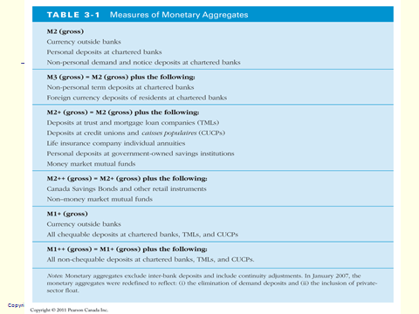
Fig 3-1
- The growth rates of three aggregates do tend to move together.
- Yet some glaring discrepancies exist in the movements of these aggregates.
- Thus, the different measures of money tell a very different story about the course of monetary policy.
- Obtaining a single precise, correct measure of money does seem to matter
- It does make a difference which monetary aggregate policymakers choose as the true measure of money.
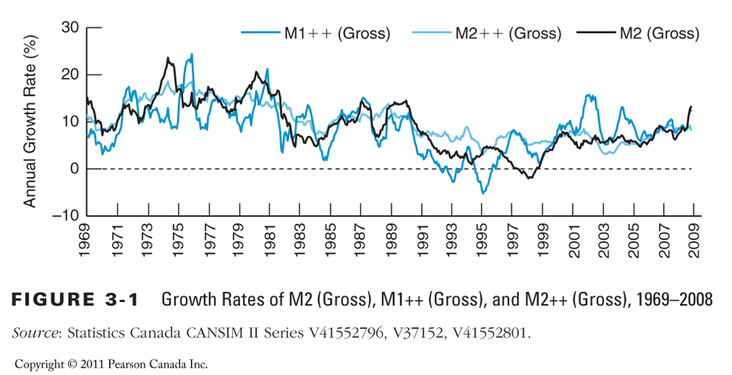
- The Bank of Canada’s money supply measures are ‘simple-sum’ indices, the index
M = x₁ + x₂ + … + x_{n} ,
Where x_{j} is one of the n monetary components of the monetary aggregate M
- all monetary components contribute equally to the money total
- cannot, in general, represent a valid structural economic variable
Money as a Weighted Aggregate
- How to properly weigh monetary components?
  - there has been a steady stream of attempts at weighting monetary components within a simple- sum aggregate.
- With no theory, any weighting scheme is questionable.
- a rigorous use of microeconomic theory, aggregation theory, and index number theory led to construction of weighted monetary aggregates
- Weighted measures of money seem to predict inflation and the business cycle somewhat better than more conventional measures.

How reliable are the money data?
- Bank of Canada revises estimates of monetary aggregates because
  - Small depository institutions report only infrequently
  - the adjustment of the data for seasonal variation is revised substantially as more data become available.
    - The monetary aggregates always rise around Christmas
    - the rise is greater in some years than in others.
    - This means that the factor that adjusts the data for the seasonal variation due to Christmas must be estimated from several years of data,
    - the estimates become more precise only as more data become available. the data are not a reliable guide to what is happening to short- run movements in the money supply, such as the one- month growth rates.
    - However, money data are reasonably reliable for longer periods, such as a year.

    - We probably should not pay much attention to short- run movements in the money supply numbers but should be concerned only with longer- run movements.

