EC 223 Chapter 2
Financial Intermediaries
- Financial markets and financial intermediaries (banks, insurance companies, pension funds) perform the basic function of moving funds from those who have a surplus to those who have a shortage of funds
- Well-functioning intermediaries are crucial to economic health

Function of Financial Markets
- The channeling of funds from households, firms and governments who have surplus funds(savers) to those who have a shortage of funds(borrowers)

Direct vs Indirect Finance

Direct
- Borrowers borrow funds directly from lenders in financial markets by selling them securities
- Securities are assets for the person that buys them and liabilities(or debts) for the individual or firm that sells (issues) them
- If RIM needs to borrow funds to pay for new capital, it borrows funds from savers by selling them bonds that make payments periodically for a specified period of time, or stocks, securities that entitle the owners to a share of the company’s profits and assets

Indirect
- People who save are not frequently presented with the same profitable investment opportunities available to them
- Without financial markets, it is hard to transfer funds from a person who has no investment opportunities to one who has them
- Financial markets are essential to promoting economic efficiency

Financial Markets
- Produce an efficient allocation of capital
- Higher production and efficiency for the overall economy
- Allow consumers to time their purchases better
- Provide funds to young people to buy what they need and can eventually afford without forcing them to wait until they have saved up the entire purchase price
- Severe economic hardship occurs when financial markets break down

A firm can obtain funds in 2 ways
- Issue a debt instrument, such as a bond or a mortgage:
- a contractual agreement by the borrower to pay the holder of the instrument fixed dollar amounts at regular intervals ( interest and principal payments) until a specified date ( the maturity date), when a final payment is made.

Structure of Financial Markets

Debt Markets
- Short-term (maturity less than 1 year) – the money market
- Long-term (maturity greater than 10 years) – the capital market
- Intermediate-term (maturity between 1 and 10 years) – the capital market

- Issue equities, such as common stock
- Claims to share in the net income and the assets of a business
- Equities pay dividends to their holders
- Are considered long-term securities because they have no maturity date
- Stock owners own a portion of the firm
- Have the right to vote on issues important to the firm and to elect its directors

Equity Markets – Common stocks
- The main disadvantage of owning a corporation’s equities rather than its debt:
- An equity holder is a residual claimant, the corporation has to pay all its debt holders before it pays its equity holders
- The main advantage of holding equities – holders benefit directly from any increases in the corporation’s profitability or asset value
- Debt holders do not share the benefit because their dollar payments are fixed

Primary Market
- New issues of a security, such as a bond or a stock, are sold to initial buyers by the corporation or government agency borrowing the funds
- Not well known to the public
- Selling of securities to initial buyers often takes place behind closed doors
- Investment bank: an important financial institution that assists in the initial sale of securities in the primary market by
- Underwriting securities: it guarantees a price for a corporation’s securities and then sells them to the public

Secondary Market
- Securities previously issued are bought and sold
- The Toronto Stock Exchange
- Bond markets – issued bonds of major corporations and Canadian gov’t actually have a larger trading volume
- FOREX markets
- Futures markets
- Options markets
- Brokers and Dealers are crucial for well-functioning secondary markets.
- Brokers: agents of investors who match buyers with sellers of securities;
- Dealers: link buyers and sellers by buying and selling securities at stated prices.

Secondary markets serve 2 important functions:
- they make it easier to sell financial instruments to raise cash;
- they make the financial instruments more liquid.
- The increased liquidity of the instruments makes them more desirable
- they determine the price of the security that the issuing firm sells in the primary market.
- The investors that buy securities in the primary market will pay the issuing corporation no more than the price they think the secondary market will set for this security.
- The higher the security’s price in the secondary market, the higher will be the price that the issuing firm will receive for a new security in the primary market and hence the greater the amount of financial capital it can raise.

Secondary markets can be organized in two ways:
- Organize exchanges: buyers and sellers of securities meet in one central location to conduct trades.
- The Toronto Stock Exchange for stocks
- the Winnipeg Commodity Exchange for commodities ( wheat, oats, and other agricultural commodities)
- Have an over- the-counter (OTC) market: dealers at different locations who have an inventory of securities stand ready to buy and sell securities “over the counter” to anyone who comes to them and is willing to accept their prices.
- the OTC market is not very different from a market with an organized exchange:
- very competitive
- over- the-counter dealers are in computer contact and know the prices set by one another,

Money and Capital Markets

Money market – trade in short term debt instruments

Capital Market – trade in longer term instruments

Money market securities tend to be more liquid
- more widely traded than longer- term securities
- As we will see in Chapter 4, short- term securities have smaller fluctuations in prices than long- term securities, making them safer investments.
- Corporations and banks actively use the money market to earn interest on funds that they expect to have only temporarily.

Capital market securities--stocks and long- term bonds-- are often held by insurance companies and pension funds, which have more certainty about the amount of funds they will have available in the future.

Money Market Instruments: maturity < 1 year
- Government of Canada Treasury Bills
- Certificates of Deposit
- Commercial Paper
- Repurchase Agreements
- Overnight Funds
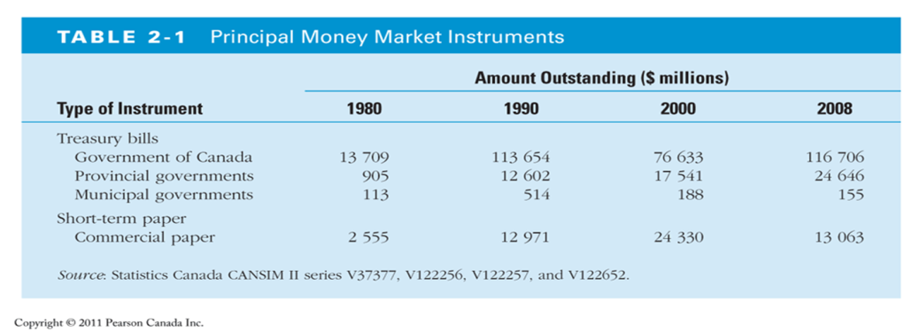

Financial Market Instruments
Government of Canada Treasury Bills
- Issued in 1, 3, 6, and 12 month maturities to finance the federal government.
- Pay a set amount at maturity and have no interest payments,
- Initially sell at a discount,
- For instance, you might pay $ 9600 in May 2010 for a one- year treasury bill that can be redeemed in May 2011 for $ 10 000.
- The most liquid of all the money market instruments because they are the most actively traded.
- The safest of all money market instruments because there is almost no possibility of default,
- A situation in which the party issuing the debt instrument is unable to make interest payments or pay off the amount owed when the instrument matures. (federal government )
- Held mainly by banks, (house-holds, corporations, and other financial intermediaries hold small amounts.)

Certificates of Deposit (CD)
- A debt instrument sold by a bank to depositors that pays annual interest of a given amount and at maturity pays back the original purchase price.
- Often negotiable, meaning that they can be traded, can be resold in a secondary market, which means liquidity.
- Can be in bearer form (called bearer deposit notes): the buyer’s name is neither recorded in the issuer’s books nor on the security itself.
- Chartered banks also issue non- negotiable CDs.
- They cannot be sold to someone else and cannot be redeemed from the bank before maturity without paying a substantial penalty.
- Also known as term deposit receipts or term notes.
- CDs are also an important source of funds for trust and mortgage loan companies. They issue CDs under a variety of names;
- DRs ( Deposit Receipts), GTCs ( Guaranteed Trust Certificates), GICs ( Guaranteed Investment Certificates), and GIRs ( Guaranteed Investment Receipts).

Repurchase Agreements (repos)
- short- term loans ( usually less than two weeks) for which treasury bills serve as collateral,
  - an asset that the lender receives if the borrower does not pay back the loan.
- A large corporation may have some idle funds, say $ 1 million, which it would like to lend for a week.
- The corporation uses $ 1 million to buy treasury bills from a bank, which agrees to repurchase them the next week at a price slightly above the corporation’s purchase price.
- The corporation makes a loan of $ 1 million to the bank and holds $ 1 million of the bank’s treasury bills until the bank repurchases the bills to pay off the loan.

Overnight Funds
- Overnight loans by banks to other banks.
- Why a bank might borrow in the overnight funds market?
  - it might not have enough settlement deposits at the Bank of Canada.
- The overnight market responds to the credit needs of the deposit- taking institutions.
  - the overnight interest rate is a closely watched barometer of the tightness of credit market conditions in the banking system.
  - When it is high, it indicates that the banks are strapped for funds, whereas when it is low, banks’ credit needs are low.

Capital Market Instruments – debt and equity instruments with maturities > 1 year.
  - Stocks
  - Mortgages
  - Corporate bonds
  - Government of Canada bonds

Additional Capital Market Instruments Include:
- Canada Savings Bonds
- Provincial and Municipal Government Bonds
- Government Agency Securities
- Consumer and Bank Commercial Loans
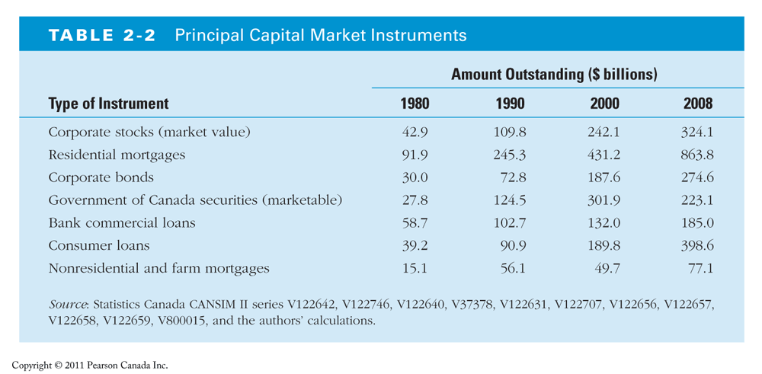
Stocks
- Equity claims on the net income and assets of a corporation.
- Individuals hold around half of the value of stocks;
- Pension funds, mutual funds, and insurance companies hold the rest.
Mortgages
- Loans to households or firms to purchase housing, land, or other real structures, where the structure or land serves as collateral for the loans.
- The mortgage market is the largest debt market in Canada.
- Banks and life insurance companies make the majority of commercial and farm mortgages.
- The federal government also plays an active role in the mortgage market via the Canada Mortgage and Housing Corporation (CMHC)
- Provides funds to the mortgage market by selling bonds and using the proceeds to buy mortgages.
Corporate Bonds
- the behaviour of the corporate bond market is far more important to a firm’s financing decisions than the behaviour of the stock market:
- Although the size of the corporate bond market is substantially smaller than that of the stock market, the volume of new corporate bonds issued each year is substantially greater than the volume of new stock issues.
- Government of Canada bonds
- issued by the federal government to finance its deficit.
- Intermediate- term bonds: with initial maturities from one to ten years
- long- term bonds: with initial maturities greater than ten years
- the most widely traded bonds in Canada, therefore they are the most liquid security traded in the capital market.
- They are held by the Bank of Canada, banks, households, and foreign investors.
- registered bonds: the name of the owner appears on the bond certificate and is also recorded at the Bank of Canada.
CANADA SAVINGS BONDS (CSB)
- Nonmarketable bonds issued by the government of Canada.
- CSBs are different from all other bonds issued by the government of Canada in that they do not rise or fall in value, like other bonds do.
- They have the valuable option of being redeemable at face value plus accrued interest, at any time prior to maturity.
- Canada Premium Bonds ( CPBs) offer a slightly higher coupon rate than the CSBs
- Can be redeemed only once a year, on the anniversary of the issue date and during the month after that date.
PROVINCIAL AND MUNICIPAL GOVERNMENT BONDS
- Issued to finance expenditures on schools, roads, and other large programs.
- provincial bonds or provincials: issued by provincial governments
- municipal bonds or municipals: issued by municipal governments
- The securities issued by the federal government are also called Canadas.
- Provincials and municipals are denominated in either domestic currency or foreign currencies.
GOVERNMENT AGENCY SECURITIES
- long- term bonds issued by various government agencies such as the Ontario Municipal Improvement Corporation
  - to assist municipalities to finance such items as mortgages, farm loans, or power- generating equipment.
- The provincial governments guarantee many of these securities.
- They function much like Canadas, provincials, and municipals.
CONSUMER AND BANK COMMERCIAL LOANS
- loans to consumers and businesses made principally by banks
- in the case of consumer loans— also by finance companies.

Internationalization of Financial Markets
- Before the 1980s, U. S. financial markets were much larger than financial markets outside the United States,
- In recent years the dominance of U. S. markets has been disappearing
- Why is there an extraordinary growth in foreign financial markets?:
  - large increases in the pool of savings in foreign countries such as Japan
  - the deregulation of foreign financial markets, which has enabled foreign markets to expand their activities.
International Bond Market
- Foreign bonds - sold in a foreign country and denominated in that country’s currency
  - German automaker Porsche sells a bond in Canada denominated in Canadian dollars
- Eurobonds – denominated in a currency other than the country in which it is sold
  - a bond issued by a Canadian corporation that is denominated in Japanese yen and sold in Germany.
  - A bond denominated in euros is called a Eurobond only if it is sold outside the countries that have adopted the euro.
- Eurocurrencies – foreign currencies deposited in banks outside the home country
  - Eurodollars: U. S. dollars deposited in foreign banks outside the United States or in foreign branches of U. S. banks.
  - 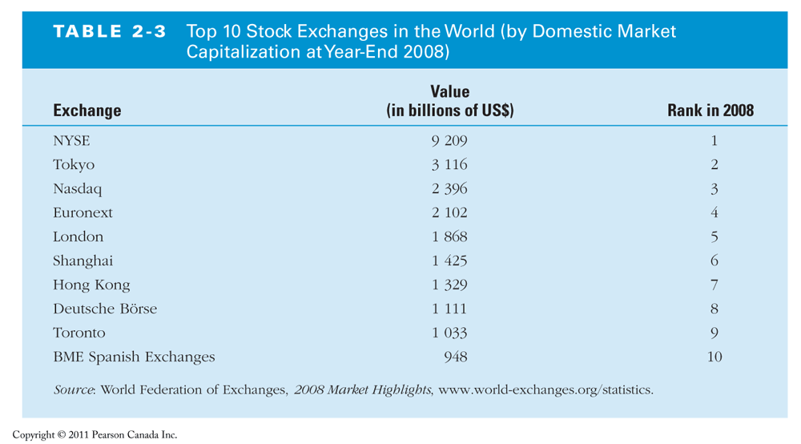

- The process of indirect finance using financial intermediaries is the primary route for moving funds from lenders to borrowers.
  - A bank might acquire funds by issuing a liability to the public in the form of savings deposits. It might then use the funds to acquire an asset by buying a Canadian Pacific bond in the financial market. The ultimate result is that funds have been transferred from the public ( the lender- savers) to Canadian Pacific ( the borrower- spender) with the help of the financial intermediary ( the bank).
Transaction Costs
- time and money spent carrying out financial transactions
- Carl the Carpenter needs $ 1000 for his new tool,
- knowing that it is an excellent investment opportunity you would like to lend him the funds, but to protect your investment, you have to hire a lawyer to write up the loan contract to specify how much interest will be and when the interest payments will be made, etc
- The contract will cost you $ 500 by the lawyer.
- When you include the transaction cost for making the loan, you can’t earn enough from the deal.
- small savers or potential borrowers might be frozen out of financial markets and be unable to benefit from them.
- Can anyone come to the rescue?
- Financial intermediaries can.
- can substantially reduce transaction costs
- they have developed expertise in lowering costs
- their large size allows them to take advantage of economies of scale:
- the reduction in transaction costs per dollar of transactions as the size ( scale) of transactions increases.
- A bank knows how to find a good lawyer to produce an airtight loan contract, and this contract can be used over and over again in loan transactions.
A financial intermediary can provide its customers with liquidity services,
- services that make it easier for customers to conduct transactions.
- For example, banks provide depositors with chequing accounts that enable them to pay their bills easily.
- Depositors can earn interest on chequing and savings accounts and yet still convert them into goods and services whenever necessary.

Risk Sharing
- Risk: uncertainty about the returns investors will earn on assets.
- Risk sharing: Financial intermediaries create and sell assets with risk characteristics that people are comfortable with, and then use the funds they acquire by selling these assets to purchase other assets that may have far more risk.
  - Low transaction costs allow financial intermediaries to share risk at low cost,
  - earn a profit on the spread between the returns they earn on risky assets and the payments they make on the assets they have sold.
  - This process of risk sharing is also called asset transformation, because risky assets are turned into safer assets for investors
Financial intermediaries also promote risk sharing by diversification
  - investing in a collection ( portfolio) of assets whose returns do not always move together,
  - overall risk is lower than for individual assets.
  - “ you shouldn’t put all your eggs in one basket.”
  - Low transaction costs allow financial intermediaries to do this by pooling a collection of assets into a new asset and then selling it to individuals.
Asymmetric Information
- Inequality of information between counterparties
- One party often does not know enough about the other party to make accurate decisions.
- Lack of information creates problems in the financial system on two fronts:
- Before the transaction is entered into—adverse selection
- After the transaction—moral hazard

Adverse Selection
- Created by asymmetric information before the transaction occurs.
- Occurs when the potential borrowers who are the most likely to produce an undesirable ( adverse) outcome— the bad credit risks— are the ones who most actively seek out a loan and are thus most likely to be selected.
- Adverse selection makes it more likely that loans might be made to bad credit risks, therefore lenders may decide not to make any loans even though there are good credit risks in the marketplace.
Moral Hazard
- created by asymmetric information after the transaction occurs.
- is the risk ( hazard) that the borrower might engage in activities that are undesirable ( immoral) from the lender’s point of view because they make it less likely that the loan will be paid back.
- moral hazard lowers the probability that the loan will be repaid, therefore lenders may decide that they would rather not make a loan.
Function of Financial Intermediaries
- financial intermediaries play an important role in the economy because:
- They provide liquidity services,
- Promote risk sharing,
- Solve information problems,
- Improve economic efficiency because they help financial markets channel funds from lender- savers to people with productive investment opportunities.
- Without a well- functioning set of financial intermediaries, it is very hard for an economy to reach its full potential.
Types of Financial Intermediaries
- Depository Institutions

Chartered Banks
- raise funds by issuing chequable deposits, savings deposits, and term deposits.
- use these funds to make commercial, consumer, and mortgage loans and to buy Canadian government securities and provincial and municipal bonds.

Trusts and Mortgage Loan Companies (TMLs)
- obtain funds through chequable and nonchequable savings deposits, term deposits, guaranteed investment certificates, and debentures.
- In the past, these institutions were constrained in their activities but these days TMLs provide most of the services provided by chartered banks.

Credit Unions and Caisses Populaires (CUCPs)
- very small cooperative lending institutions organized around a particular group: union members, employees of a particular firm, and so forth.
- acquire funds from deposits and primarily make mortgage and consumer loans.

Contractual Savings Institutions
- Financial intermediaries that acquire funds at periodic intervals on a contractual basis
- Insurance companies, pension funds
- can predict with reasonable accuracy how much they will have to pay out in benefits in the coming years,
- do not have to worry as much as depository institutions about losing funds.
the liquidity of assets is not as important a consideration for them as it is for depository institutions
- tend to invest their funds primarily in long- term securities such as corporate bonds, stocks, and mortgages.
Life Insurance Companies
- acquire funds from the premiums that people pay to keep their policies in force use them mainly to buy corporate bonds and mortgages. Also purchase stocks.
Contractual Savings Institutions

- Property and Casual Insurance Companies
- have a greater possibility of loss of funds if major disasters occur.
- use their funds to buy more liquid assets than life insurance companies do.
- their largest holding of assets is government bonds and debentures; they also hold corporate bonds and stocks.
- Debenture: medium to long term debt instrument with no collateral
- Pension Funds and Government Retirement Funds
- provide retirement income in the form of annuities to employees who are covered by a pension plan.
- Funds are acquired by contributions from employers and/ or from employees,
- The largest asset holdings of pension funds are corporate bonds and stocks.
Investment Intermediaries
Finance Companies
- raise funds by selling commercial paper and by issuing stocks and bonds.
- lend these funds to consumers, who make purchases of such items as furniture, automobiles, and home improvements, and to small businesses.
Mutual Funds
- acquire funds by selling shares to many individuals and use the proceeds to purchase diversified portfolios of stocks and bonds.
- allow shareholders to pool their resources so that they can take advantage of lower transaction costs when buying large blocks of stocks or bonds.
- allow shareholders to hold more diversified portfolios than they otherwise would.
- investments in mutual funds can be risky (the value of the mutual fund’s holdings of securities fluctuate greatly)

Investment Intermediaries

Money Market Mutual Funds
- have the characteristics of mutual funds but also function to some extent as depository institutions (offer deposit- type accounts. )
- sell shares to acquire funds that are then used to buy money market instruments that are both safe and very liquid.
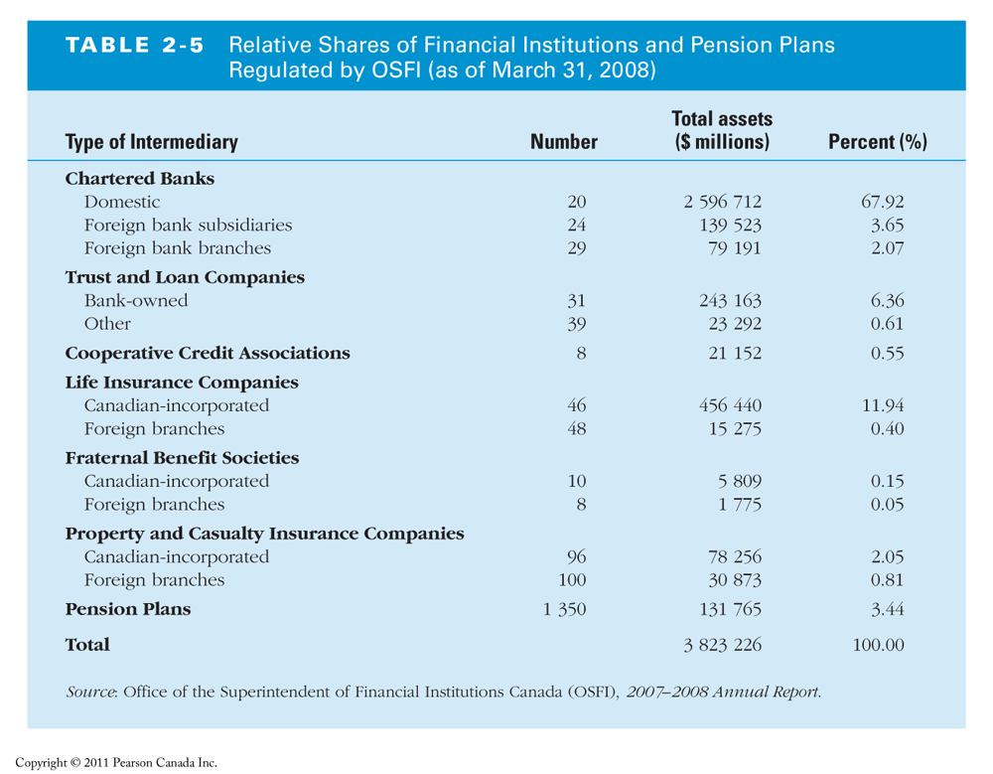
Regulation of Financial Markets

The financial system is among the most heavily regulated sectors of the Canadian economy.

- Primary Reasons for Regulation
1. Increase information to investors
2. Ensuring the soundness of intermediaries
3. Improve control of monetary policy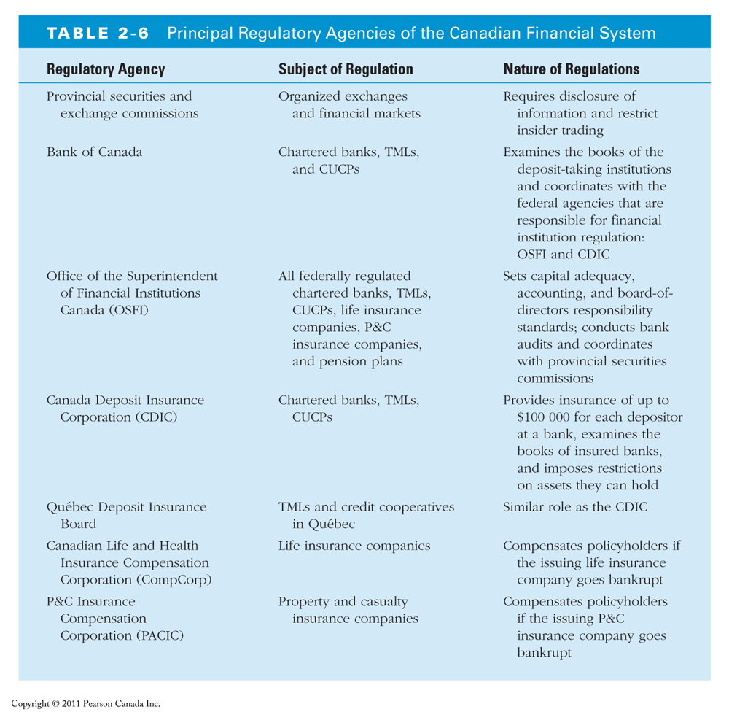
Increases information to investors
- Decreases adverse selection and moral hazard problems
- Risky firms may be the most eager to sell securities to unwary investors (adverse selection)
- Once an investor has bought a security, thereby lending money to a firm, the borrower may have incentives to engage in risky activities or to commit outright fraud ( moral hazard)
- Provincial Securities Commissions force corporations to disclose information about their sales, assets and earnings
Ensuring the soundness of intermediaries

Prevents financial panic.
- Investors may not be able to assess whether the institutions holding their funds are sound or not,
- If any doubts about the health of financial intermediaries, they may pull their funds out of both sound and unsound institutions.
To protect the economy from financial panics, the government has implemented some regulations:
- Restrictions on entry
- Disclosure
- Restrictions on assets and activities,
- Deposit insurance,
- Limits on competition
Restrictions on entry
- who is allowed to set up a financial intermediary.
- must obtain a charter from the provincial or federal government.
- Only if they are upstanding citizens with impeccable credentials and a large amount of initial funds will they be given a charter.
Disclosure
- bookkeeping must follow certain strict principles,
- their books are subject to periodic inspection,
- they must make certain information available to the public.
Restrictions on assets and activities
- restrict from holding certain risky assets, or at least from holding a greater quantity of these risky assets than is prudent.
- chartered banks and other depository institutions are not allowed to hold common stock
- Insurance companies are allowed to hold common stock, but their holdings cannot exceed a certain fraction of their total assets.

Deposit insurance
- The government can insure people’s deposits in case if the financial intermediary that holds these deposits fails.
- Canada Deposit Insurance Corporation ( CDIC) insures each depositor at a member deposit- taking financial institution up to a loss of $ 100 000 per account.
- Except for certain wholesale branches of foreign banks, credit unions, and some provincial institutions, all deposit- taking financial institutions in Canada are members of the CDIC.
- All CDIC members make contributions into the CDIC fund, which are used to pay off depositors in the case of a bank’s failure

Limits on competition
- Although the evidence is extremely weak, unbridled competition among financial intermediaries may promote failures that will harm the public.
- from 1967 to 1980 the entry of foreign banks into Canadian banking was prohibited.
- Since 1980, foreign bank subsidiaries have been regulated.
- Canada still ranks low with respect to the degree of competition from foreign banks.

Financial Regulation Abroad
- financial regulation in United States, Japan, and the nations of Western Europe is quite similar to financial regulation in Canada.
The provision of information is improved by
- requiring corporations issuing securities to report details about assets and liabilities, earnings and sales of stock
- prohibiting insider trading
The soundness of intermediaries are ensured by
- licensing
- periodic inspection of intermediaries’ books
the provision of deposit insurance
Financial Regulation Abroad
- The major differences between financial regulation in Canada and abroad relate to bank regulation.
- In the past, the US was the only industrialized country to subject banks to restrictions on branching, which limited banks’ size and restricted them to certain geographic regions.
- U. S. and Canadian banks are also the most restricted in the range of assets they may hold.
Banks in other countries frequently hold shares in commercial firms; in Japan and Germany, those stakes can be sizable.

