Definitions

Energy
The capacity to do work
•it allows useful work to be done
•anything that is able to work is able to use energy
•coined by Thomas Young in 1807

Power
The rate at which work is done
•the rate of conversion of energy from one form to another, or the transmission of energy from one place to another

Units of Measurement
-Energy
•Joule
-Power
•Watt
-a rate of one joule per second

Consumption of Energy
§The conversion of energy from one form to another
•e.g. converting chemical energy stored in oil into heat or electrical energy for a home or to kinetic energy for a vehicle

Fossil Fuels
•Coal
•Oil
•Natural gas
Consist mainly of carbon and hydrogen
•hydrocarbons
Fossil fuels provide the vast majority of global energy consumption
•approximately, 80%
Reasons for their attraction as energy sources
•highly concentrated
•easy to distribute

Geographic Distribution
-Oil
•majority of global reserves in the Middle East and North Africa
-Natural Gas
•majority of global reserves fairly evenly split between Middle East/North Africa and the former Soviet Union

Coal
-More evenly distributed globally
-However, three-quarters of reserves found in only four countries
•Australia
•China
•South Africa
•United States of America

Reserves-Production Ratio (R/P Ratio)
-An estimate of the number of years reserves would last, at continued current usage rates
•Coal – 200 years
•Natural Gas – 62.8 years
•Oil – 45.7 years

Challenges
-Pollution
-Mining accidents
-Fires and explosions on oil or gas rigs
-Conflicts over access to fuel resources
-Global change

Nuclear Energy
Obtained from harnessing energy released from the splitting or fission of uranium – 235 and plutonium – 239
More highly concentrated than fossil fuels
•the complete fission of a kilogram of uranium – 235 could produce as much energy as the combustion of over 3000 tonnes of coal
-Provides approximately 7% of global primary energy and 17% of global electricity
Reasons for attraction as energy source
•no emission of carbon dioxide or other conventional pollutants
-Current conditions point to continued availability of nuclear fuel well into the future
•reserves identified in many countries
•advanced nuclear technologies assure a more efficient use of uranium deposits

Challenges
-Devastating accidents

•Windscale, U. K. – 1957 -Release of harmful radioactive by-products into the atmosphere

•Three Mile Island, U. S. – 1979 -Disposal of nuclear waste products

•Chernobyl, Ukraine – 1986 -The security threat of nuclear materials falling into the wrong hands

Renewable Energy Sources
-Energy sources which are continuously recharged by natural processes
•flows of energy

-Their development and use have increased rapidly over the past few years
•no danger of running out
•little or no greenhouse gas emissions

Including:
•bioenergy•hydropower•solar•wind•wave•tidal•geothermal

Bioenergy
-Energy from wood and other biomass material like animal dung
•popular as a source of energy in many developing countries
•accounts for approximately 11% of global primary energy
-More modern sources of bioenergy include
•combustion of straw, forestry wastes or wood chips from specially grown trees
•alcohol (ethanol)
-fermentation of sugarcane or maize

Challenges
-Inefficient traditional wood burning processes result in the release harmful greenhouse gases
-Smoke pollution
-Deforestation

Hydroelectricity

-Energy obtained from the power of flowing water
-Accounts for about 2.3% of global primary energy

Challenges
-Relocation of residents
-Adverse effects on fish and other wildlife
-Loss of water-borne nutrients downstream
-Increase in water-borne diseases
-Methane build up from underwater decay of vegetation
-Disasters from dam failures

Solar Energy
-While about a third of the sun’s energy that reaches the earth is reflected away, there is still a huge amount of solar energy available for our benefit
•10,000 times the current rate of consumption of conventional fuels
-Solar energy is an important source of
•natural heating and lighting of buildings
•hot water
•electricity
-Using solar energy to produce electricity involves the use of solar photovoltaics (PV)
-PV modules consist of specially prepared layers of semi-conducting materials that generate electricity when photons of sunlight fall on them

-While increasing in importance, the total contribution of solar energy to global primary energy is currently small
•high cost of PV modules

Wind Energy
-The harnessing of wind to produce power
•windmills
•wind turbines
-Traditionally, windmills have been used for many centuries to produce power for grinding corn and pumping of water
-The use of modern wind turbines have increased rapidly in recent times
•15% of electricity supply in Denmark
•excess of 1000 megawatts per annum in countries like Germany, Spain, U.S.A.
•increasing initiatives for offshore wind turbine installation

Wave Energy
-Harnessing the power of waves
-The most widely used technology is the Oscillating Water Column (OWC)
•the rise and fall of the waves inside an enclosed chamber alternately blows and sucks air through an air turbine connected to a generator
-While not as fully developed as solar or wind energy, strides in the development of the technology expected to increase rapidly in the coming years

Non-Solar Renewable Energy
-Most renewable energy are direct or indirect forms of solar energy
•bioenergy
•hydro
•solar
•wind
•wave
-Renewable energy sources that do not depend on solar radiation
•tidal
•geothermal

Tidal Energy
-Due to the gravitational pull of the moon on oceans
•traditionally, a low dam with inlets that allow rising sea levels to build up behind it is built across the estuary of a river. When tides reach maximum height, the inlets are closed and the trapped water is allowed to flow back into the sea in a controlled manner through a turbine-generator system
-A newer approach uses underwater turbines to utilize strong tidal and oceanic currents in coastal areas
-For many years, the world’s largest tidal energy plant has been in France
•La Rance Tidal Energy plant, 1967
•near Mont Saint Michel
•24 turbines
-However, a larger project has been planned for South Korea, to be completed by 2015
•Wando Hoenggan Water Way
•300 turbines

Geothermal Energy
-Harnessing the earth’s internal heat
•from the core as it cools
•decay of long-lived radioactive materials in rocks
-Heat collected in aquifers (or resultant steam) used to generate electricity
-A minor but increasingly important source of energy
-Need to ensure that the rate of extraction of geothermal heat at a place does not exceed the rate at which it is replenished

Uses of Energy
-Primary Energy
•the total energy content of the original resource
-Delivered Energy
•the energy we actually receive and pay for
-Energy is wasted at each stage of processing from the input point to the useful energy point
•typically, only about a third of primary energy becomes delivered energy
-Through the ages, we have used energy for many purposes
•carrying out of the basic tedious tasks of life with less human labour
•ability to carry out our activities into the night
•the manufacturing and distribution of new products
•the ability to initiate new activities
-mass travel
-mass communication

Changing Energy Sources
-For most of the C19th, firewood was the major source of global fuel
-Coal use increased in importance during this period and by the beginning of the C20th, it had replaced firewood as the major energy source
-Oil use increased in importance around the 1920s and overtook coal as the major global energy source since the 1970s
•natural gas began to make substantial contributions around this period
•nuclear energy and hydro power also made smaller but significant contributions

Sustainable Energy Use
-Issues surround dependence on energy sources
•that do not deplete significantly with use
•that do not involve substantial emission of pollutants
•that do not lead to significant health problems or social injustices

Four key Elements of Sustainable Energy
•Brundtland Commission Report

-Sufficient growth of energy supplies to meet human needs
-Energy efficiency and conservation measures
-Measures to address public health and safety issues in the use of energy resources
-Protection of the biosphere and prevention of more localized forms of pollution

-While renewable energy sources are generally sustainable, there are some issues surrounding their use
•less concentrated so require large areas of land or building surfaces
•higher monetary costs involved in their development

Some Issues of Concern
-The expansion/adoption of renewable energy sources has not been very encouraging
-Inadequate measures instituted to promote energy efficiency and conservation
-Large numbers of people still experience significant health problems related to the collection and use of energy
•burning of traditional biomass
•burning of coal

Environmental impacts of energy use
•increasing emission of greenhouse gases
•biodiversity loss
•agricultural production

Needed Action
•reducing the use of fossil fuels
•increasing the use of renewable energy
•reducing the emission of carbon dioxide from the use of fossil fuels

Some Energy Highlights, 2011
-Global primary energy consumption grew in 2011
•oil, natural gas, coal, nuclear, hydro power
•2.5%
•5.1% growth in 2010
•all net growth in consumption occurred in emerging economies

-In the OECD, energy consumption fell by 0.8%
•third decline over the past four years
•largest decline in Japan

-Energy consumption grew in non-OECD countries
•5.3%
•much of the growth occurred in Asia Pacific
•China accounted for 71% of the growth in global energy consumption

-Fossil fuels continued to drive global energy consumption
•87% market share
•oil accounted for 33.1% of global energy consumption
•however, lost market share for the 12th consecutive year
•coal is the fastest growing fossil fuel

-Renewal energy continued to grow
•however a very small proportion of global energy consumption
Ø2%

Oil

Petroleum
- Liquid deposits of hydrocarbon material deposited within the earth’s crust
- Decomposition of aquatic animals and plants successively buried under layers of mud and silt several hundred million of years ago

Pre-requisites for Formation
- Suitable source of marine deposits contained within source rocks
- The ability for lateral movement of hydrocarbon deposits among the rocks through permeable pathways to layers of porous and permeable reservoir rocks

- The reservoir must be sealed at the top by a cap rock
- impermeable layer
- A trap must be present to prevent lateral migration of the hydrocarbon deposits away from the reservoir

- Modern day petroleum deposits are found within sedimentary basins
- areas within the earth’s crust where layers of rock and marine sediment have accumulated over time
- Modern oil explorations are concentrated on sedimentary formations that extend away from continental shelves

- Naturally occurring crude oil was discovered in Titusville, Pennsylvania, U.S. in 1859 by Edwin Drake
- the beginning of the modern petroleum extraction industry

- Following the initial discovery, concerted exploration efforts concentrated on the lower 48 states in the U.S. and Canada
- Significant amounts of oil first discovered in Canada in 1902

- Russia and Eastern Europe among the important players in the initial production of oil
- During the early years of the C20th, Mexico and Argentina also became areas of oil production

- The Middle East began oil production in 1911
- first discovered in Iran a few years earlier
- resulted in further exploration and discoveries in Iraq and Saudi Arabia
- production for export started modestly in the 1930s

- Venezuela was the other important exporter of oil around this time
- Continued exploration in Iran, Iraq and Saudi Arabia during the 1940s and 1950s led to the discovery of vast reserves of crude oil
- source of major global oil since the latter half of the C20th till now

- Exploration in the northern sector of the North Sea led to the discovery of new oil in Great Britain and Norway
- due to discovery of natural gas off the East Coast of England in 1965
- production started in the 1980s

- Other important oil producers
- Asia
  - China
  - Indonesia
- Africa
  - Algeria
  - Libya
  - Nigeria
  - Angola
  - Gabon

*******see oil slides for charts********

Conventional Sources
- Crude oils contained in the natural subterranean reservoir which are extracted by natural pressure
- Crude oils extracted by other methods and from other sources are referred to as non-conventional

Tar Sands
- Consists of deposits of loose grained rock bonded together by heavy bituminous material
- Extraction involves lifting the oil bearing sands out from the ground to a distillery where the oil is separated from the sand

- The process of separation involves adding bitumen, caustic soda and hot water
- the oil floats to the top
- invented by Karl Clark of the Alberta Research Council in 1920

Distribution
- The Athabaska oil sands in Alberta is one of the most important in the world
- exploitation began in 1967
- about 869 billion barrels of oil
- 300 billion barrels can be mined with current technology

- The Surmont project, south of Fort McMurray, Alberta is another important project
- 5 billion barrels of oil
- The other major location for tar sands can be found in Russia

Oil Shale
- Contains hydrocarbons in a waxy solid known as kerogen
- of sedimentary origin
- Heated in a closed container to eliminate volatile material

- The resultant oil can be refined further to produce the full range of petroleum products
- Yields of oil vary but during the boom years of production during the early C20th, the yield was around 5000 barrels per day, from 3 million tonnes of shale processed

Distribution
- The largest deposits of oil shale can be found in the Green River formation in the United States
- at the intersection of the borders of Utah, Wyoming and Colorado

- Estimates suggest that the Green River deposits are more than all the world’s conventional crude oil resources
- However, large scale exploitation is hampered by
- capital investment required
- environmental impacts
- need for large quantities of water for processing

- A small-scale project can be found in Queensland, Australia
- the Stuart Project
- Smaller deposits can also be found in Scotland
- in West Lothian

Heavy Oil
- Buried petroleum deposits which are extracted by steam injection
- won’t flow to the surface under natural reservoir pressure

- Steam is injected into the production wells to force the heavy crude oil to the surface
- can then be processed and refined using conventional methods
- oil is highly sulphurous

- The largest deposits of heavy oil in the world can be found in the Orinoco Basin, Venezuela
- around 400,000 barrels per day
- potential to yield significant amounts in the future

- Problems associated with Non-conventional sources of oil
- environmental impacts
- recovery
- material handling
- waste generation
- processing
- not as clean

Oil and Gas Reserves Terminology
Proven reserves (1P or P90)
- High probability of being economically recovered
- greater than 90%

Proven and Probable Reserves (2P or P50)
- Total reserves, including the proven reserves, with a medium overall probability of being economically recovered
- greater than 50%

Proven, Probable and Possible Reserves (3P or P10)
- Total reserves, including the 2P reserves, with only a low overall probability of being economically recovered
- greater than 10%

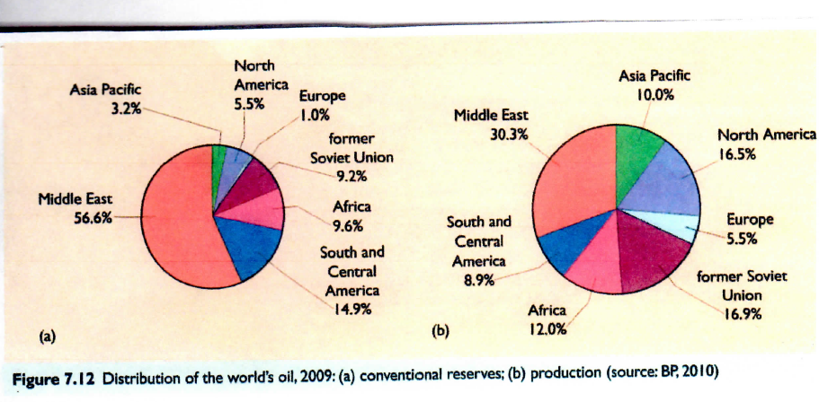

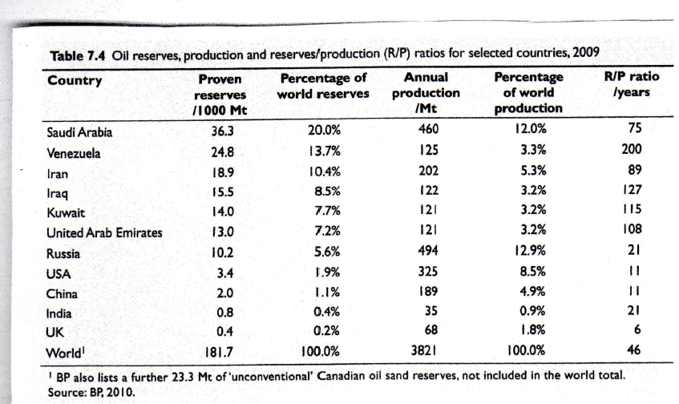

Global Proven Reserves, 2011 (Thousand Million Barrels)
- Global reserves
- 1652.6
- R/P ratio
- 54.2 years

OECD
- Reserves – 237.7
- Share – 14.2%
- R/P Ratio – 34.7 years

Non-OECD
- Reserves – 1417.9
- Share – 85.8%
- R/P Ratio 59.7 years

OPEC
- Reserves – 1196.3
- Share – 72.4%
- R/P Ratio – 91.5

Non-OPEC
- Reserves – 329.4
- Share – 19.9%
- R/P Ratio – 26.3

Region | Reserves (Thousand Million Barrels) | Share of Total (%) | R/P Ratio (Years)
Middle East | 795 | 48.1 | 78.7
South and Central America | 325.4 | 19.7 | 100+
North America | 217.5 | 13.2 | 41.7

Region | Reserves (Thousand Million Barrels) | Share of Total (%) | R/P Ratio (Years)
Europe and Eurasia | 141.1 | 8.5 | 22.3
Africa | 132.4 | 8 | 41.2
Asia Pacific | 41.3 | 2.5 | 14

- Canada’s oil sands
- total reserves – 169.2
- under active development – 25.9

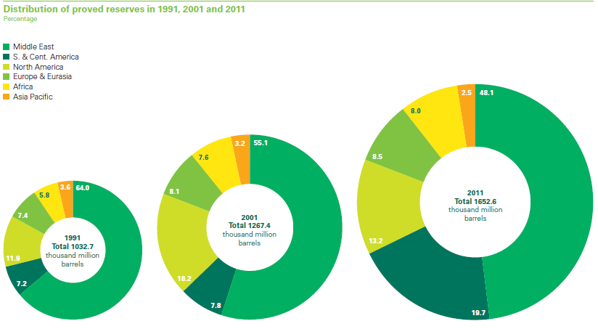

Consumption
- Global oil consumption increased by 0.7%
- weakest global growth rate among fossil fuels
- 88 million barrels per day
- OECD consumption fell by 1.2%
  - fifth decline in the past six years
  - Lowest level since 1995

- Consumption increased outside of the OECD
- 2.8%
- below average in Middle East and Africa
- China had the largest growth rate
  - 5.5%
Oil Production
- Global oil production increased by 1.3%
- almost all growth occurred in OPEC
- record output levels in
  - Saudi Arabia
  - The UAE
  - Qatar

Oil Production
- Global oil production increased by 1.3%
- almost all growth occurred in OPEC
- record output levels in
  - Saudi Arabia
  - The UAE
  - Qatar

- Largest increase in non-OPEC countries occurred in the US
- third consecutive year
- highest level since 1998
- strong growth in onshore production of shale liquids

Crude Runs
- Throughput or observed refinery intake of crude oil
- increased by 0.5%
- mostly in non-OECD countries

- Decline in OECD throughput
- however increase in US throughput
- became net exporter of refined products for the first time

Refining Capacity
- Global refining capacity increased by 1.5%
- outpaced growth in throughput for the fifth time in six years

Trade
- Global oil trade increased by 2%
- accounted for 62% of global consumption
- up from 58% around 2000
- about two-thirds of growth in trade due to China
  - increase in net imports of13%

- For exports, much of the growth accounted for by Middle Eastern countries
- 81%

- An important dimension of discussions about the future of oil relates to how long there will be ‘business as usual’
- A good perspective can be gained by looking at how world events have impacted the price of oil over the years

Oil Crisis in the 1970s
- Yom Kippur War, 1973
- disruptions in supply
- price of oil increased from about $2 per barrel at the end of 1972 to $12 per barrel by the end of 1974
- ranged between $12.21 to $13.55 fro 1974 - 1978

1980s
- Iran Revolution in 1979, Iraq-Iran War, 1980
- production cut of about 4 million barrels per day
- oil prices increased to $40 briefly and stabilized at $35 in 1981

- recession in developed countries
- increased production by non-OPEC countries alleviated the difficulties
  - 10 million barrels per day from 1980 to 1986
- Mexico
- Alaska
- North Sea

- a slump in the oil industry by the mid-1980s
  - drop to about $10 by mid-1986

1990s to present
- Major events putting pressures on prices of oil since the 1980s have been the Gulf Wars of 1990 and 2000
- OPEC has also been active in trying to control oil prices

- Around the early 2000s, prices ranged between $25 - $30
- Between 2004 and 2005, prices ranged between $40 - $50
- Due to
- interruption in supply by OPEC
- increased consumption

Crude Oil Prices at the New York Mercantile Exchange, Year end 2005 to 2012

- Other major contributory factors to current oil prices
- weak US dollar
- rapid growth of Asian economies
- associated increases in oil consumption

peak oil:

- Theory which postulates that oil production starts at zero and then rises to a peak which can never be surpassed
- After the peak is reached
- production declines
- prices go up until

- Oil production predicted to peak in the U.S. between 1965 and 1970
- peaked in 1971
- The extent to which it could be inferred to global oil reserves is subject to debate

- The International Energy Agency predicts that peak oil would be reached around 2030
- most oil predicted to be extracted by 2060

- Some things to consider
- new reserves
  - extent of new discoveries
- demand
  - nature of demand
- recoverability
  - ease of access

Coal

- A combustible rock made up of more than 50% carbonaceous material formed from the remains of land-based plants buried hundreds of millions of years ago
- as a result of tremendous heat and pressure.

- Coal seams are formed from the accretion of layers of plant material
- initially protected from atmospheric decay by water
- ultimately compressed to a tenth or less of their original thickness
- Simply, it is a black sedimentary rock containing carbon that burns

- Made up of a complex range of materials
- carbon
- hydrogen
- oxygen
- nitrogen
- lesser amounts of sulphur and other trace elements

Trace Elements
- Have an attraction to sulphur and attach themselves to coal
- arsenic
- mercury
- cadmium
- zinc

- The quality of coal deposits depends on
- types of vegetation from which it was formed
- temperatures and pressures exerted
- length of time

- Coal can be classified based on
- the extent of physical and chemical change the original plant material has undergone
  - anthracite
  - bituminous
  - sub-bituminous
  - lignite

- Anthracite (Black Coal)
- the hardest
- most carbon
- higher heat value
- Lignite (Brown Coal)
- the softest
- least carbon
- lower heat value

- Can also be classified based on
- moisture content
  - coals high in carbon and low in moisture are ranked the highest

- composition
- major components are
  - carbon
  - hydrogen
  - oxygen

Quality of Coal
- Different types of coal are characterized by their unique properties
- determines the results of burning
- Properties of coal are tested empirically by coal quality tests

Proximate Analysis
- The most basic test
- Chemical analysis to find out the amount of constituent
- moisture
- volatile matter
- fixed carbon
- ash

- Ash
- the impurities in coal
  - silica
  - iron
  - alumina
  - other incombustible matter

- Fixed carbon
- non-volatile part of the coal (minus ash)
- Volatile Matter
- the amount of gas in the coal

Ultimate Analysis
- Establishes the major elements in any sample of coal
- apart from the major elements, may indicate the presence of other elements like
  - silica
  - iron

- Coal is the cheapest way to produce intense heat for industry and for electricity generation
- produces a high useful net energy yield
- mining is highly subsidized

- The major use of coal since the late 20th Century is for the generation of electricity
- majority of world coal output sold as steam coal to be used in power stations
- The second most important use of coal is in the iron and steel industry
- approximately 2/3 of steel produced in blast furnaces using coking coal

- Different types of coal, based on their potential use
- Steam (or thermal) coal
  - used in power station
- Coking coal
  - used in iron and steel industries
- Anthracite
  - used directly as a natural smokeless fuel

- Anthracite produces the most amount of heat when it is burned
- However, it is not used as much as steam coal
- hard to crush and burn

- Other uses
- gases, oil and tar extracted from coal can be used in the manufacture of various products
  - gasoline
  - perfume
  - mothballs
  - baking powder

- can be processed in different ways to create many different products
  - carbon filters
  - pharmaceuticals
- However, in most countries less than ten percent of coal is used for purposes apart from generation of electricity or production of iron and steel

- In Alberta, coal is used to fuel more than 50 percent of the installed electricity generating capacity of power plants
- About 4/5 of Alberta’s coal is used
- as fuel for electricity generation in the province
- heating of buildings in agricultural activities
- cement manufacturing and other industrial processes

- The most abundant fossil fuel in the world
- A very widespread resource
- in over a hundred countries
- on every continent with the exception of Antarctica

- More than a quarter of the world reserves of coal is found in the U. S.
- U. S. coal can be found in two main areas
- east and west of the Mississippi
- More than 50% of the coal in the east are obtained from deep mines
- high mining costs
- high energy content per tonne
- proximity to industrial customers

- About 50% of the coal in the west are obtained from surface mines
- low sulphur content
- heat value about half of the east’s

- Canada’s proven reserves of coal rank tenth in the world
- 70% of Canada’s reserves are found in Alberta
- Alberta’s coal reserves contain more than twice the energy of all of the province's other non-renewable energy resources

Natural gas

- A mixture of hydrocarbon and small quantities of non-hydrocarbons that exists either in the gaseous phase or is in solution in crude oil in natural underground reservoirs, and which is gaseous at atmospheric conditions of pressure and temperature.

- Gaseous mixture of light hydrocarbons found underground within sedimentary rock formations
- in same locations as crude oil
- process of formation similar to crude oil

- In the early days of the oil and gas industry, discoveries of natural gas mostly connected with discoveries of oil
- for each barrel of oil discovered, 1700 cubic metres of gas is found

- Made up of mostly methane
- about 95% of total volume
- Other components
- ethane
- propane
- butane
- pentane
- nitrogen
- carbon dioxide
- helium
- hydrogen sulphide
- water vapour
- traces of other gases

- Process of capture
- holes drilled into the rocks containing the gas
  - normally will come up under its own pressure
  - sometimes, pumps and other more complicated methods may be needed to get it to come up

Distribution
- Appreciably widespread around the world, with the largest reserves in
- the former Soviet Union
- the Middle East

- Building of transnational distribution networks across Western Europe precipitated by discovery of large gas fields
- Groningen, the Netherlands, 1959
- offshore in the United Kingdom, 1965

- Continental pipelines laid to the Netherlands
- Britain got its first national transmission system to complement local distribution systems

- Large capacity pipelines built from the Soviet Union into Central Europe and from Algeria to Italy
- facilitated by increasing consumption

- One of the fastest growing energy sources
- cleaner than oil or coal
- does not carry the ‘baggage’ associated with nuclear power

- Serves a variety of purposes
- space and water heating
- electricity generation
- cooking
- mechanical power
- transportation

- The major uses are
- heating
  - approximately, 75%
  - over 90% of its potential energy can be converted into useful energy by ultra high-efficiency gas furnaces
- electricity generation
  - approximately, 15%

- For electricity generation,
- it is burned to produce heat for boiling water
- the generated steam passes through a turbine to generate electricity
- More expensive when converted into electricity
- increased fuel cost

Use in Vehicles
- Benefits over conventional fuels
- lower emissions of carbon dioxide and other harmful pollutants
  - nitrogen oxides
  - particulate matter
  - toxic and carcinogenic materials

- less dramatic impact on engine performance than gasoline
  - few cold start problems
  - higher octane value produces higher engine compression ratio
    - higher power
    - better fuel efficiency

- Generally results in cleaner and longer lasting engines
- less build up of carbon on spark plugs, engine oil and in the combustion chamber

- Can help in the transition to fuel cell vehicle technology
- hydrogen can be developed from natural gas
- lessons learned from development of natural gas technology can help in the development of hydrogen fuel

Challenges
- Low energy density compared to other fuels
- thus unfeasible as transportation fuel at ambient temperatures and pressures
- need to be either compressed or liquefied to increase its volumetric energy density

- Compressed natural gas can be very hazardous
- need to provide ventilation in maintenance garages and vehicle storage buildings
- Requires significantly different fuel supply system

- Large storage tanks needed
- long fuelling times
- might not be suited for private vehicles

Year | Total | North America | Former Soviet Union | Japan | Western Europe | Other
1970 | 955 | 590 | 185 | Negligible | 70 | 110
1980 | 1270 | 550 | 350 | 25 | 190 | 155
1990 | 1770 | 540 | 600 | 50 | 230 | 350
2000 | 2160 | 650 | 490 | 70 | 350 | 600
Increases in Consumption
- Rapid increase in use over the years, mostly in North America and Europe
- one of the highest growth rates among fossil fuels
- 230% increase in global use between 1970 and 2000
- by 2020, expected to double to about 450% of 1970 levels

- Modest consumption levels in other parts of the world
- Asia
- Africa
- South America
- Japan, however, has relatively high consumption levels

World Natural Gas Consumption, 1970-2000
(Millions of Tonnes of Oil Equivalent)

Global Proven Reserves, 2011
(Trillion Cubic Metres)
- Global Reserves
- 208.4
- R/P Ratio
- 63.6

OECD
- Reserves – 18.7
- Share – 9%
- R/P Ratio – 16 years

Non-OECD
- Reserves – 189.7
- Share – 91%
- R/P Ratio – 90 years

Regional Distribution: Proven Reserves at End of 2011

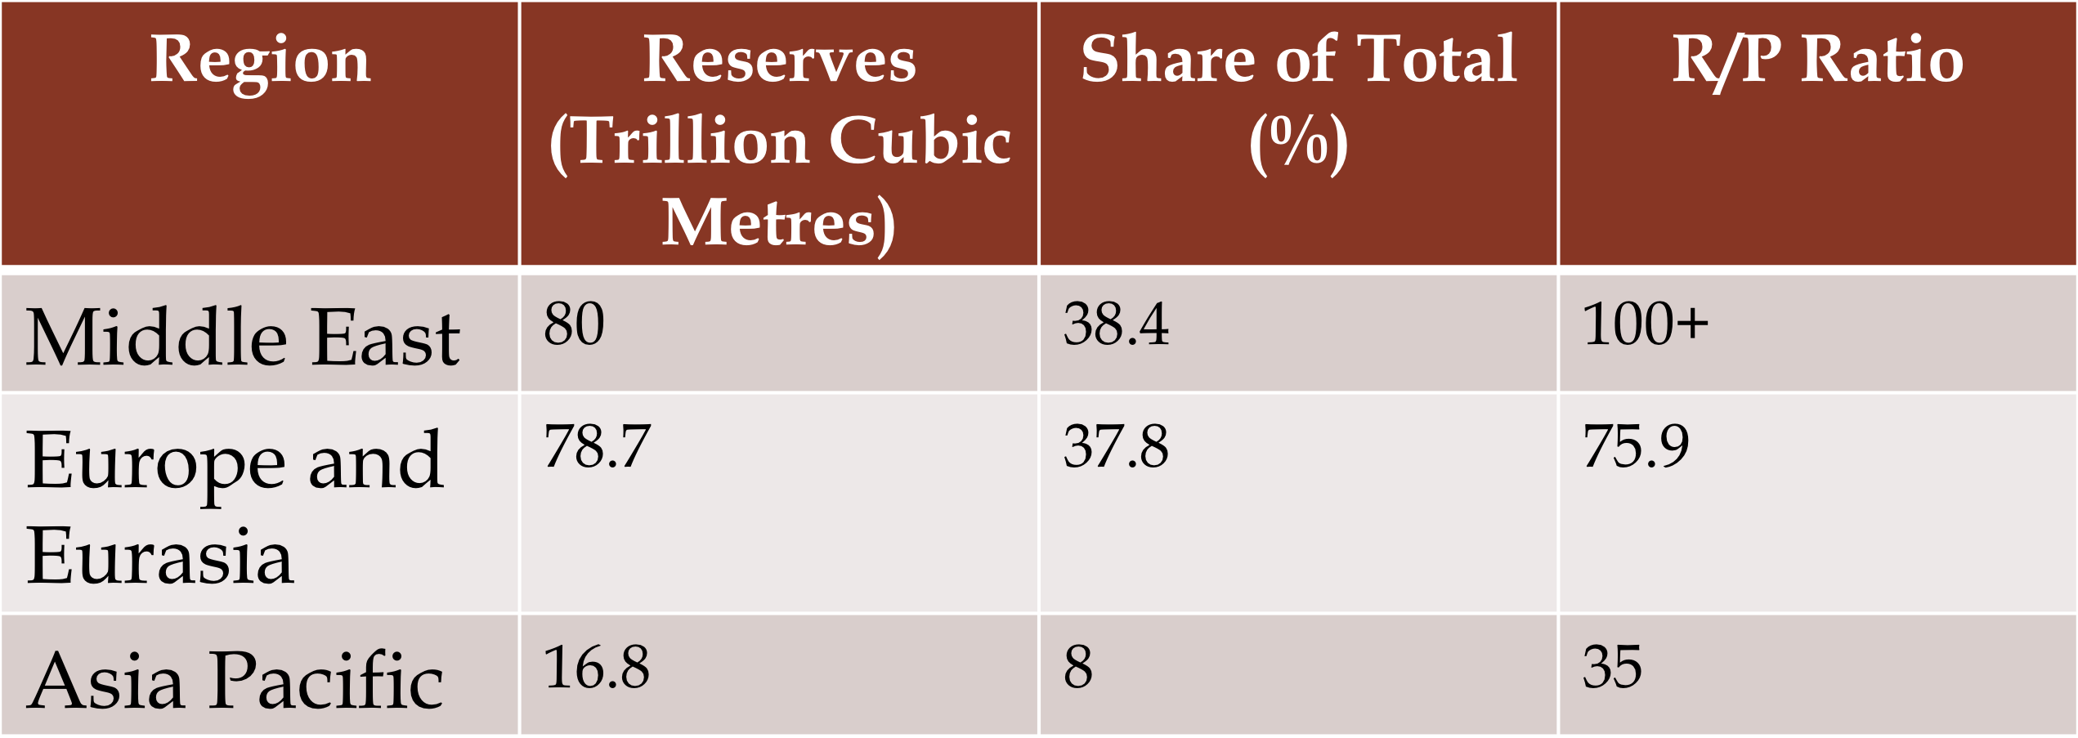

Region | Reserves (Trillion Cubic Metres | Share of Total (%) | R/P Ratio
Africa | 14.5 | 7.0 | 71.7
North America | 10.8 | 5.2 | 12.5
South and Central America | 7.6 | 3.6 | 45.2
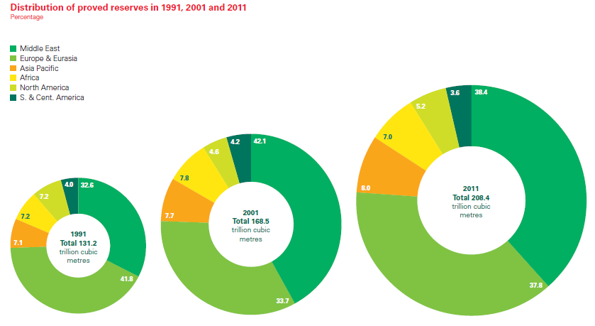

Highlights 2011:

Consumption
- Increase in global consumption
- 2.2%
- consumption growth below average in all regions with the exception of North America
  - strong growth due to low prices

- Largest growth in consumption outside North America occurred in
- China (21.5%)
- Saudi Arabia (13.2%)
- Japan (11.6%)
- The EU experienced the largest recorded decline in gas consumption
- -9.9%
  - weak economy
  - high gas prices
  - warm weather
  - continued growth in generation of renewable power

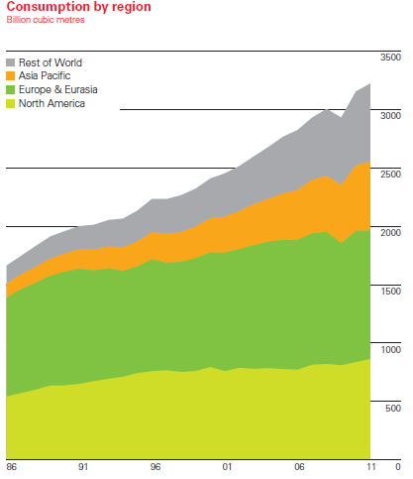

Production
- Increased by 3.1%
- largest national increase in the U.S.
  - world’s largest producer
- largest regional increase in the Middle East

- Other areas that experienced large increases in production
- Qatar
- Russia
- Turkmenistan

- The EU had the largest recorded decline in gas production
- -11.4%
  - mature fields
  - maintenance
  - weak regional consumption

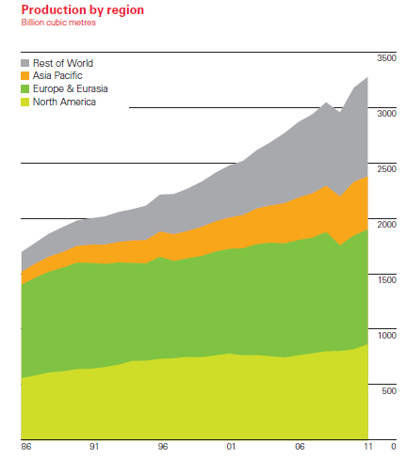

Trade
- Global natural gas trade increased by 4%
- Pipeline shipments increased by 1.3
- Increases in
- China (from Turkmenistan)
- Ukraine (from Russia)
- Turkey (from Russia and Iran)

- Declines in imports by
  - Germany
  - UK
  - US
  - Italy

- Liquefied Natural Gas shipments increased by 10.1%
- Qatar accounted for 87.7% of the increase
- Largest importers were Japan and the UK
- Accounts for 32.3% of global gas trade

Environmental impacts:

- Much cleaner than oil and coal
- 50% less carbon dioxide per unit of energy produced than coal
- 25% less than oil
- thus increasingly looked at as a potential fuel of choice in the future

- However, there are concerns about its main component – methane
- can trap more heat than carbon dioxide
- thus may offset the carbon dioxide benefits of natural gas

