Week 3 – Chapter 5: Theories of Gender Development

Freud’s Theory of Personality: emphasizes the differences between personality development and functioning of men and women
- made in the late 19th century, controversial
- women were inferior to men but he was also a supporter by hiring them
- concepts used; unconscious, conscious personal awareness, energy (life & death instincts, drive, impulse)
Oedipus Complex: the focus on genital activity as a child matures is a result of sexual attraction to the parent of the other sex and an increasing desire to have sex with this parent
Castration Complex: when the boy comes to fear that their father will remove their penises due to their hostility and affection for their mothers
Penis Envy: when the girl begins experiencing feeling of inferiority concerning their genitals
- the desire for sex and babies is the expression of penis envy

Concerning Women - women were essentially failed men.
- Considered that an intelligent, independent woman deserved credit and praise and might be « virtually as good as a man » (Gay)
- Despite his research stating women were inferior, he still hired women into the ranks of his psychoanalytic training (including his daughter)
- Paper « Femininity », acknowledging awareness of the criticisms and his own far-from-complete understanding

Horney
- Interpretation of feminine masochism (deriving pleasure from pain) differed from the Freudian version
- Accepted unconscious as a motivating force in personality, her emphasis on sexual feelings and events in personality development, and her belief in the importance of early childhood experiences for personality formation.
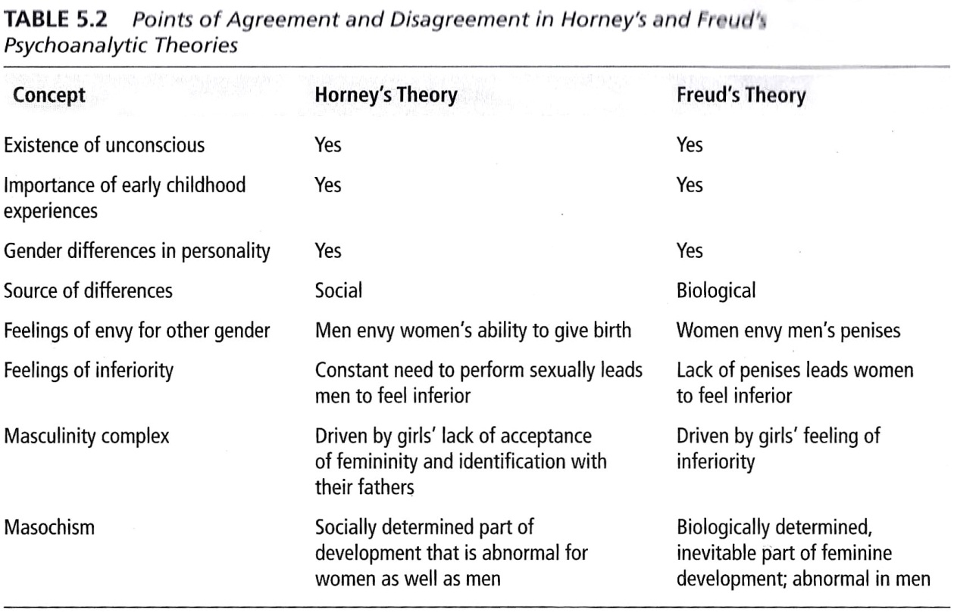
- Belief in the importance of social rather than instinctual, biological forces in personality development

Penis Envy vs. Womb Envy - Horney
- Believes penis envy was a symbolic longing for the social prestige and position that men experience rather than a literal physical desire.
- Hypothesized that men envy women’s capacity to reproduce (womb envy).
- Interpreted men’s strivings for achievement as an overcompensation for their lack of ability to create by giving birth
Feelings of Inferiority - Horney
- Believed that M fear and attribute evil to W b/c they feel inadequate when comparing themselves to W.
- M go through life needing to prove their masculinity and do so by having sexual intercourse.
- Failure in erection = lack of masculinity = feeling of inferiority.
- W do not suffer feelings of inferiority for reasons related to sexual performance.
- Female inferiorities originate with male insecurities rather than with the perception of inferior genitals. Perpetuated by men’s behavior toward W and by masculine bias in society.

- Babies have no sense of self vs. other people or the world.
- Mothers provide most nurturing and fathers do little caregiving, thus focusing on the mothers relationship with the children. Permanent imprint on personal development differs for boys & girls
- Concentrates on the pre-Oedipal period during early childhood, centers on the process of being mothered by a W
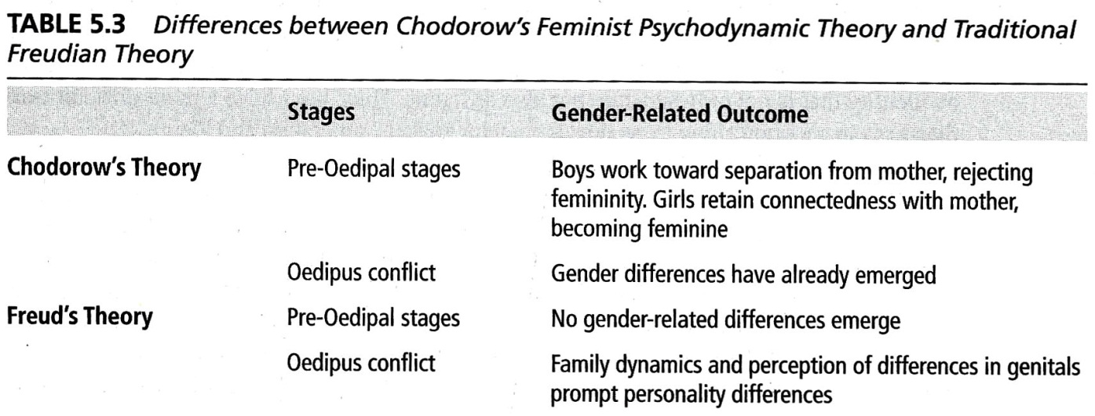

Kaschak’s Antigone Phase
- Antigone (Oedipus’ daughter and half-sister) sacrifices an independent life to take care of her blind father. He considered it his right to have this level of devotion. She became a symbol of the inevitable fate of the good daughter in the patriarchal family (passive and dependent, subservient, denying her own needs).
- In taking power men consider women their possessions. Many M and W never resolve their complexes (Oedipus and Antigone) because the social structure perpetuates differential power for W and W, encouraging both to adhere to these different roles.

- M tend to seek power and sex in self-centered ways that may be destructive to others (family violence, incest, and rape).
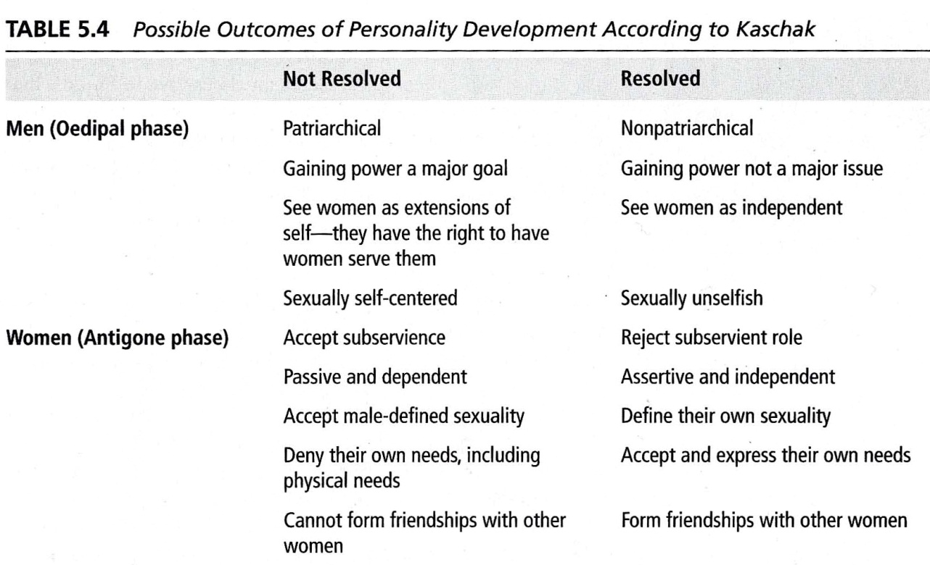
- M may engage in systematic violence within their families b/c they feel that they have the right to do so

All these theories have the shortcoming of relying heavily on unconscious mental processes to explain important events in personality development, a problem for scientific testability or how to provide adequate observable research evidence.
All these theories emphasize the importance and inevitability of gender differences. However, many other theories of gender development do not share this view.

2 Views on Gender Development for M&F
1) The Social Learning Theory
- Classifies gender development as behaviors that are learned.
- Development is a CONTINUOUS process
  - Process consists of learning a gender role composed of socially significant activities that M and W engage in with different frequencies.
  - A script that M and W follow to fulfill their appropriate masculine or feminine parts, behaving in the expected way in the appropriate situation.
- Emphasizes the influence of the social environment (gender role determined by social factors)
- Extended to include cognitive processes.
- The social environment provides children with examples of male and female models who perform different behaviors, including behaviors that vary by gender
- Children tend to be more influenced by powerful models and by models who are similar to them
- Future behavior can be predicted from past experience. Learning is cognitive, performance is behavioral
- Observation more important than reinforcement in the process of learning

Performing Learned Behaviours
- Observing the consequences of those behaviors: if rewarded, do it; if punished, refrain from doing it.
- Children are exposed to models of gender-stereotypic behaviors (home, school, readers, storybooks, television screens).
- Children learn the gender-related behaviors associated with both genders.
- Children learn which behaviors are gender-appropriate for them.
- Certain behaviors are rewarded for girls and not for boys; for other behaviors, rewards come to boys and not to girls (dolls vs. toy trucks).
Consistency
- Not necessary for children to learn gender-related behaviors (Bandura)
- Children observe many models, notice consistencies and start overlooking exceptions.
- Behaviors come to be gendered although these behaviors have no direct relationship to sex.
- Children become selective in their modeling.
Preference for Boys
- When their children are infants, parents interact differently with their sons and daughters.
- Parents choose toys for play, tend to pick masculine toys for boys and feminine or neutral toys for girls
- Adults who are not parents show even more stereotypical toy choices than parents (Campenni)
- During preschool years, boys come to believe that their fathers disapprove of cross-gender toy choices and reject them
Modeling and Approval
- 4-year-olds begin to develop a coherent set of standards that they apply to gender-related behaviors.
- Interacting with peers outside the home, other children become a major source of modeling and approval.
- Play groups tend to be segregated in school settings, using insults and severe prohibitions aimed at those who attempt to join other-sex group
Preferential Treatment
- Both parents and teachers are more likely to urge boys to persist in solving problems than they are to urge girls.
- Models and reinforcements tend to encourage boys toward careers and sexual expression; girls toward deomesticity and physical attractiveness (Peters, 1994).
- Children develop in environments that contain many sources of social learning leading to differences in gender-related behaviors.
2) Cognitive Theory of Gender Development
- Bem criticized social learning arguing that the theory portrays children as too passive.
- Our approach to the problems of sexual development starts directly with cognition
- Development occurs in a SERIES OF STAGES
- Children’s behavior shows more signs of more active involvement than what social learning theory hypothesizes.
- Children form cognitive categories for gender and then acquire gender-related knowledge around these categories.
- Children may develop stronger gender stereotypes than their parents convey. They actively organize information about gender.
PROBLEMS: 1. Emphasis on gender constancy as the primary force underlying the development of gender identity. Kohlberg’s prediction not clear enough. Research failed to demonstrate this.
2. Need to treat gender as any other cognitive category. Theory fails to explain why children choose gender as a primary domain around which to organize information. Gender schema theory addresses this problem by extending the concepts in cognitive developmental theory.

Gender Labeling: ability to label self and others as male or female.
- 2-year-olds are unable to apply the words boy or girl consistently to self or others
Gender Constancy: the belief that gender will remain the same throughout life
- concept rarely appears before age 4 for children
- for children, understanding reality develops before or concurrently with gender constancy
- kids as young as 2 years old exhibit stereotypical gender-related knowledge that relates to their comprehension of gender identity and gender constancy
- acquiring gender stereotypes is related to development of gender constancy

Cognitive Development vs. Social Learning
Emphasis on cognition.
Series of discrete stages.
Environment and culture are important.
Children acquire gender-related behaviors as part of their general cognitive development.
Cognitive adoption of a gender identity.

Emphasis on cognition
Development = continuity
Environment and culture are even more important.
Children acquire gender identity because they model gender-related behaviors.

Performance of gender-related behaviors

Schema: a cognitive structure, a network of associations that organizes and guides an individual’s perceptions
- Piaget’s term used to describe how cognitions are internalized around various topics
- hypothesized that children develop gender-related behaviours because they develop schemata that guide them to adopt such behaviours
- it is a process rather than concept , how we form them and act in ways that are consistent with them.
- theory predicts that cognitive changes accompany schema formation, which changes the ways in which we behave
Example: gender-schematic preschoolers behave in more gender-typical ways than less schematic children

- Culture provides a reference for the formation of gender schemata
- Children encode and organize gender info through a social environment that defines maleness & femaleness
- Gender schemata predicts that developing gender schemata increases accuracy and memory for gender-consistent information compared to gender-inconsistent information. Studies have demonstrated such memory effects in children and adults.
- Gender is a strong cognitive organizing principle that affects stereotyping
- Some validity across cultures

- The development of gender schemata influences the way that people interpret information
- A tendency to interpret information in gender-schematic terms may lead to gender stereotyping, exaggerated and narrow concepts of what is appropriate and acceptable for each gender.
- The formation of gender stereotypes can be understood as a natural reflection of the use of gender schemata

Effects of Gender Stereotyping
1) Positive
- increased ease in classifying behaviors and objects gives children the feeling that the environment is manageable and predictable.
2) Negative
- leading to inaccurate perceptions and failures to accept information that does not fit the stereotype.


