Week 2 – Chapter 4: Hormones and Chromosomes

Endocrine Glands: secrete hormones into the circulatory system.
Hormones: chemical substances released from endocrine glands throughout the body in the bloodstream, affecting target organs that have receptors sensitive to specific hormones. Produce different actions in different sites.
Gonads: Reproductive organs, ovaries and testes, physical characteristics differentiating sexes, essential to reproduction but not the only endocrine glands important for sexual development and functioning.
Steroid Hormones (also called gonadal hormones): relate to reproduction + differences between the sexes. Each sex produces these hormones:
- Androgens (ex. testosterone), men typically tend to produce more.
- Estrogens (ex. estradiol), women typically tend to produce more.
- Progestins (role preparing women’s bodies for pregnancy not sure role in men’s bodies)

2 Brain Structures Essential to Regulate Production of Sex Hormones
1) Hypothalamus
- its complex action results in the production of releasing hormones including gonadotropin-release hormones.
2) Pituitary Gland
- an endocrine gland within the brain that produces tropic hormones that stimulate ovaries and testes to release their hormones.
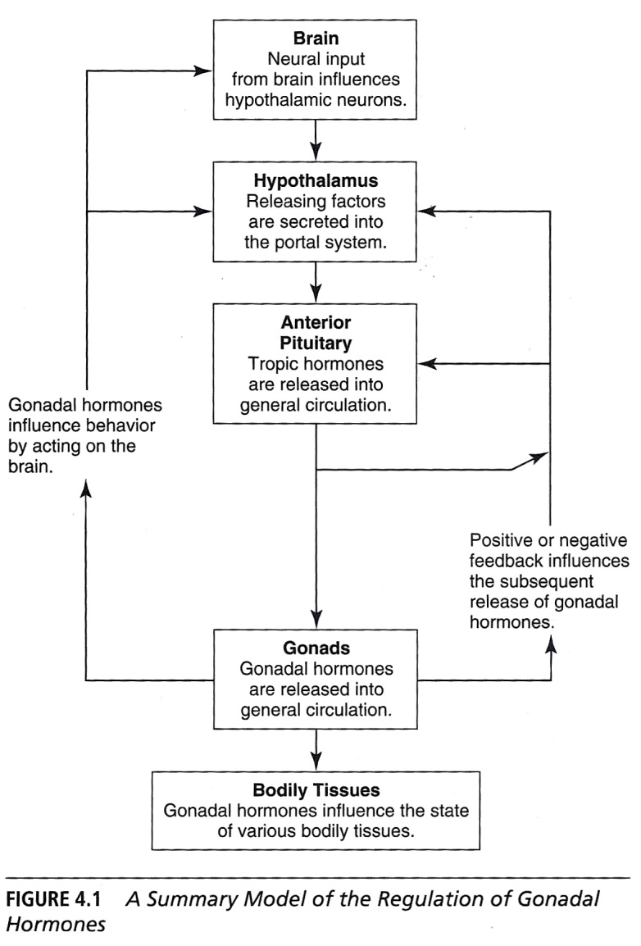

Tropic Hormones: produced by the pituitary gland that influences the release of other hormones by other glands such as the gonads.
Adrenal Glands: produce steroid hormones too, important in differentiating female and male.

Stages of Differences between Sex
- Humans are sexually dimorphic (they come in female and male physical versions).

Sexual Dimorphism: the result of development that begins with conception and ends at puberty, resulting in M & W capable of sexual reproduction.
- 5 stages of development: genetic, gonadal, hormonal, internal genitalia and external genitalia

5 Stages of Development
1) Genetics
- inheritance of the chromosomes related to sex.
2) Gonadal Stage
- development of the gonads
3) Hormonal Stage
- begins during prenatal development with the secretion of androgens and estrogens.
- also occurs at puberty, producing mature, functional gonads
4) Internal Genitalia Stage
- internal reproductive organs develop
- occurs prenatally.
- affects ovaries and testes.
- affects also other internal structures related to reproductive functioning : ovaries, Fallopian tubes, uterus and upper vagina in women and testes, prostate gland, seminal vesicles, and vas deferens in men
5) External Genitalia Stage
- reproductive structures that can be seen without internal examination including clitoris, labia and vaginal opening in women; penis and scrotum in men.
- these developments result in differences apparent at birth.
- this stage occurs later during the prenatal period, later than the development of internal genitalia

Prenatal Development
- Critically important in the development of sex characteristics.
- For a clear « It’s a boy » « It’s a girl », many prenatal events must occur in a coordinated sequence.
- These prenatal events occur within a complex set of stages that usually results in a girl or a boy. (Sometimes, things go in a different way)
- The result is a baby whose sex may be ambiguous, combining characteristics of male and female.
- Rather rare, they provide a means of understanding the necessary elements of typical development

Complex Process: most cells in human body contain 23 pairs of chromosomes, ova and sperm carry half that amount of chromosomal material. Pair number 23 is the critical one.
X Chromosomes: one of the possible alternatives for chromosome pair 23. Two make genetic females whereas only one makes genetic males.
Y Chromosomes: One of the possible alternatives for chromosome pair 23. One X and one Y chromosome make a genetic male, whereas genetic females have 2 X chromosomes in pair 23

Development of Internal Reproductive Systems
- Reproductive organs
1. Wolffian reproductive ducts (male)
2. Müllerian reproductive ducts (female)

Reproductive Organ Process for Fetuses
1) Within the first 6 weeks of prenatal development, no difference exists between male and female embryos
2) If the fetus is exposed to testosterone, the Wolffian system develops into male reproductive organs & the Mullerian system degenerates
3) If the fetus is left unexposed to anything, the Mullerian system develops into female reproductive organs

Wolffian System: a system of ducts occurring in both male and female embryos that forms the basis for the development of the male internal reproductive system (testes, seminal vesicles, and vas deferens).
Müllerian System: a system of ducts occurring in both male and female embryos that forms the basis for the development of the female internal reproductive system (ovaries, fallopian tubes, uterus and upper vagina).
- during the 3rd month of prenatal development, 2 processes begin occurring in fetuses with XY chromosome patterns

2 Reproductive Organ Diseases
1) Production of Androgens
- a gene on Y chromosome prompts the development of fetal testes, which produce androgens (Hiort, Thyen, & Holterhus, 2005).
- presence of androgens stimulates the development of the Wolffian system.
- growth of the testes increases production of testosterone which stimulates development of the male pattern (masculinization)
2) Production of Müllerian-inhibiting substance.
- causes the Müllerian system to degenerate (defeminisation)

From the Mullerian System
- differentiation of the ovaries also occurs because of the action of the genes but the female ovaries produce few estrogens.
- development of the system requires no surge of fetal hormones.
- in female embryos, Wolffian system degenerates and the Müllerian system develops, resulting in ovaries, uterus, fallopian tubes and upper part of the vagina

6 Weeks After Conception
- External genitalia of male and female fetuses are identical.
- Structures start to differentiate into the two different patterns after the 7th week of gestation.
- Prenatal production of androgens generates the male pattern and the absence of androgens results in an incomplete version of the female pattern.
- The only thing that is defaulted in female development is our failure to understand how it is regulated (Breedlove, Cooke, & Jordan)

The Nervous System
- during prenatal development, hormones that produce sexual dimorphism also affect the brain, making it possible for the brain structure and function to vary by sex
- M have larger brains than W
- some brain structures differ for M & W
- Are men smarter b/c of their larger brains (McDaniel)? Some conclude that type of cognitive activity and brain organization interact with brain volume and gender in complex ways that prevent any simple correlation

Sexually Dimorphic Structures: structures in the brain beneath the cerebral cortex are considered sexually dimorphic
- these structures include; anterior commissure, massa intermedia and corpus callosum (callosum is considered the place where SD occurs as little evidence supports the others)
- left and right hemispheres may also differ in M & W, making lateralization a different way to study the brain

Lateralization: concept that two cerebral hemispheres are not functionally equal but rather that each hemisphere has different purposes
- these purposes would include; left language and speech; right spatial abilities

Meta-Analyses: lateralization of function does not differ significantly for M & W

Sexually Dimorphic Nucleus (SDN): a small section of the hypothalamus
- Evidence for sexual dimorphism in the brain is strongest for that small section of the hypothalamus as its function may be related to sexual behavior or gender identity
- Very sensitive to testosterone and estrogen, both influence it’s development
- From birth to 4yrs, the number of cells in the SDN increases rapidly
- Number of cells decrease in girls but not in boys creating a sexual dimorphism that peaks in young adulthood to middle age (SDN is 2.5x larger in M than W)
- Spinal Nucleus of the Bulbocavernosus is 25% larger in M than in W
- The neurons aid in the ejaculation of sperm in M and constrict the opening of the vagina in W

Caution in Interpretation
1. Related to interpretations for sex and gender differences in understanding hormonal vs social factors.
2. Tendency exists to see a one-way chain of causality in which genetic and hormonal influences produce physiology which in turn produces behavior.
3. This reasoning is false because it is impossible to separate biological from social influences and because the causality goes both ways.
4. It is possible to concentrate on either biological or psychological measurements BUT any distinctions made are illusory. Social influences can affect behavior which can alter the brain

Changes During Puberty Gonodal, hormonal, genital and brain organization are not sufficient to produce sexually interested and sexually active people capable of reproduction.
Such changes depend on the activating effects of hormones during puberty (releasing effect).

Hormones Important for the development of sexual interest in humans
Sexual interest usually precedes puberty. Around age 10, many children show great curiosity concerning sex
One mechanism for this development is the maturation of the adrenal glands which occurs at this time (produces androgens & estrogens which may be important to the development of sexual interest)

2 Hormones Produced by the Pituitary Gland
1) Follicle-Stimulating Hormone (FSH)
- the gonadotropic hormone that stimulates development of gonads during puberty and development of ova during the years of W’s fertility
2) Luteinizing Hormone (LH)
- the gonadotropic hormone that prompts sexual development during puberty and also causes a maturing ovum to be released

FSH & LH Reproduction Steps
1) The cyclic variation of LH and FSH produces the menstrual cycle, beginning with an increase in the production of LH releasing factor and FSH releasing factor by the hypothalamus.
2) FSH stimulates follicles, a group of cells within the ovaries, to mature an ovum. LH causes the follicle to rupture and release the ovum which begins to travel down the fallopian tube.
3) Remainder of the follicle starts to produce the hormone progesterone which prepares the uterus to receive and implant the ovum, if it happens to be fertilized. Then all of these hormone levels begin to decline.
4) If the ovum is fertilized, pregnancy will produce an increase in estradiol and progesterone but if the ovum is not fertilized, the prepared lining of the uterus is shed in menstruation.

FSH & LH in Boys
- Puberty causes the maturation of internal and external genitalia, including growth of the penis, seminal vesicles, and prostate.
- Maturation of seminal vesicles and prostate is necessary for ejaculation of seminal fluid and sperm production is necessary for fertility.
- FSH is involved in the production of sperm.
- LH contributes to the maturation of sperm, but its main function is to stimulate the production of testosterone.
- Testosterone is controlled by feedback to the hypothalamus which can inhibit or prompt the production of LH and FSH, which in turn can affect the production of sperm.

Hormonal Declines and their Effects
- such declines can occur for a number of reasons, including removal of the gonads or decreased hormone production associated with aging.
MEN - removal of the testes tends to produce a decrease in sexual activity, but the extent and
rate of decrease varies from person to person (Bancroft)
- some men experience the significant and rapid loss of either ability to get erections or ability to ejaculate or both.
- other men experience a slowly decreasing interest in sexual activity, followed by difficulty in ejaculating, and then by loss of ability to achieve erections
- Replacement testosterone can be used to reverse the decline in sexual interest and possibly in sexual performance
- Testosterone replacement therapy (TRT) has created testosterone patches & testosterone gel with clear short-term effects. Long-term effects are not yet known
WOMEN - sexual interest does not always seem to decline in the removal of ovaries
- may be because a. androgens are used in women for sexual interest and are unaffected by the removal of ovaries (sufficient enough to maintain with just androgens)
b. mature, older women mediate the procedure by experience and expectation leaving hormones with little control over the person

Sexual Development Problems That Can Occur
1) Number of Sex Chromosomes

a. Turner Syndrome: disorder that occurs when an individual has only one chromosome of pair 23, one X chromosome.
- these individuals appear to be female (have the external genitalia of females) but do not have fully developed internal genitalia.
- they do not produce estrogens, do not undergo puberty, and are not fertile.
b. Klinefelter Syndrome: the disorder that occurs when a chromosomal male has an extra X chromosome, resulting in the XXY pattern of chromosome pair 23.
- these individuals have the appearance of males, including external genitalia
- may also develop breasts and a feminized body shape
- testes are not capable of producing sperm, thus sterile

2) Prenatal Hormones

a. Congenital Adrenal Hyperplesia: disorder that results in masculinization , producing
premature puberty in boys and masculinization of the external genitalia in girls.
- girls are more likely to be « tomboys ».
- also called adrenogenital syndrome.
b. Androgen Insensitivity Syndrome: disorder in which body cells are unable to respond to androgens, resulting in the feminization of chromosomal males.
- these individuals have undescended testes, but their external genitalia appear female.
- they have no ovaries, fallopian tubes or uterus
- will never reach menarche or grow pubic hair

Menarche: the beginning of menstruation

Intersexuality: disorder in which individuals have characteristics of both sexes, either an ovary on one side of the body and a testicle on the other side, or both types of tissue combined into a structure called an ovotestisa.
- a more modern term for hermaphroditism (extremely rare)
- the intersex individuals represent cases in which chromosomal, hormonal, gonadal, and genital sex are not consistent and show that the determination of sex does not necessarily require complete consistency
- these individuals may identify themselves unambiguously as male or female. Or they may not. Some experience difficulties.
- although hormones play a very important role in determining reproductive physiology, sex and gender are more than the function of hormones
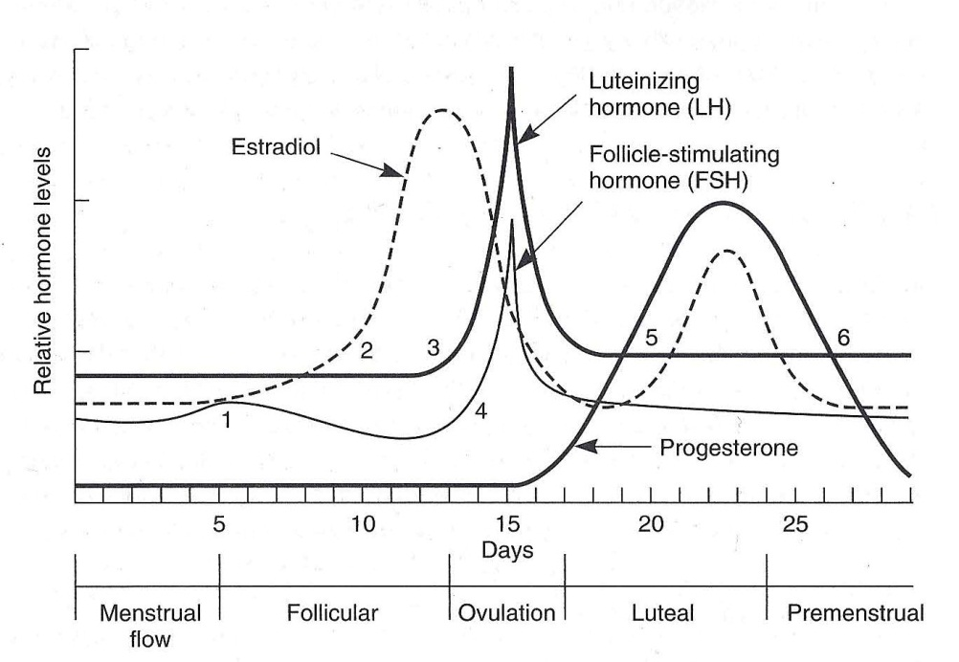

Premenstrual Syndrome (PMS): symptoms include headache, backache, abdominal bloating and discomfort, breast tenderness, tension or irritability, depression, increased analgesic, alcohol or sedative use, decreased energy and disruption in eating, sleeping, sexual behavior, work, and interpersonal relationships
- this concept can be traced to the 1960’s

PMS & Hormonal Change
- All hormonal changes that occur during the menstrual cycle have been candidates for the underlying cause of PMS
- Possibilities include an excess of estrogens, falling progesterone levels, and the ration of estrogens to progesterone (However hormonal differences show no relationship with symptoms)
- The failure to tie any pattern of hormonal changes to PMS experience is major problem for the concept.

PROBLEMS FOR DIAGNOSIS
1. No hormone or laboratory test for PMS.
2. Almost 19% of women in the United States report menstrual-related problems. These
problems include menstrual symptoms (heavy flow and cramping) and PMS symptoms
(anxiety, depression, and sleep problems).
3. Confusing the diagnosis of PMS with PMDD (premenstrual dysphoric disorder). Check
DSM-IV. This is a more severe version of PMS. Treatment includes prescription antidepressant drugs.
4. The belief in PMS is more widespread than PMS

2 Longitudinal Studies (McFarlane)
1) Involved instructing women (and men) to keep records of their daily moods without knowing that the menstrual cycle was the focus of the study (to avoid bias by alerting participants to the topic of the study).
- included women who were cycling normally, women who were taking oral contraceptives and thus not ovulating, and men.
- no differences in mood stability appeared when comparing young women and young men who participated in the study.
- all participants experienced similar mood changes within a day and from day to day.
- men and women reported similar variability in mood during the 70 days of the study
2) Participants were older than the typical college student participants and lasted at least 12 weeks to cover more menstrual cycles. The analysis included an evaluation of each participant’s cyclic mood variation over time.
- people experienced cyclic mood variations but these changes did not conform to the PMS pattern.
- the women who were cycling normally reported more pleasant moods during and immediately after their periods than in the ovulatory or premenstrual periods.
- few reported emotional symptoms consistent with PMS

Why Do So Many Women Believe They Have PMS?
- One reason is perception of the signals that predict the onset of menstruation.
- Most women recognize their bodies’ signals and know when their periods are going to start. Some are more sensitive than others
- The cognitive process of attribution allows for the maintenance of beliefs in PMS that have no basis (illusory correlation).
- It may be easier for some women to attribute negative moods to PMS rather than other source (i.e. stress, pressures in daily life, relationship conflicts)

PMS Can Become A Self-Perpetuating Myth
- Both M & W are willing to attribute moody behavior to PMS
PMS easy explanation for women who react to problems, stress and irritation in their lives and for people who observe the reactions.
- so is the syndrome « real » or « not real »?
- women are not imagining their discomfort, irritations, anxiety, bloating, sleep problems, and cramps. But, they may be misattributing the symptoms to PMS when other explanations would be more accurate.
- even PMDD may be a created disorder with little validity as a separate diagnosis

Summarizing PMS
1. It has received wide publicity and acceptance.
2. Research has failed to confirm a biological basis.
3. Emotional symptoms are subject to expectations and attribution.
4. It may be convenient to explain women’s negative moods in terms of PMS or even PMDD but it is probably not accurate to do so

Menstrual Cycle Phases
1. In response to an increase in FSH, small spheres of cells called ovarian follicles begin to grow around individual egg cells (ova).
2. The follicles begin to release estrogens such as estradiol.
3. The estrogens stimulate the hypothalamus to increase the release of LH and FSH from the anterior pituitary.
4. In response to the LH surge, one of the follicles ruptures and releases its ovum.
5. The ruptured follicle under the influence of LH develops into a corpus luteum (yellow body) and begins to release progesterone, which prepares the lining of the uterus for the implantation of a fertilized ovum.
6. Meanwhile, the ovum is moved into the Fallopian tube by the rowing action of ciliated cells. If the ovum is not fertilized, progesterone and estradiol levels fall and the walls of the uterus are sloughed ouff as menstrual flow and the cycle begins once again.

3 Possibilities of Testosterone Aggression
1) Testosterone may cause increases in aggression.
2) Aggressive behavior may cause increases in testosterone levels.
3) Levels of testosterone and aggression may be mediated through some other biological or social mechanism

Dabbs
- dozens of studies on hormone levels and behavior in M and W: discovered that high testosterone levels are related to impulsive and antisocial behaviors, but few studies found a link to aggressive or violent behaviors.
Men with high levels of testosterone: Drug and alcohol abuse, antisocial behavior,
affective disorders
History of trouble with parents, teacher and
classmates
More instances of going AWOL (absent without
leave) while in the military.
Lower-status occupations
- discovered that women with high levels of testosterone had the highest incidence of unprovoked violence within the prison group, low levers were those who had committed violence in protecting themselves
- aggression and violence are influenced by factors other than testosterone level, including SES, which moderate the relationship between testosterone and problem behaviors in men

Aggression May Cause Increases in Testosterone
- Much evidence for this position comes from investigations of male and female athletes and the effects of competition on testosterone levels.
- Mazur’s study examined the relationship between testosterone levels and winning vs. losing in tennis competition.
- Researchers expected to find effects for winning vs. losing matches but the effects were much more complex and related to the players’ evaluations of their performance; players who felt positively about their performance tended to have higher testosterone levels after games.
- Competition boosts testosterone levels, and the effects apply to both M and W. Competition raises testosterone levels but the findings also hint that other factors may also be important.

Another Explanation? - another possibility for a relationship holds that violence and aggression are the products of an interaction in which testosterone is only one component (Ramirez)
- other components include psychological and environmental factors such as personality trait (i.e. sensation seeking), peer influence or parenting

The Challenge Hypothesis: a model that explains how testosterone may relate to aggression and to nurturing.
- Testosterone may play a role in making men warriors and fathers.
- Testosterone levels rise at puberty to support reproduction. Competition and challenges boost testosterone levels which may result in aggressive behaviors (which further increase testosterone levels).
- However, caring for offspring lowers testosterone and is compatible with nurturing. This model’s application to humans is recent and may provide an integrated explanation for the complexities of testosterone action.

Cultures
- English includes many words to describe variations in sexual interest and behavior. But we have no word for people who do not fit either the male or female patterns of sexual development. Some cultures do and name a category for a third sex.
Third Sex - Some cultures show a high frequency of 5-alpha-reductase-deficiency
- This disorder prevents prenatal testosterone from taking action to produce the normal male pattern. Individuals are born with normal internal genitalia but with external genitals that more closely resemble a girl’s than a boy’s, a clitoris-like penis, an unfused scrotum that resembles labia, and undescended testes.
- At birth, these babies are sometimes identified as boys but are more often identified and reared as girls
- at PUBERTY, they produce testosterone and become masculinized (penis grows, testes descend, facial hair, and their musculature increases. Change from individuals who look like girls to ones who look like boys.

Dominican Republic and New Guinea
- common in both culture but neither accepts the individuals as normal

Native Americans
- more than 130 Native American societies identified individuals whose « spirit » did not match the sex of their bodies
Berdaches: M or W that adopt gender-related behaviours of the other gender
- NOT intersex individuals though

India
- trace their origin to Hindu mythology as men who worship the goddess Bedhraj Mata, sacrifice their genitals to her, and live without sexuality
Hijras: men who wish to become women
- may be intersex, transvestites or transgendered

Muslim Countries
- women who perform jobs that these cultures consider the domain of men and fail to wear the clothing considered proper for women are considered neither and fit into the category of the third sex (Female journalists, attorneys, physicians, and professors fit into this category)

- The role of hormones in sexual development is not subject to cultural variation, but how culture deals with sexes varies enormously.

