Week 2 - Chapter 3: Gender Stereotypes. Masculinity and Femininity

2 Things about Women
1) Be skinny, young and beautiful
2) Be sexualized

Gender Stereotypes: beliefs about the psychological traits and characteristics of, as well as the activities appropriate to, men or women
- masculinity and femininity have more generalized beliefs and attitudes
- they form categories that may not correspond to reality
HIGHLY INFLUENTIAL they affect conceptualization of women and men, and establish social categories for gender

History of Stereotypes of Women and Men
- current gender stereotypes reflect the Victorian era, 19th century.
- the Industrial Revolution (moving men outside the home to earn money) coupled with leaving women at home to manage households and children resulted in the production of 2 beliefs;
2 Beliefs
1) Doctrine of Two Spheres
- belief that women and men’s interests diverge
- women and men have their separate areas of influence (Lewin, 1984)
- women: home and children
- men: work and outside world
- 2 different spheres with little overlap, forming opposite ends of one dimension.
2) Cult of True Womanhood
- arose between 1820 and 1860
- the attributes by which a woman judged herself and was judged by her husband, her neighbors, and society could be divided into 4 virtues: piety, purity, submissiveness and domesticity
- see women’s magazines and religious literature.
- the combination of those characteristics provided the promise of happiness and power to the Victorian woman
4 Virtues of a True Woman According to the Cult of True Womanhood
1. Piety : Naturally religious
2. Purity : Sexually uninterested
3. Submissiveness : weak, dependent and timid
4. Domesticity : Domain is in the home

- the Victorian ideal of manhood was the basis for what Pleck referred to as the Male Gender Role Identity
- Men seen as opposite of women
- The Myth of Masculinity (Pleck, 1981)
- Industrialization, world exploration and civil wars associated with men, basis of masculinity

Stereotypical Traits of Men
1. No Sissy Stuff : A stigma is attached to feminine characteristics
2. The Big Wheel : Men need success and status
3. The Sturdy Oak : Men should have toughness, confidence and self-reliance
4. Give ‘Em Hell : Men should have an aura of aggression, daring and violence

Pleck
- proposes new model called Gender Role Strain
- during the 60’s and 70’s, men and women started departing from traditional roles
- men who deviate from the role are perceived as harmful to society, role being a strain (a discomfort)
- research supports this (Mahalic & Robertson)

Hegemonic Masculinity
- gender has been constructed as part of each society throughout history.
- gender is something that people do rather than part of what people are (West & Zimmerman)
- one version of masculinity is sanctioned as the one which men should adopt, a narrow, dominant form of masculinity. Attempts to subordinate women and male homosexuality.
- still very present in our society

Development in Stereotypes in Children
- gender knowledge begins to develop early.
- 3 years old show signs of gender stereotyping present in children (Martin & Little, 1990).
- 6 years old show a pattern of selective stereotyping, making gender-stereotypical judgments about children whose toy interests were similar to their own but not the others.
- 8 to 10 years old made stereotypical judgments for both genders (Martin et al, 1990)

Stages of Gender Stereotype Development
Stage 1. Behaviors and characteristics are directly associated with gender and gender stereotypes are undeveloped.
Stage 2. Beginnings of indirect associations with gender for own sex but not other sex. (Self-stereotype, but none for others)
Stage 3. Complex, indirect gender –related associations for same and other sex. So, stereotypes for self and other sexes. (I am me, I am a girl, you are a boy/girl)

Illusory Correlation: the incorrect belief that two events vary together , or the perception that the relationship is strong when little or no actual relationship exists (Meehan & Janik, 1990).
- allows children to maintain stereotypes once they have been formed.

Gender Fits: people perceive that relationship exists between gender and various behaviors when no relationship exists or when it is not as strong as the perception indicates.

Counterstereotypical Information
- Children’s tendency to gender stereotype creates distortions in their memory for gender-related information.
- When people believe that activities are related to one or the other gender, they feel comfortable in thinking in terms of these categorizations.
- This perceptual bias maintains stereotypes.
- Children do not ignore counterstereotypical information. The presentation of such information may be one way to diminish gender stereotyping. (Susskind 2003)

Age Related Trends
- Young children show less gender stereotyping than older children (Durkin & Nugent, 1998).
- Younger children look for male-female differences, try to understand and categorize them (Martin & Ruble, 2004).
- Older children more acceptant of deviations from gender stereotypes (more flexible with age) - - Another period of inflexibility occurs at adolescence, greater flexibility occurs during young adulthood
- The tendency to rely on the stereotype is always present

Conceptualizing and Measuring Masculinity and Femininity (M&F)
Maccoby One can be more or less feminine. One cannot be more or less female.
- psychologists’ efforts to measure M&F have a long history but not a great deal of success

Androgyny: having both masculine and feminine characteristics
- Bem published a different approach to the measurement of M&F by adding the concept of androgyny.

1936 Attitude Interest Analysis Survey (456 items) - Yields MF scores increasingly positive the masculine way and negative the feminine way. MF Victorian concepts.
NO longer used.
1940 MMPI Mf scale, also unidimensional and bipolar - Wanted to measure homosexual tendencies so validation procedure included a comparison of the Mf responses of 13 homosexual men to the responses of 54 heterosexual male soldiers. NOT very successful scale.

M&F
Instrumental: men’s behaviors, autonomous and achievement-oriented leaders.
Expressive: women’s behaviors, nurturance and support.
- M &F not opposite ends of a continuum and separate from sexual orientation.

Bem Sex Role Inventory (BSRI): measures ones masculinity and femininity amongst 2 scales
- scores match 4 possibilities: masculine, feminine, androgynous (many traits associated with both F & M), undifferentiated (few traits of either gender endorsed)

Personal Attributes Questionnaire (PAQ)
- designed by Spence, Helmreich, & Stapp
- designed the PAQ to overcome problems with the BSRI
- Critique: no revolutionary reconceptualization of the measurements of M&F + validity issues (Choi & Fuqua)
- now we refer to them more in terms of instrumentality and expressiveness than M&F.
- others use Bakan’s terminology of agentic (assertive, controlling associated with men) and communal (concern with the welfare of others associated with women)

Ricciardelli & Willams (1995)
Woodhill & Samuels (2003)
Alternative Conceptualization: involves positive and negative dimensions for M&F&A
- Positive and negative A consists of combinations of the positive and negative traits from both M & F. Useful addition.
- People with positive A show better mental health and well-being than all other groups. Those with positive M and positive F only slightly less so.
- M&F tests are NOT satisfactory. They measure gender stereotypes rather than personality characteristics.

The Process and Implications of Stereotyping
- the function of gender stereotyping (GS) can be understood in developmental terms as a useful way to approach the complexities of gender.
- adults continue to use GS producing much distortions and incorrect generalizations so many disadvantages

Gender Stereotypes: descriptions of how people think about women and men
- prescriptions about what women and men should be.
- places limits and evaluations on what traits and behaviors are allowed.
Prejudice (an attitude): negative evaluation of an entire group which allows prejudiced people to react to members of the group without any personal contact or without knowing anything about people in the group as individuals.
Discrimination (a behavior): behavior that holds people or groups apart from others and results in different treatments for those people

Perception of Women and Men, Content of GENDER STEREOTYPES
- Deaux and Lewis’s Model of GS (1984) Fig. 3.2 p. 55

4 Components Used to Differentiate Men and Women
1) Traits
2) Behaviour
3) Physical Characteristics
- these seem to be central and used most
4) Occupations

- People do not view the stereotypes for women and men as separate and dichotomous categories but as probabilistic and overlapping.
- People use several dimensions to categorize men and women, drawing inferences on one dimension based on information from another

Gender Stereotyping
Explicit Attitudes: people are explicitly, consciously aware of the opinions they furnish.
Implicit Attitudes: people have underlying components to their attitudes that they may not know about on a conscious level
- GENDER STEREOTYPES include implicit components.

Implicit Association Test (Greenwald & Farnham, 2000): people’s GS are more extreme on the implicit than on the explicit level. GS may be more hidden than in the past & is far from dead

Negative Effects of Stereotyping
- 2 effects of GS that are negative but also less obvious than explicit prejudice and discrimination
1) Stereotype Threat
- a phenomenon that occurs in situations in which the presence of negative stereotypes affects the performance of those to whom the stereotype applies
- members of stereotyped groups may handicap themselves by accepting the negative evaluations of others
- threatens performance and self-concept
- individuals who are less accepting of stereotypes or who receive instructions that nullify those stereotypes may avoid these negative effects.
2) Benevolent Sexism
- positive attitudes that nonetheless serve to belittle women and keep them subservient.
- goes with hostile sexism
- represented in the attitudes that women deserve special treatment, deserve to be set on a pedestal, and should be revered
- people who hold such attitudes tend to see women as weaker, in need of protection and less competent than men
- this type of benevolent prejudice may rationalize racism as well as sexism, casting the dominant group as benevolent protectors rather than oppressors

Are men and women in-groups and out-groups to each other?
- research results are not consistent with this view. Attitudes about women are not uniformly negative
- women as a category receive more favourable evaluations than men (Eagly)
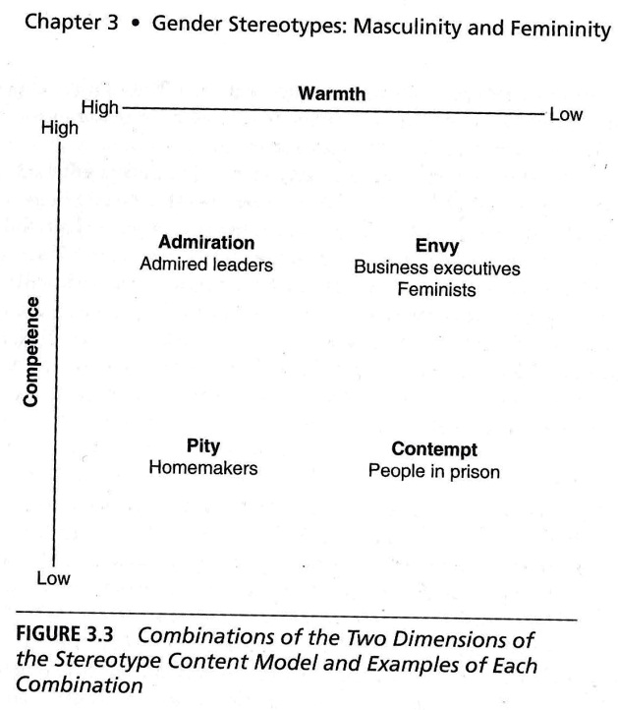
- results from a meta-analysis (Feingold, 1998) also indicate the same
- these findings are not consistent with an overall prejudice against women

Competence and Warmth
- research on the contents of stereotypes show that the combination of those two dimensions capture many beliefs about stereotyped groups
- the mixed values of low competence-high warmth and high competence-low warm have been of most interest to researchers
Stereotype Content Model – Combination of 2 Dimensions
High = H Low = L
Competence = C Warmth = W
1. HC + HW = Admiration (admired leaders)
2. HC+ LW = Envy (business executives feminists)
3. LC + HW = Pity (homemakers)
4. LC + LW = Contempt (people in prisons)
5. Men are not exempt from ambivalent sexism, they also come with hostile and benevolent components but men are perceived as « bad but bold » characterized as men being in charge

Do cultures around the world make similar distinctions between what is considered M & F?
- cross-cultural investigations of GENDER STEREOTYPES seek universals. This search yields
both similarities and differences in the concept of M & F (Williams and Best, 1990) : 30
different countries rating a list of 300 adjectives.
- 6 associated with males in all cultures: adventurous, dominant, forceful, independent,
masculine and strong
- 3 associated with females in all cultures: sentimental, submissive, and superstitious

The Five-Factor Model
- re-analysis of Williams & Best (1990) data in terms of the FFM of personality revealed even more similarities across cultures
- using averages of 25 countries, differences in GS appeared in all 5 factors
- Male stereotype was scored higher in Extraversion, Conscientiousness, Emotional Stability and Openness to Experience.
- Placed the female stereotype higher on Agreeableness.
- differences were small according to Costa
- no single gender distinction applied to all cultures

More Examples
- Japan was one of those cultures that showed a different pattern of GS.
- Asian culture promotes the development of strong family ties and obligations, making conformity and obedience valued traits for everyone (Nesbitt)
- In China, the ideal man is a warrior but also a cook, teacher, artist, and musician (Chia)
- Research on Arab women in the U.S.A. (Read) show that Arab women are more diverse and less traditional than the GS suggests, especially Arab women who are Christian rather than Muslim

Men are NOT dominate and women SUBORDINATE in all cultures. This pattern is NOT universal.
- some societies include equal access to resources and power for both M and W.
- Egalitarian Cultures tend to be simple, pastoral societies rather than complex, industrialized cultures.
- some speculation involves men’s tendencies to a social dominance orientation vs. women’s greater emphasis on forming relationships

Glick et al Study (2000)
- conducted a cross-cultural study in 19 countries around the world (over 15000 persons).
- found that a positive relationship between hostile and benevolent sexism in every one of the 19 nations.
- emphasizes the fact that women are valued as sexual and domestic companions and caregivers.
- this ideology perpetuates societies in which men dominate. Both M & W endorse it.

Another study (Glick et al., 2004) reveals similar patterns across 16 nations.
- men were seen as more ruthless, unfeeling and self-centered than women and also as more powerful and bold.
- the division of activities and behaviors between M & W is universal without worldwide agreement about what those activities and characteristics are.

IN SUMMARY
- GS: beliefs associated with the characteristics and personalities appropriate to M & W
- GS : 4 aspects, physical characteristics, traits, behaviors and occupations.
- Current Stereotypes: influenced by historical views of M & W including Cult of True Womanhood and Male Gender Role Identity model.
- Children develop rigid rules that become more flexible over time except for adolescence
- Concept of M & F measured as personality traits in many ways.
- All cultures delegate different roles to M & W but what traits are associated with each varies from culture to culture.

Exam Questions
1. Does the concept of androgyny (A) offer improvements?

