Week 1 – Chapter 2: Researching Sex & Gender

Biological Essentialism: the tendency to focus on innate differences and to downplay social factors when it comes to explaining gender differences
- it encourages the maintenance of prejudice and stereotypes

Empirical Observation: collecting information through direct observation

Objectivity: the notion that the observation is free of bias by the observer
- a cornerstone of scientific observation

Science Wars: masculine bias is inherently part of science
- objective reality does not exist

Quantification: turning observations into numbers
- quantification does not make science precise though

2 Approaches to Research
1) Quantitative Research
- numbers are the data
Example: Likert type scales with a 1-7 response scale
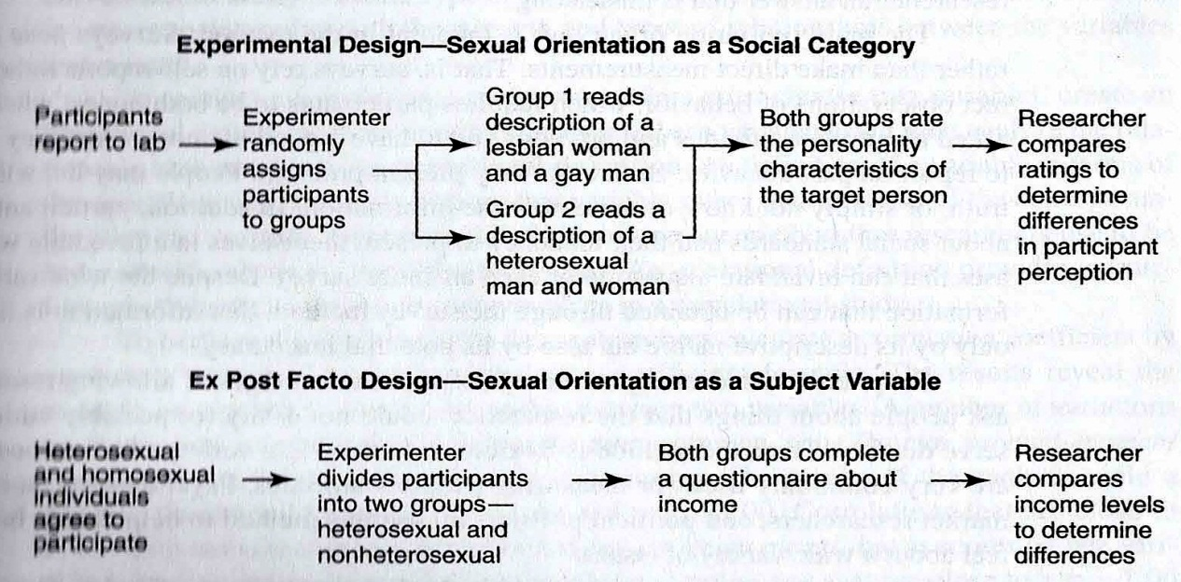

The Psychology of Sex Differences, a classic in research review on gender-related differences (Maccoby & Jacklin)

Comparing heterosexual and non-heterosexuals (subject variable) in terms of income (dependent variable). Example of ex-post-facto design (Berg & Lien)
Variable: the factor of interest in a research study

1. Experimental Designs (Deaux)
Independent Variable (IV): factor manipulated to create a difference that did not previously exist in participants.
Dependent Variable (DV): factor measured to determine if manipulation of IV has an effect
2. Ex Post Facto Designs (Christensen)
- subject variable (participant variable), a characteristic of the subjects such as gender that allows researchers to form contrast groups in quasi-experimental studies (groups studies on specific ailments [ie. people with brain damage in a specific area])
3. Surveys
- a descriptive research method
- involves the measurement of attitudes
- administration and interpretation of questionnaires
- pose questions rather than make direct measurements
- Brown et al (2004): campus climate and sexual orientation study (more likely to come out in college vs. high school)
4. Correlational Studies
- a descriptive research method
- measures 2 factors known to occur within a group of people
- determine the degree of relationship between the 2 factors.
- Davies (2004):correlation between attitudes towards gay men and other attitudes (those who held hostile attitudes towards gay men also held hostile attitudes toward women)

Operational Definition: definition of a variable in terms of the operations used to obtain data on that variable, rather than in terms of the concepts underlying the variable
- very specific.

2) Qualitative Research
- Case Studies: intensive study of a case
- Interviews: quantitative, uniform set of questions, allows statistical analysis
- Ethnography: observation and recording of behavior and events
- Focus Groups: a discussion centered on a specific topic.

- Using qualitative research methods has expanded but are a minority
- Most common method is interview (Wilkinson, 1999)
Gender Bias in Research
- some criticize science because it grew from activities of men and from a gendered, masculine bias that is inherently part of science

Constructionist Perspective: we do not discover reality, we invent it (Hare-Mustin & Marecek, 1988)
- the study of gender gives good examples of the distortions and misrepresentations of science
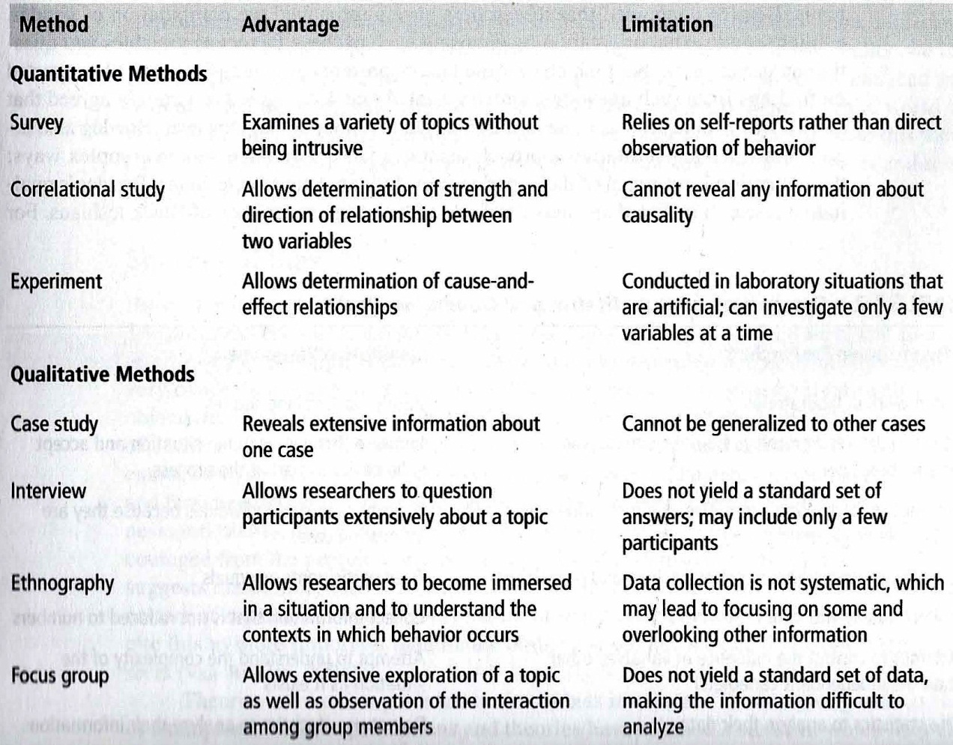
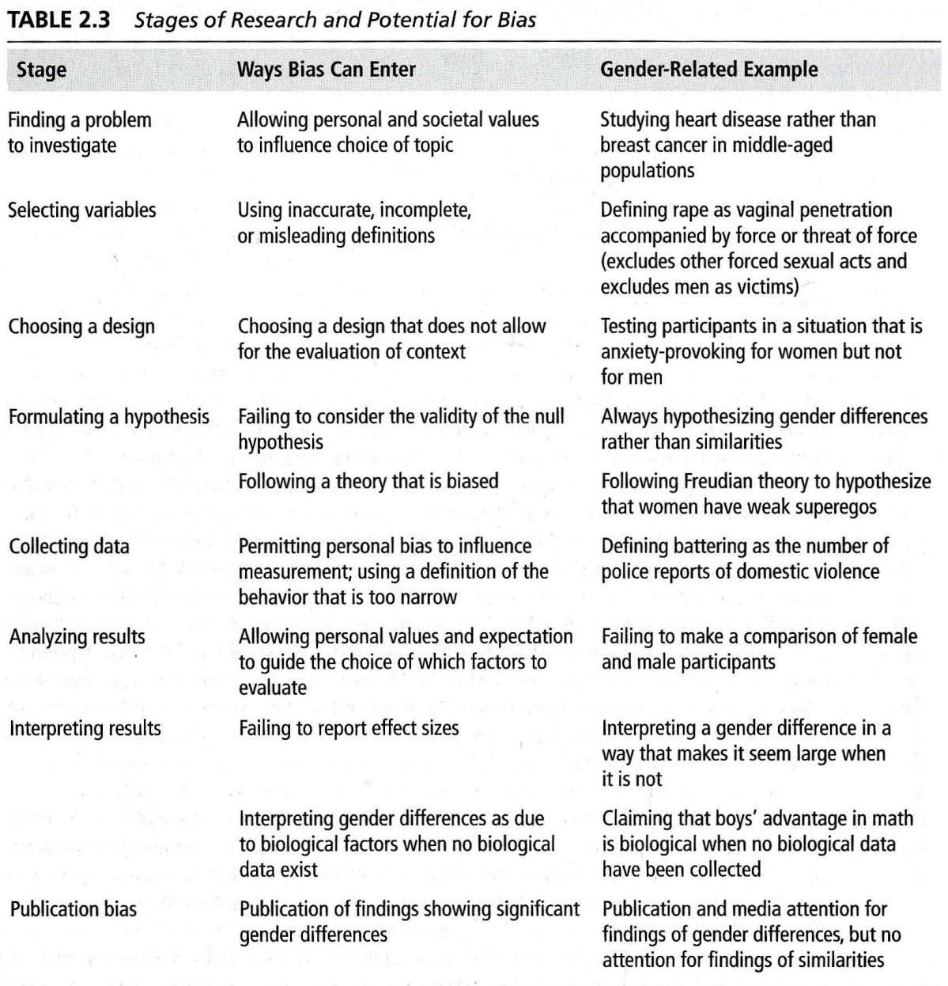

Sources of Bias
1. Science (Keller)
Masculine values: rationality and objectivity
Feminine values: feeling and subjectivity
Masculine : science
Feminine : nature
- culture of science remains masculine (Schiebinger)
- procedures to plan studies and evaluate results influence choices on problems to investigate and choice of questions to ask

Hypothesis: statement about the expected outcome of a study

Statistically Significant Result: result obtained by analysis with statistical tests and found unlikely to have been obtained on the basis of chance alone

Practical Significance: important result with practical implications, different from statistical significance

Ways To Deal with Bias in Science
1) Advocating Transformation To Feminist Standpoint Epistemologies- Schiebinger
- the constructionists deny the possibility of objectivity, reject the basis of science.
- abandon science as a way to deal with the biases?
- feminist research has the power to transform research with women and discipline of psychology?

Feminist Standpoint Epistemologies: those who want to create a woman-centered approach to researching the female experience
Disadvantages perpetuates emphasis on gender differences that they criticize and carry the risk of emotionally harming participants because it may be considered too radical

2) Decreasing Bias
- the use of diverse and appropriate methods is best for the study of women and gender-related behaviors.
- bias can come from context of observation, subtle sexism
- analysis and reporting results also requires change
Meta-Analysis: a statistical analysis that allows the evaluation of many studies simultaneously (Hyde)

Feminist Empiricists: advocate a more objective study of gender and suggest recommendations for making researchers more careful
Conclusion
Correlational studies and surveys help understand the world.
Experimental designs help understand cause-and-effect relationship between IV and DV
Qualitative studies are alternatives
Bias can enter the research process anytime.

