- Two Layers
  - Epidermis
    - Keratinized stratified squamous epitherlium of four or five layers.
      - Stratus Basale.
        - Deepest layer – one row of actively mitotic stem cells, some newly formed cells become part of the more superficial layers.
        - Mitotic Cells = Stratum Germinativum
      - Stratum Spinosum (Prickly Layer)
        - Several layers of keratinocytes unified by desmosomes. Cells contain thick bundles of intermediate filamens made of pre keratin.
      - Stratum Granulosum
        - 5 Layers of keratinocytes
        - Organelles deteriotating, cytoplasm full of lamellar granules (release lipids) and keratohyaline granuals.
      - Stratum Corneum
        - 20 30 layers of dead cells. Flat sacs with keratin, Glycolipids in extracellular space.
      - Stratum Ludidum
        - Present only in THICK SKIN. Thin translucent band just above the stratum granullosum
  - 4 cell Types
    - Keratinocytes
      - Produce Keratin, the fiberous protein that gives the epidermis its protective properties. Most epidermal cells are keratinocytes.
      - Connected by desmosome, arise from stratum basale.
      - Undergo a lot of mitosis in response to epidermal GF.
      - The cells are pushed upwards and eventually rub off. Totally new epidermis every 25 to 45 days
    - Melanocytes.
      - Spider shaped epithelial cells that synthesize the pigment melanin. Found in the deepest layer of epidermis.
      - Spider like arms transfer melanin to nearby keratinocytes
    - Dendritic Cells
      - Star shaped dendritic cells arise from bone marrow and migrate to epidermis. Langerhan Cells they ingest foreign substances and are key activators of our immune system.
    - Tactile Cells.
      - Merkel Cells
      - Epidermal Dermal Junction – each cell is intimately associated with a disclike sensory nerve ending.
  - Dermis
    - Strong, flexible connective tissue.
    - Fibroblasts, macrophages, occasional mast cells and white blood cells.
    - Rich supply of nerve fibers, blood vessels, lymphatic vessels.
    - Papillary Layer
      - Thin, superficial, areaolar connective tissue. Fine collagen fibers form a net that is heavily vascular. Phagocytes wander in it.
      - Dermal Papillae are indents in the overlying epidermis. Contain capillary loops and touch receptors.
      - Dermal Ridges make finger prints. Have sweat glands positioned on the ridges.
    - Reticular Layer
      - 80% of the thickness of the dermis is dense fibrous connective tissue.
      - Lots of collagen Fibers, less dense regions form cleavage lines
      - Collagen fibers give the dermis the strength and the reiliancy to prevent most jabs and scraps from penetrating dermis.
      - Flexure Lines occur at joints where the dermis is tigtly secured to deeper structures.
      - Striae: Stretch Marks
  - Skin Colour
    - Melanin:
      - From reddish yellow to brownish black.
      - All people have around the same number of melanocytes.
      - It’s the pigment of this melanin that determines skin colour, not number of melanocytes.
      - When we expose our skin to sunlight, keratinocytes secrete a chemical that encourages melanin production.
        - Tanning
      - SUN DOES NOT CAUSE SUN SPOTS.
    - Carotene:
      - Yellow to orange pigment found in certain plant products. Tends to accumulate in the stratum corneum and in fatty tissue of the hypodermis. Colour is most obvious in palms and soles, where the stratum corneum is the thickest.
      - The pink hue of fair skinned people is hemoglobin
    - Skin conditions
      - Redness = erythema
        - Blushing, fever, hypertension, allerg
      - Pallor, fear, anger, emotional stress, anemia, etc
    - Jaundice – yellow skin, liver disorder, yellow bile pigments in skin.
    - Bronzing
      - Addison’s disease in which adrenal cortex produces too few steroid hormones.
    - Black and White marks – bruises.
      - Hematomas.
- Appendages of the skin.
  - Hair and Hair Follicles.
    - Hairs or Pilli are flexible strands produced by hair dollicles and consist largely of dead keratinized cells.
    - Hard Keratin, not soft keratin
    - Shaft where keratinization is complete and the root
    - Medulla – middle: large cells and air space
      - Absent in fine hairs.
    - Cortex – Bulky layer surrounding medulla – flattened cells
    - Cuticle –
      - One layer of overlapping cells. Tends to wear off at the ends and cause split ends
    - Pigment is made by melanocytes at the base of the hair follicle.
    - Structure of a hair follicle
      - Hair Bulb, a knot of sensory nerve endings called the hair follicle receptor, or root hair plexus, wraps around each hair bulb. Bending the hair causes a touch sensation.
      - Hair papilla – a nipple like bit of dermal tissue protrudes into the hair bulb. Capillaries that supply nutrients to the hair and signals growth.
      - Peripheral Connective tissue sheath – derived from dermis. Glassy membrane and epithelial root sheath.
      - Vellus hair = hair with no medulla,
      - Terminal Hair = with medulla.
    - Active phase, resting phase.
    - Alopecia = balding
    - Male Pattern Baldness
  - Nails
    - Scale like modification of the epidermis – protective usefull tool.
    - Free edge, body, nail folds. 2 lateral, 1 proximal
    - Lunela = little moon. Thick nail matrix, blood cannot be seen through it.
    - Different Conditions
      - Yellow Tinged = fungal infection or serious respiratory or thyroid gland disoprder.
      - Thick – fungal infection
      - Spoon Nail – Possible iron defficiency
      - Beau’s Lines – malnutrition – Sporadic stoppage of matric growth.
  - Sweat Glands
    - Eccrine and apocrine
    - Not located on the nipples, and parts of the external genitalia
    - Myoepithelial cells.
    - Eccrine
      - Far more common, simple, coiled, tubular gland.
      - Secretes sweat – hypotonic, filtrate of the blood that passes through the secretory cells of the sweat glands and is released by exocytoisis. 99% water.
      - Some salts – mostly soidium chloride, vit c, antibodies, dermcidin, metabolic wstes.
      - Acidic, 4 – 6 pH
      - Managed by the sympathetic nervous system.
    - Apocrine Sweat Glands
      - Armpits and anogenital regions. Still merocrine glands, secrete into hair follicles with fatty substances and proteins.
      - Body Odor.
      - Apocrine glands begin to function at puberty,
      - May be the scent glands.
      - Ceruminious Glands – external ear canal – secrete earwax.
      - Mammary Glands – secrete milk.
  - Sebaceous (Oil) Glands
    - Simple, branched alveolar glands
    - Found everywhere except thick skin
    - Secrete sebum
    - HALOCRINE GLANDS
    - Usually have a hair follicle associated with it.
- Functions of the Integumentary System
  - Protection
    - Chemical Barriers
      - Skin secretions and melanin.
      - Low pH of skin secretions – the ACID MANTLE retards their multiplication.
      - Defensins
      - Cathelicidins
    - Physical Barriers
      - Continuity of skin and hardness of keratinized cells provide physical barriers.
      - Layers of keratinized cells act as bricks and mortain – glycoproteins are mortar.
    - Biological Barriers
      - Dendritic cells of epidermis, macrophages, and DNA itself.
      - DNA collects NRG from UV, radiates to nearby water, turning radiation into harmless heat.
  - Body Temp Reg
    - Body must remain in homeostatic limits.
    - Sweating causes body to remain at t agood temperature.
  - Cutaneous sensation
    - Touch receptors.
  - Metabolic Functions
    - Vitamin D precursor is created, makes chemical conversions that supplement those of the liver.
  - Blood Reservoir
    - 5% of total blood volume, this can be shunted to muscles.
  - Excretion
    - Nitrogen containing wastes in sweat.

- Skeletal Cartiage - cartilage tissue. Mostly Water
  - Resiliancy, ability to pspring back
  - Non vascular, non innverated.
  - Perichondrium, membrane around cartilage, provide bvs
  - Hyaline
    - Frosted Glass
    - Flex and resiliency
    - Chondrocytes are spherical
    - Fine collagen fibers
    - E.gs Articular Cartilages (ends of movable joints) Costal Cartilages - connect the ribs to the sternum, respiratory cartilages (larynx) nasal cartilages.
  - Elastic
    - Hyaline but more stretchy elastic fibers so better able to stand up to repeated bending.
    - External Ear and epiglottis
  - FibroCartilage
    - Highly compressible with great tensile strength
    - Lines of parallel chondrocytes alternating with thick collagen fibers.
  - Growth
    - 1. Apositional Growth,
      - Growth from outside
      - Cells in perichondrium secrete new matric
    - 2. Interstititial Growth
      - Chondrocytes divide and secrete new matrix
- Classification of Bones.
  - 1. Axial
    - Long acis
    - Bones of skill, vertebral skeleton, rib cage.
  - 2. Appendicular Skeleton
    - Upper and lower limbs and the girdles.
  - Long Bones
    - Longer than wide
    - Shaft (Diaphysis) + 2 Epiphyses
  - Short Bones
    - Cube shaped
    - Sesamoid Bones
      - Special kind, form in tendon.
      - Vary in size and number in dif individuals.
      - Some Alter direction of pull of a tendon
  - Flat Bones
    - Thin, flattened, usually a bit curved
  - Irregular
    - Misc.
    - E.g Vertebrae, hip bones
- Functions of Bones
  - 1. Support
  - 2. Proteiction
  - 3. Movement
  - 4. Mineral and Growth factor storage
    - Cacium and phosphate
    - Growth Factors
  - 5. Blood Cell formation
  - 6. Triglyceride Storage
  - 7. Hormone production.
    - Osteocalcin
- Structure
  - Compact bone
    - Structural unit is the osteon or Haversian System
    - An osteon is a group of hollow tubes of bone matrix, one outside the next like tree rings.
    - Each matrixis called a LAMELLA – compact bone is also called lamellar bone.
    - Adjacent lamella have their collagen facing different directions – withstands twisting.
    - Perforating Canals go through at right angles and provide nutrients to all things inside from the periosteum
    - Osteocytes occupy Lacunae at the junctions of the lamellae.
    - Canaliculi connect the lacunae to each other and to the the central canal.
    - Canaliculi form when osteoblasts mature and become encased in osteoblasts.
    - Interstitial and Circumferential Lamellae: Interstitial lamellae fill the gaps between forming osteons or are the remantns of osteons that have been cut through by bone remodeling.
    - Circumferential Lamella
      - Located just deep to periosteum and just superficial to the endosteum, extend around disaphysis and resist twisting of the long bone.
  - Spongy Bone
    - Honeycomb of trabeculae
    - Spaces in between filled with yellow or red bone matrix
  - Short Bones
    - Plates of spongy bone covered by compact bone.
  - Long Bone
  - Diaphysis – shaft, epiphyses – ends, membranes – periosteum
  - Sharpeys fibers – tufts of collagen fibers that secure the periosteum. Endosteum covers internal surfaces.
  - Hematopoitic Tissue – red marrow is typically found within the trabecular cavities and diploe
  - Most red marrow is gone by adulthood, most formation of RBC happens in the head of the femur and humerous.
  - Yellow can become red if the person becomes anemic.
- Bone Markings
  - Projection
    - Heads, trochanters, spines
  - Depressions
    - Fossae, sinuses, foramina, grooves.
- Cells of Bone Tissue
  - Osteogenic cells
    - Mitotically active stem cells found in the membrane periosteum
  - Osteoblasts
    - Bone forming cells that secrete the bone matrix, actively mitotic.

    - Cube Shapped
  - Osteocytes
    - Mature bone cells that occupy lacunae in the bone.
    - Monitor and maintain bone matrix.
    - Stress/strain sensors and respond to mechanical stimuli
  - Bone Lining Cells
    - Flat cells found on bone surfaces where bone remodeling is not goingon. Like Osteocytes, they are thought to help maintain the matrix.
  - Osteoclasts
    - are giant, multinucleate cells that are located at sites of bone reabsorbtion.
- Bone Development.
  - Endochondral Ossification
    - Essentially all bones below the skull formed by endochondral ossification.
    - Bone collar forms, primary ossification center in middle.
    - Spongy Bone Forms
    - Secondary Ossification center in the epiphysis.
  - Intramembranous Ossification
    - Forms the cranial bones and clavicles.
    - Fiberous connective tissue membranes formed by mesenchymal cells. 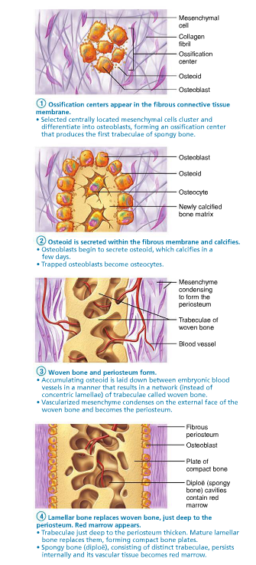
- Postnatal bone growth.
  - Occurs in the epiphyseal plate. Cartilage between epiphysis and diphysis.
  - Top is facing epiphysis, proliferation zone.
  - End of growth happens when two bones fuse.
  - 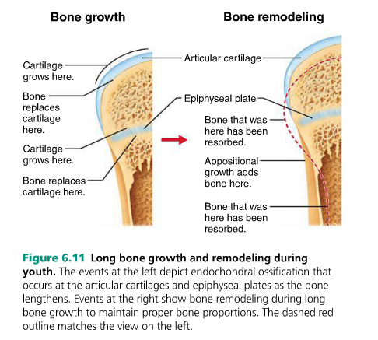
  - AN osteoid Seam – unmineralized band of gauzy looking bone matrix marks areas of new matrix deposits by osteoblasts. Mechanical signals calcification. Osteons must mature for a week before
- Bone reabsorbtion
  - Osteoclasts
  - Move along bone surface, digesting the bone . Lysozomal enzymes that digest organic matrix and protons. This forces the calcium solution to be absorbed into solution.
  - Controls
    - One is a negative feedback hormone loop that maintains Ca in the blood.
    - Two is responses to mechanical and gravitational foces acting n the skeleton
    - Hormonal Controls
      - Parathyroid Hormone
      - Calcitonin

- 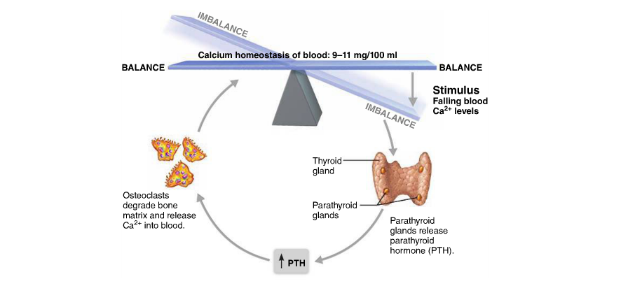
  - Wolff’s Law: A bone grows or remodels itself according to the demands placed on it.

- See Diagrammes
- Structurally
  - Fibrous
    - Joined by fibrous CT.
    - No Joint Cavity
    - Sutures
      - Seams only found between bones of skill
      - Overlap, junction filled with very short CT fibers
    - Syndesmoses (Very Limited Movement)
      - Cord ( Ligament) or a sheet (interosseus membrane) of fibrous CT
    - Gomposes
      - Peg in Socket, only example is the tooth in bony socket.
  - Cartilaginous (No joint Cavity, united by cartilage)
    - Synchondroses
      - Areas of growth between each of the 1st 7 ribs and sternum
    - Symphysis
      - Articular Surfaces covered with hyaline cartilage – linking plate of fibrocartilage
      - Strength and flexibility
  - Synovial

- Functionally
  - Synarthroses
  - Amphiarthroses
  - Diathroses
- Factors that influence stability of Synovial Joiints
  - Articular Surfaces
    - Shape of many don’t contribute stability
    - Deep ball and socket joints have good shape for stability
  - Ligaments
    - More = Good
    - Ligs can only stretch 6% before they break
    - Stretched ligaments may stay stretched
  - Muscle Tone
    - Tendons of muscles crossing joints, usually the most important stabilizing factor.

