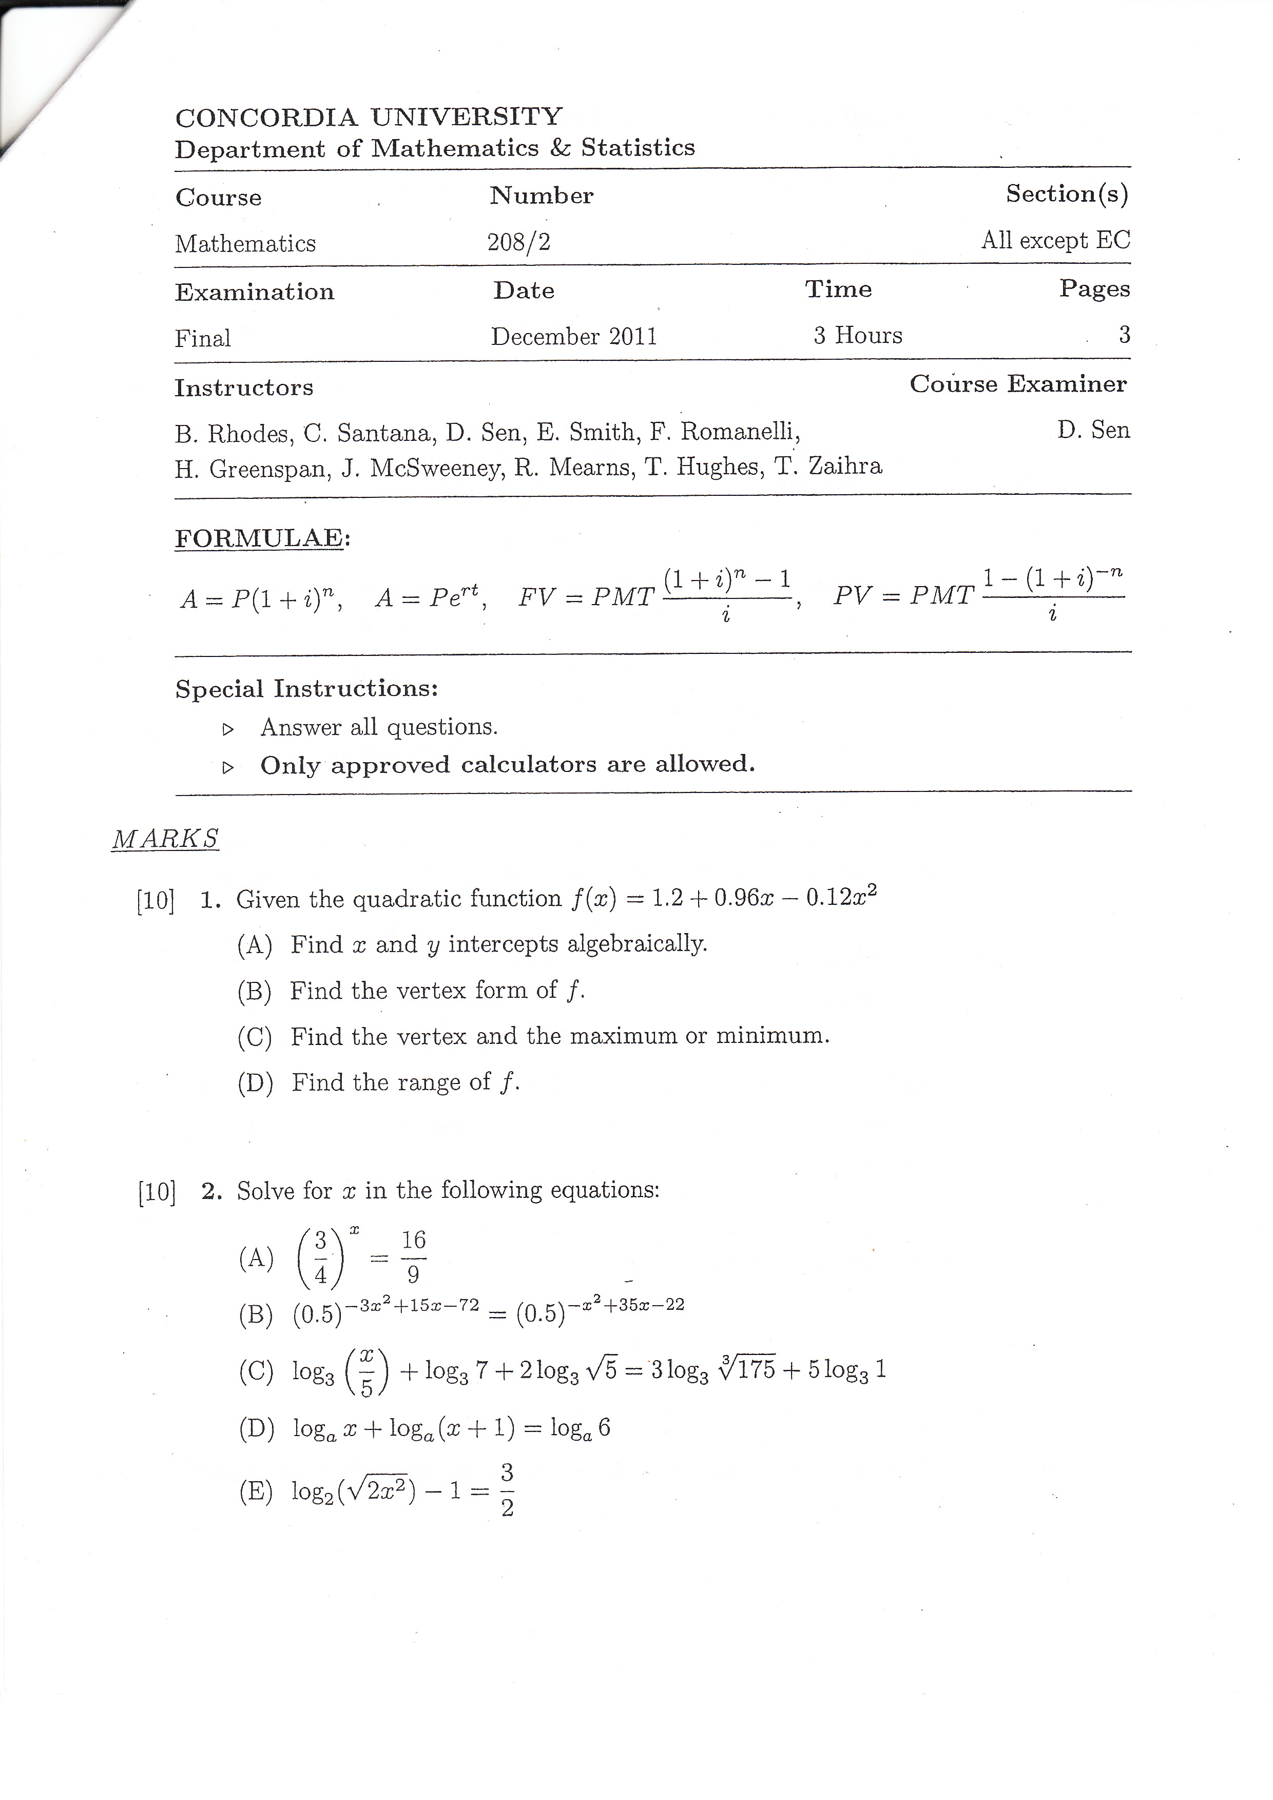

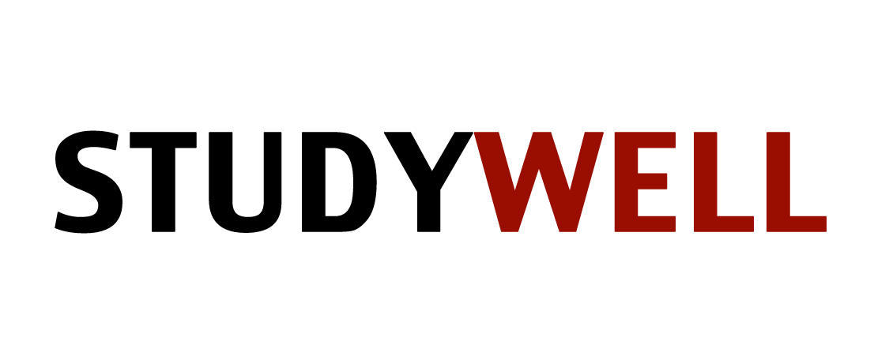

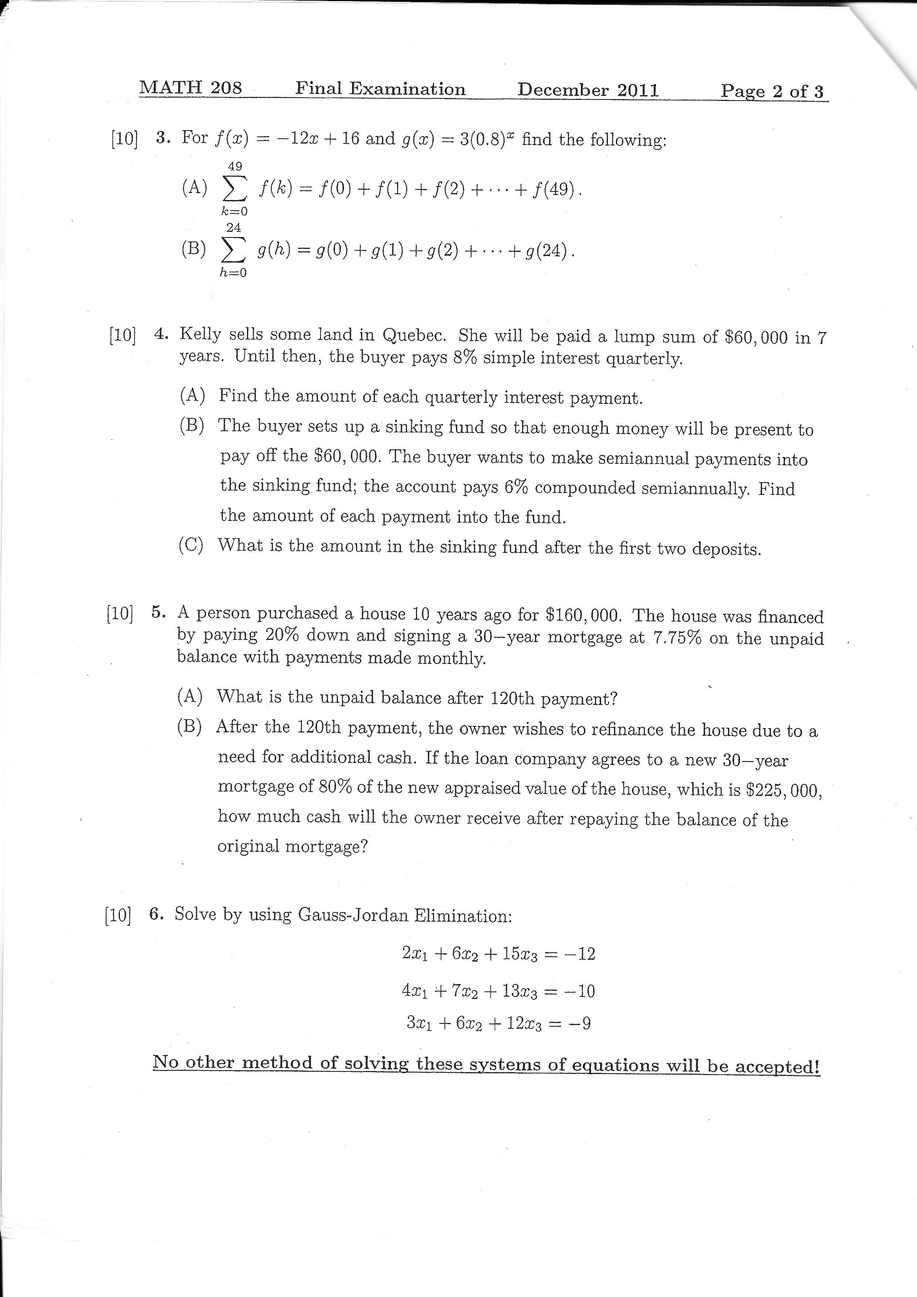

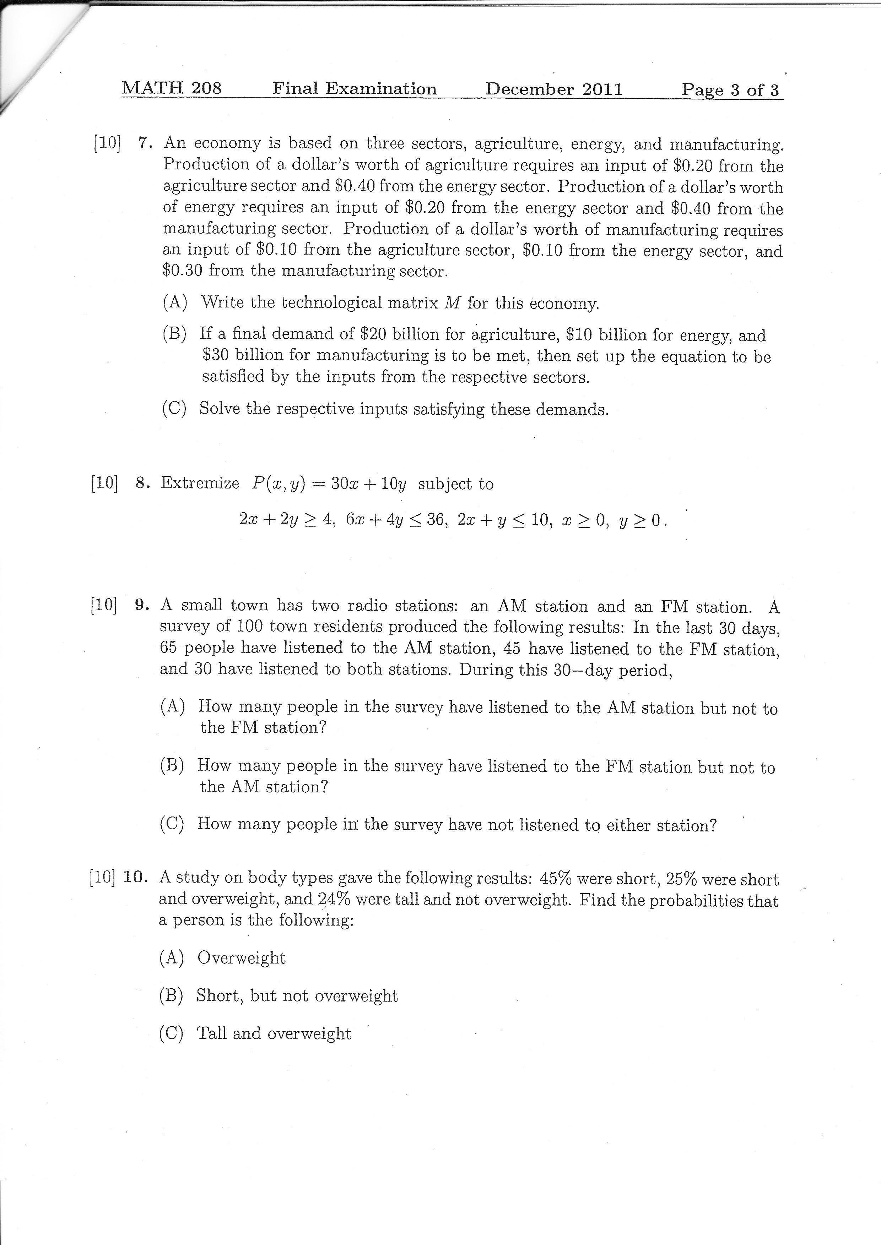

MATH 208
DECEMBER 2011 FINAL EXAM ANSWER SHEET

- A) X=-1.1, Y=1.2
B) Y=-.12(X-4)^2+3.12
C) (4, 3.12) Vertex is a maximum
D) (-∞, 3.12)

- A) X=-2
B) X=-5
C) X=25
D) X=2
E) X=-4 OR X=4

- A) -13900
B) 14.94

- A) 1200
B) 3511.58
C) 7128.51

- A) 111,701.27
B) 68298.73

- X=(21/101)
Y=(-.03960396)
Z=(-82/101)

- A) A|.2 0 .1 |
(INPUT)E|.4 .2 .1|
M|0 .4 .3 |
(OUTPUT)
B) [I-M]X=D WHERE D IS |20| AND X IS |X1|
|10| |X2|
|30| |X3|
C) X1=51/2
X2=103/4
X3=4

- (5,0)=>150 MAXIMUM
(0,2)=>20 MINIMUM

- A) 35
B) 15
C) 20

10. A) 56/100
B) 20/100
C) 31/100

