Professor: Fadi Malek

Resistor Value

Step 1Problem Statement:
This program helps you calculate the resistance value. It will ask the user to enter the color code and the program would calculate and output the the information to the user.


Step 2: Information gathering and I/O Description:
Color | 1st band | 2nd band | 3rd band (M, multiplier) | 4th band (T, tolerance)
Black | 0 | 0 | ×10⁰
Brown | 1 | 1 | ×10¹
Red | 2 | 2 | ×10²
Orange | 3 | 3 | ×10³
Yellow | 4 | 4 | ×10⁴
Green | 5 | 5 | ×10⁵
Blue | 6 | 6 | ×10⁶
Violet | 7 | 7 | ×10⁷
Gray | 8 | 8 | ×10⁸
White | 9 | 9 | ×10⁹
Gold |  |  | ×10⁻¹ | ±5%
Silver |  |  | ×10⁻² | ±10%

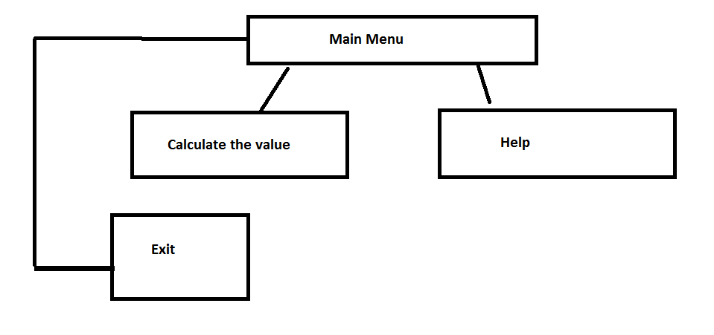

Step 3: Algorithm Design:

Step 4: Implementation:
#include <stdio.h >
#include <stdlib.h>
#include <stdbool.h>
#include <math.h>

int main()
{
int option = 0;
int exit = 0;
while (exit == 0)
{
printf("=================================================\n");
printf("You have entered the resistance value calculator!\n");
printf("=================================================\n\n");
printf("Please choose one of the options:\n");
printf("1- Calculate Resistance Value\n");
printf("2- Help\n");
printf("3- Exit\n\n");
scanf("%d", &option);
if(option == 1)
{
int firstBand = 0;
int secondBand = 0;
int thirdBand = 0;
int fourthBand = 0;
int resistance = 0;
int valueIsValid = 0;
char resMultiplier;

printf("\n\nBand Color Code Quick Reference!\n");
printf("================================\n");
printf("Please choose the correct color code for each band from the table below\n\n");
printf("Black = 0 | Brown = 1 | Red = 2 | Orange = 3\n");
printf("Yellow = 4 | Green = 5 | Blue = 6 | Violet = 7\n");
printf("Gray = 8 | White = 9 | Gold = -1 | Silver = -2\n");
printf("================================\n\n");
printf("Entering resistance calculator:\n\n");

while (valueIsValid == 0)
{
printf("Please enter the value of first band: ");
scanf("%d", &firstBand);
if(firstBand < 0 || firstBand > 9)
{
valueIsValid = 0;
printf("\nInvalid value. Color code for first band should be between 0 to 9\n\n");
}
else
valueIsValid = 1;
}
valueIsValid = 0;
while (valueIsValid == 0)
{
printf("Please enter the value of second band: ");
scanf("%d", &secondBand);
if(secondBand < 0 || secondBand > 9)
{
valueIsValid = 0;
printf("\nInvalid value. Color code for second band should be between 0 to 9\n\n");
}
else
valueIsValid = 1;
}

valueIsValid = 0;
while (valueIsValid == 0)
{
printf("Please enter the value of third band: ");
scanf("%d", &thirdBand);

if(thirdBand < -2 || thirdBand > 9)
{
valueIsValid = 0;
printf("\nInvalid value. Color code for third band should be from -2 to 9\n\n");
}
else
valueIsValid = 1;
}

valueIsValid = 0;

while (valueIsValid == 0)
{
printf("Please enter the value of fourth band: ");
scanf("%d", &fourthBand);

if(fourthBand < -2 || fourthBand > -1)
{
valueIsValid = 0;
printf("\nInvalid value. Color code for fourth band should be either -1 or -2\n\n");
}
else
{
valueIsValid = 1;
if(fourthBand == -2) fourthBand = 10;
if(fourthBand == -1) fourthBand = 5;
}
}
resistance = (firstBand*10) + secondBand;

if((thirdBand/3) == 0) resMultiplier = ' ';
if((thirdBand/3) == 1) resMultiplier = 'k';
if((thirdBand/3) == 2) resMultiplier = 'M';
if((thirdBand/3) == 3) resMultiplier = 'G';

if((thirdBand%3) == -1)
{
resistance = resistance*100;
resMultiplier = 'm'; //milli
}
if((thirdBand%3) == -2)
{
resistance = resistance*10;
resMultiplier = 'm'; // milli
}
if((thirdBand%3) == 1) resistance = resistance*10;
if((thirdBand%3) == 2) resistance = resistance*100;

printf("\n\n The resitance value is: %d%c Ohm +/- %d%\n\n\n", resistance, resMultiplier, fourthBand);

}
else if(option == 2)
{
printf("\n\nBand Color Code Quick Reference!\n");
printf("================================\n");
printf("Please choose the correct color code for each band from the table below\n\n");

printf("Black = 0 | Brown = 1 | Red = 2 | Orange = 3\n");
printf("Yellow = 4 | Green = 5 | Blue = 6 | Violet = 7\n");
printf("Gray = 8 | White = 9 | Gold = -1 | Silver = -2\n");
}
else if(option == 3)
{
exit = 1;
}
else
{
printf("\n\nYou have chosen invalid option. Please try again!\n\n");
}
}
system("PAUSE");
return 0;
}

Step 5: Software testing and verification


