OB Midterm 2 Review Chapter 7
Reasons for teams:
- Help solve complex problems
- Reduce hand-offs so there is less chance of mistakes
- Reduce the time it takes to get things done
- Replace Serial Development with Parallel Development
- Combine knowledge and authority to enhance the organization’s performance

Successful teams should have:
- Support of senior management
- Resources and accountability to achieve their mandate (Rewards, training, autonomy, etc.)
- The right people on the team (Horizontal Fit – right skills for the right job)
  - Group polarization – everyone in the group takes greater risks because they are in a group
- Clear engaging direction
- Real team tasks
- Reward s for team excellence
- Basic material resources
- Authority to manage the work
- Team goals
- Team norms that promote strategic thinking/effective communication/performance
- Some stability
- Appropriate size

Potential Problems with teams:
- Free rider – people not contributing but taking credit for the work
- Social loafing
- Dominant group member
- Disagreement on goals
- Division of labour
- Hidden agendas
- See slides for others

Types of Tasks
- Additive: the more people you add the greater the team performance
- Disjunctive: performance it dependent on strongest member
- Conjunctive: Performance is limited by the weakest member

Member Attributes:
- Member diversity
  - Surface Diversity: Visual (race, appearance, etc.)
  - Deep Diversity: Attitudes and beliefs
  - Pros: more creative/open, multiple perspectives, increased flexibility, etc.
  - Cons: longer development time, more conflict and confusion, Miscommunication, etc.
- Tasks that Homogenous groups are good for:
  - Simple
  - Sequential
  - Requiring cooperation
  - Must be done quickly
- Tasks that Heterogeneous groups are good for:
  - Complex
  - Collective
  - Require creativity
  - Do not need to be done quickly
*Type of task + Composition/Diversity +Size = Group Effectiveness
*Performance Potential ≠ Actual Performance

Group Process Gain or Loss:
- Gain: More resources, more ability to perform and make decisions. Effectively coordinate.
  - Happens when there is a common understanding of roles, collective expectations, and desire to remain in a group
- Loss: Social loafing, coordination loss, groupthink, cognitive process loss, Group Polarization

How to improve group performance:
- Appealing to self interest
- Hold everyone accountable for group performance
- Improve info sharing (i.e. play devil’s advocate sometimes to avoid groupthink)
- Set appropriate goals
- Manage member diversity

Questions to determine if a group is needed:
- Can the work be done better by more than one person? (Needs creativity, variety of skills, etc.)
- Does the work create a common purpose or set goals for the people in the group
- Are members of the group interdependent?

Types of Formal Groups or teams (NEED TO KNOW):
- Cross-functional teams: contain members from each of the departments in the organization
  - The belief that the company can save time if a problem is addressed simultaneously by all departments rather than sequentially
- Quality Circles: 5-10 department work leaders and line operators who have volunteered to work overtime to help solve departmental quality problems.
- Multidisciplinary and Innovative Teams: Experts from several fields join to generate a broad array of possibilities and concepts for solving problems and increasing productivity
- Work Teams: Perform the actual work (could be autonomous work teams).

Gersic’s Equilibrium Model (NEED TO KNOW):
- A model of group development that describes how groups with deadlines are affected by their first meetings and crucial midpoint transitions
- Phase 1: lasts from the first meeting to the midpoint. Set the agenda, but very little actual progress is made towards the goal. Assumptions and precedents made here dominate the first half of the group’s life. Leader should stress motivation and excitement.
- Midpoint: Almost exactly at the halfway point to the deadline. Changes made in the group’s approach and how they are handled is crucial to the group’s progress. Leader should focus on strategy.
- Phase 2: Decisions made at the midpoint are played out here. Final meeting that reveals a burst of activity and a concern for how outsiders will evaluate the product. Leader should be sure there are enough resources to execute the Phase 2 plan and AVOID DEADLINE CHANGES.

Stages of Development:
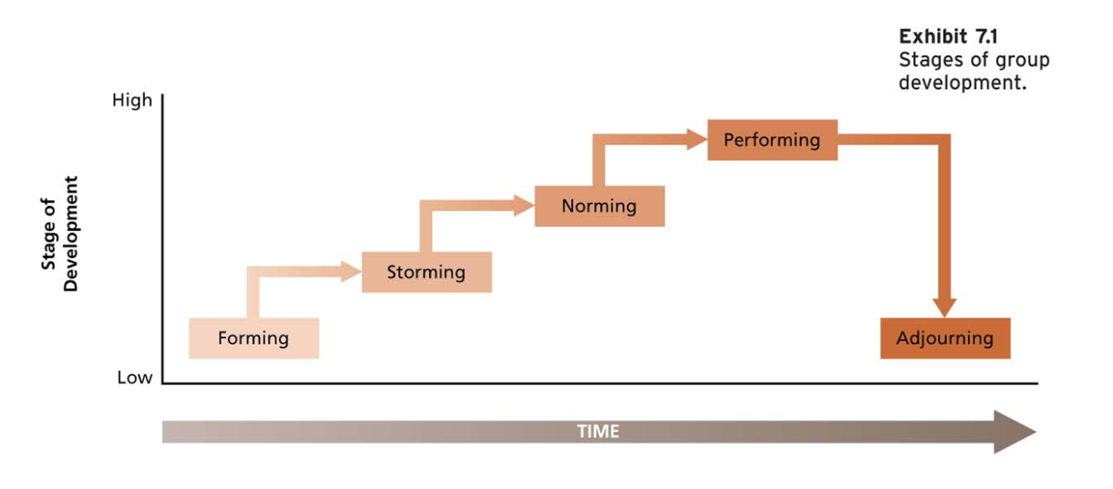
- Forming: get together and figure out what to do
- Storming: How will it get done? Individual roles and strengths/weakness established
- Norming: Set a contract with team norms and timing. Understand what is happening in the team
- Performing: achievement, creativity, mutual assistance
- Adjourning: Ceremonies, parties. Evaluation and reflection on the team.

Research Findings about Teams
- Presence of others may motivate you to enhance yourself, but it may sometimes also lead to a decrease in performance
- Individuals in groups have been found to be more likely to take risks and make extreme decisions than when working alone
- Groups tend to focus on information and views shared by all members and ignore info held by only a few

Groupthink: The desire for unanimity overrides the motivation to realistically appraise alternative courses of action
- Likely to occur when the group is:
  - Cohesive
  - Isolated from outsiders
  - Under stress due to external threat
  - Experiencing recent failures or other problems
  - Lacking clear guidance from corporate policies or procedures (makes its own rules)
- Likely to occur when the leader:
  - Expresses an opinion rather than remaining impartial
  - Has a directive style rather than participative
- Symptoms of GT:
  - Illusion of invulnerability – comfortable with risky decisions b/c weakness is ignored
  - Assumption of morality – such an unquestioned belief in the rightness of goals that no one debates their ethicality
  - Rationalization – information that is inconsistent with team decisions is discounted
  - Stereotyping outgroups – oversimplifies external threats, viewing enemies as evil
  - See slides for more
- Consequences
  - Incomplete search for alternatives and solutions
  - Group members suggesting fewer alternatives
  - No consulting with outside experts
  - Failure to examine risks of the preferred choice
  - Failure to reappraise initially rejected alternatives
  - Selective bias in processing information at hand

Vigilant Decision-making
- Identify a wide range of objectives to be achieved
- Generate a comprehensive list of alternative courses of action
- Search for new information relevant to evaluating the alternatives
- Process all info in a way that minimizes biases
- Reconsider the pros and cons of alternatives already rejected
- Carefully examine the costs, benefits and risks that flow from the preferred alternatives
- Develop a plan for implementation, with special attention given to contingency plans

- Nominal Group technique
  - (5 stages)
    - Intro and explanation of the procedure and problem
    - Silent generation of ideas
    - Sharing ideas
    - Group discussion
    - Voting and ranking
  - Members are not reluctant to share ideas because they are not concerned about being criticized
  - Members are not concerned about creating conflict
  - Equal Participation
  - Time-saving
  - A Large number of ideas
- Delphi Technique
  - Relies on panel of experts
  - Answer questionnaires in two or more rounds
  - After each round, facilitator provides anonymous summary of expert forecasts
  - Experts are encouraged to revise their earlier answers in light of the replies of other members
  - Range of answers will decrease (converge)
- Train Discussion Leader
  - State the problem in an objective manner
  - Draw out all group members to participate on an equal basis
  - Wait out pauses, be non-directive
  - Ask stimulating questions that move the discussion forward
  - Keep an open mind
- Stimulate controversies
  - Incorporate members with diverse ideas and backgrounds
  - Form subgroups to tear the problem apart
  - Establish norms that favour the open sharing of info

