OB Midterm 2 Review Chapters 5&6
Motivation – the extent to which persistent effort is directed toward a goal
- Basic characteristics: Effort, Persistence, Direction
Performance – the extent to which an employee contributes to the achievement of a goal
**review Inner Core vs. Outer Core, Cost Reduction vs. Product Differentiation, etc.**
Methods of coordination as a continuum of worker discretion:
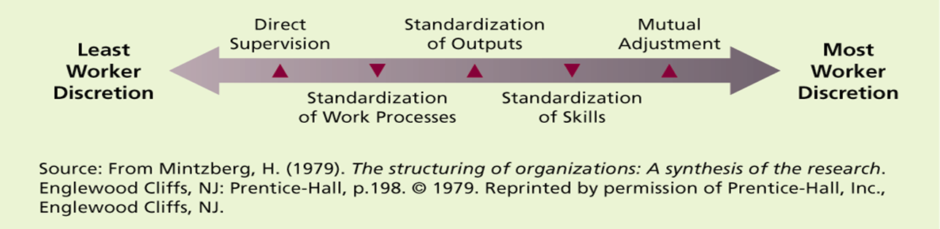
- Controlled ---------------------------------------------------------------------Autonomous Motivation
- Peripheral---------------------------------------------------------------------- Core
- Low Cost------------------------------------------------------------------------Innovation/Quality
Intrinsic and Extrinsic Motivation:
- Intrinsic – stemming from the relationship between the worker and the task
  - Usually self-applied, from inside
  - Strong and stable impacts
- Extrinsic – stemming from the work environment external to the task
  - Usually applied by others (i.e. managers) from outside
  - Only works in certain situations, not long-lasting
Early Theories:
- Hedonism – humans seek pleasure vs. pain, comfort vs. discomfort
  - Works to an extent, but doesn’t fit for volunteers, athletes, etc.
- Economic Man – Humans are motivated to earn as much money as they can
  - Taylor’s Scientific Management
  - Challenged by behaviours such as “acceptable level of output”, don’t go too fast and make others look bad
- McGregor’s Theory – X&Y
  - X – lazy and avoid work
  - Y – ambitious, self-motivated & ability for creative problem solving
  - Humans can be motivated by many things including money (Leads to Need Theories)
Current Theories:
- Content Theories
  - Focus on those needs that must be met in order to motivate individuals (the WHAT)
  - Maslow’s theory
- Need theories – people act to satisfy their needs
  - Maslow was first to talk about needs
  - Lowest unsatisfied need produces the most motivation. Once it is satisfied, it is no longer an effective motivator and the next highest need becomes more motivational.
  - Alderfer’s ERG Theory
    - Existence needs, Relatedness needs, Growth needs
    - The more lower level needs are gratified, the more higher level needs are desired
    - The less higher level needs are gratified, the more lower level needs are desired
    - Extrinsic motivators might substitute for intrinsic motivators, and vice versa
  - McClelland’s Theory
    - Need for Achievement – prefer work that allows them to take responsibility for outcomes, set moderately difficult goals with calculated risk, obtain feedback
    - Need for Affiliation – desire to establish friendly, compatible interpersonal relationships
    - Need for Power – desire to have strong influence over others. Effective managers are Low nAff, High nPow
  - Dual Structure Theory – Jobs consist of 2 factors:
    - Hygiene factors – lower order like pay, security, working conditions
    - Motivation factors – higher order like achievement and recognition
    - Move toward job enrichment
  - Reinforcement Theory – pleasant= repeated behaviour, unpleasant = avoided behaviour
    - Positive – reward desirable behaviour
    - Avoidance – Escape unpleasant Behaviour
    - Extinction – eliminate rewards to decrease frequency of behaviour
    - Punishment – punish behaviour
- Process theories
  - Focus on the underlying processes involved in motivating employees (the HOW)
  - Expectancy theory
    - Strength of a tendency to act in a certain way depends on the strength of the expectation that the act will be followed by a given outcome and the attractiveness of that outcome to the individual
    - Effort – can I do it?
    - Performance – will it work?
    - Obtaining the outcome – Do I want it? If not, it won’t motivate
    - Attractiveness – importance an employee places on the potential outcome
    - Performance-reward linkage – will it be recognized
    - Force – the end product of the other components of the theory
      - F = Expectancy x SUM of all (Instrumentality x Valence)
E = 1
E = 0.5
Chocolate
V=10

High participation

Low participation

Increased understanding
V = 5
Chocolate
V = 10
Increased understanding
V = 5
I = 0.5
I = 0.8
I = 0.2
I = 0.5

High participation: Low Participation
F = E x SUM(IxV) F = 1 x [(0.2x5)+(0.5x10)]
F = 0.5 x [(0.5x5)+(0.8x10)] F = 6
F = 5.25

Recall Equity theory
- My own treatment by the firm, compared to others’ treatment by the firm, Own vs. Others’ Circumstances, Perception of Equity
- If inequity is perceived, change numerator or denominator of Input/output
- Distributive Justice – the outcomes people receive
- Procedural justice – way/process allocation decisions are made
- Interactional justice – the treatment received during the decision-making process
- To avoid, companies should:
  - Avoid underpayment
  - Avoid overpayment
  - Make relevant inputs and outcomes very clear
  - Have fair procedures
  - Provide employees with clear and thorough explanations about decisions that affect them
  - Treat employees with dignity and respect

Applied motivation Techniques (Chapter 6)

Three performance enhancement strategies
- Goal setting – higher performance through social learning, self-conceptions, self-monitoring
- Job Design Approach – Specialization, rotation, enlargement, enrichment, motivation, etc.
- Money – self-explanatory

Reciprocal Determinism – Person + Situation + Behaviour
Cognitive psychology regards Observational learning as the most important form of learning & doesn’t see reinforcement as an essential aspect of learning
- Self-observation – monitoring one’s own activities
- Self-judgement – evaluating one’s performance
- Sefl-reactions – reactions to performance outcomes
Reinforcement and punishment
- Have indirect effects on learning
- Influence the extent to which an individual exhibits a behaviour that has been learned
- The expectation of reinforcement influences cognitive processes that promote learning
- Environment reinforces and punishes:
  - Observer is influenced by the model (wear a suit to fit in with a certain group)
  - Observer is reinforced by a third person – modelling the actions of a leader
  - Imitated behaviour leads to reinforcing consequences – observer enjoys the new behaviour
  - Consequences of the model’s behaviour affect the observer’s behaviour vicariously
Goal Setting theory
Lock & Latham’s Goal Setting Theory
- Goals are motivators of human action
- Theory lays out how goals are translated into motivation
- Goals affect behaviours by:
  - Directing attention to a particular task
  - Mobilizing on-task effort
  - Encouraging task persistence
  - Facilitating strategy development
Goals must be SMART:
- Specific
- Measurable
- Action-oriented
- Realistic/Relevant
- Time-bound
3 types of Goal Acheivers:
- Learning goal oriented – people achieve goals to learn (Most persistent achievers)
- Performance oriented – want favourable judgements (they just want an A)
- Performance avoid – they just don’t want to fail
Management by objectives – breaking big goals into several small, cascading goals
Job specialization – break down + Standardize tasks
Job rotation – individuals rotate through specialized jobs
Job enlargement – combining small task (horizontal loading)
Job Enrichment – adding more tasks + control (vertical loading)

Job Characteristics Approach – Jobs lead to motivation when individuals:
- Experience meaningfulness
- Feel responsible for outcomes
- Have knowledge of results

Job characteristics model
V = Variety
I = Identity
S = Significance
A = Autonomy
F = Feedback

Motivating Score = (V+I+S)/3 *A*F

Money as a motivator:
- Creates a competitive environment, but also increases the organization’s variable costs

