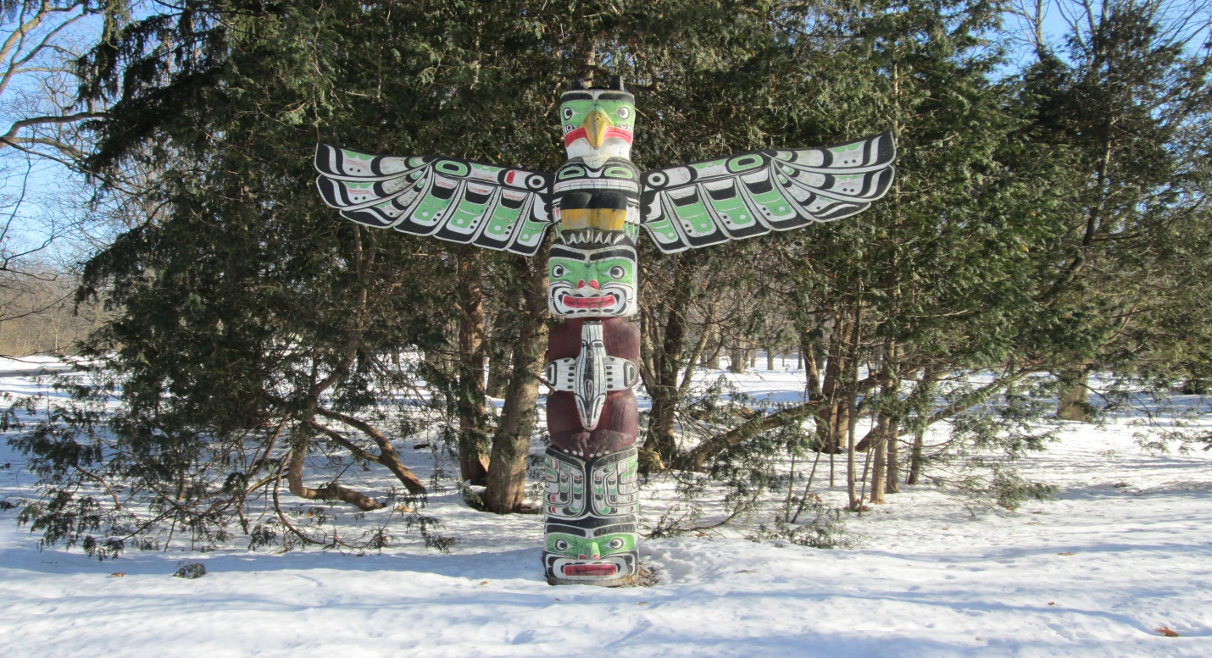
“A Gift to Honorary Chief Nakupunkim”

GEG2108B
Prof. Brenda MacDougall
ID:6692019
31/JAN/2013

Federico Albarran Hidalgo

Introduction
In the year of 1946, the British King found in Viscount Alexander the best man that could fulfill the task of being Governor General of Canada. Lord Alexander was hero of the Second World War, and was considered Britain's greatest military commander since the Duke of Wellington. In addition to his reputation for military genius, Lord Alexander had a charismatic gift for making friends and communicating with people. This made him a popular and successful Governor General. He took his duties seriously. He saw his role as a vital link between Canadians and their head of State, and was eager to convey that message wherever he went. He had a big interest in communicating to Canadians no matter the place, whether he was meeting with residents of the Yukon Territory, speaking at a Canadian Club luncheon in Ottawa, talking with members of various First Nations or with a villager in rural Ontario. He travelled the country extensively, eventually logging more than 184,000 miles during his five years as Governor General.
On his first major visit out west, he was presented on July 13, 1946, with a very interesting mnemonic device, which is an object used as a symbol for many cultures that do not have hand writing. This device was a trunk carved with three different figures. As part of their natural gift-giving and generosity that was common in the First Nations, this art work was presented to Lord Alexander by the carver artisan Mungo Martin who belonged to the Kwakwaka’wakw Tribe from British Columbia. However, this trunk was something more than a simple piece of wood with forms, it was a totem pole which represents many different things between the peoples of the first nations, and is one of the many elements that for their idea of place which is very different from the European perspective. In this essay I will develop this magnificent piece of artwork that remains in grounds of Rideau Hall and how it impacts the population that visits such place.
Totem Poles’ Meaning
Totem poles are monuments created by First Nations of the Pacific Northwest and represent one or many animals or figures such as bears, caribous, whales, birds, and others. Usually totem poles embody the story of a single tribe or band. Also, these pieces of artwork commemorate ancestry, histories, people, or events.
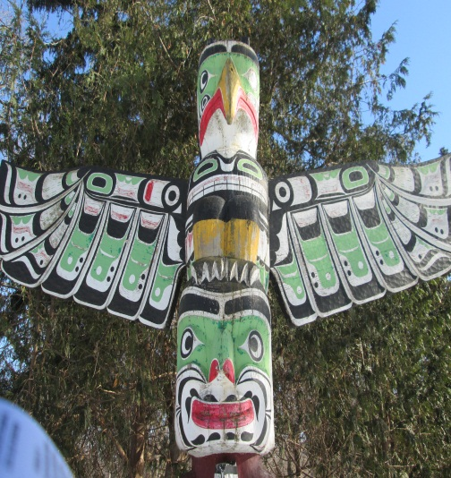
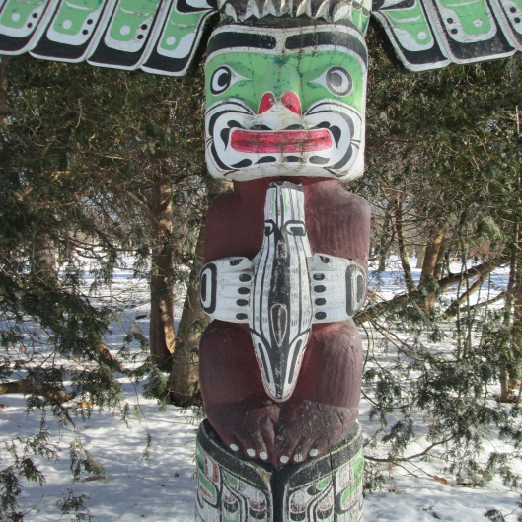
The Totem pole that was presented to the new Governor General, Lord Alexander was composed of three parts that were the symbol of greatness. The top of the totem was signified by the Thunderbird, this mighty animal was on top of a human with a salmon in his hands, and the last part was a serpent. The Thunderbird which according to the board that explains the totem itself at Rideau Hall “Can cause lightning by the blinking of its eye and thunder by flapping its wings,” is a big part of the Kwakwaka’wakw mythology. Thunderbird is not only the lord of the winter dance season, but also is the parent of Tseiqami who was the first man and brought the origin of the Kwakwaka’wakw people. The middle part was the representation of a human embracing a salmon which might have different meanings depending on the group. It can be interpreted as a sign of wealth since the salmon was an animal of huge importance for the diet of the tribe. Thus, having salmon meant having stability in terms of food and economy. The bottom of the totem pole was embodied by the mythological creature Sisiutl who was represented by a two headed serpent. Sisiutl was the god of warrior invincibility, and guardian of the house. The form of this creature was employed by warriors as a protection. Thus, it means that it Sisitul will protect and guard the people.
This totem pole was given to Lord Alexander when he was named Honorary Chief Nakupunkim to commemorate him as a leader, and to represent that he would be a powerful, wealthy, guardian of the Canadian territory.
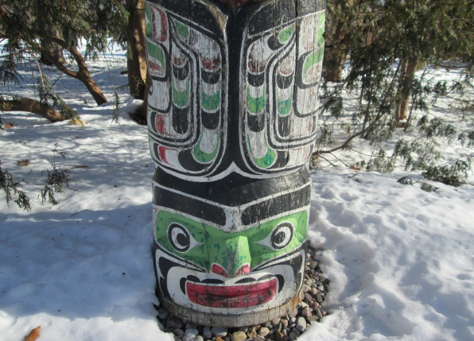
Meaning of “Place” for Non-Natives
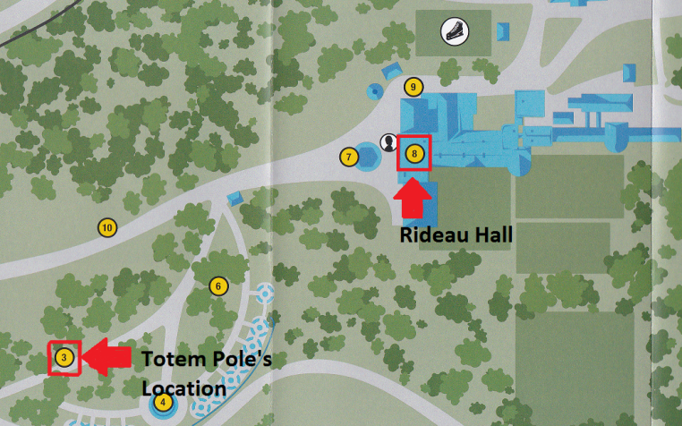
For every single person, a space of land, trees, rocks, rivers do not mean the same thing as for the people that find a truthful significance to it either by having stories of the space, or living around it. This space with meaning is called “Place.” In relation to the totem pole made by Mungo Martin, a special mnemonic device needed a special space that could give not only meaning to the one who made it and the one who received it, but to all the people visiting the surroundings of the Hall. For that reason, the totem pole is located close to Rideau Hall itself, but in order for it not to lose its contact to nature as it is usual from the First Nations, the monument is located in between many trees and on top of rocks. Even though the space is not inhabited by people, the peacefulness and calmness of the surroundings, accompanied by the sounds of the wind, give a truthful meaning to this place.
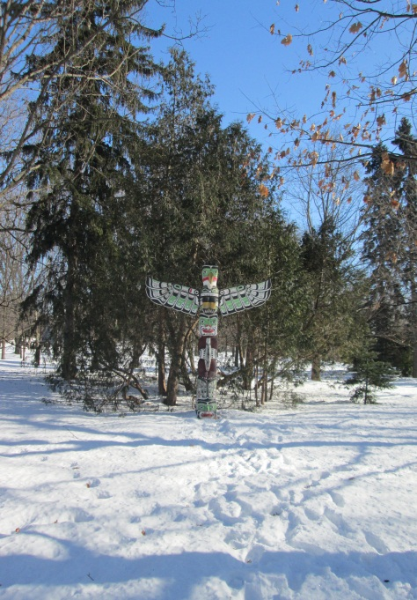
It is moving to see how even though the groups of people that come to see the surroundings are excited and usually loud,4 usually take some time to observe this magnificent monument, and to feel the flow of the moment. It is, without a doubt a perfect location that makes the visitors feel the connection not only to the pole, but to the Kwakwaka’wakw people itself.
Meaning of “Place” for Indigenous People
It is know that the worldview that the non-natives and the people of the First Nations is completely different, and so is their sense of place. Thus, this totem pole represents a lot more for indigenous people that usually have a wider knowledge of totem poles and can find a more complete significance on what it represents, why was the pole located exactly where it is, who carved it and for whom, and how it was carved.
There is no gender role playing in this site since it is a public space that natives can visit whenever they want considering that totem poles where usually “open to the public” in pre-colonial times as for they were the banner of a clan or a band and indigenous wanted to show their banner to their world.
Visitation of the Monument
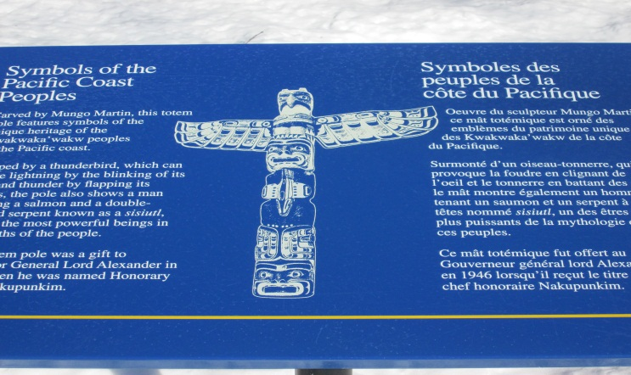
It is known that the combination of the pole, with its surroundings makes beautiful and quiet place. However, its location makes it hard for visitors to find it in the summer because the totem mixes with nature and might be difficult reached by many. For this reason, the pole has an board on a side of the pathway that gives some information about the monument and shows were it can be located.
Another important aspect is that this monument can be not only visited, but enjoyed by every audience since not only adults can find meaning in it, but also children could enjoy this majestic pole and be overwhelmed by its size, bright colors and different forms. However, the totem pole does not have the same meaning for all the people who visited considering that unfortunately very few people really understand the true symbol and what it represents yet this do not mean the space loses its sense of place depending on the information that the visitor has regarding Martin’s Project.
Conclusion
In conclusion, the totem pole presented to Lord Alexander was without a doubt a marvelous piece of art work that takes a space and makes it a place, but also is there as a reminder of how good the relationship between the First Nations and the White Man could be. Furthermore, the location of this monument within the park gives a certain grade of comfort and spirituality that most spaces do not have. There should be more places like this in the city of Ottawa for people to have a spiritual connection of this type disregarding age, gender or origins.

