Web 2.0 and Social Networks
How to develop a social media strategy
- The social technologies enable the strategy, they do not define it
- The “Change in mindset” requires should be under-estimated
- Stat mall- quick win- big impact
- Social media is about the people
The internet- Business Disruption
- Internet changing business
- Organizations must be able to transform is the following change
  - Markets
  - Economic environments
  - Technology
- Focusing on the unexpected organizations focusing ahead gives them the opportunity for new business growth from a disruptive technology
- Internet impact on industry

  - Travel
  - Entertainment
  - Electronics
  - Financial services
  - Retail
  - Automobiles
  - Education
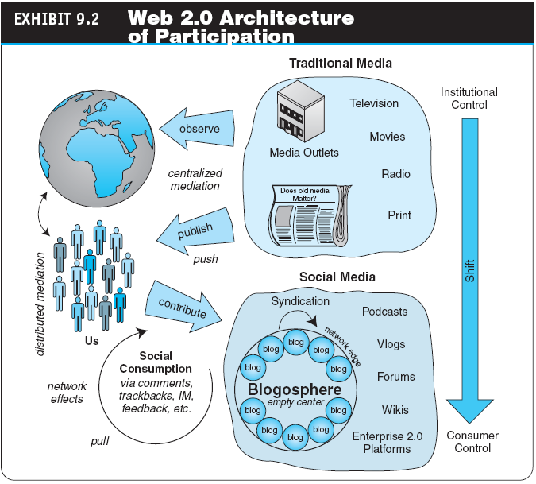
The Web 2.0 Revolution, Social Media, and industry Disruptors
- Social media
  - Online platforms and tools that people use to share opinions, experiences and various media (photos, music, etc.) with each other
- Disruptors
  - Companies that introduce a significant change in their industries, causing a disruptions in normal business operations
Disruptors in Business
- Internet has disrupted the way businesses operate, employees communicate and products are developed and sold
The Web 2.0 Revolution, Social networks, innovations, and industry disruptors
- Industry and market disruptors Disruptors
  - Companies that introduce a significant change in their industries thus cause disruption in the way business is done
- Checklist of questions to help identify disruptors
- Is the services or product simpler, cheaper or more accessible?
- Does the disruptor change e basis of competition with the current suppliers?
- Does the disruptor have a different business model?
- Does the Product or service fit with what customers value and pay for?
- The potential for disruption and opportunity
  - Best future for companies create innovative new ways to facilitate collaboration by millions of us who can be reached and embraced by effective architecture of participation
  - Enables us and encourages us to take control and direct the designs of the products and services that we in turn consume
Virtual Communities
- A group of people with similar interest who interact with one another using the Internet
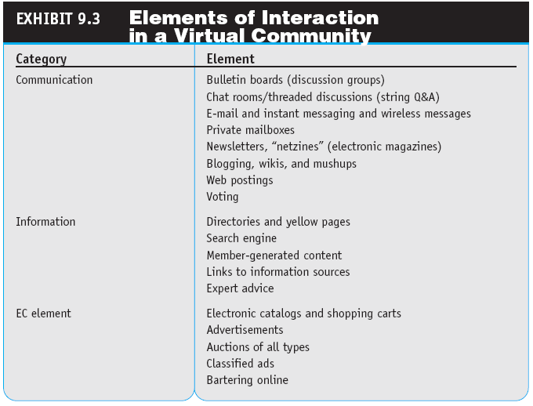
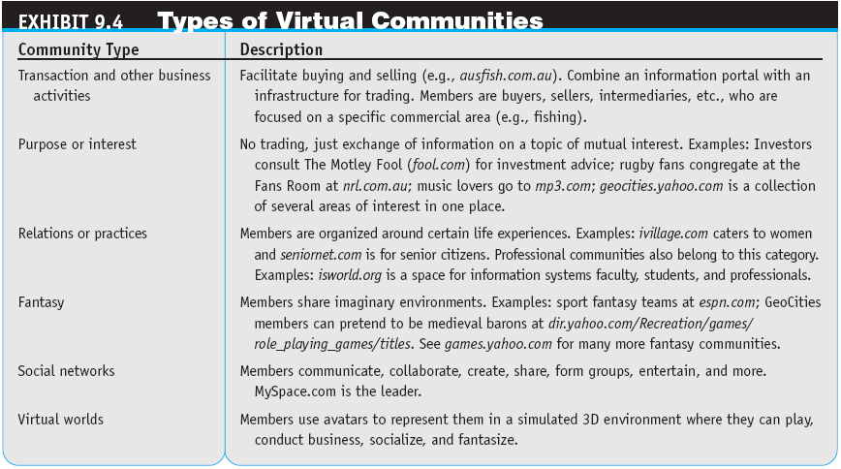
Online Social Networking
- A social network is a place where people create their own space, or homepage on which they write blog; pos picture, etc.; and link to other web locations they fin interesting
- The size of social network sites
- A global phenomenon
What Is Social Networking
- An extended group of people with similar interests or concerns who interact and remain in informal contact for mutual assistance or support.
- Involves building “Social Capital”
What is Social Capital?
- The core concept in business, economic, organizational behavior, political science and sociology
- Defined as the advantage created by a person’s location in a structure of relationships. It explains how some people gain more success in a particular setting through their superior connections to other people
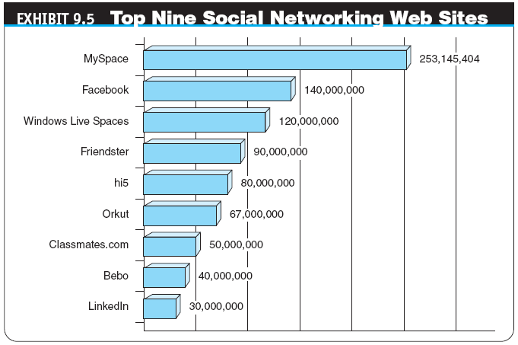
Why are these of interest to businesses?

Information into Capital
- The business challenge is analyzing and shaping the information to be meaningful from a business perspective
Online Social Networking:
- Social network analysis (SNA software) The mapping and measuring of relationships and information flows among people, groups, organizations, computers, and other information- or knowledge-processing entities.
- The nodes in the network are the people and groups, whereas the links show relationships or flows between the nodes. SNAs provide both visual and mathematical analyses of relationships
Examples of Network Classification
- Aggregators: Linkedin, Facebook, Xing, Ecademy etc. etc..
- Geographic: “Link to” sites: Chicago, Charlotte, Nashville, New York etc. etc..
- Industry: Wireless Factors, Wine & Spirits, Motor Sports, Entrepreneurs etc. etc..
- Topical: Politics, Music, Sports Investments, etc.
Online Social Networking
- Mobile social networking
  - Members converse and connect with one another using cell phones or other mobile devices
    - Mobile Enterprise Network
    - Mobile Community Activities

