Flatteners #7 and 8 from Friedman
Apple
- Challenges in early-mid 1990’s (lost market share to windows)
- Shifted focus to digital music (creation and storage/playing)
- Launched IPod in 2001 expanded with accessories
- Public image of Apple shifted dramatically including PCs
Digital Goods
- Goods that can be delivered over a digital network
  - E.g., Music tracks, video, software, newspapers, books
- Cost of producing first unit almost entire cost of product: marginal cost of producing 2nd unit is about zero
- Costs of delivery over the Internet very low
- Marketing costs remain the same
- Industries with digital goods are undergoing revolutionary changes (publishers, record labels, etc.)
Supply-Chaining (Flattener #7)
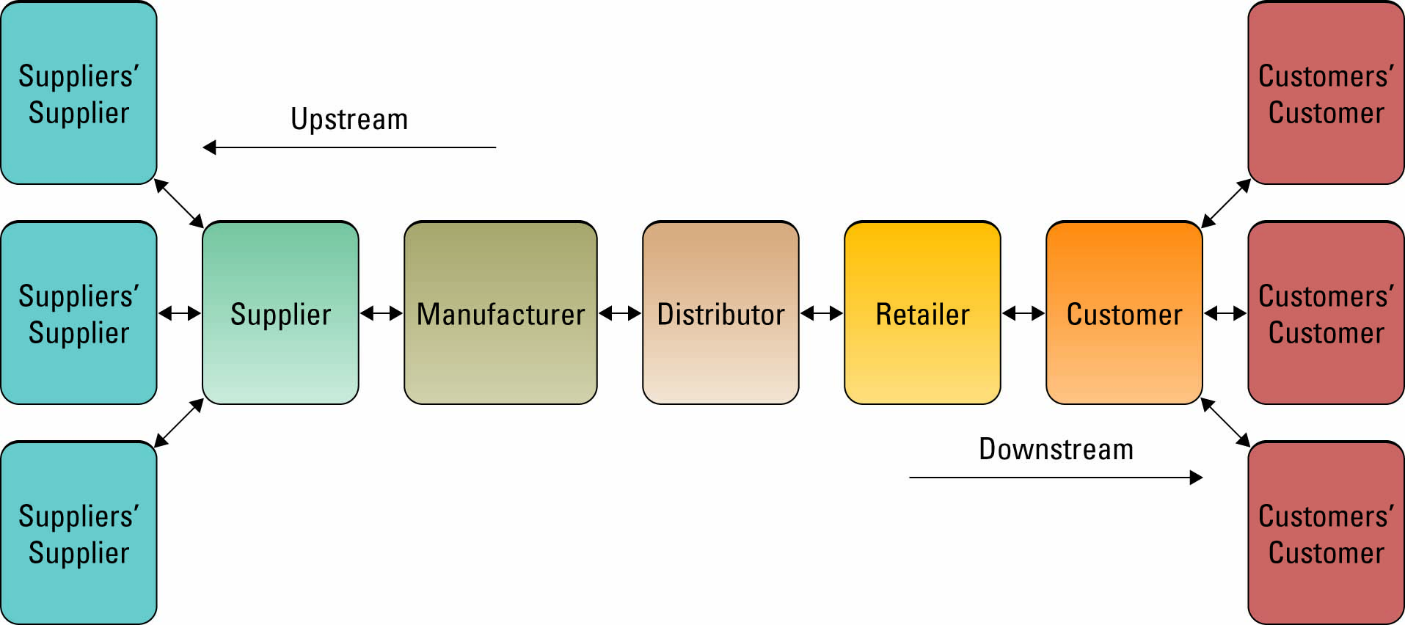
- Global optimization
  - Total cost of delivering part on time from all factors of the globe to your factories has to be low
- Supply and Demand
  - Innovation is happening faster, products go in and out of fashion much quicker
Wal-Mart’s Solutions- Procurement
- Wal-Mart emphasized the need to reduce purchasing costs and offer the best price to the customer
- The company directly procured from manufactures, by passing all intermediaries
- Wal-Mart finalizes a purchase deal only when it is confident that the product being bought is available else where at a lower price
Wal-Mart Underlying structure
- Uses IT to foster efficiency and streamlining operations
- As a computer is sold it automatically increment a count
- Replaced inventory with information physical to digital
- Coefficient of flatness
- Linkage between manufactures, suppliers and customer demand, facilitated by IT
- Facilitate the eruption of information technology & global economy
- One of the first companies to electronically track inventory and the first to develop a comprehensive computer network to share this information
- Gain of supply-chain efficiencies by working directly with factories
- Mastered the process of production, movement of goods, warehousing of goods, ensuring goods arrives on time at the right place, and for a cheap price
Wal-Mart Leveraged Technologies for new efficiencies and relationships0 Electronic Data interchange (EDI)
- Computer-to-computer exchange of standard transactions such as invoices, purchase orders
- Major industries have EDI standards that define structure and information fields of electronic documents for that industry
- More companies increasingly moving away from private networks to Internet for linking to other firms
  - E.g., Businesses can now use Internet to locate most low-cost supplier, search online catalogs of supplier products, negotiate with suppliers, place orders, etc.

Electronic Data Interchange (EDI)
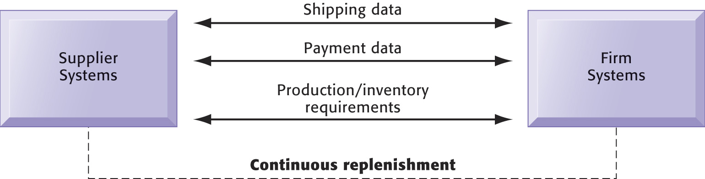
Using EDI for procurement
- Computer systems of Wal-Mart were connected to those of its suppliers
- EDI allowed the suppliers to download purchase order along with store-to-store sales information relating to their products sold
- Receiving information about the sales of various products, the suppliers shipped the required goods to Wal-Mart’s distributing centers
Further Innovation
Knowing what consumers want
- Barcodes: reveals everything about a product
  - Barcodes are purchased are relayed to the manufactures of Wal-Mart
  - Manufacturers are dependent on Wal-Mart’s demand information
Radio Frequency Identification Technology
- When implementing these new technologies to reduce costs and increase efficiency
- Wal-Mart planned to replace bar-code technology with RFID technology
- The company believes his replacement would reduce its supply chain management costs and enhance efficiency
- Implementation of RFID: employees don’t have to physically scan the bar codes if goods entering the stores and distribution centers (saves labour costs and time)
- Wal-Mart sees that RFID would reduce the instances of stock-outs at the stores
- Wal-Mart: analysts felts it would impost a heavy burden on its suppliers
- RFID compliant: suppliers would need to earn around $20 million
  - 50% would be spent on integrating the system and making modification in supply chain software
- Manufacturer becomes dependent and somewhat subservient to the retailer, some supplier have accused Wal-Mart of bulling tactics
- Need to make standards and compliance with the standards if you want to do business with Wal-Mart
Flattener #8- Insourcing UPS
- Worlds largest air & ground package service
- Spends billions of dollars on IT to boost customer service while keeping costs low

