Chapter 12- 588
The Cash Flow Statement
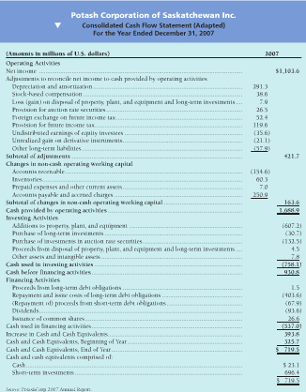
Basic Concepts: The Cash Flow Statement
Cash Flow statement report cash flows cash receipts and cash payments
- Where the cash came from and how the money was spent
Helps investors and creditors perform the following functions
- Predict Future cash Flows Past cash receipts and payments are reasonably good predictors of future cash flows
- Valuate Management Decision businesses that make wise investment decisions prosper, and those that make unwise decisions suffer losses. The cash
  - The cash flow statement reports how managers got cash and how they use cash to run the business
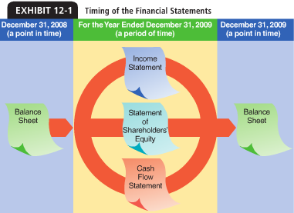
- Determine ability to pay dividends and interest Shareholders want dividends on their investments. Creditors collect interest and principal on their loans
- She the relationship of net income to cash flow cash and net income move together. High levels of income lead to increase in cash. Company’s cash flow can suffer even when income is high
Cash cash in the bank, which includes cash equivalents (highly liquid short-term investments that can be converted to cash immediately).
Operating, Investing and Financing Activities
Operating activities
- Creates revenues, expenses, gains and losses net income which is a product of accrual basis accounting
- Most important out of the three
  - Reflects the core of the organization
Investing
- Increases and decreases long term assets (e.g land, buildings)
- Purchases and sales of these assets are investing activities
Financing Activities
- Obtain cash from investors and creditors
- Issuing and repurchasing shares, borrowing money, paying cash dividends
Two Formats for Operating Activities
Indirect Methodreconciles net income to net cash provided by operating activities
Direct MethodReports all cash receipts and cash payments from operating activities
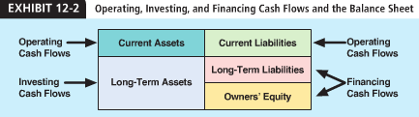
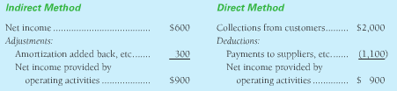
Preparing a Cash Flow statement
Step 1: lay out the template (^)
Step 2: Use comparative balance sheet to determine the increase or decrease in cash during the period. The cash is the “check figure” for the cash flow statement
Step 3: From the income statement, take the net income, amortization expense, and any gains or losses on the sale of long-term assets
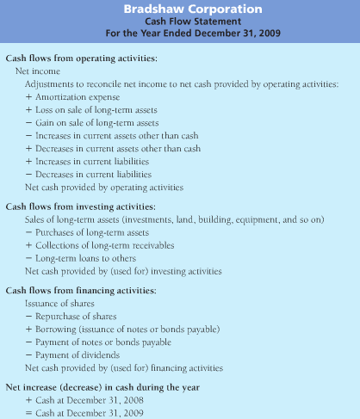
Step 4: Use the income statement and the balance data to prepare the cash flow statement. The cash flow statement is complete only after you have explained the year-to-year changes in all the balance sheet accounts
Cash Flow from Operating Activities
Operating activities are related to the transactions that make up net income

Amortization Expense
Added back to net income when we go from net income to cash flow
- Has no effect on cash, but decreases net income to cash flow
Gains and Losses on The Sale of Long-Term Assets
Investing activities often gain and loss on the sale
- A gain or loss on the sale is an adjustment to net income
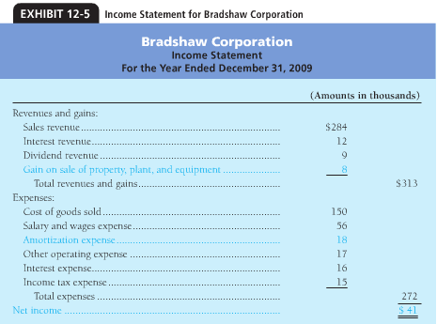
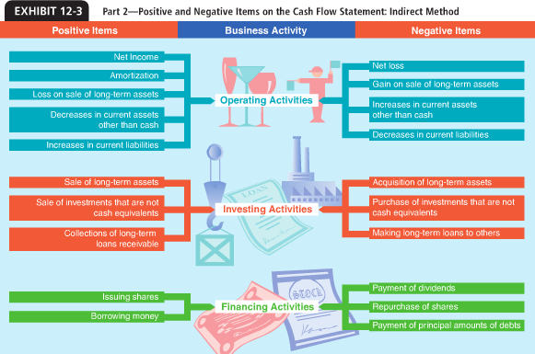
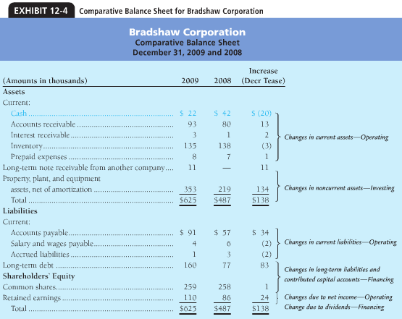

A loss on the sale of property, plant…. Also creates and adjustment in the operating section. Losses are added back to net income to compute cash flow from operations

Changes in the Current Assets and Liabilities
- An Increase in another current assets decreases cash
- A Decrease in another current asset increases Cash
- A decrease in a current liability decreases cash
- An increase in a current liability increases cash
Cash Flows from Investing Activities
Investing Activities affect long-term asset accounts, such as long-term assets, investment and notes receivables
Computing Acquisitions and Sales of property, plant, and equipment Assets
- Companies keep separate accounts for each items
  - Cash flow combine into a single account
- Subtract accumulated amortization from the assets’ cost and use the net figure
T-account for Assets sold
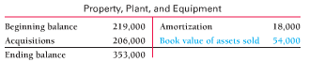
Computing Acquisitions and Sales of Investments, and Loans and Collections
Cash amounts of Investment transactions can be computed in the manner illustrated for property, plant and equipment
Investments are easier because there is no amortization to account
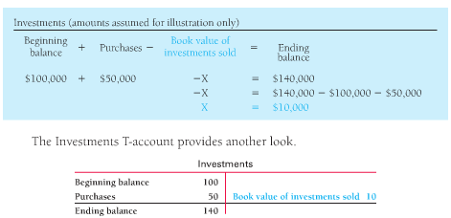
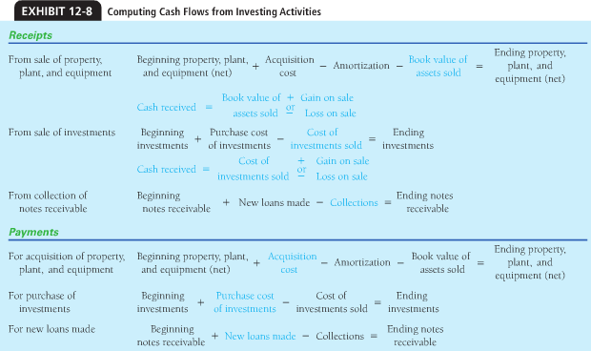
Cash Flow from Financing Activities
Financing activities affect liabilities and shareholders’ equity accounts such as notes payable, long-term debt, common shares and retained earnings

Computing Issuances and Payments of Long-Term Debt
Taken from the Balance Sheet
- If amount of either the new issuances or the payments is known, the other amount can be computed

Computing Issuances of Shares and Repurchases of Shares
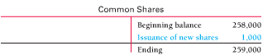
These cash flows can be determined from the share accounts
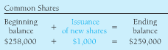
T-accounts provide another view of the dividend declaration computation
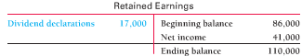
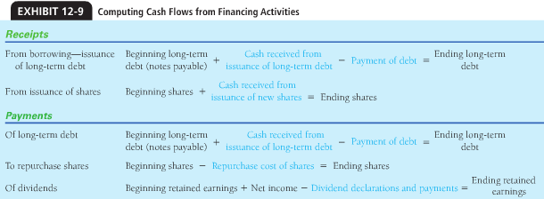

Noncash Investing and Financing Activities
Companies make investments that do not require cash
Transaction would not be reported on the cash flow statement because they didn’t pay cash
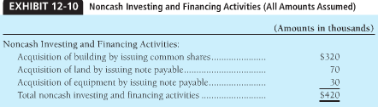
Preparing the Cash Flow Statement: Direct Method
To prepare the cash flow statement by the direct method:
Step 1: lay out the template to the cash for statement by the direct method
Step 2: Use the comparative balance sheet to determine the increase or decrease in cash during the period. The change in cash is “check figure” for the cash flow statement
Step 3: use the available data to prepare the cash flow statement. These transactions affect both the income statement and the cash flow statement.
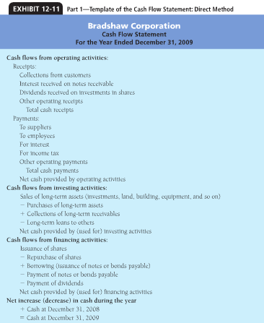
- The cash flow statement report only those tractions with cash effects

Cash Flows from operating Activities
Cash Collections for customers both cash sales and collections of accounts receivables are reported on the cash flow statement as “collection from customers”
Cash Receipts of Interest The income statement reports revenue. Only the receipts of interest appear on the cash floor statement
Cash Receipts of Dividends Dividends are earned on investments in shares. Dividend revenue is reported on the income statement, and only cash receipts are reported on the cash flow statement
- Dividends received are operating, dividends paid are financing
Payments to Suppliers Includes all payments for inventory and operating expenses except employee compensation, interest, and income taxes. Suppliers are those entities that provide the business with its inventory and essential services
Payments To Employees the payments for salaries, wages, commissions, and other forms of employee compensation. Accrued amounts are excluded because they a have not yet been paid
Payments for interest expense and income tax expense interest and income tax payments are reported separately. Pay all interest expense in cash. Same amount appears on the income statement and the cash flow statement. Interest payments are operating expense because the interest expense.
Amortization Expense expense is not listed on the cash flow statement because it does not affect cash
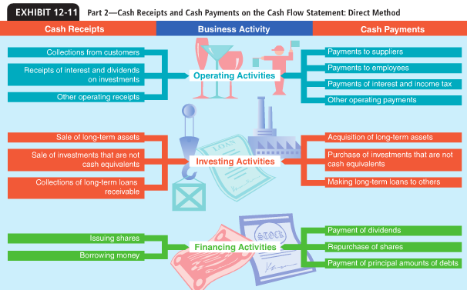
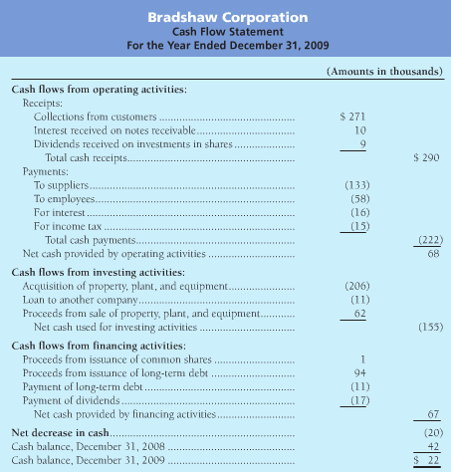
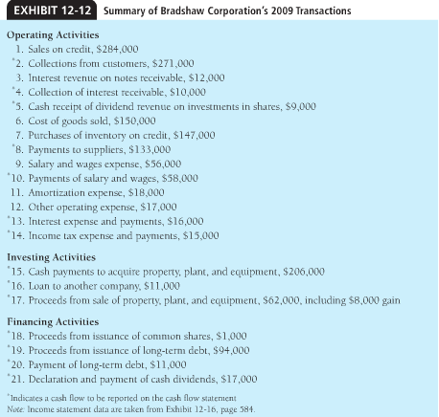

Cash Flows from Investing Activities
Investing determine future course
Purchases of Long-term assets; purchasing investments and making loans to other companies
- These payments acquire long-term assets
Proceeds from selling long-term Assets and investments and from collecting notes receivables
- These cash receipts are also investing activities
Cash Flows from Financing Activities
Proceeds from issuance of shares and debt issuing shares and borrowing money are two common ways to finance operations
Payments of debt and repurchases of the company’s own shares the payment of debt (notes payable0 decreases cash, which is opposite effect of borrowing
Payment of Cash Dividends the payment of cash dividends is a financing activity. A stock dividend has no effect on cash and is no reported on the cash flow statement
Noncash Investing and Financing Activities
Obtain financing other then cash.
Not reported on the cash flow statement paid no cash
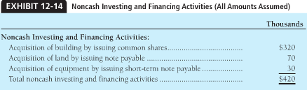
Computing Operating Cash Flows By the Direct Method
Computing operating cash flows by the direct methoduse income statement and the changes in the related balance sheet accounts
Computing Cash Collections from Customers
Collections start with sales revenue (accrual-basis amount). Income statement reports sales. Accounts receivable increased from the beginning of the year.

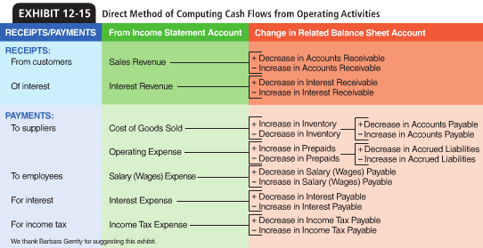
T-accounts Receivable provides another view of the same computation A/R increased, so collections must be less than sales
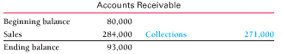
Computing payments to suppliers
- Payments for inventory
- Payments for operating expenses (other than interest and income tax)
Payments for inventory are computed by converting COGS to the cash basis

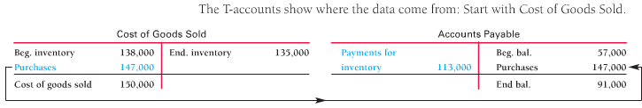
Computing Payments for Operating Expenses
Other than interest and income tax can be computed from three accounts: prepaid expenses, accrues liabilities, and other operating expenses
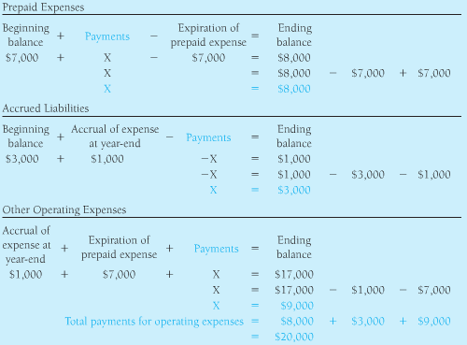

Computing Payments to Employees
Combine all payments to employees into one account, salary and wage payable 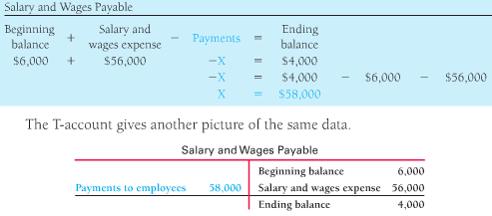
Computing Payments of interest and income taxes
Amounts are the same for interest and income tax (no analysis)
Measuring Cash Adequacy: Free Cash Flow
Free Cash Flow is the amount of the cash available from operations after paying fro planned investments in property, plant, and equipment and other long-term assets.
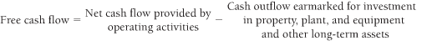
A large amount of free cash flow is preferable means a lot of cash new investments

