Chapter 9
Shareholders’ Equity
Separate Legal Entity
Corporation is an entity formed under federal or provincial law grants Article of incorporation

A corporation is a distinct entity, artificial person that exists apart from its owners, the shareholders

Continuous Life and Transferability of Ownership
Corporations have continuous lives regardless of change in their ownership

Shareholders can transfer shares as they wish

Proprietors and partnerships terminate when ownership changes (contrast to a corporation)

Limited Liability
Have no personal obligation for corporate liabilities
(Shareholders can lose on an investment in a corporation’s shares is the cost of the investment)

Proprietors and partners are personally liable for all debts of their businesses (unless its organized as a limited liability partnership)

Separation of Ownership and Management
Shareholders own the corporation, but a board of directors (elected from the shareholder) appoints officers to mange the business

Management goal is to maximize the firm’s value for the shareholders
Corporate officers may run the business for their own benefit and not for the shareholders

Corporate Taxation
Corporations are separate taxable entities
Double Taxation (corporation)
- Pays corporate income tax
- Shareholders pay personal income tax on cash dividends
  - Proprietors and partnerships don’t pay income tax only taxed on their share of their income
Government Regulation
Since shareholders have limited liability for corporation debt, outsiders doing business with the company can look no further than the corporation if it fails to pay
To protect a corporation’s creditors and the shareholders, both federal and provincial governments corporations (makes sure they disclose information to investors and creditors)
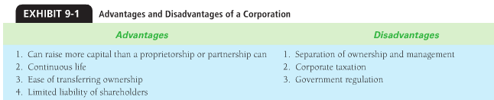
Organizing a Corporation
Incorporators: the organizer who being the business
- They submit articles of incorporation to the federal or provincial government for approval
Articles of incorporation
- Authorization for corporation to issue a certain number of shares of stock, which are shares of ownership
The incorporators
- Pay Fees
- Sign the Charter
- File the required documents with the incorporating jurisdiction
- Agree to a set of bylaws, which act as the constitution for governing the corporation
After this the corporation comes into existence
Position
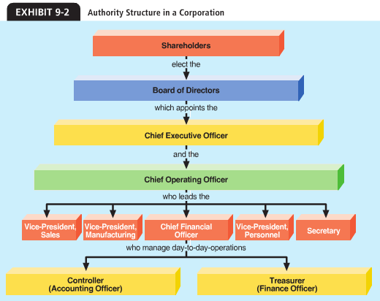
- Ultimate control Shareholders
- Sets the company policy and appoints officers Board of directors (elected by shareholders)
- Most power in the corporation Chairperson (elected by board)
- In charge of day-to-day operations Chief executive officer (CEO) (elected by board)
- Responsible for administering day-to-day operations and reports to the CEO Chief Operating officer (COO)
- In charge of sales, manufacturing, accounting and finance Vice President (chief financial officer CFO)

Shareholders’ Rights
- The right to sell the shares my be restricted
- Voteright to participate in management by voting on matters that come before shareholders (normally entitled to one vote for each common share owned)
  - Classes of common shares that give they holders multiple votes or no votes
- Dividends right to receive a proportionate part of any distributed payment, or dividend
  - Each share in a particular class gets an equal dividend
- Liquidation right to receive proportionate share of any assets remaining after the corporation pays all liabilities in liquidation
  - Liquidation means to go out of business (sell assets, pay liabilities and distribute remaining cash to owners
- Preemption right to remain one’s proportionate ownership in the corporation when new shares are released
Shareholders’ Equity
Shareholders equity represent the shareholders’ ownership interest in the assets of corporation
Contributed Capital (common stock): the amount of shareholders equity the shareholders have contributed to the corporation
Retained Earnings: the amount of shareholders’ equity the corporation has earned through profitable operations (not used for dividends)
Cash dividends are declared from retained earnings
Owners’ equity: divided into shares of stock
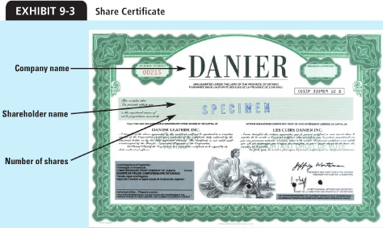
Corporations give share certificates to the owners exchange for investment
- Share: basic unit of contributed capital
Corporation can issue as many share certificates as pleased
- Total number of authorized shares is limited by charted
Authorized: the maximum number of shares a corporation is allowed to distribute to shareholders
Issued: the number of shares sold or transferred to shareholders
Outstanding Shares: actually in the hands of shareholders

Class of Shares
- Common Shares basic form of stock
  - Have the five basic rights of share ownership (unless specifically withheld)
  - Common Shareholders are the owners (benefit the most but face higher risks)
- Preferred Shares gives their owners certain advantages over common shareholders
  - Receive dividends before common shareholders
  - Receive assets before common shares
  - Company can issue classes of preferred shares
  - Expect fixed dividends
    - Required payment
- No-Stated-Value Shares: stock that do not have value assigned to them by articles of corporation
  - Stated Value: Board of directors assigns the value to the shares when issued
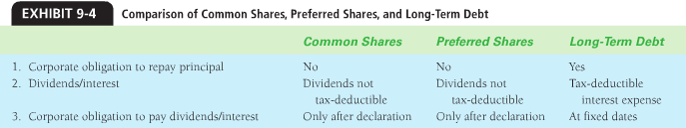
Issuing Shares
- Corporations can sell shares directly to shareholders or use a service of an underwriter
Common Shares
Issuing Common Shares at a stated Value
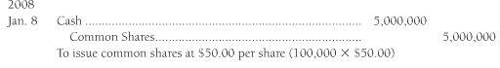
- Contributed Capital the amount invested in the corporation
  - Al transaction recorded in this section include a receipt of cash by the corporation as it issues new shared
  - Has no affect on earnings
Common Shares issued for Assets Other than Cash
- Issues shares in exchange for assets other then cash
  - Records the assets at their current market value and credits the capital amount because shareholders will demand shares equal
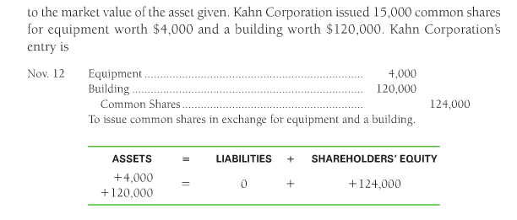
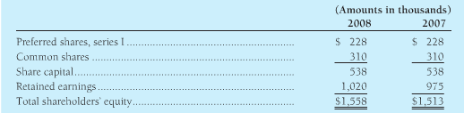
Preferred Shares
- Records a preferred shares account as its stated value
  - Reporting shareholders equity on the balance sheet

- Journal Entry
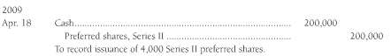
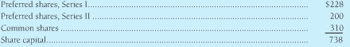
After this issuance, share capital in shareholders’ equity section would appear

- The preferred shares are usually convertible into company’s common shares and always at the discretion of preferred shareholders
  - Can change when market prices gets high or low enough
  - You just remove preferred shares from the books and add common shares
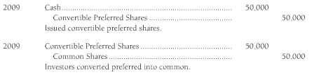

Repurchase of Shares by a Corporation
- The company needs the repurchased shares to fulfill future shares insurance commitments, such as those related to share options plans and conversions of bonds and preferred shares not common shares
- Help support the share’s current market price by decreasing supple available
- Management wants to avoid a takeover by an outside party
Should a Company buy back its own Shares?
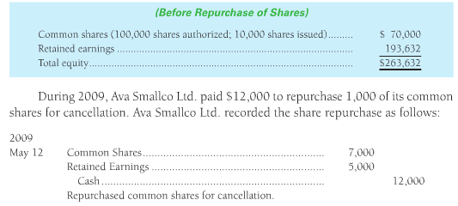
- When a company repurchases shares for more than the shares were issued originally, it is deemed as distributing profits (retained earning)
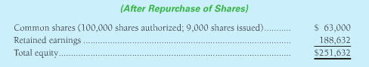
- Repurchase of shares has the opposite effect of issuing shares
  - Issuing shares grows a company’s assets and equity
  - Repurchasing shares shrinks assets and equity
- When a company repurchases its shares for less than the issue price
  - Difference is considered contributed surplus
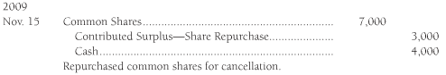
  - Contributed surplus share repurchase is credit for the difference between issue price and repurchase price

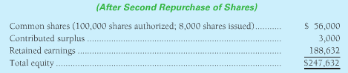
- Most cases a company cancels the shares when they are repurchased
Retained Earnings, Dividends, and Splits
- Retained Earnings account carries the balance of the business’s net income less then its net losses and less any declared dividends accumulates n the corporations life-time
- Retained Earnings reinvesting back into the business the assets they generate through profitable operations
- A credit balance in retained earnings mean earnings exceed losses and dividends
  - Debit balance is losses and dividends exceeds earnings
- Deficit amount subtracted from the sum of the other equity accounts to determine total shareholders’ equity
  - RE deficits not uncommon
- Dividends Corporation’s return to its shareholders of the benefits of earnings. Forms of dividends:
  - Cash
  - Shares
  - Noncash Assets (debit RE credit the asset e.g. long term investment)
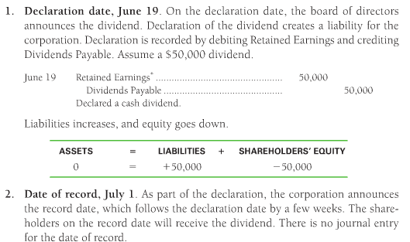
Cash Dividends
How to tell if a company can pay dividends
- Enough Retained Earnings to declare the dividend
- Enough cash to pay dividends
A company declares a dividend before paying it
Only Board of Directors had authority to declare dividends
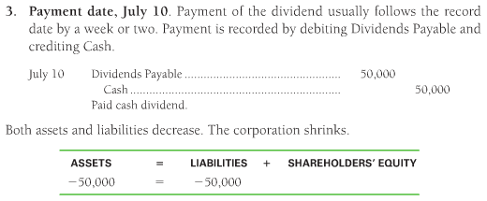

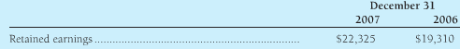
Analyzing the Shareholder’s Equity Accounts
Telling what the company did during the current year
- Retained Earnings increased in 2007
- Net income is the only item that increases RE
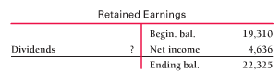
Dividends on Preferred Shares
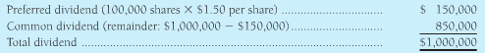
Preferred shareholders receive dividends first (CS receive dividends only when declared)

Expressing the Dividend on Preferred Share
Dividends on preferred shared are stated as a dollar amount since it’s a stated value
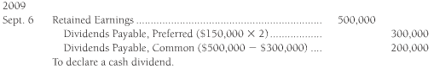
Dividends on Cumulative and Noncumulative Preferred shares
Owners of cumulative preferred shares must receive all dividends in arrears plus the current year’s dividends before the corp. can pay dividends the common shareholders.
Participation feature: company pays extra dividends on participating preferred shares:
- Preferred shareholders receive their usual dividend
- Common Shareholders receive the dividends declared for CS
- The excess above these amounts is shared by common and preferred in proportion to the total value of both classes of shares or according to some other agreed formula
Limited Voting Rights
PS shares are generally non-voting limited voting granted for these reason:
- Company wants to liquidate a large person of corporate assets
- To merge with another company
- To issue new bonds or preferred shares
Call Provisions
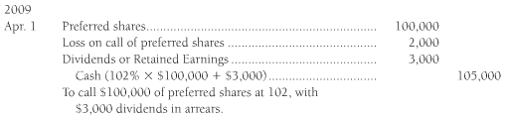
Preferred shares may be callable allows companies to repurchase shares from shareholders at a predetermined price and retire them
Stock Dividends
Is a proportional distribution by a corporation of its own shares to its shareholders.
- Stock dividends increase, RE decrease, Total equity is unchanged and no assets or liability is affected
A company may choose to distribute stock dividends for the following reasons:
- To continue dividends but conserve cash
  - Shareholders pay tax on stock dividends
- To reduce the per-share market price of its shares
  - Distribution of stock dividends
  - Makes shares less expensive and thus more attractive to more investors
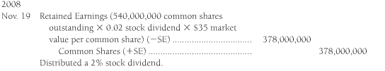
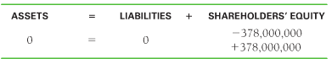
The increases in equity offset the decrease and the net effect is zero

Stock Splits
Is an increase in the number of authorized, issued and outstanding shares of stock, coupled with proportionate reduction in the shares’ book value.
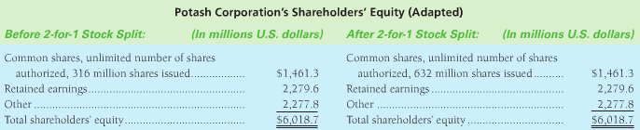
Retained Earning Restrictions
Restrictions are disclosed in the notes accompanying financial statements and result from one or more:
Legal regulatory agencies limit dividend payments to the balance of RE
Contractual debt covenants related to bank loans may restrict dividends to a specified percentage of RE
Voluntary corporate directors may limit dividends so that cash can be used in the business to take advantage of investment opportunities
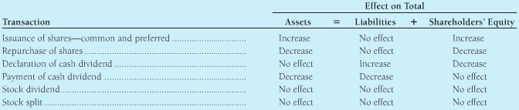
Using Book Value per share
Relating Profitability to a Company’s Shares
Investors search for companies whose shares are likely to increase in value
Comparing companies of different sizes, investors use some standard profitability measures include:
- Return on assets
- Return on equity
Return on Assets
The rate of return on total assets (ROA), measure companies success using its assets to earn income:
- Creditors to whom the corporation owns money (creditors want interest)
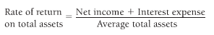
- Shareholders who own the corporation’s shares (shareholders want net income)

Return on Equity
ROE shows the relationship between net income and average common shareholders’ equity
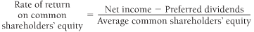

ROE is always higher then ROA for a successful company
- Shareholders take more investments risks than bondholders, so shareholders demand that
- If ROA were higher return on debt (interest) is higher than ROE (net income)
Cash Flow Statement
Issuance of Shares
- Basic transactions in which a company issues its share for cash. The sales was reported as a financing activity
Repurchases of Shares
- A company can repurchase its shares
Dividends
- The company paying its shareholder for the use of their money
- Stock dividends are not reported on the cash flow statement because the company pays no cash
Variations in Reporting Shareholders’ Equity


