CHAPTER 2

Levels of Strategic Planning in Corporations
- Strategic planning in most organizations occurs on at least two levels, the corporate level and the functional level
  - Corporate Level
    - Corporate level planning is done by the company's top management and focuses on the overall direction of the entire company
    - Corporate level planning focuses on the long-term direction of the company, which is updated regularly to respond to changes in the business environment
  - Functional Level
    - The marketing function develops marketing plans for the company's various products, brands, and markets. These plans could take the form of annual plans or three- to five-year plans
    - The marketing function may also be involved in both corporate-level and SBU-level planning because of its focus on creating value for customers and the company.
- An SBU is a division of the company that can be managed somewhat independently from other divisions since it markets a specific set of products to a clearly defined group of customers.
- Marketing planning process is a set of steps a marketer goes through to develop a marketing plan.

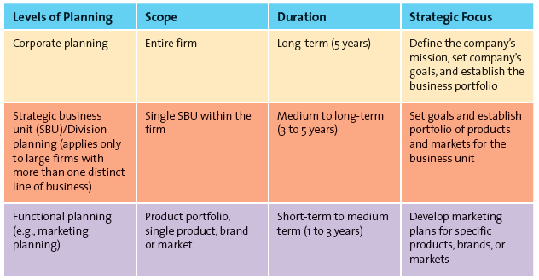

The Marketing Plan
- A marketing plan is a written document composed of an analysis of the current marketing situation, opportunities and threats for the firm, marketing objectives and strategy specified in terms of the four Ps, action programs, and projected or pro forma income (and other financial) statements.
- The three major phases of the marketing plan are planning, implementation, and control.
  - The planning phase is where marketing executives and other top managers define the mission and objectives of the business, and evaluate the situation by assessing how various players, both inside and outside the organization, affect the firm's potential for success.
  - The Implementation phase is where marketing managers identify and evaluate different opportunities by engaging in a process known as segmentation, targeting, and positioning. They then develop and implement the marketing mix by using the four Ps.
  - The control phase is the part of the strategic marketing planning process when managers evaluate the performance of the marketing strategy and take any necessary corrective actions
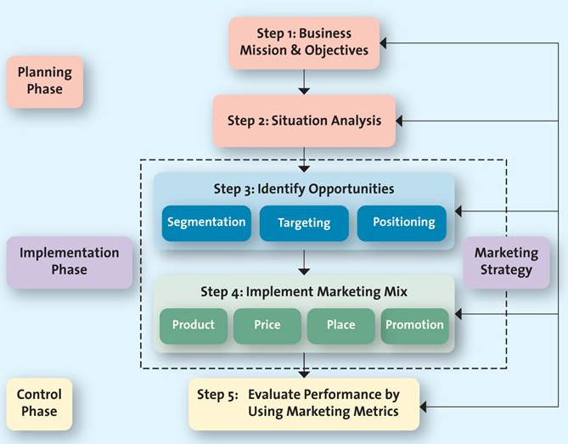

Step 1: Defining the Business Mission and Objectives
- A mission statement a broad description of a firm's objectives and the scope of activities it plans to undertake; attempts to answer two main questions: What type of business is it? and What does it need to do to accomplish its goals and objectives?
- Another key goal or objective often embedded in a mission statement is how the firm is building a sustainable competitive advantage.
Step 2: Conduct a Situational Analysis
- A situational analysis is the second step in a marketing plan; uses a SWOT analysis that assesses both the internal environment with regard to its strengths and weaknesses and the external environment in terms of its opportunities and threats.
- The firms should assess the opportunities and uncertainties of the marketplace due to changes in cultural, demographic, social, technological, economic, and political forces (CDSTEP)
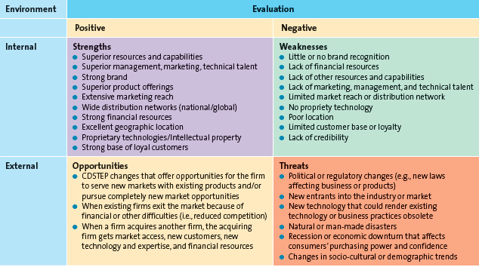
- A SWOT analysis requires the firm to undertake a critical assessment of its resources, capabilities, organization, strategies, and performance in relation to competitors.

Step 3: Identify and Evaluate Opportunities by Using STP
- STP is the processes of segmentation, targeting, and positioning that firms use to identify and evaluate opportunities for increasing sales and profits.
- With STP, the firm must first understand customer needs and wants through market research, then divide the market or customers into distinct subgroups or segments, determine which of those segments it should pursue or target, and finally decide how it should position its products and services to best meet the needs of those chosen targets.
  - Segmentation
    - A marketing segment is a group of consumers who respond similarly to a firm's marketing efforts
    - Market segmentation is the process of dividing the market into distinct groups of customers where each individual group has similar needs, wants, or characteristics—who therefore might appreciate products or services geared especially for them in similar ways.
  - Targeting
    - Target marketing is the process of evaluating the attractiveness of various segments and then deciding which to pursue as a market.
  - Positioning
    - Positioning is what consumers think and feel about a brand or product; marketers try very hard through their various marketing efforts to shape consumers' perceptions regarding their brand or product.
    - Market positioning involves the process of defining the marketing mix variables so that target customers have a clear, distinct, desirable understanding of what the product does or represents in comparison with competing products

Step 4: Implement Marketing Mix and Allocate Resources
- Product and Value Creation
  - Because the key to the success of any marketing program is the creation of value, firms attempt to develop products and services that customers perceive as valuable enough to buy.
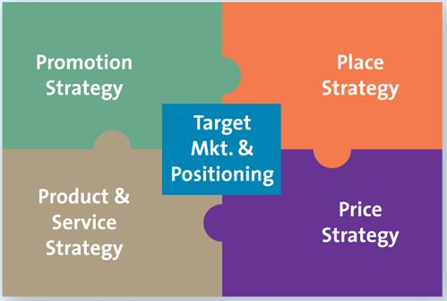
- Price and Value for Money
  - Value-based marketing requires that firms charge a price that customers perceive as giving them good value for the products and services they receive.
- Place and Value Delivery
  - The firm must be able to make the product or service readily accessible when and where the customer wants it.
- Promotion and Value Communication
  - Marketers communicate the value of their offering, or the value proposition, to their customers through a variety of media.
  - These retailers and thousands like them have added value to their offerings through their efficient and effective communications strategies.
  - Marketing managers must develop schedules: timelines for each activity and the personnel responsible for the respective activity to avoid bottlenecks and ensure smooth and timely implementation of the marketing mix activities.

Step 5: Evaluate Performance by Using Marketing Metrics
- A metric is a measuring system that quantifies a trend, dynamic, or characteristic. Metrics are used to explain why things happened and to project the future.
  - Who is Accountable for Performance?
    - Performance evaluations are used to pinpoint problem areas
  - Performance Objectives and Metrics
    - One approach is to compare a firm's performance over time or to competing firms, using common financial metrics such as sales and profit.
  - Financial Performance Metrics
    - Some commonly used metrics to assess performance include revenues, or sales, and profits.
    - The metrics used to evaluate a firm vary depending on:
      - The level of the organization at which the decision is made
      - The resources the manager controls.

Strategic Planning is Non Sequential
- In portfolio analysis, for example, management evaluates the firm's various products and businesses—its “portfolio”—and allocates resources according to which products are expected to be the most profitable for the firm in the future.
- A product line is a group of products that consumers may use together or perceive as similar in some way.
- An SBU (strategic business unit) is a division of the company that can be managed somewhat independently from other divisions a division of the company that can be managed somewhat independently from other divisions since it markets a specific set of products to a clearly defined group of customers.

Growth Strategies
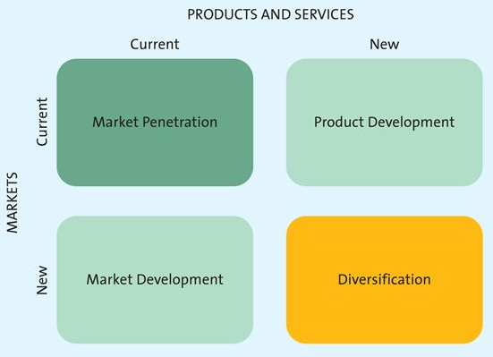

Market Penetration
- A market penetration strategy is a growth strategy that employs the existing marketing mix and focuses the firm's efforts on existing customers.
- Such a growth strategy might be achieved by encouraging current customers to patronize the firm more often or buy more merchandise on each visit or by attracting new consumers from within the firm's existing target market.

Product Development
- A product development strategy is a growth strategy that offers a new product or service to a firm's current target market.

Market Development
- A market development strategy is a growth strategy that employs the existing marketing offering to reach new market segments, whether domestic or international or segments not currently served by the firm.
- International expansion is generally riskier than domestic expansion because firms must deal with differences in government regulations, cultural traditions, supply chain considerations, and language.
- Market development may also include segments the firms are not currently serving but that represent great opportunities.

Diversification
- A diversification strategy is a growth strategy whereby a firm introduces a new product or service to a market segment that it does not currently served.
- In a related diversification opportunity, the current target market and/or marketing mix shares something in common with the new opportunity.
- In an unrelated diversification, the new business lacks any common elements with the present business.

Marketing Strategy and Sustainable Competitive Advantage
- A market strategy identifies a firm's target market(s), a related marketing mix—the four Ps, and the bases upon which the firm plans to build a sustainable competitive advantage.
- A sustainable competitive advantage is something the firm can persistently do better than its competitors that is not easily copied and thus can be maintained over a long period of time.

Building a Sustainable Competitive Advantage
- There are four overarching strategies that focus on aspects of the marketing mix to create and deliver value and to develop sustainable competitive advantages.
  - Customer Excellence: Involves a focus on retaining loyal customers and excellent customer service.
  - Operational Excellence: Involves focus on efficient operations and excellent supply chain management
  - Product Excellence: Involves a focus on achieving high-quality products and effective branding and positioning
  - Locational Excellence: Involves a focus on a good physical location and Internet presence.

