CHAPTER 3

A Marketing Environment Analysis Framework
- One of the goals of value-based marketing is to provide greater value to consumers than competitors offer.

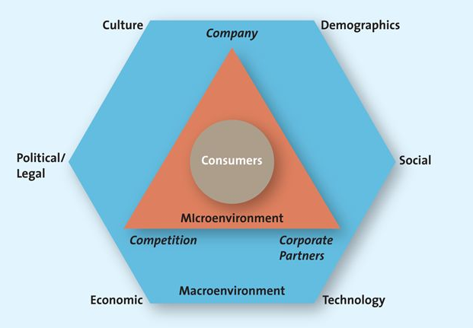

Microenvironment Factors
Company Capabilities
- Successful marketing firms focus their efforts on satisfying customer needs that match their core competencies.

Competition
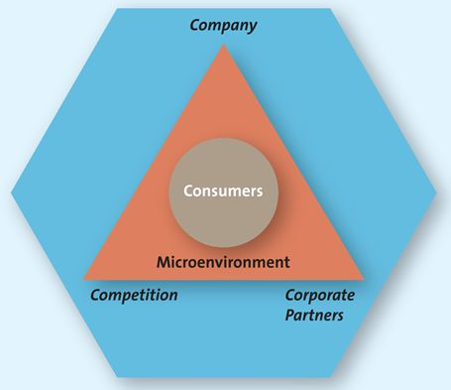
- It is critical that marketers understand their firm's competitors, including their strengths, weaknesses, and likely reactions to the marketing activities their own firm undertakes.
- Competitive Intelligence (CI) is used by firms to collect and synthesize information about their position with respect to their rivals; enables companies to anticipate changes in the marketplace rather than merely react to them.
- CI enables companies to anticipate changes in the marketplace rather than merely react to them

Corporate Partners

Macroenvironmental Factors
- Macroenvironmental factors are aspects of the external environment—culture, demographics, social trends, technological advances, economic situation, and political/legal environment (CDSTEP)—that affect companies.

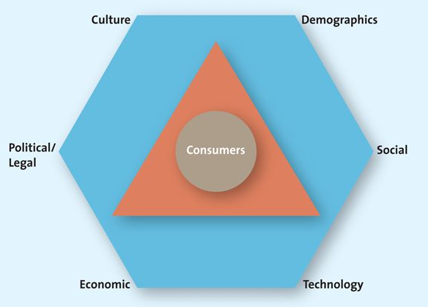

Culture
- Culture is the shared meanings, beliefs, morals, values, and customs of a group of people.
- The challenge for marketers is to have products or services identifiable by and relevant to a particular group of people.
- Two dimensions of culture that marketers must take into account as they develop their marketing strategies are the culture of the country and that of a region within a country.
  - Country Culture
    - Country culture entails easy-to-spot visible nuances that are particular to a country, such as dress, symbols, ceremonies, language, colours, and food preferences, and more subtle aspects, which are trickier to identify.
  - Regional Subcultures
    - The region in which people live in a particular country affects the way they react to different cultural rituals, or even how they refer to a particular product category.

Demographics
- Demographics are characteristics of human populations and segments, especially those used to identify consumer markets, such as age, gender, income, race, ethnicity, and education.
- Demographics thus provide an easily understood “snapshot” of the typical consumer in a specific target market.
  - Generational Cohorts
    - Generational cohorts are a group of people of the same generation—typically have similar purchase behaviours because they have shared experiences and are in the same stage of life.
      - Tweens
        - Tweens are a generational cohort of people who are not quite teenagers but are not young children either (ages 9 to 12).
        - Three in four Canadian tweens make shopping decisions jointly with their parents.
        - Since tweens are the first generation born after the emergence of the Internet, technology has no novelty for them.
      - Generation Y
        - Generation Y are a generational cohort of people between the ages of 13 and 32; the biggest cohort since the original postwar baby boom.
        - They are more skeptical about what they hear in the media, which makes marketing to this group even more challenging.
        - Gen Yers are Internet- and technology-savvy and love digital electronics.
      - Generation X
        - Generation X is a generational cohort of people between the ages of 36 and 47.
        - Unlike their baby boomer parents, gen X is the first generation of latchkey kids: those who grew up in homes in which both parents worked.
        - Gen Xers possesses considerable spending power.
        - They grew more knowledgeable about products and more risk averse than other generational cohorts.
      - Baby Boomers
        - Baby boomers are a generational cohort of people born after World War II; are between the ages of 48 and 66.
        - Leisure time represents a high priority to them.
      - Seniors
        - Seniors are North America's fastest-growing generational cohort; people aged 65 and older.

    - Income
      - Canadians may be classified into distinct groups based on their income and other factors such as background, education, and occupation.
        - Upper Class ($70 000 +)
        - Middle Class ($30 000 - $70 000)
        - Working Class ($20 000 - $30 000)
        - Underclass ( < $20 000)
    - Education
    - Gender
    - Ethnicity

Social Trends
- Social trends tend to change over time in their popularity and importance, and savvy marketers work hard to identify emerging trends to understand whether they present an opportunity or pose a threat to their business.
  - Green Consumers
    - Green marketing involves a strategic effort by firms to supply customers with environmentally friendly merchandise.
  - Marketing to Children
    - Guidelines for Responsible Food Marketing to Children, which outlines a variety of changes to advertising directed at children.
    - The new guidelines require advertisers to market food in reasonably proportioned sizes. The advertised food items also must provide basic nutrients, have less than 30 percent of their total calories from fat, and include no added sweeteners. The advertising also cannot be aired during children's programming, and companies cannot link unhealthy foods with cartoon and celebrity figures.
  - Privacy Concerns
    - More and more consumers worldwide sense a loss of privacy. At the same time that the Internet has created an exploding volcano of accessibility to consumer information, improvements in computer storage facilities and the manipulation of information have led to more and better credit check services.
  - The Time-Poor Society
    - Reaching a target market has always been a major challenge, but it is made even more complicated by several trends that increase the difficulty of grabbing those markets' attention.
    - Their divided attention means they simply cannot focus as well on the advertisements that appear in those media.
    - Marketers are thus faced with the challenge of finding more creative ways to get their marketing messages out to consumers under these ever-changing media consumption trends.

Technological Advances
- Technological advances are technological changes that have contributed to the improvement of the value of both products and services in the past few decades.
- Other areas of technical advance include how we bring media into our homes.
- Not only are marketers trying to make social media an integral part of their marketing strategy, but also consumers are using social media to share information and their experiences and frustrations with products, services, and marketers.
  - Economic Situations
    - Economic situations are economic changes that affect the way consumers buy merchandise and spend money; see inflation, foreign currency fluctuations, interest rates, and recession.
    - Some major factors that influence the state of an economy include the rate of inflation, foreign currency exchange rates, interest rates, and recession.
    - Inflation refers to the persistent increase in the prices of goods and services.
    - Foreign Currency fluctuations are changes in the value of a country's currency relative to the currency of another country; can influence consumer spending.
    - Interest rates represent the cost of borrowing money.
    - If the interest rate goes up, consumers have an incentive to save more, because they earn more for loaning the bank their money; when interest rates go down, however, consumers generally borrow more.
    - Recession is a period of economic downturn when the economic growth of the country is negative for at least a couple of consecutive quarters.

Political/Legal Environment
- Political/legal environment comprises political parties, government organizations, and legislation and laws that promote or inhibit trade and marketing activities.
- The government has enacted laws that promote both fair trade and competition by prohibiting the formation of monopolies or alliances that would damage a competitive marketplace, fostering fair pricing practices for all suppliers and consumers, and promoting free trade agreements among foreign nations.



