CHAPTER 6

B2B marketing is the process of buying and selling goods or services to be used in the production of other goods and services, for consumption by the buying organization, or for resale by wholesalers and retailers.
Therefore, B2B marketing involves manufacturers, wholesalers, retailers, and service firms that market goods and services to other businesses but not to the ultimate consumer

B2B Markets
- B2B firms focus their efforts on serving specific types of customer markets to create value for those customers.
Manufacturers or Producers
- Manufacturers, for example, buy raw materials, components, and parts that allow them to manufacture their own goods.
- Not only does the manufacturer purchase products from other firms to make its products, but it also works with its corporate partners, such as transportation companies and retailers, to facilitate the movement of the raw supplies to the factory and finished products to the stores.

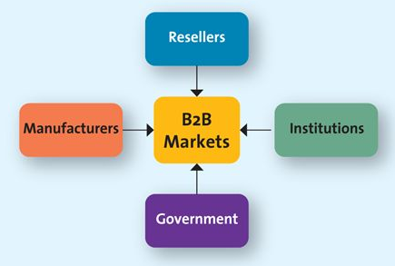
Resellers
- Resellers are marketing intermediaries that resell manufactured products without significantly altering their form.
- Wholesalers, distributors, and retailers are all resellers.

Institutions
- Institutions, such as hospitals, educational organizations, prisons, religious organizations, and other nonprofit organizations, also purchase all kinds of goods and services for the people they serve.

Government
- In most countries, the central government tends to be one of the largest purchasers of goods and services.

Key Challenges of Reaching B2B Clients
- The first challenge is to identify the right persons or decision makers within the organizations who can authorize or influence purchases.
- Second, marketers must understand the buying process of each of its potential clients.
- The third challenge is to identify the factors that influence the buying process of potential clients
- To address the complexity of B2B markets, many companies have salespeople or a sales team dedicated to specific clients.
Differences Between B2B and B2C Markets
- Market Characteristics
  - In B2C markets, consumers buy goods to satisfy their own individual or household needs and are heavily influenced by price, personal tastes, brand reputation, or personal recommendations of friends and family. In B2B markets, demand for goods and services is derived from B2C sales in the same supply chain.
  - Derived demand is the linkage between consumers' demand for a company's output and its purchase of necessary inputs to manufacture or assemble that particular output.
  - Another characteristic of B2B markets is that the number of business buyers is substantially fewer than in B2C markets, and the business buyers are more concentrated in big cities, towns, and industrial areas.
- Product Characteristics
  - In B2B markets, the products ordered are primarily raw materials and semi finished goods that are processed or assembled into finished goods for the ultimate consumers.
  - In B2C markets, consumers buy finished goods for their own personal consumption.
- Buying Process Characteristics
  - For purchases of highly technical or complex products involving thousands or millions of dollars, the buying effort is much more structured, formalized, and professional.
  - They are usually technically trained and qualified professionals, and they represent different interests (e.g., managerial, technical, and departmental) within the organization.
  - In B2B markets, buyers and sellers strive to develop close relationships with each other and so will often provide help or advice to ensure a win-win situation for both parties.
  - Some firms may engage in reciprocal buying arrangements—a practice where two firms agree to buy each other's products and services.
  - Two such consequences are that it excludes other vendors from participating in the buying process and may limit the firms to each other's products, which may not be the best thing.

B2B Classification System and Segmentation
- North American Industry Classification System (NAICS) is a classification scheme that categorizes all firms into a hierarchical set of six-digit codes.
- The NAICS classification system can be quite useful to B2B marketers for segmenting and targeting markets.
- The first two digits represents the sector in the economy (e.g., 51 is the information sector); the third digit represents the subsector (e.g., 515 is “Broadcasting except Internet”); the fourth digit represents the industry group; the fifth digit represents a specific subgroup within the industry; and the full six-digits refer to the country-level or national industry.

The B2B Buying Process
- Not all B2B purchases go through each stage or go through each stage with the same intensity.

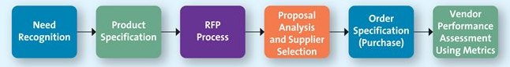
Step 1: Need Recognition
- The buying organization recognizes, through either internal or external sources, that it has an unfilled need.
- Through suppliers' salespeople, tradeshow demonstrations, ads in trade journals, Internet searches, and white papers, the company also has become aware of the benefits of different tire manufacturers.

Step 2: Product Specification
- After recognizing the need, the organization considers alternative solutions and comes up with potential specifications that suppliers might use to develop their proposals to supply the product.

Step 3: RFP Process
- Request for proposals (RFP) is a process through which buying organizations invite alternative suppliers to bid on supplying their required components.

Step 4: Proposal Analysis and Supplier Selection
- The buying organization, in conjunction with its critical decision makers, evaluates all the proposals it receives in response to its RFP.

Step 5: Order Specifications (Purchase)
- The firm places its order with its preferred supplier (or suppliers). The order will include a detailed description of the goods, prices, delivery dates, and, in some cases, penalties if the order is not filled on time. The supplier then will send an acknowledgement that it has received the order and fill it by the specified date.

Step 6: Vendor Performance Assessment Using Metrics
- Firms analyze their vendors' performance so they can make decisions about their future purchases.

Factors Affecting the B2B Buying Process
The Buying Centre
- The buying centre is the group of people typically responsible for the buying decisions in large organizations.
- We can categorize six different buying roles within a typical buying center.
  - Initiator is person who first suggests buying the particular product or service.
  - Influencer is the person whose views influence other members of the buying center in making the final decision
  - Decider is the person who ultimately determines any part of or the entire buying decision
  - Buyer is the person who candles the paperwork of the actual purchase
  - User is the person(s) who consumes or uses the product or service
  - Gatekeeper is the person(s) who controls information or access, or both, to decisions makers and influencers.

Organizational Culture
- Organizational culture reflects the set of values, traditions, and customs that guides a firm's employees' behaviour.
- The firm's culture often comprises a set of unspoken guidelines that employees share with one another through various work situations.
- Organizational culture can have a profound influence on purchasing decisions, and corporate buying center cultures might be divided into four general types: autocratic, democratic, consultative, and consensus.
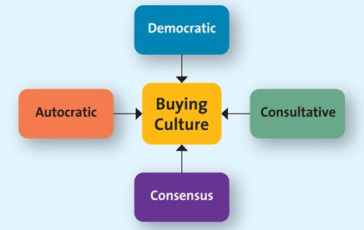
  - Autocratic buying centre is when one person makes the decision alone, though there may be multiple participants.
  - Democratic buying centre is when the majority rules in making decisions.
  - Consultative buying center is when one person makes the decision, but he or she solicits input from others before doing so.
  - Consensus buying center is when all members of the team must reach a collective agreement that they can support a particular purchase.
- Building B2B Relationships
  - Blogs and social media can build awareness, provide search engine results, educate potential and existing clients about products or services, and warm up a seemingly cold corporate culture.
  - The majority of B2B marketers use white papers for their marketing efforts, and 71 percent of B2B buyers regularly read them prior to making a purchase.
  - The goal of white papers is to provide valuable information that a businessperson can easily understand and that will help the company address its problems with new solutions.
Buying Situations
- Most B2B buying situations can be categorized into three types: new buys, modified rebuys, and straight rebuys.
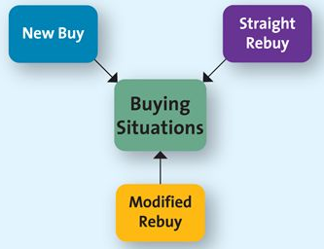
- New buy is a purchase of a good or service for the first time; the buying decision is likely to be quite involved because the buyer or the buying organization does not have any experience with the item.
- In the B2B context, the buying center is likely to proceed through all six steps in the buying process and involve many people in the buying decision.
- Modified rebuy is when the buyer has purchased a similar product in the past but has decided to change some specifications, such as the desired price, quality level, customer service level, and options.
- Straight rebuy refers to when the buyer or buying organization simply buys additional units of products that had previously been purchased.
- These varied types of buying situations call for very different marketing and selling strategies.
- The most complex and difficult is the new buy because it requires the buying organization to make changes in its current practices and purchases.
- In modified rebuys, the buyers spend less time at each stage of the B2B buying process.
- In straight rebuys, however, the buyer is often the only member of the buying center involved in the process.

Role of the Internet in Business-to-Business Marketing
- The Internet has become the communication mode of choice, and sometimes of necessity, for connecting divisions and employees located in disperse locations.
- Another increasingly common use of the Internet involves virtual trade shows
- Today companies can set up “booths” inside a virtual space and engage in product demonstrations and conversations with potential clients.
- The Internet is equally useful for communications between business through private exchanges and auctions.
- Private exchange occurs when a specific firm invites others to participate in online information exchanges and transactions.
- English auction is when goods and services are simply sold to the highest bidder.
- Reverse auctions when the buyer provides specifications to a group of sellers, who then bid down the price until the buyer accepts a specific bid.

