CHAPTER 8

Why do Firms Create New Products?
- New market offerings provide value to both firms and customers.
- Innovation is the process by which ideas are transformed into new products and services that will help firms grow.
Changing Customer Needs
- When they add new products to their offerings, firms can create and deliver value more effectively by satisfying the changing needs of their current and new customers or simply by keeping customers from getting bored with the current product or service offering.
- Sometimes, companies can identify problems and develop products that customers never knew they needed.
- In other cases, the firms take a well-known offering and innovate to make it more interesting.

Market Saturation
- The longer a product exists in the marketplace, the more likely it is that the market will become saturated. Without new products or services, the value of the firm will ultimately decline.

Managing Risk Through Diversity
- Through innovation, firms often create a broader portfolio of products, which helps them diversify their risk and enhance firm value better than a single product can.

Fashion Cycles
- In industries that rely on fashion trends and experience short product life cycles—including apparel, arts, books, and software—most sales come from new products.

Innovation and Value
- New product introductions, especially new-to-the-world products that create new markets, can add tremendous value to firms.
- Pioneers are new product introductions that establish a completely new market or radically change both the rules of competition and consumer preferences in a market.
- First movers are product pioneers that are the first to create a market or product category, making them readily recognizable to consumers and this establishing a commanding and early market share lead.
- Studies also have found that market pioneers can command a greater market share over a longer time period than later entrants can.

- There are many reasons that consumer goods fails, but the following are most common:
  - They offer consumers too few benefits compared with existing products
  - They are too complex or require substantial learning and effort before consumers can use them
  - Bad timing

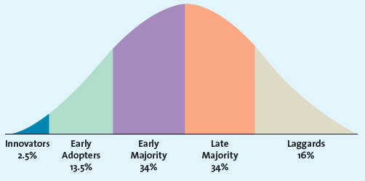
Adoption of Innovation
- Diffusion of innovation is the process by which the use of an innovation, whether a product or service, spreads throughout a market group over time and over various categories of adopters.
Innovators
- Innovators are those buyers who want to be the first to have the new product or service.
- However, these innovators are crucial to the success of any new product or service because they help the product gain market acceptance.

Early Adopters
- Early adopters are the second group; they generally don’t like to take as much risk as innovators but instead wait and purchase the product after careful review.
- Opinion leaders who spread the word to the next big groups: early majority and late majority. As a result, early adopters are crucial for bringing the other three buyer categories to the market. If the early adopter group is relatively small, the number of people who ultimately adopt the innovation likely will also be small.

Early Majority
- Early majority members don’t like to take much risk and therefore tend to wait until bugs are worked out.
- Its members don't like to take as much risk and therefore tend to wait until “the bugs” are worked out of a particular product or service.
- When early majority customers enter the market, the number of competitors in the marketplace usually also has reached its peak, so these buyers have many different price and quality choices.

Late Majority
- Late majority is the last group of buyers to enter a new product market and when they do the product has achieved its full market potential.
- By the time the late majority enters the market, sales tend to level off or may be in decline.

Laggards
- Laggards are those consumers that like to avoid change and rely on traditional product until they are no longer available.
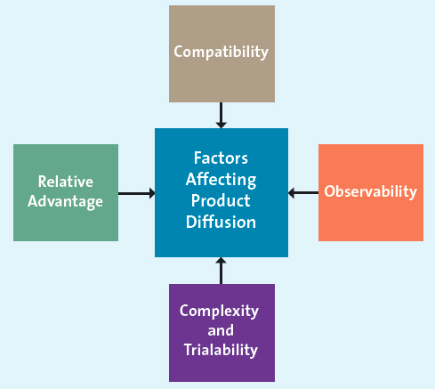
Using the Adoption Cycle
- Using the diffusion of innovation theory or adoption cycle, firms can predict which types of customers will buy their new product or service immediately after its introduction, as well as later as the product gets more and more accepted by the market.
  - Relative Advantage
    - If a product is perceived to be better than substitutes, then the diffusion will be relatively quick.
  - Compatibility
    - Compatible with current lifestyle
  - Observability
    - On the one hand, when products are easily observed, their benefits or uses are easily communicated to others, thus enhancing the diffusion process.
  - Complexity and Triability
    - Products that are relatively less complex are also relatively easy to try. These products will generally diffuse more quickly than those that are not.

How Firms Develop New Products
- The new product development process begins with the generation of new product ideas and culminates in the launch of the new product and the evaluation of its success.
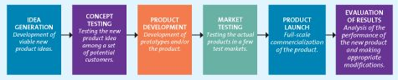
- Marketing plays a crucial role in the new product development process by communicating customer needs and wants and marketplace preferences and attitudes to the research and development (R&D) and engineering group.

Idea Generation
- To generate ideas for new products, a firm can use its own internal R&D efforts, collaborate with other firms and institutions, license technology from research-intensive firms, brainstorm, research competitors' products and services, and/or conduct consumer research.
  - Internal Research and Development
    - Many firms have their own R&D departments, in which scientists work to solve complex problems and develop new ideas.

  - Licensing
    - For many new scientific and technological products, firms buy the rights to use the technology or ideas from other research-intensive firms through a licensing agreement.
  - Brainstorming
    - Firms often engage in brainstorming sessions during which a group works together to generate ideas.
    - No idea can be immediately accepted or rejected.
    - Only at the end of the session do the members vote on the best ideas or combinations of ideas. Those four to eight ideas that receive the most votes are carried forward to the next stage of the product development process.
  - Competitors Products
    - A new product entry by a competitor may trigger a market opportunity for a firm, which can use reverse engineering to understand the competitor's product and then bring an improved version to market.
    - Reverse engineering involves taking apart a competitor’s product analyzing it, and creating an improved product that does not infringing on the competitor’s patents, if any exists.
  - Customer Input
    - Listening to the customer is essential for successful idea generation.
    - This joint effort between the selling firm and the customer significantly increases the probability that the customer eventually will buy the new product.
    - Lead users are innovative product users who modify existing products according to their own ideas to suit their specific needs.

Concept Testing
- Ideas with potential are developed further into concepts.
- Concepts are a brief written description of a product or service.
- Concept testing is the process in which a concept statement that describes a product or a service is presented to potential buyers or users to obtain their reactions.
- Because concept testing occurs very early in the new product introduction process, even before a real product has been made, it helps the firm avoid the costs of unnecessary product development.

Product Development
- Product development entails a process of balancing various engineering, manufacturing, marketing, and economic considerations to develop a product’s form and features or service’s features.
- Prototype is the first physical form or service description of a new product.

- Product prototypes are usually tested through alpha and beta testing.
  - Alpha testing is when the firm attempts to determine whether the product will perform according to its design and whether it satisfies the need for which it is intended.
  - Beta testing uses potential consumers, who examine the product prototype in the ‘real use’ setting to determine its functionality, performance, potential problems, and other issues specific to its use.

Market Testing
- The firm has developed its new product or service and tested the prototypes. Now it must test the market for the new product with a trial batch of products
- These tests can take two forms: premarket testing or test marketing.
  - Premarket test is conducted before a product or service is brought to market to determine how many customers will try and then continue to use it.
  - Test marketing introduces the offering to a limited geographical location prior to national launch
- Test marketing costs more and takes longer than premarket tests,
- However, test marketing offers a key advantage: The firm can study actual consumer behaviour, which is more reliable than a simulated test.
- Many firms use BehaviorScan to improve the probability of success during the test-marketing phase of a new product introduction. BehaviorScan utilizes consumer panel data collected passively at the point of sale in stores and through home scanning to measure individual household first-time trial and repeat purchases.
- Once the market demand is estimated, the product is released nationally.

Product Launch
- If the market testing returns with positive results, the firm is ready to introduce the product to the entire market.
- A product launch is the most critical step in the new product introduction and requires tremendous financial resources and extensive coordination of all aspects of the marketing mix.
  - Promotion
    - For products that are somewhat complex or conceptually new, marketers may need to provide for more consumer education about the product's benefits than they would for simpler and more familiar products.
  - Place
    - The firm must have an adequate quantity of products available for shipment and to keep in stock at relevant stores.
  - Price
    - The firm needs to ensure that it gets the price right. It is sometimes easier to start with a higher price and offer promotions (e.g., coupons, rebates) and then over time to lower the price than it is to introduce the new product at a low price and then try to raise it.
  - Timing
    - The timing of the launch may be important, depending on the product.

Evaluation Results
- Firms measure the success of a new product by three interrelated factors:
  - Its satisfaction of technical requirements, such as performance.
  - Customer acceptance
  - Its satisfaction of the firm's financial requirements, such as sales and profits.

The Product Life Cycle
- Product life cycle defines the stages that new products move through as they enter, establish in, and ultimately leave the marketplace and thereby offers marketers a starting point for their strategy planning.
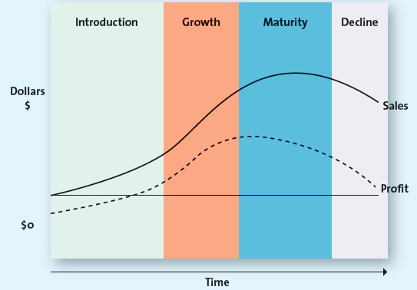

- Introduction stage is when innovators start buying the product.
- Growth stage is when the product gains acceptance, demand and sales increase, and competitors emerge in the product category.
- Maturity stage is when industry sales reach their peak, so firms try to rejuvenate their products by adding new features or repositioning them.
- Decline stage is when sales decline and the product eventually exits the market.

Introduction Stage
- Sensing the viability and commercialization possibilities of this market-creating new product, other firms soon enter the market with similar or improved products at lower prices.

Growth Stage
- The growth stage of the product life cycle is marked by a growing number of product adopters, rapid growth in industry sales, and increases in both the number of competitors and the number of available product versions
- Also during the growth stage, firms attempt to reach new consumers by studying their preferences and producing different product variations—varied colours, styles, or features—which enables them to segment the market more precisely.

Maturity Stage
- The maturity stage of the product life cycle is characterized by the adoption of the product by the late majority and intense competition for market share among firms.
- Firms may pursue several strategies during this stage to increase their customer base and/or defend their market share, such as entering into new markets and market segments and developing new products or promotions.
  - Entry into New Markets of Market Segments
    - Because the market is saturated at this point, firms may attempt to enter new geographical markets, including international markets that may be less saturated.
  - Development of New Products
    - Despite market saturation, firms continually introduce new products with improved features or find new uses for existing products because they need constant innovation and product proliferation to defend market share during intense competition.
    - Innovations by such firms ensure that they are able to retain or grow their respective market shares.

Decline Stage
- Firms with products in the decline stage either position themselves for a niche segment of diehard consumers or those with special needs, or they completely exit the market.

The Shape of the Product Life Cycle Curve
- In theory, the product life cycle curve is assumed to be bell-shaped with regard to sales and profits.
- New products and services that consumers accept very quickly have higher consumer adoption rates very early in their product life cycles and move faster across the various stages.

Strategies Based on Product Life Cycles
- The most challenging part of applying the product life cycle concept is that managers do not know exactly what shape each product's life cycle will take, so there is no way to know precisely what stage a product is in.

