Rafik Yonathan
6616021
Solar Energy
Solar Energy one of many renewable energy sources–energy that is continually replenished such as wind, water and sunlight. Solar energy is a renewable energy that is based only on heat and sunlight. Technology helps store this energy to allow the people to fulfill their household needs such as heating, air conditioning and electricity. While solar energy seems like an easy costless process, there are some obstacles that face scientists when it comes to implementing this process. Nowadays, most energy in buildings and factories is run by oil, which harms the environment and all living organisms. This paper discusses how solar energy works, its advantages and its disadvantages.

The literal meaning to solar energy is energy pertaining to the sun. The two kinds of solar energy technologies are active solar and passive solar. Active solar (Picture 1) converts solar energy by the sun to other forms of energy such as heat and electrical energy; it has collectors that consist of flat-plate PV panels and air or liquid conductors. A great example of active solar technology is solar photovoltaic electricity which, using solar cells, converts solar energy to electric current for different purposes like powering wristwatches, calculators and road signs. On the other hand, passive solar (picture 2) absorbs the sunlight and conducts the heat directly to the walls and floors of the building; it is designed to absorb sunlight in the winter and to reject it in summer. An example can be as simple as a house with glass walls and heat absorbing floors, which will keep the house warm even through the night. A breakthrough application to solar energy is solar air conditioning where the sun’s heat is used to keep buildings cool. Active (photovoltaic) air conditioning is a lot more efficient and effective than passive air conditioning as passive air conditioning only slows the heat transfer into a building. Active solar air conditioning is the most implemented solar cooling technology for residence; it works like regular air conditioners, but it gets its electricity from solar cells, i.e. conventional compressor or based on absorption. A common question on Solar energy is, “What if we need electricity at night?”, the answer is solar energy can actually be stored. Sunlight is stored as heat in a form of liquid and therefore the heat is not lost. Another common question is “How do photovoltaics transfer the sun’s heat to electricity?”–That is simple–when sunlight hits the PV cells, it knocks electrons loose from their atoms so as the electrons flow through the cell, they generate electricity. Solar energy can vary in size from a PV cell on a calculator to concentrated solar energy where the sunlight is collected in a central tower “collector tower” by mirrors and lenses–this intense heat concentration maximizes the solar energy produced. (Picture 3)

Solar energy is one of the most significant discoveries of all time as it solves some of the world’s major problems. Humans’ energy consumption has been increasing exponentially in the past few years; this increase has been harming the environment and thus affecting the people’s everyday life. Solar energy will not only minimize humans’ ecological footprint but also reduce their monthly electricity bills (picture 4). Solar energy can be used as a helping or main electricity source for residence or other buildings. The sun is not only a free power source but also an abundant source of energy; every hour the sun beams onto Earth more than enough energy to satisfy global energy needs for an entire year (national geographic). Moreover, solar energy doesn’t produce pollution; thus, it reduces global warming and protects the ozone layer. Global warming has been increasing due to the increase in combustion in factories and cars, which have been polluting the air, and raising earth’s temperature; the rise in temperature causes the earth poles to melt and therefore the sea level to rise and cause floods. Furthermore, solar energy can be used for air conditioning, which will stop the release of Chlorofluorocarbon (CFC) gases produced by most current air conditioners; the CFC gases are the reason for the hole in the ozone layer, which allows dangerous radiations from the sun to enter earth. Solar air conditioners are convenient as the demand on air conditioners increases in summer–when the sun is abundant. They are also easy to install, as they don’t require wires, cords or power and they are quiet, as they are stable and motionless throughout the entire process. Solar technology gives rise to different jobs including installing, monitoring and maintaining the solar panels, as well as research, development, design and policy jobs. Also, solar cookers are a lot cleaner and safer to sanitize water and cook food than wood-fired stoves; solar cookers cost nothing to operate, as they don’t use fuel. Besides, Homes that produce extra solar energy can sell energy back to the electric provider. Most buildings are run by oil, which is not a renewable resource; in other words, one-day earth will run out of oil. However, solar energy is a free infinite energy resource that will only end if the sun does. Lastly, solar energy requires little, if any, maintenance, as the panels have no moving parts or complicated machinery.

Everything has a negative side to it; solar energy is not perfect and hence there are some disadvantages. Although earth gets more than enough solar energy daily to power it, a stormy week or a few cloudy days can cause a dilemma, as technology is not at its best yet when it comes to storing solar energy. Storing solar energy for the night is easy in both passive and active solar technologies but in countries like Canada, sunlight is scarce and it can be difficult to have buildings that only run on solar energy. Solar energy is still a developing technology so it is risky as it hasn’t been used/tested many times. Although sunlight is free and monthly electricity bills will be relatively low, the cost of installation of solar panels and cells is rather costly as the material of the panels are scarce and expensive. In addition, solar panels require a large area of implementation to produce an efficient amount of energy; consequently, implementing solar energy in crowded urban cities like New York can be challenging. Also, for solar panels on rooftops, cleaning the panels can be difficult and has to be frequent because they are outdoors; pollution can affect the cells so it is crucial to clean them regularly. Additionally, solar equipment is heavy; the roof must be strong, large and oriented towards the sun’s path. Another obstacle is the cost of replacing old systems that are run by oil or electricity systems is very high and will take a lot of time.

In summary, as electricity and fuel start to cost more and harm the environment, people look for new solutions–one of which is solar energy. Active solar energy creates electricity through a process where a fluid is heated and stored, while passive solar energy is used as a simple heating system for buildings. There are pros and cons to this “invention”. It is unlimited, free, money-saving and environmentally friendly; nevertheless, its installation is expensive, it is dependent on the weather and the sunlight and it requires a large area for implementation. In conclusion, with the technology thus far, a good balance between fuel energy and solar energy is the best solution; for example, garden lights and heater/air conditioner would run on solar energy while house lights and television would run on fuel energy.

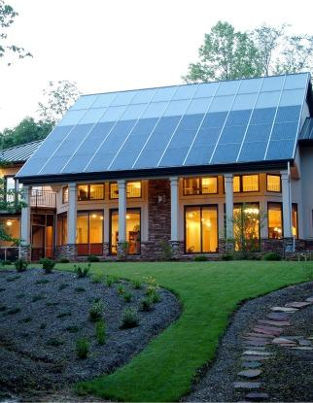  (1)  An example of a house that runs on active solar energy.  Source: Energy.gov http://energy.gov/energysaver/articles/active-solar-heating | 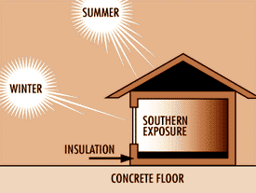  (2)  An example of a house that runs on passive solar energy.  Soure: Island energy http://islandenergy.wordpress.com/2008/09/14/passive-solar-the-unexplored-value-concepts-practice-and-resources/

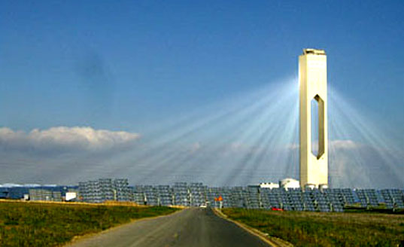
(3) Collector tower
Source: Inhabitat http://inhabitat.com/sevilles-solar-power-tower/

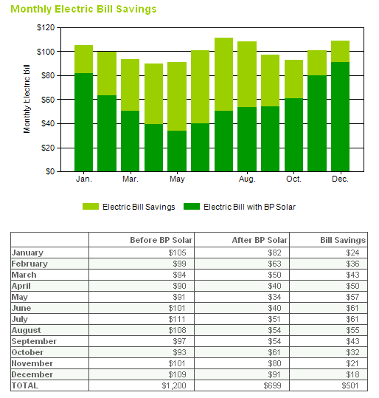
(4) Solar Energy bill savings
Source: Art-tech http://www.arttec.net/SolarPower/2_financing/

Bibliography:
"Active Solar Heating." Energy.gov. N.p., 24 June 2012. Web. 25 Feb. 2013. <http://energy.gov/energysaver/articles/active-solar-heating>.

Foster, Robert, Majid Ghassemi, and Alma Cota. Solar Energy: Renewable Energy and the Environment. Boca Raton: CRC, 2010. Web.

Haberlin, Heinrich. "Introduction." Photovoltaics: System Design and Practice. Chichester, West Sussex: John Wiley & Sons, 2012. N. pag. Web.

Krauter, Stefan C. W. Solar Electric Power Generation - Photovoltaic Energy Systems: Modeling of Optical and Thermal Performance, Electrical Yield, Energy Balance, Effect on Reduction of Greenhouse Gas Emissions. Berlin: Springer, 2006. Web.

Kreider, Jan F., and Frank Kreith. Solar Heating and Cooling: Active and Passive Design. Washington: Hemisphere Pub., 1982. Print.

Kruser’s, Paul. “Renewable Energy Resources: Solar Energy” English 1112 Course Pack (Winter 2013). 97-105.

Maier, Karyn, and Demand Media. "What Is the Difference Between Active & Passive Solar Collectors?" National Geographic, n.d. Web. 23 Feb. 2013. <http://greenliving.nationalgeographic.com/difference-between-active-passive-solar-collectors-3222.html>.

Morse, Elizabeth, and Andrew Turgeon. "Solar Energy." - National Geographic Education. National Geographic, n.d. Web. 26 Feb. 2013. <http://education.nationalgeographic.com/education/encyclopedia/solar-energy/?ar_a=2>.

Rapp, Donald. Solar Energy. Englewood Cliffs, NJ: Prentice-Hall, 1981. Print.

Santamouris, M. Advances in Passive Cooling. London: Earthscan, 2007. Web

