Final Notes
POL 3142

Intro to EU Structure

What is Economic Integration?
- It is the European Union with increasing influence to commensurate w/ its economic importance, standard of living and its place in diplomatic, commercial and monetary forums

Where does the Economic Community derive its power from?
- It derives its strength from common values of democracy and human rights. It rallies its people and it has preserved the diversity of cultures and languages and the traditions of member states.

What is the difference b/w the European Council and the Council of Europe
- The European Council is an institution within the EU. It is comprised of the heads of states (president, PMs) of Member States of the EU along with the Prez of the European Commision and the Prez of the European Council.
- The EC is charged under the Lisbon Treaty with defining the general political directions and priorities of the Union.
- The EC is a strategic and crisis solving body acting as the collective presidency of the EU
- The Council of Europe is a UN-like governing body that handles human rights issues, etc.
- The CoE is a non-EU organization that works towards further European integration. It has a particular emphasis on legal standards, human rights, democratic development, the rule of law and cultural co-operation. It is a non-governing body
- The CoE is a forum for discussion
  - No legislative power. Just normative

Treaty of Paris, 1951
- Created the European Coal and Steel Community (ECSC)
- Countries included were: FRA, GER, BEL,LUX, ITA and NED

Maastritch Treaty, 1993
- Was the founding act of the EU
- Based on a Pillar Structure
  - European Community that consisted of:
    - European Citizenship
    - Single Market
    - Education
    - Transportation
  - Common Foregin Security
  - Justice and Home Affair Pillar
    - The criteria in which countries must follow in order to be part of the EU

Amsterdam Treaty, 1999
- Greater emphasis on citizenship and the rights of individuals.
- There was an attempt to achieve more democracy in the shape of increased power for the European Parliament and the start of the Common Foreign and Security Policy

What is the EP?
- It is the European Parliament
- Aka the legislative body of the EU

What is the EC?
- It is the European Commission
- Aka the executive body EU
- It is responsible for proposing legislation, implementing decisions, upholding th Union’s treaties and the day-to-day running of the EU

Another EC?
- As noted before yes, the European Council
- It can make decisions but unlike the EP it has NO legislative power. Only Normative

What does the European Central Bank do?
- ECB is the central bank of the Euro-zone
  - The Euro-zone are MS who take part in the single monetary act of the EU. Aka they use the Euro as their currency as opposed to the currency of their respective countries.
- ECB defines the policy of Euro(money) countries
  - It is suppose to keep prices stable
- ECB has no economic policy

What is the European Court of Justice?
- It is the highest court in Europe

What is the Euro Zone?
- It is the area that countries have adopted a single currency
  - The euro
- 17 countries plus the other 6

What is the Euro-Group?
- Finance ministers of the 17 countries that have implemented the Euro
- They discuss the development of the EU
- EU has no budgetary power over states
  - Purely monetary which only allows them (EU) to control prices

What is the difference b/w president and presidency of the EU?
- President of the EU
  - Is the permanent representative of the EU
  - Looks over the work of the European council
- Presidency
  - Rotates b/w countries every six months
    - Allows country in charge to bring up their respective priorities forward

European Integration Theories

What is the purpose of EITs?
- Theorize the outcome of European Constitution

Kinds of EIT?
- EITs that Explain
  - Causal relations, independent varilable impacts on dependant variables
- EITs that describe
  - Constructivist approach
  - Focus on institution structure, agents built in relation to one another
- EITs that are normative
  - Observing whats wrong and what is good governance
    - Is there something wrong at the Euro level? How can it be fixed?

The Theories
- Federalism
- It is Normative
- Based on the avoidance of War.
  - To avoid war, federal state must be created
- Idea was spurred by the fact that state failed to protect citizens and territory during times of war. Hence, it was time to change the nation state
- Neo- Functionalism
- It is a theory that want to explain and understand European integration
- NF aim is to integrate individual sectors in hopes of achieving spill-over effects to further the process of integration.
- NF describes and explains the process of regional integration with reference to how three causal factors interact with one another
  - Growing economic interdependence with one another
  - Organizational capacity to resolve disputes and build int’l legal regimes
  - Supranational market rules that replace national regulatory regimes
- Spill over effect
  - Is the notion that integration b/w states in one economic sector will create strong incentives for integration in further sectors, in order to fully capture the perks of integration in the sector which started it started
- Inter-governmentalsim
- A theory that seeks to explain and understand EI
- It refers to theory of regional integration and states and national govs as he primary factors for integration
- National Govs
  - Control the level ans speed of EI
- Hoffman suggests
  - That any increase at the supra national level results from a direct decision by govs
  - Integration driven by national gov often flowed from domestic political and economic issues
- IG
  - Treats states as the actors in integration process
- Multi-level Governance
- a descriptive theory
- based on networks. Networks are what make it move.
- Legal/governance system organization
  - Competence goes to level which is most able to organize it
- Policy Networks
- Descriptive theory
- It involves the study of networks in the EU
- According to this theory
  - Networks are more important than the state
  - The way in which actors link together determines the outcome of policy
- Neo-Institutionalism
- A descriptive theory
- Has branches
  - Rational
    - How do actors pursue preference changes who institutionalism changes
    - Includes values, ideas, discussions
  - Historical
    - Path dependence
    - Descions taken at start of European construction are still shaped by integration
- Social Constructivism
- Another descriptive theory
- Institutions, actors and structures shape each other
  - Context important
- What actors do in international relations, the interests they hold and the structures within which the operate are defined by social norms rather than by purely objective and material conditions
- SC
  - Can offer powerful accounts for the EU enlargement b/c it is based on a notion of inter-subjective understandings and discourses being central in shaping over time the identities, interests and interactions of actors – the states –
  - Underlies the importance of identities in shaping the behaviour of actors
- Discursive
- A normative approach
- Theory asks what the EU is?
  - According to theory it is a discourse
- How does the EU move?
  - Creation of specific dispcurse
- Political Space
  - Not studied from the POV of state or int’l orz.
- EU is a relation
- Gender Studies
- Normative approach to EI
- Topic related
  - Economic, legislative theory
- Gender as a basic organizing principle of society

European Construction

3 Notions of European Construction?
- Rupture
  - Of the state’s sovereign power to legislate on all purposes
- Path –(dream, possibility, necessity)
  - From international to supranational law
- Process
  - From sectorial to complete supranationalisation of th law amking-process

Criticism of EU
- Foreign affairs
- Military affairs
- Intergovernmentals
  - These three things are not yet integrated into society

Rise of European Ideas – How did EU come about?
- European construction
  - Achievement that contributed an organized link European states. (pushed by necessity)
- European union
  - Pragmatic implementation of a dream
    - The dream was to unite to Europe goes hand in hand with pessimism

What is European Geo-political system?
- The end of European Empire Age
  - BRI, FRA empires fell in 19th century
  - Holy Roman Empire
    - Been around since Constantine. Fell in early 19th century
  - Austria, RUS, GER, OTT
    - Al respectively fell in 19th and 20th century

Vienna Congress, 1914
- There was a desire to maintain the balance of power within E
- Henrie de St. Simon
  - European construction project
    - Had a pamphlet called Re Organization of European Society
  - His Template
    - Federal Europe
    - Preserve Peace
    - Unification of 2 Antagonistoc Countries
  - His theories did not produce favorable response b/c
    - Post war issues
      - Resolved through wiiners’ interests
    - Project did not fit into social discourse of the time

History of European Integration II

Is there a possibility of a new Order?
- Consequences of WWI
  - In regards to EUs eventual emergence was understood as political continuity
- Inter War Years
  - There was a clash b/w pacifism and nationalism & Isolation and Pan European ideas
  - What was needed?
    - Political Space
- Consqeunces of WWII
  - Historical break point
    - Breaking point of sovereignty
- Economy?
  - During times of war
    - Such as WWI
      - Continental movement to “war economics”
        - Emphasis on self suffieciency
        - Women in th work force
        - Major production weapons
      - Lead to extensive gov debts
        - Inflation afterwards
          - Money was almost worthless
        - Example of GER
      - USA
        - No debts
        - Mass industrialization
  - 1929: Financial Bubble in the US
    - Wall Street Crash = the Great Depression in the world
      - Talk about the connection of US to FRA and GER (Versallies and shit)
- More on Interwar Years
  - Discourses developed in order to come up with Peace
    - Fourteen Points of Wilson
      - Open Diplomacy
      - Freedom of the Seas
      - Removal of Econ Barriers
      - Adjustment of Colonial Claims
      - Territory Fixes in RUS, BEL, FRA, ITA, AUH, Balkans, POL
      - League of Nations
        - To be founded on cooperation of nations
        - Goal was to have preservation of peace
    - Treaty of Versailles
      - Reparations from GER to Allies
      - Loss of colonies (GER)
      - Return of Alsacce – Loraine
      - Fueled by revenge and satisfacton of winners
      - Article 231
        - GER acceptance of WWI reparations. Leads to GER national socialism
- European Community
  - 1923
    - Pan Europa idea by Richard N. Coudenhove-Kalergi
    - He says that
      - Euro question will be answered by a UNION of the peoples of Europe. This union to be made voluntarily by the construction of pan-European federaio, or forced by a RUS conquest
      - Pan – Europe
        - The political concept of Europe as opposed to the geographical concept
- Aristide Briand’s Speech
  - There must be a federal link in Europe
    - This will allow Europeans to have an opportunity at any time to get in touch to discuss their interests, to take joint resolutions, to establish b/w them a bond of solidarity that enables them to cope in time, with serious circumstances, should they arise
- Address by Winston Churchill
  - Build a kind of United States of Europe
  - Solidarity b/w FRA and GER for Pan-European Union
  - Limited time
  - First step is to form a council of Europe
- Schuman Declaration
  - World peace cannot be safeguarded w/o the making of creative efforts proportionate to dangers which threaten it.
  - Europe to be built through concrete achievements which first create a de facto solidarity
  - GER and FRA must be friends
- Neo Functionalism by Jean Monnet
  - Related to de facto solidarity mentioned
  - First step to integration
- Franco-German production of coal and steel
  - To be placed under a common High-Authority
  - This pooling of coal and steel production should immediately provide for the setting up of common foundations for economic development as the first step in the federation of Europe

European Discourse
- Origins: Reconciliate (break the cycle of violence in terms of rupture)
- Becoming: unification of European Countries in Peace (political vision)
- Lenght: open to all countries (franco-german borders)
- Meaning: preserve peace
- (applies to ECSC, Treaty of Rome etc.)

Schuman Declaration
- Creates idea of European Community
  - Political space in which actors are not only concerned with defending their own interests but also more

European Institutions, Supranational Governance and Internal Affairs: Is the European Governance System Democratic?

Robert Dahl on Democracy
- Free and fair elections
- Universal suffrage
- All citizens must hold the right to stand for election
- Access to alternative source of information
- Freedom of association
- Freedom of speech
- Some elected officials

Democracy with Adjectives
- Dahl theories+
  - Elections w/o any massive frauds
  - Legal guarantees on the effectiveness of the freedom of expression and of association

Problems of democratic transition and consolidation?
- Linz and Stepan
  - Democratic
    - Attitude
    - Behaviour
    - Constitution

Guillermo O’Donnell
- D requires the autonomy and accountability of all sectors in the poli game, which demands a form of socio-economic equality

Is European Governance System democratic?
- Must understand the European Institutional Triangle
  - European Parliament
    - The institution that represents the EU citizen
  - European Commission
    - Executive Body
      - Carried by 2/3 majority
      - Represents majority component of Members Parliament
  - European Council
    - Takes decision independently from the commission or the parliament

Divisions of Competences
- From Maastritcht to Lisbon
  - The Pillar System of the European Union
    - The First Pillar: European Communites
    - Second Pillar: Common Foreign and Security Policy
    - Third Pillar: police and Judicial cooperation in criminal matters
- Distribution of Competences
  - Lisbon Treaty
    - Exclusicve Competence
      - The EU alone is able to legislate and adopt binding acts in these fields
        - Customs unions
        - The establishing of the competition rules necessary for the functioning of the internal market
        - Monetary policy for the Member States whose currency is the euro
    - Shared Competence
      - The EU and Member States are authorised to adopt binding acts in these fields
        - Internal markets
        - Social policy, for the aspects defined in this Treaty
        - Economic, social and territorial cohesion
        - Environment
    - Supporting Competences
      - The EU can only intervene to support, coordinate or complement the action of Member States.
      - At the European Level
        - Protection and improvement of human health
        - Industry
        - Culture
        - Tourism
        - Education, vocational training, youth and sport
        - Civil protection
        - Administrative cooperation

Metaphysics of the EU

Theories on speculating about the world around us
- Ontology – territory
  - The Nature of Reality
    - Three ways to grasp reality
      - Objective – laws, rules, truths
      - Perception – as close as we get to reality
      - Construction – discourses
    - Most important in a theory, helps to understand and asses the EU
      - Structure-
      - Institutions-
      - Actors-
  - Epistemology
    - It is the nature of the RELATION b/w the knower and the knowledge
    - How do we know what is valid knowledge?
      - Objectivity – subject (outside of) object/ objective truth (repeat and predict)
      - Subjectivity – subject (impacts) object
      - Inter-subjectivity – subject (interaction) subject
      - Positivism – uncover it. Universal laws
      - Post positivisim: theory – Data – Method
      - Constructivism – reaction to positivism. Truth and validity equals viability. Truths in the fact/action
  - Methodology
    - Technique/method used in scientific demonstrations
    - Two designs
      - Quantative
        - Positivist/post-positivist/structure/institutionalist
        - Based on math
        - Dominant methodology in comparative politics
      - Qualitative
        - Direct observation
        - Survey
        - Complementary records to make stories coherent
Theory
- Federalism
  - EI theory. How to prevent war. Created through common institutions.
  - Normative, objective way of doing politics
  - Achieve peace by means of federal model
- Neo-federalism – state is the actor
- Inter-governmentalism – state interest is what counts
- Multi-level governance – relations of power institutions by actors
- Policy network – relation to post positivism
  - Actors differentiate instead of converge
  - Pursue own interest which are rational
- Neo-institutionalism – rational choice, historical sociological

The European Geo-Political Space

Territorial Construction (Europe’s geography, EU Enlargement)
- Achievements in creation of the EU
- Size of Europe
  - Changes often (cycle of violence)
  - States don’t change too much except overtime
    - Result of violence, exclusions and annexation
    - Expand territory beyond borders (invasion, colonization)
- Why are European States always at war?
  - Lots of territories in the continent overlap. As a result there are disputes on who controls what land

- Some examples of borders changing in Europe?
  - Borders in 1914 (Empire system)
    - Some territories were part of the Triple Entente, others were with the Central Powers while a few were neutral.
      - 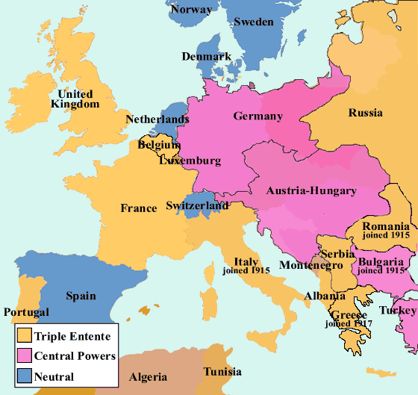
  - After WWI,
    - empires were dismantled and new countries were created in 1919
      - 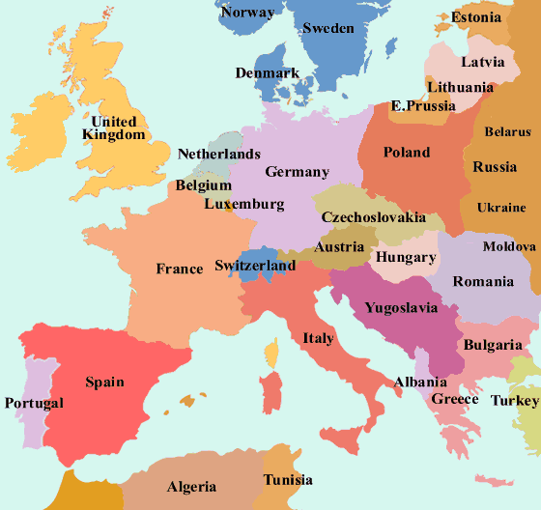
  - WWII
    - Before, GER changes borders through invasion
      - 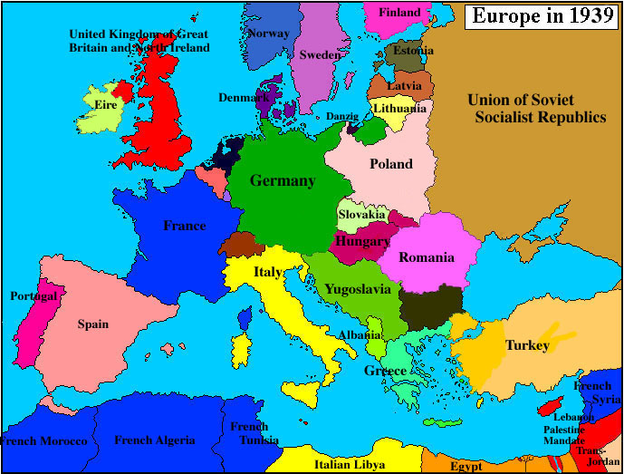
    - After WWII, the allies divided GER into three sections in an effort to make sure they do not rise again.
      - 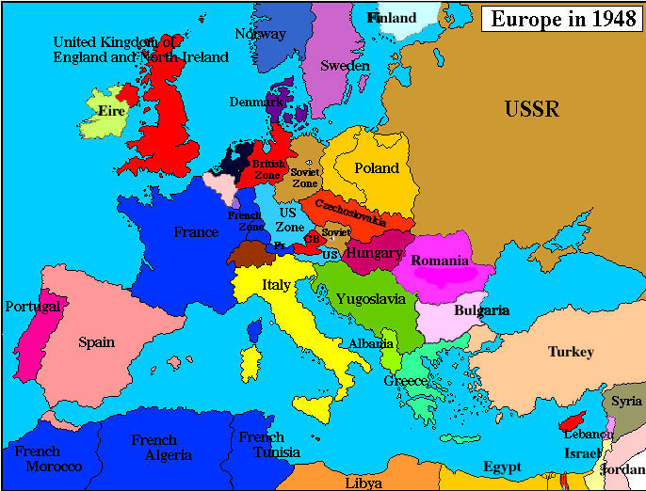

  - Cold War
    - There were divisions b/w NATO states and satellite states of the USSR
      - 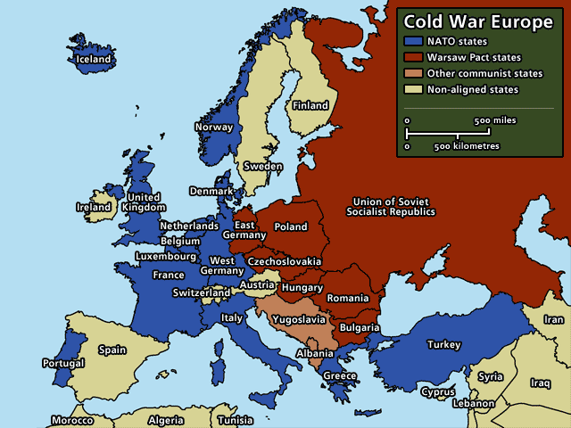
  - Council of Europe
    - 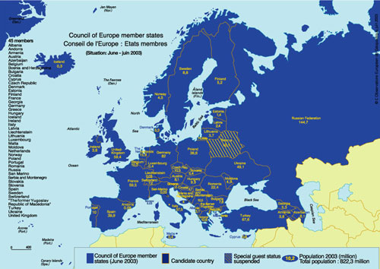
  - European Union
    - 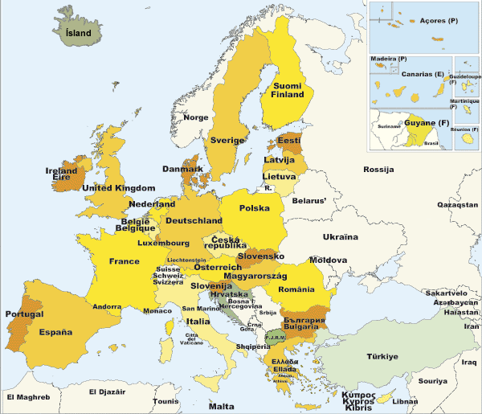
- In short...Europe has many shapes and forms
  - 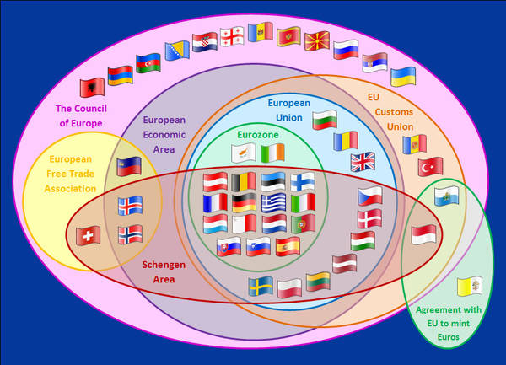

Space in Europe
- It can be seen that it is variable
- Enlargement of Europe is necessary b/c it is not practiced to leave out non members

Territorial Integration (Aquis Communicvation, Pooling of Sovereignty)
- What is the future of the EU
  - Continue to move towards the East
- Acquis Communautaire
  - Body of rights
  - The content, principles and political objectives o the Treaties
  - The legislation adopted in application of the treaties and the case law of the Court of Justice
  - The declaration and resolutions adopted by the union
  - Resources relating to the common foreign and security policy
  - Measures relating to justice and home affairs
  - International agreements concluded by the community and those concluded by the Member States b/w themselves in the field of the Unions activities
What is State Sovereignty?
- Sate that has a defined territory, permanent population, independent government and it holds the capacity to freely determine its relations with other states.
- It must be recognised as such by other states
- External Sovereignty
  - Indendence from other states
- Internal soverengty
  - Own rules, power to create own legislation, governance, supreme authority in state
- Legal Supremacy, Coinage, Military Forces
  - Very important in state sovereingty
What is Pooled Sovereignty?
- EU can act over the state in procedures that do not involve the State Veeto
- Supremacy and direct effect of the European Law and also important factors of sovereignty
- This creates an intensive and extensive interdependence and makes it difficult for a state to pull out of such agreements
How does European Integration explain Pooled Sovereignty?
- Federalists – the best way to achieve peace, prosperity and power is through the setting up of Pooled Sovereignty
- Inter-governmentalists – it was the states decision to pool sovereignty for their own interests
- Neo-functionalists – Pooled sovereignty is the result of European institutions
- Rational Choice – denationalized actors create new institutions in order to best serve their interests
- Social Constructivism – form new way of conducting politics. Interaction creates institution.

Economic Integration – The European Economic Space: A Multi-spaced Europe

Intro
- What does multi-spaced Europe mean?
  - It means a differentiated process in Europe
- Issue of War?
  - It is to be unthinkable
  - As a result. The ECSC was put together as a supranational institution composed of members who are appointed.
- What happened to borders?
  - In Europe, they became institutionalized

What were the steps toward economic integration?
- Free Trade Area
  - Eliminates tariffs within the area only (Europe). Each country retains its own policy towards non-members.
- Custom Union
  - Add a common external policy to the free trade area.
- Common Market
  - Factors of production can flow freely within a custom union. Free movement of capital, labour and goods/services.
- Economic Union
  - Common market with common determination of some structural and macroeconomic polices

What is The High Authority?
- It was a proposal by France that Franco-German production of coal and steel as a whole be placed under a common high authority, within the framework of an organization open to the participation of the other countries of Europe
- HA is entrusted with the management of the scheme will be composed of independent persons appointed by the govs giving equal representation. The Authority’s decisions will be enforceable in all member countries
- What were its objectives?
  - Economic Expansion
  - Growth of employment
  - Rising the standard of living
- HA entails
  - Common Market which is the free movement of produtcis w/o custom, duties or taxes, discriminatory measures, subsidies or aids granted by the States, special charges imposed by the States
- Example?
  - ECSC – which was created after WWII. It was the first step towards “pooled sovereignty”

Monetary Integration 1972-(...)

Policy Mix aka ways to optimally combine economic policy levers:
- First there is Monetary Policy
  - Which controls the supply of money (buying and selling currencies on the int’l market) influencing interest rates in order to promote
    - Price stability and economic growth
- There is also Budgetary Policy
  - Which the govs use of revenue collection (aka taxation) and expidenture (spending) to influence the economy
  - Its cental goals were
    - Growth, full employment and balance of payments
Snake in the Tunnel – Werner report, 1970
- There was reduction of the fluctuation margins b/w the currencies of the Member States
- Achievement of a complete freedom f capital movements w/ integration of the financial markets, and particularly of the banking systems
- It came up during the oil crisis after the fall of Bretton Woods. It gave way for the rise of systems such as the EMU(European Monetary Union) and the EMS(European Monetary System)
  - Stages of the EMU
    - To set up co-operation b/w central banks
      - Free movement of capital within the EU (abolition of exchange controls);
      - Increasing the amount of resources devoted to removing inequalities b/w European regions (Structural Funds)
      - Economic convergence
    - To establish a European system of central banks
      - Independence of national central banks
      - Rules to curb national budget deficits
    - Create a single currency
      - Birth of the Euro
      - Central bank takes over the EMI and becomes responsible for the monetary policy of the Eurozone
- What is Convergence Criteria?
  - What it takes to become part of the Single Currency aka Euro-zone. The following are considered before becoming a member.
    - Price stability
    - Inflation
    - Deficits
    - Public debt
    - Exchange rate stability

EITs and European Legal Integration(ELI)

What does Social Constructivism say about ELI?
- European construction by interaction/intersovereingty
- Political space with economic actors
- Euro is created through interaction b/w nations
  - Turns into an idea of economic convergence
  - Idea into institution of “single market”
Same question with Neo-Functionalism
- Economic-political
- Supranational institutions
- EMU developed the European Economic System
- “Spill – Over” Effect
Same question with Inter-governmentalism
- States work together
- They give up sovereignty so that they are able to get together and create the Euro
- States to protect its own interests
Same question with Federalism
- Common Europe is to implement peace, prosperity and power
- Their goal is to create a federal state
- Goal of preventing war
Same question with Policy Network
- Power shared b/w levels
- Web governance
- Re-organization of the powers
- Monetary policy is better managed at EU level rather than the state level

European Legal Integration – The most integrated spaces of all

Outline
- Institutions
  - Legislative Process (institutional triangle)
  - European Court System
- Instruments
  - Primary source of law: the Treaties
  - Secondary Source of Law: the legislation
- Hierachy of Norms
  - Direct effect
  - Primacy
- Legal Order
  - Autonomy of the EU legal order
  - Relation b/w the EU and National Law

EU’s legal space consists of?
- A RUPTURE of the sates sovereign power to legislate on all purposes
- A PATH from international to supranational law
- A PROCESS from sectorial to complete supranationalisation of the law making process
Legal Institutions
- Legislative Process
  - Competences
    - Exclusive (EU only)
    - Shared (EU and state)
    - Supporting (coordination only)
  - Principles
    - Conferral
    - Proportionality
    - Subsidiarity
- EU’s legislative triangle
  - 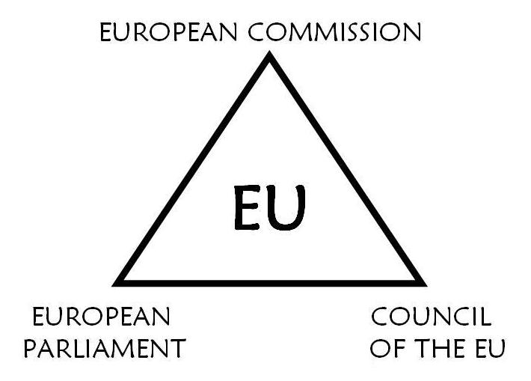
- EU Decision Making
  - 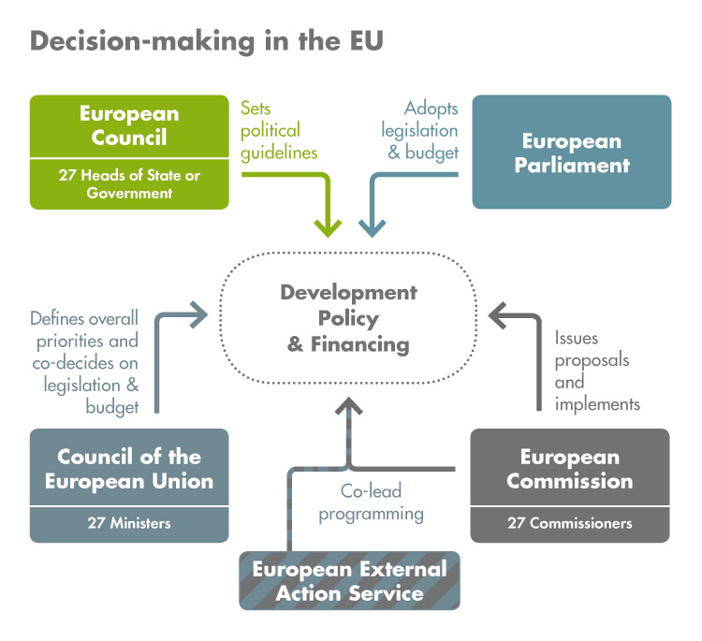

What does the European Court of Justice do?
- It reviews the legality of the acts of the institutions of the European Union
- It ensures that the Member States comply with obligations under the Treaties
- It interprets European Union law at the request of the national courts and tribunals
What are the fundamental principles of the court?
- Direct application, primacy and liability
Are there rulings that affect citizens directly?
- Free movement of goods
- Free movement of persons
- Freedom to provide services
- Equal treatment and social rights
- Fundamental rights
- Euro citizenship
Other Courts?
- General court
  - Direct actions against acts, bodies, offices or agencies of the EU
  - Actions brought by the member states against the Commission
- EUs civil service
  - Disputes involving EUs civil service (employees)

Instruments of ELI
- Primary Source of Law: the treaties
  - Founding – ECSC, EEC, EUROATOM
  - Meregr Treaty, 1967
  - Single European ACT, 1987
  - Treat of the European Union, 1993
  - Amsterdat Treaty, 1999
  - Nice Treaty, 2003
  - Lisbon Treaty, 2009
- Secondary Sources of Law: the legislation
  - Unilateral Acts
    - Legislative acts
      - It envolved regulations, directives and decisions
    - Non-legislative acts
      - Delegated acts
      - Implementing acts
      - Recommendations, opinions
  - Conventions and Agreements
    - International agreements
    - Agreements b/w member states
    - Inter-institutional agreements
What is the source of EU’s Law?
- 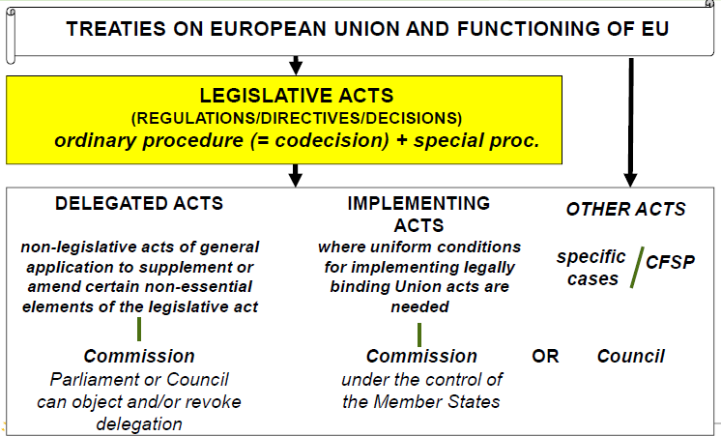
Hierarchy of Norms
- Consists of
  - Direct Effect
    - Union law confers rights and imposes obligations doirectly, not only on the EUs institutions and the Member-States, but also the union’s citizen
  - Primacy
    - The EUs law is part of Member State legal system and prevail statuses and other national sources of law (ie: constitutions)
EU’s Legal Order
- Autonomy
- Relations EU/States
  - Principle of sincere cooperation
  - EU and MS must assists each other in carrying out tasks which flow form the treaties
  - Ms shall take any appropriate measure, general or particular, to ensure fulfilment of the obligations arising out of the Treaties
  - MS shall facilitate the achievement of the Union’s tasks and refreain from any measure which could jeopardise the attainment of the Union’s objectives

External Affairs – EEAS, EU as a normative power, European Neighbourhood Policy, EU/Canada Relations

EUs foreign policy: historical background
- 1958(Rome): trade and development assistance
- 1992(Maastricht): Common foreign policy and security policy(CFSP)
- 1997(Amsterdam): High representative for CFSP
- 2009(Lisbon): Common security and defense policy(EEAS+HR Common Security Defense Policy)
2 pillars of European Foreign Policy System(EFPS)
- Community Method
  - Not a co-decision, rather it is commission plus council or enhanced cooperation
- Inter-governmentalist method
  - Common Foreign and Security Policy
Institutions
- High Representatives(HR)
  - Represent the union
  - They coordinate the commissions external policies
  - They are the head of the EUs diplomatic service
- European External Action Service
  - Assist HR
  - Officials from commission + council
  - EUs diplomatic service
What are the objectives of Foreign Policy?
- To support stability, promote human rights and democracy, seek to spread prosperity and support the enforcement of rule of law and good governance

EU as Normative Power
How to conceptualise the EU as a regional and international actor?
- Consider Europe as a civilian power
  - Centrality of economic power
  - Primacy of cooperation to solve international problems
  - Use of legally-binding supranational institutions to achieve international progress
- Consider “Normative Power Europe”
  - The central component of normative power Europe is that is exists as being different to pre-existing political forums and that this particular difference pre-disposes to act in a normative way
    - Not what it does or say but what it IS
What are the EU’s normative basis? (Check Manners reading)
- Sustainable peace
- Freedom
- Democracy
- Human rights
- Rule of law
- Equality
- Social solidarity
- Sustainable development
- Good governance
What are the EU’s normative diffusion process?
- Contagion
- Transference
- Informational diffusion
- Procedural diffusion
- Overt diffusion
- Cultural filters

What is the European Neighbourhood Policy?
- It is mutual commitment to common values such as democracy, human rights, rule of law, good governance, market principles and sustainable development
- Political association + deeper economic integration

Political Parties and Electoral Systems

What are some conditions for a democracy?
- According to Dahl, Linz and Stepan
  - Free and fair elections by universal suffrage
  - Every citizen holds the right to stand for elction and there must be some elected officials
  - Access to alternative source of information
  - Freedom od association and of speech
  - In addition to
    - Independent and effective judicial system
    - Democratic attitutude/behaviour/constitution
    - Socio-economic equality

Requirements for European Political Parties?
- Have legal personality
- Be represented, in at least one quarter of the Member States, by Members of the European Parliament
- Respect the founding priniciples of the EU: the principles of liberty, democracy, respect for human rights and fundamental freedoms and the rule of law
- Have participated in elections to the European Parliament

Institutions and Political Parties of four European Countries

European Union
- Capital is brusels
- With 500million people
- On avg they have 11.7% unemployment

EU members by form of government
- Constitutional monarchy
- Semi-presidential republic
- Presidential republic
- Parliamentary republic

GER
- Berlin is the Capital
- 81million
- Very low unemployment rate at 5.4%
- Its a federation
  - Made up of 16 constituent states that are autonomous and decentralized
  - Bicamreal parliament of the federal government
    - Bundestag (lower house, elected)
      - Mixed-member proportional representation
      - 2 votes (candidate + party)
    - Bundesrat (upper house, delegates)

FRA
- Paris is the Capital
- 65million people
- Average unemployment rate at 10.7%
- Political Situation in France
  - Transition fomr right to left
  - Euro-crisis
  - Extereme right
  - Mali
  - Unemployment
- Republic
  - Unitary semi-presidential republic
  - Bicameral parliament
    - National Assembly that is directly elected for a 5 year term (lower house)
    - Senate chosen by electoral college every 6 years (upper house)
- National Elections
  - Presidential elections: direct suffrage
  - Legislative elections: two rounds system

BEL
- Capital is Brussels
- 11million people
- Below average unemployment at 7.4%
- Political Situation
  - Tensions b/w communities (French and dutch issues)
  - Government of coalition
  - Immigration question
  - Flanders independence
- Kingdom of Belgium
  - Parliamentary constitutional monarchy
  - Bicarmel
    - Senate
      - Made up of
        - 40 directly elected
        - 21 appointed by the 3 community parliaments
        - 10 co-opted senators
        - Senators by right
    - Chamber of representatives
      - 150 members elected through proportional system
  - They have federal elections that are compulsory voting proportional system

