Test 2 Biomechanics
Muscle Power
Muscle Power = Muscular F x velocity of muscle shortening
- Is the rate of torque production at a joint
- Product of net torque & angular velocity at a joint

Linear Kinetics of Human Movement

Newton’s 3 Laws

1st Law
- Every object in a state of uniform motion tends to remain in that state of motion unless and external F is applied to it
- Also called “law of Inertia”

2nd Law
- The relationship between object’s m, a & applied F is F=ma

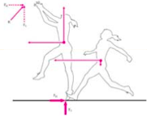
3rd Law
- For every action there is an equal & opposite rxn

Free Body Diagrams
- A sketch that shows a defined system in isolation with all of the F vectors acting on the system
- Is a pictorial example of NET force acting on an object

Developing FBD’s
- Identify system of interest
- Redraw (stick figure)
- Draw weight F pointing down from center of gravity (if applicable)
- Replace all external contacts w/ appropriate F’s
- Show reference frame

Every joint that a muscle crosses EFFECTs its length!!

Mechanical actions of common F’s in human movement

- Rope-like structures
- Examples: Muscle/tendon complex & Ligaments
- Actions: F pulls along the line of action of structure

- Contact w/ “rough surface”
- Force along the surface created by friction
- Force perpendicular to surface (normal F) which pushes against body

- Contact w/ “Smooth Surface”
- Example: Ground rxn F when standing on ice
- Action: Acted only by Normal force

Force is located over the whole surface, but considered acting at center of pressure

- Free rotation around an Axle
- Pin joint free to move
- Example: Bone on Bone forces
- Action: Axle replaced by a F in any direction, pushing or pulling acting @ center of rotation

- Constrained rotation around an axle
- Pin joint not free to move
- Example:
  - Grasping tool w/ offset center of gravity
  - Joint rxn forces, when muscles considered to act as a moment
- Action:
  - Axle is replaced by both Force and Torque:
    - F pushing or pulling at center of rotation(any direction)
    - Torque can be either clockwise or counter-clockwise

- Forces associated with movement through a fluid
- We tend to neglect this a lot
- Examples:
  - Air resistance (Drag & lift)
  - Water (if you are studying biomechanics of swimming)
- Actions:
  - Direction depend on relationship between velocity of flow & velocity of system and specific to Force in question
Reference Frame
- Tells your audience what you consider positive when doing your analysis
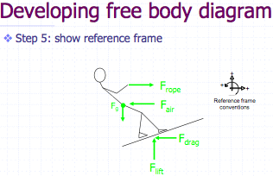

Friction
- Force that acts at interface of surfaces in contact
- Is opposite to direction of motion/ impeding motion
- Dependent on:
  - Applied F that friction is resisting
  - Whether object in motion
  - u
  - R

Rolling Friction
- Friction that occurs b/w a rolling object and a flat surface
- Smaller than (1/100th) friction b/w 2 flat surfaces
- Dependent on:
- Coefficient of friction
- Normal F
- Radius of Curvature
- Contact Area

Fluid Friction
- Fluid between2 surfaces reduced friction due to
- nature of fluid
- fluid T
- velocity b/w 2 surfaces

Ground Reaction F (GRF)
- Made up of 2 components:
- Normal (push) F (always present)
- Friction F (not present if you jump straight up)

Levers
- Simple machine consisting of a relatively rigid bar-like body that may be made to rotate about an axis
- Contains 4 parts:
- Bar
- Fulcrum (A)
- Applied F (F)
- Resistance F (R)

3 classes of levers
- Based on relationship b/w fulcrum (A), applied F (F) and resisting F (R)
= leading to diff. advantages and disadvantages

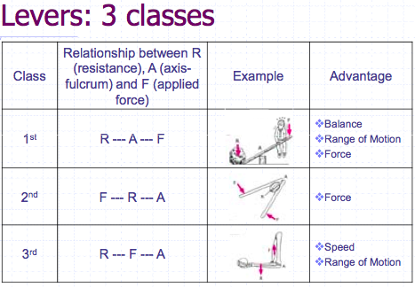

“Resistance arm”
  - Moment arm associated w/ resistance (load)

“Force arm”
  - Moment arm associated w/ applied F is called the “Force arm”

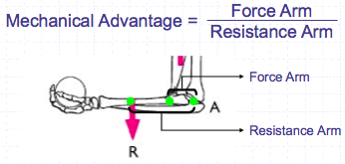

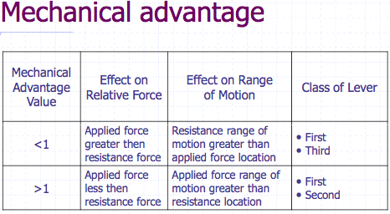

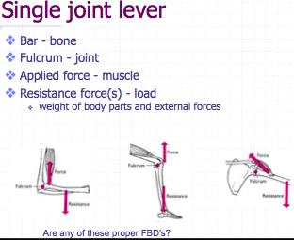

Torque
- Rotational effect created by applied F
- Also called “moment of F”

“Pure Torque” is rotational twist

Moment arm (d)
- Perpendicular distance from F’s line of action to axis of rotation

Net Joint Torque
- Is the vector sum of all these individual torques at any instant in time

Note: Each muscle that crosses a joint can exert a torque at that joint- both as an agonist or antagonist depending on what is needed to produce the movement

