Chapter 13 – Cash Flow Statements

- main purpose is to provide information that enables users to assess a company’s ability to generate cash and a company’s needs in using cash
Helps analyze:
- difference between profit and cash provided by operating activities
- individual inflows of cash provided by investing and financing activities
- ability to generate future cash flows
- often prepared based on cash and cash equivalents
- compare with other companies
- investing/financing transactions, effect upon capital structure
Cash equivalents: short-term, highly liquid investments that are readily convertible to cash within a short period of time. Ex: treasury bills, commercial paper

Types of activities:
Operating activities: include transactions that create revenues and expenses. Company must generate positive cash in operating activities to stay in business– affect income statement accounts and current asset/liabilities.
Investing activities: purchasing and disposing of long-term investments and long-lived assets, extending/collecting loans – non-current asset accounts
Financing activities: borrowing cash or repaying debts, obtaining cash from shareholders and paying them dividends – non-current liability accounts and equity accounts

IFRS – interest and dividends received may be operating or investing and interest/dividends paid may be operating or financing.
ASPE – Interest received/paid and dividends received are operating and dividends paid are financing

- noncash activities are not reported in the body of the statement of cash flows but disclosed in a note to the financial statements
- format: operating activities section 1st, investing 2nd, financing 3rd.
- individual inflows/outflows of cash from investing and financing activities are reported separately
- reported inflows/outflows of cash used by each activity result in net cash used in all three types of activites
- net cash used by each activity is totaled to arrive at a net increase or decrease which is then added to the beginning-of-period cash balance to arrive at the end-of-period balance. Should agree with statement of financial position

Format
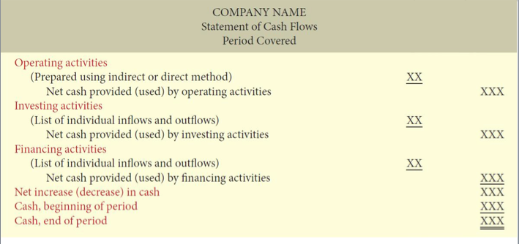

Preparation
- not prepared using the adjusted trial balance
- inflow comes from comparative statement of financial position, income statement and selected additional information
- Four steps
  - Prepare operating activities: determine net cash used by converint profit from accrual to cash basis
  - Prepare investing: by analyzing changes in non-current asset accounts and certain current asset accounts (not related to operating/investing activities)
  - Prepare Financing: analyzing change sin non-current liability and equity accounts
  - Complete the statement of cash flows: compare net change in cash in statement of cash flows with change in cash reported on statement of financial position, ensure amounts agree

Operating Activities
- profit MUST be converted form accrual basis to cash basis
- choose between indirect or direct method
- choice only affects operating activities
- direct method is preferred for comparison but most companies choose indirect because it is easier and discloses less information to competitors
Indirect method:
- converted from accrual to cash basis by adjusting for items that affected accrual basis profit but no cash.
- Example: depreciation or loss of sale on asset, revenues and gains that increase profit but not cash aka gain on sale of asset.
- Expenses and losses are added back to profit and gains are subtracted from profit
- Depreciation is first item added back to profit, adding depreciation expense cancels the effect of the expense, not added back because it’s a source of cash
- Current assets (accounts receivable, inventory, prepaid expenses): add decrease to profit, deduct increase
- Current liabilities (accounts payable, accrued expenses payable) add increase to profit and deduct decrease
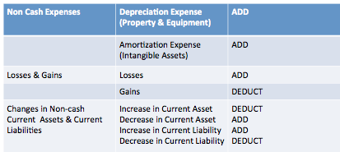
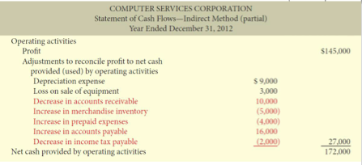

Direct Method:
- each item on the IS is adjusted from accrual to cash basis
- only major classes of operating cash receipts and cash payments are reported
- in order in which they are reported on IS

Example using direct method:

Revenue
Add: Decrease in accounts receivable OR
Deduct Increase in accounts receivable
Equals: Cash receipts from customers

Purchases
Add: Decrease in accounts payable OR
Deduct: Increase in accounts payable
Equals: Cash payments to suppliers

Cost of goods sold
Add: Increase in inventory OR
Deduct Decrease in inventory
Equal purchases

Operating Expenses
Add: Increase in prepaid expenses OR
Deduct: Decrease in prepaid expenses AND
Add: Decrease in accrued expenses payable OR
Deduct: Increase in accrued expenses payable
Equals: Cash payments for operating expenses

Salaries expense
Add: Decrease in salaries payable OR
Deduct: Increase in salaries payable
Equals: Cash payments to employees

Interest expense
Add: Decrease in interest payable OR
Deduct: Increase in interest payable
Equals: Cash payments for interest

Income tax expense
Add: Decrease in income tax payable OR
Deduct: Increase in income tax payable
Equals: Cash payments for income tax
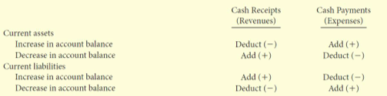
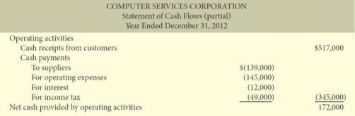

- profit, depreciation, loss/gain on sale of assets do not appear on a statement of cash flows under the direct method because they are accrual basis items
- Cash payments are subtracted from cash receipts to arrive at net cash provided (used) by operating activities.
- Regardless of method, investing/financing activities are the same

Investing
- changes in non-current asset accounts and certain current asset accounts ex. Short-term notes receivable issued for lending not trade
- cash inflow/outflow reported should consist only of the amount paid to purchased/received the investment upon sale of investment
- asset acquisitions are uses of cash; disposals are sources of cash
Financing
- looks are changes in non-current liability accounts, equity accounts and short-term loan payable accounts (lending purposed not trade)
- analyze share capital and retained earnings
- other comprehensive income does not affect cash flows; does not affect cash

Completing Statement of Cash Flows
- major items in the activities sections should be listed separately
- ex. Purchases asset for $80,000 and sells asset for $20,000, should be listed separately
- reported inflows/outflows of cash used by each activity result in net cash provide of the three activities
- net increase/decrease is added to beginning-of-period cash balance to arrive at end-of-period cash balance
- identify any noncash disclosures
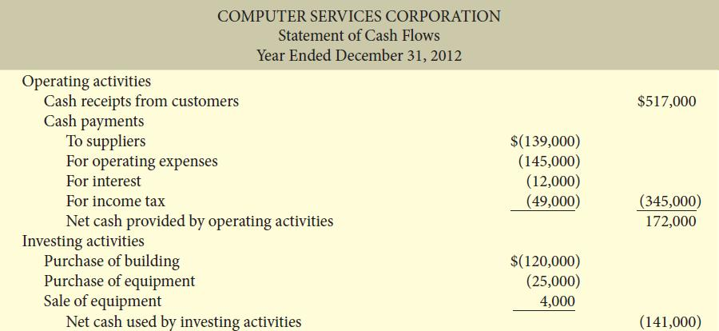
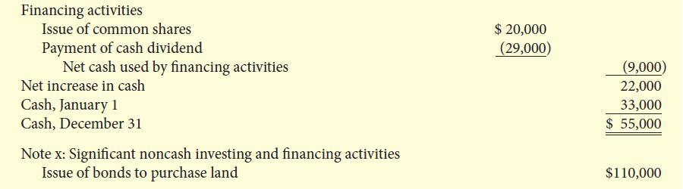

Evaluate the Company
- Liquidity: ability to pay obligations expected within the year
  - Current ration: current assets/current liabilities
  - Cash current debt coverage ratio: net cash provided by operating activities/ average current liabilities (higher)
- Solvency: ability to survive long term
  - Cash total debt cover ratio: net cash used by operating activities/average total liabilities (higher)
  - Free cash flow: net cash use by operating activities – net capital expenditures – dividends paid), helps determine how much cash flow a company has left from its operating activities to use. (higher)

