Balancing the System
- Explain the different mechanisms of steroid hormones and protein hormones.
Protein hormones bind to cell surface receptors on the target cells plasma membrane and steroid hormones diffuse through the plasma membrane and bind to intracellular receptors.
- Classify the various endocrine hormones mentioned in Activity 1 and Activity 2 as protein or steroid hormones.
Melatonin- protein
Cortisol - steroid
Progesterone - steroid
Testosterone - steroid
Insulin - protein
luteinizing hormone - steroid
follicle stimulating hormone. - steroid
antidiuretic hormone - steroid
growth hormone -protein
prolactin - protein
- Describe how the nervous system and endocrine system work together to maintain homeostasis.
the nervous system is composed of the CNS and the PNS which can control the endocrine system. It controls the endocrines systems production of hormones, most of which help maintain homeostasis.
- cAMP is a second messenger. Describe two other 2nd messengers with examples in the cell.
IP3 and DAG. IP3 binds to receptors on endoplasmic reticulum and releases calcium ions into the cytosol. DAG activates Protein kinase C.
calcium ions Ca2+ - most widely used intracellular messenger. A rise in Ca2+ in the cytosol triggers events such as muscle contraction, exocytosis, apoptosis, etc.
- What is a G-protein? What does this protein do in the cell?  They bind the guanine nucleotides GDP and GTP. G proteins are made of 3 subunits. | 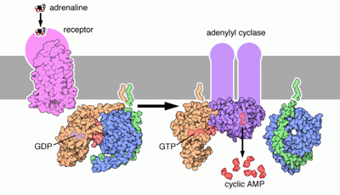
- List the hormones that can affect blood pressure.
Aldosterone – Steroid
Renin – Protein
Angiotensin – Protein
- If part of the anterior pituitary was attacked by a virus, especially the cells that produce ACTH, what would the outcome be on the individual?  If ACTH was attacked then the adrenal cortex would not be able to be used. The adrenal glands can malfunction because of the lack of ACTH and this can cause cortisol deficiency. In some cases, cortisol deficiency has resulted in collapsing and even death. Some symptoms are dizziness, fatigue, etc. | 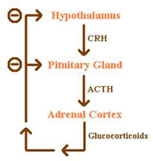
- Explain the terms, hyperpolarized and summation as they apply to a neuron
hyperpolarized is when there’s a change in a cells membrane that makes it more negative. Summation is the addition of post-synaptic potential when it reaches the neuron.
- Myasthenia Gravis is a muscle disorder. Explain its cause and how it is related to the neuromuscular junction.
This disorder is caused be a defect in the transmission of nerve impulses to muscles. This disorder either blocks, alters, or destroys the receptors for acetylcholine at the neuromuscular junction. Muscle contraction is prevented.
- Why is there a refractory period in the action potential?
There is a refractory period so the neuron cannot fire.
- Why do nerve impulses move quicker along a myelinated nerve?
Nerve impulses are able to jump from one node of ranvier to the next, which speeds up the movement of the impulse rather than travelling all across the neuron.
- Explain the term repolarization.
When depolarization changed the membrane potential to a positive value, repolarization is when it changes the membrane potential back to a negative value.
- How is serotonin related to mood disorders and depression? Using your answer, hypothesize a possible mechanism for how antidepressants might work.
An imbalance of serotonin levels may influence your mood. It is believed that low levels of serotonin plays a role in depression. Antidepressants might work if it increases your serotonin level.

- If a bacteria attacked juxtaglomerular apparatus (where rennin is secreted) in the kidney, and this part of the nephron no longer worked, what specific pathways would be affected?
you won’t be able to regulate blood pressure . if you have low blood pressure, renin won’t be able to produce to help regulate because bacteria has attacked the juxtaglomerular.
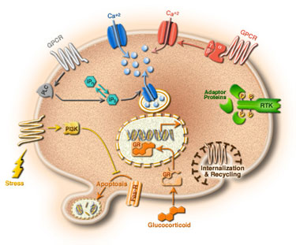
- This diagram shows the effects of stress at the cellular level. Explain any two processes here and how it is stress related.
The glucocorticoid enters the cell and binds to the GR. This results in the GR changing conformation and the shock proteins fall off.

Calcium ions are used Ca2+. Increase in this will trigger a muscle contractions
http://users.rcn.com/jkimball.ma.ultranet/BiologyPages/G/G_Proteins.html
http://users.rcn.com/jkimball.ma.ultranet/BiologyPages/S/Second_messengers.html
http://www.wisegeek.com/what-is-cortisol-deficiency.htm
http://www.ninds.nih.gov/disorders/myasthenia_gravis/detail_myasthenia_gravis.htm

http://www.webmd.com/depression/features/serotonin
http://www.wisegeek.com/what-is-the-juxtaglomerular-apparatus.htm

