Biochemistry
Covalent Bond = sharing electron
Polar covalent = different electronegativity’s
Ionic bond = Transfer of bonds ie. Sodium loses a valence electron to become an ion- metal/nonmetal. One atom gains and another atom loses.
Condensation reaction = two molecules join together to form a large one. = This is how polymers are formed.
Dehydration reaction –condensation except the two molecules that are removed are H20 this forms a peptide bond and connects two amino acids at the end add h20
Dehydration reaction – condensation carboxylic acid and alcohol are joined by removing h20 this forms an ester (cOOc-)
Neutralizing reaction – between an acid and base – molecule of water is removed and salt is formed
Hydrolysis reaction – opposite of dehydration , break apart with water
Oxidation = lose an e-, remove a hydrogen atom or add an oxygen atom
Reduction = gain an e-, add a hydrogen atom or remove an oxygen atom
Disacharides are linked via edter
Intermolecular forces hold two covalent molecules to one another. Intramolecular forces keep the atoms in a compound stuck to each other (chemical bonds).
The greater the electronegativity then the more polar the bond is
Water can dissolve both bases and acids because of its polarity.
The polarity of the water molecule with the attraction of positive and negative partial charges is the basis for the hydrogen bonding. The hydrogen must be attached to an electronegative atom of one molecule and an electronegative atom of a different molecule. The electronegative atom is usually oxygen, nitrogen, or fluorine, which has a negative partial charge. Hydrogen has a positive partial charge.
Hydroxyl = OH, Carboxyl = COOH, Amino = NH2, phosphate = PO4, carbonyl = COH or CO
Hundreds of amino acids = primary structure
Molecule Name : ATP -adenosine triphosphate
2 subunits: ADP (adenosine diphosphate) and phosphate.
Glycoside linkage – hydrolysis reaction disaccharide
Types of fat – triglyceride, phospholipids and steroids
DNA is a polymer made up of monomers called nucleotides. A nucleotide consists of a five carbon sugar (ribose), a nitrogen base, and a phosphate group.
These are fats that are made of glycerol and three molecules of fatty acid. Fatty acids are long hydrocarbon chains with a carboxyl group on the end to make an acid. – Triglyceride
Polypeptide is a short chain of amino acids, protein is several chains
Pinocytosis occurs smaller molecules into cell
Phagocytosis is the engulfing and digesting of substances, usually food, by vacuoles with a lysosome attached
example of phagocytosis – white blood cells attacking foreign bodies, engulfing bacteria
Example of pinocytosis – New born baby feeding from mother.
Exocytosis is used to transport molecules such as proteins and cell products from inside the cell to outside the cell.
Endocytosis is used to transport materials into the cell
If the concentrated solution is high, it is hypertonic. The concentration dehydrates the fruit (removing the water from fruits), preventing bacteria from growing.
Backbone of DNa phospodiesternlinkage
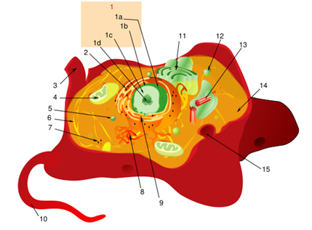
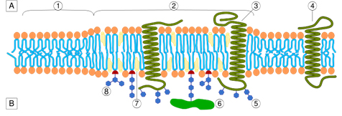
- phospholipid bilayer
three. Alpha helix protein
5. carbohydrate
7. cholesterol

1D) NUCLEOLUS
1C) CHROMATIN
TWO. RIBOSOMES
FOUR. MITOCHONDIRA
8. SMOOTH ENDOPLASMIC RETICULUM
9. ROUGH ENDOPLASMIC
10. FLAGELLUM
11. GOLGI APPARATUS
12. LYSOSOME
13. CENTRIOLE
15. SECRETARY VESICLE

