Lecture on Power
- Power= Capacity to control or influence the behavior of others.
- Tangible factors are things that can be measured; territory, nukes, natural resources.
- Military capabilities (Nukes, missiles)
- Geo-political forces-resources, territory, location.
- Economic wealth-mineral resources, oil, water, GDP (GDP is the total value of economic goods and services produced marketed annually within a state)
- Population- number of people, demographic profile, children, diseases, health
- Tangible Source of Power- Hard Power
- The ability through military or economic pressure to make others do what they otherwise would not do.
- Tangible assets and factors do not necessarily translate power into actual influence. (ex. Clinton)
- Intangible factors are things that cannot be measured.
- Belief systems, industry, time, and energy.
- Leadership and decision-making capabilities (ex. Gorbachev, Castro)
- Diplomatic and strategic skills (ex. Sadat, Pearson)
- Intelligence capabilities (Mossad/CIA)
- Communication Capabilities (ex. Satellites, computers)
- Power involves a Perceptual relationship
- Perception of capabilities and intent, rather than what they really are determines how states will act.
- Power is a relative and reciprocal relationship. Each party influences the other, even the weak ones. (Burundi/Rwanda/Somalia)
- Power tends to be Issue oriented 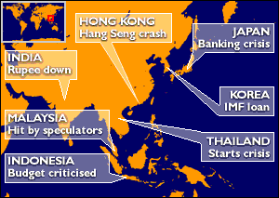
- Power is affected by one’s expectations (ex. USSR, reputation of being tough) (ex. US, reputation of promoting democracy)
- “International politics is a struggle for power. Whatever the ultimate aims of international politics, power is always the immediate aim.”- Morgenthau, Politics Among Nations
- Canada Power
- Geo-political power, Canada is larger than the US.
- Economic Wealth- mineral resources such as nickel, zinc, gold, potash, silver, uranium, timber, oil, water. GDP of 639.8 Billion.
- Military- no nukes, no missiles. Budget is 1.6% of GDP
Soft Power-intangible
- “The ability to get desire outcomes because others want what you want”- Keohane and Nye.
- “an appeal of one’s cultures or the ability to set the agenda through standards and institutions that shape the preferences of others are often sources of soft power”- Keohane and Kye.
Canada- soft power
- Leadership and decision-making capabilities. (ex. Confederation with parliamentary democracy, Chretien, Blair)
- Diplomatic and strategic skills (ex. Bill Graham, Lucien Bouchard, Stephane Dion)
- Intelligence Capabilities (ex. CSIS, CSE, RCMP)
- Belief in multilateralism, industry (work ethic), literacy (97% of population over 15 literate)
Lecture on Game Theory and Rationality
- Game theory rationally dispassionately examines the strategic behavior of nations.
- Game theoretical models illuminate the underlying structure of conflict.
- Game models can explain and describe situations; they can also be used to prescribe.
- War games are an example of how this is still relevant. Used by think tanks, the naval war college and the Pentagon.
- Language- conceals underlying political realities.
- 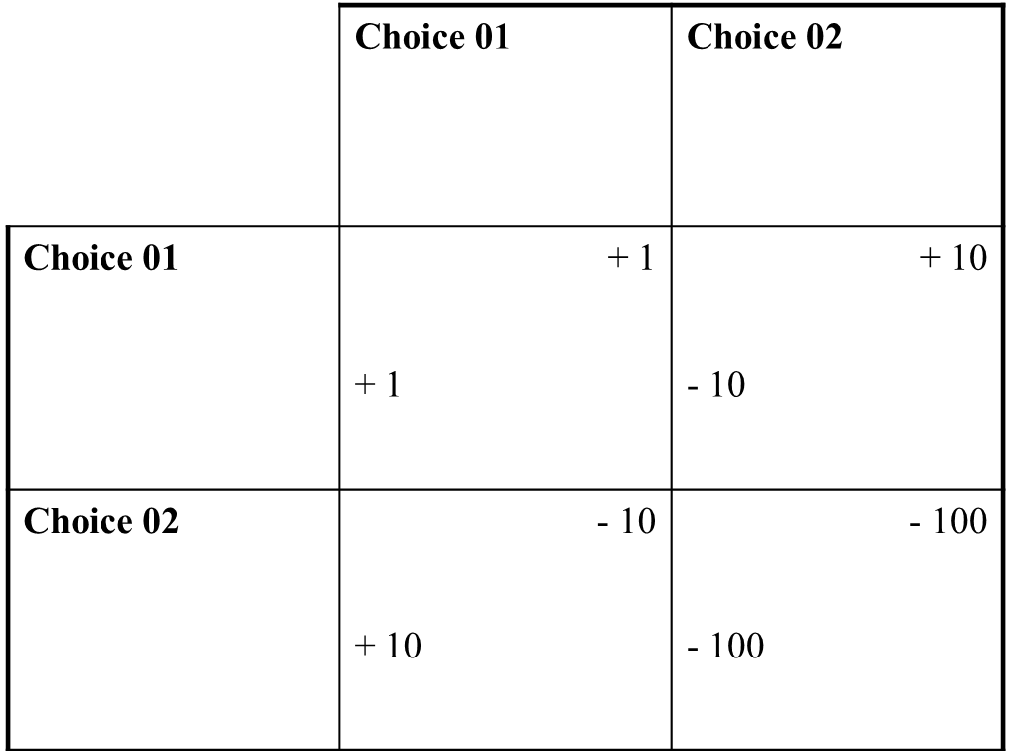

- Chicken Game or deterrence game
- 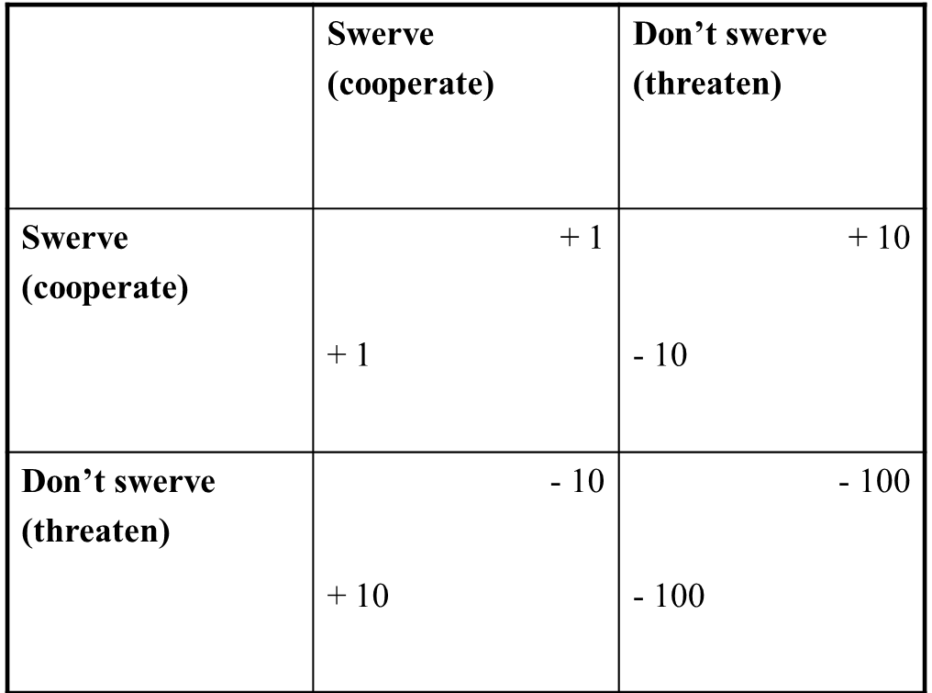
- Sam= US, Ivan= USSR.
- Developed by Daniel Ellsberg of RAND think tank. Based upon the tennage driving game, chicken.
- Both Cooperate (swerve)- +1-+1.
- One Threaten (don’t swerve)- -10/+10.
- Both threaten- -100/-100, both die.
- Must make a decision. Should consider what the worst possible choice it.
- They should choose to avoid the worst conceivable outcome- mini-max.
- Mini-max principle-look for the payoff where my minimal payoff is maximal. Look to make the decision which makes the best of the worst behavior of my opponent.
- If both Sam and Ivan follow this principle, they both swerve to avoid the worst pay off=rational solution.
- Conclusion is that the US and USSR should not rely on M.A.D.
- How can we credibly threaten to use nuclear weapons to make deterrence work?
- Those in favour of unilateral first-strike tend not to appreciate the potential interplay of both players’ choices. They also tend to forget that the other play may more highly value another outcome.

- Prisoner’s Dilemma
- 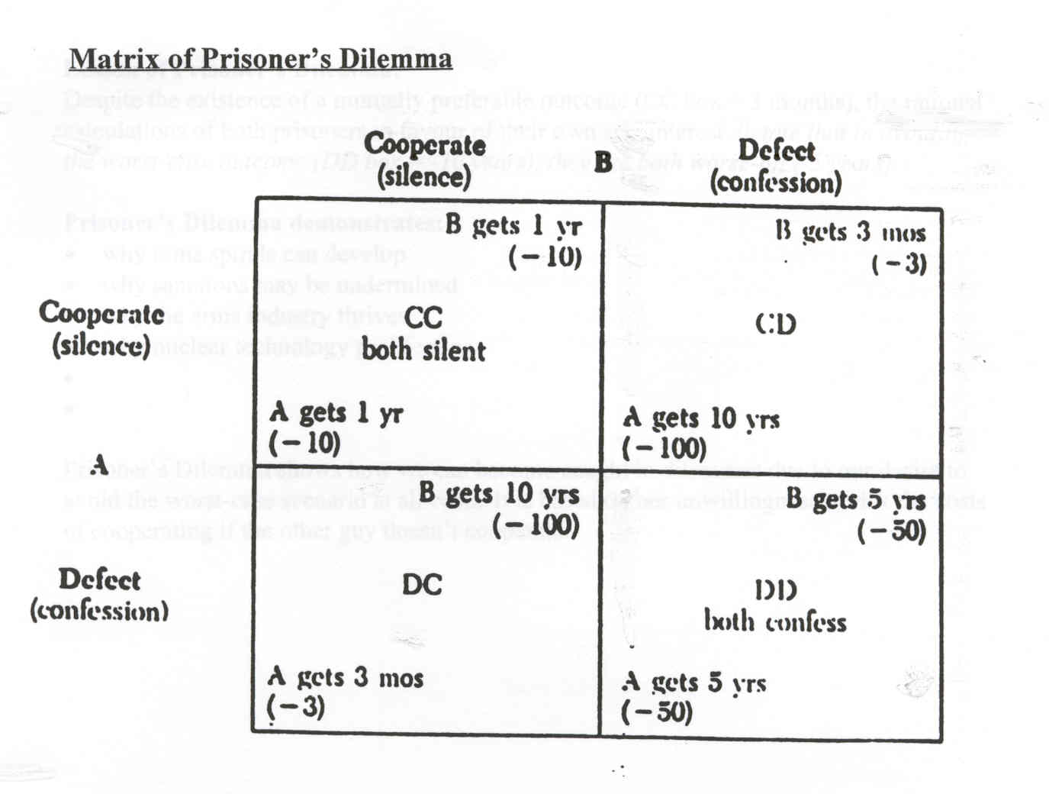
- The worst-case outcome is 10 years in jail. If both make the same calculations based on their desire to avoid serving 10 years (worst-case outcome), then both will tattle and get 5 years.
- Despite a mutually preferable outcome (3 months), rational calculations of both prisoners favour their own self-interest.
- Prisoner’s Dilemma shows: why arms races develop, Why sanction may be undermined, why the arms industry thrives, why nuclear technology proliferates.
- 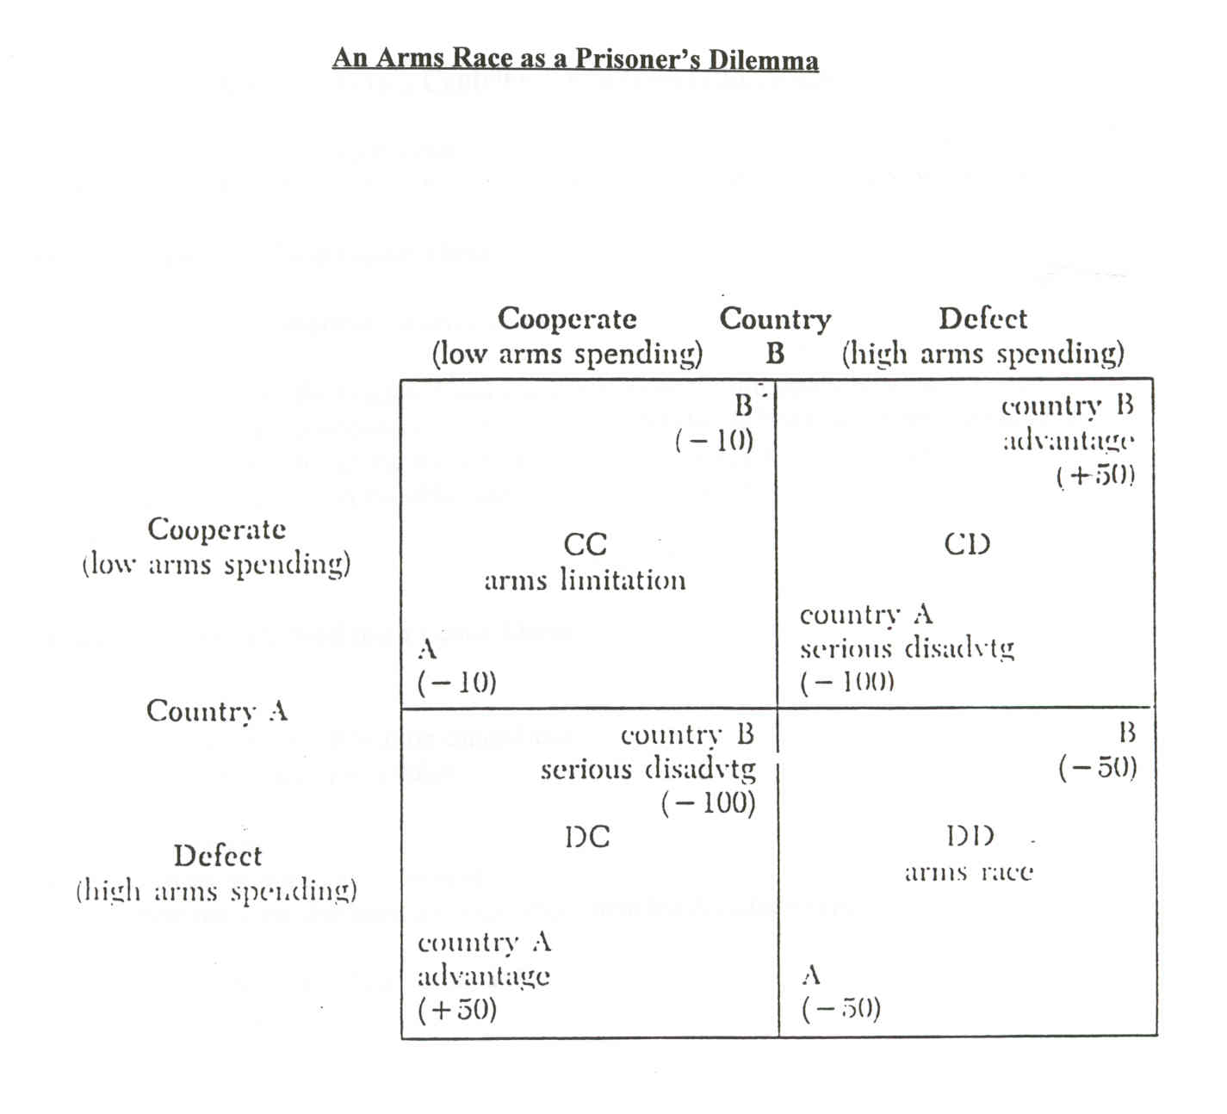
- Cooperating with other countries to impose sanctions against a violator country (e.g. cooperating to impose sanctions on Serbia) – or defecting from an international agreement to impose sanctions (e.g. loosening trade restrictions with Burma’s military regime).
- Cooperating with other countries to limit weapons stockpiles (e.g. ratifying the Chemical Weapons Convention) – or choosing to export certain weapon systems (e.g. exporting ‘dual-use’ weapons systems to Turkey)
Strategies Derived From Game Theory
- Promote trust and improve communication.
- Verify- develop increased verification capabilities, negotiate verification schedules.
- Change the pay-offs- Make arms racing more expensive. Promote the view that agreement can incur benefits and reduce expenses.
- Develop strategies based on Prisoner’s Dilemma- Robert Axelrod The Evolution of Cooperation, Anatol Rapoport’s Tit for Tat winning strategy.

- Tit for Tat strategy
- 1. Be nice by cooperating.
- 2. Retaliate immediately in the case of defection by defection once after each defection by another (reciprocate)
- 3. Forgive if adversary cooperates again.
- 4. Be clear and transparent.
Rationality and the Cuban Missile Crisis
- Themes= The Cold War, Nuclear Deterrence, Crisis decision-making, Realism vs. Idealism.
- Diefenbaker-three main IR policies
- 1. Signed onto NORAD- North American Aerospace Defence Agreement, bilateral defence agreement.
- 2. Avro Arrow- in 1957 it was the world’s fastest jet interceptor. Symbolizes our defence/industrial independence from the US. Cancelled in 1959.
- 3. Canada should acquire nuclear weapons.-
  - acquired Bomarc missiles in 1958 (SAM), could be conventional or nuclear.
  - CF-101 ‘Voodoos” fighter jets with nuclear capabilities.
  - Nuclear depth charges/ nuclear torpedoes. Used for anti-submarine warfare.
  - CF-104 ‘Starfighters’- a first strike fighter jet, made up 20% of NATO’s striking forces.
  - Lacrosse/Honest John Missile
- NONE OF THESE WEAPONS WERE EVER EQUIPED WITH NUKES
- Since 1954 the US had advocated Mutual Assured Destruction as an official policy.
- Nuclear Deterrence- “I (Nation A) will deter you (Nation B) from attacking me by threatening to react, if necessary, to any attack by using my full nuclear arsenal.”
- Ex. If the USSR attacked Berlin, US would respond with a Nuclear Attack.
- Kennedy advocated a Flexible Response. This meant a response without nuclear war. Emphasis on conventional or nuclear.
- USSR had nukes on Cuba, Kennedy responded with conventional means. Blockaded Cuba, dissolved the tension.

Foreign Policy Decision-Making, Instrument of Foreign Policy
- Rational Actor Model-
  - actors seek to maximize their goals. Goals are clear, ex. To increase power/prosperity/territory
  - Foreign policy consists of rational calculations in response to other sides moves. Decisions are based on rational calculations of alternatives.
  - Objective is to maximize utility¸ not to minimize loss.
- A main assumption is; do leaders calculate rationally?
  - ex. US increased bombing of N. Vietnam thinking it would lead to surrender, instead strengthened their resolve.
- Decision making is not entirely rational. (ex. Diefenbaker’s hatred of Kennedy)
- Personality type of a leader can be important.
  - Abnormal personalities can be a key factor (ex. Stalin-paranoid, Begin-mentally disturbed)
  - Personalities becoming characterized by media; Stalin-aloof, Khrushchev-insensitive, Thatcher-tough,
  - Look at leaders past history, their need for affliation.
  - Idealism or Realism?
How can (mis)perceptions affect policy choice?
- rational choices are impeded by (mis)perceptions & (mis)calculations
  - Perception is skewed by images, belief systems, national myths, traditions.
- A leader’s expectation usually determines his or her perception.
- Cognitive Consistency can prompt leaders to overlook information.
- Misperception and Miscalculation can be reduced by:
  - Hiring critics, Watchdogs, widing info channels, soliciting alternative options, consulting opponents and other nation leaders, firing bureaucrats intent upon retaining standard operating procedures.
- Bureaucracy can impede decision making.
- Groupthink is characterized by the illusion of group invulnerability, unquestioned beliefs about own group’s morality, stereotyping of the enemy, self-censorship, silence, high esprits de corps.
- Lobbying by special interest groups can influence foreign policy (e.g. friendships, paid retired lobbyists, be the first/last person to offer advice, show many letters from constituents, etc.)
- In democracy, public opinion can affect policy. Although the mass public concerned more with domestic issues.

- Graham Allison three models of Decision making
  - Ration Actor Model (classic model)
  - Organizational process model (SOP’s predictable, marginal change)
  - Bureaucratic Politics model (inter-agency struggle, competition, domestic politics)
- Domestic effects on Foreign Policy
  - Thinktanks
  - Expert organizations
  - Philanthropic organizations
- ‘counter-consensus’ is the notion that ‘we think we have influence but we don’t’/decision-making is structured so as to solicit public opinion but decisions are made by the elite
Instruments of Foreign Policy
- Foreign policy instrument are divided into military and non-military.
- Military
  - War- the most destructive tool available. Should be the last resort. Can range from limited to total war.
  - Military Alliances- Requires signing a treaty, can be permanent or temporary.
  - Military Pressure- to intimidate and deter
- Non-Military
  - Diplomatic Pressure- to convey a message of disapproval ಠ__ಠ,
  - Types of diplomatic pressure include letter of protest, withdrawing an ambassador, closing an embassy, and cutting diplomatic relations completely
  - Diplomatic Negotiation- a process in which parties seek some form of common agreement.
  - Legal Instruments- a body of rules that govern the conduct of states.
  - Confidence and Security Building Measures (CSBMs)- Increase openness among states about their affairs, especially openness and transparency about each other’s military plans.
  - Unilateral Measures-Independent measures, like promising to undertake unilateral disarmament (e.g. Trudeau undertook the Trudeau Peace Initiative by himself, and went around the world asking for leaders like Reagan to disarm)
  - Foreign Aid-Provides help to countries which are poor and underdeveloped in the form of food, financial assistance, education, access to technology, and access to skilled personnel
  - Domestic Opinion- The use of domestic opinion (at the grassroots or elite level) to convince the world or the rest of the country that another country’s actions are wrong and pressure must be exerted to change that country’s behavior.
  - Mobilizing International Opinion to effect change- the mobilization of international opinion to convince the rest of the world that another’s actions are wrong

International Conflict- Terrorism
- What type of terrorist threats can we expect?
  - Cyber Attacks- destruction of the Infrastructure of the information superhighway, internet, WWW (‘cyberwar’)computer viruses in sensitive networks.
- Will we see an increase in terrorism?
  - Large immigrant communities create a Human Jungle make is easier for terrorists to operate.
  - rise of narco-terrorists with vast resources and ability to influence and demoralize governments
  - Rise of issue-oriented groups including fringe elements of the pro-life movement and extremist animal rights groups.
  - Lone Wolf Terrorists a huge issue for the US- McVeigh, Kaczynski
Conflict and Belief System
- I. Focus can be upon individual-level characteristics (especially characteristics of leaders):
  - perceptions and misperceptions of leaders (e.g. Executive Committee during Cuban missile crisis and problem of groupthink)
  - skewed perceptions of leaders due to physical ailments can fuel conflict
  - personal characteristics of leaders (e.g. Bill Clinton)
  - psychological characteristics of leaders (e.g. Hussein al-Takrit ⇒ Saddam Hussein )
  - personal weaknesses of leaders (e.g. George Bush)
- II. Individual beliefs of leaders matter. But shared belief systems may matter more. Shared belief systems greatly affect International Conflict:
  - Belief systems refer to the underlying beliefs and assumptions we hold to be self-evident (they are the ‘back-drop’ of our thinking).
  - For example, during the Cold War most Canadian leaders believed the Soviet Union was opportunistic and aggressive.
  - A belief is the “mental concept at the basis of an argument or action”.
  - Normative Goals: “a goal assumes some hoped-for departure from the empirical reality of one’s situation. To have a goal is to propose that something should or ought to happen.”
  - Normative Beliefs: normative type of beliefs (e.g. what is right and wrong, what should be, what ought to be…)
- Summary: Individual Beliefs, Shared Beliefs, Goals, Normative Values and Lessons Learned by Leaders Can Influence a State’s Foreign Policy Decision-making leading to International Conflict
  - leaders learn individual lessons. For example, John and Bobby Kennedy learned lessons from the Bay of Pigs and Bobby’s ‘nuclear taboo’.
  - leaders learn shared lessons. For example, Israeli President Yitzhak Shamir & the Holocaust, Henry Kissinger and the Concert of Europe & balances of power. Leaders rarely change their mind about the lessons they learned!
  - Leaders learn 'lessons of history‘. For example, the 'lesson of Munich‘ & the 'Vietnam syndrome‘ have been powerful lessons.
- Shared belief systems can be manipulated to incite actors to go to war against each other
  - Many beliefs can be used to rally domestic opinion (e.g. ‘national unity’)
  - beliefs which facilitate integration (e.g. EU, AU)
- Competing Belief Systems: What ideological belief systems dominated during the 20th century?
  - A. Marxism-Leninism is a communist ideology that promotes the vanguard-party leadership (‘internationalist’) over a revolutionary socialist state (class struggle) that represents a dictatorship of the proletariat. It is a ‘far-left’ ideology’ based on principles of egalitarianism, class conflict, dialectical materialism, rationalism, social progress, anti-capitalism, anti-fascism, anti-imperialism and it is opposed to bourgeois democracy.
  - B. Soviet Marxism was a ‘branch’ of Marxist-Leninist ideology (‘Stalinism’) and promoted beliefs about ‘peaceful co-existence’ and ‘détente’ at the same time as Stalinist policies included ‘Socialism in One Country’, a centralized state, collectivization of agriculture, and subordination of community parties to those of the Soviet party. It is now associated with ‘reign of terror’ and totalitarian rule.
  - C. New Thinking (common Security): Glasnost (openness) was promoted by M. Gorbachev as openness and transparency in government together with freedom of information and perestroika (restructuring). It was supposed to reduce corruption and moderate the abuse of power at the top of the Communist party and the Soviet government.
  - D. Social-Democratic belief systems: Fabian influence from Britain, historical movement, benefit working class within framework of capitalism, fights for social justice, wants to maintain capitalist mode of production, welfare state, Keynesian economic policies, collective bargaining but wants also to balance the power of capital, favors reform, etc.
  - E. Fascism is an authoritarian, nationalist political ideology that is anti-egalitarian. Totalitarian, single-party state seeks mass mobilization of a nation through discipline, indoctrination, eugenics and seeks to ‘purify’ the nation; fascism promotes violence, paramilitary organizations and all other ideologies, including communism and social democracy. Supreme leader (e.g. Mussolini) rejects democracies.
  - F. Nazism believes in ‘Aryan superiority’, hyper-nationalism,
  - G. Liberal-Democratic belief systems tend to believe in the ‘laissez-faire’ economy and individual ‘liberal’ rights
- Francis Fukuyama, noted that the number of Liberal Democratic states were increasing.
- Are constitutional democracies more likely to select peaceful options? Fukiyama said ‘yes’. Are Christian civilizations more or less likely to resort violent conflict? Huntington said there would be more international conflict along the edges, where civilizations ‘clash’.
- Nationalism, as an ideology, an organizing principle, and a rationale for the nation state, even as the principle underlying the international state system, still appears dominant
- But Globalization, as an ideology, an organizing principle, and as the principle underlying the international system, appears to be strengthening
International Law and Organization
- According to former Prime Minister Joe Clark, “no other major power has Canada’s institutional reach.”
- GATT and the World Trade Organization
  - GATT was signed in 1947 and then the Bretton Woods agreement was signed by Congress in 1953
  - GATT was a multilateral (not bilateral) trade liberalization agreement
  - GATT was characterized by a number of ‘rounds’ of negotiations (e.g. Tokyo Round, Uruguay Round)
  - The GATT often resulted in cuts of tariffs, lower taxes on transactions, better trade dispute resolution mechanisms, and improved rules of trade and investment
  - the ‘most favored nation’ principle prohibited GATT members from discriminating against any GATT signatory in terms of trade. For example, the US extended MFN status to China, despite criticisms about China’s human rights’ violations after Tiananmen Square.
  - GATT allowed small and middle-sized countries (like Canada) to exert influence and pursue special interests in a multilateral forum
- Canadian-American trade relations:
  - 1966 Canada-US Autopact -introduced sectoral free trade
  - 1971 Nixon Shock -US imposed a 10% surcharge on all imports
  - Mitchell Sharp’s Third Option -tried to diversify trade with Europe
  - Foreign Investment Review Agency (FIRA) established in 1974
  - National Energy Policy (NEP ) tried to control Canadian energy policy in 1980
- Trend Toward economic continentalism:
  - 1988 Free Trade Agreement (FTA)
  - 1994 North American Free Trade Agreement NAFTA)
- Problems with GATT:
  - trade dispute settlement mechanism was insufficient for Canadian concerns
  - long tedious 'rounds’
  - vague agendas
  - GATT was slow in resolving issues
  - Canada needed a multi-tiered approach
  - Government thought we couldn’t rely just on GATT but needed to mix multilateralism and bilateralism
- GATT and the WTO: Moving Toward an Age of Globalization and a Multilateral Trade System:
  - The Liberal gov’t claimed that moving toward a ‘rules-based multilateral system’ should be the bedrock of Canadian trade policy
  - GATT became the World Trade Organization (WTO) and was supposed to be universal and multilateral
  - Yet the fact that Canada had negotiated a regional-based free trade deal (NAFTA) with the US in 1994 aroused considerable concern. “The mere fact that two of the most staunch supporters of non-discriminatory trade policies have ‘gone bilateral’ signals to the world that 40 years of progress towards an open trade system have come to an end and retreat into trade blocs has commenced.”
- World Trade Organization:
  - created on January 1, 1995
  - it is an institution for GATT, not a replacement
  - the WTO does not presently include China and Russia; negotiations for their entry continue
  - The WTO plans to introduce improved dispute resolution mechanisms. For example, the WTO ruled against Canada with respect to our subsidies to cultural industries, like Canadian magazines. We cannot any longer subsidize Canadian magazines' postage costs, control advertising, or prohibit American 'inserts'...
  - The WTO is a very young organization. But it is notable that the WTO has not done much to oppose the Foreign Extraterritorial Measures Act (i.e. Helms-Burton Act)
- What is the Helms-Burton Act?
  - US law that penalizes Canadian companies investing in Cuba and bans executives of those companies from entering the US
  - The law allows US citizens with claims on expropriated property in Cuba to sue foreign nationals, such as Canadians, in US courts.
  - Canada is challenging the law under the terms of NAFTA; we have raised the matter in the WTO and the Organization for Economic Cooperation and Development (OECD) and in the negotiations toward the Multilateral Agreement on Investment (MAI)
- What was the Multilateral Agreement on Investment?
  - it came up for negotiation and possibly ratification in 1999; 29 nations met in Paris but failed to reach agreement, due mainly to protests
  - most conceded its central purpose was to ensure protection for foreign investors
  - negotiators tried to ensure foreign investment could compete on a 'level footing' with national investment;
  - negotiators tried to ensure foreign investors would be compensated if they suffered losses that could be attributed to any bias in the state's regulations
- Objectives of MAI:
  - 1. non-discrimination- treat foreign and domestic investors the same
  - 2. Investment protection- provide assurance to investors of protection and compensation
  - Canada and US support MAI.
Multilateralism
- Multilateralism is the practice of conducting diplomacy with 3 or more states (as opposed to bilateralism or unilateralism).
- “Multilateralism involves working with coalitions of three or more states and within formal associations or institutions”
- “We have a lasting and visceral commitment to multilateralism which is ingrained, and endemic to the Canadian character.”- Stephen Lewis
- 6 Reasons for Canadian Traditional Support for Multilateralism
  - lessons learned by diplomats and soldiers from 1930s and 1940s about “the legacy” of World Wars I and II and the Great Depression
  - after WWII, during the ‘Golden Age of Canadian Diplomacy”, we were a significant power or a major power so we hoped to have some influence over Great Power discussions
    - Ogdensburg Agreement led to ⇒ Permanent Joint Board on Defence (PJBD), which was the first bilateral agreement between the United States and Canada
  - Multilateralism was perceived to be one of the chief responsibilities of a typical ‘middle power’ in a ‘bipolar’ system.
  - The geo-strategic facts of our relationship with the US also led Canadians to support multilateralism. Membership in multilateral organizations became important as a ‘counterweight’ to US dominance. Multilateralism helped Canada move away from an overly ‘continentalist’ policy. It helped ‘counterbalance’ American pressure.
  - There has long been considerable domestic support for multilateralism. The concept permeates the ‘liberal ideology’ that dominated during the 1950s and 1960s in Canada. Canada’s multilateralist strategy enjoyed popular support. There was widespread pride in the fact that we are strong supporters of UN, G-7, OAS, la francophonie, the Commonwealth, NATO, NAFTA, NORAD, ICC, etc.
  - Canadian diplomats also learned that ‘unilateral’ initiatives by Canada had little effect on the international community. We tended not to undertake unilateral moves because we learned we were more powerful by acting in coalitions with other ‘like-minded states’. Like-minded states continue to act in coalitions, like the Middle Powers Initiative (MPI), which lobbies the superpowers on behalf of middle powers.
The UN, Peacekeeping, and International Law
- United National Background
  - UN security council composed of P5 and 10 non-permanent members elected by the General Assembly for 2 year terms.
  - Established in San Francisco in 1945.
  - Official languages are Arabic, Chinese, English, French, Russian, Spanish
- Chapters 6 & 7 of the UN Charter
  - Deals with conflict management provisions.
  - Chapter 6 calls on members to: “deal with disputes that could lead to war to first of all try to seek solutions through peaceful methods such as negotiation, enquiry, mediation, conciliation, arbitration, judicial settlement, resort to regional agencies or arrangements, or other peaceful means of their own choice."
Peacekeeping
- Peacekeeping is: the deployment of international military and civilian personnel to a conflict area, with the consent of the major parties to the conflict, [acting impartially] in order to:
  - stop or contain hostilities or
  - supervise the carrying out of a peace agreement.
- Types of Operation in order of increasing force:
  - Peace Making, Peace Building, Humanitarian Assistance, Peace Keeping, Peace Enforcement.
- Four types/generations of Peace Keeping:
  - Observer Missions:
    - “The Soldier-Diplomat”
  - Interpositional missions
    - Pearson wins Nobel Peace Prize for ending the Suez Crisis in 1957.
  - “Multidimensional Operations”
    - Changing conflict means changing peacekeeping

- Fourth generation is transitional Administration
  - Governing a territory during a transitional period
  - Goal: turn over power to a peaceful, stable country power governed by a local, democratically-elected leadership
Canadian Peacekeeping
- Canadians overwhelmingly support peacekeeping.
- Canada has pulled out of peacekeeping in the last 20 years.
- Currently ranks 53rd in UN for Peacekeeping support.
International Law
- Political will is absolutely crucial if one wants to develop effective mechanisms for the implementation of international law, as is political consensus, given the lack of enforcement tools needed to ensure state compliance.
- natural states- access to state privileges is limited to the elite, and the provision of services is limited to those that support the elite. Order and the absence of violence rest upon a system of rights and privileges that provides elites with incentives to cooperate rather than fight.
- Under International Law, there are 3 justifications for the use of force.
  - Self-defense
  - Humanitarian intervention
  - Authorization of UNSC
- Case of Iraq
  - France and Russia vetoed the invasion of Iraq.
  - Doctrine Automaticity was used to justify Iraq. Said that it authorized individual states to use force.
  - Used the right of self-defense against terrorism and WMD arguing it could only be invoked “pre-emptively.”
  - Was humanitarian, “there is little doubt as to whether Iraq under Saddam Hussein fit the profile of a “tyrannical and totalitarian regime.” Moreover, the appalling human rights situation in Iraq at the time was extremely well-documented.
- Foreign Policy Magazine says there are up to 60 failed states currently.
- Failed States, "though retaining legal capacity, has, for all practical purposes, lost the ability to exercise it.”

