General Principles of Microbiology

Basic Structure
Viruses : consist mostly entirely of nucleic acids, a protein shell (capsid)
- Enter cells and divert the synthetic processes
micro = small
bio = life
logy = study (of) or science
Immunology= study of our protection from foreign macromolecules or invading organisms and our responses to them
Different classes of organisms…
✓Viruses / chlamydia (grow only in living cells)
✓Mycoplasma (grow on non-living media)
✓Bacteria (no separate nucleus; unicellular)
✓Parasites
✓Small (microscopic)
1-2 microns (1 mm = 1000 microns)
Address them by their proper names !!!
-(i.e., not “germs”, “bugs”)

What are they made of?
✓Viruses
-Nucleic acid (either RNA or DNA…never both!)
-Surrounded by protein shell (capsid)
-Attach, inject nucleic acid (penetration), highjack synthetic processes inside cells to make more viruses, package, get out while going is good…

What are they made of?
✓Bacteria
-Rigid cell wall to keep things in place
-Genetic material –circular chromosome
-No nucleus (nucleoid)
-Both DNA and RNA
-Binary fissionSome bacteria do not have a rigid cell wall and are more fragile (i.e., Mycoplasmas)

What are they made of?
✓Eukaryotes
-Unicellular and multicellular animals and plants
-Genetic material is organized into a nucleus
✓Are all bacteria bad?
✓biotechnology, spoilage of foods, bioremediation, functional foods, etc…
✓Can we live without bacteria?

“Normal” flora…the good guys ☺
✓Resident versus Transient
✓GI-tract: colon is inhabited by anaerobes and coliforms
✓Skin: mostly coagulase negative staphylococci
✓Where should there be NO bacteria?
What can they do for us?
-protection from invasive (bad) bacteria
-metabolism (vitamin K), immune stimulation
The ways in which normal flora are clinically important are:
- A healthy active normal flora will to some extent protect a person from infection by invasive organisms
- The normal flora of the gut participates in the metabolism of the host. In particular vitamin K is synthesized by certain microorganisms and if there are disturbances in the normal flora there may be secondary nutritional deficiencies
- Disturbances in the ecology and balance of the normal flora may be produced by antibiotic therapy- this is the basis of antibiotic induced diarrhoea
- The normal flora is controlled by various host defences may result, in some patients, in infections caused by organism which are normally not pathogenic

What protects us from the bad guys?
✓Mechanical barriers
-skin, saliva, mucous, tears, hairs, etc.
✓Other helpers include
-antibodies
-complement
- A system of plasma proteins that work together to resist bacterial infection
-immune cells (T-cells, NK cells, macrophages)
-immune system (cell mediated; humoural)

How do the bad guys get in?
✓Adherence
✓Toxin production (destroys some of our defenses)
✓Opportunism
✓Compromised host (how does this happen?)
✓bacteraemia versus septicaemia? (aemia = blood)

crobial disease
✓Interaction between microorganisms and the host (us) is continuous battle
-They need to enter-live-multiply
✓In order to enter, they need to colonize(establish and multiply) in/on body; clinical infection(disease) can result when damage occurs to host [contamination= deposition without multiplication]
✓Clinical disease = easy to recognize
✓Sub-clinical infection = hard to diagnose (no symptoms)

How do we measure how dangerous a bacteria/virus/parasite is?
✓Pathogenicity= ability to produce disease
✓Virulence= relative capacity to cause damage (i.e., the degree of pathogenicity)
✓Opportunistic= do not normally cause disease but can do so when defense mechanism(s) breached or compromised

Pathogenesis of infectious diseases
✓A pathogenic microorganism enters your body…two things happen:
1.Microorganism (invader) tries to multiply / invade and cause disease (2º event)
2.Host tries to prevent #1
✓Whether the invader wins or not is dependent on several factors

✓Transmission:
-inhalation, ingestion, break in protective barrier, direct deposit
-pathogenicity
-invasiveness(adherence, persistence, avoidance of immune system)
-toxigenicity(ability to make toxins)

How does a pathogen adhere to us?
✓A bacteria needs to adhere, evade and invade the host
✓Tools used to achieve these huge objectives:
✓surface structures (pili, fimbriae)
✓capsules
✓Enzymes

Bacterial Infections and Host Defences
In human health the normal flora bacteria function as a balanced ecosystem with multiple species at a site and no single organism predominating.

Mechanical Barriers
A barrier to the invasion of deep tissues by bacteria. Extensively colonized larger numbers of organisms

Adherence
First requirement adhere to the host tissues and bacteria have developed specific mechanisms to achieve this. Ligands bind to specific receptors on the mammalian cell surface

Phagocytosis
Macrophages and the blood neutrophil are capable of ingesting bacteria and killing them. These are very important defence against invasion by bacteria. Phagocytosis depends for its initiation on the ability of phagocytic cells to attach and form a vacuole. Host response is sometimes to produce antibodies to the capsule which modifies the surface of the capsule in a way that permits the phagocyte to take up the capsulated organism (opsonization)*****

Toxinogenicity
✓Toxins are substances (usually proteins) secreted by bacteria with the hope to cause damage
✓Two classes:
✓Exotoxins
-excreted by livingcells
-specific affinities
-thermolabile
-potent
✓Endotoxins
-liberated when cell wall disintegrates
-less specific, causes fever, malaise, shock
-thermostable
-less potent than exotoxins

Cell Mediated Immunity (CMI)
-killed by activated macrophages and cell mediated immunity is a vital defence against these organisms.

Exotoxin Production
- Produce exotoxins which damage those tissues
- Host defence against exotoxins is antibody

Metastatic Spread
Bacteria may become distributed around the body from a single focus of infection through the blood stream. A primary focus of infection followed by dissemination of the organisms causing that infection through the blood stream and the form their own individual first sign of infection

Microorganism- organisms invisible to the naked eye

Infection- penetration of a microorganism, into a host organism, producing apparent (disease) or inapparent (no disease)

Colonisation: establishment and multiplication in/on the body of a microorganism without producing any apparent or inapparent change

Contamination: deposition of microorganisms without multiplication

" Clinical infection"- occurs when changes result in functional damage to the infected host

- Microorganisms that are capable of producing clinical or subclinical infection are classified based on pathogenicity and virulence
  - Pathogenicity: ability of a microorganism to produce disease
  - Virulence: relative capacity of a microorganism to cause damage resulting in disease

- Opportunisitic pathogens: microorganism which rarely cause disease in healthy humans

Pathogenesis of infectious disease
- The microorganism- striving to multiply and invade the tissues
- The host- striving to block the invasion of microorganisms and destroy them

Capacity of a microorganism to initiate an infection and produce disease is dependent upon:
- Transmissibility: transfer of an effective challenge amount from a source to a host
  - Routes of entry:
    - Inhalation
    - Ingestion
    - Break in protective barrier
    - Direct deposit
- Pathogenicity: capacity to inflict damage as a result of invasiveness (ability to overcome host defences and multiply)and toxingenicity (production of toxins)
  - Invasiveness
    - When microorganisms overcome their host's immediate defence mechanisms; their ability to:
      - Adhere and persist on body surfaces
      - Protect themselves against bactericidal substances present in body fluids
      - Avoid ingestion and destruction by phagocytes
2.1.1 surface structures- adhere to specific receptors present on body cell surfaces

2.1.2 Capsules- protect the microorganism against leucocytes
- Enzymes- contribute towards the virulence of the pathogen that elaborate them

2.2 Toxinogenicity
-Toxins are substances produced by bacteria that damage host tissues or upset systems vital to the host
2.2.1 Exotoxins
- Proteins excreted byliving bacterial cells
- Have specific affinities for host systems
- Active in very small concentrations
2.2.2 Endotoxins
- Toxic substances associated structurally with the bacterial cell and liberate only when the cell disintegrates
- less specific and less potent
Transient flora- removed when washed
Resident flora- already there (ie. Sharing pens)
  - Inhalation, ingestion- 2 major ways of infection

?What is Immunity ?
•Immunity = the protection against infectious disease conferred either by the immune response generated by immunization or previous infection or by other nonimmunologic factors…a.k.a. body’s ability to resist infection
•2 types of immunity
–Non-specific (innate)- whatever invader, pH in stomach, enzymes when you cry
–Specific (adaptive, acquired)
How we go about attacking a foreign body
Innate Immunity- mechanical barrier
•Skin
–What characteristics of the skin make it an effective mechanical barrier ?
  - Acidic; sebaceous secretions and sweat- unsaturated fatty acids, bactericidal
  - Mechanical barrier
  - Dry (lowered water activity; water available for bacteria growth)
  - Repairs itself quickly
  - Lowered temperature- suboptimal for some bacteria
  - Has oils
•Mucous membranes (mechanical)
–Cilia in respiratory tract eliminate particles larger than 5 microns
–Lysozyomes (antibacterial substance) (stomach)
  - pH- e.g. gastric juice pH 1-2
•Iron-binding proteins- transferrin, lactoferrin, which bind the iron necessary for bacterial growth
–Some bacteria require iron for growth
–Transferrin, lactoferrin
•Phagocytosis- general purpose vacuum cleaner (macrophages); fixed macrophages in the tissue engulf and eventually destroy bacteria
–PMNs, monocytes and macrophages
•Complement
  - Set of proteins that circulate in your blood; make a membrane attack complex (mac; proteins come together and punch a hole in bacteria and insides come out of bacteria, bacteria dies); obsinization (to decorate)

Specific Immunity
•Humoral (antibodies) and Cell-Mediated (CMI)(immune cells)
  - Humoral: specific circulating antibodies in body fluid
  - Cell- mediated: cells trained to attack specific invading organisms
  - Both are "specific": directed against one particular species of microorganism and not any other
•What is the difference between innate immunity and adaptive immunity?
–Innate: protects against ANY invader, does not discriminate
–Adaptive: directed against one type of invader, dependant on past exposure

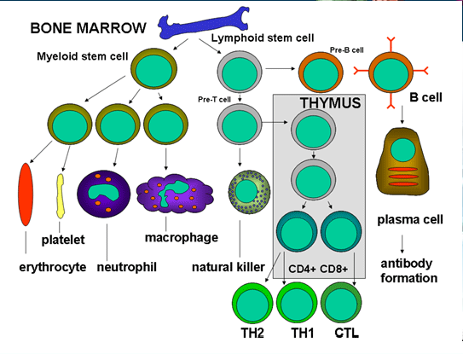

Immune cells come from:
  - Most arise from stem cells
  - b- cells: make antibodies (humoral immunity); need to be turned on by TH2 cells
  - t- Helper 1 and 2; TH1- activate cell mediated immunity
Humoral Immunity
•Circulating antibodies
•Antibody: protein that binds specifically to a substance (its antigen)
  - Heterogeneous group of proteins called immune globulins
  - Produced by the body in response to stimulation by antigens
–Igs or immunoglobulins

–Produced by B-lymphocytes (plasma cells) upon stimulation from antigen presenting T-cells
  - B- Lymphocytes need antigen-producing cells, production is regulated by T-helper and T-suppressor cells
  - Important role in infections in which the pathogenic mechanism involves production of toxins or presence of a capsule as well as in come viral infections
–Recognize toxins, capsules, some viral proteins
  - Antibodies don't appear to differ significantly from each other in gross physical or chemical characterisitcs but do differ in ability to combine with different antigens
•Antigen
–“non-self”; must be recognized by the body as foreign
– usually a foreign natural Protein, glycoprotein, lipoprotein, polysaccharide
  - Can be particulate or soluble
  - Is a substance capable of inducing a specific immune response
–What structures could be “antigenic” in a bacteria? Virus?
  - Most organisms have an easier target on the outside which triggers anitbody production
antibody recognizes small and unique antigen
Antibody Binding: how does it occur?

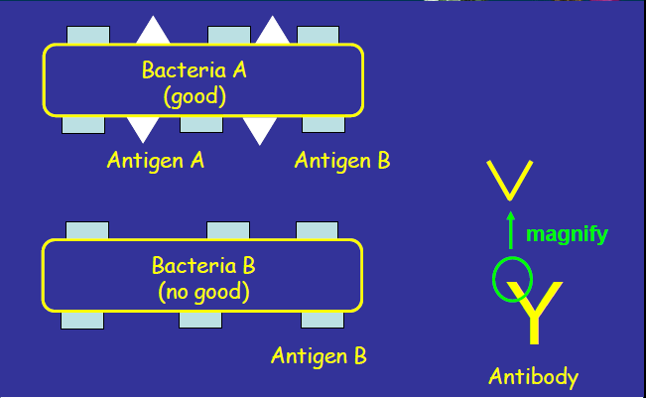

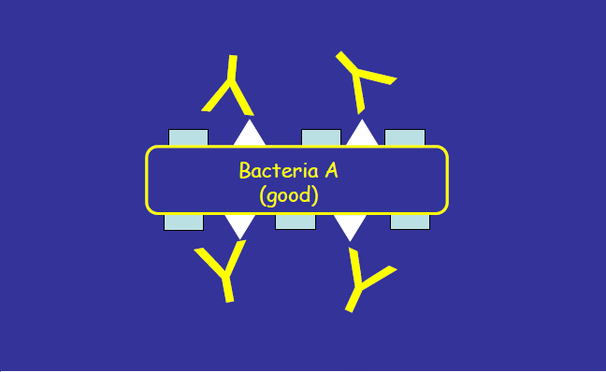

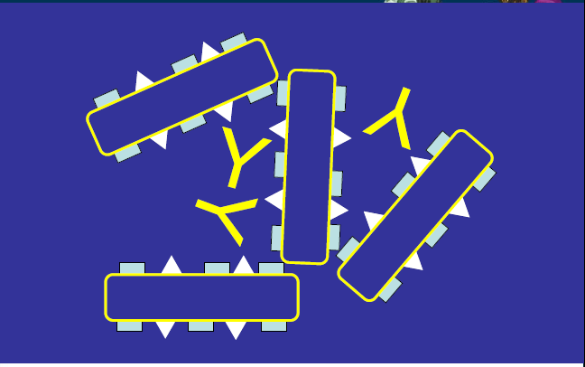
"good" is the one that wants to attack
Bottom of Y is constant
Top is variable which allows specific immunity
One arm of the Y binds to one bacteria and the other to another bacteria - causes clumping

Immunoglobulins (Igs) a.k.a. Antibodies
  - IgG, IgA, and IgM are involved in the defense mechanisms
•Antibody: Ig produced in response to stimulation by an antigen and reacting specifically with it.
•Distinguish “non-self” from “self”
•Constant and variable region
–Variable region is responsible for antigen recognition

Classes of Igs
•5 classes: IgG, IgA, IgM, IgE, IgD
•IgG
  - Each Y-shaped IgG molecule has two combining sites; rest of the molecule can hook up onto phagocytes and macrophages
  - Host defense
–Crosses placenta and protects newborn
  - Encourages women to breastfeed
  - 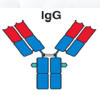
•IgD
–Role is unknown
  - Structure slightly different from IgG
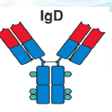
•IgA
–Host defense
–Found in secretions
•Tears, saliva, milk, respiratory, GI and genito-urinary tract
–Dimer( 2 molecules linked by a molecule) (must be a dimer to work)
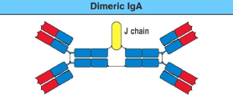
•IgM
–Host defense
  - Main immune globulin produced in the early immune response
  - Doesn't cross the placenta
–Early immune response
–Pentamer ( must be a pentamer to work)(5 units joined)
  - Usually first to be made
  - Can switch to IgG or IgA
  - 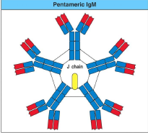
•IgE
–Hypersensitivity (allergies)
–Defends against parasites
  - Binds to master cells (causes histamine production)

  - All different classes; can never be the same class
1º and 2º Immune Response( Primary and Secondary)
•1º Response
–Antibody production triggered on first antigen introduction
–Latent period of several days
–Circulating antibody detectable after 5-10 days
–Antibody in serum is maximum at ~21 days, then drops to low levels
  - First time recognition of bacteria (antibody production)
•2º Response
–Basis for Immunizations
–Occurs when Antigen is introduced 2nd, 3rd,4th…time
–Lag, rapid Anitbody increase (2-3 days), slow decrease over a much longer period
  - May be repeated several times until antibody level reaches a maximum usually after 3-5 injections of antigen
–Booster injections to maximize Ab levels

  - Complement in blood can cause activation of antibody production
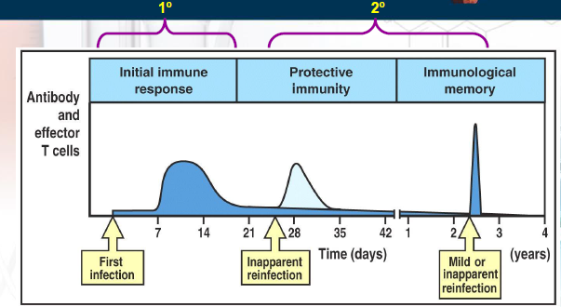
Antibody Detection
•Serological Reaction
–Detects presence of antibodies in serum sample; look for antibodies circulating
–Antigen and antibody interact; agglutination
–Antibody titration
–Detect unknown microorganisms using known antisera

Cell-Mediated Immunity (CMI)
•T-cells NOT antibodies!
–Helper, suppressive, cytotoxic (killer) generated from memory T-cells
•Exposure to antigen induces response from trained T-cells which are active against that antigen or any organism that carries it
  - Soluble antibodies are not involved
  - Based on a large number of T-cell subpopulations and a complex system of interactions
  - Active in most microbial infections
  - Essential in the defense against intracellular organisms and in the defense against parasites, tumor cells and foreign cells
•Essential for defense against intracellular organisms, parasites, tumors and other foreign cells (i.e., transplants, grafts)
•Immune-suppressive medication for transplant recipients
  - TH1 usually involved and turns on the response
  - Trained T -cells: attach to antigen and controls it

Disorders of Immunity
1 Allergy and Hypersensitivity
–OVER-reaction to antigens in absence of true infection
–Can be fatal…..ANAPHYLAXIS
  - Observed when administering vaccines to individuals who are allergic to a component of the vaccine
    - Allergies show immune system it's good at recognizing antigens
2 Auto-immune diseases
–Immune system reacts to its own “self” antigens
–“auto-antibodies”
–Type I diabetes, MS, rheumatoid arthritis, lupus
3 Immunodeficiency states
–Inability to produce antibodies and/or disfunctional CMI or both
–result of Congenital abnormalities, irradiation or disease (AIDS)
4 Graft rejection
–NORMAL immune reaction to “non-self”
–Control by immune-suppressive medication
  - Very common

Immunization(TESTS and EXAMS DON'T put names of vaccine just the TYPE)
•Passive Immunization
–administration of pre-formed antibody against a specific microbial agent through a intramuscular route
–IgG animal origin: short lived, risk of hypersensitivity reaction
–IgG human origin: short lived, no risk of reaction
  - Protection is immediate
–Gamma globulin (IgG):pooled from large grouped of blood donors and has antibodies to many common infections
–Hyperimmune globulins (IgG):specific for a particular microbe; are IgG fractions
  - High titers of antibody to a specific disease that have resulted from natural exposure or hyperimmunization
    - Injection of premade antibodies
    - Hypersensitivity caused when the origin is from an animal as the base is different from ours
    - IgG- can pool from human and animal origin

  - IgG of animal origin is recognized as foreign by the immune system
  - Passive immunity is short-lived and carries the risk of hypersensitivity reactions
  - IgG of human origin also disappears from the circulation after several weeks and is also short-lived

Active Immunization
•Stimulates immune system by administration of antigen
•LONGER LASTING
•Live-attenuated vaccine
–Sub-clinical or mild illness mimicking the disease; duplicates to a limited extent to allow the disease to be prevented
– provide both Local (IgA) and humoral (IgG) immunity
–Rapid immunity development
–Serious illness in immuno-compromised individuals
  - Huge problem with polio vaccine
  - killed vaccine needs to have same make up/ antigen as live vaccine

Active Immunization (con’t)
•Killed vaccines, sub-unit vaccines and toxoids
–Antigens without infectivity
  - Administered parenterally with one or more spaced injections
–May require boosters (subsequent)
–Adjuvant with toxoids
–Polysaccharide vaccines can be conjugated to protein (see conjugate vaccines)
•Recombinant vaccines
–DNA recombinant technology
–Attenuates microorganism
–Hep B vaccine
•Adsorbed vaccines
–Vaccine mixed with inorganic salt for slower adsorption and longer-lasting immunity
–Tetanus, diptheria
  - Longer lasting
  - Longer its in your body the greater the chance of immune system recognizing and responding
  - Conjugate vaccines
– contain a polysaccharide capsule Designed for poorly antigenic microorganisms
  - Antibodies against this capsule protect against infection
  - Capsular material is attached to an altered, non-toxic protein
–Conjugate antigen of interest to immunogenic, non-toxic protein
  - Change the vaccine by adding a more appealing part on an antigen
–Haemophilus influenzaetype b
•Combined vaccines
– several live attenuated or several killed vaccines combined together For ease of administration
•Combined Active-Passive Immunization
–Immediate protection after possible exposure to microbe
  - Desirable to provide the patient with immediate protection through passive immunization while at the same time proceeding with active immunization
–Hyperimmune Igs and vaccine injected at DIFFERENT sites
–Tetanus, Rabies, Hep B

Introduction
➢The first antibiotic (?)
➢discovered in 1929 by Sir Alexander Fleming
➢World War II
➢penicillin used to treat staphylococci and streptococci (1946)
➢How effective was penicillin?
Resistance to penicillin recognized almost immediately
➢80% of all strains of Staphylococcus aureus
➢Streptococcus pyogenes(Group A strep) still treated with penicillin
➢Interestingly, penicillin has never been effective against Gm-negatives (Salmonella, Shigella, Bordetellapertussis, Yersinia pestis, Pseudomonas) –why? ☺
➢Late 1940s and early 1950s?

Antibiotic therapy
➢Effective chemotherapy depends on selective toxicity
➢good against pathogen, does not affect host… ☺
➢Exploit pathogen processes not seen in humans
➢cell wall, metabolism, etc.
➢Knowledge of likely microorganism is crucial…
➢site
➢organism
➢allergy to host?
Other considerations…
-route of administration
-Monitoring therapy
-Adverse effects
-GI-tract, skin, haemopoietic system, renal system, liver
Acquired resistance
-Three major mechanisms of resistance
-Alteration in drug target
-Production of inactivating enzymes
-Decreased uptake of antibiotic

Antibiotic resistance
  - Antiboitics significantly reduced the morbidity and mortality associated with pathogenic bacterial infections
  - Increases in antibiotic resistance severely limits the agents available to treat patients with serious infectious diseases
➢Resistance occurs when a susceptible microorganism is no longer inhibited by an antibiotic agent
➢Many reasons why this can happen
  - Reasons underlying the marked increase in antibiotic resistant bacteria include:
    - Use and misuse of antibiotics in agriculture and aquaculture
    - Use and misuse of antibiotics in the human population
    - With advances in medical therapies, many more immunocompromised patients are remaining alive longer and are serving to harbour and transmit antibiotic resistant bacteria
    - Emergence of multiple antibiotic resistant strains which develop simultaneous resistance to most of the commonly used antibiotics, has rendered some infections untreatable
  - Antibiotic Resistance Mechanisms
    - Resistance develops more often and more quickly in immunocompromised patients resulting in increased morbidity
➢intrinsic-characteristics of microorganism vis-à-vis antibiotic’s mechanism of action (inherent or “natural”); form of resistance based on the mechanism of action of the antibiotic and the characteristics of the microorganism
➢acquired-new or added (driven by two genetic processes in bacteria…mutation and selection (vertical evolution); and exchange of genetic material (horizontal evolution); susceptible organism becoming resistant to an antibiotic's action. Three main mechanisms of resistance:
  - Alteration in drug target
  - Production of inactivating enzymes
  - Decreased antibiotic uptake
  - Some organisms can produce chemicals that kill bacteria
  - Penicillin attacks the cell wall of bacteria
  - Monitoring therapy is rarely done
The chromosome: role in antibiotic resistance…
➢Mutations lead to
➢Change it site of antibiotic target (but protein for bacterial still works fine!)
➢Regulatory genes
➢turn on alternative path
➢turn on efflux mechanisms- proteins pump out just as fast at it's pumped in (efflux)
➢Change cell permeability

Post-antibiotic era: is it possible?
➢With current overuse of antibiotics, we are forcing bacteria to change (evolve) in order to survive
➢How is this achieved/helped by us?

Decreasing antimicrobial resistance?
➢Withhold antibiotics
➢self-limited viral infections (i.e., the “common cold”)
➢Use narrowest spectrum antimicrobial agents
➢Base decision about broadness of empiric antibiotic coverage on severity of illness
➢clinically stable and not at risk for significant morbidity…may be appropriate to wait culture results and MIC testing

  - Overprescribing antibiotics aren't mechanisms
  - Achieved by us
    - Human behaviour (not finishing prescription)
    - Agriculture (antibiotic usage; animal feed lots)
    - Day-care centers
    - Hospitals
    - Long- term care facilities
Decreasing antimicrobial resistance?
➢Prevention of infection
➢hygiene, handwashing
➢Education
➢helps to achieve therapeutic and preventative goals
➢when are antibiotics needed?
➢how to take them?
➢proper duration!!
➢Earlier detection of therapeutic failure
➢good for patients with antibiotic-resistant pathogens

Genetics of Antibiotic Resistance
  - Antibiotic resistance genes can be encoded by the bacterial chromosomes or plasmids

  - Exchange of genetic material
    - Conjugation(plasmid)- requires cell-to cell contact and specialized bacterial structures known as conjugative pili for the transfer of DNA molecules usually in the form of plasmids
    - Plasmids containing genes that allow them to initiate their own transfer from organism to organism are conjugative plasmids
    - All plasmids have limited host ranges
    - Transformation: uptake of free or naked DNA from the environment
    - Transduction- involves the transfer of genetic material among bacterial cells
    - An entirely random mechanism depending on the accidental incorporation of bacterial DNA within a phage particle
    - Transposition- powerful mechanism for mobilizing antibiotic resistance genes from one DNA molecule to another( from a chromosome to a plasmid)
iv. Important group of genetic element (intregrons) a mobile DNA element with a specific structure consisting of two conserved segments flanking a central region in which "cassettes" that encode functions such as antibiotic resistance my be inserted
  - Chromosomal alteration or activation
  - Antibiotic resistance may be encoded by bacterial chromosomes
  - Origin of resistant phenotype is usually associated with mutation of a chromosomal gene involved with either:
    - Encoding the target site of the antibiotic, rendering the site functional but nonsusceptible
    - Being a regulatory element which controls alternative pathways or efflux mechanisms
    - Controlling cell permeability and regulating the uptake of the antibiotic and consequently the intracellular concentration of the drug

Diagnostic Microbiology
➢Isolation of pure culture from specimen
✓why?

Isolation of pure culture from specimen
- One must isolate different species from a specimen
- Source of sample tested
- Species suspected to be in sample
- Nutritional requirement of the suspected organism
- Small sample is used to inoculate different media to isolate microorganisms

Inoculated media must then be incubated at the appropriate temperature to allow the microorganisms to grow and multiply. Each colony is derived from a single cell and all cells within a colony are identical to each other.
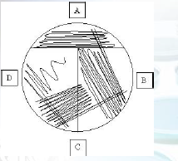
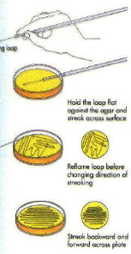
➢Culture media
✓why?
✓what?
✓who?
➢Inoculation methods
Methods of inoculation
- Streak plate method
- Spread plate method
- Pour plate method

✓streak, spread, or pour

Streaking a plate for isolated colonies
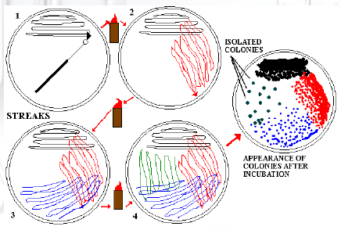
Pour plates
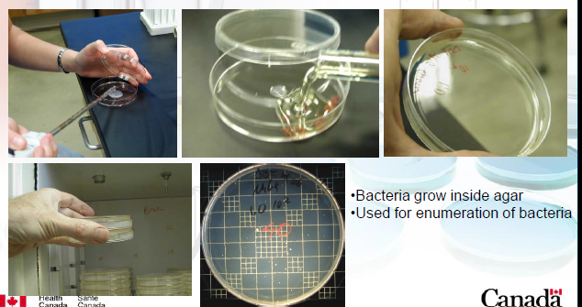
Spread plates
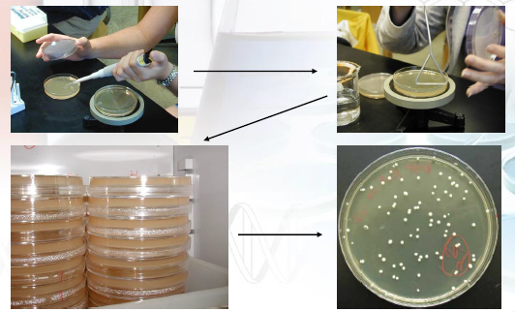
Preservation of Cultures
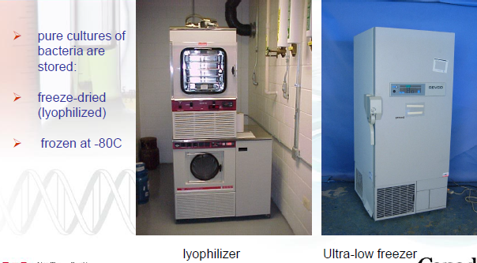
Preservation of pure cultures
➢Why would we want to keep a “copy” of a bacteria we isolated from a patient?
➢Short term versus long-term
Long Term Preservation
✓liquid nitrogen (-195oC)
✓Freezers (-70 to -120 degrees)
✓lyophilization (freeze-drying) dehydration followed by vacuum sealing
- Short term preservation- cultures are stored in medium refrigeration temperatures

Identification
➢Now that you have a pure culture…
✓colony morphology
✓cellular morphology
➢The microscope is your friend
✓resolving power (resolution) = ability to distinguish two closely located objects as separate, distinct entities
- Size of most microbial cells and viruses is in range of nanometer to micrometer

Colonial morphology
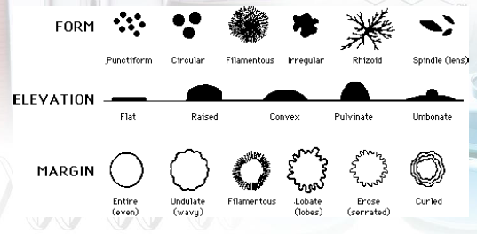
Examples of colonial morphologies
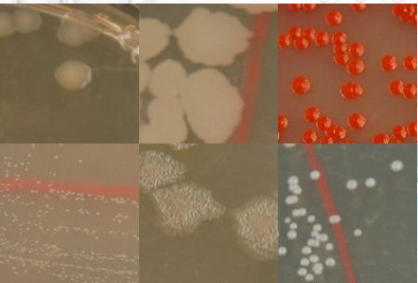
Identification -Staining Techniques -
➢Generally, three steps:
1.Make a smear (a thin film of specimen (smear) is placed onto a clean microscope slide and let air dry)
2.Fix dried smear by heat ( the dried smear is fixed by heat to make microorganisms stick to glass slide)
3.Stain with desired dye (stain with one or more dyes prior to viewing with microscope

Simple vs. Differential staining
➢Simple stain
✓single dye normally used; single general dye colors all microorganisms
✓all organisms same colour
✓ Allows the observation of size, shape, number, arrangement, etc.
➢Differential stain
✓two or more dyes
✓differences between microorganisms or parts of cells
✓acid fast, Gram ( characterize bacteria into two groups: gram positive and gram negative
- Most important staining procedure

The Gram Stain (Hans Christian Gram)
1. Flood slide with crystal (or gentian) violet. (Wash with running tap water).
2. Flood with Gram's iodine. (Wash with water).
3. Carefully decolorize with 95% ethanol. (Wash with water). This third step is the most critical and also the one most affected by technical variations in timing and reagents.
4. Flood with safranin (pink color). (Wash with water). Air dry, or blot with absorbent paper
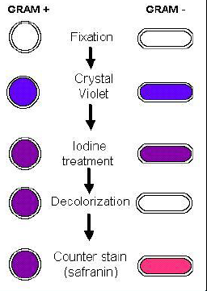

Cell wall is the key!
➢Essential for cell growth and division
➢Shape of bacteria related to peptidoglycan layer
➢Gram negative usually thinner than Gram positive
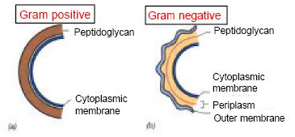

Gram Negative Cell Envelope
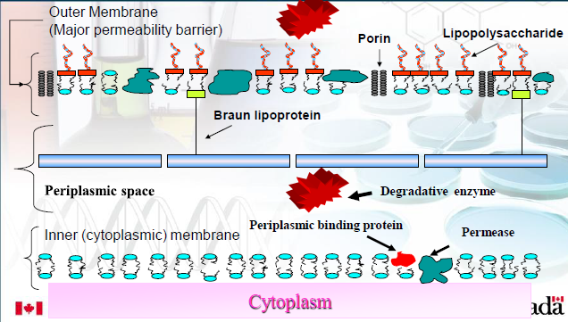

- Thick structure made up mainly of thick layer of peptidoglycan

Gram Positive Cell Envelope
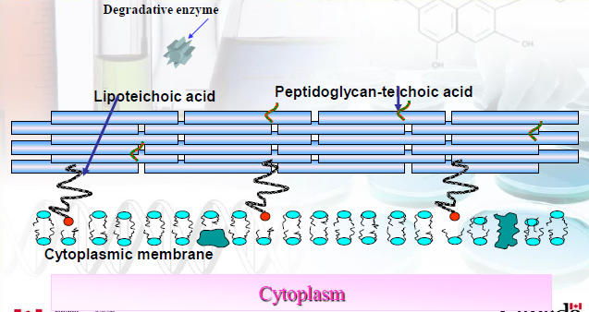

- More complex
- Has a outer membrane covering a thin layer of peptidoglycan
- Outer layer anchored to peptidoglycan by a lipoprotein
- Outer membrane is a selective barrier based on size and charge of molecules

Difference in staining is determined by different cell wall structures
- Endospore staining- malachite green applied with heat to penetrate spores followed by counter staining with safranin
- Capsule staining- treat with copper sulfate before staining to visualize capsule as a clear zone surrounding cells
- Flagella staining- use of mordant to thicken flagella before staining to visualize

Other Stains
Fluorescence microscopy
➢dye fluoresces at specific wavelength
➢antibodies tagged with dyes are common (immunofluorescence microscopy)
- Useful in revealing only objects of interest in an otherwise black background
- Immunofluorescence is a common and important aspect
- Ex. Antibody reacts (binds) to the foreign particles forming a complex, fluorescent dye is attached to a specific antibody and this complex is added to the specimen

Electron microscopy
➢Electron beam (instead of light)
➢Million times magnification possible (0.003 μm)
✓TEM (stain with heavy metals)
✓SEM (3-D image of cell surface)
- Short wavelength of the electron beam as compared to light allows for greater resolving power
- Transmission electron microscopy requires staining with heavy metals of whole specimen or slicing of microorganisms into thin sections
- Electron beam moving back and forth generates a 3-dimensional image of cell surface of microorganisms coated with a fine film of metal

So what’s the bottom line?
➢Morphology helps to classify and identify
✓Gram stain
➢Gives clues to how they behave in environment
✓capsules, endospores

Characteristics of bacteria
➢Small (0.75 –1.25 μm in diameter/width)
➢Higher surface area / volume ratio
✓higher metabolism
✓faster growth
✓replication rate (~20 minutes)

Shapes and sizes of bacteria
➢Bacteria are usually arranged in specific patterns:
✓single cells (spiral and/or rod shaped)
✓diplococci (pairs) –single plane
✓chain (divide in one plane and remain attached)
✓tetrads (cocci dividing at right angle to first plane of division)
✓division in three planes in an irregular pattern (grapelike clusters)
✓cubical packet of 8 cells; further division in third plane (sarcinae)

- Spherical cells (coccus) - usually round or ovoid
- Cylindrical or rod shape (bacillus)- vary in width and length, ends can be square, rounded, tapered or pointed
- Spiral or helical shape (spirillum)- corkscrew like shape

Shapes and sizes of bacteria
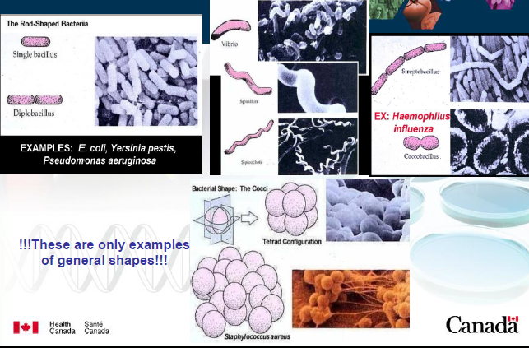

With what do we grow bacteria?
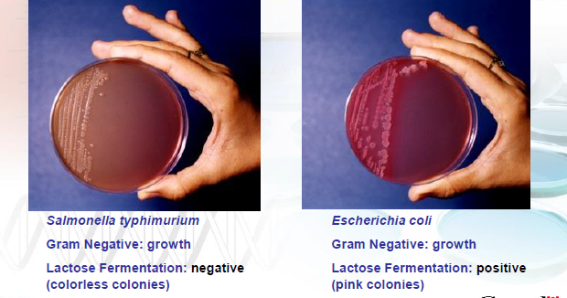

-Chemically defined –exact composition known
-Chemically undefined –some components can’t be controlled (beef extract, blood, etc.); natural products added to media
-If solid (versus liquid) growth –1.5% agar used
- Enrichment media –increase # of specific bacteria in sample by favouring growth of interested species
- Tissue culture media –for cultivating viruses, derived of plant or animal cells
- Media for growing bacteria- requirements varies between different bacteria
Microorganisms with demanding nutritional requirements- fastidious
- Require complex, undefined media for cultivation

General media requirements
➢Bacteria –requirements vary
➢Yeasts –high sugar and lower pH
➢Anaerobes ( those that tolerate little to no oxygen) –must remove oxygen

Selective, differential and S/D media
➢Selective media –enhance growth of one bacterial species or suppression of another
➢Differential media –differentiate bacteria based on their nutritional requirements and phenotypic characteristics
➢Selective / Differential media –very useful in clinical labs (e.g., MacConkey agar)
- Enrichment media- used to increase number of specific organism in a sample by favoring growth of the interested species
- Tissue culture media- plant or animal cells grown in lab in specialized media used to cultivate viruses in vitro

Temperature Requirements
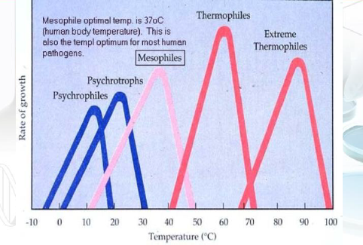

Temperature Definitions
- Microorganisms in general can grow over a wider temperature range
- Temperature at which a species grows most rapidly is the optimum growth temperature
- Cardianl temperatures
  - Minimum temperature
  - Optimum temperature ( usually closer to maximum temperature since enzyme activity increases with temperature until upper limit at which enzymes degrades)
  - Maximum temperature
- Changes depending on nutritional content of growth medium
Psychrophiles
✓grow best at temperatures 15-20oC
- Bacteria and fungi from this group are found in colder waters and soils such as oceans and polar regions
➢Mesophiles
✓grow best at temperatures 25-40oC
✓most bacteria belong here
- Paraiste organisms of humans and animals grow at the upper part of this range
➢Thermophiles
✓grow best at temperatures 40-85oC
- Volcanic areas, compost heaps and hot springs

Extreme Thermophiles
•Pyrolobus fumarii
•“fire lobe of the chimney”
•Lobed shape
•Discovered in the walls of a deep sea hydrothermal vent
•Grows between 30 and 113C
•106C is optimal

Oxygen Requirements
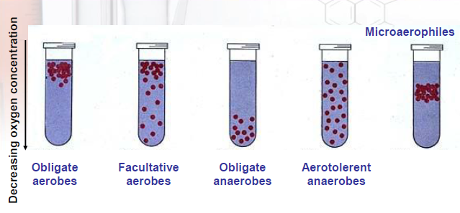

- Right combination of gases such as oxygen, carbon dioxide, nitrogen and methane resembling those found in natural environment
Aerobic Microorganisms
- Microbes which can grow in standard atmosphere 21% oxygen
- Requires more energy
Anaerobic microorganisms
- May be poisoned by oxygen, cannot grow in air atmosphere, do not use oxygen for energy-yielding chemical reactions
- Toxicity of oxygen due to production of superoxide radical, hydrogen peroxide and hydroxyl radicals
- Aerobes protect against these radicals by producing enzymes such as superoxide dismutase, catalase and peroxidase
Facultative Microorganisms
- Grow in air atmosphere but can also grow anaerobically
- Do not need oxygen but can use it for chemical reactions
Microaerophilic Microorganisms
- Can use oxygen for chemical reactions

pH and Water requirements
➢Optimal pH varies from bacteria to bacteria
➢Intracellular pH must be ~7.5
➢Growth observed at pH values of 4-9 (optimum 6-8)
- Molds and yeasts generally have a broader pH range for growth than bacteria
- Growing cells release acidic or alkaline waste products into the growth medium environment
➢Water (light) can be important for certain microorganisms
➢Osmotic pressure (hypertonic (cell loses water and eventually shrivels up), hypotonic (lower concentration of solutes in the environment leads to inflow of water resulting cell rupture), isotonic (no net flow of water occurs resulting in normal cell growth))
Gram Positive Cocci

Staphylococcus aureus- found as normal flora
- "Staphule" means grape in Greek
- Toxins are quite the problem
  - Cytotoxins- toxic to many cells
  - Haemolysins- lethal
  - Enterotoxon (A-E, G-I)- important causes of food poisoning
  - Exfoliative toxins (ETA, ETB)- " scalded skin" snydrome in infants
  - Toxic shock syndrome toxin 1 (used to be exotoxin C and entertotoxin F)

- Enzymes
  - Coagulase (coagulation of fibrin)
    - Made by almost all pathogenic staphylococci
    - Used in laboratory test to differentiate from S. epidermidis, S. capitis and S. saprophyticus
  - Beta- lactamase (penicillinase)
    - Destroys penicillin

- Many S. aureus strains found in normal population (~15%)
- Grows well on simple media
- Carried in anterior nares, axilla, perineum and hands
- Problem:
  - 85-90% of strains isolated in hospital are penicillin resistant
  - Localized purulent infections (pustules, boils, styes, conjunctivitis, otitis, etc.)
  - Pneumonia, osteomyelitis, septicaemia, endocarditis
  - Food poisoning, toxic shock syndrome, scalded skin syndrome
- Important cause of hospital acquired nosocomial infections from stitch abcesses, infected wounds, or generalized infections
- Preventative measures includes
  - Aseptic technique in ER and OR, wound precaution
  - Education of health personnel
  - Handwashing
- Epidemiology: strains are lysed by a number of different bacterial viruses. Cells originating from the same parental cells are lysed by the same bacteriophage

Staphylococcus epidermidis
- Part of normal skin/muscous membrane flora
- Non-pathogenic, excpet in compromised patients where can cause post-operative infections (brain, open heart, endocarditis, shunt infections)
- Considered an opportunistic pathogen

Steptococci
- Arranged in pairs or forming chains
- " streptos"- Greek word for twisted
- Subdivided into "groups" based on
  - Haemolytic properties (alpha, beta)
  - Carboydrate C antigen (Lancefield classification); extracted from the cell wall, subdivides streptococci in groups
  - M- protein
    - Divided beta- haemolytic
    - Mostly group A
    - Permits subdivision of beta-haemolytic streptococci in to over 70 serotypes
Streptococcus Pyogenes
- Group A, beta- hemolytic, S. pyogenes causes:
  - Acute tonsilitis (strept throat)- can lead to rheumatic heart disease
  - Impetigo, cellulitis, etc. (skin infections)
  - Fever and septicaemia
- Caused by toxins
  - Streptolysins (O and S); beta-haemolytic and highly toxic for neutrophils and macrophages
    - Neutriphils and macrophages
  - Streptococcal pyrogenic exotoxins (Spes)
    - Scarlet fever rash
- Enzymes
  - Hyaluronidase (helps spreading of bacteria)
- Virtually all are penicillin G sensitive (vs S aureus)
- Education of health personnel
- Aseptic obstetric procedures
- Early detection and treatment
- Splits hyaluronic acid in connective tissue and helps spreading
- Can be found in 5-10% of healthy individuals

Flesh-eating disease … aka Necrotizing fasciitis
- Streptococcus pyogenes culprit
- Does not actually eat anything
- Toxin is responsible for damage
- Research indicated that
  - Hijacking human plasminogen from blood, attach to surface and activate it into protease… good for spreading
  - Bacteriophage has gene encoding for enzyme allowing bacteria to escape entrapment and killing by neutrophils (white blood cells)
Streptococcus agalactiae
- Group B
- Found in vagina of health women (can cause neonatal infections)
  - Early septicaemia
    - Respiratory distress or shock at birth
    - High fatality rate (serious)
  - Delayed meningitic form
    - 1-12 weeks post- partum
    - Sequelae
    - Neurologic/mental abnormalities may result

Other Streptococci

Streptococcus faecalis
- Group D aka Enterococcus
- Part of normal flora of GI- tract
- Prey on compromised individuals

Viridens Streptococci
- Found in oral cavity of healthy individuals
- Can cause endocarditis in individuals with damaged heart valves

Streptococcus pneumoniae
- Diplococci (pairs)
- Also known as pneumococcus
- Polsaccharide capsule has antiphagocytic properties
  - ~90 distinct capsular serotypes
- Found in naso-pharynx of healthy individuals
- Can cause
  - Lobar pneumonia
  - Meningitis
- Prevention strategies (elderly, alcoholics, crowded living, vaccination)
  - Programs for the elderly and alcoholics
  - Avoidance of crowded living quarters
  - Vaccination of those at highest risk with a polyvalent pneumococcal vaccine containing 23 capsular polysaccharide serotypes
- Lobar pneumonia: often an auto-infection, though it may spread as a "carrier epidemic"
- Meningitis: more often in infants and in the elderly

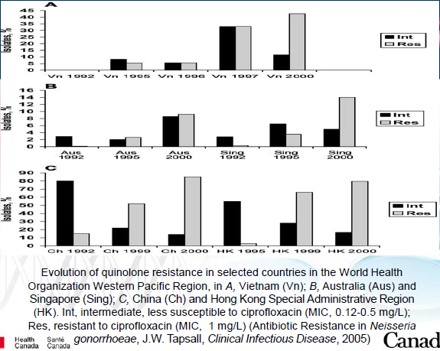

Gram Negative Cocci

Neisseria Meningitidis (Meningococcus)
- Gram negative diplococci
- Labratory isolation using chocolate agar, 5-10% CO2, 37C
  - Use selective media (ie. Thayer- Martin) when isolating from nasopharynx
- Frequently found in the naso-pharynx of healthy individuals; carrier state may last from a few days to several months
- Grows best on enriched media
- Antiphagocytic polysaccharide capsule are anti-phagocytic
  - 13 different serogroups divided based on their polysaccharide capsule
  - A,B, C,X,Y and W135 most prevelant
- Carriers can occasionally develop infection or pass organism to non- immune individuals who develop infection
- Only infects humans
  - Usually children or those living in crowded living quarters(miltary recruits)
  - Occasional epidemics
- Infection can result in
  - Meningitis; high fatality rate if not treated promtly
  - Septicaemia (starts as skin rash); high fever
  - Waterhouse- Friderichsen Syndrome (complicationf o septicaemia… most severe form of septicaemia by N. meningitidis); bilateral adrenal cortical haemorrahage with fulminating collapse/death in less than 24 hours; complication of meningococcal septiceaemea
    - First described in 1894 by Arthur Francis Voelcker
    - Then in 1901 by the British dermatologist Ernest Gordon Graham Little
    - It was first reported as an entity by Waterhouse in 1911, and the subject was comprehensively reviewed in 1918 by the Danish paediatrician Carl Friderichsen
    - So it was called Waterhouse- Frriderichsen syndrome
Prevention and Treatment
- Penicillin is primary antibiotic used
- Vaccination is recommended for children (11-12 years), teenagers and college/ university students living in dormitories
  - Conjugated vaccine for serogroups A, C, Y and W135
  - Now have meningococcus vaccine for infants at 2-5 months (serogroup C)

Neisseria gonorrhoeae
- Gram negative diplococci, 0.6-1 um in diameter; grows well only on special media
- In a clinical lab, grow on Thayer- Martin plates, in damp environment with CO2
  - Very sensitive to drying and changes in temperature
- Causative agent of STD gonorrhea
- In US, it is the second highest reported STD, after chlamydia
  - >350,000 cases/ year reported in the US (2001)
  - Number of cases is now decreasing every year

- Clinical gonorrhea
  - MEN: causes acute infection of urethra (90-95%); may cause epididymitis, prostatitis
  - WOMEN: 50% are asymptomatic
    - Cervicitis
    - If untreated can cause PID( pelvic inflammatory disease), sterility
  - Disseminated Gonococcal Infection (DGI)
    - Gonococcal bacteraemia
    - 1-3% cases, usually women
    - low grade Fever, skin infection, arthritis
  - Neonatal infections
    - Rare, but newborns can acquire infection from mother during birth
    - Causes gonococcal ophthalmia neonatorum (acute purulent conjunctivitis)

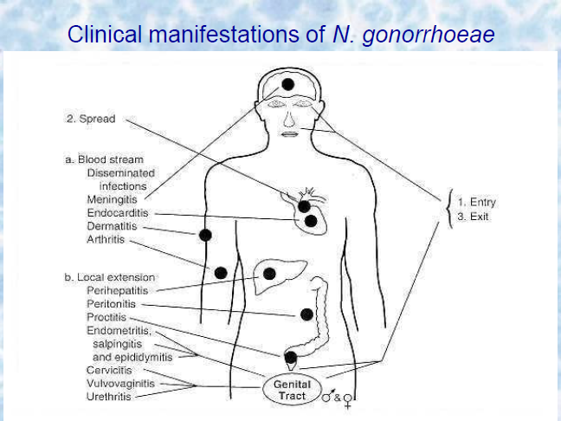

- Diagnosis
  - MEN: use microscopy to directly observe swabs of urethral discharge
    - Smears of urethral discharge in men
    - Gram- negative diplococci are for all practical purposes diagnostic
  - WOMEN: culture is necessary from endocervical, urethral and anal swabs; isolation from vaginal swabs is significantly lower
- Epidemiology
  - Most infections are acute (men) while in women 50% or more are asymptomatic
  - Steady increase in resistance to penicillin
  - Strains highly resistant to penicillin have been selected through abusive use of penicillin
- Prevention and Treatment
  - Penicillin resisitance is emerging (south- East Asia, West Africa, Canada and US)
  - Treat using ceftriaxone, cefixime, ciprofloxacin or ofloxacin combined with doxyxyxline/azithromycin
  - Resistance to ciproflaoxacin (quinolones) emerging
  - Simultaneous treatment of partners is essential
  - No vaccine available

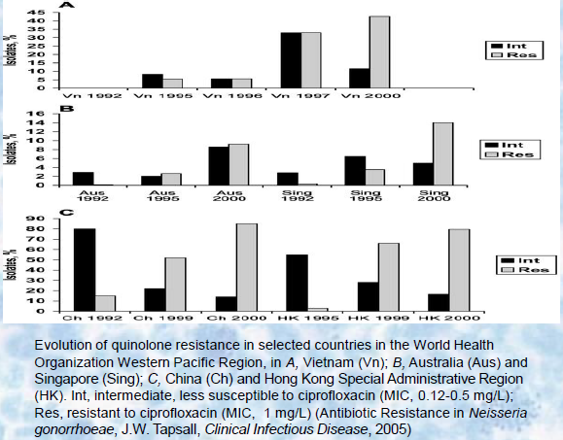

Gram Positive Bacilli

Spore Forming Rods
- Bacillus and Clostridium
- Release of potent exotoxins causes disease

Bacillus anthracis
- Causative agent of anthrax
- UNIQUE protein capsule, antiphagocytic
- Aerobic growth conditions
- Spores are very stable, resistant to heat, drying, UV and disinfectants; spores germinate and toxins are made
- Humans exposed to spores usually through contact with animals or soil
- Used in bio-terrorism and warfare

Bacillus anthracis exotoxin
- Encoded on pXO1 plasmid
  - Plasmid contains virulence factors which are transcribed optimally @37 degrees celsius, increased CO2 and serum proteins
  - Where are these conditions found?
- Exotoxin composed of 3 separate proteins:
  - Edema factor (EF)
  - Protective antigen (PA)
  - Lethal factor (LF)
  - Separately proteins are not toxic, but combined are lethal
- pXO2 plasmid encodes capsule genes
- BOTH plasmids required for virulence

Prevention and Treatment
- RAPID treatment is essential
- Antibiotics: penicillin, doxycyclin, ciprofloxacin or levofloxacin
- Vaccines against PA protein is available

Bacillus cereus
- Causes food poisoning when spores enter food product
- Motile, non-encapsulated, resistant to penicillin
- ENTEROTOXIN is responsible for illness
- 2 types of enterotoxin
  - Heat labile: nausea, abdominal pain, diarrhea. Lasts 12-24 hours
  - Heat stable: SEVERE nausea and vomiting, short incubation
- Antibiotic treatment useless… performed toxins

Clostridium
- anaerobic→differentiates this bacteria from other spore-forming bacilli
- Botulism, tetanus, gas gangrene and pseudomembranous colitis
- POWERFUL EXOTOXINS→RAPID DIAGNOSIS

Clostridium botulinum
- Rapidly fatal food poisoning from lethal neurotoxin
- Neurotoxin blocks Ach release in autonomic system; flaccid muscle paralysis:
  - Afebrile, bilateral cranial nerve palsies, double vision, trouble swallowing, muscle weakness
  - Respiratory paralysis→DEATH
  - Treatment: antitioxin and respiratory assistance
- Smoked fish, improperly canned vegetables
  - Proper cooking destroys spores

Action of Botulinum Neurotoxin
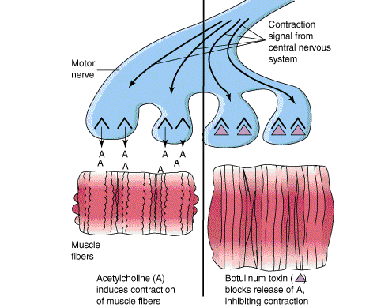

Infant Botulism
- Honey contamination with spores
  - Spores germinate and bacteria colonizes intestine
  - Neurotoxin release→2-3 days constipation→ trouble swallowing, muscle weakness

Clinical Manifestations of Clostridium botulinum
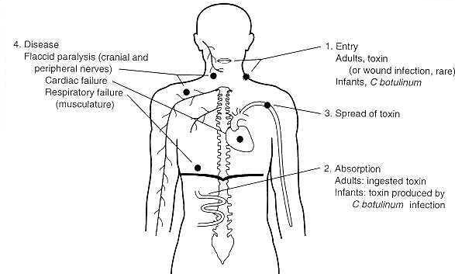
Clostridium tetani
- Tetanus
- Rusty nail contaminated with spores punctures skin; wound provides anaerobic environment
- Exotoxin: tetanospasmin
  - Sustained contraction of skeletal muscles
  - Severe muscles spasms (lock jaw); high mortality at this stage
- Booster (inactivated toxoid) given every 10 years

Clinical manifestations of Clostridium tetani
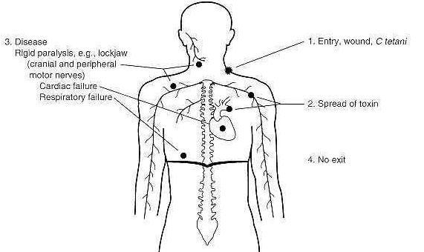
Clostridium perfringens
- Gas gangrene
- Seen in soldiers wounded in battle
- 2 classes of infection:
  - Wound infection/ cellulitis
    - Necrotic skin exposed to bacteria, damage to local tissues; skin feels moist, spongy, with ' crackly' pockets
  - Clostridial myonecrosis
    - Bacteria inoculated from trauma into muscles; exotoxin secretion destroys adjacent muscles; as muscles degrade get black fluid excreted from skin
    - FATAL unless treated with oxygen, antibiotics (penicillin) and removal of damaged tissue

Cllstridium difficile
- Causes antibiotic-associated pseudomembranous colitis
- Seen more commonly in hospitals than tetanus, anthrax or botulism
- Overuse of broad- spectrum antibiotics destroys normal intestinal flora
- Infects colon and releases exotoxins
  - Toxin A: diarrea
  - Toxin B: cytotoxic to colon cells
- Symptoms: severe diarrhea, abdominal cramping, fever
- Possible cause of diarrhea in patients on antibiotics
- Treatment
  - Discontinue antibiotic treatment
  - Administer metronidazole or vancomycin
    - What is different about these antibiotics?
Clinical manifestations of Clostridium difficile
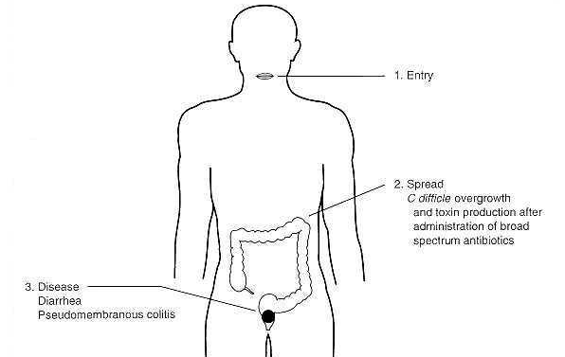

Non- Spore forming Rods
- 2 medically important bacilli
  - Listeria monocytogenes and Corynebacterium diptheriae

Listeria monocytogenes
- Causative agent of listeriosis; immunocompromised are at high risk
- Found in foods such as soft cheeses, unpasteurized milk, cold cuts, pate
- PSYCHROPHILE- survives in refrigerator
- Variety of symptoms:
  - General malaise, diarrhea, meningitis, septicaemia, still-birth/ abortions
- Faculative intracellular aerobe
- Crosses 3 protective barriers (blood-brain, GI and feto-placental)
- Treatment: ampicillin or trimethorprim- sulfamethoxazole
Clinical manifestations of Listeria monocytogenes
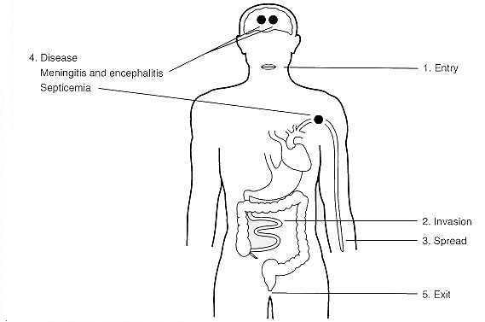

Corynebacterium diptheriae
- Causative agent of diptheria
  - Colonization of pharynx and release of exotoxins into bloodstream
- Exotoxin damages heart and neural cells
- Treatment (3 steps):
  - Antitoxin
  - Penicillin or eythromycin
  - DPT vaccine
- Can by lysogenized by a bacteriophage (virus that infects bacteria)
Clinical manifestations of C. diptheriae
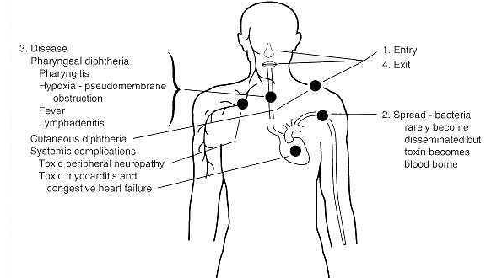

Gram Negative Bacilli- The Enterics

Enterics
- found as part of normal intestinal flora BUT can also cause disease
- 4 major Groups: Enterobacteriaceae (Salmonellae, Shingellae, E. coli), Vibrionaceae( Vibrio, Campylobacter) Pseudomonadaceae (Pseudomonas), Bacterioidaceae
- Organisms are divided into groups based on biochemical and antigenic properties

Biochemical Classifications
- Ability to ferment lactose
  - EMB Media:
    - Lactose fermenters are dark purple/black
    - Inhibits Gram positive bacteria
  - MacConkey Media:
    - Lactose fermenters are pink-purple
    - Inhibits Gram positive bacteria
- What type of media are these? Selective/ differential
- H2S production
- Hydrolysis of urea
- Liquefy gelatin
- Decarboxylation of amino acids

Classifications using surface antigens
- Variable O-antigen: outermost layer of LPS
  - Changes between enterics
- K-antigen: covers the O-antigen
- H-antigen: flagellar sub-unit
  - Only in motile bacteria

Diseases caused by Enterics
- Cause diarrhoea with various complications and other infections
- Diarrhea- with/without systematic invasion
  - Bacteria bind intestinal cells but do not enter
  - EXOTOXIN release causes diarrhoea; ENTEROTOXIN causes fluid/ electrolyte loss
  - Watery diarrhoea, NO FEVER
  - Vibrio cholera
- Diarrhea with intestinal cell invasion
  - Bacterial virulence factors allow binding and invasion of cells
  - Toxin release destroys cells leads to bloody stools
  - Fever response
  - Shigella
- Diarrhea with invasion of lymph nodes and bloodstream
  - Abdominal pain with diarrhoea containing red and white cells
  - Fever, headache, increased white cell counts
  - Salmonella Typhi, Yersinia enterocolitica, Campylobacter jejeuni

Other Enteric Infections
- Urinary tract infections, pneumonia, bacteremia and sepsis
- Nosocomial infections by: E. coli, Klebsiella pneumoniae, Proteus mirabilis, Enterobacter, Serratia, Pseudomonas aeruginosa
- Pseudomonas aeruginosa: opportunistic pathogen, often infects burn patients and can disseminate through body into CNS

Salmonellae
- Member of Enterobacteriaceae family
- Unable to ferment lactose
- All have animal reservoirs EXCEPT S. enterica serovar Typhi ( humans are only host)
- Types of infections in humans: enterocolitis, enteric fever, opportunistic infections, septicemia and osteomyelitis

- Two species: S. enterica and S. bongori
- Enterocolitis (tummy troubles):
  - S.enterica serovar Enteritidis
  - S. enterica serovar Typhimurium

- Enteric fever:
  - S. enterica serovar Typhi
  - S. enterica serovar Paratyphi

S.enterica serovar Enteritidis→ Enterocolitis
- Pathogenesis depends on:
  - Dose of ingested organism (min 10^5)
  - Immune status of host
  - Virulence of strain
- Incubation time: 6-48hrs; multiplication in small intestine
- Ingestion of contaminated food
- Poultry, eggs, meat and milk
- Person to person spread
- Most cases occur at home
- Under-reported and undiagnosed
- Antibiotics NOT RECOMMENDED- WHY?

Enterocolitis
- Symptoms
  - Nausea, vomiting, profuse diarrhoea, abdominal pain
  - Fever, chills, headache, myalgia
  - 2-3 days recovery
  - Septicaemia- rare
- Use stool culture for lab diagnosis

Enteric Fever
- S. enterica serovar Typhy - typhoid fever
- S. enterica serotypes Paratyphi A, Schottmuelleri, Hirschfeldii- paraytphoid fever (milder)
- Enteric fever: generalize infection; bacterial multiplication in lymphoid tissue
- Necrosis of intestinal lymphoid tissue- ulceration, haemorrhage, perforation
- untreatedL 10% mortality
- Convalescent carriers: excrete bacteria for 3 months
- Chronic carriers (1-2%): excrete bacteria for at least 6 months, sometimes life long
- Diagnosis: isolation of bacteria from blood (1st week) stool and urine (2-3 week)
- Infective does is 10^6 organisms
- Sources are contaminated drinking water, shellfish, milk and milk products
- Clean handling of food, water treatment and safe sewage disposal are essential
- Vaccine available, but only effective against small bacterial load

Escherichia coli
- Most numerous aerobic bacteria of normal gut flora
- Lactose fermenting
- Pathogenic to other parts of the body
  - Responsible for 85% of bacteriuria

- coli→ Gastroenteritis
- Enterotoxigenic E. coli
  - Infant diarrhoea (developing countries)
  - Traveller's diarrhoea
  - Enterotoxins
- Enteroinvasive E. coli
  - Symptoms similar to shingellosis
- Enteropathogenic E. coli
  - Older name for some serotypes causing infant diarrhoea
- E. coli O157:H7
  - Haemorrhagic colitiss
  - Hamburger disease
  - Proper handling of food, safe preparation and proper cooking practices are essential to prevent illness
- E. coli is also implicated in neonatal meningitis and nosocomial urinary and wound infections

Shigellae
- Cause acute diarrhoea with musuc, pus and blood
- Generally non-lactose fermentors
- Dose of 10^5 infects 25% of people, 10^9 infects 95%
- Shigella sonnei- Europe and North America
- S. dysenteriae:
  - Tropics
  - SEVERE illness: watery diarrhoea, cramps, fever
  - Infections from SMALL numbers of organism
- Most commonly seen in children; poor sanitiation and crowding
- Prevention by safe handling of food, treatment of water, safe disposal of sewage
- NO VACCINE

Vibrio cholerae
- Causes cholera: acute gastrointestinal illness
- Profuse watery diarrhoea, cramps and vomiting
- Enterotoxin binds cells in small intestine
  - Cells secrete chloirdes; decrease in Na+ absorption
  - Water accumulates in gut leads to watery diarrohea
  - Can lead to SEVERE dehydration and death if untreated
- Endemic in South East Asia and parts of Africa
  - Lack of clean drinking water
- Mainly water-borne
- Massive (10-15 liters per day) loss

Campylobacter
- C. jejuni and C. coli
- Major cause of human enteritis
- Normal flora in birds and domestic animals
- Some strains invasive, others toxigenic
- Symptoms: fever, abdominal pain, bloody diarrhoea
- Maybe one cause of traveler's diarrhoea

Pseudomonas
- Opportunistic pathogen
- Found in many moist habitats and water
- Source of infection can be humidifiers etc.
- Treatement is diffcult because all Pseudomonas sp. are resistant to many antibiotics

Pseudomonas aeruginosa
- Respiratory pathogen in cystic fibrosis patients
- Infections in lesions of burn patients

Pseudomonas cepacia
- Common contaminant of saline solutions and water
- Able to multiply in low nutrient environment
- Respiratory pathogen of cystic fibrosis patients

Haemophilus influenzae
- Part of normal nasopharyngeal flora in many adults and children
- Causes invasive infections of young children
  - Meningitis, pneumonia, joing infections
  - Development of vaccine, now used routinely, decreased the number of cases in Canada
- Can cause increased bronchial inflammation in patients already having chronic bronchitis

Enterobacter spp.
- Can cause nosocomial infections
- Wound infections, pneumonia, bacteremia
- E. sakazakii linked to infant illness from powdered infant formula
- Now called Cronobacter

Helicobacter pylori
- Microaerophillic, spiral bacilli
- Most common cause of stomach ulcers
  - In the past, cause was thought to be stress and diet
  - 1982- Dr. Robin Warren and Dr. Barry Marshall discovered linke between H. pylori and ulcers
  - Medical community slow to accept their theory (1994- National Institute of Health Conference concludes strong association between ulcers and H. pylori)
  - Urease: protection from low pH
  - Triple therapy treatment: antibiotics and h+ pump inhibitors

Bordetella pertussis
- Whooping cough ( violent cough)
- 4 virulence factors
  - Pertussis toxin (A-B)
  - Extra cytoplasmic adenylate cyclase (weakens host defense)
  - Filamentous hemagglutinin (bronchial attachment and exotoxoin release)
  - Tracheal cytotoxin (destroys ciliated cells→ poor clearance of mucous and bacteria)
- Prevention: vaccination with heat-killed organism

Legionella pneumophila
- Causes Legionnaires disease
- Opportunisitc pathogen
- May cause severe pneumonia
- Grows in water and is found in shower heads, water tanks, air cooling/ heating tanks
- Exposure is by aerosol and there is NO person to person transmission
Mycobacteria
Causative agents of tuberculosis and leprosy
•Waxy coat NO Gram stain
- Resistant to disinfectants
•Acid-fast bacilli- Resist decolorisation
•Use Ziehl-Neelsen staining technique

1.Ziehl-Neelsen carbol fuchsin to the slide for five minutes while applying heat.
2.Follow with a gentle wash with water to cool the slide.
3.Acid alcohol is now added to decolorize the slide.
4.Wash the slide in water again and counterstain with methylene blue for 1-2 minutes.

Mycobacterium tuberculosis
- Chronic slow-progressing pulmonary infection; transmission by aerosol droplets
•Obligate aerobe, facultative intracellular parasite
•4-6 WEEKSto see colonies on a plate
•Lowenstein-Jensen medium
•Use microscopy of sputum smears as first line of diagnosis
•Leading cause of death world-wide form a single infection (Bacteriology, Kenneth Todar, 2005)
•Affects 1.7billion/year
•Declining in US
•Infection develops in stages

Today…June 23, 2008…
➢Someone in the world is newly infected with TB bacilli every second.
➢Overall, one-third of the world's population is currently infected with the TB bacillus.
➢5-10% of people who are infected with TB bacilli (but who are not infected with HIV) become sick or infectious at some time during their life. People with HIV and TB infection are much more likely to develop TB.

Primary Tuberculosis
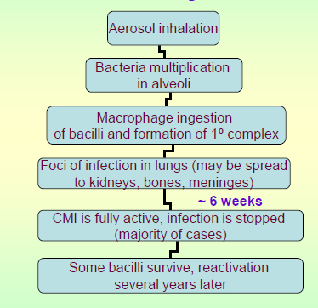
Mycobacterium tuberculosis
•Post-primary tuberculosis
•Late reactivation of lesions in lungs, kidneys, bones etc
•5% of cases; higher in patients with AIDS
•Chronic infection
Immunity in Tuberculosis
•Cell mediated immunity is most important (T-cells)
•Mantoux test
•Tuberculin solution is injected INTRADERMALLY, wait 48-72 hrs, check for redness
•Record diameter of redness
•>10mm POSITIVE
•5-9 mm Doubtful, maybe cross reaction with other Mycobacteria
•<4mm NEGATIVE
•**A positive test does not necessarily mean there is currently an active infection**

Atypical Mycobacteria
•Occasionally isolated from patients with chronic
•pulmonary disease indistinguishable from TB
•M. kansassi, M. avium, M. intracellulare
•Higher resistance to anti-TB drugs
•Give “doubtful” Mantoux test (5-9 mm)
•M. marinum: skin infections
•M. fortuitum: soft tissue abscesses
•All these infections are most typically seen in the immune-compromised

Mycobacterium leprae
•Causes leprosy
•2 kinds
•Tuberculoid leprosy: visible nerve enlargement, few erythmatous plaques, few bacilli in infected tissues, but many lymphocytes and granulomas; low infectivity
•Lepromatous leprosy: no visible nerve enlargement, many erythromatous nodules, many bacilli in infected tissue; high infectivity
•Rarely found in developed countries

Spirochetes
Treponema pallidum
•Syphilis
•Gram negative, helical bacteria
•Unculturable in vivo
•Use dark field microscopy; almost invisible under Gram stain, Geimsa stain and Ziehl-Neelsen

Syphilis
Primary syphilis
•Appearance of chancre 3-4 weeks after infection
•Fluid from lesion contains bacteria seen under dark-field microscopy
•Secondary syphilis
•6 weeks after appearance of chancre
•Generalized or local rash
•Mucosal lesions with many treponemes
•Spontaneous remission may occur after 1or 2phase
•Latent syphilis
•No symptoms of infection
•Non-transmittable after 4 years
•BUT congenital infection may occur
•Late syphilis
•Obliterative endarteritis
•Can involve skin, mucosae, nervous system, cardiovascular system and tissues

Serology Testing
•Non-treponemal tests(VDRL, RPR, Wassermann)
•Non-specific: use cardiolipin as antigen
•Screening
•Positive in early stages
•Treponemal tests
•Specific: Use treponemal extracts
•FTA-ABS: Flourescent Treponemal Antibody Absorption
•MHA-TP: Microhemagglutination of T.pallidum
Used to confirm positive VDRL

Borrelia burgdorferi
•Lyme disease
•Tick bites
•Affects skin, joints, nervous system and heart
•Common in US, rare in Canada
•Use serology for diagnosis (ELISA)
•organism is very difficult to see under microscope
•difficult to culture
•Serology does not give +ve result in first 2-4 weeks of infection

Lyme Disease
•Treatment
•Doxycycline, amoxicillin, cefuroxime for early disease
•For neurological and musculoskeletal manifestations, undergo prolonged treatment
•Prevention
•Avoid ticks and wear protective clothing in woods (long sleeves and pants)
•Vaccine available: ospA antigen of organism

Chlamydiae
•Obligate intracellular energy parasites; cocci
•Can NOT make their own ATP or other energy intermediates
•Can NOT be grown on artificial media
•Life cycle has 2 forms:
•Elementary body (300-400 nm)
–Infectious form
–No growth or replication
•Reticulate body (800-1000 nm)
–Replication and growth
Chlamydia trachomatis
•STD chlamydia
•Most common STD in Canada and US
•Males: urethritis
Females: cervicitis
•Many patients are asymptomatic and untreated
Limited diagnostic tools
Untreated male: prostatitis,epididymitis
Untreated female: PID, tubal infertility, ectopic pregnancy, chronic pelvic pain
•2 biovars:Trachoma and LGV
•Trachoma:15 serovars; LGV: 4 serovars
•Other infections
•Trachoma: chronic ocular infection; leading cause of blindness in Middle East, North Africa and South East Asia
•Conjunctivitis in newborns perinatal transmission
•Lymphogranuloma venereum: STD from some serotypes of C. trachomatis; endemic in tropical and subtropical countries

Other Chlamydiae
•CHLAMYDIA PNEUMONIAE
•Respiratory tract infections, mild pneumonia
•Usually sub-clinical infections
•CHLAMYDIA PSITTACI
•Bird pathogen
•Can transmit to humans
•Pneumonia or endocarditis

Mycoplasmas
•Smallest free-livingbacterium (100-300 nm)
•Saprophytes, part of normal flora of oropharynx and genital tract of humans and animals
•Lack true cell wall
•Some species are pathogenic
•MYCOPLASMA PNEUMONIAE
•PRIMARY cause of atypical pneumonia
•More common in younger individuals (15-35 years)
•RARELY complications lead to meningoencephalitis, myocarditis
•Diagnosis is usually clinical, no lab confirmation
•Treatment: erythromycin or tetracycline
•GENITAL MYCOPLASMA (MYCOPLASMA HOMINIS, UREAPLASMA UREALYTICUM)
•Part of normal genital flora
•Rate of colonization increases with number of sexual partners
•May cause urethritis, epididymitis, pelvic inflammatory disease and postpartum fever
•?? Infertility and premature birth ??

Levels (depth) of infection by fungal pathogens
Superficial | skin
Cutaneous
Subcutaneous
systemic | bloodstream



