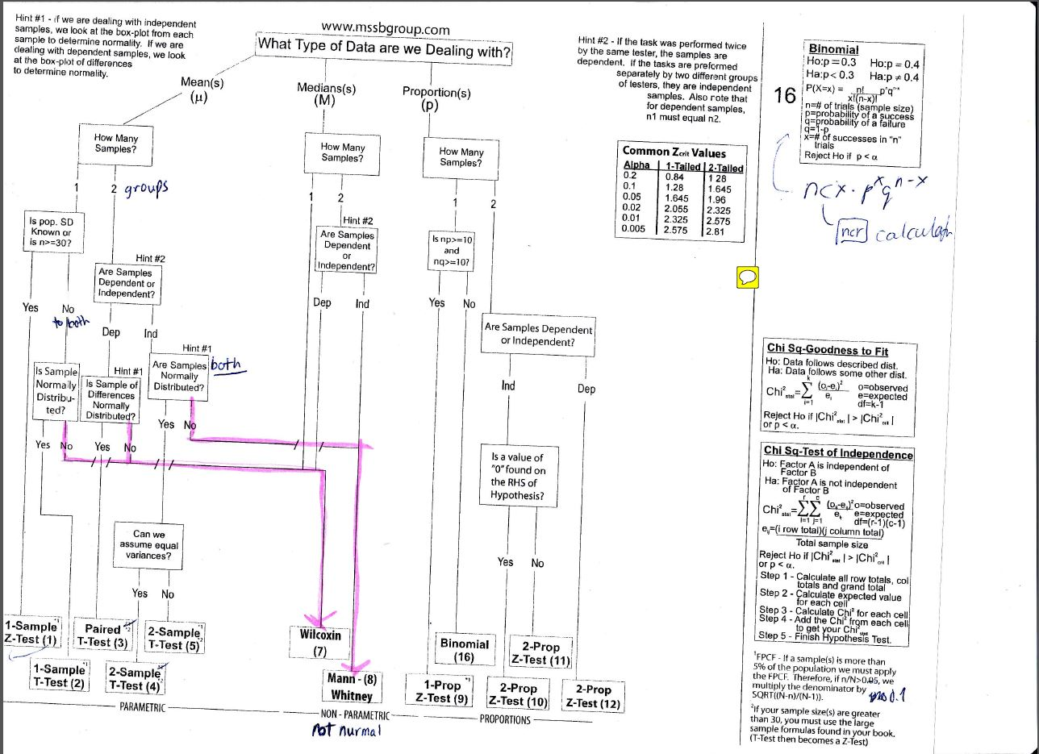
Note about hint #2: Second, some of you have Mike Sinclair's cheat sheet. Hint #2 is actually wrong. It is not relevant that the tester is the same in both cases in order to justify dependence. It is the one being tested that needs to be the same or be linked through shared characteristics.


