Ch6.
Sensation

Representations of external world determined by sensation and perceptions
Sensation process by which sensory receptors and nervous sys. Receive and represent stimuli from env.
Perception process of selecting, organizing, + interpreting our sensations, enabling us to recog. Meaningful objects and events

2 ways we process sensory info- bottom up, and top-down
- Bottom up- from sense rec. to brain= “A” sensed at black blotch, decomposed by brain and perceived by “A” by brain
- Top-down- using higher level mental proc. Construct perceptions drawing on expectations + exp. (predictive abilities used)
  - Picture of fruit man, top down, b/c recognize food and face shape
Psychophysics- study of relationship btw physical characteristic of stimuli (their intensity) and our psychological exp. Of them (physical world= psychological world, light= brightness, sound=volume)

- Absolute threshold- minimum stim. Needed to detect a particular stim 50% of the time
- Signal detection- predicts how and when we detect the presence of a faint stim (signal) amid background stimuli (noise) (cell phone in mall)
  - Assumes there is no single abs threshols and detections depends on- person’s experience, expectations, motivations, level of fatigue
- Subliminal stimuli-when stim. Below abs threshold for conscious awareness
- Priming- an invisible image/word can prime your response to later questions (prime you to like a person, even if you haven’t met b4); also, most info processing occurs automatically, outside of our conscious awareness

- We can be influences by subliminal messages, but its complicated
- Like- if we are not really noticing, then they effect us
- Do subliminal messages make us do things we don’t want? No
  - Self-esteem tapes given to students, and control= no tapes, there was no diff btw groups
- Difference threshold= min. diff btw 2 stimuli req. for detection 50% of the time also called JUST NOTICEABLE DIFF (JND) – AKA. When they notice and don’t notice light, the diff in those units
- Weber’s law- to be perceived as diff, two stimuli must differ by a constant min. %age rather constant amount
  - So like a 10cent increase in coffee, you will notice, but not a 10c diff in a 3000$ vacation. UNLESS if it was 10% increase, you’ll notice it in both
- Sensory adaptation- diminishes sensitivity as a consequence of constant stimulation- neuron stops firing- example, glasses first feel them after a while you don’t

Vision
- Light E converter to sensory stimuli to be processed by brain
- Our eyes transduce light E to neural messages, that brain processes
- Transduction- transformation of stim. E into neural impulses
- Light E= what we see as visible light is only a slice of light spec 400-700
Light E- range of electromag. Radiation that can be detected by eye
Light E= forms in waves (wavelength and amplitude
Wavelength- peak to peak distance of one wave
- Short= high freq (high pitched sounds- bluish color)
- Long= low freq (low sounds, reds)
Amplitude- height peak to trough
- Large= bright colours, small= dull colours
2 physical characters of light help us sense
- Hue- dimension of color determines by wavelength (400nm-short, violet, 700nm-long red)
- Intensity- amount of E in a wave- brightness- determines by amp. As instensity increases, colours look darker, decreases= washed out
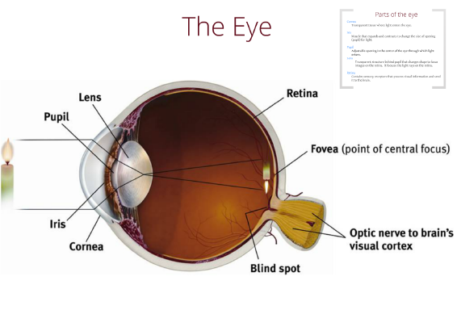
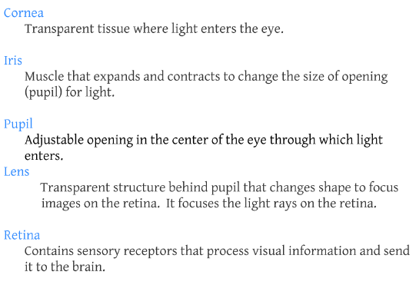

Eye focuses using accomadation- lens changes shape to focus on near or far objects on retina
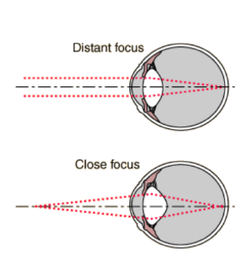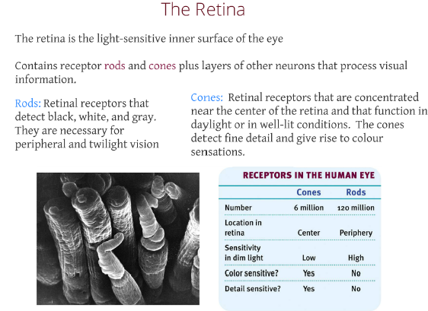
Fovea-central point in retina, around which clones cluster
Optic nerve- carries neural impulses from eye to brain
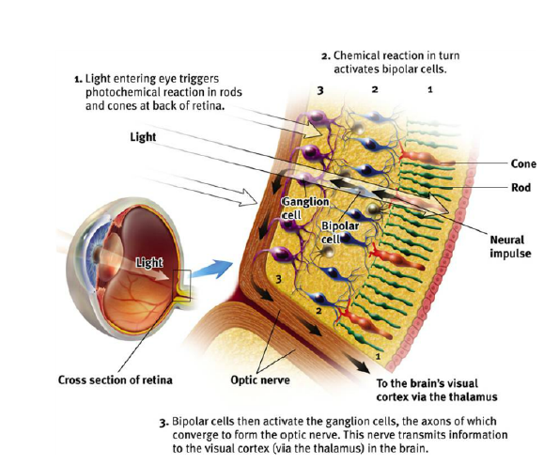

Bipolar+gang. Cells= bipolar receive messages from photoreceptors and transmit them to gang cells, which converge to form optic nerve
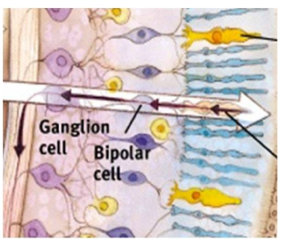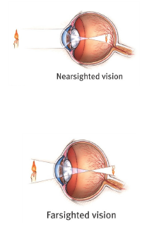
Nearsighted- near objects seen better than far
Farsighted- vice versa
Blindspot- where optic nerve leaves the eye, no rec. cells therefore blind spot

Visual info processing
- Optic nerves connect thal. In the middle of brain to the thal. To the vis. Cortex
- 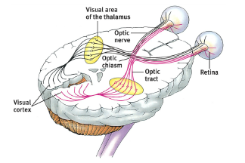

How does the brain process visual info?- feature detections and parallel processing
Feature detection
- Nerve cells in brain respond to specific features (edges, angle mvt)
Parallel processing- analysis of several aspects of stim simultaneously- brain divides visual scene into subdivisions- color, depth, mvt etc…
NOTE: neural networks determine (or help determine) what we are actually looking at
Blindsight= damage to visual cortex
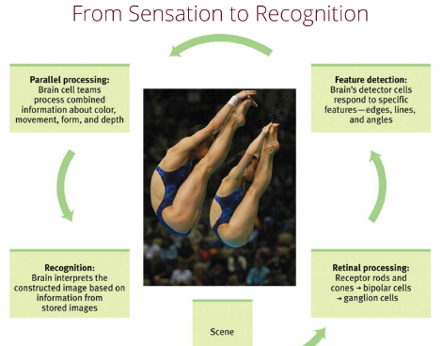

Colour vision
2 theories- young-helmholtz trichromatic and opponent process theory
- young-helmholtz trichromatic- retina receptors sensitive to 3 colors RGB- other colors just a comb. Of three
- red-green blindness supports this theory
Opponent process theory
- opposing retinal processes enable color vision (yellow-blue, red-green, white-balck)
- eg. when looking at green, green stimulated neurons and inhbit red

Hearing
- audition- transduction (conversion) of soundwaves into neural message that are interpreted as sound
- sound waves- compression and expansion of air molec.- our ear then detects these briefe changes in air P
- same wavelength and amplitude as vision
- wavelength- # of complete wavelenths that pass a point in a given period of time (/sec ex)
- pitch- tones high or low (long waves= low pitch) dependant on frequency
- loudness= amt of E in wave= determined by amp
- decibels measure loudness(amp) of sound- prolonged above 85 can cause hearing loss

The ear
- outer ear- what we see- focuses soundwaves to eardrum- eardrum is a tight membrane that vibrates w/ sound waves
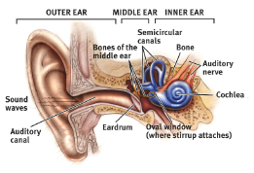
- middle ear- btw eardrum and cochlea- has three bons (hammer anvil stirrup)- they concentrate the vibrations of eardrum to oval window in cochlea
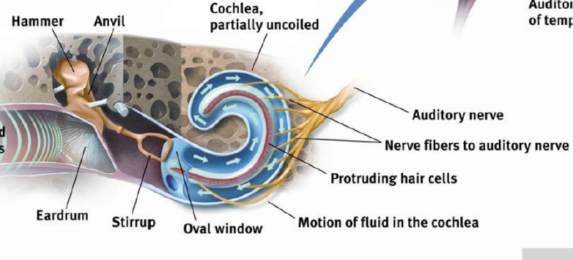
- inner ear- contains cochlea, semicirc. Canals, and vestib. Sacs
  - cochlea- a coiled bondy fluid filled tube in the inner ear, through which sound waves trigger nerve impulses
- from inner ear to brain, goes to aud. Cortex of temp. lobe
  - vib. From middle ear cause cochlear membrane to vibrate, moving fluid in cochlea
  - motion causes ripple in BM, moving haircells
  - this in turn, innervates nerve cells, which send neural messages to t. lobe, in aud. Cortex
How do we perceive loudness?
- # of activated hair cells- loud sounds activate many hair cells AND neighboring ones to amplify sound
How do we perceive pitch?
- 2 ways: place theory, frequency theory
  - Place theory- perception of pitch based on place in cochlea BM that is stimulated
  - Long waves are harder to place however, therefore use freq. theory
  - Frequency theory- rate of nerve impulses traveling to the aud. Nerve matches the freq. of a tone, thus enabling us to sense it’s pitch
    - Fast firing of nerves= high pitch
    - NOTE: our neurons have a firing limit
How do we localize sound?
- Intensity diff. sound intensity reduces over distance- space btw 2 ears, can be perceived by brain
- Time diff. sound travels 750 mph, the difference in each ear is perceived by brain. Time diff of 1/100000 of a second can be perceived by brain to localize sound

Hearing loss
- Conduction hearing loss- damage to mechanical sys, that conducts waves to cochlea
- Sensorineural hearing loss- damage to cochlea rec. cells, or aud. Nerve= nerve deafness
  - Older people hear low freq, not high
- Hearing aids- amplify sound to stimular neighboring hair cells
  - Amplify vibrations for freq. which one is weakest to sensing
- Cochlear implants- devices that convert sound to electric signals, by stimulating aud. Nerve through electrodes threaded into cochlea

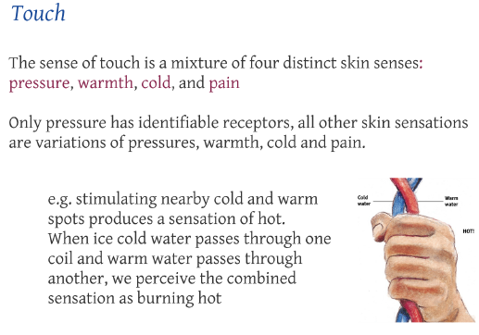
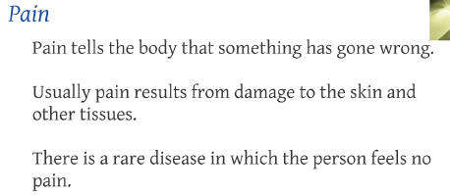
Pain is effected by the following- biological/ psychological/ socio-cultural influences


