





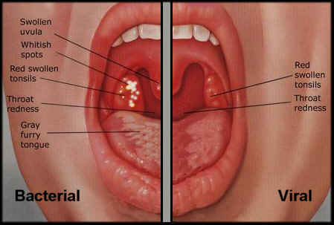

FAM1241

October 1st, 2012

- Child must be taking medication for at least 24 hours before returning to school or childcare.
- Communicability (transmission) is a period of 10-21 days, without treatment of a 24-hour cycle of antibiotics.
- If child shows signs, see a physician to get prescribed antibiotics (ex. Family doctor, walk in clinic or a pediatrician.)
- Long as the antibiotics are maintained in the original bottle and have the child’s name and info on it, the childcare facility or school can assist with providing antibiotics.
- Be extra precautious, and frequently wash hands to prevent spreading of germs and bacteria.
- If strep throat goes untreated it can lead to Rheumatic fever that can lead to inflamed joints, kidney inflammation and a viral rash.

  - What You Need to Know About Strep Throat

Regulations for Strep Throat

Roles of Guardians
Teachers Role
To ensure that the parents are aware of the child’s illness and as well making sure that the child gets the follow ups he/she needs so the condition is managed thoroughly. If the teacher senses that the child is not feeling well he/she should take immediate action and contact guardians.

Parents Role
Ensuring that the child gets appropriate medical attention, and have the child at stay home for that period of illness to prevent spreading of bacteria. Maintaining doctors orders in regards to sleep, medication, and proper diet; until the child’s health is completely restored itself.

Strep throat is considered to be contagious between people. Generally the infectious agent may be transmitted by saliva, air, cough, fecal-oral route, surfaces, blood, needles, blood transfusions, sexual contact, mother to fetus, etc. Strep throat, although infectious, is not a genetic disease that is not caused by a defective or abnormal gene. The contagious disease strep throat, can be transmitted from person to person; by saliva, air, coughing, contact, surfaces, fecal-oral route, etc.

Not all sore throats are strep throats. Most episodes of sore throat — which can be accompanied by a runny nose, cough, hoarseness, and red eyes — are caused by viruses and usually clear up on their own without medical treatment.
A child with strep throat will start to develop other symptoms within about 3 days, such as:
- Red and white patches in the throat
- Difficulty swallowing
- Tender or swollen glands (lymph nodes) in the neck
- Red and enlarged tonsils
- Headache
- Lower stomach pain
- Fever
- General discomfort, uneasiness, or ill feeling
- Loss of appetite and nausea rash

In the circumstance that your child develops one or more of the signs and symptoms of strep throat you should take the following courses of action:

- Take your child to a doctor and if your child does have strep throat the Doctor will prescribe antibiotics.
- Strep throat is contagious for up to 24 hours after the antibiotics have been taken so you must keep your child at home from the daycare center for one day to prevent the spread of the disease to other children.
- In the daycare center we encourage all of the children to engage in proper, frequent hand washing and to always cough and sneeze into their sleeves as opposed to their hands, to avoid easily spread bacteria.

Strep Throat
vs.
Sore Throat
Sore throats can be uncomfortable, but they usually improve with a few simple self-care steps. Low humidity in your home, winter dryness, cigarette smoke or failure to drink enough fluids can be the cause. But sometimes a throat is a sign of infection. Two types of infections cause sore throats. The serious bacterial infection known as strep throat can be a result. Strep throat is most common in the winter months when school aged children are in closed quarters for extended periods of time. This allows the disease to be very contagious and children may pick up the virus at school and bring it home to their family. Parents may develop strep throat and need to take time off of work. Without health coverage the antibiotics prescribed for the treatment of strep throat can be quite costly.
This brochure gives you information about strep throat. It includes common symptoms, diagnosis and care for sore throats and advice for when to call your doctor.

