Section 5.1 – Operations Management:
- Production: The creation of goods and services using the factors of production: land, labour, capital, entrepreneurship, and knowledge.

Operations Management Fundamentals:
- Productions Management: Describes all the activities managers do to help companies create goods.
- Operations Management: The management of systems or processes that convert or transform resources (including human resources) into goods and services.
- Transformation Process: Often referred to as the technical core, especially in manufacturing organizations, and is the actual conversion of inputs to outputs.
  - To ensure that the desired outputs are obtained, an organization takes measurements at various points in the transformation process (feedback) and then compares them with previously established standards to determine whether corrective action (control) is needed.
- Value-Added: The term used to describe the difference between the cost of inputs and value of price of outputs

OM in Business:
- Forecasting: Estimating demand, growth, or reduction.
- Capacity Planning: Key essential metric to maintain cash flow and increase revenues.
- Scheduling
- Managing Inventory
- Assuring Quality: Reduce unexpected issues and put emphasis on efficiency and courtesy.
- Motivating/Training Employees
- Locating Facilities: Where to host maintenance facilities, major/minor hubs.

Information Systems’ Role in OM:
- Key Questions: What, When, Where, How, and Who?
- Hierarchy of Operational Planning:
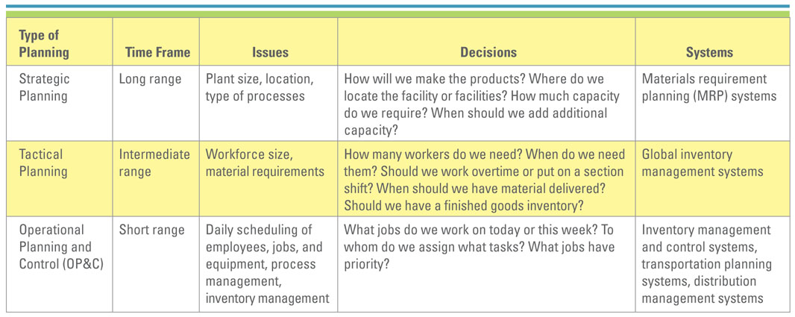
- Strategic Business Units (SBUs): When companies become really large, they are thought of as being composed of a number of businesses.
- Strategic Planning: Long range planning
  - Material Requirement Planning (MRP) Systems: Use sale forecasts to make sure that needed parts and materials are available at the right time and place in a specific company.
- Tactical Planning: Focuses on producing goods and services as efficiently as possible within the strategic plan.
  - Global Inventory Management Systems: Provide the ability to locate, track, and predict the movement of every component or material anywhere in the production process.
- Operational Planning and Control (OP&C): Deals with day-to-day procedures for performing work, including scheduling, inventory, and process management.
  - Inventory Management and Control Systems: Provide control and visibility to the status of individual items maintained in inventory.
  - Transportation Planning Systems: Track and analyze the movement of materials and products to ensure the delivery of materials and finished goods at the right time/place, and lowest cost.
  - Distribution Management Systems: Coordinate the process of transporting materials from a manufacturer to distribution centers to the final customers.

Competitive OM Strategy:
- Cost: Being the low-cost producer does not guarantee profitability. Products sold strictly on the basis of cost are typically commodity-like products.
- Quality: Can be divided into two categories.
- Product: Quality levels vary as to the particular market.
- Process: Critical in every market segment. Produce error-free products.
  - Six Sigma Quality: Prevent the occurrence of problems and achieve no more than 3.4 defects per million opportunities.
  - ISO 900: A nongovernmental organization established in 1947 to promote the development of world standards to facilitate the international exchange of g/s.
  - ISO 14000: Certification in ISO 14000 displays that a firm has a world-class management system in both quality and environmental standards.
  - CMMI: Capability Maturity Model Integration is a framework for best practices.
- Delivery: The ability of a firm to provide consistent and fast delivery allows it to charge a premium price for its products.
- Flexibility: Refers to the ability of a company to offer a wide variety of products to its customers. Also is a measure of how fast a company can convert its processes from an old product line to a new product line.
- Service: Customer service can add tremendous value to an ordinary product.

OM and the Supply Chain:
- Supply Chain: Consists of all parties involved directly or indirectly, in the procurement of a product or raw material.
- Supply Chain Management: Involves the management of information flows between and among stages in a supply chain to maximize total effectiveness and profitability.
- Strategy: Managing all the resources required to meet customer demand for all g/s.
- Partners: Chosen to deliver finished products, raw materials, and services, including pricing, delivery, and payment processes along with partner relationship monitoring metrics.
- Operation: The schedule for production activities, including testing, packaging, etc.
- Logistics: The product delivery process and elements, including orders, warehouses, carriers, defective product returns, and invoicing.

Section 5.2 – Supply Chain Fundamentals:
- The average company spends nearly half of every dollar that it earns on production.
- Three Main Links:
- Materials flow from suppliers and their “upstream” suppliers at all levels.
- Transformation of materials into semi-finished and finished products through the organization’s own production process.
- Distribution of products to customers and their “downstream” customers at all levels.
- Organizations must embrace technologies that can effectively manage supply chains.
- The Five Basic SCM Components:
- Plan: Strategic portion of SCM. The company must have plans for managing all the resources that go toward meeting customer demand for products or services.
- Source: Companies must carefully choose reliable suppliers that will deliver goods and services required for making products.
- Make: This is the step where companies manufacture their products or services.
- Delivery/Logistics: Set of processes that plans for and controls the efficient and effective transportation and storage of suppliers from suppliers to customers.
- Return: Companies must create a network for receiving defective product.

Information Systems’ Role in the Supply Chain:
- IS’s primary role is to create integrations or tight process and information linkages between function within a firm.
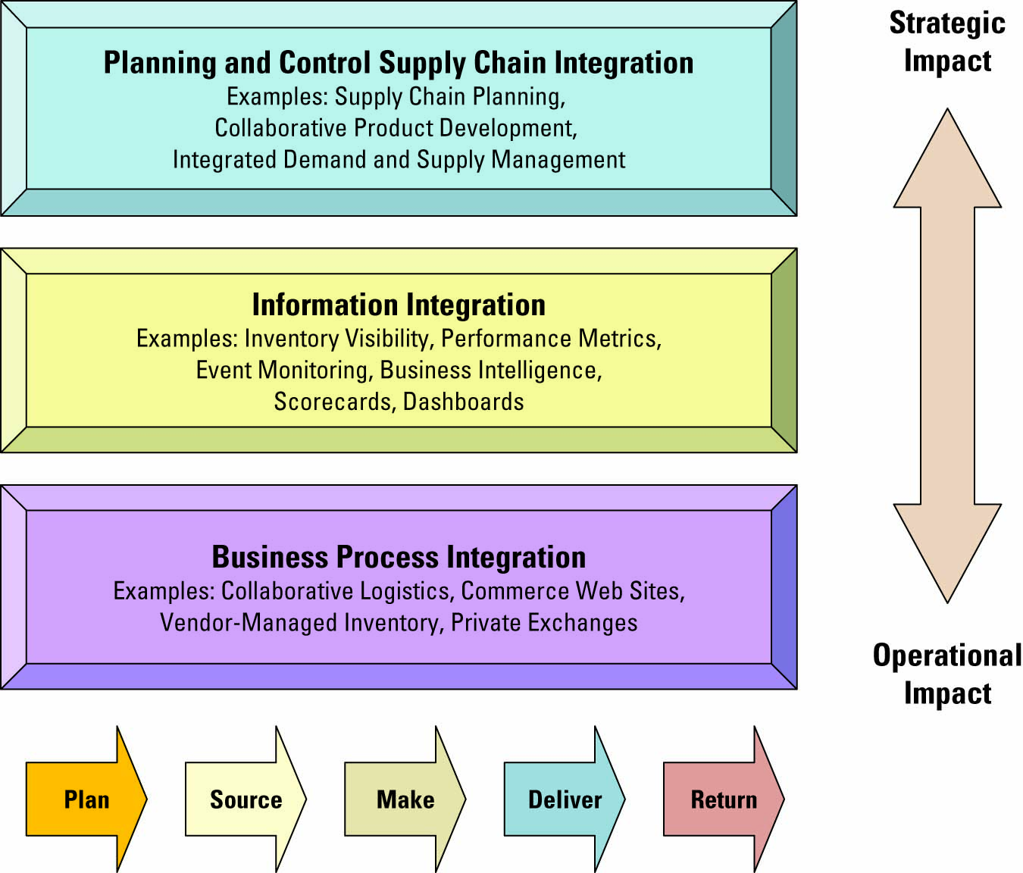
- Visibility: The ability to view all areas up and down the supply chain.
  - Bullwhip Effect: Occurs when distorted product demand information passes from one entity to the next throughout the supply chain.
- Consumer Behaviour:
  - Companies can respond faster and more effectively to consumer demands through supply chain enhances.
  - Demanding Planning Software: Generates demand forecasts using statistical tools and forecasting techniques.
- Competition:
  - Supply Chain Planning (SCP) Software: Uses advanced mathematical algorithms to improve the flow and efficiency of the supply chain.
  - Supply Chain Execution (SCE) Software: Automated the different steps and stages of the supply chain.
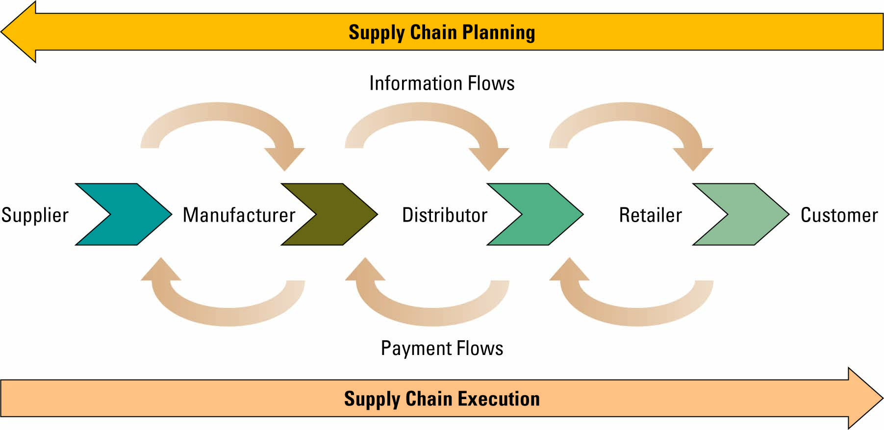
- Speed: During the past decade, competition has focused on speed.
  - Three Factors Fostering Speed:
- Pleasing customers has become a corporate obsession. Serving the customer in the best, most efficient/effective manner has become critical.
- Information is crucial to manager’s abilities to reduce inventory and human resource requirements to a competition level.
- Information flows are essential to strategic planning for and deployment of resources.

Supply Chain Management Success Factors:
- SCM Success Metrics:
- Back Orders: An unfilled customer order. Demand against an item whose stock level is INSF.
- Customer Order Promised Cycle Time: Gap between order creation and requested delivery.
- Customer Order Actual Cycle Time: Average time it takes to fill customer purchase order.
- Inventory Replenishment Cycle Time: Measure of manufacturing/distribution cycle time.
- Inventory Turns: # of times a firm’s inventory cycles or turns over per year.

- Seven Principles of Supply Chain Management:
- Segment customers by service needs, regardless of industry, and then tailor services to those particular segments.
- Customize the logistics network and focus intensively on the service requirements and profitability of the pre-identified customer segments.
- Listen to signals of market demand and plan accordingly
- Differentiate products closer to the customer, since companies can no longer afford to hold inventory to compensate for poor demand forecasting.
- Strategically manage sources of supply, by working with key suppliers to reduce overall costs of owning materials and services.
- Develop a supply chain information technology strategy that supports different levels of decision making and provides visibility.
- Adopt performance evaluation measures that apply to every link.
- SCM Industry Best Practices Include:
- Make the sale to suppliers
- Wean employees off traditional business practices.
- Ensure the SCM system supports the organizational goals.
- Deploy in incremental phases and measure and communicate success.
- Be future-oriented.

Future Supply Chain Trends:
- Supply Chain Event Management (SCEM): Enables an organization to react more quickly to resolve supply chain issues. SCM software increases real-time information sharing among supply chain partners and decreases their response time to unplanned events.
- Selling Chain Management: Applies technology to the activities in the order life cycle from inquiry to sale.
- Collaborative Engineering: Allows an organization to reduce the cost and time required during the design process of a product.
- Collaborative Demand Planning: Helps organization reduce their investment in inventory, while improving customer satisfaction through product availability.

