Section 4.2 – Enterprise Resource Planning:
- Integrates all departments and functions throughout an organization into a single IT System so that employees can make enterprise wide decisions by viewing enterprise-wide information on all business operations.
- Reasons ERP Systems are Powerful Organizational Tools:
- ERP is a logical solution to the mess of incompatible applications that had sprung up in most businesses.
- ERP addresses the need for global information sharing and reporting.
- ERP is used to avoid the pain and expense of fixing legacy systems.

Enterprise Resource Planning:
- The Heart of ERP: At the heart of ERP systems is a database; when a user enters or updates information in one module, it is immediately and automatically updated throughout the entire system.
  - Central database that collects data from and feeds data into all the ERP system’s individual application components (called modules), supporting diverse business functions such as accounting, manufacturing, marketing, and HR.
  - ERP enables employees across the organization to share data across a single, centralized database.
- The Evolution of ERP:
- ERP: Originally, ERP solutions were developed to deliver automation across multiple units of an organization, to help facilitate the manufacturing process and address issues such as raw materials, inventory, order entry, and distribution.
  - However, ERP was unable to extend to other functional areas of the company, such as sales, marketing, and shipping.
  - It could not tie in any customer relation management, nor did it work with web applications or portals used for customer service.
- Extended ERP: From its beginning as a tool for materials planning, it has extended to warehousing, distribution, and order entry.
  - With its next evolution, ERP expands to the front office, including customer relationship management. Now all functional departments can share a tool that is truly enterprise-wide.
- ERP II – Core and Extended:
  - Core ERP Components: Traditional components included in most ERP systems and they primarily focus on internal operations.
  - Extended ERP Component: Extra components that meet the organizational needs not covered by the core components and primarily focus on external operations.

Core ERP Components:
- Accounting and Finance ERP Components: Manages accounting data and financial processes within the enterprise with functions such as general ledger, accounts payable, accounts receivable, budgeting, and asset management.
- Production and Materials Management ERP Components: Handles the various aspects of production planning and execution such as demand forecasting, production scheduling, job cost accounting, and quality control.
- Human Resource ERP Components: Track employee data, payroll, benefits, performance, etc. and assure compliance with legal jurisdiction and tax authorities.

Extended ERP Components:
- Business Intelligence Components: Describes information that people use to support their decision-making efforts.
  - E-Logistics: Manages the transportation and storage of goods.
  - E-Procurement: The B2B purchase and sale of supplies and service over the internet.
- Customer Relationship Management Components: Involves managing all aspects of a customer’s relationship with an organization to increase customer loyalty, retention, and profitability for the organization.
- Supply Chain Management Components: Involved managing data flows between and among stages in a supply chain to maximize total supply chain effectiveness and profitability.

Integrating SCM, CRM, and ERP:
- Breakdown: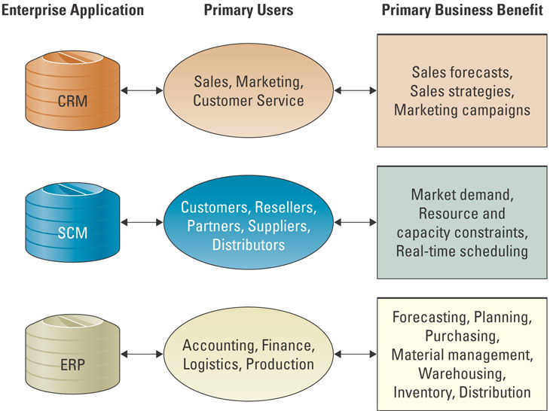
- Integration Tools: Many companies purchase modules from an ERP vendor, an SCM vendor, a CRM vendor, and must integrate the different modules together.
  - Middleware: Several different types of software which sit in the middle of and provide connectivity between two or more software applications.
  - Enterprise Application Integration (EAI) Middleware: Packages together commonly used functionality which reduced the time necessary to develop solutions that integrate application from multiple vendors.

Measuring ERP Success:
- Balanced Scorecard: A management system, in addition to a measurement system, that enables organizations to clarify their vision and strategy and translate them into action.
  - Financial, Internal Business Processes, Learning and Growth, and Customers.
- Finding the Right ERP Solution:
- Overall Fit: This refers to the degree of gaps that exist between the systems and the business process.
- Proper Business Analysis: The best way to determine which fit strategy is right is to conduct a thorough business analysis.
- Solid Implementation Plans: Like the installation of any successful process or piece of machinery, a plan is needed to monitor the quality objectives and timelines.

ERP and SME Markets: ERP is no longer the purview of large organizations.
- In hopes of expanding their client base, many large-scale ERP vendors, such as SAP and ORACLE are attempting to enter the small to medium enterprise (SME) markets.
- However, what many ERP vendors are finding is that SMEs constitute a different marketplace than what these large-scale ERP vendors are traditionally accustomed for four primary reasons:
- SMEs demand affordability and easy to use, more so than their large organizational cousins.
- Large-scale ERP vendors are relatively unknown to most SME organizations.
- In Canada, several large-scale ERP vendors have missed the mark when attempting to market their ERP solutions to SME companies.
- Most important, the SME market space demands the use of partners (resellers) to sell software solutions.

