Decision Making:
- Reasons for the growth of decisions-making information system:
- People need to analyze large amounts of information.
- People must make decisions quickly
- People must apply sophisticated analysis techniques, such as modeling and forecasting, to make good decisions.
- People must protect the corporate asset of organizational information.

Transactional Data and Analytical Information:
- Transactional Data: Encompasses all the raw facts contained within a single business process or unit of work and their primary purpose is to support the performing of daily operational tasks.
- Analytical Information: Encompasses all summarized or aggregated transactional data, and its primary purpose is to support the performing of analysis tasks.
- Moving up through the organizational pyramid, users move from requiring transactional information to analytical information.
  - Transactional Proceesses Analystical
  - Fine Granularity Coarse
  - Analysts Managers Executives
  - Online Transaction Processing Processing Online Analytical Processing
- Transactional Processing System (TPS): The basic business system that serves the operational level (analysts) in an organization.
- Online Transactional Processing (OLTP): The capturing of transaction and event information using technology to (1) process the information according to defined business rules, (2) store the information, (3) update existing information to reflect the new information.
- Online Analytical Processing (OLAP): The manipulation of information to create business intelligence in support of strategic decision-making.
  - Consolidation: Involves the aggregation of information and features simple roll-ups to complex groupings of interrelated information.
  - Drill-Down: Enables users to view details and information.
  - Slice-and-Dice: The ability to look at information from different perspectives.

TPS, DSS, and EIS:
- Transaction Processing System (TPS): The basic business system that serves the operational level (clerks and analyst) in an organization. Ex: Payroll system.
- Decision Support System (DSS): Models information to support managers and business professionals during the decision-making process.
- Sensitivity Analysis: The study of the impact that changes in one (or more) parts of the model have on other parts of the model.
- What-if Analysis: Checks the impact of a change in an assumption on the proposed solution.
- Goal-Seeking Analysis: Finds the inputs necessary to achieve a goal such as a desired level of output.
- Executive Information System (EIS): Specialized DSS that supports senior-level executives within the organization.
  - Digital Dashboard: Integrates information from multiple components and tailor the information to individual preferences.
- Market Pulse: Daily sales numbers, market shares, and subscriber turnover.
- Customer Service: Examples include problems resolved on the first call, call center wait times, and on-time repair calls.
- Cost Driver: Examples include number of repair trucks in the field, repair jobs completed per day, and call center productivity.

Artificial Intelligence (AI):
- The ultimate goal of AI is the ability to build a system that can mimic human intelligence.
- Four most common categories of AI include:
- Expert System: Computerized advisory programs that imitate the reasoning processes of experts in solving difficult problems.
- Neural Network: Attempts to emulate the way the human brain works.
  - Fuzzy Logic: A mathematical method of handling imprecise or subjective information.
- Genetic Algorithm: An artificial intelligent system that mimics the evolutionary, survival-of-the-fittest process to generate increasingly better solutions to problems.
- Intelligent Agent: Special-purposed knowledge-based information system that accomplished specific tasks on behalf of its users.
  - Shopping Bot: A software that will search several retailer web sites and provides a comparison of each retailer’s offerings, including price and availability.
- Multi-Agent Systems: Groups of intelligent agents have the ability to work independently and to interact with each other.
  - Biomimicry: Learning from ecosystems and adapting their characteristics to human and organizational situations.
    - Learn how people-based systems behave.
    - Predict how they will behave under a given set of circumstances.
    - Improve human systems to make them more efficient and effective.

Artificial Intelligence vs. TPS, DSS, and EIS:
- AI systems are intelligent systems designed to provide optimal answers to problems and determine the best decisions to make.
- TPS, DSS, and EIS systems are designed to support end-users in their decision-making, as opposed to making decisions for them.

Business Processes:
Understanding the Importance of Business Processes:
- Business Process: Standardized set of activities that accomplish a specific task, such as processing a customer’s order.
- Customer Facing Processes: Result in a product or service that is received by an organization’s external customer. Ex: Order processing, customer service, sales process, customer billing, and order shipping.
- Business Facing Processes: Invisible to the external customer but are essential to the effective management of the business. Ex: Strategic planning, tactical planning, budget forecasting, training, and purchasing raw materials.

Business Process Improvement: Attempts to understand and measure the current process and make performance improvements accordingly.
- Business processes should drive information system choices.

Business Process Reengineering: The analysis and redesign of workflow within and between enterprises. BPR relies on a different school of thought than business process improvements.
- BPR assumes the current process is irrelevant, does not work, or is broken and must be overhauled from scratch.
- Finding Opportunity Using BPR:
  - A company can improve the way it travels the road by moving from foot to horse and then horse to car.
  - BPR looks at taking a different path, such as an airplane which ignores the road completely.
- Process Change Spectrum:
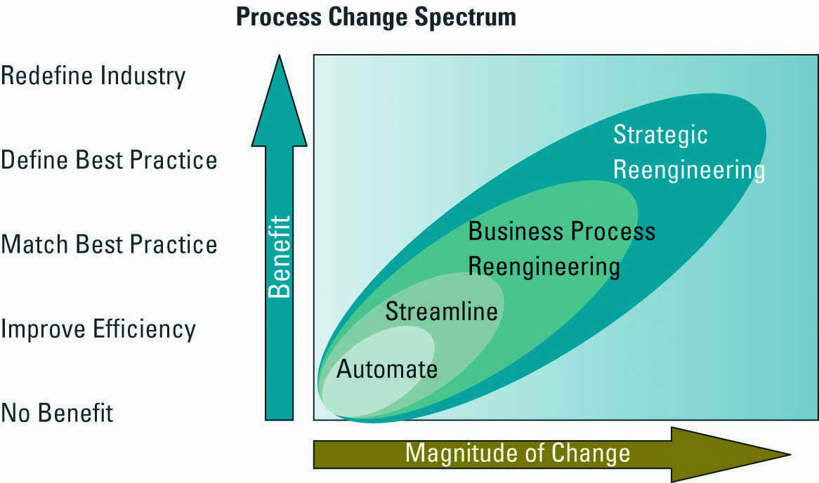
- BPR Pitfalls: One hazard of BPR is that the company becomes so wrapped up in fighting its own demons that it fails to keep up with its competitors in offering new products/services.

Business Process Modelling: The activities of creating a detailed flow-chart or process map of a work process showing its inputs, tasks, and activities, in a structured sequence.
- Business Process Model: A graphic description of a process, showing the sequence of process tasks, which is developed for a specific purpose and from a selected viewpoint.
Business proves Management: Integrates all of organizations business processes to make individual processes more efficient.
- Key Reasons for Using BPM:
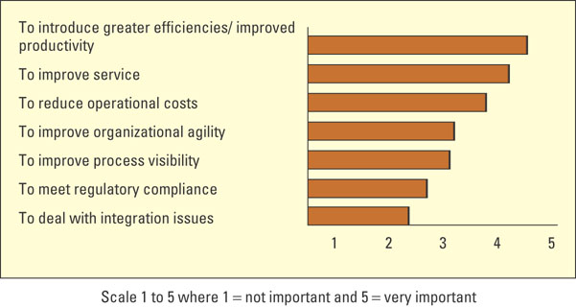
- Opportunities:
    - Bringing processes, people, and information together.
    - Breaking down barriers between business areas and finding owners for the processes.
    - Managing business processes within the enterprise and outside the enterprise with suppliers, business partners, and customers.
    - Looking at automation horizontally instead ofvertically.

