Section 1.1 - Information Systems in Business:
- Everywhere in business.
- Impact on business operations:
  - Functions receiving greatest benefit from I.T: Customer service, finance, sales/marketing, IT operations, Operations mgmt., HR, and Security.
  - Project goals as a result of IT: Reduce costs/improve productivity, improve customer satisfaction/loyalty, create competitive advantage, growth, streamline supply chain, and global expansion.
  - Organizations typically operate by functional areas or functional silos that act independently of one another.
Information Systems Basics:
- Information Systems (IS): Any computer-based tool that people use to work with information and that supports the information and information-processing needs of an organization.
  - An information system can be an important enabler of business success and innovation.
- Management Information Systems (MIS): The function that plans for, develops, implements, and maintains IS hardware, software, and applications that people use to support the goals of an organization.
  - MIS is a business function, similar to accounting, finance, operations, and human resources.
- When beginning to learn about information systems it is important to understand the following: The difference between data, information, and knowledge, IS resources, and IS cultures.
Data – Information – Knowledge:
- Data: Raw facts that describe the characteristic of an event.
- Information: Data converted into a meaningful and useful context.
- Knowledge: Information that can be enacted upon i.e. “actionable information.”
IS Resources: People use information systems to work with information.
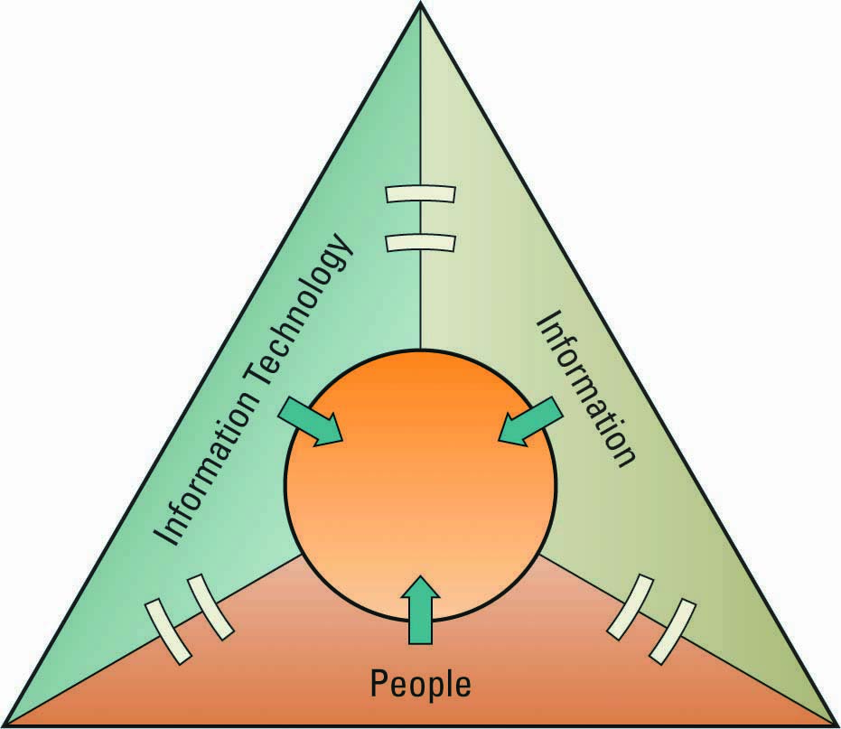
IS Cultures:
- Information-Functional Culture: Use information as a means of exercising influence or power over others.
- Information-Sharing Culture: Departments trust each other to use information (especially about problems and failures) to improve performance.
- Information-Inquiring Culture: Search for information to better understand the future and align themselves with current trends and new directions.
- Information-Discovery Culture: Open to new insights about crisis and radical changes and seek ways to create competitive advantage.
Roles and Responsibilities in IS:
- Chief Information Officer (CIO): Oversees all uses of IS and ensures the strategic alignment of IS with business goals and objectives.
- Broad CIO Roles:
- Manager: Ensuring the delivery of all IS projects, on time, and within budget.
- Leader: Ensuring the strategic vision of IS is in line with the strategic vision of the organization.
- Communicator: Building and maintaining strong executive relationships.
- Chief Technology Officer (CTO): Responsible for ensuring the throughput, speed, accuracy, availability, and reliability of IS.
- Chief Security Officer (CSO): Responsible for ensuring the security of information systems.
- Chief Privacy Officer (CPO): Responsible for ensuring the ethical and legal use of information.
- Chief Knowledge Office (CKO): Responsible for collecting, maintaining, and distributing the organization’s knowledge.
Skills Pivotal for Success in Executive IS Roles:
- Ability to communicate effectively.
- Strategic thinking and planning.
- Understanding business processes and operations.
- Negotiation/sales skills.
- Through knowledge of technology options.
- Technical proficiency.
The Gap between Business Personnel and IS Personnel:
- Business personnel possess expertise in functional areas such as marketing, accounting, and sales, while the IS personnel have the technological expertise.
  - This typically causes a communications gap between the business personnel and IS personnel.

Improving Communications:
- Both groups, business and IS, must seek to increase their understanding of one another.
- It is the responsibility of the CIO to ensure effective communication between business personnel and IS personnel.
Efficiency and Effectiveness Metrics:
- Efficiency IS Metric: Measures the performance of the information system itself including throughput, speed, and availability.
- Effectiveness IS Metric: Measures the impact IS has on business processes and activities including customer satisfaction, conversion rates, and sell-through increases.
- Benchmarking – Baselining Metrics:
  - Regardless of what is measured, how it is measured, and whether it is for the sake of efficiency or effectiveness, there must be benchmarks – baseline values the system seeks to attain.
  - Benchmarking: A process of continuously measuring system results, comparing those results to optimal system performance (benchmark values), and identifying steps and procedures to improve system performance.
Interrelationships of Efficiency and Effectiveness Metrics:
- Efficiency IS metrics focus on information systems and include: Throughput, transaction speed, system availability, web traffic, and response time.
- Effectiveness IS metrics focus on:
- Usability: The ease which people perform transactions and/or find information.
- Customer Satisfaction: Measured by such benchmarks as satisfaction surveys, percentage of existing customers retained, and increases in revenue.
- Conversion Rates: The number of customers an organization “toughes” for the first time and persuades to purchase its products or services.
- Financial: Such as return on investment, cost-benefit analysus, and break-even analysis.
- Security is an issue for any organization offering products/services over the internet.
- It is inefficient for an organization to implement internet security, since it slows down processing. However, to be effective, it must implement internet security.
  - Secure internet connections must offer encryption and Secure Sockets Layers (SSL denoted by the lock symbol in the lower right corner of a browser).

Section 1.2 – Business Strategy
Identifying Competitive Advantages:
- Competitive Advantage – a product or service that an organization’s customers place a greater value on than similar offerings from a competitor
- First-Mover Advantage – occurs when an organization can significantly impact its market share by being first to market with a competitive advantage
- Organizations watch their competition through Environmental Scanning:
  - The acquisition and analysis of events and trends in the environment external to an organization.
- Three common tools used in industries to analyze and develop competitive advantages include:
- Porter’s Five Forces Model
- Porter’s Three Generic Strategies
- Value Chains
Porter’s Five Forces Model:
- Determines the relative attractiveness of an industry.
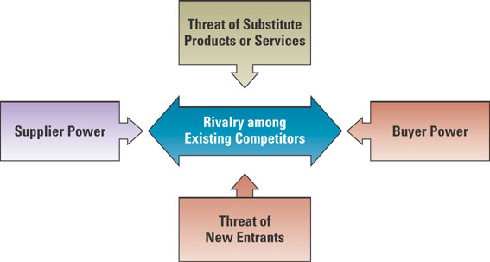
- Buyer Power: High when buyers have many choices of whom to buy from.
  - Loyalty Programs: Rewards customers based on the amount of business they do with a particular organization. Reduces buyer power.
- Supplier Power: High when buyers have few choices of whom to buy from.
  - Supply Chain: Consists of all parties involved in the procurement of a product.
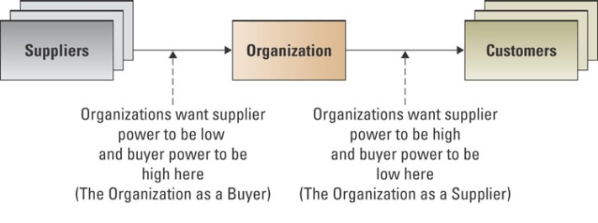
  - Organizations that buy goods and services in the supply chain can create a competitive advantage by locating alternative supply sources through B2B Marketplaces.
  - B2B Marketplace: An internet-based service that brings together many buyers and sellers.
- Private Exchange: A single buyer posts its needs and then opens bidding to any supplier who would care to bid.
- Reverse Auction: An auction format in which increasingly lower bids are solicited from organizations willing to supply the desired product/service at an increasingly lower price.
  - Value Creation: Once an organization chooses its strategy, it can use tools such as the value chain to determine the success or failure of its chosen strategy.
- Business Processes: A standardized set of activities that accomplish a specific task, such as processing a customer’s order.
- Value Chain: Views an organization as a series of processes, each of which adds value to the product or service for each customer.
- Threat of Substitutes: High when there are many alternatives to a product or service.
  - Switching Cost: Costs that can make customers reluctant to switch to another product.
- Threat of New Entrants: High when it is easy for new competitors to enter a market.
  - Entry Barrier: A product or service feature that customers have come to expect from organizations in a particular industry and must be offered by an entering organization to compete and survive.
- Rivalry Among Existing Competitors: High when competition is fierce in a market.
  - Although competition is always more intense in some industries than in others, the overall trend is toward increased competition in just about every industry.
Porter’s Three Generic Strategies:
- Broad Cost Leadership
- Broad Differentiation
- Focused Strategy

