Chapter 3 – Protein and Function
Key Terms
Peptide backbone Prebiotic Soup

_____________________________________________________________________________________________
- Proteins made up of amino acids, and the difference in structure and function are due to the differences in side chain composition

- Chemical Evolution began with production of small organic compounds such as H2CO, HCN from reactants H2, C02, CH4, NH3
- H2C0 and HCN and other molecules combined to form amino acids, sugars, and nitrogenous bases which accumulated in ocean creating the prebiotic soup (monomers)
- The various amino acids, sugars and nitrogenous bases combined to form macromolecules; proteins, nucleic acids and carbohydrates
- Life started when one of these molecules gained the ability to self-replicate by the using the chemical reactions it could control

3.1 What do proteins do?
- Most diverse in terms of function
Defence | Antibodies protein attack and destroy viruses and bacteria
Movement | Myosin, actin examples of contractile proteins
Catalysis | Enzymes; speed up reactions
Signalling | Hormones; act as signals coordinating the activity of cells
Structure | Provide support for cells and tissues
Transport | Moving substances across the membrane and throughout the cell body

3.2 Early Origin of Life Experiments
- Stanley Miller wanted to recreate ancient earth in terms of the elements present in the atmosphere; mainly CO2, NH3, CH4, which were contained in a large flask
- The large flask was connected to a smaller flask containing sea water which was heated up so that the water vapour could react with the gases in the larger flask, as they reacted, the gases condensed which stimulated “rain” that went back into the flask with boiling water Q: Why was it essential to boil water?
- Initially there was no reaction as the reactants did not react spontaneously, but when he added electrodes to create sparks to stimulate lightning, it provided the energy to start the reactions Q: Why was the addition of electrodes essential in his experiment?
- After days the solution had turned pink, and after weeks it turned red and cloudy
- When he examined which products were in the apparatus, he found HCN and H2CO, these reactants were required for the synthesis for more complex molecules
- Complex molecules like amino acids were found in the miniature ocean
Q: What was so significant about the initial products, HC0 and H2CO he found in the mini ocean flask?

Q: How did the amino acids he found relate to the prebiotic soup?

- Strong consensus that amino acids and other components of the prebiotic soup are readily produced under conditions that accurately stimulate the atmosphere and oceans of early earth

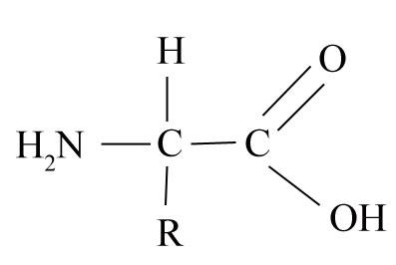
3.3 Amino Acids and Polymerization
Structure of Amino Acids

- NH2 – Amino Functional Group
- COOH- is the carboxyl functional group
- The COOH- is acidic; The oxygen atoms are highly electronegative; they have a strong attraction for shared electrons. The carboxyl group is acid because the high electronegative oxygen atoms pull the electrons away from the H atom in the O-H bond. When the electrons are pulled away from the H, it leaves the group as an H+ ion. Thus, the -COOH group is acidic (donates a proton).
- When in water, the NH2 acts as a base to form NH3+ and the COOH loses an H to become COO⁻
Q. Relate the properties of the functional groups found on the amino acid
Q. How do they behave in water, and why?
Q. Draw the amino acid in as many variations as possible (google images of different ways they represent amino acids)
Nature of the Side Chains
- The R group is what differentiates the properties of various amino acids into hydrophobic, hydrophilic, and electrically charged
- The nature of the side chain dictates nature of the whole amino acid
- Hydrophobic side chains render the whole amino acid nonpolar and thus incapable to react in water
- With polar side chains, they readily react with water
- Polarity of the R group correlates with the amino acids ability to react with water (solubility)
- R groups with carbon and hydrogen atoms are relatively non-reactive
- R groups with OH-, H2N, COOH-, SH- are reactive

Q. why are the side chains important?
Q. How do they affect properties of the amino acid?

Isomers
- Molecules with the same molecular formula but different structures

Structural Isomers | Same atoms but differ in the order in which covalently bonded atoms are attached
Geometric Isomers | Differ in the arrangement of groups on sides of the double bond (involve –cis and –trans) | 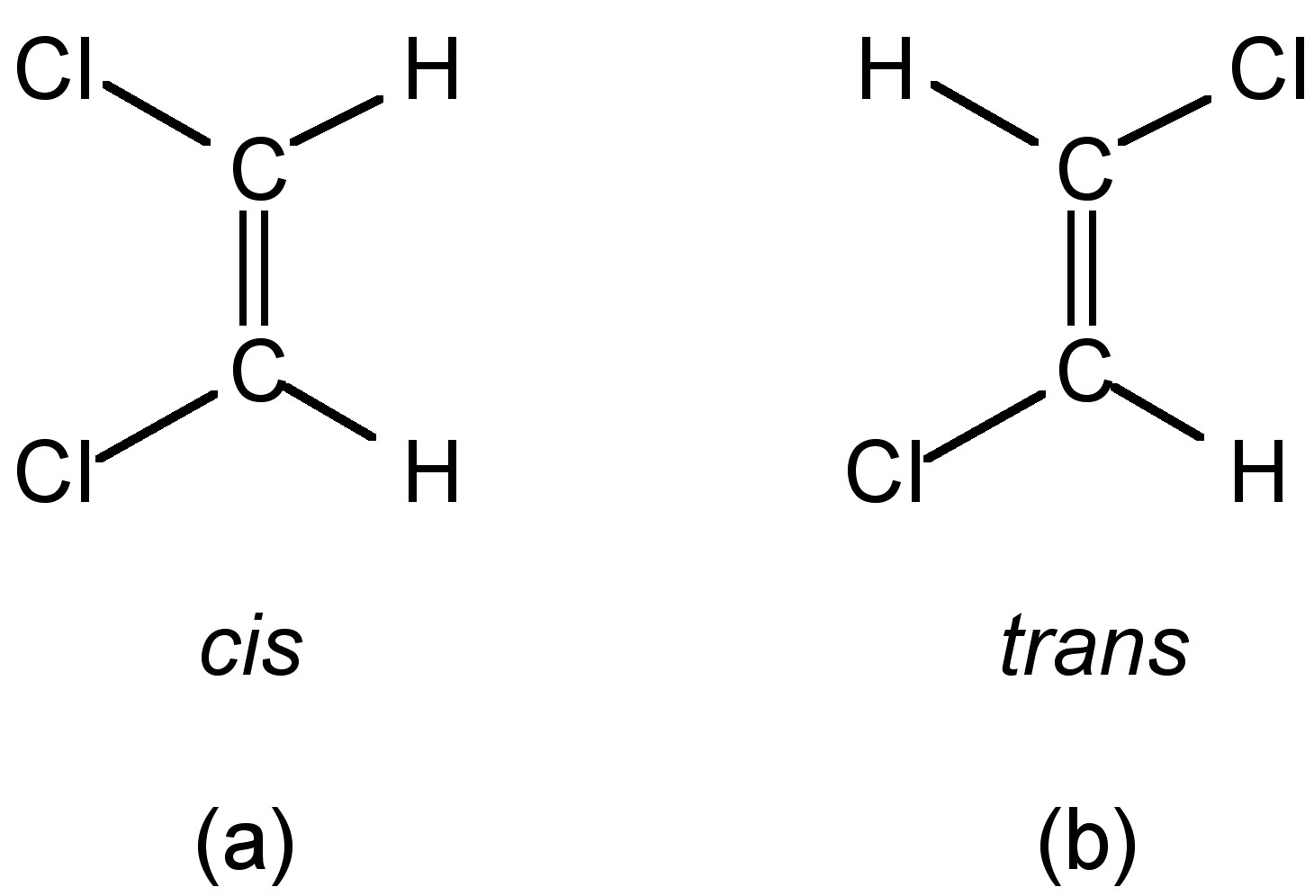
Optical Isomers | Mirror images of each other | 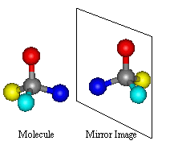

Optical Isomers – because amino acid structure relates directly to its function, mirror isomers have different functions, only the left handed version are found in cells and if you place the right mirror version, it will not function properly
Q. Relate isomers to their function and structure, and why is the correct isomer important in cells?
How do Amino Acids link to form proteins?
- Amino acids are monomers which have gone through polymerization to form protein polymers
- Theory of chemical evolution states that the monomers in the prebiotic soup polymerized to form polymers
- They do not form spontaneously and are endergonic, meaning they must absorb energy to form monomer links
Q. How did adding electrical charges affect the amino acid linkages?
Could polymerization occur in the Energy Rich Environment of Early Earth?
- Form via Condensation (dehydration) reactions involving the removal of water
- Polymers break via Hydrolysis reaction involving the addition of water
- *Read the part about the mud

The peptide Bond
- Formed between the carboxyl group of one amino acid and the amino group of another
- C-N bond that results is called a peptide bond

- Free amino group placed on left, and is called N-Terminus
- End with free carboxyl group called C-Terminus
- Less than 50 called oligopeptide
- More than 50 called proteins

3.4 What do Proteins Look like?
- Proteins serve diverse functions because they are diverse in size and shape, which relates to diversity in chemical properties
- Primary Structure; refers to the unique amino acid sequence
  - A slight change in the amino acid sequence can be catastrophic
  - e.g. sickle cell, which involves a change in the primary sequence of a red blood cell, due to a change of the amino acid with a different R chain, it changes its structure, therefore its function
Q. How does structure and function relate to primary structure?

- Secondary Structure; Refers to the structures resulted from Hydrogen bonding between the carboxyl oxygen of one amino acid and the H from the amino group
  - THIS IS NOT DUE TO INTERACTIONS FROM THE SIDE CHAINS
  - H-bonds are only possible if the protein is bent in a way to allow the carboxyl and amino groups to be close together
    - Alpha Helix – coiled
    - Beta Pleated Sheets – segments bent at 180 degrees and folded in same plane
  - The orientation the protein bends to depends on the primary structure
  - Individual H Bonds are weak relative to covalent, cumulatively they are strong
  - Therefore, the purpose of the 2ndry structure is to increase stability via cumulative H-Bonds
Q. What is the purpose of the 2ndry structure?
Q. What physical feature makes the H-Bonds possible?
Q. Relate the strength of the H Bonds.

- Tertiary Structure; shape determined by interaction between R- side chains, and backbone
  - *Read the 4 types of interactions
  - Depends on the secondary and primary structures; each structure depends on its processor

- Quaternary Structure; combination of polypeptide subunits
  - the polypeptide subunits can be distinct in terms of the levels of structure
  - combinations of tertiary structures

Folding and Function
  - folding is spontaneous because the van der waal forces make the molecule more stable and can thus release free energy
  - denatured proteins, or unfolded proteins do not function normally
  - in cells, folding is facilitated by molecular chaperons
Prions
  - infectious, disease causing protein that are the result of improperly folded forms of normal protein present in healthy individuals
  - do not differ in terms of primary structure (amino acid sequence) but rather in conformation
  - can be hereditary but mostly caused by consumption of tissue infected by prions
  - e.g. mad cow disease

