Marketing: Canadian Edition
Chapter One | Overview of Marketing

what is marketing?
Definition: Marketing is a set of business practices designed to plan for and present an organization’s products or services in ways that build effective customer relationships.
- Marketings Core aspects are. Marketing is about satisfying customer needs and wants. Marketing entails value exchange. Marketing requires product, price, place and promotion decisions. Both individuals and organizations can perform marketing. Marketing occurs in many settings. Marketing helps create value. There for there a 6 core aspects of marketing
- Marketing plan: is a written document composed of an analysis of the current marketing situation, opportunities and threats for the firm, marketing objectives and strategy specified in terms of the four P’s, action programs, and projected or pro forma income
- Good marketing requires thoughtful planning, emphasizing ethical implications of decisions on consumers and society in general.
- In any exchange, buyer and seller should be satisfied with the value obtained from the transaction.

Marketing is about satisfying customer needs and wants
A need is when person feels deprived of the basic necessities (food, shelter, clothing, safety etc.)
A want is how the person goes about fulfilling the need. Shaped through person’s culture, knowledge and personality.
- To understand the needs and wants of a customer a company must identify the market (group of people whom the organization wishes to market its products, services or ideas.)
- It is not practical to sell products and services to everyone so companies have target markets (customers segment that the firm is interested in selling its products to [i.e., young children for Crest ’s kid’s toothpaste])
  - Find a target market to which your product is relevant to, and build a marketing strategy that meets the needs/wants of them.

marketing entails value exchange
- Marketing is all about an exchange — trade of things of value between buyer and seller so that each is better off as a result.
- Buyers (customers/consumers) provide information and money to sellers, and sellers provide communications and delivery to buyers.

marketing requires product, price, place and promotion decisions
The marketing mix is the controllable set of activities that a firm uses to respond to the wants of its target markets.

product: creating value
- Creates value by developing goods, services, and ideas to satisfy customer needs.
A good is an item you can physically touch.
A service is an intangible customer benefit created by machine or people.
An idea is a thought, opinion, philosophy, or intellectual concept.

price: transacting value
The price is the overall sacrifice a consumer is willing to make— time, money, and energy— to acquire a specific product or service.
- The marketer must determine the price of a product based on the potential buyer’s belief about the value.
- The key to determine price: how much customers will pay so they are satisfied + the seller must achieve a profit.

place: delivering value
The place is all the activities of getting product from the manufacturer/producer to the right customer.
- Efficient system to distribute the right quantities to the right locations at the right time.

promotion: communicating value
The promotion is communication that informs, persuades and reminds potential buyers about a product or service to influence their opinions.
- Promotion can enhance a product or service’s value.
- Creates an image for the product.
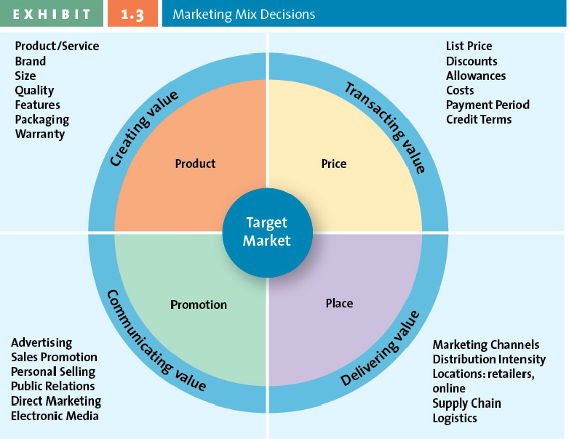

Tools used——>>
To achieve———————>

marketing is shaped by external forces and players
- Social/cultural trends, technological, political/regulatory, economic, demographic, and competitive forces all shape a company’s marketing activities.
  - For example, environment and obesity are current social trends, which have created the “Green” and “Low-fat” marketing strategies.
- Suppliers, distributors, and advocacy groups can also affect marketing decisions…
  - For example, PETA & KFC …

marketing can be performed by individuals and firms
Business to business marketing is when businesses sell to each other. Business to consumer is when businesses sell to consumers. Consumer to consumer marketing is when consumers sell to each other.
- Individuals market themselves too.
  - For example, through resumes, dressing up for an interview etc.
  - Professional service providers also market their services.

marketing occurs in many settings
- Hospitals, theatres, colleges, universities, charities, politicians, etc. all rely on marketing to communicate their message.
- Third world countries also depend on marketing to stimulate the economy
  - For example, A Piece of Africa
- “Got Milk” campaign is an example of how marketing for an entire industry helped the different firms within it.
  - Increases awareness of benefits of drinking milk, increased milk consumption in different target segments (thanks to the celebrity endorsements)

marketing helps create value

production oriented era | 1900-1920
- Belief that “good product would sell itself”
- Manufacturers didn’t care about satisfying each customer’s needs, and were more focused on product innovation.

sales oriented era | 1920-1950
- When manufacturers produced more than the consumer wanted to buy.
- Dependent on a lot of personal selling and advertising.
- Marketing was selling as much as possible of the products made rather than focus on making what the consumer really wanted.

market oriented era | 1950-1990
- Manufacturers focused on consumer products— the customer became king after Canada became a buyer’s market.
- Since now consumers could choose what to buy (based on quality, convenience, and price), manufacturers focused on customer’s wants and needs before designing, making, or selling their products.

value based marketing era | 1990-NOW
Value is the relationship of benefits to cost, or what the consumer gets of what they give.
- Discovering and satisfying the customers’ needs and wants.
  - In addition to this, they would have to provide greater value than their competitors.
- Customers want a fair return for their money and time.
- Value-based marketing firms must implement their strategy according to what customers value (speed, size, convenience, price, cost, packaging, design etc.)

what is value-based marketing?
Value-based marketing focuses on providing customer benefits that exceed the customer’s costs (time, money, energy)

how firms compete on the basis of value
- Marketers must constantly be in tune with consumer perceptions, competitors, and global pressures all of which change and reshape opportunities.
  - They must adjust their offerings to meet needs and be ahead of competition.

how firms become value driven

Sharing information
- Sharing customer and competitor information (collected through CRM) and integrating it across various departments.
- Purchase information, customer trends etc. all are critical and allow for sales forecasts which allow accurate merchandising etc.

balancing benefit with costs
- Measuring benefits that customers perceive against the cost of the offering.
- Using available customer data to find opportunities in which they can find ways to improve customer satisfaction and develop long-term loyalties.
  - For example, RIM’s superior customer service… cheap domestic flights… etc..

building relationships with customers
- Customers are more than just transactions, marketers should develop relationships with them.
Transactional orientation is individual transactions, anything occurring prior or post the transaction is not important; useful for one-time purchases (used car sales).
Relational orientation is a method of building a relationship with customers since buyers and sellers should develop long-term relationships.
Customer relationship management is a business philosophy, set of stratigies, programs, and systems that focus on identifying and building loyalty among the firm’s most valued customers. Systematically collect information about customers’ needs and use it to target the best customers with products, services, and special promotions.

why is marketing important?
- Marketing used to be an afterthought; now it is a major industry.
- Works with other departments to ensure high quality, innovative products are available at the right place, at the right quantity, at the right price.

expands firms’ global presence
- By using the internet and other various media outlets, we (consumers) share the latest trends to others (consumers) all over the globe…
- Thus marketers take advantage of this and the global manufacturers and retailers open stores/make products available in different countries.
- Marketing is critical to a company’s global expansion since you must understand customers on a segment-by-segment, region-by-region basis.

marketing is pervasive across the firm
- Marketing department works seamlessly with other functional areas of the company to design, promote, price and distribute products.
- Marketing dept. must work closely with distribution to ensure advertising and promotions reach all distributors’ territories and that distribution exists where those promotions occur; marketing is responsible for coordinating all of these factors of supply and demand.

marketing is pervasive across the supply chain
Supply chain is the group of firms that make and deliver a given set of goods and services.
- Supply chain parties (manufacturers and retailers) must be relational-oriented with one-another to share data, make joint forecasts and coordinate shipments so that they can provide significant value for the customer.
  - By doing so, each party’s profitability increases.

marketing makes life easier and provides career opportunities
- Balances product with a reasonable price, provides guarantees and return polices.
- Provides convenient and pleasant places to shop.
- Offers variety of jobs: artists, photographers, graphic designers; database analysts, market researchers; strategists, sales associates, project managers.

marketing enriches society
- Employees are encouraged to take part of local community activities and corporate citizenry.
- Employers that market themselves as being corporate citizens are seen as more trusting and valuable.

marketing can be entreprenurial
- Many entrepreneurs launch ventures that aim to satisfy unfulfilled needs.
- They understand marketing opportunities, conduct examinations of the marketplace, and develop and communicate the value of their product to potential consumers.

