Lecture 12
October-22-12
10:32 AM

Inheritance in Populations

IS

Outcomes
1. strategy to distinguish between a phenotype that results from codominance relative to incomplete dominance
2. characteristics that identify a pleiotropic allele
3. conditions under which Hardy Weinberg Equilibrium is possible in a population

Lecture

Outcomes
general pathway of eukaryotic membrane protein production.
general physiology of skin/hair pigmentation.
characteristics of dominant alleles.
which allele in a heterozygote is dominant, given the biochemical mechanism of action of allele products.
factors that affect how allele frequencies change over time in a population.
allele frequencies (p and q), given genotypic frequencies.
function of various MC1R alleles.

CQ: Which of the following is a true characteristic of dominant alleles?
- They are the most evolutionarily "fit" alleles.
- They are the most common alleles in a pop.
- They inhibit the expression of recessive alleles.
- They determine the phenotype of heterozygotes.
Ans: (probably) 4 only

Scenario:
Putting only black pigs (b) and breeding them on left side; only brown pigs (w) on right.
Q: If you mated a pure-breeding black pig with a pure-breeding brown pig, what would the piglets look like?
Ans: All black
- this is F₁ generation

Q: If crossed two F₁ generation piglets together, what would the F₂ generation look like?
Ans: blacks and browns; 3:1 - black allele is dominant over brown

- melanin (black and red/yellow), for skin colour, produced by melanocytes, packed with melanosomes (with melanin) and export it to skin cells for pigmentation
- MC1R normally sits in membrane and makes black melanin with high cyclic AMP levels
- in response to hormones, cyclic AMP level can fall, and red melanin is produced instead
- MC1R W allele can make black or red melanin
- MC1R B allele has cyclic AMP level high all the time: black melanin
- some brown (W) alleles, some black alleles
- in a cell, alleles are in homologues in DNA in nucleus
- alleles get transcribed and spliced, transcripts leave nucleus and attract attention of ribosomes, ribosomes take transcripts to ER, transcripts translated on the ER, packaged to vesicles that go to golgi, then into new vesicles that send those proteins to cell membrane
- receptors on the surface of the cell (two different kinds because of two different alleles)

- black allele is on all the time
- even though brown allele is sometimes off, cyclic AMP is always on for black allele
- (this is dominance) dominance occurs because of the interaction of the gene products (biochemistry)
- dominant allele never inhibits the recessive allele
- the allele that is on all the time determines the phenotype

- red allele is off all the time
- in red homozygotes, cyclic AMP levels are always low
- always making red melanin
- thus pigs are always red

- genetics of families --> genetics of populations

CQ: If we start with a dominant allele that is common, and a recessive allele that is rare, what will eventually happen?
Ans: The dominant allele will reach 0.75; recessive 0.25.

- abundance of brown pigs (B common allele), some red pigs (R rare allele)
- allele frequencies do not change
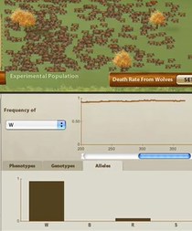
- abundance of red pigs (R rare allele), some brown pigs (B common allele)
- allele frequencies do not change

THUS:
- in a large population, in the absence of selection, starting allele frequencies determine future allele frequencies

- applying Punnett squares to populations
- use product rule to predict offspring genotypes
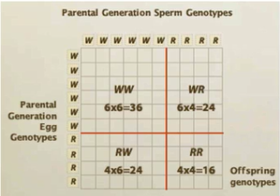
- if we know the starting allele frequencies, Hardy-Weinberg principles:
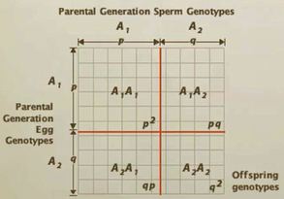

CQ: What if a population contains many alleles?
B (p=0.3), W (q=0.3), and R (r=0.4)
How many possible genotypes are there?
Ans: 6

Lecture 13
October-24-12
10:32 AM

Selection and Fitness

IS

Outcomes
1. Meaning of deme, population, allele frequency, genotype frequency
2. Allele frequencies in a population, given the genotype frequencies
3. Genotype frequencies in the next generation, given the allele frequencies and assuming Hardy-Weinberg equilibrium
4. Assumptions of Hardy-Weinberg equilibrium

Lecture

Outcomes
conditions necessary for Hardy-Weinberg equilibrium
whether a population is in HWE, given observed genotype or phenotype frequencies
effect of selection on changes in allele frequency
relative vs absolute fitness
how to calculate relative fitness
how to quantify strength of selection
relationship between dominance/recessiveness of alleles and response to selection.
effect of heterozygote advantage on genetic variation
why the amount of genetic variation in a population is important
different types of selection (stabilizing, directional) and their effect on genetic variation

Hardy Weinberg Principle

- recessive alleles don't automatically die out
- dominant alleles aren't extremely superior

CQ: If this population is in Hardy-Weinberg equilibrium at MC1R, what percent of pigs are genotype WR?
Ans: 0.24: 0.12 (q*r) from W-mom, R-dad; 0.12 from W-dad, R-mom

In a large, random-mating population, where mutations are rare enough to be ignored, in the absence of immigration or emigration, and if there is no selection...
…then we can use allele frequencies to calculate genotype frequencies:

f(A₁A₁) = p² f(A₁A₂) = 2pq f(A₂A₂) = q²

- only occurs if all assumptions are met

1. Use observed phenotype or genotype frequencies to calculate allele frequencies
- calculation of genotype frequencies and allele frequencies
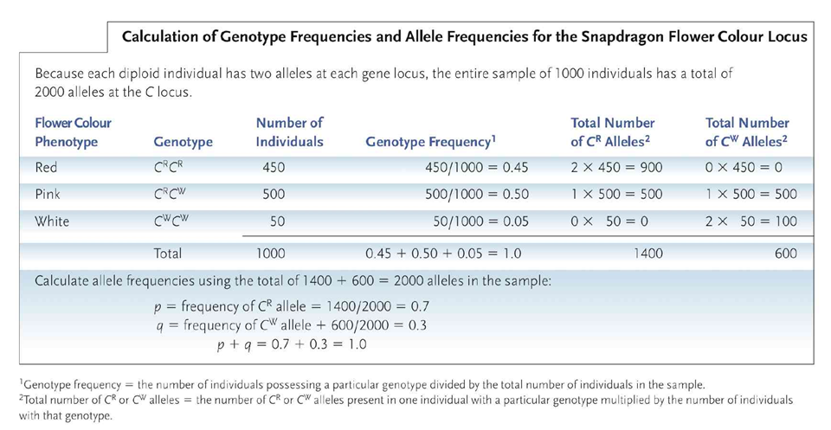
2. Use product rule to calculate expected genotype frequencies (under HWE)
- if all HWE conditions are met, then these are expected ratios
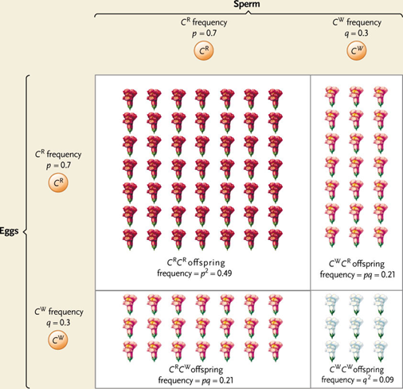
3. Compare observed vs expected genotype frequencies: is the population in HWE?
Which of these populations are in HWE at the G locus?
25% GG, 50% Gg, 25% gg HWE
10% GG, 80% Gg, 10% gg not HWE (too many heterozygotes)
49% GG, 42% Gg, 9% gg HWE

- Hardy-Weinberg is a "null model"
- tells what happens when evolution does not occur
- to recognize evolution, we need to know what a non-evolving population looks like
- if genotype frequencies can be predicted from allele frequencies, population is in HWE at this locus
- allele frequencies will not change while this is true (evolution not occurring)
- as long as population is in HWE, no evolutionary forces are operating

- if expected genotype frequencies are different from observed genotype frequencies, then population is not in HWE
- thus, one or more assumptions of HWE are violated; the population may be evolving

Selection

- two alleles in a population, B (black) allele and R (red) allele
- scenario: 5 red, 5 black (equal amount)
- apply mild selection pressure: 20% of black pigs eaten by wolves before adulthood
- B allele decreases over time, R increases
- 80% of black pigs eaten by wolves
- B allele frequency disappears much quicker
- if selection pressure is weak, evolution proceeds slowly
- if selection pressure is strong, evolution proceeds quicker

Fitness

- for each genotype we can estimate (based on lifetime reproductive success, survival…):
- average absolute fitness (W)
- quantify absolute fitness for a genotype in terms of how many offspring they produce
- use same measure of absolute fitness for all genotypes
- average relative fitness (w)
- by definition, fittest genotype(s) has w = 1
- all others w = W/W_{max}
- difference in w between genotypes reflects strength of selection

- dominance interacts with selection pressure
- scenario:
- selection of 80% of red pigs eaten by wolves
- R allele decreases over time, but still hangs in there
- never goes to 0
- R allele is sheltered in the form of heterozygotes
- R allele will always be in the heterozygotes
- even if the R allele is deleterious
- similarly, dominant allele will go pretty high in frequency but may never reach 1
- most genetic disorders in recessive alleles (if they were in dominant alleles, then natural selection wouldn’t be true)

- simplest selection: selection in favour of one allele
- selection is arguably the most important evolutionary force
- heterozygosity: what percentage of a pop. is heterozygote in a given locus

- if a population lacks genetic variation, it cannot adapt to a changing environment
- raw material of evolution
- sufficient levels of variation/polymorphism to adapt to environmental change

- inbreeding depression (in song sparrows)
- offspring of close relatives tend to have low fitness
- more likely to get two copies of a recessive (deleterious) allele

- scenario:
- population favours heterozygotes
- only pigs with high fitness are heterozygotes (red, many spots; 0.3 death rate), red: 0.3
- almost always if a pop. is out of HWE, pop. is probably evolving
- but in heterozygous advantage, it can be out of HWE but not necessarily evolving
- allele frequencies not changing

Selection on quantitative traits: stabilizing, directional, disruptive
- most traits are under stabilizing selection (most dominant form of selection)
- indicates the phenotypes that have the highest fitness
- ex. babies that are born very light or very heavy, they have low survivorship compared to babies that are born around the average
- directional selection: individuals at one end of the extreme are favoured
- shifts the mean value toward the one extreme side
- ex. long tails on birds, faster runners for cheetahs
- why hasn't directional selection already removed all gen. variation for traits related to fitness?
- selection pressure varies over time, and across habitats
- not always uniform, can be one extreme then the other extreme
- adaptations (traits that increase bearer's relative fitness) are environment-specific
- disruptive selection: less common than stabilizing and directional
- opposite of stabilizing
- individuals at either extreme are favoured
- eventually more and more on extreme sides
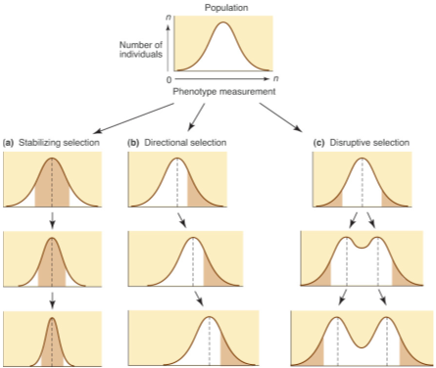

Lecture 14
October-28-12
5:09 PM

Selection versus Other Evolutionary Forces

IS

Evolution: Principles and Processes
i) Chapter 15, sections "Selection and Mimicry" and "Selection and Industrial Melanism" (pg 295-298).
ii) Chapter 13, "Additional Sources of Variation in Populations": pg 249 only.

Outcomes
1. difference between Batesian and Mullerian mimicry
2. how the population frequency of a mimic phenotype may affect its fitness
3. why the same phenotype may be selected against in one environment but have a selective advantage in a different environment
4. meaning of genetic load and genetic death

Selection and Mimicry
- conditions responsible for polymorphism
- mimicry is one of the most obvious examples of convergent evolution
- frequency-dependent selection
- Batesian mimicry: mechanism where palatable species that mimic distasteful models are protected against predators
- non-harmful species mimic harmful species to fend off predators
- Müllerian mimicry: sharing of a common warning colour/pattern among several species that are all dangerous to predators
- benefits both species by enabling predators to learn a single warning pattern that applies to all potential but distasteful prey
Selection and Industrial Melanism
- in a population, there is a variety of genotypes, each of which is superior in a particular habitat
- industrial melanism: effect of dark-coloured pollution increasing the frequency of darkly pigmented (melanic) forms
- perhaps because of selection by predators against non-pigmented or lightly pigmented forms

Additional Sources of Variation in Populations
- genetic load: extent to which a population departs from an optimal genetics
- loss in average fitness of individuals in a population because the population carries deleterious alleles
- genetic death:

Lecture

Outcomes
effect of various types of selection on amount of variation in a population.
examples of stabilizing, directional, disruptive.
reasons why directional selection does not remove all genetic variation from a population.
characteristics, and examples, of frequency dependent selection.
reasons why all living things are not perfectly adapted to their environment.
effect of genetic drift on allele frequencies within a population, particularly in the case of bottlenecks etc.
effect of genetic drift on variations between populations.
mechanism that explain why mutation is NOT directed toward the needs of the organism.
general fitness effects of mutations.
why most mutations that affect fitness are harmful.
effect of gene flow on allele frequencies.
characteristics of adaptive vs. non-adaptive mechanisms affecting allele frequency.
how various evolutionary forces reinforce or oppose one another.

Frequency-Dependent Selection
- negative frequency-dependence
- e.g. predators form search images (see which are most recognizable) of prey
- preferentially hunt common forms
- advantage of being rare (balancing selection)
- provides a fitness advantage if you are a rare form
- results in both alleles in the population being maintained; a balance
- as common form dwindles, rare form will not be rare anymore
- rare male mating advantage: females will choose rare male phenotype (e.g. white eyed drisophila as opposed to common red eyes)
- positive frequency-dependence
- e.g. warning colouration
- brightly coloured; advertises the fact that they are toxic
- predator has bad experience with those species, so they avoid other species that also look like that
- thus selective advantage goes to common form
- instead of both alleles being maintained, advantage of common form will replace the other allele

ThinkOn: Why aren't all living things perfectly adapted to their environment?
Selection --> Adaptation (But not Perfection)
- gene flow and genetic drift: selection is not the only evolutionary force operating
- selection is limited by available genetic variation (raw material of selection)
- limited by dominance relationships
- when deleterious alleles are recessive, they will be maintained at a low level
- selection/adaptation plays catch-up after environment changes
- environment continually changes, so adaptations are always at least one generation behind
- trade-offs: compromise between competing demands
- male bird has to attract female birds (e.g having long tails) but also has to fly (long tail restricts flying)

- selection is the only force driving adaptive evolution
- but there is nonadaptive evolutionary forces
- recall Hardy-Weinberg assumptions:
- very large pop size
- no mutation
- no gene flow
- random mating
- no selection

Other Evolutionary Forces
- genetic drift: whenever population size is less than infinite
- random, unpredictable changes in allele frequencies due to sampling error
- drift strongest in small populations, and populations suddenly becoming small (bottleneck, founder events)
- e.g. flipping coin 2000 times and getting heads is surprising, but flipping coin 10 times/heads is not
- e.g. low genetic diversity in cheetahs (population went through bottleneck [reduction in pop size])
- given enough time, one allele goes to fixation (1), other alleles disappear
- e.g. polydactyly in Pennsylvania Amish (founder event; founded by a small amount of individuals)
- why small populations are a huge concern because they might be swamped by founder/genetic drift
- drift often opposes selection
- outcome depends on strength of selection, and population size
- how does drift affect variation within a population?
- decreases variation
- how does drift affect variation (differences) among populations?
- increases variation
- if we had 100 pops subjected to genetic drift, and all started off of equal frequencies of A and a, in some pops, A will go to fixation, and in others a will go to fixation
- because of random processes: drift

- mutation: creates new alleles
- not "random", but not directed towards the needs of the organism either
- most mutations have neutral or nearly-neutral effects on fitness
- of those that affect fitness, most (but not all) are harmful
- mutation often opposes selection, but also provides raw material for adaptive evolution
- e.g. if taking apart laptop, randomly switching wires around, easier to make it worse than to make it better
- similarly, most mutations will be harmful

- gene flow (migration): moves alleles between populations
- like mutation, can introduce new alleles
- also often opposes selection (selection-migration balance)
- selection-migration balance: preventing local populations to become perfectly adapted to their selective environments
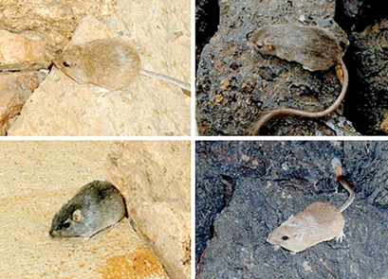
- e.g. adapted mice aren't always where they should belong (e.g. if they look for food), so they oppose selective forces (gene flow)

How do these evolutionary forces reinforce or oppose one another?
- selection (several kinds) [adaptive]
- genetic drift
- mutation
- gene flow

Which have similar effects on genetic variation within a population?
On differences between populations?

- Hardy-Weinberg also assumes random mating with respect to genotype
- but mating is often non-random
- inbreeding (ants) or inbreeding avoidance (humans)
- reflects entire genome
- assortative or disassortative mating
- e.g. assortative: blue-eyed mates with blue-eyed
- e.g. disassortative: "opposites attract"
- ex. white/tan-throated sparrows: type I is aggressive, type II isn't; can't have two type Is

Lecture 15
October-31-12
10:30 AM

Why Evolution is True

IS
Chapter 17, sections 17.1, 17.2, 17.3, 17.4
Outcomes
1. how Darwin's theory of evolution differed from that proposed by Lamarck
2. meaning of catastrophism, gradualism, uniformitarianism
3. difference between relative versus absolute ages of rock formations and the fossils they contain
4. principle behind radiometric dating of rock strata
5. why most living things never form fossils

Lecture

Lecture Outcomes
types of non-random mating
effect of non-random mating on HWE and on evolution
characteristics of a scientific theory
components of the theory of evolution
evidence for "descent with modification"
examples of homology and why they support the idea of evolution
examples of vestigial traits and why they support the idea of evolution
role of fossil record as evidence for evolution

- non-random mating and evolution
- if a pop begins mating assortatively for a certain trait, but all genotypes have the same fitness, what will happen?
- at a locus: 2 alleles, 3 genotypes (AA, Aa, aa)
- intermediate dominance
- heterozygotes have distinct genotype; can distinguish themselves from other genotypes
- each genotype mates assortatively
- nonrandom mating disrupts HWE, but does not cause evolution
- 250 AA, 500 Aa, 250 aa

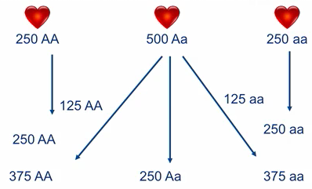
- thus fewer heterozygotes
- pop falls out of HWE, but allele frequencies do not change

Evolution
- a scientific theory: a coherent set of testable hypotheses that attempt to explain facts about the natural world
- atomic theory of matter
- germ theory of infectious disease
- gravitational theory

Six main aspects to this theory:
- Evolution happens: change in allele frequencies in a population, between generations
  - Changes in environment
  - Natural selection
  - Change in gene frequencies (loss of particular alleles due to random processes (genetic drift))
- Most evolution is gradual
  - Evolution is not always super slow (bacteria, viruses can evolve quickly)
  - See many transitional forms linking ancient species to modern species
- Speciation happens
  - Single common ancestor of all living things, and winding up to all the species living today
- All life is related through common ancestry
  - Any species can be traced back to find out MRCA
- Much of evolutionary change is caused by selection
  - Natural selection
- Evolution occurs in populations, not within individuals
  - Populations change but individuals do not adjust in response to selection
  - Start off with variable population, but due to differences in fitness between phenotypes, wind up with population gradually changing its composition over time

- descent with modification (from a common ancestor)
- homologies
- intermediates in fossil record
- earth must be old
- vestigial traits
- fossil evidence that species change
- fossil evidence that lineages split (speciate)
- direct observation of evolution in real time

- descent: homologies show common ancestry
- structural, developmental, and molecular similarities
- homologies: similarity between two species, not explainable by shared function, that reflects shared ancestry
- turtle, human, horse, bird, bat, seal have structural homology: same bones, different function
- developmental homology: embryos of different species are similar
- molecular homology: different species have similar genetic codes as others
- we all have same genetic code because we were all inherited from the same ancestor

- descent: transitional forms link related groups
- ancestral whale:
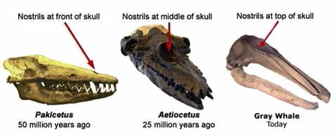

- modification: fossil evidence of change
-

- vestigial traits
- morphological: dandelions have sexual parts but reproduce asexually
- molecular: already a gene

Lecture 16
November-04-12
3:53 PM

Why Sex?

IS
i) Chapter 7, pg 126-134. Look at sections "Sex-linked genes and sexual reproduction"; "Sex determination"; "Sex Chromosomes"; "Autosomes and sex determination"; and "Environmentally induced sex determination" (including Boxes 7.3 and 7.4).
(You do not need to read Fig 7.3 or Box 7.2.)
Outcomes
1. Relationship between sexual reproduction and genetic variation
2. Different modes of genetic sex determination
3. Different modes of environmental sex determination
4. Meaning of haplodiploid
5. Meaning of hermaphrodite, and whether hermaphroditism is generally rare or common in plants

Lecture

Lecture Outcomes
relationships among sexual reproduction, meiosis and genetic variability
mechanisms of asexual reproduction
examples and predictions of size-advantage model of sex change
distribution of sexual reproduction among all life forms, and particularly among animals
costs of sexual reproduction
cost of meiosis
cost of sons
"Muller's Ratchet" mutational load explanation for advantage of sexual reproduction
"Ruby in the Rubbish" hypothesis explanation for advantage of sexual reproduction
combination of beneficial mutations for advantage of sexual reproduction
relationship between extinction rate and sexual reproduction

- sex and recombination go hand in hand
- recombination - genetic diversity; new combinations of alleles
- via crossing over, independent assortment
- offspring distinct from either parent and usually each other
- exceptions: identical twins (not fraternal) (created from same zygote thus identical)
- armadillos: produce identical quadruplets

- sex does not necessarily mean reproduction
- you can have sex without reproducing, and reproduce without sex
- ex. binary fission: mother cell divides and gives rise to two daughter cells
- ex. quaking aspen colony: facultatively sexual
- option of reproducing sexually (pollen, fertilize flower, ovule, etc)
- or asexually: vegetative propagation (sending runners along the ground and growing closeby to parent)
- ex. amazon molly: obligately asexual
- lay eggs and give rise to clones of themselves
- they need to be in close contact with sperm of a male of related species (sexually reproducing)
- never actually fertilizes though

- sexually reproducing organisms may be dioecious or monoecious
- dioecious: male or female; male gametes are housed in one individual, females in other
- in humans, some plants
- monoecious: one individual holding both male and female functions (e.g. roses); hermaphroditic
- e.g. sea slugs - hermaphrodite/monoecious
- these are simultaneously monoecious
- sequentially monoecious (sex change)
- e.g. bluestreak wrasse (fish): born female, but once it reaches an absolute threshold body size, changes sex to male in a matter of hours
- e.g. clownfish: born male, become female

- fitness and body size correlation
- large female has more to gain by being large, more to lose if it is small
- if you are small, better to be a male; if you are large, better to be a female
- protandry: when two lines cross, that is when the sex change occurs
Size-Advantage Model of Sex Change:
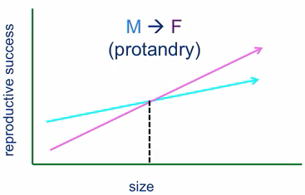
- if males are competing for access for females, then there is an advantage of being large for male

Distribution of Sex
- first life forms almost certainly reproduced asexually
- vast majority of living things (mostly unicellular, perhaps) reproduce asexually (except plants and animals)
- sexual reproduction: more derived state; asexual: ancestral state
- but vast majority of animals reproduce sexually
- obligately asexual species are rare

Why Reproduce Sexually
- seems as though there are serious costs of sexual reproduction
- cost of mating (takes time, energy; predators; chosen mate already taken)
- cost of meiosis: reproducing sexually, passing only half of genes/alleles go into next generation - diluting own genome
- cost of males: females who reproduce asexually will easily outcompete females who reproduce sexually
- only daughters are the ones that produce next generation offspring
- but sexual reproduction produce daughters and sons
- mutational explanation for sex
- sexual recombination benefits the species by speeding up evolution (evolve/adapt quicker)
- speeds up rate of discarding harmful mutations
- speeds up rate of combining beneficial mutations
- this decreases the likelihood of extinction
- Muller's ratchet: asexual lineages accumulate harmful mutations
- with every generation, there is more opportunity for things to go wrong
- no way to get rid of harmful mutations
- over time, more harmful mutations will accumulate
- thus will go extinct eventually
- sex breaks this ratchet; can throw away harmful mutations
- Ruby in the Rubbish hypothesis: every time you reproduce sexually, it is a gamble
- sometimes you will result in beneficial genes, but sometimes it will be deleterious
- sex continually creates genotypes with fewer (and more) harmful mutations than parental genotypes
- by reforming new genotypes, some genotypes are going to have more harmful mutations
- sometimes, stumble across some rubies

- not all mutations are deleterious
- some are advantageous
- sex can speed up the rate at which beneficial mutations will occur in an individual
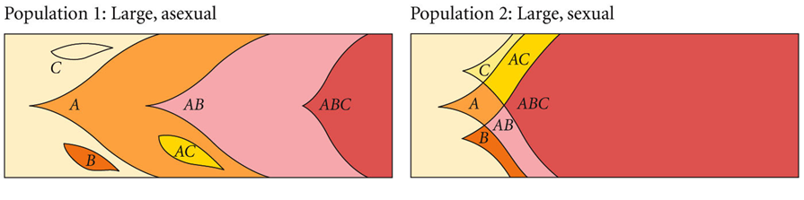
- if reproduced sexually, there is a good chance that an individual in pop. 2 will have more than one of the beneficial mutations
- soon some individuals will have 3 beneficial mutations - best fitness
- both wind up eventually to have all three (ABC), but sexual is way quicker

- sex decreases extinction risk
- ex. dandelions still have sexual parts, but reproduce asexually
- ex. rotifers: they are the one type of animal where obligate asexual reproduction seems to have persisted through a long evolutionary time (why haven't they gone extinct yet?)
- but turns out they have another way: they have high rate of horizontal gene transfer

ThinkON
Over evolutionary time, sexual populations usually outlast asexual populations. So does this explain the persistence of sex?
- traits almost never spread among a population if it benefits the populations at the expense of the individual
- altruism is fundamentally unstable

Lecture 17
November-07-12
9:22 PM

Sexual Selection

IS
i) Chapter 39, pg 981-983. Look at sections "Mates as Resources"; and "Sexual selection".
ii) Chapter 16, p 376 (section 16.3e) and 378 (Figure 16.13)
Outcomes
1. Meaning of monogamy, polygamy, polygyny, polyandry, promiscuity, lek
2. Conditions favouring the evolution of monogamous versus polygynous mating systems
3. Handicap explanation for why females prefer males with extravagant ornaments
4. Meaning of sexual dimorphism, intersexual selection, intrasexual selection

Lecture

Lecture Outcomes
“lottery ticket hypothesis” and “red queen hypothesis” to describe the relationship between environmental stability and benefits of sexual vs. asexual reproduction
long-term vs. short term advantages to sexual vs. asexual reproduction
why sex places different selective forces on males vs. females
relationship between sexual selection and investment in offspring
role of parasites as an explanation for the persistence of sexual reproduction
how sexual selection maintains traits seemingly incompatible with natural selection
examples of traits favoured by intra vs. inter sexual selection
why males are more usually competing for access to females (rather than vice versa)
relationship between parental investment and which sex is choosy vs. competing
what happens (in terms of sexual selection) when both sexes invest heavily in offspring
average vs potential fitness of males vs females
limiting factors on male vs. female fitness
traits valued in mate choice by human males vs. females

- selection does not favour traits that benefit long-term persistence of 'the group' at the expense of immediate individual fitness
Ecological Explanations:
- in a changing environment, sex benefits individuals
- lottery ticket hypothesis: sex in constant versus unpredictable environments
- if a female survives into reproductive age in a given environment, then it must be surviving well in the current adaptive conditions
- if environment is extremely stable, and offspring is going to experience the same environment as parent, then asexual reproduction makes sense
- if environment is changing, offspring does not necessarily mean it will survive the same way parent does
- thus, reproducing asexually in a changing offspring is as stupid as buying the exact same lottery ticket multiple times
- you want to reproduce sexually to maximize the chance that at least some offspring will be well suited to the new environmental conditions
- red queen hypothesis: sex is favoured when your environment (natural enemies) is continually evolving
- keep running just to stay in the same place, not to fall behind
- if disease-causing organisms (parasites, viruses) are in place (enemies), all of them are continually evolving
- thus the individual benefits to rapidly reproduce diverse offspring
- places with more infections (selection pressure) have more sexual reproduction
- to summarize
- sex is costly and inefficient, but phenomenally successful
- long-term advantages
- removing harmful mutations, and combining helpful mutations
- short-term advantages
- bet-hedging in a changing environment (Lottery Ticket/Red Queen)
- which is more important in maintaining sex?
- ecological explanations (lott/queen)
- reduced extinction risk may be just a consequence of sex, not an explanation

Sexual Selection
- a consequence of sex
- explains sexual dimorphism
- advantageous for males to look a certain way, and vice versa
- explains traits that reduce survival
- intrasexual selection: competition between members of the same sex (usually males) for access to other sex
- e.g. convergent evolution of horns (weapons)
- e.g. body size in males (ex. elephant seals)
- intersexual selection: (female choice) females choosing between males (with males competing more indirectly)
- e.g. long tails in birds, ability to sing
- sometimes, selection can be favoured by both male competition and female choice (intra + inter)
- e.g. bowerbirds love the colour blue, so the males surround their "nest" (bower) with blue things to attract females (inter)
- also intra, because males will sabotage each other's bowers (steal blue, bring in red, rip it up)
- why is it usually females choosing; and why choosy?
- for males, more females mated, increased fitness
- females are limited by # they can produce, so there is no relationship with # of males mated with and fitness
- females are focused on increasing offspring quality
- direct benefits:
- e.g. if male cricket is interested in female cricket, he will bring an ant (gift) and a spermatophore
- e.g. house finch: brighter males are better fathers - better able to forage, berries cause the pigment thus they are good foragers
- indirect (genetic) benefits:
- e.g. grey tree-frog: sings well; leads to offspring is more likely to hatch successfully and survive

- anisogamy - unequal gamete size
- eggs are energetically costly to produce
- sperm is not
- sex differences in parental investment and potential fitness determine which sex is choosy, and which sex competes
- low investing sex (less parental care) spends a lot more time competing for high investing sex

- selective forces on males and females
- what determines fitness of a male, versus fitness of a female?
- males: higher quantity, less quality
- females: higher quality, less quantity
- potential fitness is always higher for males
- males and females have the same average fitness because in most populations, there is 50/50 m/f ratio
- more variation for males (extreme highs and lows)
- less variation for females around that average

Parental Investment and Sex-Role Reversal
- e.g. red phalaropes (birds) are competing for access for male (sex-role reversal); male provides parental investment
- e.g. seahorses: female lays eggs but male gestates egg

- for humans, when it comes to choosing long-term mating partners,
- males prefer physical attractiveness in females more, but females too
- facial, body symmetry are predictors of how attractive somebody is
- because someone who is developed symmetrically, has high developmental stability
- able to withstand all the stresses of development
- perhaps they did not get sick from flu when face was still developing

Lecture 18
November-11-12
12:51 PM

Cooperation and Conflict

IS
Chapter 39, Sections 39.13 "Kin selection and Altruism" (including Figure 39.37) and 39.14 "Eusocial animals".
Outcomes
1. identify the meanings of kin selection, altruism, reciprocal altruism, eusocial
2. calculate degree of relatedness between two individuals, given the type of relationship (parent-offspring, cousins, etc)
3. identify why haplodiploidy can favour high levels of cooperation in social insects

Kin Selection and Altruism

- family members share alleles inherited from ancestors
- by calculating degree of relatedness, average percentage of alleles shared by relatives can be figured out
- half-siblings share one genetic parent: 0.25 of alleles by inheritance from shared parent
- degree of relatedness: 0.25
- full siblings share both parents' share (0.25 from both mom/dad): 0.5
- degree of relatedness between nephew/niece and aunt/uncle: 0.25
- degree of relatedness between first cousins: 0.125
- kin selection: individuals should be more likely to help close relatives because increasing a close relative's fitness means that the individual is helping to propagate some of its own alleles
- extent of altruistic behaviour by an individual to another is directly proportional to % of alleles they share
ex:
- male grey wolf helps his four younger full siblings (0.5 of his genes)
- created "by proxy" two copies (0.50 x 4 = 2) of any allele they shared
- but, if he raised two offspring, each would carry half of his alleles, preserving only one copy of a given allele (0.5 x 2 = 1)
- altruism: doing something that enhances the situation of another individual
- reciprocal altruism: each member of the partnership can potentially benefit from the relationship
- would be favoured by natural selection as long as individuals that do not reciprocate are denied future aid
- eusocial: form of social organization (in some insect species) where numerous related individuals live and work together in a colony for the reproductive benefit of a single queen and her mate(s)

- haplodiploidy can favour high levels of cooperation in social insects
- female bees are diploid because they receive a set of chromosomes from each parent
- male bees (drones) are haploid because they hatch from unfertilized eggs
- all sperm will be genetically identical because he has only one set of chromosomes
- when queen bee mates with just one male, all worker offspring will inherit same set of alleles from male parent (at least 50% degree of relatedness)
- plus 25% through female parent
- thus workers are related by 75%
- higher degree of relatedness than they would have to any offspring they would have produced had they been fertile
- high degree of relatedness among workers leads to high level of cooperation

Lecture

Lecture Outcomes
examples of different types of social interaction
behaviours that are, or are not, "altruistic"
how kin selection theory explains selection for altruistic traits
direct vs. indirect vs. inclusive fitness
reasons why cooperation can evolve in face of prisoners' dilemma
role of human emotions in support of reciprocal altruism
conflicting interests of parents vs. offspring

(Lec 17 cont'd)
- females rank potential mates with athletic ability, kindness to children, resource holding potential (likelihood of being successful)
- males rank potential mates with cues that indicate fertility (facial and body attractiveness: small waist relative to hip size)

CQ: Males care more about partner cheating sexually, whereas females care more about cheating emotionally.
- males do not want female to have offspring with another person
- females do not want male to not invest their emotion to another person

Sexual Selection
- low investing sex will competing for the high investing sex
- sex differences in males vs females, short-term sexual relations, different kinds of jealousy

---------------------------

- selection is fundamentally competitive
- there is struggle for existence
- but within the world, there is an abundance of group living and cooperation
- wolves, fish, elephants, amoeba
- cooperation is widespread, group living is even more widespread

Types of Social Interaction

 | Actor Benefits | Actor is Harmed
Recipient benefits | Cooperation | Altruism
Recipient is harmed | Selfishness | Spite

- many examples in the world of selfishness, cooperation
- why would spite ever be favoured?
- extremely rare; almost never happens
- altruism
- Darwin identified altruism as a potentially huge problem
- providing care to own descendants (offspring) is not altruism
- parents are also getting their own genetics carried on
- adult ground squirrels who give out an "alarm" call because of predators hides offspring but risking her own survival
- bird species offspring forego own opportunity to reproduce and help raise other offspring

How can traits reducing fitness (offspring production) be selectively favoured?
- Sacrificing individual fitness for the good of the group? (False)
- More to "fitness" than simply producing direct descendants
- personal reproduction --> direct fitness
- additional reproduction by relatives, due to your ‘altruism’ --> indirect fitness
- direct + indirect = inclusive fitness
- kin selection favours traits that increase indirect fitness
- Hamilton's Rule determines whether "altruistic" (costly) traits will be favoured
- rb > c
- when rb is greater than c, benefits outweigh costs; should be favoured by kin selection
- b: benefit received by donor's relatives
- r: weighted by degree of relationship
- c: donor's direct fitness
- does this outweigh costs to c?
- two brothers = eight cousins (in terms of genetic relatedness)

- Prisoner's Dilemma
- defecting is always the rational choice
- but payoff for mutual defection is worse than payoff for mutual cooperation
- both players would be better off if they could trust each other
- solutions:
- if the partners have had repeated interactions in the past, then selection will favour cooperation (not necessarily same family; not kin selection)
- most likely when groups are small and stable, and when individuals can recognize and remember helpers and cheaters
- human emotions (trust, resentment, guilt, gratitude) as adaptations for reciprocal altruism (score-keeping)

Inclusive Fitness
- explains much self-sacrificing behaviour
- also explains conflicts between relatives
- parent-offspring conflict: how much, how long to invest in a particular offspring?
- the longer a parent provides care to an individual offspring
- benefits to parent and offspring through increased offspring fitness
- but diminishing returns
- ex. give 2 gallons of milk to baby, same as giving 10 gallons
- costs to parent and offspring
- lost opportunity for parent to produce other offspring
- relatives have overlapping, but not identical, genetic interests
- parent is equally related to all offspring, so they should cut offspring once b < c
- offspring is twice as related to itself as to siblings, so they should demand care until b < 2c, then become independent

Outcomes
examples of different types of social interaction
behaviours that are, or are not, "altruistic"
how kin selection theory explains selection for altruistic traits
direct vs. indirect vs. inclusive fitness
reasons why cooperation can evolve in face of prisoners' dilemma
role of human emotions in support of reciprocal altruism
conflicting interests of parents vs. offspring

Lecture 19
November-14-12
11:04 AM

Speciation

IS
Evolution: Principles and Processes
Page 308, "Species identification and species concepts" and "Morphological species".
Page 313-316 (don't worry about Fig 16.2) "Biological species"
Page 316-317 "Evolutionary species"
Outcomes
1. identify the differences between morphological, biological and evolutionary species concepts
2. identify strengths and limitations of each of the above three species concepts

Lecture

Lectures Outcomes
Meaning of parent-offspring conflict, tragedy of the commons, morphological species concept, biological species concept, phenotypic clusters, pre-zygotic vs. post-zygotic isolating mechanisms; ecological (habitat) isolation, temporal isolation, behavioural (courtship) isolation, mechanical isolation; hybrid inviability, hybrid sterility; allopatric, peripatric, parapatric, sympatric; speciation; isolation, divergence, secondary contact, reinforcement
- why conflicts of interest can arise even between closely related individuals
- why rational decisions by individuals can lead to the overexploitation of shared resources
- applications of, and strengths and weaknesses of, biological vs morphological species concepts
- which species concept is being used, given ‘real world’ examples
- which type of isolating mechanism is occurring, given ‘real world’ examples
- why coming into secondary contact is not required for speciation to occur, but can promote prezygotic isolation
- role of islands in speciation
- why most speciation occurs in allopatry (ie why parapatric and sympatric speciation are rare)
- how polyploidy can induce sympatric speciation
(Lec 18 cont'd)
- coefficient of relatedness explains a lot of conflict in evolution context: within a family group
- parent-offspring conflict before birth
- fetus selected to 'demand' more resources from mother than mother selected to give
- a lot of difficulties and health risks associated with pregnant women
- because of asymmetry in relatedness
- fetus is selected to get just a little bit stronger than mother
- "tug of war" situation: how much should the mother provide?
- played out within the body of the mother, played out by placenta
- fetal tissue in placenta secrets allocrine hormones to manipulate the physiology of the mother; elevates maternal blood pressure and blood sugar
- goes in best interest for fetus
- but mother also does not want to
- maternal sensitivity to these signals drops
- this conflict endangers both parties
- gestational diabetes, pre-eclampsia

- unrelated individuals may have similar, but not overlapping, interests
- Tragedy of the Commons: social dilemma (conflict) over use of shared resource
- a resource is shared by multiple individuals but there is asymmetry (a lack of complete overlap)
- 10 farmers each own their own cows, but all share "the commons" (the land that the cows live on)
- as more cows are added, cost of overgrazing shared by all the farmers
- benefits of owning another cow are not shared
- everyone shares the cost, but only individual benefits
- so in best interest for farmers to keep adding cows
- and this is a tragedy because rational decisions by individuals leads to overexploitation of shared resource

Summary
- altruism, like sex, is puzzling
- but more we examine, examples of true altruism become harder and harder to find
- many "altruistic" traits may not be truly costly at all; increase indirect fitness
- can be explained by shared genetic interests; others by reciprocity; but rational decisions by individuals may deplete shared resources
- even when genetic interests overlap (family groups) they can be different enough to induce conflict
- asymmetry will lead to conflict

Species and Speciation
- macroevolution (as opposed to microevolution that has been prevalent prior to this lecture)
- speciation marks the lineage between micro/macro

Morphological Species Concept
- species concept that identifies species according to whether or not they look similar to each other
- members of the same species look morphologically more similar than they are to any other group/organism

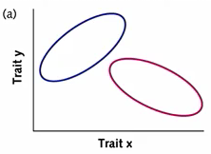
- no overlap between species
- runs into problems when there is sexual dimorphism
- when sexual selection is strong, males in a species can often look very different compared to females

Biological Species Concept
- most widespread species concept
- defines species based on criterion of interbreeding
- species: interbreeding (or potentially interbreeding) group of individuals, reproductively isolated from other such groups
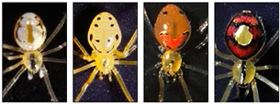
- all one species (assuming they reproduce with each other): just a lot of phenotypic variation
- polymorphic species but a single species; all one big gene pool; not reproductively isolated

Limitations to Biological Species Concept
- grey area: hybrids such as ligers/tigons
- does this occur in natural conditions?
- does this hybrid have normal fitness? (can it interbreed with other species; sterile?)
- two populations that never have the opportunity to interbreed; geographically separate from one another (no one would know) [geographic isolation]
- extinct species (no one would know)
- asexual reproductive organisms
- they reproduce through binary fission so no one would know if same species since they do not interbreed

- at what point does one lineage become two distinct lineages
- achieving reproductive isolation: prezygotic isolating mechanisms
- temporal isolation: different breeding seasons
- habitat isolation: cold, dark; warm, bright; etc.
- behavioural / courtship isolation: other species find other species unattractive; females refuse to mate with the male
- mechanical isolation: sexual organs do not fit together
- achieving reproduction isolation: postzygotic isolating mechanisms
- hybrid inviability: hybrid does not survive (for long); more costly because of investment of time given already
- hybrid sterility: no problem reaching adulthood, but sterile; evolutionary dead end

Speciation
- allopatry
- geographic isolation/barrier
- populations diverge (selection, drift)
- given enough time, they will diverge until they will no longer interbreed with each other
- thus speciation has occurred
- secondary contact, if it occurs, may either reinforce reproductive isolation or re-establish gene flow
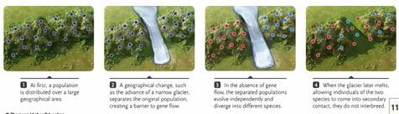
- types of allopatric speciation:
- peripatric: large source population; small population splits off and is separated by some sort of barrier
- parapatric: ranges of two populations are neighbouring each other (adjacent); the barrier is "leaky"
- not complete geographic isolation; some gene flow
- generally less likely to result in speciation since there is some gene flow

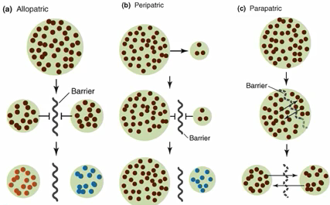
- thus most of the time it is either allopatric or peripatric that results in speciation
- speciation occurs often on islands
- e.g. Galapagos Islands: 13 species of Darwin's finches, all reproductively isolated
- e.g. Hawaii: >100 species of Drosophila
- because of isolation; limitations to resources; differences in predators

- populations may come back into secondary contact
- if little divergence has happened, resume interbreeding (hybrid swarm)
- if divergence has happened long enough, populations may become reproductively isolated
- evolved differences in courtship, etc.
- unfit hybrids
- direct selection favouring prezygotic isolating mechanisms (reinforcement)
- postzygotic isolation: low fitness
- reinforcement: avoiding mating with wrong population
- if postzygotic isolation happens, puts selection favouring prezygotic isolation
- does pre/postzygotic isolation occur first?

- speciation without allopatry:
- polyploidy: "instant" sympatric speciation
- if a diploid parent goes through a mistake in meiosis and accidentally produces diploid gametes and fuses to form a tetraploid offspring; then that offspring is going to be separated from parents

Lecture 20
November-17-12
1:24 PM

Phylogeny

IS
Biology: Exploring the Diversity of Life, 2nd Ed.
Chapter 18, up to and including sections 18.3 ("Why it matters; The significance of similarities and differences; Systematic biology, an overview; The Linnaean system of classification").
Outcomes
1. the meaning of systematics, phylogeny, phylogenetic tree, classification, taxon, taxonomic hierarchy
2. why similarities in morphology or lifestyle do not necessarily reflect close relatedness, using examples
3. the two major goals of systematics
4. principles underlying the Linnaean system of classification (species, family etc) and which groupings include which other groupings

Lecture

Lecture Outcomes
correct interpretation of evolutionary trees, close and distant relatives, and where extinct taxa would be placed in a tree
principles of phylogenetics
homology vs. misleading similarities due to convergence of unrelated taxa or misleading
differences due to divergences among closely related taxa, and examples of each
synapomorphies, symplesiomorphies and autapomorphies on a phylogenetic tree
the significance of outgroup analysis

Speciation without allopatry?
- adaptations to a new food type can --> sympatric speciation
- Hawthorn maggot introduced to NA
- subset of maggots began feeding (and mating) only on apples
- competition, disruptive selection and assortative mating --> sympatric speciation
- strong competition with low resources
- stickleback species pairs
- each lake has two distinct forms: a benthic and a limnetic form
- closely related but no longer interbreed
- no intermediate food sources, insipient speciation

- use a metaphor of a phylogenetic tree to describe the pattern of every living species (every leaf is a species)
- in between branches (nodes) represent common ancestors

1. Reading phylogenies
- if you want to know how closely related two species are, need to know how long ago their common ancestor existed
- time passes from root to tips
- how much time? not known, there is no scale bar
- D/E and C/F splits did not necessarily happen at the same time
- some phylogenies convey more information than branching order
- scale bar
- rotating nodes changes nothing
- order in which the "leaves" are arranged from left to right; irrelevant
- higher and lower life forms?
- highly evolved and less highly evolved?
- which group is the most highly evolve?

Q: According to this phylogeny, what are humans' next closest relatives (after birds)?
Ans: A. salamander B. frog C. we are equally related

Q: Is the frog closer related to the fish or the human?
Ans: Human
- last shared common ancestor, farther down in evolutionary time to the fish

Phylogenies are like pedigrees
- who is more closely related to your cousins: you, or your sibling?
Q: Which is more closely related to species K?
Ans: both equally related

2. Building phylogenies
- how do we know which groups are closely related, and which are more distantly related?
- closely related: many traits in common
- more likely to share MCRA
- similarity versus relatedness
- homology: similarity that reflects recent common ancestry
- each species use same bones for different function
- ex. batwing, whale fin…
- homoplasy: misleading similarity, OR misleading dissimilarity
- ex. crocodiles and hippos both have similar placement of eyes, but not a similarity
- just a common adaptation from environment
- same selection pressures
- can also be different selection pressures
- Darwin's finches all have similar structure but different function
- homologous traits lead us towards the correct phylogeny; homoplasious traits mislead
- but without knowing the phylogeny in advance, how do we know if a similarity reflects homology or convergence?
- sometimes, can infer from structure or development
- if underlying structure is similar (patterns of bones), probably similarity due to homology
- another solution is cladistics
- only some similarities are informative
- synapomorphy = shared traits that are derived from a common ancestor
- not all traits are informative
- synapomorphy: shared by two or more groups
- derived from a common ancestor
- symplesiomorphy: shared by two or more groups
- ancestral (trait was also already present in MRCA before the groups diverged)
- autapomorphy
- unique to a single group
- derived within the group
- shared vs unique is easy; what about derived vs ancestral?
- how can we know what traits the common ancestor of a group had?
- find an outgroup; close relative known to have branched off earlier than any of the groups of interest, but does not belong to group of interest

Lecture 21
November-19-12
4:28 PM

Phylogeny II and Evolutionary Ecology

IS
Evolution: Principles and Processes.
Chapter 18, pg 345-353.
Outcomes
1. What happened to the dinosaurs?
2. relative severity of the end-Cretaceous mass extinction, compared to other mass extinction events
3. meaning of orthogenesis
4. factors that enabled mammals to diversify after the end-Cretaceous mass extinction
5. evidence supporting the collision theory regarding the end-Cretaceous mass extinction

- end of Cretaceous Period 65 mya, most dinosaurs died out
- most well supported theory: asteroid impact
- iridium (rare) found in meteorites, also found in a stratum at Cretaceous-Tertiary boundary
- also quartzes that only form in impacts
- Chicxulub crater: said to be site of impact
- more than half of all species of reptiles became extinct at the end of cretaceous
- orthogenesis: species die out by internal factors that cause evolution to proceed in a direction unrelated to selection and adaptation
- ex. nonadaptive characters: large, clumsy antlers of Irish elk Megaloceros
- small mammals survived asteroid impact (small size may not mean it was favourable back when dinosaurs were alive)
- radiated into many forms and diversifying into new habitats
- adaptation of specialized limbs
- breakup of Pangaea enabled more radiation
- changes in vegetation led to new landscapes; thus new habitats for mammalian adaptation

Lecture

Lecture Outcomes
whether a particular trait is probably ancestral or derived, given a phylogeny and a suitable outgroup
whether or not a particular trait is a synapomorphy, given its distribution among the outgroup and the ingroup
why similarity does not always imply relatedness
meaning of parsimony, as it relates to phylogenetic trees
the most parsimonious phylogenetic tree among several options
the importance of monophyletic groups
natural vs. unnatural groupings of taxa, given a phylogeny
why biodiversity changes over time
meaning of adaptive radiation
factors that may trigger an adaptive radiation

- outgroup analysis provides clues to which traits derived, which ancestral
- evolution does not always proceed toward greater complexity (4 legs --> 6 legs)
Reading & Building Phylogenies
- "related to" does not mean "descended from"
- related to siblings, not descended
- "more complex" does not mean "more evolved"
- relatedness does not mean similarity
- not all similarities are homologies
- some traits are similar because homologous, some are convergent
- not all homologies are synapomorphies

- is this trait ancestral or derived?
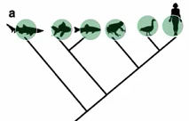
- present in outgroup and all of ingroup: MRCA had the trait: most likely ancestral

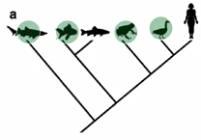
- present in outgroup and some of ingroup: most likely ancestral
- common ancestor of out/ingroup occurred at root; had trait but some lineages lost the trait (one fish, human)

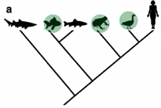
- absent in outgroup, present in some of ingroup: derived

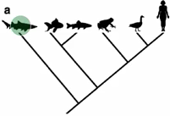
- present in outgroup, but none of ingroup: unknown
- cannot tell if ancestral or derived because there are two equally likely possibilities
- one possibility: MRCA did not have trait; derived on the path to shark
- other possibility: ancestral; loss of a trait in ingroup lineage

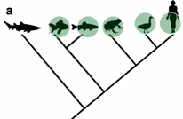
- absent in outgroup, present in all of ingroup: unknown

- parsimony: simplest explanation is usually the best
- whichever tree requires the smallest number of evolutionary changes (gains or losses of a trait), is probably correct
- often used to evaluate potential trees
- more species/groups, larger potential # of candidate trees
- 2 taxa: 1 possible tree
- 3 taxa: 2 possible trees
- 4 taxa: 15 possible trees
- 10 taxa: 34.5 mil trees, etc.

- outgroup
- shark
- ingroup
- chicken
- bat
- chipmunk

- outgroup species should be reasonably related to ingroup, not too distant

- which tree more likely to be correct?
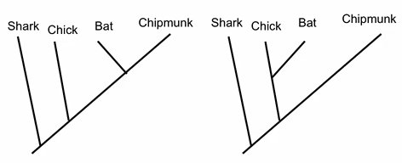
- assess phylogenies: (identify which traits are synapomorphies)
- outgroup
- shark: no milk, no fur, no wings, no beak
- ingroup
- chicken: no milk, no fur, wings, beak
- bat: milk, fur, wings, no beak
- chipmunk: milk, fur, no wings, no beak
- having a beak is NOT a synapomorphy because it has to be shared (only chicken has beak)
- THUS, first tree is correct; more parsimonious
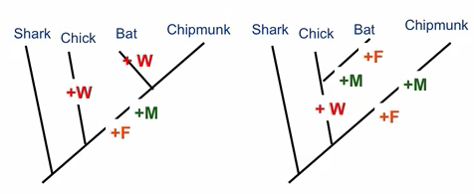

Using Phylogenies in Classification
- in cladistic systematics, only monophyletic groupings are recognized
- monophyletic: all of the descendants of that group's MRCA

- many traditionally-recognized groups are not monophyletic
- prokaryotes are not monophyletic group
- dicots are not monophyletic group

Evolutionary Ecology
- ecology: interactions between organisms and their environment
- abiotic vs biotic components
- biotic: members of other species (predators, parasites) as well as same species
- these interactions affect evolution
- origin and demise of species (rates of speciation, extinction)A

Ecology and Biodiversity
- most species that have ever existed are now extinct; constant turnover and replacement
- biodiversity: # of species currently alive on planet
- varies over time, reflecting the balance between speciation (how fast are lineages/new species forming/becoming reproductively isolated) and extinction (how fast are lineages dying off)
- e.g. land plants over past millions of years, angiosperm species are taking off

- adaptive radiation: rapid speciation into many descendant lineages
- sometimes, speciation occurs very rapidly, some groups will undergo explosive bursts of speciation (new lineages)
- e.g. single species of ancestral finch (in Galapagos); over the course of <2mil years, the ancestral finch gave rise to 14 new lineages; and now all have different ecological niches
- ecological opportunity: competitive release after colonizing new environment
- when founding population made it onto Galapagos, not many competing resources
- new ecological niches became available
- rapid diversification of the ancestral species
- on a larger scale;
- ecological opportunity: competitive release after a mass distinction
- when mammals moved into new environment, they were competitively released
- opened up a lot of ecological niches for mammals without dinosaurs
- produced the huge amount of mammals
- evolutionary innovations can induce adaptive radiation
- e.g. angiosperms use animals as pollinators
- efficient way of reproducing
- different pollinators --> reproductive isolation
- flowers that are diff colours/shape or bloom during night/day will attract different pollinators
- pollinator isolation
- has promoted huge degree of speciation
- shark is outgroup

Lecture 22
November-24-12
10:07 PM

Arms Races

IS
Watch: http://blog.ted.com/2008/05/07/paul_ewald/
Outcomes
1. Factors influencing why some pathogens (disease-causing organisms) evolve towards greater virulence (harmfulness)
2. How reducing a pathogen's opportunity for water-borne and vector-borne transmission is predicted to affect its virulence
3. Predicted relationship between virulence and antibiotic resistance

1.
- if a pathogen relies on a healthy, mobile host for its spread, natural selection will favour pathogens that do not harm their host as much
- if a pathogen does not require a host to be healthy to spread, the pathogens that are the most exploitative for their own reproductive gains will be favoured
- mode of pathogen transmission is a factor influencing virulence

2.
· When a pathogen is transmitted through water, it evolves to be more virulent (because it does not require a healthy host)
· If the opportunity for water-borne transmission is restricted, the pathogen will evolve to be more mild
· Water-borne transmission favours more virulent pathogens but without access to water, natural selection favours more mild pathogens because they need a relatively healthy, mobile host to spread
· Vector-borne diseases (like malaria) are more harmful than non-vector borne diseases

3.
· Increased virulence coevolves with increased antibiotic resistance
· A virulent organism causes a high proportion of people to be symptomatic and get antibiotics, which creates a high selection pressure favouring antibiotic resistance
· Decreased virulence will favour decreased antibiotic resistance
· Therefore, preventing water-borne transmission will not only decrease
virulence, it will decrease antibiotic resistance in the same sweep

Lecture

Lecture Outcomes
mutualistic, competitive and antagonistic relationships between species, given 'real world' examples
examples of Red Queen equilibrium
factors that advantage one side or the other in an evolutionary arms race
meaning of 'life-dinner principle'
difference between prudent-parasite hypothesis and trade-off hypothesis, in terms of the evolution of virulence
factors that influence the optimal virulence of a given host/parasite relationship
costs and benefits of being highly virulent (from the point of view of the parasite)
why improving equipment for survival does not always translate into 'winning' an evolutionary arms race
differences in virulence depending on mode of transmission
disease management practices that might reduce virulence of parasites
predicted effects of given factors on virulence of parasites, given “real world” examples

- evolutionary innovations can induce adaptive radiation
- angiosperms use animals as pollinators
- different pollinators --> reproductive isolation
- flowers that are diff colours/shape or bloom during night/day will attract different pollinators
- pollinator isolation
- has promoted huge degree of speciation

- but what is in it for the bird?
- bird gets nectar (food)

- when two species interact
- both may benefit: mutualism
- both may suffer: competition
- ex. trees compete for height
- ex. hyenas and cheetahs compete for prey
- one may benefit at the expense of the other: antagonism
- predator benefits, prey suffers (prey abundance is going to be reduced)
- ex. herbivore eats plants
- ex. disease-causing organisms (parasites, pathogens) benefit at the expense of host

- evolutionary arms race
- any one of these species interactions can give rise to an "evolutionary arms race"
- adaptation by species A improves its ability to interact with species B
- selection pressure on B to evolve counter-adaptation
- selection pressure on A to evolve counter-counter-adaptation
- ex. newt becomes more toxic, garter snake's resistance becomes better
- all these adaptations are dangerous
- but if they weren't developing these adaptations they would lose ground in "arms race"
- improved equipment does NOT mean improved success
- ex. lions and wildebeest both become faster; lions still cannot catch wildebeest

- who wins the arms race?
- may keep escalating until costs outweigh benefits
- Red Queen equilibrium (ex. newt example)
- have to have improved adaptations to keep up with predator/prey
- sometimes, one side has the advantage; evolves faster than the other
- generation time
- population size
- strength of selection
- life-dinner principle: selection pressures are stronger on the prey to avoid being captured since the prey is running for his life while predator is just running for dinner
- ex. roadrunner/coyote: roadrunner has more to lose

- arms races between mutualists?
- over evolutionary time, pollinating species have developed longer and longer beaks
- plants evolving longer and longer pollen tubes, or more dilute pollen

- arms races within a species?
- showy adaptations (metabolically costly)
- fancier males get, pickier females get

- antagonism: host-parasite relationships
- parasite gets resources at the expense of host fitness
- some parasites more virulent than others
- virulence: degree of which it can harm the host

CQ: What type of parasite would you expect to have the highest fitness?
Ans: ??? (intermediate)

- prudent-parasite hypothesis (don't want to make host too sick that it will die)
- parasite that kills its host too soon, before colonizing a new host, is doomed
- optimal virulence is low
- because parasite does not want the host to die, needs it to live so it can live
- high virulence suggests recent host/parasite interaction (hasn't had time to become benign)
- trade-off hypothesis
- optimal virulence depends of ecology of parasite and host
- balance costs and benefits of virulence
- how does having a high replication rate benefit the parasite?
- how does having a high replication rate harm the parasite?
- optimal balance of keeping current host alive versus making lots of copies is going to vary according to host and parasite ecology

- transmission mode affects virulence
- optimal virulence depends on how the parasite spreads
- requires direct contact?
- can it spread indirectly?
- HIV-2 is less easily transmitted between hosts than HIV-1
- what do you predict about its virulence, relative to HIV-1?
- HIV-2 is less virulent
- takes longer for disease to colonize
- so in best interest for disease to keep host alive
- this nematode parasite is transmitted mainly vertically (from parent to offspring)
- what would you predict about its virulence, compared to horizontally-transmitted nematodes
- more and more benign; some consider it not even a parasite
- HIV and other STIs can be blocked by the use of barrier contraceptions
- how will this likely affect their optimal virulence?
- blocking opportunities for the disease to be sexually transmitted
- selection pressure on disease: reduce optimal virulence
- cause disease to evolve less virulent forms
- not only blocks STIs but evolutionarily, helps make it less harmful

Lecture 23
November-27-12
1:42 PM

Evolutionary Medicine
Lecture

Lecture Outcomes
examples of relevance of evolutionary principles to human health
trends in incidence of infectious vs. autoimmune disorders with respect GDP
evolutionary basis of diseases of civilization
evolutionary basis of the "hygiene hypothesis"
reasons why harmful traits are maintained by trade-offs, antagonistic pleiotropy etc.

How does evolution affect human health?
- pathogens evolve
- evolve resistance to drugs, vaccines that try to prevent them
- by changing ecology of pathogens, try to steer virulence away
- traces of our evolutionary history affect our health
- we are subject to certain constraints
- natural selection does not necessarily provide the best form
- trade-offs between competing demands
- human body is a big bundle of compromises
- symptoms may be defenses, not defects (problems with human health)

- pathogens evolve to influences of human health and therefore we may never “close the book” on infectious diseases

- past vs. current environment: diseases of civilizations
- disorders that arise because of the fact that there is a mismatch between our current environment and our ancestral environment (environment that we are best adapted)
- past: survivorship
- current: major health concerns: metabolic syndrome such as diabetes, obesity, insulin resistance → reflects disease of civilization because food is abundant and available and where we are evolutionarily adapted

- another potential disease of civilization
- myopia (near-sightedness) → genetic basis, this may be heritable
- historically, myopia would be a huge problem
- why would past selection pressures not weed out things like myopia if it lowers your fitness?
- Barrow Inuit study, 1970
- 42% of 6-35 year olds myopic
- 5% of 36-88 year olds myopic
- thus, older individuals are less likely to have myopia, the majority of the young ones are attending school and reading, etc. while the older ones back then when they were young didn’t experience that
- presumably alleles that predispose us to become nearsighted would not have resulted in myopia in ancestral environment; current mismatch between current and ancestral visual environment

- infectious disease declining; autoimmune disorders rising
- reflects advances of modern drugs to combat such diseases
- sanitation is increasing developing and getting better
- autoimmune disorder: situation where body’s immune system turns upon itself (e.g. allergies, MS, asthma); things that aren’t associated with pathogens, are increasing because of the medicine advancements
- autoimmune disorder is becoming more and more common in higher income societies → this is also another disease of civilization

- hygiene hypothesis: we’re adapted to dirtier environments
- our current environment is too clean (antibacterial products, frequent handwashing)
- immune systems are much more active now than they need to be
- there’s a mismatch in the way that our immune system has evolved, because we used to be constantly exposed to infectious diseases and now that these diseases have been eliminated, the body has started to turn on itself (allergies, MS, asthma, etc.)

- you are less likely to have allergies if you:
- have older siblings
- had a dog as a child
- grew up on a farm
- rarely washed hands as a child
- grew up in a dusty home
- had a childhood infection transmitted by fecal-oral contamination

- major threats to health, then vs. now
- what would a caveman’s health concern be?
- infectious diseases
- exposure
- starvation (big selection pressure)
- predators
- accidents
- what would a man’s (today) health concern be?
- infectious diseases (such as HIV)
- heart attack/stroke (coronary disease)
- cancer
- metabolic syndrome
- autoimmune disorders

- historical constraints: traits have an evolutionary history
- perfect eye tinkers with existing traits
- we have detached retina
- it has evolved through convergent evolution; evolved through many species

- historical constraints: why can’t we get rid of this?
- vestigial trait: appendix
- appendix is subjected to get infected by bacteria and could’ve been fetal
- risk of appendicitis paradox: appendix being maintained
- if the appendix was even smaller, the risk of appendicitis would be greater

- trade-offs and competing demands
- selection may maintain a “harmful” trait (sickle cell allele) because it benefits fitness in another context (malaria)
- example:
- some traits are beneficial in early life, but become costly later in life
- antagonistic pleiotropy: single locus has multiple phenotypic effects; better at an early life and works against you and harms your survivorship later on
- example:
- high levels of sex steroids: increases offspring early, increases risk of certain cancer later on

Lecture 24
December-02-12
2:52 AM

Human Evolution
Lecture

Lecture Outcomes
arguments for and against the notion that humans are still evolving.
possible reasons for why evolution may be slowing down among humans.
evidence for recent evolution in humans.
costs of large brains
possible advantages of large brains wrt the "utility hypothesis" vs. "mating mind hypothesis"

ThinkON
If a trait is very helpful during early life, but very harmful during later life, should the trait spread?
- when is selection stronger?
- selection is stronger later in life than it is early in life
- survivorship late in life is more rare

Antagonistic pleiotropy and senescence (growing old)
- selection should favour alleles that increase reproduction early in life
- even at the expense of reproduction or survival late in life
- body says "it's not worth it" to repair body cells
- energy better channeled into growth/reproduction at younger age
- less of a priority for tissue repair to occur
- ex. indy mutants outlive wild type Drosophila,, but produce fewer offspring
- ex. age-1 mutants in C. elegans

- is cancer risk a strong selective force?
- anything that doesn't start afflicting you until after prime reproductive years is not likely to represent a strong selective force
- result: energy channeled into early reproduction, not repair
- why we break down with age

- why do we get sick?
- pathogens and parasites keep evolving
- to steer their evolution, change their ecology
- effects of history
- different selective pressures than in the past
- historical constraints
- ex. human have inhabited in different environments
- the body is a bundle of compromises (trade-offs)
- between competing demands such as tissue repair vs. growth
- between energy allocated for sex vs. repair/maintaining a good state of health
- selection acts on lifetime reproductive success, not on health, happiness, or longevity

Human Evolution

ThinkON
Are humans still evolving?
- medicine/technology has made human survivorship increase, thus stops natural selection

- why might human evolution stop?
- weaker natural selection, due to medical advances
- immune to effects of natural selection
- BUT there still could be natural disasters
- while it's true every child in developed world can expect to make it to the age of reproduction, it is not true in undeveloped countries
- increase in diseases, poverty
- weaker sexual selection, due to increased monogamy?
- not an important selective force on humans
- not that much variation in number of mates
- BUT there is sperm donation (willingness of becoming a sperm donor may increase)
- fewer mutations, due to decreasing reproduction by old men?
- old men are contributing less to gene pool
- 29 year old male: 300 cell divisions
- 50 year old male: >1000 cell divisions
- average paternal age at reproduction is decreasing (associated with increased prevalence for monogamy), there are less mutations thus slowing down human evolution
- decreasing randomness (drift)
- human populations are huge and superconnected
- over past few thousand years, human population has grown exponentially
- associated with the rise of agriculture
- not a lot of small, isolated populations
- mostly swarming, superconnected
- assortative mating now easier than ever
- 500 years ago, find person in same village
- now we can go online and find that one exact person across the world

- evidence of recent evolution: SNPs and sweeps
- is there some sort of signature that human allele frequencies have changed?
- selective sweep: beneficial mutation rises quickly to high frequency, surrounding sequence variation decreases
- detect sweeps, and measure speed of adaptive evolution, by analyzing sequence variation around SNPs
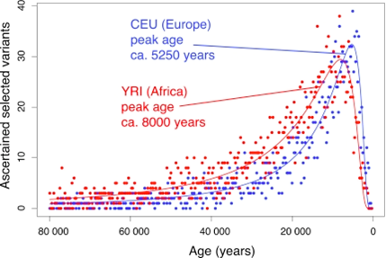
- y axis: adaptive evolution
- we see a rapidly accelerating speed of evolution of 2000 genes of interest examined in the study
- at least up to 2000 years ago, humans were evolving faster than ever before
- research: attempted to identify what sort of traits were associated with high fitness in human women
- evidence of selection
- women tended to produce more offspring on average if they were somewhat shorter, heavier than average, lower circulating cholesterol levels, younger age of reproduction, older age of menopause
- all positively selected
- tells that humans are evolving
- hallmark of human evolution: increased brain size
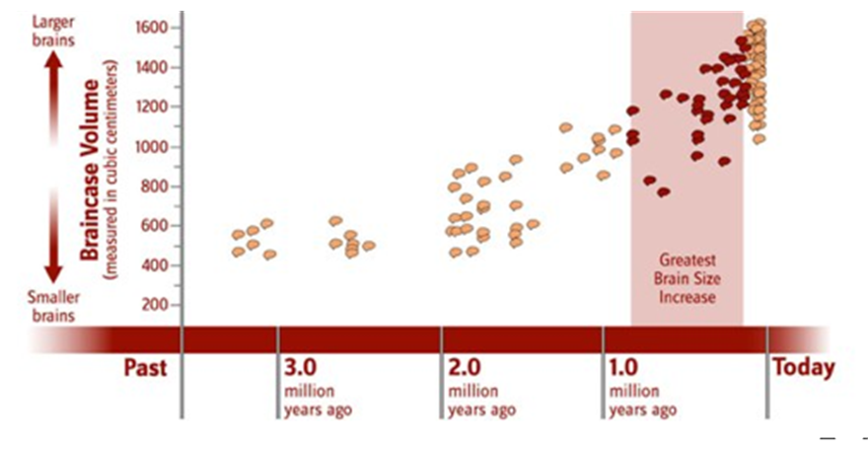
- human brain size has increased over evolutionary time
- especially relative in body size
- presumably associated with increase in intelligence
- big brains (and thus intelligence) are costly
- energetically (2% of mass, 20% of energy)
- metabolically expensive
- logistics of childbirth
- bigger child heads would present a big health risk (but there is c-section now)
- what did our ancestors use their brains for?
- we need big brains to survive, to outwit predators
- utility hypothesis: having a big brain is important for survival
- language, tool use, planning, to keep warm (build fires) --> survival
- selection for survivorship selected bigger brains
- individuals with big brains are likely to express themselves artistically, to tell jokes, etc. (traits that just come along with having a big brain)
- some people question this, however:
- do we really need such a big brain?
- human vocabulary 60 000 - 100 000 words
- that means 10 new words a day from ages 1-18
- do we need such a big vocab in order to survive, since most of it is hardly ever used
- what kind of selection promotes the evolution of wastefully extravagant traits?
- sexual selection
- mating mind hypothesis: word play, humour, art --> mating success
- but men and women are both intelligent
- aren't sexually selected traits sexually dimorphic?
- usually yes, however:
- in humans, both sexes choose mates
- assessing intelligence of a potential mate requires that you yourself are intelligent

