MIS Midterm Review

Chapter #1 - Information Systems and Business Strategy

Information systems role in business:
- Information systems are everywhere in business

Information Systems’ Impact on Business Operations:
Greatest benefits from IT-
- Costumer service, 70%
- Finance, 51%
- Sales and Marketing, 42%
- IT operations, 39%
- Operations Management, 31%
- HR, 17%
- Security, 17%

Information System project goals-
- Reduce costs/improve productivity 81%
- Improve costumer satisfaction/loyalty 71%
- Create competitive advantage 66%
- Generate growth 54%
- Streamline supply chain 37%
- Global expansion 16%

-Organizations typically operate by functional areas or functional silos
-Functional areas are interdependent

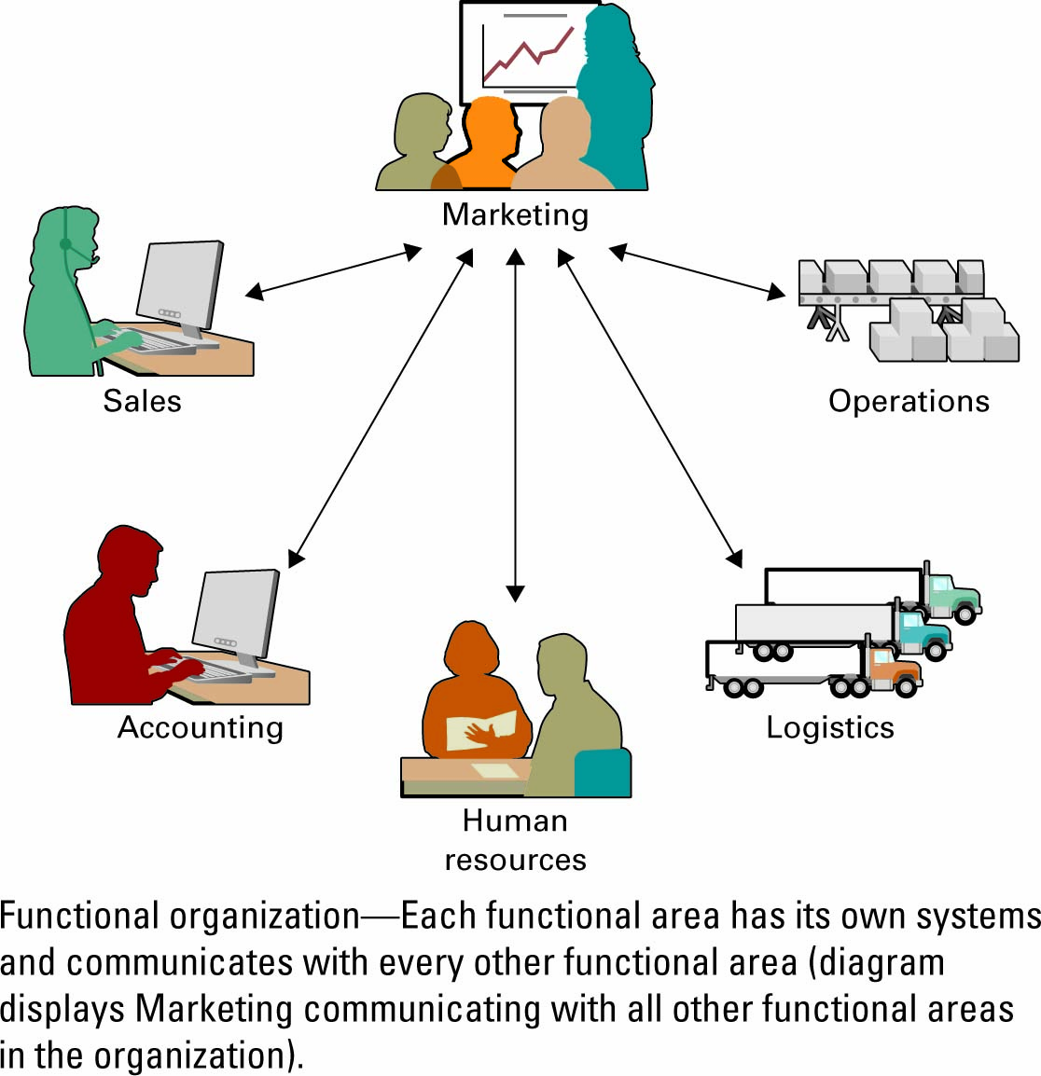
Functional organization – Each functional area has its own systems and communicates with every other functional area.

Information Systems Basics:
Information systems (IS) – any computer-based tool that people use to work with information and that supports the information and information-processing needs of an organization

An information system can be an important enabler of business success and innovation

Information Technology (IT) – is the acquisition, processing, storage, and dissemination of vocal, pictorial, textual, and numerical information by a microelectronics-based combination of computing and telecommunications

Management information systems (MIS) – the function that plans for, develops, implements, and maintains IS hardware, software, and applications that people use to support the goals of an organization

MIS is a business function, similar to Accounting, Finance, Operations, and Human Resources

- When beginning to learn about information systems it is important to understand the following:
  - The difference between data, information and knowledge
  - IS resources
  - IS cultures

Data – Information – Knowledge:
Data - raw facts that describe the characteristic of an event

Information - data converted into a meaningful and useful context

Knowledge - information that can be enacted upon i.e “actionable information”

IS Cultures:
  - Information-functional culture
    - use information as a means of exercising influence or power over others
  - Information-sharing culture
    - departments trust each other to use information (especially about problems and failures) to improve performance.
  - Information-inquiring culture
    - search for information to better understand the future and align themselves with current trends and new directions
  - Information-discovery culture
    - open to new insights about crisis and radical changes and seek ways to create competitive advantage

ROLES AND RESPONSIBILITIES IN IS:
- Chief Information Officer (CIO) – oversees all uses of IS and ensures the strategic alignment of IS with business goals and objectives
- Broad CIO roles include:
  - Manager – ensuring the delivery of all IS projects, on time and within budget
  - Leader – ensuring the strategic vision of IS is in line with the strategic vision of the organization
  - Communicator – building and maintaining strong executive relationships
- Chief Technology Officer (CTO) – responsible for ensuring the throughput, speed, accuracy, availability, and reliability of IS
- Chief Security Officer (CSO) – responsible for ensuring the security of information systems
- Chief Privacy Officer (CPO) – responsible for ensuring the ethical and legal use of information
- Chief Knowledge Office (CKO) - responsible for collecting, maintaining, and distributing the organization’s knowledge

ROLES AND RESPONSIBILITIES IN IS
Skills pivotal for success in executive IS roles:

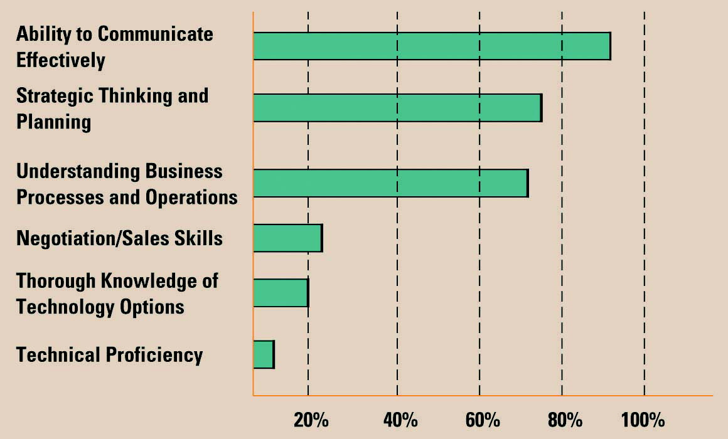

The Gap Between Business Personnel and IS Personnel:
- Business personnel possess expertise in functional areas such as marketing, accounting, and sales
- IS personnel have the technological expertise
- This typically causes a communications gap between the business personnel and IS personnel

Improving Communications:
- Business personnel must seek to increase their understanding of IS
- IS personnel must seek to increase their understanding of the business
- It is the responsibility of the CIO to ensure effective communication between business personnel and IS personnel

- Key performance indicator (KPI) – measures that are tied to business drivers

- Efficiency IS metric – measures the performance of the information system itself including throughput, speed, and availability
- Effectiveness IS metric – measures the impact IS has on business processes and activities including customer satisfaction, conversion rates, and sell-through increases

- benchmarks – baseline values the system seeks to attain
  - Benchmarking – a process of continuously measuring system results, comparing those results to optimal system performance (benchmark values), and identifying steps and procedures to improve system performance

- Efficiency IS metrics focus on information systems and include:
Throughput – Refers to how much material goes through the system.
Transaction Speed – How fast you can do a transaction.
System Availability – There is no disruption in business. Whenever the costumer wants it, it is available.
Web Traffic – How many visitors you get on your site.
Response Time – How fast you respond back to your costumer.

IDENTIFYING COMPETITIVE ADVANTAGES:
- To survive and thrive an organization must create a competitive advantage
  - Competitive advantage – a product or service that an organization’s customers place a greater value on than similar offerings from a competitor
  - First-mover advantage – occurs when an organization can significantly impact its market share by being first to market with a competitive advantage

  - Environmental scanning – the acquisition and analysis of events and trends in the environment external to an organization
  - Three common tools used in industry to analyze and develop competitive advantages include:
  - Porter’s Five Forces Model
  - Porter’s three generic strategies
  - Value chains

THE FIVE FORCES MODEL – EVALUATING BUSINESS SEGMENTS:
- Porter’s Five Forces Model determines the relative attractiveness of an industry
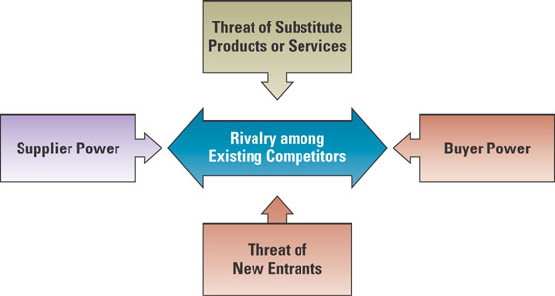

- Buyer power – high when buyers have many choices of whom to buy from and low when their choices are few
- One way to reduce buyer power is through loyalty programs
  - Loyalty program – rewards customers based on the amount of business they do with a particular organization

- Supplier power – high when buyers have few choices of whom to buy from and low when their choices are many
  - Supply chain – consists of all parties involved in the procurement of a product or raw material

- Two types of business-to-business (B2B) marketplaces
  - Private exchange – a single buyer posts its needs and then opens the bidding to any supplier who would care to bid
  - Reverse auction – an auction format in which increasingly lower bids are solicited from organizations willing to supply the desired product or service at an increasingly lower price
Value Creation:
- Once an organization chooses its strategy, it can use tools such as the value chain to determine the success or failure of its chosen strategy
  - Business process – a standardized set of activities that accomplish a specific task, such as processing a customer’s order
  - Value chain – views an organization as a series of processes, each of which adds value to the product or service for each customer

Value chains with porter’s forces:
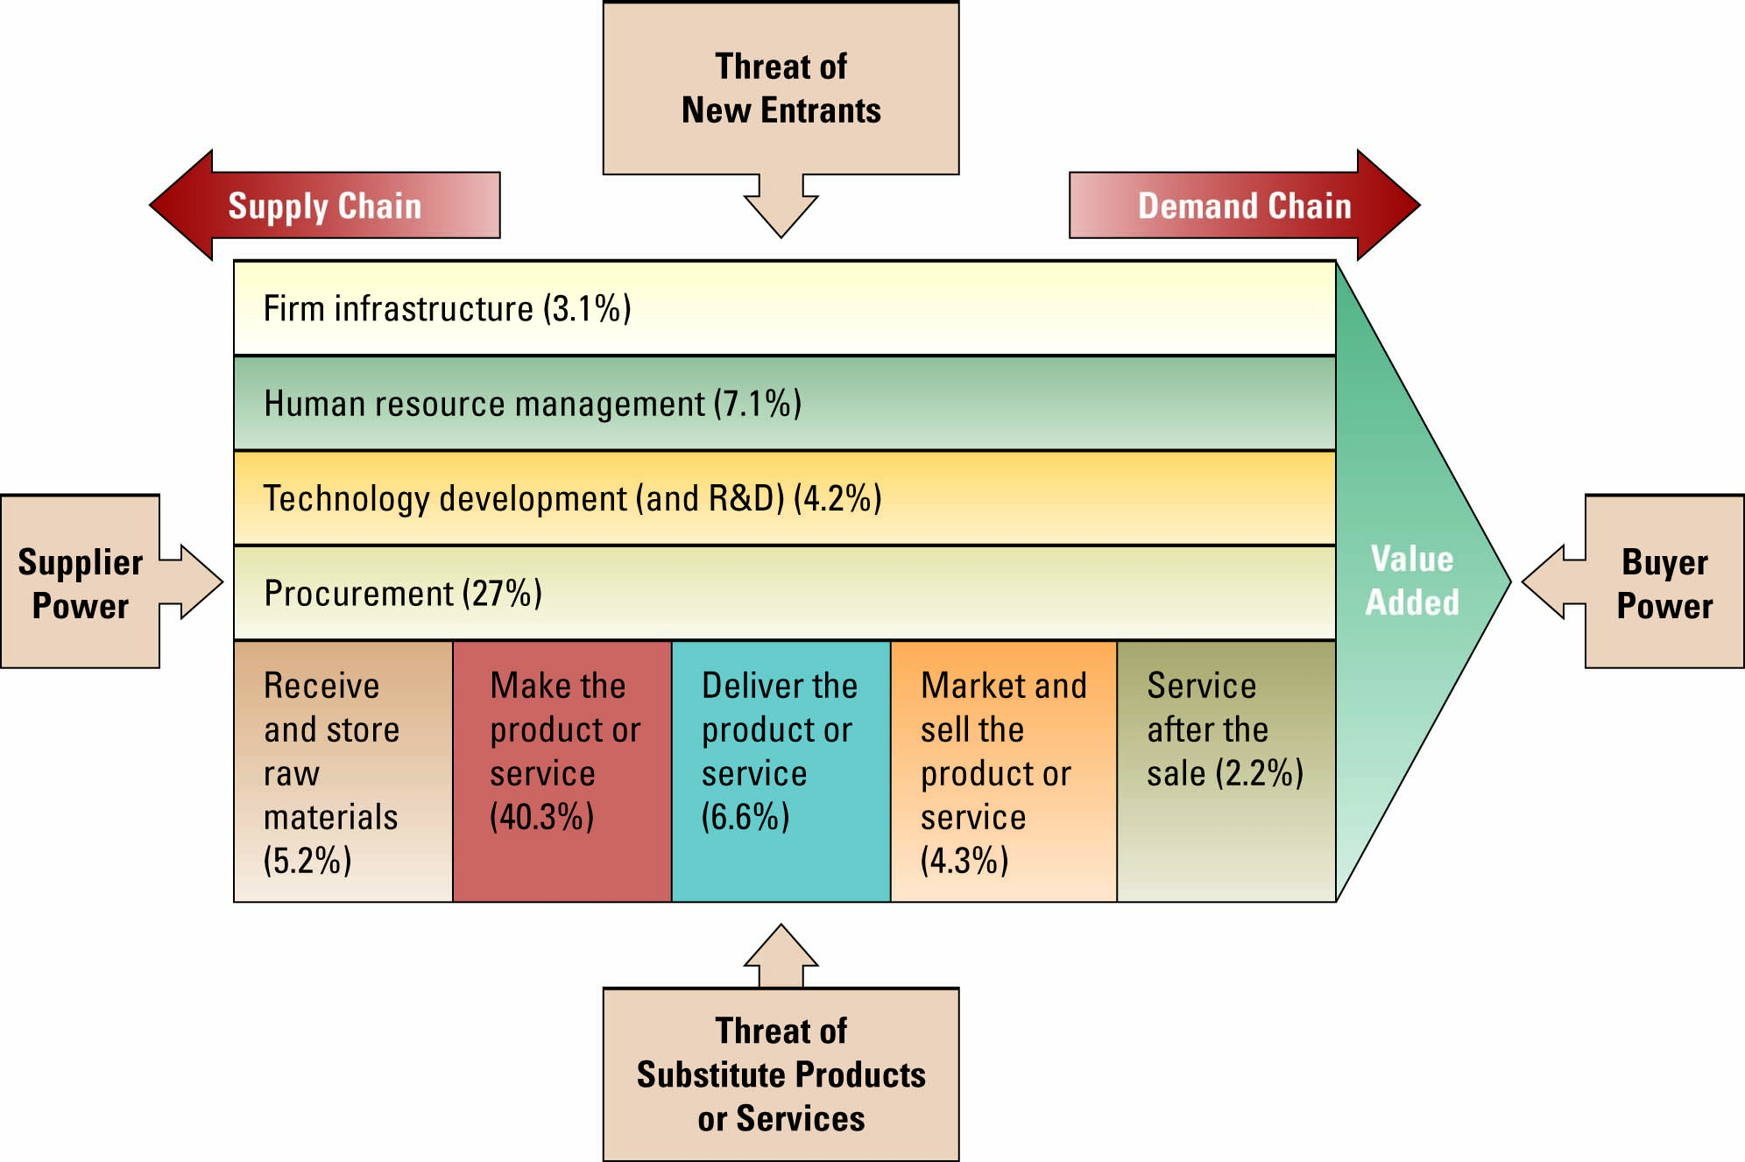
- Threat of substitute products or services – high when there are many alternatives to a product or service and low when there are few alternatives from which to choose
  - Switching cost – costs that can make customers reluctant to switch to another product or service

- Threat of new entrants – high when it is easy for new competitors to enter a market and low when there are significant entry barriers to entering a market
  - Entry barrier – a product or service feature that customers have come to expect from organizations in a particular industry and must be offered by an entering organization to compete and survive

- Organizations typically follow one of Porter’s three generic strategies when entering a new market
  - Broad cost leadership
  - Broad differentiation
  - Focused strategy

Chapter #2 - Decision Making and Business Processes
Decision-Making, Problem-Solving, and Opportunity-Seizing Information Systems:
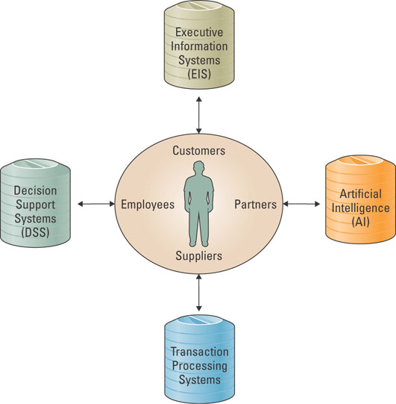
- Reasons for the growth of decision-making information systems
  - People need to analyze large amounts of information
  - People must make decisions quickly
  - People must apply sophisticated analysis techniques, such as modeling and forecasting, to make good decisions
  - People must protect the corporate asset of organizational information

Transaction Processing Systems
- Transaction processing system (TPS) - the basic business system that serves the operational level (analysts) in an organization
- Online transaction processing (OLTP) – the capturing of transaction and event information using technology to (1) process the information according to defined business rules, (2) store the information, (3) update existing information to reflect the new information

Decision Support Systems:
- Decision support system (DSS) – models information to support managers and business professionals during the decision-making process.
- Online analytical processing (OLAP) – the manipulation of information to create business intelligence in support of strategic decision making

- Three quantitative models used by DSSs include:
  - Sensitivity analysis – the study of the impact that changes in one (or more) parts of the model have on other parts of the model
  - What-if analysis – checks the impact of a change in an assumption on the proposed solution
  - Goal-seeking analysis – finds the inputs necessary to achieve a goal such as a desired level of output

- Interaction between a TPS and a DSS

- Executive information system (EIS) – a specialized DSS that supports senior level executives within the organization

- Digital dashboard – integrates information from multiple components and presents it in a unified display

ARTIFICIAL INTELLIGENCE (AI):
- Intelligent system – various commercial applications of artificial intelligence
- Artificial intelligence (AI) – simulates human intelligence such as the ability to reason and learn

- Four most common categories of AI include:
  - Expert system – computerized advisory programs that imitate the reasoning processes of experts in solving difficult problems
  - Neural Network – attempts to emulate the way the human brain works
    - Fuzzy logic – a mathematical method of handling imprecise or subjective information
  - Genetic algorithm – an artificial intelligent system that mimics the evolutionary, survival-of-the-fittest process to generate increasingly better solutions to a problem
  - Intelligent agent – special-purposed knowledge-based information system that accomplishes specific tasks on behalf of its users

UNDERSTANDING THE IMPORTANCE OF BUSINESS PROCESSES:
Customer facing processes – result in a product or service that is received by an organization’s external customer.
Business facing processes – are invisible to the external customer but are essential to the effective management of the business

BUSINESS PROCESS REENGINEERING:
Business process – a standardized set of activities that accomplish a specific task, such as processing a customer’s order
Business process reengineering (BPR) – the analysis and redesign of workflow within and between enterprises
The purpose of BPR is to make all business processes best-in-class
BUSINESS PROCESS MODELLING:
Business process modelling (or mapping) – is the activity of creating a detailed flow-chart or process map of a work process showing its inputs, tasks, and activities, in a structured sequence.
Business process model – is a graphic description of a process, showing the sequence of process tasks, which is developed for a specific purpose and from a selected viewpoint.

BUSINESS PROCESS MANAGEMENT:
Business Process Management (BPM) – integrates all of an organization’s business processes to make individual processes more efficient.
Key reasons for using BPM:
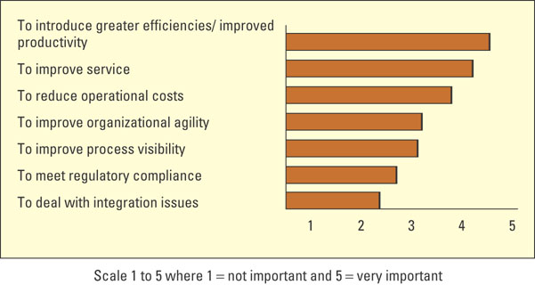

Chapter #3 - The Internet and E-Business
DISRUPTIVE TECHNOLOGY:
- Digital Darwinism – implies that organizations which cannot adapt to the new demands placed on them for surviving in the information age are doomed to extinction

Disruptive versus Sustaining Technology:
- What do steamboats, transistor radios, and Intel’s 8088 processor all have in common?
  - Disruptive technology – a new way of doing things that initially does not meet the needs of existing customers
  - Sustaining technology – produces an improved product customers are eager to buy

- Innovator’s Dilemma - discusses how established companies can take advantage of disruptive technologies without hindering existing relationships with customers, partners, and stakeholders

The Internet – Business Disruption:
- One of the biggest forces changing business is the Internet
- Organizations must be able to transform as markets, economic environments, and technologies change
- Focusing on the unexpected allows an organization to capitalize on the opportunity for new business growth from a disruptive technology

- The Internet has had an impact on almost every industry including:
  - Travel
  - Entertainment
  - Electronics
  - Financial services
  - Retail
  - Automobiles
  - Education and training

EVOLUTION OF THE INTERNET:
- The Internet began as an emergency military communications system operated by the U.S. Department of Defense
- Gradually the Internet moved from a military pipeline to a communication tool for scientists to businesses
  - Internet – computer networks that pass information from one to another using common computer protocols
  - Protocol – standards that specify the format of data as well as the rules to be followed during transmission

- World Wide Web (WWW) – a global hypertext system that uses the Internet as its transport mechanism
- Hypertext transport protocol (HTTP) – the Internet standard that supports the exchange of information on the WWW

- The Internet’s impact on information
  - Easy to compile
  - Increased richness
  - Increased reach
  - Improved content

- The Internet makes it possible to perform business in ways not previously imaginable
- It can also cause a digital divide
  - Digital divide – when those with access to technology have great advantages over those without access to technology

- Web 2.0 is a set of economic, social, and technology trends that collectively form the basis for the next generation of the Internet.

ACCESSING INTERNET INFORMATION:
- Four tools for accessing Internet information
  - Intranet – internalized portion of the Internet, protected from outside access, for employees
  - Extranet – an intranet that is available to strategic allies
  - Portal – Web site that offers a broad array of resources and services
  - Kiosk – publicly accessible computer system that allows interactive information browsing

PROVIDING INTERNET INFORMATION:
- Three common forms of service providers
  - Internet service provider (ISP) –provides individuals and other companies access to the Internet
  - Online service provider (OSP) – offers an extensive array of unique Web services
  - Application service provider (ASP) – offers access over the Internet to systems and related services that would otherwise have to be located in organizational computers

- Common ISP services include:
  - Web hosting
  - Hard-disk storage space
  - Availability
  - Support

Wireless Internet service provider (WISP)

- ISPs, OSPs, and ASPs use service level agreements (SLA) which define the specific responsibilities of the service provider and set the customer expectations

E-BUSINESS BASICS:
- How do e-commerce and e-business differ?
  - E-commerce – the buying and selling of goods and services over the Internet
  - E-business – the conducting of business on the Internet including not only buying and selling, but also serving customers and collaborating with business partners

Business-to-Business (B2B):
- Electronic marketplace (e-marketplace) – interactive business communities providing a central market where multiple buyers and sellers can engage in e-business activities

Business-to-Consumer (B2C):
- Common B2C e-business models include:
  - e-shop – a version of a retail store where customers can shop any time without leaving their home
  - e-mall – consists of a number of e-shops; it serves as a gateway through which a visitor can access other e-shops
- Business types include:
  - Brick-and-mortar business
  - Pure-play business
  - Click-and-mortar business

Consumer-to-Business (C2B):
- Priceline.com is an example of a C2B e-business model

Consumer-to-Consumer (C2C):
- Online auctions
  - Electronic auction (e-auction) - Sellers and buyers solicit consecutive bids from each other and prices are determined dynamically
  - Forward auction - Sellers use as a selling channel to many buyers and the highest bid wins
  - Reverse auction - Buyers use to purchase a product or service, selecting the seller with the lowest bid

- C2C Communities
  - Communities of interest - People interact with each other on specific topics, such as golfing and stamp collecting
  - Communities of relations - People come together to share certain life experiences, such as cancer patients, senior citizens, and car enthusiasts
  - Communities of fantasy - People participate in imaginary environments, such as fantasy football teams and playing one-on-one with Michael Jordan

Marketing/Sales:
- Generating revenue on the Internet
  - Online ad (banner ad) - box running across a Web page that contains advertisements
  - Pop-up ad - a small Web page containing an advertisement
  - Associate program (affiliate program) - businesses generate commissions or royalties
  - Viral marketing - a technique that induces Web sites or users to pass on a marketing message
  - Mass customization - gives customers the opportunity to tailor products or services

- Generating revenue on the Internet (cont.)
  - Personalization - occurs when a Web site can fashion offers that are more likely to appeal to that person
  - Blog - Web site in which items are posted on a regular basis and displayed in reverse chronological order
  - Real simple syndications (RSS) - a Web feed format used for Web syndication of content
  - Podcasting - the distribution of audio or video files, such as radio programs or music videos, over the Internet to play on mobile devices

- Generating revenue on the Internet (cont.)
  - Search engine optimization (SEO) - a set of methods aimed at improving the ranking of a Web site in search engine listings
    - Spamdexing - uses a variety of deceptive techniques in an attempt to manipulate search engine rankings, whereas legitimate SEO focuses on building better sites and using honest methods of promotion

Procurement:
- Maintenance, repair, and operations (MRO) materials (also called indirect materials) – materials necessary for running an organization but do not relate to the company’s primary business activities
  - E-procurement - the B2B purchase and sale of supplies and services over the Internet
  - Electronic catalogue - presents customers with information about goods and services offered for sale, bid, or auction on the Internet

- Intermediaries – agents, software, or businesses that bring buyers and sellers together that provide a trading infrastructure to enhance e-business
- Reintermediation – using the Internet to reassemble buyers, sellers, and other partners in a traditional supply chain in new ways

MEASURING E-BUSINESS SUCCESS:
- Web site traffic analysis can include:
  - Cookie
  - Click-through
  - Banner ad
  - Interactivity

Web Site Metrics:
- Clickstream data tracks the exact pattern of a consumer’s navigation through a Web site
- Clickstream data can reveal:
  - Number of pageviews
  - Pattern of Web sites visited
  - Length of stay on a Web site
  - Date and time visited
  - Number of customers with shopping carts
  - Number of abandoned shopping carts

- Web site metrics include:
  - Visitor metrics
  - Exposure metrics
  - Visit metrics
  - Hit metrics

E-BUSINESS BENEFITS AND CHALLENGES:
- E-business challenges include:
  - Protecting consumers
  - Leveraging existing systems
  - Increasing liability
  - Providing security
  - Adhering to taxation rules

- There are numerous advantages and limitations in e-business revenue models including:
  - Transaction fees
  - License fees
  - Subscription fees
  - Advertising fees

NEW TRENDS IN E-BUSINESS:
E-GOVERNMENT AND M-COMMERCE:
- E-government - involves the use of strategies and technologies to transform government(s) by improving the delivery of services and enhancing the quality of interaction between the citizen-consumer within all branches of government

- Mobile commerce - the ability to purchase goods and services through a wireless Internet-enabled device

Chapter #4 - Enterprise Computing Trends and Enterprise Resource Planning
Greener IT:
Ways to go green
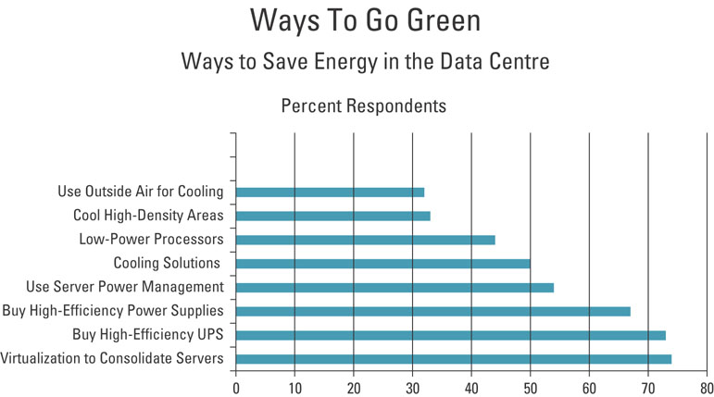

ENTERPRISE RESOURCE PLANNING:
- Enterprise resource planning – integrates all departments and functions throughout an organization into a single IT system (or integrated set of IT systems) so that employees can make enterprise-wide decisions by viewing enterprise-wide information on all business operations

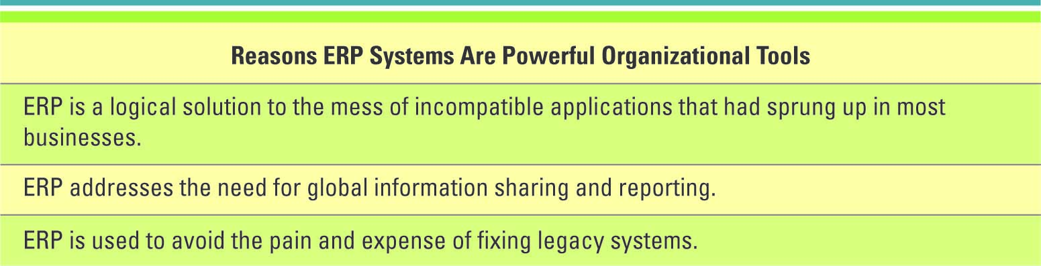

ENTERPRISE RESOURCE PLANNING:
ERP Integration Data Flow
- At the heart of all ERP systems is a database; when a user enters or updates information in one module, it is immediately and automatically updated throughout the entire system

The Organization after ERP
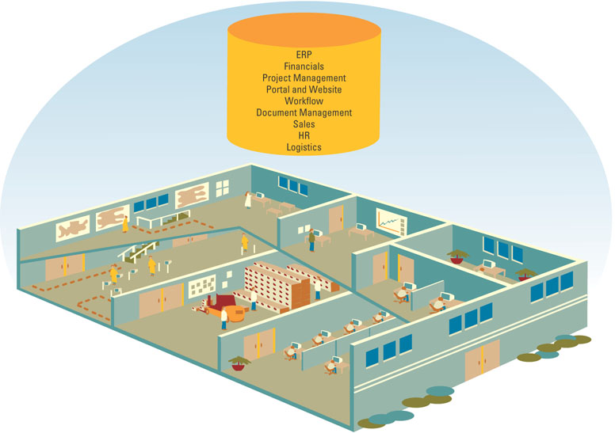

CORE AND EXTENDED ERP COMPONENTS:
Core ERP component – traditional components included in most ERP systems and they primarily focus on internal operations
Extended ERP component – extra components that meet the organizational needs not covered by the core components and primarily focus on external operations

Accounting and Finance ERP Components:
- Accounting and finance ERP component – manages accounting data and financial processes within the enterprise with functions such as general ledger, accounts payable, accounts receivable, budgeting, and asset management

Production and Materials Management ERP Components:
- Production and materials management ERP component – handles the various aspects of production planning and execution such as demand forecasting, production scheduling, job cost accounting, and quality control

Human Resource ERP Component:
- Human resource ERP component – tracks employee information including payroll, benefits, compensation, performance assessment, and assumes compliance with the legal requirements of multiple jurisdictions and tax authorities

- Extended ERP components include:
  - Business intelligence
  - Customer relationship management
  - Supply chain management
  - E-business

E-Business Components:
- E-business components include e-logistics and e-procurement
  - E-logistics – manages the transportation and storage of goods
  - E-procurement – the business-to-business (B2B) purchase and sale of supplies and services over the Internet

Integration Tools:
- Many companies purchase modules from an ERP vendor, an SCM vendor, and a CRM vendor and must integrate the different modules together
  - Middleware – several different types of software which sit in the middle of and provide connectivity between two or more software applications
  - Enterprise application integration (EAI) middleware – packages together commonly used functionality which reduced the time necessary to develop solutions that integrate applications from multiple vendors

THE CONNECTED CORPORATION:
- SCM, CRM, and ERP are the backbone of e-business
- Integration of these applications is the key to success for many companies
- Integration allows the unlocking of information to make it available to any user, anywhere, anytime

MEASURING ERP SUCCESS:
Balanced scorecard is a management system, in addition to a measurement system, that enables organizations to clarify their vision and strategy and translate them into action.

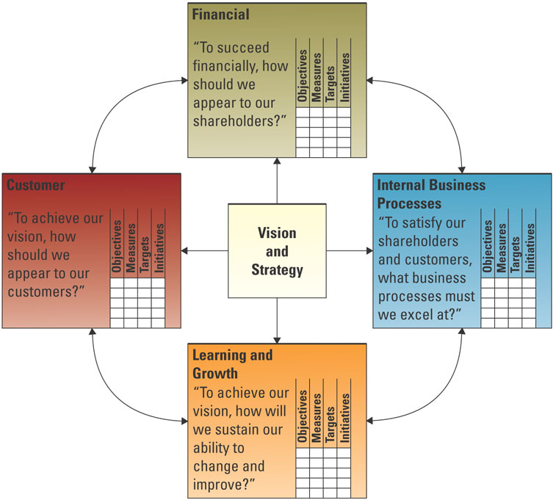

CHOOSING ERP SOFTWARE:
Successful ERP projects share 3 attributes
  - Overall fit
    - Off the rack
    - Off the rack and tailored to fit
    - Custom made
  - Proper business analysis
    - Successful companies spend up to 10 percent of the project budget on a business analysis
  - Solid implementation plans
    - A plan is needed to monitor the quality, objectives, and timelines

ERP AND SME MARKETS:
- ERP is no longer the purview of large organizations.
- In the hopes of expanding their client base, many large-scale ERP vendors, such as SAP and Oracle, are attempting to enter the small to medium enterprise (SME) market

Chapter #5 - Operations Management and Supply Chain Management
OPERATIONS MANAGEMENT FUNDAMENTALS:
Production management describes all the activities managers do to help companies create goods.
Operations management (OM) is the management of systems or processes that convert or transform resources (including human resources) into goods and services.
A transformation process is often referred to as the technical core, especially in manufacturing organizations, and is the actual conversion of inputs to outputs.

OM IN BUSINESS:
Typical OM activities include:
- Forecasting
- Capacity planning
- Scheduling
- Managing inventory
- Assuring quality
- Motivating and training employees
- Locating facilities

COMPETITIVE OM STRATEGY:
Five key competitive priorities:
- Cost
- Quality
- Delivery
- Flexibility
- Service

OM AND THE SUPPLY CHAIN:
- Supply chain consists of all parties involved, directly or indirectly, in the procurement of a product or raw material
Supply chain management (SCM) involves the management of information flows between and among stages in a supply chain to maximize total effectiveness and profitability

OM AND THE SUPPLY CHAIN:
- The four basic components of Supply chain management are:
  - Supply chain strategy
  - Supply chain partners
  - Supply chain operation
  - Supply chain logistics

SUPPLY CHAIN FUNDAMENTALS:

- The average company spends nearly half of every dollar that it earns on production
- In the past, companies focused primarily on manufacturing and quality improvements to influence their supply chains

- The supply chain has three main links:
  - Materials flow from suppliers and their “upstream” suppliers at all levels
  - Transformation of materials into semi-finished and finished products through the organization’s own production process
  - Distribution of products to customers and their “downstream” customers at all levels

- Organizations must embrace technologies that can effectively manage supply chains

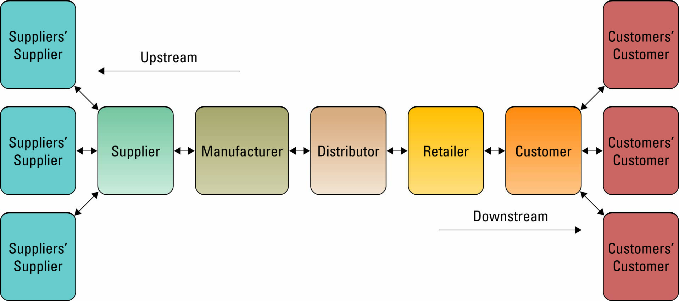

The five basic supply chain management components:
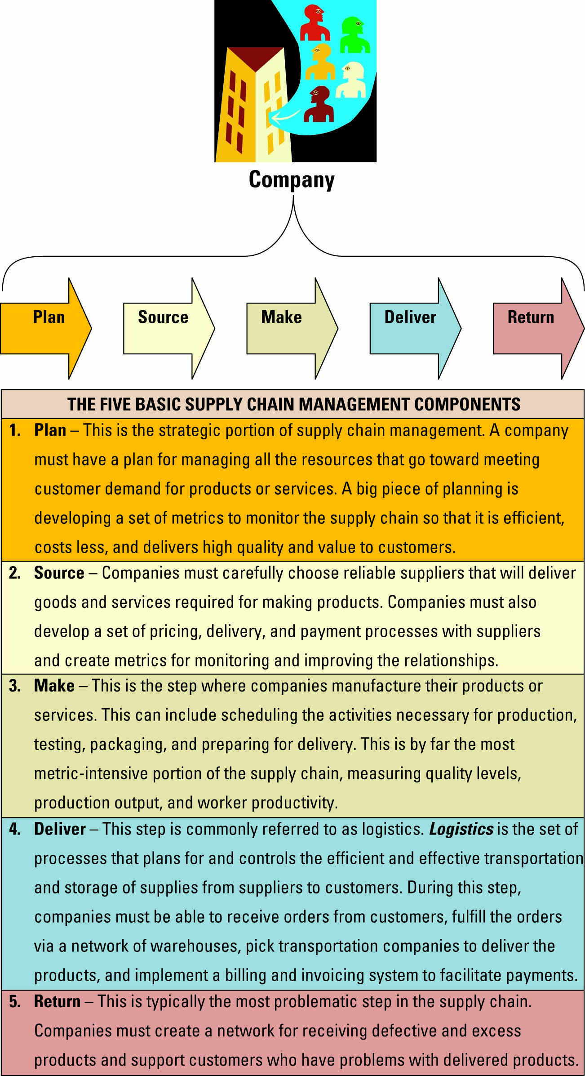

INFORMATION SYSTEMS’ ROLE IN THE SUPPLY CHAIN:
- IS’s primary role is to create integrations or tight process and information linkages between functions within a firm
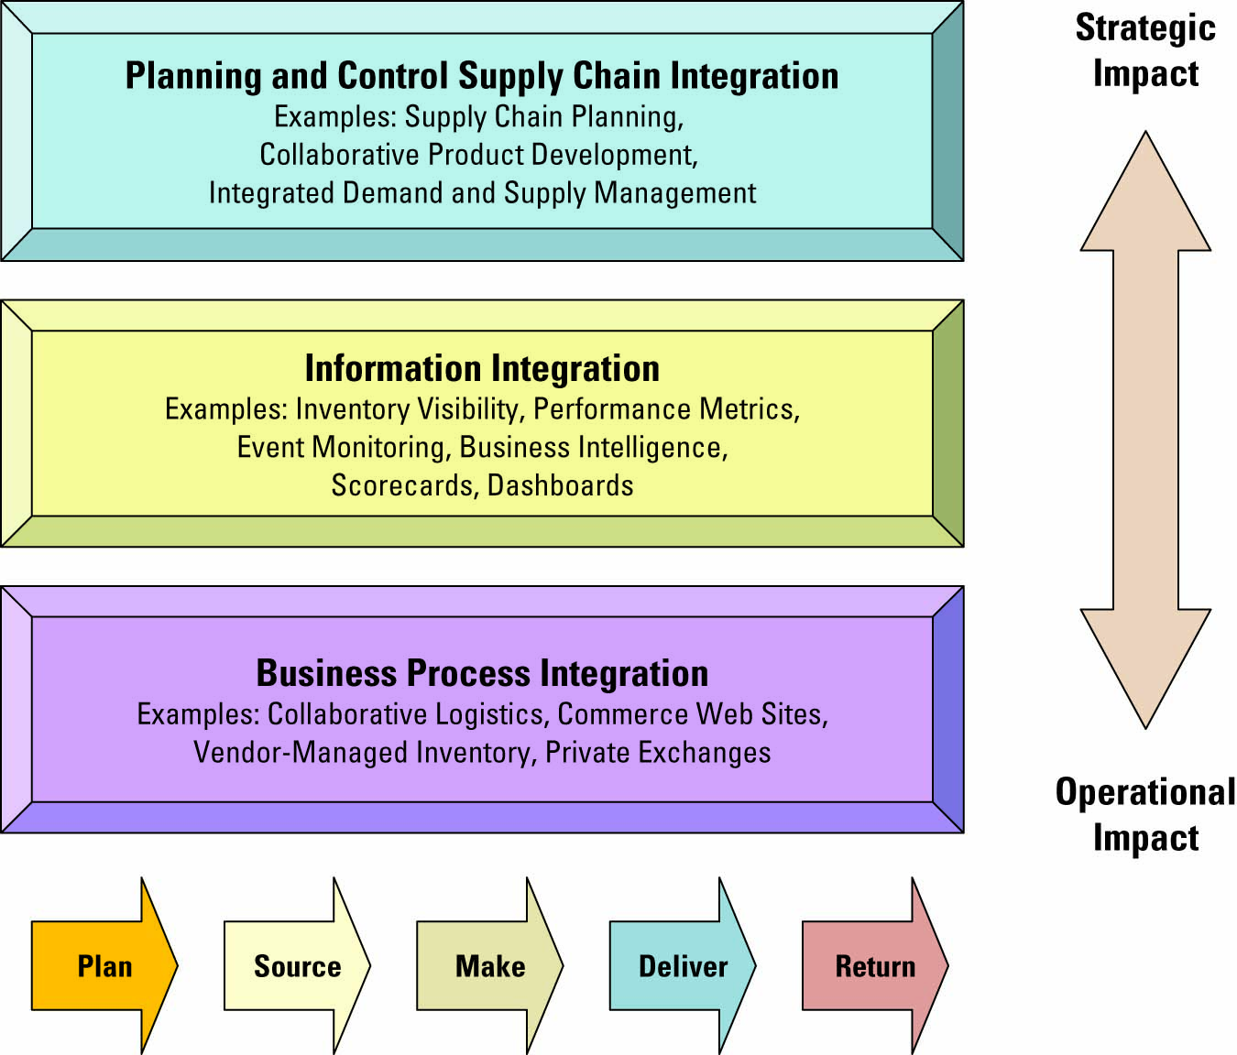

Factors Driving SCM
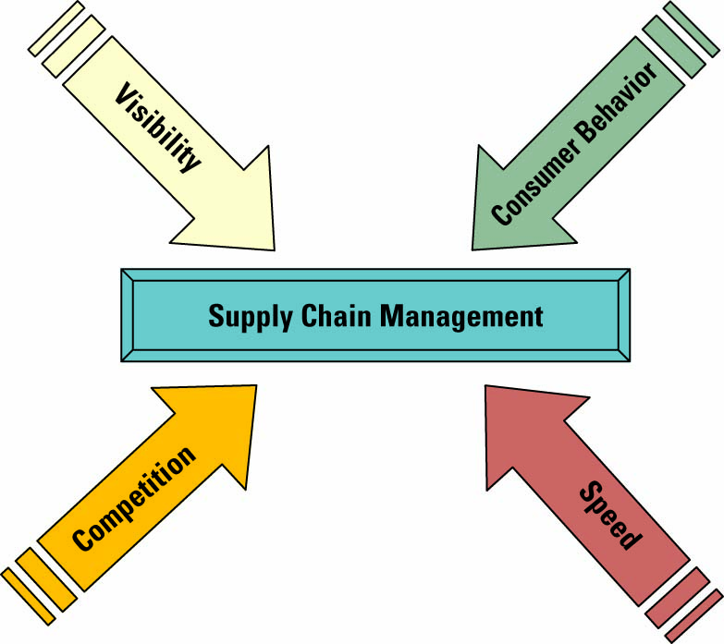

Visibility:
- Supply chain visibility – the ability to view all areas up and down the supply chain
- Bullwhip effect – occurs when distorted product demand information passes from one entity to the next throughout the supply chain

Consumer Behaviour:
- Companies can respond faster and more effectively to consumer demands through supply chain enhances
- Demand planning software – generates demand forecasts using statistical tools and forecasting techniques

Competition:
- Supply chain planning (SCP) software– uses advanced mathematical algorithms to improve the flow and efficiency of the supply chain
- Supply chain execution (SCE) software – automates the different steps and stages of the supply chain

- SCP and SCE in the supply chain
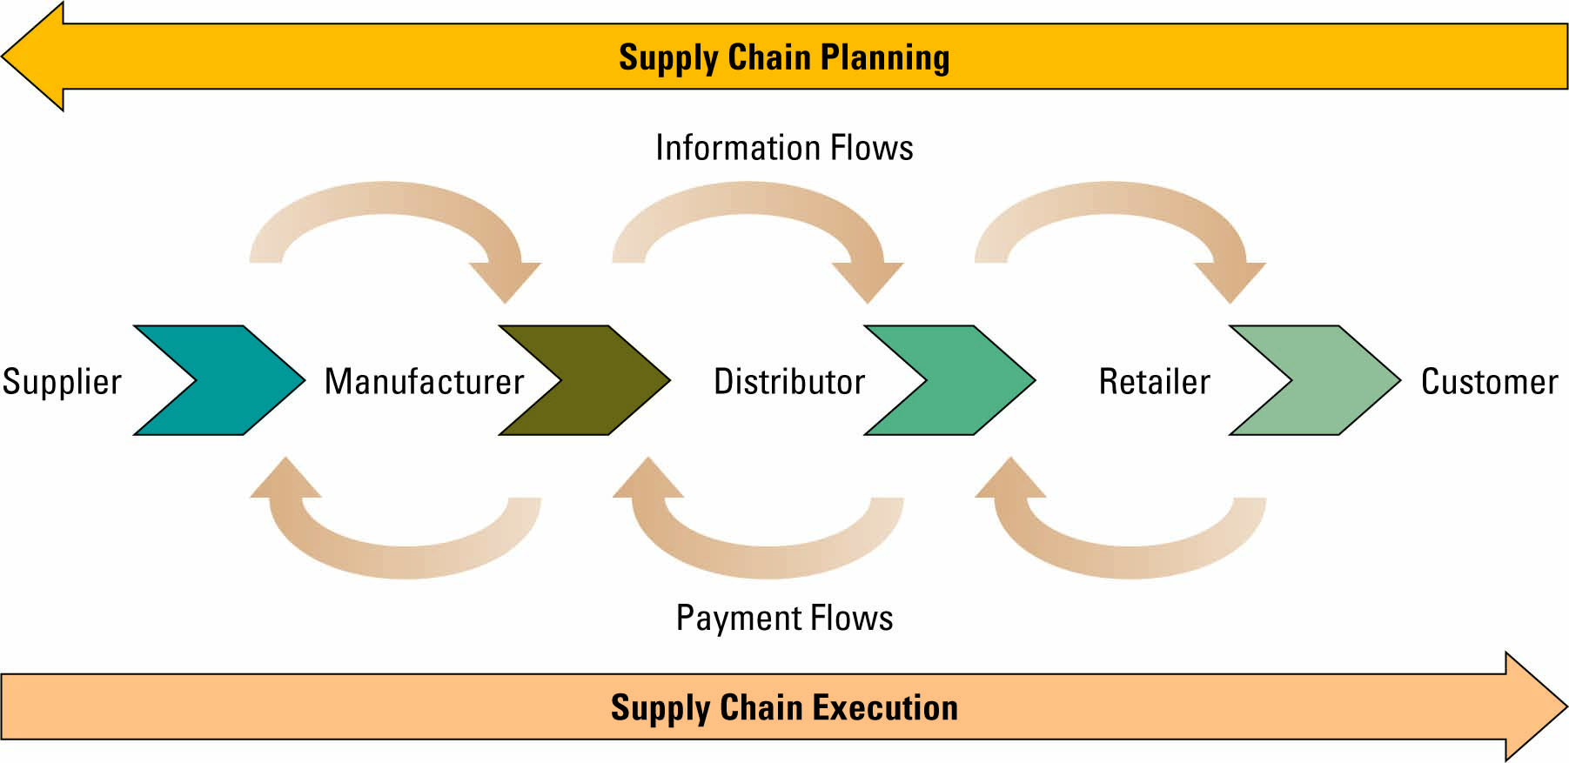

Speed:
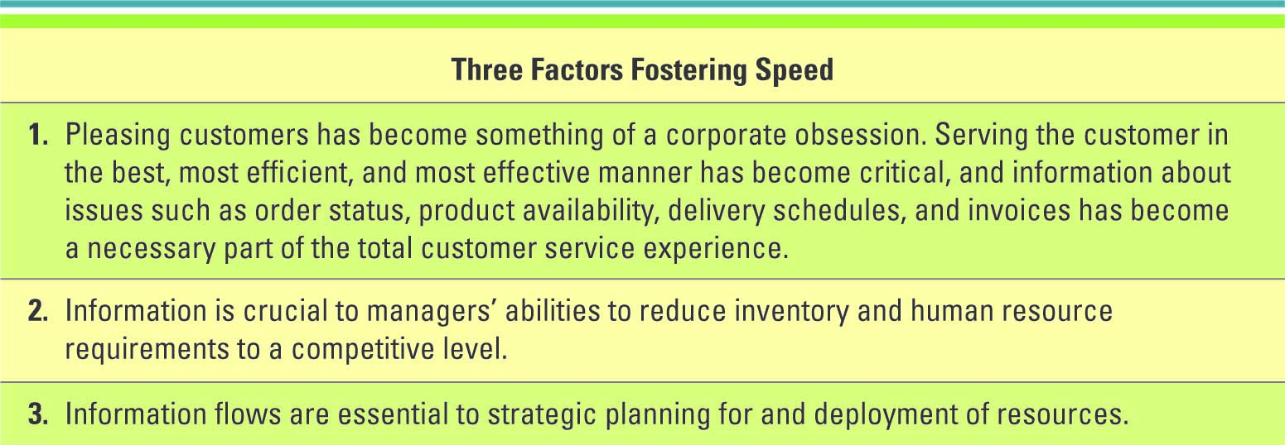

SUPPLY CHAIN MANAGEMENT
SUCCESS FACTORS:
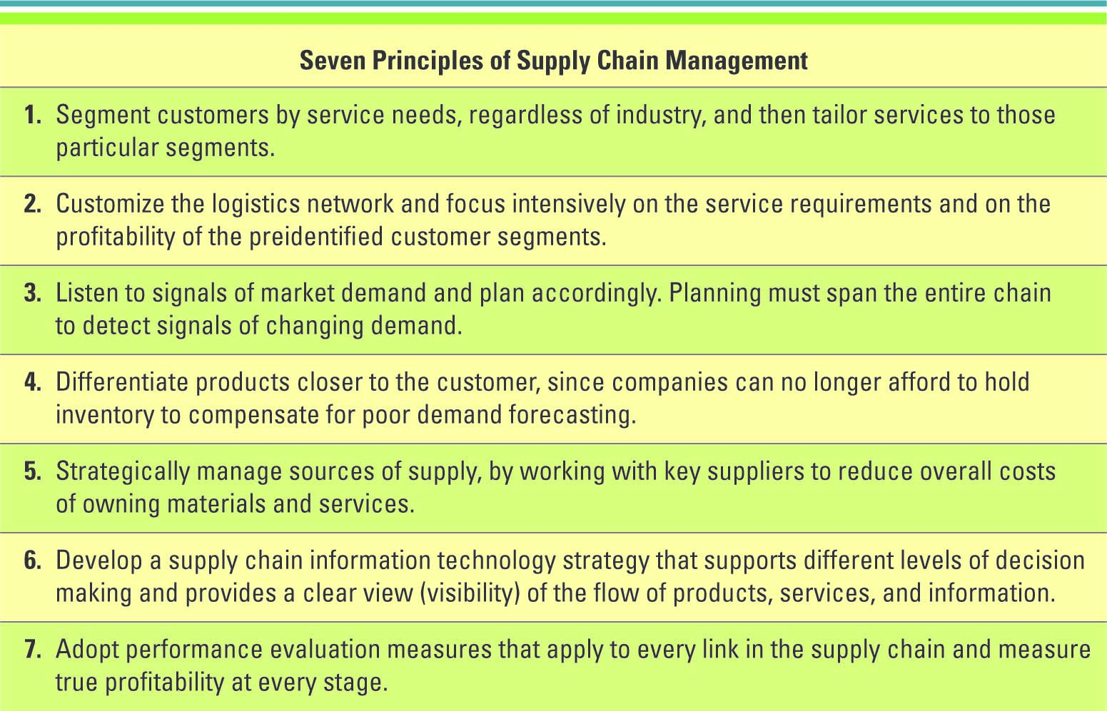

- SCM industry best practices include:
  - Make the sale to suppliers
  - Wean employees off traditional business practices
  - Ensure the SCM system supports the organizational goals
  - Deploy in incremental phases and measure and communicate success
  - Be future oriented

SCM SUCCESS STORIES:
- Numerous decision support systems (DSSs) are being built to assist decision makers in the design and operation of integrated supply chains
- DSSs allow managers to examine performance and relationships over the supply chain and among:
  - Suppliers
  - Manufacturers
  - Distributors
  - Other factors that optimize supply chain performance

Chapter #6 - Customer Relationship Management
BUSINESS BENEFITS OF CRM:
- CRM enables an organization to:
  - Provide better customer service
  - Make call centres more efficient
  - Cross-sell products more effectively
  - Help sales staff close deals faster
  - Simplify marketing and sales processes
  - Discover new customers
  - Increase customer revenues

“RFM”:
- Organizations can find their most valuable customers through “RFM” - Recency, Frequency, and Monetary value
  - How recently a customer purchased items (Recency)
  - How frequently a customer purchased items (Frequency)
  - How much a customer spends on each purchase (Monetary Value)

The Evolution of CRM:
- CRM reporting technology – help organizations identify their customers across other applications
- CRM analysis technologies – help organizations segment their customers into categories such as best and worst customers
- CRM predicting technologies – help organizations make predictions regarding customer behaviour such as which customers are at risk of leaving

Operational and Analytical CRM:
- Operational CRM – supports traditional transactional processing for day-to-day front-office operations or systems that deal directly with the customers
- Analytical CRM – supports back-office operations and strategic analysis and includes all systems that do not deal directly with the customers

Marketing and Operational CRM:
- Three marketing operational CRM technologies:
  - List generator – compiles customer information from a variety of sources and segments the information for different marketing campaigns
  - Campaign management system – guides users through marketing campaigns
  - Cross-selling and up-selling
    - Cross-selling – selling additional products or services
    - Up-selling – increasing the value of the sale

Sales and Operational CRM:
- The sales department was the first to begin developing CRM systems with sales force automation – a system that automatically tracks all of the steps in the sales process

- Sales and operational CRM technologies
  - Sales management CRM system
    - automates each phase of the sales process, helping individual sales representatives coordinate and organize all of their accounts
  - Contact management CRM system
    - maintains customer contact information and identifies prospective customers for future sales
  - Opportunity management CRM system
    - targets sales opportunities by finding new customers or companies for future sales

- CRM Pointers for Gaining Prospective Customer
  - Get their attention
  - Value their time
  - Overdeliver
  - Contact frequently
  - Generate a trustworthy mailing list
  - Follow up

Customer Service and
Operational CRM:
- Three customer service operational CRM technologies:
  - Contact centre (call centre)
  - Web-based self-service system
    - Click-to-talk
  - Call scripting system

USING IS TO DRIVE
ANALYTICAL CRM:
- Personalization – when a Web site knows enough about a person’s likes and dislikes that it can fashion offers that are more likely to appeal to that person
- Analytical CRM relies heavily on data warehousing technologies and business intelligence to glean insights into customer behaviour
- These systems quickly aggregate, analyze, and disseminate customer information throughout an organization

- Analytical CRM information examples
  - Give customers more of what they want
  - Find new customers similar to the best customers
  - Find out what the organization does best
  - Beat competitors to the punch
  - Reactivate inactive customers
  - Let customers know they matter

IMPLEMENTING CRM:
- CRM industry best practices include:
  - Clearly communicate the CRM strategy
  - Define data needs and flows
  - Build an integrated view of the customer
  - Implement in iterations
  - Scalability for organizational growth

Eight building blocks of CRM:
  - Creating a CRM vision that provides a “big picture” of what the customer-centric organization should look like.
  - Defining and weaving a CRM strategy that aligns with broader marketing and sales strategies, and informs operational and production strategies.
  - Understanding and engaging the customer

MANAGING OTHER RELATIONSHIPS:
Supplier Relationship Management (SRM) focuses on keeping suppliers satisfied by evaluating and categorizing suppliers for different projects.
Partner Relationship Management (PRM) focuses on keeping vendors satisfied by managing alliance partner, dealer, retailer, and reseller relationships that provide customers with an optimal sales channel.
Employee Relationship Management (ERM) is a management activity that focuses on managing an organization’s relationships with its employees

FUTURE CRM TRENDS:
- CRM future trends include:
  - CRM applications will continue to evolve and be used by a wide variety of partners
  - CRM will continue to be a major strategic focus for companies
  - CRM applications will continue to adapt wireless capabilities supporting mobile sales and mobile customers
  - CRM suites will incorporate SRM, PRM and ERM modules

