ADM 2320 – Marketing
Chapter 1 – Overview of Marketing
What is Marketing?
Marketing: a set of business practices designed to plan for a present organization’s products or services in ways that build effective customer relationships
- Informing the consumers about the possibilities
- Building relationships
- Marketing must also address ethical implications of their actions on society
- Marketing is not only about buyers and sellers changing money for goods and services, or about making a profit
- Marketing mix: create, transact, communicate, and deliver value
Marketing plan: a written document composed of an analysis of the current marketing situation, opportunities and threats for the firm
- Firms develop a marketing plan that specifies the marketing activities for a specific period of time
  - Broken down into various components:
    - How the product or service we be conceived or designed
    - How much it should cost

Value: the fundamental purpose of marketing is to create value for both the firm and customer
- “What you get for what you give up”
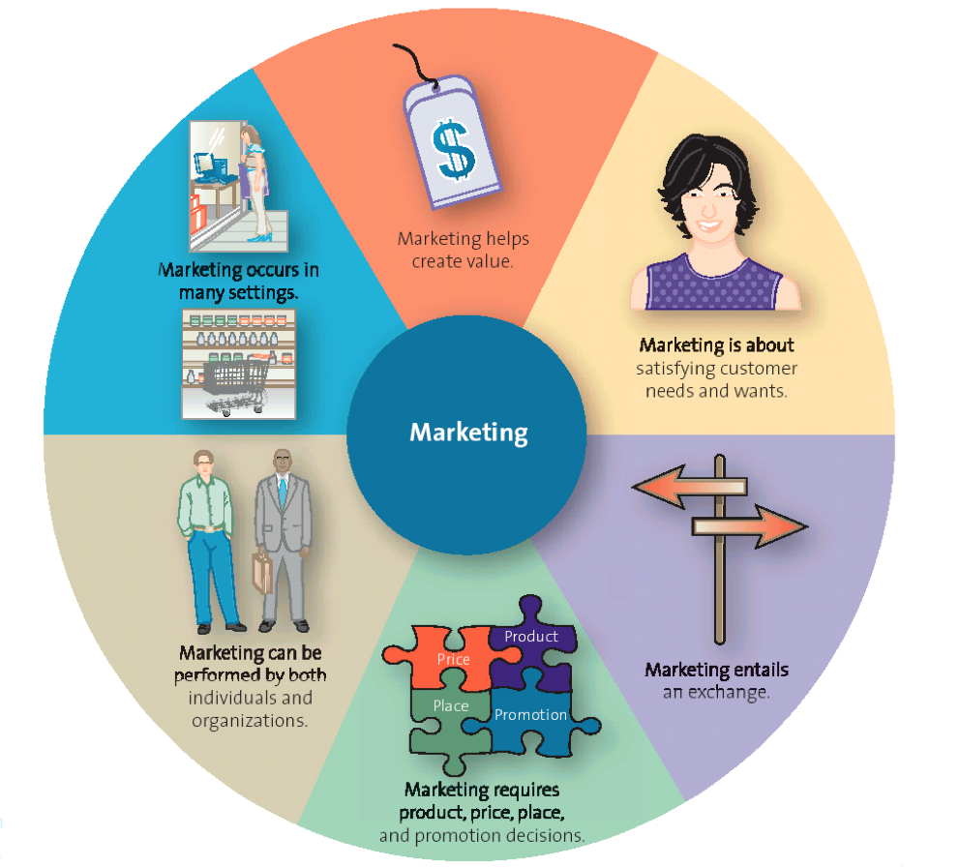
Core One: Satisfying Customer Needs and Wants
- Begins with understanding their needs and wants
Marketing's Core Aspects
  - Need: a person feeling physiologically deprived of basic necessities, such as food, clothing shelter, and safely
  - Want: the particular way in which a person chooses to satisfy a need, which is shaped by a person’s knowledge, culture and personality
  - Market: refers to the group of people who need or want a company’s products or services and have the ability and willingness to buy them
- Companies divide the market into subgroups or segments of people to whom they are interested in marketing their products, services, or ideas

Core Two: Marketing Entails Value Exchange
Exchange: the trade of things of value between the buyer and the seller so that each is better off as a result
- The exchange can occur between any two parties
- Not simply a buyer and seller exchanging money for a good or service
  - Can be an exchange of information for convenience

Core Three: Marketing Requires Product, Price, Place and Promotion Decisions
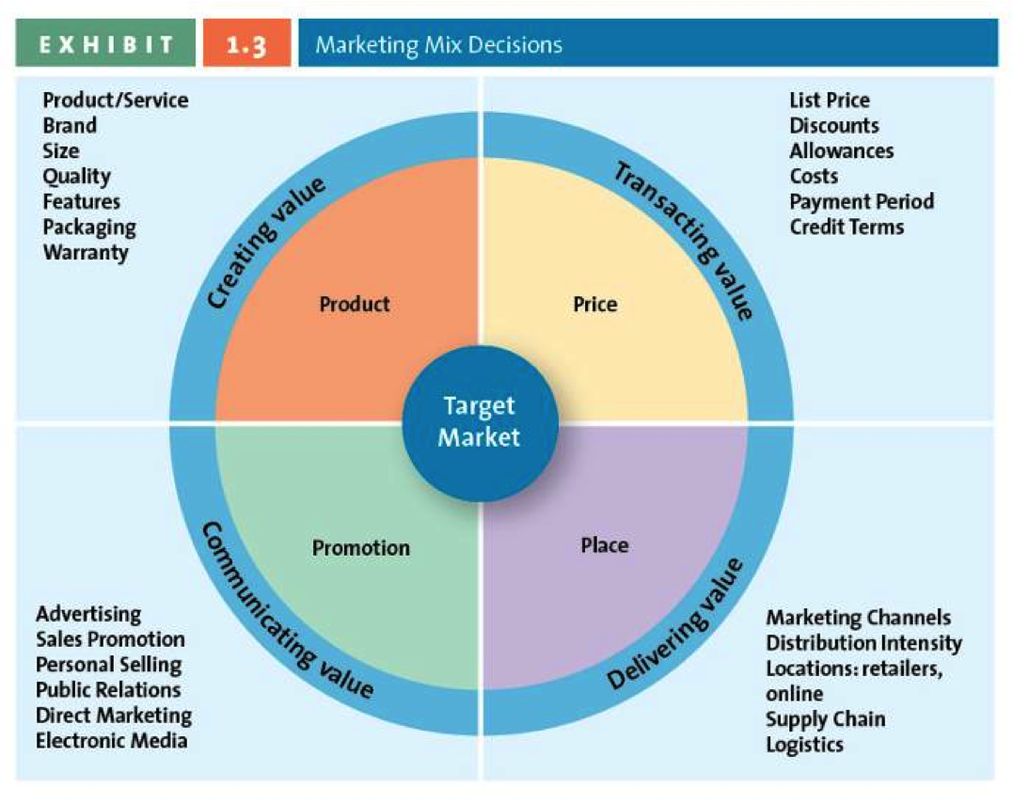
Marketing Mix (the four P’s): Product, Price, Place, and Promotion – the controllable set of activities that a firm uses to respond to the wants of its target markets

Product: Creating Value
- Main purpose of marketing is to create value by developing a variety of offerings (including good, services, and ideas)
- Goods: items that you can physically touch
- Services: intangible customer benefits that are produced by people or machines and cannot be separated from the producer
- Ideas: thoughts, opinions, philosophies, and intellectual concepts that also can be marketed
- Many offerings represent a combination of goods and services

Price: Transacting Value
- Price: the overall sacrifice a consumer is willing to make – money, time, energy – to acquire a specific product or service

Place: Delivering Value
- All the activities necessary to get the product from the manufacturer or producer to the right customer when that customer wants it
- Concerned with developing an efficient system for merchandise to be distributed in the right quantities, to the right locations, and at the right time in the most efficient way in order to minimized system wide costs

Promotion: Communicating Value
- Communication by a marketer that informs, persuades, and reminds potential buyers about a product or service to influence their opinions or elicit a response
- Can enhance a product or service’s value

Marketing is Shaped by Forces and Players Within the Firm
- Marketing activities are shaped by factors that are both internal to the firm and external
- The consumer is the centre of all marketing activities
- To deliver the best value, they must leverage the full potential of their internal and external capacities

Marketing is Shaped by Forces and Players External to the Firm
- Cultural, demographic, social, technological, economic, and political and legal changes shape a company’s marketing activities

Marketing can be Performed by Both Individuals and Organizations
B2C: The process in which businesses sell to consumers
B2B: the process of selling merchandise or services from one business to another
- Some companies are engaged in both B2B and B2C marketing at the same time
- Consumers have started marketing their products and services to other consumers, creating C2C (consumers to consumers)
- Individuals can also undertake activities to market themselves
- Social media is quickly becoming an integral part of marketing and communication strategies
  - At the heart and minds of Canadians

Marketing Occurs in Many Settings
- Occurs in both the profit and non profit sectors
- Marketing isn’t useful only in countries with well-developed economies
  - Can also jump-start the economies of less developed countries by actually putting buyers and sellers together to create new markets
- Marketing is often designed to benefit an entire industry

Marketing Helps Create Value
- Over the last 100 years, marketing as evolved from an activity designed simply to produce and sell products to an integral business function aimed at creating value for consumers and the company’s shareholders

Product Orientation
- Focus on developing and distributing innovative products with little concern about whether the products best satisfy customers’ needs
- Manufacturers believed that a good product would sell itself, and retail stores typically were considered places to hold the merchandise until a consumer wanted it
- Generally start out by thinking about the product they want to build; they try selling the product after it is developed rather than starting with an understanding of the customers’ needs

Sales Orientation
- View marketing as a selling function where companies try to sell as many of their products possible rather than focus on making products consumers really want
- Depend on heavy doses of personal selling an advertising to attract new customers
- Tend to focus on making a sale or on each transaction rather than building long-term customer relationships

Value-Based Orientation
- Most successful firms today are market oriented
- They have gone beyond a production or sales orientation and attempt to discover and satisfy their customers needs and wants
- Better marketing firms recognized that there was more to good marketing than simply discovering and providing what consumers wanted and needed
  - They would have to give their customers greater value than their competitors
    - Value: reflects the relationship of benefits to costs, or what the consumer gets for what he or she gives
- They want to produce products and services that meet their specific needs or wants and that are offered at competitive prices
- Must implement its strategy according to what its customers value
- Sometimes providing greater value means providing a lot of merchandise for relatively little money

What is Value-Based Marketing?
Value-based marketing: focuses on providing customers with benefits that far exceed the cost of acquiring and using a product or service while providing a reasonable return to the firm
- Customers naturally seek options that provide the greatest benefits at the lowest costs
- Marketing firms attempt to find the most desirable balance between providing benefits to customers and keeping their costs down
- A business must also understand what customers view as the key benefits of a given product or service and how to improve them
- Some critical benefits may be service quality, convenience, and merchandise quality
- The other side of the value equation entails the firm’s ability to provide either a better product/service mix at the same cost or the same level of quality and convenience for a lower cost

How Firms Compete on the Basis of Values
- Consumers perceptions change quickly, competitors constantly enter markets, and global pressures continually reshape opportunities
  - Marketers must keep a vigilant eye on the marketplace so they can adjust their offerings to meet customers needs and keep ahead of their competition
- Value-based marketing isn’t just about creating strong products and services should be at the core of every firm’s functions

How Firms Become Value-Driven
- Become value-driven by focusing on three activities:
  - Share information about their customers and competitors across their own organization and with other firms that might be involved in getting the product or service to the marketplace
    - Integrate information across the firm’s various departments
    - Information can be used to determine various aspects of the customers needs and wants, and when those would appear
  - Strive to balance their customers benefits and costs
    - Constantly using available customer data to find opportunities in which they can better satisfy their customers’ need and in turn develop long-term loyalties
  - Concentrate on building relationships with customers
    - Marketers have begun to realize that they need to think about their customer orientation in terms of relationships rather than transactions
    - Transactional orientation: regards the buyer-seller relationship as a series of individual transactions
    - Relational orientation: a method of building a relationship with customers based on the philosophy that buyers and sellers should develop a long-term relationship
      - The lifetime profitability of the relationship matters, not how much money is made during each transaction
    - Customer relationship management (CRM): a business philosophy and set of strategies, programs, and systems that focus on identifying and building loyalty among the firm’s most valued customers
      - Firms that employ CRM systematically collect information about their customers’ needs and then use that information to target their best customers with the products, services, and special promotions that appear most important to those customers

Why is Marketing Important?
- It creates mutually valuable relationships between the company and its suppliers, distributors, and other external firms that are involved in the firm’s marketing process
- Without marketing, it would be difficult for any of us to learn about new products or services

Marketing Expands Firms’ Global Presence
- Global entertainment venues, such as MTV, cheap foreign travel, and the internet are ways that fashion, music, and food trends disseminate rapidly around the world
- Many companies will export their production to different countries all around the world
- It would be difficult for a company to expand globally if a firm does not know a customers wants and needs, segment-by-segment, and region-by-region

Marketing is Pervasive Across the Organization
- The marketing department works seamlessly wit other functional areas of the company to design, promote, price, and distribute products
- Marketing is generally responsible for coordinating all sorts of types of supply and demand

Marketing is Pervasive Across the Supply Chain
Supply chain: the group of firms and set of techniques and approaches firms use to make and deliver a given set of goods and services
- Some supply chain participants take a transactional orientation in which each link in the chain is out for its own best interest
- For the supply chain to provide significant value to the ultimate customer, the parties must establish long-term relationships with one another and cooperate to share data, make joint forecasts, and coordinate shipments

Marketing Makes Life Easier
- Marketers balance the product or service offering with a price that makes you comfortable with your purchase
- After the sale, they provide reasonable guarantees and return policies
- Marketing’s responsibilities also includes offering pleasant and convenient places for you to shop, appropriate opening hours for you to shop, products and services in the form you want, and purchase options
Marketing Provides Career Opportunities
- Offers a host of career opportunities that require a variety of skills
- On the creative side: artists, graphic designers, voice talent, animators, music composers, and writers represent just a few of the opportunities available
- On the analytical side: database analysts, market researchers, and inventory managers, who can quickly digest information, cross-reference data, and spot trends that might make or break a company
- On the business side, marketing require strategists, project/brand/product managers, sales associates, and analysts who are capable of designing and implementing complex marketing strategies that increase the bottom line

Marketing Enriches Society
- Many corporations believe that they should focus on factors other than financial profitability, such as good corporate citizenry (CSR)
  - Encourages their employees to participate in activities that benefit their communities and invest heavily in socially responsible actions and charities
- Strong social orientation is in both the company and the customers’ best interest
  - Demonstrates to the consumer that the firm can be trusted with their business
  - Investors view firms that operate with high levels of CSR and ethics as safe investments

Marketing Can Be Entrepreneurial
- Can the be centre of successes of numerous new ventures initiated by entrepreneurs, or people who organize, operate, and assume the risk of a business venture
- Key to the success of many entrepreneurs is that they launch ventures that aim to satisfy unfilled needs

Chapter 2 – Developing a Marketing Plan and Marketing Strategies
Levels of Strategic Planning in Corporations
- Companies carefully plan their marketing strategies to react to changes in the environment, the competition, and their customers by creating a marketing plan
- Strategic planning in most organizations occur on at least two levels, the corporate level and the functional level
  - Corporate level planning is done by the company’s top management and focuses on the overall direction of the entire company
- Each function of a company (human resources, R&D, finance, manufacturing, marketing) have their own planning within each department
- Large companies that operate several business lines may see each of their strategic business units develop strategic plans for their products and the markets they serve
- SBU: division of the company that can be managed somewhat independently from other division since it markets a specific set of products to a clearly defined group of customers
  - Marketing can advise SBUs of changing consumer trends or recommend that SBUs develop customer service and loyalty programs for all business units
- Marketing planning process: a set of steps a marketer goes through to develop a marketing plan

The Marketing Plan
- A marketing plan is a written document composed of an analysis of the current marketing situation, opportunities and threats from the firm, marketing objectives and strategy specified in terms of the four Ps, action programs, and projected or pro forma income statements
- Three key phases of the marketing plan are: planning, implementation, and control
- Planning phase: where marketing executives and other top managers define the mission and objectives of the business, and evaluate the situation by assessing how various players, both inside and outside the organization, affect the firm’s potential for success
  - Step 1: marketing executives, along with other top managers, define the mission and objectives of the business
  - Step 2: they evaluate the situation by assessing how various players, both inside and outside the organization, affect the firm’s potential for success
- Implementation phase: where marketing managers identify and evaluate different opportunities by engaging in a process known as segmentation, targeting, and positioning
  - Step 3: marketing managers identify and evaluate different opportunities: segmentation, targeting, positioning (STP)
  - Step 4: responsible for implementing the marketing mix of the 4 Ps (product, price, place, promotion)
- Control phase: the part of the strategic marketing planning process when managers evaluate the performance of the marketing strategy and take any necessary corrective actions
  - Step 5: evaluate performance by using marketing metrics
    - Not always necessary to go through the entire process every time

Step 1: Define the Business Mission and Objectives
- Mission statement: a broad description of a firm’s objectives and the scope of activities it plans to undertake
  - Attempts to answer two main questions:
    - What type of business is it?
    - What does it need to do to accomplish its goals and objectives?
- A key goal or objective often embedded in a mission statement is how the firm is building a sustainable competitive advantage

Step 2: Conduct a Situation Analysis
- Situation analysis: uses a SWOT analysis that assesses both the internal environment with regard to its strengths and weaknesses and the external environment in terms of its opportunities and threats
  - Internal analysis: strength and weaknesses
  - External analysis: opportunities and threats
- Includes an examination of market trends, customer analysis, and competitive analysis
- Firms should assess the opportunities and uncertainties of the marketplace due to changes in cultural, demographic, social, technological, economic, and political forces (CDSTEP)
- A SWOT analysis is designed to help the firm determine areas in which it is strong and can compete effectively and areas where it is weak and vulnerable to competitive attacks
- Enables a firm to understand where it has sustainable competitive advantage or unique advantages that cannot be easily compiled by competitors and how it can leverage those advantages in response to new opportunities arising from changes in its external environment
- A SWOT analysis requires the firm to undertake a critical assessment of its resources, capabilities, organization, strategies, and performance in relation to competitors
- A company must fully understand their firm to complete a proper SWOT analysis

Environment | Evaluation
 | Positive | Negative
Internal | Strengths | Weaknesses
External | Opportunities | Threats

Step 3: Identify and Evaluate Opportunities by Using STP (Segmentation, Targeting, and Positioning)
- STP: the processes of segmentation, targeting, and positioning that firms use to identify and evaluate opportunities for increasing sales and profits
- The firm must first understand customer needs and wants through market research, then divide the market or customers into distinct subgroups or segments, determine which of those segments it should pursue or target, then decide how it should position its products and services to best meet the needs of those chosen targets
- Segmentation
  - Market segment: a group of consumers who respond similarly to a firm’s marketing efforts
  - Market segmentation: the process of dividing the market into distinct groups of customers where each individual group has similar needs, wants, or characteristics
- Targeting
  - Target marketing/targeting: the process of evaluating the attractiveness of various segments and then deciding which to pursue as a market
  - After identifying its target segments, a firm must evaluate each of its strategic opportunities
- Positioning
  - Positioning is what consumers think and feel about a brand or product
    - Marketers try various marketing efforts to shape consumers’ perception regarding their product or service
    - All marketers would like consumers to think of their brand or product in the way the company wants to present it to them
  - Market positioning: involves the process of defining the marketing mix variables so that target customers have a clear, distinct, desirable understanding of what the product does or represents in comparison with competing products
- Set marketing objectives
  - A marketing manager is responsible for setting the specific objectives for a product or brand over the life of the plan
    - These objectives include: market shares, revenues and profitability targets, unit sales volumes, and brand awareness

Step 4: Implementing Marketing Mix and Allocating Resources
- Marketers implement the marketing mix for each product and service on the basis of what it believes its target markets will value
- Must also make important decisions on how it will allocate its scarce resources to its various products and services
- Product and Value Creation
  - The key to the success of any marketing program is the creation of value, firms attempt to develop products and services that customers perceive as valuable enough to buy
- Price and Value for Money
  - Value-based marketing requires that firms charge a price that customers perceive as giving them a good value for the products and services they receive
    - If a price is set too high, it will not generate much volume
    - If a price is set too low, it may result in lower-than-necessary margins and profits
- Price and Value Delivery
  - A firm must be able to make the product or service readily accessible when and where the customer wants it
  - A way of doing this that many firms are adopting is online websites where customers can order online, or mail-order forms through catalogues
- Promotion and Value Communication
  - Communicating the product or service to their customers through a variety of media
    - TV, radio, magazines, buses, trains, blimps, sales promotion, publicity, the sales force, and the internet
  - Now possible for firms in out-of-the-way locations to expand their market area to the whole world
  - Marketers must consider which are the most efficient and effective methods to communicate with their customers
    - Must understand customers, the created value, and the message being communicated
  - Marketers must balance the effectiveness of their value communication activities with their costs
  - Many companies spend a large portion of their marketing budget on sales promotions

Step 5: Evaluate Performance by Using Marketing Metrics
- A metric is a measuring system that quantifies a trend, dynamic, or characteristic
  - Used to explain why things happened and to project the future
  - Can be used to compare across regions, business units, product lines, and time periods
  - Firms can determine why they didn’t achieve certain performance goals
- Who is accountable for performance?
  - The business unit and its manager should be held accountable only for the revenues, expenses, and profits that they can control
  - Expenses that affect several levels of the organization shouldn’t be arbitrarily assigned to lower levels
- Performance objectives and metrics
  - Difficult to determine a firm’s overall performance due to many factors that contribute to it
    - A way to analyze it is to compare a firm’s performance over time or to competing firms, using common financial metrics such as sales and profits
    - Assessing the firm’s relative performance, the profits from some products or services are used to fuel growth for others
- Financial performance metrics
  - Common metrics to assess performance: revenues, sales, profits
  - Metrics can be easily manipulated by the manager
  - Managers must understand how their actions affect multiple performance metrics
  - A manager must assess both absolute levels of sales and profits, and relative sales and profits
  - The metrics used to evaluate a firm vary depending on;
    - The level of the organization at which the decision is made
    - The resources the manager controls
- Social Responsibility Performance Metrics
  - Becoming more important to companies

Growth Strategies
Market Penetration
- Market penetration strategy: a growth strategy that employees the existing marketing mix and focuses the firm’s efforts on existing customers
- Achieved by encouraging current customers to patronize the firm more often or buy more merchandise on each visit or by attracting new consumers from within the firm’s existing target market
- Requires greater marketing efforts
  - Increased advertising, additional sales and promotions, or intensified distribution efforts
- Easiest to implement
  - Focuses on promoting existing products to existing customers

Market Development
- Market development strategy: a growth strategy that employees the existing marketing offering to reach a new market segments, whether domestic or international or segments not currently served by the firm
- International is riskier than domestic
- May also include segments the firm is not currently serving but that represents great opportunities
- Marketers have experience with one element and must learn the other element

Product Development
- Product development strategy: a growth strategy that offers a new product or service to a firm’s current target market
- Marketers have experience with one element and must learn the other element

Diversification
- Diversification strategy: a growth strategy whereby a firm introduces a new product or service to a market segment that it does not currently serve
- Diversification opportunities may be related or unrelated
  - Related opportunities: the current target market and/or marketing mix shares something in common with the new opportunity
    - Firm might be able to purchase from existing vendors, use the same distribution and/or management information system
  - Unrelated opportunities: the new business lacks any common elements with the present business
- Requires marketers to go outside of both their current products and markets and take risks of making mistakes

- Marketers may also develop strategies for downsizing
  - Downsizing: existing markets, reducing product portfolios, or closing certain businesses or store or plant locations

Marketing Strategy and Sustainable Competitive Advantage
- Sustainable competitive advantage: something the firm can persistently do better than its competitors that is not easily copied and thus can be maintained over a long period of time
- Customer excellence: involves a focus on retaining loyal customers and excellent customer service
  - Retaining loyal customers: the goal is to solidify a loyal customer base
    - Important method of sustaining an advantage over competitors
    - Emotional attachment through loyalty programs (points programs)
  - Customer service
- Operational excellence: achieved through efficient operations and excellent supply chain and human resource management
  - Efficient operations: getting the customers the merchandise they want, when they want it, in the required quantities
  - Excellent supply chain management and strong supplier relations:
    - Firms with strong relationships may gain exclusive rights to
      - Sell merchandise in a particular region
      - Obtain special terms of purchase that are not available to competitors
      - Receive popular merchandise that may be in short supply
  - Human resource management: those who interact with customers when providing services are important for building customer loyalty
    - Employees that are knowledgeable and skilled and who are committed to the firm’s objectives are critical assets in success
- Product excellence: having products with high perceived value and effective branding and positioning
  - Important for a company to be able to maintain their sustainable competitive advantage by investing in their brand itself
    - Positioning their product or service by using a clear, distinctive brand image
    - Constantly reinforcing that image through their merchandise, service, and promotion

Chapter 17: Ethics and Socially Responsible Marketing
The Scope of Marketing Ethics
Business ethics: refers to a branch of ethical study that examines ethical rules an principles within a commercial context, the various moral or ethical problems that might arise in a business setting, and any special duties or obligations that apply to persons engaged in commerce
Marketing ethics: refers to those ethical problems that are specific to the domain of marketing
- Can include societal issues, (sales of products or services that could damage the environment), global issues( use of sweatshops), and individual consumer issues (deceptive advertising, marketing of a dangerous product)

Ethical Issues Associated with Marketing Decisions
Creating an Ethical climate in the Workplace
Ethical climate: the set of values within a marketing firm, or in the marketing division of any firm, that guides decision-
making and behaviour
- Process includes having a set of values that guides decision making and behaviour
- Everyone within the firm must share the same understanding of these values and how they translate into the business activities of the firm
- A firm must develop a set of explicit rules and implicit understandings that govern all the firm’s transactions
- Each individual holds his or her own set of values, and sometimes those values result in conflicts between employees or even within them

The Influence of Personal Ethics
Why People Act Unethically
- All of us vary in the way we view various situations, depending on our own level of understanding about ethical dilemmas
- In many cases, people must choose between conflicting outcomes
- Common areas where employees commit unethical behaviour is by participating in high pressure, misleading, or deceptive sales tactics, misrepresenting company earnings, sales, and/or revenues, withholding or destroying information that could hurt company sales or image, and conducting false or misleading advertising
- To avoid: the long-term goals of the firm must be aligned with the short-term goals of each individual within the firm

Ethical and Corporate Social Responsibility
Corporate Social Responsibility: refers to the voluntary actions taken by a company to address the ethical, social, and environmental impacts of its business operations and the concerns of its stakeholders
- For a company to at in a socially responsible manner, the employees within the company must also maintain high ethical standards and recognize how their individual decisions lead to the collective actions of the firm
- Firms should implement programs that are socially responsible and employees should act in an ethically responsible manner

A framework for Ethical Decision Making
Step 1: Identify Issues
- Data collection methods: not informing respondents that they will be observed
- Hiding the true purpose of a study from respondents: telling them they are an independent research company, but actually doing research for a particular politician
- Using results to mislead or harm the public: results of a pharmaceutical study

Step 2: Gather Information and Identify Stakeholders
- Identify all ethical issues and relevant legal information
- Identify all relevant stakeholders and get their input on any identified ethical issues
- Analyse the needs of the industry and the global community
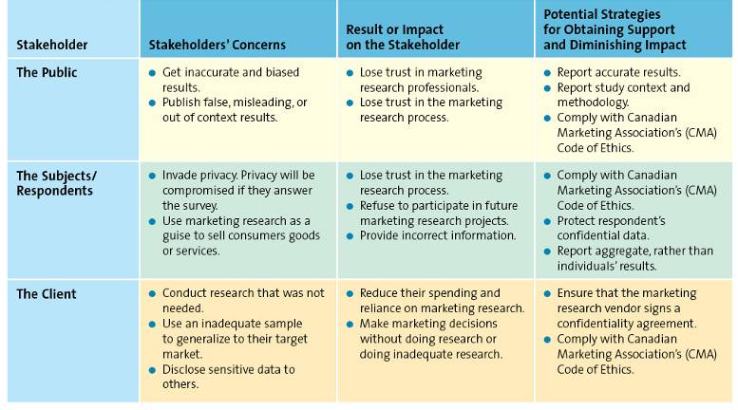
Step 3: Brainstorm and Evaluate Alternatives
- Half the market research project
- Make responses anonymous
Step 4: Choose a Course of Action
- Must weigh the various alternatives and choose a course of action that generates the best solution for the stakeholders by using ethical practices
- To evaluate each alternative, managers must use the same system of evaluation to decide in a fair manner

Integrating Ethics into Marketing Strategy
Planning Phase
- The mission or vision statement sets the overall ethical tone for planning
- Firms often go beyond the mission or vision statement by including a values statement
- During planning, ethical mission statements can also take on another role as a means to guide a firm’s SWOT analysis

Implementation Phase
- Marketers should always be vigilant
- A firm’s choice of target markets for its products can lead to charges of unethical behaviour
- Firms have to ensure their implementation strategies are ethical to gain the respect of customers
- Once the strategy is implemented, controls must be in place to be certain that the firm is actually done what it has set out to do

Control Phase
- Check successful implementation
- React to change
- Managers must be evaluated on their actions from an ethical perspective
- Ethics should be incorporated into all the firm’s decision making

Consumerism, Ethics, and Social Responsibility
Consumerism: a social movement aimed at protecting consumers from business practices that infringe upon their rights
- Consumers want to purchase products or services from companies that act in a socially responsible way

Ethical and Social Criticisms of Marketing
- Companies are criticized for engaging in unethical or illegal marketing practices
- Markets may engage in illegal practices such as bait-and-switch, deceptive advertising regarding the prices, sales, and features of their products
- Another criticism: grossly exaggerating claims about product benefits
- Criticized for making people feel that they are more valued for the products they use than for who they are as individuals

Chapter 3: Analyzing the Marketing Environment

Microenvironmental Factors
Company Capacities
- Successful marketing firms focus their efforts of satisfying customers needs that match their core competencies
- SWOT can be used to categorize an opportunity as either attractive or unattractive, and assess the firm’s existing competencies

Competition
- More choices influence consumers buying decisions
- Critical for marketers to understand their firm’s competitors, including their strengths, weaknesses, and likely reactions to the marketing activities their own firm undertakes
- Competitive intelligence (CI): used by firms to collect and synthesize information about their positions with respect to their rivals
  - Enables companies to anticipate changes in the marketplace rather than merely react to them

Corporate Partners
- Firms are part of alliances
- Align with competitors, supplies, etc.

Macroenvironmental Factors
Macroenvironmental factors: aspects of the external environment – culture, demographic, social trends, technological advances, economic situation, and political/legal environment (CDSTEP) that affect companies

Culture
- Culture: the shared meanings, beliefs, morals, values, and customs of a group of people
- It is hard for marketers to identify what is relevant to a particular group of people
- Our various cultures influence what, where, why, how and when we buy
- Marketers must take into account the culture of the country and the region in the country
- Country culture: entails easy-to-spot visible nuances that are particular to a country, such as dress, symbols, ceremonies, language, colours, and food preferences, and more subtle aspects which are trickier to identify
- Regional subcultures are the way people react to different cultural rituals, or even how the refer to a particular product category

Demographics
- Demographics: characteristics of human populations and segments especially those used to identify consumer markets, such as age, gender, income, race, ethnicity, and education
- Provides an easily understood snapshot of the typical consumer in a specific target market
- Not everyone in that specific demographic will act the same way

Generational Cohorts
- Generational cohorts: a group of people of the same generation = typically have similar purchase behaviours because they have shared experiences and are in the same stage of life
- Includes tweens, generation Y, generation X, baby boomers, and seniors

Tweens: generational cohort of people who are not quite teenagers but are not young children either
- Have immense buying power
- Have a great affect in the cellphone market
- Spend their money mainly on food and drinks, electronics, and clothing
- Learn about new products through TV shows and friends
- Once they get bored, they are gone doing something else

Generation Y: generational cohort of people between the ages of 13 and 32; the biggest cohort since the original postwar baby boom
- Grew up in a more media-intensive and brand-conscious era
  - More sceptical about what they hear in the media
  - Marketing even more challenging
- Internet and technology savvy, love digital electronics
- Generation Y members are having different expectations and requirements than those of other cohorts
- Want a good balance between work and life

Generation X: generational cohort of people between the ages of 36 and 47
- A generation that grew up with both parents working
- More likely to be unemployed, carry lighter debt loads, travel the world, and move far away from their parents
- Most likely to live longer than their parents
- Possess considerable spending power
- Must less interested in shopping but are most cynical astute consumers
- Good “word-of-mouth” advertisers
- Less likely to believe advertising claims or what salespeople tell them
- Much less interested in status products than older generations don’t see the point

Baby Boomers: generational cohort of people born after World War II; are between the ages of 48 and 66
- Possess sever traits that sets them apart from those born before World War II
  - They are individualists
  - Leisure time high priority
  - Believe they will always be able to take care of themselves
  - Obsession with maintaining their youth
  - Will always love rock n’ roll

Seniors: North America’s fastest-growing generational cohort; people aged 65 and older
- Seniors are more willing to spend money on goods and services rather than saving it, like before
- More seniors are using the Internet
  - Use for emailing, searching travel information and making travel arrangements, obtaining weather reports, and banking electronically
- Tend to like “made in Canada” products and recognizable brand names, value, quality, and classic styles
- Typically loyal and willing to spend but are extremely quality conscious an demand hassle-free shopping

Income
- Purchasing power is tied to income
- Statistics Canada tracks income
- Many middle class families feel the decline in purchasing power in recent years
- Upper class consumers are very affluent, by economic conditions
  - High discretionary income and tend to purchase luxury items
- Middle class families can afford a good life most of the time
  - Tend to be careful about their spending and are often value-conscious
- Working class families (or low income families) earn barely enough to cover their basic needs
- Under Class families often rely on assistance to cover their basic needs
- Although some marketers choose to target only affluent population segments, others have had great success delivering value to middle and low income earners
- Consumers are looking for more value for their dollar
- Middle class squeeze: many developing countries face similar income inequalities to those found in North America
  - Pay gaps also cause problems for new college graduates who find they cannot afford to live on their own and must move back in with their parents

Education
- Education is related to income, which determines spending power
- For some products, marketers can combine education level with other data such as occupation and income to obtain pretty accurate predictions of purchase behaviour

Gender
- Male/female roles have been blurred
  - Affects how firms design and promote their products and services
- Women make the majority of purchasing decisions and influence most of the remainder
- Working women’s segment is a large complex, and lucrative market
- A lot of advertisements involve the dads interacting with the kids, getting them involved in the purchasing decision

Social Trends
Greener Consumers
- Green marketing: involves a strategic effort by firms to supply customers with environmentally friendly merchandise
- Customers appreciate the efforts of companies who supply them with environmentally friendly merchandise
- This gives companies a great opportunity to gain more consumers
- Companies who sell products that are harmful to the environment may see this as a threat to their profits
- Companies can provide more green products by eliminating all or most materials that could be harmful to the environment

Privacy Concerns
- Loss of privacy
- Identity theft
- Do not call
- Do not email
- Consumers are constantly worried about their identity being stolen because they are reminded of it through commercials

Time-Poor Society
- In the majority of families, most parents work
- Consumers have many more choices regarding leisure time
- Many consumers multitask
- Marketers have to come up with new ways to advertise with social media becoming so popular
  - Have to move to more internet

Technological Advances
- Technological advances: technological changes that have contributed to the improvement of the value of both products and services in the past few decades
- Technology has impacted every aspect of marketing
- New products
- New forms of communication
- New retail channels
- Arguably the single most important change in the way we live is the introduction of new technology

Internet Marketing 4.1 VOIP
- 10% of Canadian homes have VOIP/ cable phones
- Allows the Internet to be used for voice applications: telephony, instant messaging, and teleconferencing
- Converge voice, video, and data on a single channel

Economic Situation
- Economic situation: economic changes that affect the way consumers buy merchandise and spend money
- Some major influences: rate of inflation, foreign currency exchange rates, interest rates, and recession
- Inflation: refers to the persistent increase in the prices of goods and services
  - A dollar buys less than it used to
- Foreign currency fluctuations: changes in the value of a country’s currency relative to the currency of another
- Interest rates: represent the cost of borrowing money
- The cost to customers or the fee the bank charges those customers for borrowing the money
  - A savings account will help a customer earn interest on the amount saved
- Recession: a period of economic downturn when the economic growth of the country is negative for at least a couple of consecutive quarters
  - The stock market declines sharply
  - Unemployment increases
  - Business and consumer confidence falls
  - Spending by both business and consumers is severely reduced
  - May cause people to delay purchases, go one level down on where they buy their stuff and where they eat out

Political/Legal Environment
- Political/legal environment: comprises political parties, government organizations, and legislation and laws that promote or inhibit trade and marketing activities
- Organizations must fully understand and comply with any legislation regarding fair competition, consumer protection, or industry-specific regulation
- The government is the largest regulator of products
  - Control what goes in and out
  - The government has enacted laws that promote both fair trade and competition by prohibiting the formation of monopolies or alliances that would damage a competitive marketplace, fostering fair pricing practices for al suppliers and consumers, and promote free trade agreements among foreign nations
    - Competition act
    - North American Free Trade Agreement (NAFTA)
- Legislation also has been enacted to protect consumers in a variety of ways:
  - Regulation require manufacturers to abstain from false or misleading advertising practices that might mislead customers
    - Consumer packaging and labelling act
  - Manufacturers are required to identify and remove any harmful or hazardous materials that mi ght place a consumer at risk
    - Access to information act
  - Organizations must adhere to fair and reasonable business practices when they communicate with consumers
  - The government enacts laws focused on specific industries on consumers
- Other acts the government created:
  - Food and drugs act
  - Patent act
- Government regulation ma have a negative or positive impact on marketers:
  - Positive side: certain laws create an opportunity for markets to sell more of their products
  - Regulation may help to create a level playing field for competition and set standards for marketers to follow

Chapter 4: Market Research
Market Research: a set of techniques and principles for systematically collecting, recording, analyzing, and interpreting data that can id decision makers involved in marketing goods, services, or ideas

The Market Research Process

Step 1: Define the Research Problems and Objectives
- Determine what information is needed to answer specific research questions
- Determine how the information should be obtained
- Pour research design arises from three major sources:
  - Basing research on irrelevant research questions, focusing on research questions that marketing research cannot answer, or addressing research questions to which the answers are already known

Step 2: Design the Research Project
- Researchers identify the type of data needed and determine the type of research necessary to collect it
- Two purposes:
  - Determine relative market share straightforward
  - Assessing the extent to which the firm’s market position will improve, stay the same, or deteriorate not easy to obtain
- The marketer must decide whether the data required to make a decision should be obtained from secondary sources or primary sources

Secondary Data
- Secondary data: pieces of information that have ben collected prior to the start of the focal project
- Includes both internal and external data sources
- Primary data are those collected to address the specific research needs/questions current under investigation
- A marketing research project often begins with a review of the relevant internal and external secondary data, such as the company’s own records and other published sources
- Generally, secondary data can be quickly accessed at a relatively low cost
- Researchers must ensure that the secondary data they use are current, relevant, and can shed light on the research problems or objectives
- A marketing research project often beings with a review of the relevant internal and external secondary data
- Syndicated data: data available for a fee from commercial research firms
- Markets must pay careful attention to how the secondary data were collected

Primary Data
- Primary data: data collected to address the specific research needs/questions currently under investigation
  - Some primary data collection methods include focus groups, in-depth interview, and surveys
- Can help eliminate some of the problems inherent to secondary data
- Advantage: Tailed to fit the research questions
- Disadvantages: more costly and longer to collect
  - Marketers often require extensive training and experience to design and collect primary data that is unbiased, valid and reliable
- Reliability: the extent to which the same result is achieved when a study is repeated under identical situations
- Validity; the extent to which a study measures what is suppose to measure
- A market researcher must be both reliable and valid for it to be useful
- Sample: a segment or subset of the population that adequately represents the entire population of interest
- 3 important questions need to be answered when selecting a sample:
  - Who should be surveyed
  - How big should the sample be
  - What types of sampling procedures to use
    - Sampling: the process of picking a sample
- The larger samples tend to yield more reliable results up to a certain point

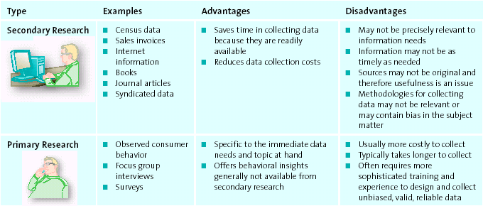

Step 3: Collect Data
- Exploratory research: attempts to begin to understand the phenomenon of interest
  - Provides initial information when the problem lacks any clear definition
  - More informal and qualitative
  - Methods include: observation, following social media sites, in-depth interviews, focus groups, and projective techniques
- If form is ready to move beyond preliminary insights move to conclusive research
  - Provides the information needed to confirm preliminary insights, which managers can use to pursue appropriate courses of action
- Usually means confirming implicit hunches through surveys, formal studies or some combination of these
- Enables researchers to test their hypothesis or prediction
  - A statement or proposition predicting a particular relationship among multiple variables that can be tested through research
- Examining data: starts with exploratory, ending with conclusive

Exploratory (Qualitative) Research Methods
- Focus groups and in-depth interviews are used most frequently
- Deciding which method to use takes into account many important considerations

Observation
- Observation: an exploratory research method that entails examining purchase and consumption behaviours through personal or video camera scrutiny
- Can last for a very brief period of time, or a lengthy one
- Useful when consumers are unable to articulate their experiences
- Ethnography: an observational method that studies people in their daily lives and activities in their home, work, and communities
- Used when market researchers believe that potential respondents may be unable to express in a useful way their experiences with a product or service
- Requires very highly trained researchers to analyse data

In-depth Interviews
- In-depth interview: a research technique in which trained researchers ask questions, listen to and record the answers, and then pose additional questions to clarify or expand on a particular issue
- Benefits:
  - Provide a historical context for the phenomenon of interest
  - Can communicate how people really feel about a produce or service at the individual level
  - Can use results to develop surveys
- Relatively expensive and time consuming

Focus Group
- Focus group; a research technique in which a small group of persons comes together for an in-depth discussion about a particular topic, which the conversation guided by a trained moderator using an unstructured method of inquiry
- Usually recorded interactions so they can carefully comb through the interviews later
- Gather qualitative data about initial reactions to a new or existing product or service, opinions about different competitive offerings, or reactions to marketing stimuli
- There is also such a thing as virtual focus groups

Projective Technique
- Projective technique: a type of qualitative research in which subjects are provided a scenario and asked to express their thoughts and feelings about it

Social Media
- Marketers believe that social media can provide valuable information that could aid them in their marketing research and strategy endeavours
- Can provide insights into what consumers are saying about the firm’s own products or its competitor’s products
- Can monitor customers likes, dislikes, preferences through social networking sites
- Marketers are paying attention to reviews written online
- Social media sites can be used in very creative ways
- Many companies now market through blogs, twitter or Facebook
- Firms can gather the most up-to-date news about itself, its products, and its services, as well as its competitors
- Allows companies to learn about customers’ perceptions and resolve customer complaints they may never have heard about through other channels

Conclusive (Quantitative) Research Methods
Survey Research
- Most popular type of conclusive research method used in marketing research
- Used to study consumers’ attitudes, preferences, behaviours, and knowledge about products and brands
- Generally more cost-effective
- Data can be easily analyzed by using sophisticated statistical methods to examine the relationships among variables
- Disadvantages:
  - Some consumers may not be able to answer some questions
  - May not be able to recall the information
  - May interpret the questions differently
- Incomplete data makes the analysis and interpretation of the data more complicated and tricky
- Survey: a systematic means of collecting information from people that generally uses a questionnaire
  - Can take different forms: phone, mail, fax, internet, in person
- Questionnaire: a form that features a set of questions designed to gather information from respondents and thereby accomplish the researchers’ objectives
  - Individual questions on a questionnaire can either be unstructured or structured
    - Unstructured questions: open-ended questions that allow respondents to answer in their own words
    - Structured questions: close-ended questions for which a discrete set of response alternatives, or specific answers, is provided for respondents to evaluate
- The question must be carefully designed to address the specific set of research questions
- Must produce meaningful results
- Questions cannot be misleading in any way
- Worded in vocabulary that will be familiar and comfortable to those being surveyed
- Marketing surveys can be conducted either online or offline, but online marketing surveys offer researchers the chance to develop a database quickly with many responses
- Offline marketing surveys provide a more direct approach that includes interaction with the target market
- Many online survey tools let researchers quickly design a survey, launch it, download the data, and analyze the data eve as the survey is progressing
- Lowest response rate: mail surveys
- Middle response rate: phone surveys
- Highest response rates: online surveys
- Online surveys are inexpensive; phone surveys are very expensive
- Open-ended questionnaires can be used to collect more in-depth qualitative data
- Typically use different scales to measure certain concepts such as attitudes, perceived quality, perceived value, loyalty, and convenience

Experimental Research
- Experimental research: a type of quantitative research that systematically manipulates one or more variables to determine which variable as a causal effect on another variable
- In general, the more expensive the item, the less it will sell

Scanner Research
- Scanner research: a type of quantitative research that sues data obtained from scanner readings of UPC codes at checkout counters
- The information helps leading consumer packaged goods firms to assess what is happening the marketplace

Panel Research
- Panel research: a type of quantitative research that involves collecting information from a group of consumers over time
- Data may be collected from a survey or a record of purchases
- Provides consumer packaged goods firms with a comprehensive picture of what individual consumers are buying or not buying

Step 4: Analyze Data
- Analysis should be both thorough and methodical
- Data: raw numbers or other factual information of limited value
- When data is interpreted, it turns into information
  - Information: data that has been organized, analyzed, interpreted, and converted into a useful form for decision makers
- Purpose of converting data is to describe, explain, predict, and/or evaluate a particular situation
- Must analyze and interpret data in an objective manner
- Try not to hide or colour-cote findings that are different from what they had hoped for
- Misinterpreting or manipulating the data to fit a hunch or prediction can lead to making the wrong decision

Step 5: Present Action Plan
- Typical marketing research presentation includes an executive summary, the body of the report, the conclusions, the limitations, and the appropriate supplement tables, figures and appendices
- Must be short, interesting, methodical, precise, lucid, and free of errors

The Ethics of Using Customer Information
- Databases that contain information on millions of customers must not be accessed by the marketers, unless authorized
  - Unauthorized sharing of customer data with third parties or for purposes other than legitimate company business is a serious breach of customer trust
  - Firms must also ensure they take every precaution to prevent hackers retrieving the personal information of customers
- Privacy Act: a regulation that governs the collection, use, disclosure, and retention of personal information by federal government institutions
- Personal Information Protection and Electronic Documents Act (PIPEDA): governs the collection, use, disclosure, and retention of personal information by certain parts of the private sector
- The Canadian Marketing Association provides three guidelines for conducting marketing research:
  - It prohibits selling or fundraising under the guise of conducting research
  - It supports maintaining research integrity by avoiding misrepresentation or the omission of pertinent research data
  - It encourages the fair treatment of clients and suppliers
- Marketing research should be used only to produce unbiased, factual information

Chapter 5: Consumer Behaviour
The Consumer Decision Process
- Generally does not occur when purchasing habitual products

Step 1: Need Recognition
- Need Recognition: occurs when consumers recognize they have an unsatisfied need and want to go from their actual needy state to a different desired state

Functional needs
- Functional needs: pertain to the performance of a product or service
- Some brands prominently display the high-end brands so consumers are more willing to spend the money to purchase it knowing it is made with quality materials

Psychological needs
- Psychological needs: pertain to the personal gratification consumers associate with a product or service
- Purchasing a necessary item, but spending much more than necessary on it
- Christian Louboutin shoes satisfy both the psychological and functional needs of shoes
  - Psychological need overrides the functional need
- A key to marketing is determining the correct balance of function and psychological needs that best appeals to the firm’s target market
- Common tactics marketers employ include using reminder advertising for their products, creating awareness about a new product and its capabilities, showing how a product could enhance consumers’ image, and even altering the physical layout of a store or where products are placed in the store

Step 2: Information Search
- The consumer will search for information about the various options that exist to satisfy the need
- Length and intensity of search depends on degree of perceived risk associated with purchasing the product or service and the importance of the product to the consumer
- Internal search for information: buyer examines his or her own memory and knowledge about the product or service, gather through past experience
- External search for information: the buyer seeks information outside his or her personal knowledge base to help make the buying decision
- Internet is a great source to look up information

Factors Affecting Consumers’ Search Processes
- The perceived benefits verses perceived costs of search: debating whether is it worth the time and effort to search for information about a product or service
- The locus of control:
  - People who have an internal locus of control believe they have some control over the outcomes of their actions
  - With an external locus of control consumers believe that fate or other external factors control all outcomes
- Actual or perceived risk: 5 types of risk associated with purchase decisions can delay or discourage a purchase
  - Performance risk: involves the perceived danger inherent in a poorly performing product or service
  - Financial risk: risk associated with a monetary outlay and includes the initial cost of the purchase, as well as the costs of using the item or service
  - Social risk: involves the fears that consumers suffer when they worry others might not regard their purchases positively
  - Physiological risk (safety risk): risk associated with the fear of an actual harm should the product not perform properly
  - Psychological risks: risks associated with the way people will feel if the product or service does not convey the right image
- Types of products or service:
  - Specialty goods/services: products or services toward which the customer shows a strong preference and for which he or she will expend considerable effort to search for the best suppliers
  - Shopping goods/services: products or services for which consumers will spend a fair amount of time comparing alternatives
  - Convenience goods/services: products or services for which the consumer is not willing to spend any effort to evaluate prior to purchase

Step 3: Alternative Evaluation
- Often occurs while consumers are engaged in the process of information search
- Often base their evaluations on a set of important attributes or evaluative criteria
  - Evaluative criteria: consists of a set of salient, or important, attributes about a particular product that are used to compare alternative products
- To shorten this process, consumers generally use shortcuts such as determinant attributes and consumer decision rules
  - Determinate attributes: products or services features that are important to buyers and on which completing brands or stores are perceived to differ
    - Consumers look for that “something special” that sets one product or service apart from another
  - Consumer decision rules: the set of criteria that consumers use consciously or subconsciously to quickly and efficient select from among several alternatives
    - Several different forms: compensatory, noncompensatory, decision heuristics
    - Compensatory: assumes the consumer, when evaluating alternatives, trades off one characteristic against another
    - Noncompensatory: the consumer chooses a product or service on the basis of a subset of its characteristics, regardless of the values of its other attributes
    - Decision Heuristics: mental shortcuts that help the consumer narrow down their choices
      - Price: consumers choose the more expensive option, thinking they are getting better quality
      - Brand: buying the same brand allows the consumers to feel safe with their choices; buying a national brand gives consumers the feeling they are buying a higher quality item
      - Product presentation: the manner in which a product is presented can influence the decision process

Step 4: Purchase Decision
- Once the consumer considers the possible alternatives and evaluates the pros and cons of each, they can move towards a purchase decision
- Value is a strong driver of the purchase decision
  - They want the have the best value for their dollar
- After the purchase is made, the consumer generally goes though a special type of consumption called the ritual consumption
  - Ritual consumption: a pattern of behaviours tied to life events that affect what and how we consume
  - Behaviours tend to have symbolic meanings and vary greatly by culture
  - Many firms try to tie their products and services to ritual consumption
- Situational factors also help consumers decide what they will purchase
  - Having the merchandise in stock when needed, offering multiple payment options, having many checkout lanes, offering tactics such as delivery, price-match guarantee, a warrantee, or simply return policy

Step 5: Postpurchase
- Entails actual customers
- Marketers want to have new loyal customers that will come back again, but unsatisfied customers will patronize the store and spread negative word of mouth
- 3 possible postpurchase outcomes:
  - Customer satisfaction
    - Selling unrealistically high consumer expectations might lead to higher initial sales, but will eventually result in high dissatisfaction when the product fails to achieve these high expectations
      - Potential for negative word of mouth
    - Selling expectations that are too low is very dangerous also
      - Store fronts must be appealing right from the entrance to attract customers into the store
    - Marketers can take the following steps to ensure postpurcahse satisfaction:
      - Build realistic expectations and deliver on them
      - Demonstrate correct product use
      - Stand behind the product or service by providing money-back guarantees and warranties
      - Encourage customer feedback, which cuts down on negative word of mouth and helps marketers adjust their offerings
      - Periodically make contact with customers and thank them for their support
        - Reminds customers the firm cares about their business and wants them to be satisfied
  - Postpurchase cognitive dissonance (buyer’s remorse)
    - Postpurchase dissonance: an internal conflict that arises from an inconsistency between two beliefs, or between beliefs and behaviour
    - Usually occurs when consumers feel that they made the purchase without all the information they needed, were persuade by a salesperson, they liked the good features of the product or service but do not like the negative aspects of the product or service, or if immediately following the purchase they see the product or service advertised elsewhere for a better price
    - Especially likely to occur for products that are expensive, infrequently purchased, highly expressive, and associated with high levels or risk
    - Negativity is involved with postpurchase dissonance
    - To reduce the dissonance, here are several actions:
      - Pay attention to positive information
      - Get positive feedback from friends
      - Seek negative information about the other considerations; reading reviews makes the customer feel more comfortable with their purchase
  - Customer loyalty (or disloyalty)
    - Develops over time with multiple repeat purchases of the product or brand from the same marketer
    - Marketers attempt to build and nurture a loyal relationship with their customers
    - When consumers have a loyal relationship with a company, they do not consider other brands when making purchases

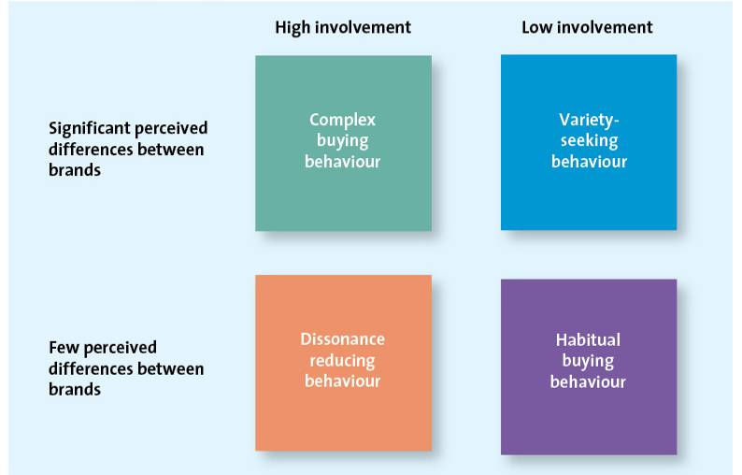

Undesirable Consumer Behaviour
- Firms sometimes fail to attain loyal customers
- Negative word of mouth: occurs when consumers spread negative information about a product, service, or store to others
- Consumers generally do not tell other when they are beyond satisfied with a brand, but tell everyone when they are dissatisfied
- The internet is an effective method of spreading negative word of mouth quickly
- Firms have customers service representatives that can be accessed through the phone, or online that deal with complaints

Factors Influencing Consumer Buying Decisions
- Psychological factors: influences internal to the customer
- Social factors: influences external to the customers, like family and friends
- Situational factors: specific to purchase situation

Psychological Factors
- Psychological factors affect the way people received marketers’ messages
- Factors: motives, attitudes, perceptions, learning, and lifestyle

Motives
- Motives: a need or want that is strong enough to cause the person to seek satisfaction
- Best-known paradigm for explaining these motives is Maslow’s Hierarchy of Needs
  - Physiological, safety, love or social, esteem, self-actualization
    - Physiological needs: deal with the basic biological necessities of life: food, drink, rest, and shelter
    - Safety needs: pertain to protect and physical well being
    - Love or social needs: relate to our interactions with others
    - Esteem needs: allows people to satisfy their inner desires
    - Self-actualization needs: occurs when you feel completely satisfied with your life and how you live

Attitudes
- Attitude: a person’s enduring evaluation of his or her feelings about and behavioural tendencies toward an object or idea
  - Consists of 3 components:
    - Cognitive: reflects what a person believes is true
    - Affective: what we feel about the issue at hand
    - Behavioural: the actions we take based on what we know and feel
- Ideally, agreement exists among these components
  - If there is incongruence among the tree, cognitive dissonance might occur
  - Marketers believe that they can influence consumers attitudes through persuasive communication and personal experience
- Marketing communication can attempt to change what people believe to be true about a product or service (cognitive) or how they feel toward it (affective)

Perception
- Perception: the process by which we select, organize, and interpret information to form a meaningful picture of the world
- Influences our acquisition and consumption of goods and services through our tendency to assign meanings to such things as colour, symbols, taste, and packaging
- Culture, tradition and our overall upbringing determines our perceptual view of the world
- In trying to influence perception, marketers must understand and focus on the four components of perception:
  - Selective exposure: people who look at the news and sports channels but not the comedy or women’s TV network channels are engaged in selective exposure because they are excluding other programs or channels
  - Selective attention: consumers who only listen to messages that are consistent with their beliefs, and not others
  - Selective comprehension: occurs when consumers interpret a marketing message in a way that is different from what the marketer intends
  - Selective retention: describes the situation where consumers do not remember all the information they see, read or hear

Learning
- Learning: a change in a person’s thought process or behaviour that arises from experience that takes place throughout the consumer decision process
- Affects both attitudes and perceptions
- When a consumer learns more about a company, they realize how much they like the brand (affective component) and then subscribes to it (behavioural component)

Lifestyle
- Lifestyle: the way consumers spend their time and money to live
- The question of whether the product or service fits with their actual life is an important one to consumers
- A person’s perceptions and ability to learn are affected by their social experiences

Social Factors
Family
- Many purchase decision are made about products or services that the entire family will consume or use
- Firms must consider how families make purchase decisions and understand how various family members might influence these decisions
- Children and adolescents play an increasingly important role in the family buying decisions

Reference Groups
- Reference groups: one or more personas in individual uses as a basis for comparison regarding beliefs, feelings, and behaviours
- A consumer might have various reference groups, including family, friends, co=workers, or famous people
- These reference groups affect buying decisions by
  - Offering information
  - Providing rewards for specific purchasing behaviours
  - Enhancing a consumer’s self-image
- Provide information directly through conversation or indirectly through observation
- Some references groups also influence behaviours by rewarding behaviour that meets with their approval or chastising those who engage in behaviour that doesn’t
- Consumers can identify and affiliate with reference groups to create, enhance, or maintain their self-image

Culture
- Culture: shared meanings, beliefs, morals, values, and customers of a group of people
- One of the most persuasive factors influencing consumer behaviour
  - Marketers must work hard to understand how it is different not only in Canada but those countries to which they plan to market their products
- There are cultural differences between various subgroups or subcultures
  - Subculture: a group of people whose beliefs and values are different from the rest of the larger society in which they live
  - Examples: Chinese-Canadian, South-Asian, Acadian

Situational Factors
- Situational factors: factors affecting the consumer decision process; those that are specific to the purchase and shopping situation and temporal state that may override, or at least influence, psychological and social issues

Purchase Situations
- Customers may be predisposed to purchase certain products or services because of some underlying psychological trait or social factor, but these factors may change in certain purchase situations

Shopping Situation
- Consumer might be ready to purchase a product or service but for a variety of reasons be completely derailed once they arrive at the store
  - Store atmosphere: some retailers and service providers have developed unique images that are based at least in part on their internal environment
  - Salespeople: well-trained sales personnel can influence the sale at the point of purchase by pointing out the advantages of one item over another and by encouraging multiple purchases
  - Crowding: customers can feel crowded because there are too many people, too much merchandise, or lines are too long
  - In-store demonstrations: the taste and smell of new food items may attract people to try something they normally wouldn’t
  - Promotions: retailers employ various promotional vehicles to influence customers once they have arrived in the store
    - Ex: multi-item discounts
  - Packaging: marketers spend millions of dollars designing and updating their packages to be more appealing and eye-catching than their competitors

Temporal State
- Our state of mine at any particular time can alter our preconceived notions of what we are going to purchase
- Mood swings can also alter consumers behaviour

Involvement and Consumer Buying Decisions
- Consumers engage in two types of buying process/decisions depending on their level of involvement:
  - Extended problem solving for high-priced, risky, infrequent, or highly expensive purchases
  - Limited problem solving, which includes impulse buying and habitual purchases/decision making
- Involvement: the consumer’s degree of interest or concern in the product or service
- Consumers may have different levels of involvement for the same type of product
- A low-involvement consumer will likely process the same advertisement in a less thorough manner
  - Might pay less attention to the key elements of the message and focus on heuristic elements such as brand name, price, and the presence of a celebrity endorser

Extended Problem Solving
- Extended problem solving: a purchase decision process during which the consumer devotes considerable time and effort to analyze alternatives
  - Often occurs when the consumer perceives that the purchase decision entails a great deal of risk

Limited Problem Solving
- Limited problem solving: occurs during a purchase decision that calls for, at most, a moderate amount of effort and time
- Engage in this type of buying process when they have had some prior experience with the product or service and the perceived risk is moderate
- Impulse buying: a buying decision made by customers on the spot when they see the merchandise
- Habitual decision making: a purchase decision process in which consumers engage in little conscious effort
- Marketers strive to attract and maintain habitual purchasers by creating strong brands and store loyalty because these customers don’t even consider alternative brands or stores
- Marketers who are trying to get consumers to switch to their brands often use marketing tactics that require greater involvement in the purchase decision

Chapter 6: Business-to-Business Marketing
Business-to-business (B2B) Marketing: the process of buying and selling goods and services to be used in the production of other goods and services, for consumption by the buying organization, or for resale by wholesalers and retailers
- Involves manufacturers, wholesalers, retailers, and service firms that market goods and services to other businesses but not to the ultimate consumer
- Distinction between B2B and B2C transactions is not the product or service itself, rather it is the ultimate purchaser and user of that product or service

B2B Markets
- Focus their efforts on serving specific types of customer markets to create value for those customers

Manufacturers or Producers
- B2B buyers are both manufacturers and producers
  - Manufacturers buy raw materials, components, and parts that allow them to manufacture their own goods
- Not only does the manufacturer purchase products from other firms to make its products, but it also works with its corporate partners, such as transportation companies and retailers, to facilitate movement of the raw supplies to the factory and finished products to the stores
- B2B companies are demanding, as a condition for doing business, that suppliers demonstrate social responsibility by putting in place policies and practices to reduce their carbon footprint

Resellers
- Resellers: marketing intermediaries that resell manufactured products without significantly altering their form
- Wholesalers, distributors, and retailers are all resellers

Institutions
- Institutions also purchase all kinds of goods and services for the people they serve
  - Ex: hospitals, educational organizations prisons, religious organizations, and other non-profit organizations

Government
- The central government tends to be one of the largest purchasers of gods and services
  - The bulk of purchases is done centrally by Public works and Government Services Canada on behalf of more than 85 departments, agencies, Crown corporations, and Special Operating Agencies
  - Government buying information can be obtained from Business Access Canada or from MERX
    - MERX: the most complete source of Canadian public tenders, private tenders, U.S. tenders, and private-sector construction news available for Canada

Key Challengers of Reaching B2B Clients
- For marketers to be effective and successful at B2B marketing, they must master 3 key challengers for each business customer they want to serve
  - Identify the right persons or decision makers with the organization who can authorize or influence purchases
  - Marketers must understand the buying process of each of its potential clients
  - Identify the factors that influence the buying process of potential clients
- Differ in varying degrees on these 3 dimensions marketers must invest the time and resources to understand these challenges
- Governments make much larger purchases, but their buying processes must not only satisfy strict policy guidelines and directives set by the government, but also meet international trade rules set by the World Trade Organization (WTO) or the North American Free Trade Agreement (NAFTA)
  - Government purchases are subject to public scrutiny and can be subjected to legal challenges or be cancelled or modified
- Private sector companies rarely disclose their buying criteria or buying process
  - They are likely to engage in reciprocal buying, where two companies agree to buy each others products
- To address the complexity of B2B many companies have salespeople or a sales team dedicated to specific clients

Differences Between B2B and B2C Markets
Market Characteristics
- B2C markets: consumers buy goods to satisfy their own individual or household needs and are heavily influenced by price, personal, tastes, brand reputation, or personal recommendations of friends and family
- B2B markets: demand for goods and services are derived from B2C sales in the same supply chain
  - Derived demand is the linkage between consumers’ demand for a company’s output and its purchase of necessary inputs to manufacture or assemble that particular output
- Demand for raw material and semi finished goods purchased by business firms end to fluctuate more, and more frequently
- Demand in many business markets is inelastic
  - The total demand for goods is not affected much by price changes in the short run
- B2B: the number of business buyers is substantially fewer than in B2C markets and the business buyers are most concentrated in big cities, town, and industrial areas
  - The sizes of the orders are substantially larger than consumer purchases

Product Characteristics
- B2B: the products ordered are primarily raw materials and semi finished goods that are processed or assembled into finished goods for the ultimate consumers
  - The products are very technical and sophisticated in nature and must conform to technical standards specified by the buyer
  - The raw materials, components, and semi finished goods undergo rigorous testing before shipping
  - Orders must be delivered on a date that is both agreed on by the sender and receiver

Buying Process Characteristics
- Routine purchases or small-dollar-value purchases, only one or a few individuals within a department or the company may be responsible for the buying decisions
- Purchases for highly technical or complex products involving thousands or millions of dollars, the buying effort is much more structured, formalized, and professional
  - More people are generally involved in complex buying decisions
  - Usually technically trained and qualified professionals
- Most companies have formal policies and procedures to guide buying decisions that must be closely followed by the people involved
- Difference between B2C and B2B: buying lies in the nature of the relationship between the firm and its suppliers
  - In B2B markets: buyers and sellers strive to develop close relationships with each other and so will often provide help or advice to ensure a win-win situation for both parties
- Some firms may engage in reciprocal buying arrangements
  - Reciprocal buying has both negative and positive consequences for both the buying and selling firms involvement
    - Consequences:
      - In excludes other vendors from participating in the buying process
      - May limit the firms to each other’s products

Marketing Mix Characteristics
- The role of the salesperson is different with B2B and B2C markets
  - B2C: salespeople are an important component to the communication mix in transactions such as sales of real estate, jewellery, insurance, consumer electronics, and high-end apparel; not necessary for sale of foods
  - B2B: the salesperson is an integral component of the transaction

B2B Classification System and Segmentation
- North American Industry Classification System (NAICS): a classification scheme that categorizes all firms into a hierarchical set of six-digit numbers
  - Designed jointly by Canada, the U.S. and Mexico to provide comparable statistics about business activity in all of North America
  - Replaced the Standard Industrial Classification (SIC) that had been in use since the 1930s
  - First two digits: sector in economy
  - Third digit: subsector
  - Forth digit: industry group
  - Fifth digit: represents a specific subgroup with the industry
  - Full six-digits refer to the country-level or national industry
- Useful for B2B marketers to segment and target markets
- Marketers may segment B2B markets in several other ways, including geographical location, firm size, account size, and types of products purchased

The B2B Buying Process
- B2B buying process is based on the B2C process, but differs in many ways

Stage 1: Need Recognition
- The buying organization recognizes, through either internal or external sources, that it has an unfilled need

Stage 2: Product Specification
- The organization considers alternative solutions and comes up with potential specifications that suppliers might use to develop their proposal to supply the product

Stage 3: RFP Process
- Request for proposals (RFP): a process through which buying organizations invite alternative suppliers to bid on supplying their required components
- The purchasing company may post its RFP needs on its website, work through various B2B linkages, or contact potential suppliers directly

Stage 4: Proposal Analysis and Supplier Selection
- Evaluations of all the proposals received in response to its RFP
  - Firms are likely to narrow the process to a few suppliers, often those with which they have existing relationships, and discuss key terms of the sale
- Some firms have a policy that they need to negotiate with multiple suppliers
  - Keeps suppliers on their toes

Stage 5: Order Specification (Purchase)
- The firm places the order with its preferred supplier (or suppliers)
- Include detailed description of the goods, prices, delivery dates, and if the order is not filled on time

Stage 6: Vendor Performance Assessment Using Metrics
- Firms analyze their vendors’ performance so they can make decisions about their future purchases
- Analysis is typically more formal and objective
- Performance is generally evaluated based on these steps:
  - Buying team develops a list of issues that it believes are important to consider in the evaluation of the vendor
  - To determine how important each issue is, the buying team assigns an importance score to each column
    - The more important, the higher a score it will receive
    - The scores must add up to 1
  - The buying team assigns a number that reflects its judgements about how well the vendor performs
    - 1 = poor performance
    - 5 = excellent performance
  - The team combines the importance of each issue and the vendor’s performance scores by multiplying them together

1 – Key Issues | 2 – Importance Score | 3 – Vendor’s Performance | 4 – Importance/Performance
Strength of Brand | 0.30 | 5 | 0.15
Meets delivery dates | 0.20 | 4 | 0.8
Product Quality | 0.40 | 5 | 2.0
Ease of ordering | 0.10 | 3 | 0.3
Total | 1.0 |  | 4.6

Factors Affecting the B2B Buying Process
The Buying Centre
- Buying centre: the group of people typically responsible for the buying decisions in large organizations
  - Each member is likely to play a different role in the buying process
- 5 different buying roles within a typical buying centre:
  - Initiator: the personal who first suggests buying the particular product or service
  - Influencer: the personal whose views influence other members of the buying centre in making the final decision
  - Decider: the person who ultimately determines any part of or the entire buying decision
    - Whether to buy, what to buy, how to buy, or where to buy
  - Buyer: the personal who handles the paperwork of the actual purchase
  - User: the person(s) who consumes or uses the product or service
  - Gatekeeper: the person(s) who controls information or access, or both, to decision makers and influencers

Organizational Culture
- Organizational culture: reflects the set of values, traditions, and customs, that guides its managers’ and employees’ behaviour
- Generally comprises of a set of unspoken guidelines that employees share with one another through various work situations
- Can have a profound influence on purchasing decisions
- Corporate buying centre cultures might be divided into four general types:
  - Autocratic buying centre: one person makes the decision alone, thought there may be multiple participants
  - Democratic buying centre: the majority rules in making decisions
  - Consultative buying centre: one person makes the decision, but he or she solicits input from others before doing so
  - Consensus buying centre: all members of the team must reach a collective agreement that they can support a particular purchase
- Culture may vary by geography, division, or functional department

Building B2B Relationships
- There are a vast variety of ways to enhance relationships, which are changing by the minute
- Social media is a great way to build relationships
  - Can talk to other companies whenever they want

Buying Situations
- Type of buying situation also affects the B2B decision process
  - Most situations are categorized into three types:
    - New buys: a customer purchases a good or service for the first time
      - The buying decision is likely to be quite involved because the buyer or the buying organization does not have any experience with the item
    - Modified rebuys: the buyer has purchased a similar product in the past but has decided to change some specifications
    - Straight rebuys: the buyer or buying organization simply buys additional units of products that had previously been purchased

Roles of the Internet in Business-to-Business Marketing
- B2B markets have increasingly been reliant on the Internet
- Social Media Marketing has become very popular and a critical marketing strategy
- Internet trade shows is increasingly more common
  - Each company sets up their own virtual booth and engage in product demonstrations and interact with possible customers
  - Very easy to use for both the purchaser and the seller
  - Saves a lot of money rather than going to actual trade shows
- Equally useful for communications between businesses through private exchanges and auctions
  - Private exchange: a specific firm invites another to participate in online information exchanges and transactions
  - Manufacturers and suppliers can work together to design better products
    - Manufacturers and retailers collect information about their customers’ preferences and other market trends
    - Shares that with suppliers involved in product design
  - Formed on the manufacturer-to-retailer side of the supply chain
- B2B transactions have increasingly turned to online auctions whether English or reverse
  - English auction: goods and services are simply sold to the highest bidder (traditional auction)
    - Two companies can trade unsold merchandise, and then sell to the buyer with the highest bid
  - Reverse auction: the buyer provides specifications to a group of sellers, who then bid down the price until the buyer accepts a specific bid

Chapter 7: Segmentation, Targeting, and Positioning
The Segmentation-Targeting-Positioning Process

Step 1: Establish Overall Strategy and Objectives
- Must be consistent with and derived from the firm’s mission and objectives as well as its current situation
  - Its strengths, weaknesses opportunities and treats (SWOT)

Step 2: Segmentation Bases
- Develops descriptions of the different segments, their needs, wants, and characteristics, which helps firms better understand the profile of the customer in each segment
- Includes: geographic, demographic, psychographic, and behavioural, or a combination of these segmentation approaches
Segmentation Method | Sample Segments
Geographic | Country, province, city, urban, rural, climate  Continent: North America, Asia, Europe, Africa,  Region: Atlantic, Central, Western Canada
Demographic | Age, gender, income, education, occupation, religion, family life cycle, etc.
Psychographic | Lifestyles, values, self concept
Behavioural | Benefits derived, usage rates, user status, loyalty

Geographic Segmentation
- Geographic segmentation: the grouping of consumers on the basis of where they live
- Firms can provide the same basic goods or services to all segments even if they market globally or nationally
  - Better markets make adjustments to meet the needs of smaller geographic groups

Demographic Segmentation
- Demographic segmentation: the grouping of consumers according to easily measured, objective characteristics such as age, gender, income, and education
- Most common method
- Census excellent source of segmentation data
- May not be useful for defining the target segments for other companies

Psychographic Segmentation
- Psychographic segmentation: how consumers describe themselves
  - Allows people to describe themselves by using those characteristics that help them choose how they occupy their time
- Self-values: goals for life, not just the goals one wants to accomplish in a day
  - Overriding desires that drive how a person lives his or her life
  - Causes people to develop self-images of how they want to be and then determine a way of life that will help them arrive at these ultimate goals
- Self-concept: the image a personal has of himself or herself
- Lifestyles: refers to the way a person lives his or her life to achieve goals
  - If values provide an end goal and self-concept is the way one sees oneself in the context of that goal, lifestyles are how we live our lives to achieve goals
  - VALS is a questionnaire where consumers are classified into the eight segments in two dimensions
- Psycholgraphics are a very good complement to demographics to produce an in-depth profile and predict consumer behaviour
- Limitations to using psychographic segmentation:
  - Not as objective as demographics
  - Harder to identify potential customers

Behavioural Segmentation
- Behavioural segmentation: groups consumers on the basis of the benefits they derive from products or services, their usage rates of products or services, their user status, and their loyalty
- Dividing the market into segments whose needs and wants are best satisfied by the product benefits can be very powerful
- Benefit segmentation: groups consumers based on the benefits they derive from products or services
  - Makes a lot of sense to divide market in this way
- It pays to retain loyal customers
  - Those who feel so strongly that the firm can meet their relevant needs best that any competitors are virtually exclude from their consideration
  - Most profitable in the long-run
  - Loyalty segmentation: strategy of investing in retention and loyalty initiatives to retain the firm’s most profitable customers
- Usage rates and user status (current, potential and ex- users) are segmentation variables as well

Using Multiple Segmentation Methods
- Geodemographic segmentation: the grouping of consumers on the basis of a combination of geographic, demographic and lifestyle characteristics
  - Most widely used tools for geodemographic segmentation are PSYTE clusters
    - PSYTE clusters: the grouping of all neighbourhoods in Canada into 60 different lifestyle clusters
    - PRIZM CE: a tool developed by Environics Research, groups Canadians into one of 66 lifestyle types
  - Can particularly be useful for retailers because customers typically patronize stores close to their neighbourhood
- Firms often use a combination of segmentation methods to identify and target marketing communications to their customers, and then using benefits or lifestyles to design the product or service and the substance of the marketing message

Step 3: Evaluate Segment Attractiveness
- Marketers must first determine whether the segment is worth pursuing by using several descriptive criteria:
  - Is the segment identifiable, reachable, responsive, and substantial and profitable?

Identifiable
- Firms must determine who is within their market to be able to design products or services to meet their needs
  - Segments must be distinct of one another because too much overlap between segments means that distinct marketing strategies aren’t necessary to meet segment members’ needs

Reachable
- Product or service cannot have any impact if that market cannot be reached through persuasive communications and product distribution
- Consumers must know the product or service exists, understand what it can do for them, and recognize how to buy it

Responsive
- Customers in the segment must react similarly and positively to the firm’s offering
  - If the firm cannot provide products or services to that segment, it should not target it
- A customer must:
  - React positively to firm’s offering
  - Move toward the firm’s products or services
  - Accept the firm’s value proposition

Substantial and Profitable
- If a market is too small, or its buying power insignificant, it wont generate sufficient profits or be able to support the marketing mix activities
- Marketers must also focus their assessments on the potential profitability of each segment, both current and future
  - Key factors: market growth, market competitiveness, and market access
- Calculations:
  - Segment profitability = (Segment size x Segment adoption percentage x purchase behaviour x profit margin percentage) – Fixed costs
    - Segment size: number of people in the segment
    - Segment adoption percentage = percentage of customers in the segment who are likely to adopt the produce or service
    - Purchase behaviour = purchase price x number of times the customer would buy the product or service during a given time period
    - Profit margin percentage = (selling price – variable costs)/selling price
    - Fixed costs = advertising expenditure, rent, utilities, insurance, administration salaries

Step 4: Select Target Market
- The key factor likely to affect the decision of selecting a target market is the marketer’s ability to pursue such an opportunity or target segment
- Marketers use a SWOT analysis to see if a market has potential
- The degree to which firms should segment their markets depends on the balance the firm wants to achieve between the added perceived customer value that segmentation can offer and its cost

Undifferentiated segmentation strategy (mass marketing)
- Undifferentiated segmentation strategy (mass marketing): a marketing strategy a firm can use if the product or service is perceived to provide the same benefits to everyone, with no need to develop separate strategies for different groups
- Not common strategy in today’s complex marketplace, can be effective for basic items
- Common among smaller firms that offer products or services to consumers perceived to be indistinguishable such as a neighbourhood bakery

Differentiable Segmentation Strategy
- Differentiable Segmentation Strategy: a strategy through which a firm targets several market segments with a different offering for each
- Helps firms obtain a bigger share of the market and increase the market for their products overall
- Providing products or services that appeal to multiple segments helps diversify the business thereby lowering the company’s overall risk
- Can be expensive

Concentrated (Niche) Segmentation Strategy
- Concentrated (or niche) segmentation strategy: marketing strategy of selecting a single, primary target market and focusing all energies on providing a product to fit that marker’s need
- Entrepreneurial start-up ventures often benefit from using this strategy
  - Allows them to employee their limited resources more efficiently

Micromarketing
- Micromarketing (one-to-one) marketing: an extreme form of segmentation that tailors a product or service to suit an individual customer’s wants or needs
- Small producers and service providers generaly can tailor their offering to individual customers more easily
- Firms that interact on a one-to-one basis with many people to create custom-made products or services are engaged in mass customization
  - Mass customization: the practice of interacting on a one-to-one basis with many people to create customer-made products or services
    - Providing one-to-one marketing to the masses

Step 5: Identify and Develop Positioning Strategy
- Positioning: the mental picture that people have about a company and its products or services relative to competitors
  - The thoughts, feelings, and impressions that people have about a company, its products and brands relative to competing products, brands or companies
- Whether companies like it or not, consumers form their own ideas and feelings about a product or brand, and it is those very ideas and emotions that drive them toward or away from a brand or company
- Positioning is what determines consumers’ preference for a company’s products or brands
  - Preference is when consumers want a company’s brand and not accept competition substitutes
- Most important but difficult and least understood aspects of marketing strategy development
  - Difficult because it is not easy to shape consumers’ perceptions in the way marketers want it
  - While marketers must keep their positioning fresh to keep abreast with the ever-changing marketplace, consumers’ perceptions are enduring and do not change easily
- Very risking for marketers because if not done correctly, the brand may not succeed in the marketplace
- Effective positioning requires the marketers to not only shape their customers’ thinking and feelings, but also evolve these feelings as they reposition their products and brands to keep up with the dynamic marketplace
- Involves a process of defining the marketing mix variables so that target customers have a clear, distinctive, desirable understanding of what the product does or represents in comparison with competing products
- Letting consumers know what the company’s unique value proposition is and for who it is intended
- When positioned against competitors, the objective is to play up how the brand is being marketed provides the desired benefits better than those competitors
- Positioning strategies are realized by communicating particular messages
  - the positioning statement: expresses how a company wants to be perceived by consumers
Value
- Popular positioning method because the relationship of price to quality is among the most important considerations for consumer when they make a purchase decision
- May open up avenues to attract new customer segments
- Other value-based positioning strategies emphasize that consumers are offered the best product or service but must pay a premium price to cover the additional costs

Product Attributes
- Focuses on those attributes that are the most important to target market
  - Vary by target market
- Tend to focus on product leadership, emphasizing dimension such as innovation, quality, performance, design, and reliability

Benefits and Symbolism
- Emphasizes the benefits of the brand as well as the psychological meaning of the brand to consumers
- The meaning created by the companies are the main reason why consumers buy them rather than lesser know brands that sometimes offer similar benefits and quality
- A well-known tool can be used as a positional tool
  - Especially with loyal customers

Competition
- Firms can choose to position their products or services head-to-head against a specific competitor or an entire product/service classification on similar attributes within the target market
- Head-to-head positioning often leads to price wars which are good for consumers but bad for businesses
- Must be careful not to position their product too closely to their competition
  - Risk of confusion
  - Facing legal challenges
- Differentiation strategy: going after a less competitive, smaller market niche

Market Leadership
- Market leaders may emphasize their leadership position within their industry
  - Play up their status as market leaders in their respective industries

Positioning Using Perceptual Mapping
- When developing a position strategy, firms go through five important steps
- Perceptual map: displays, in two or more dimensions, the position of products or brands in the consumer’s mind
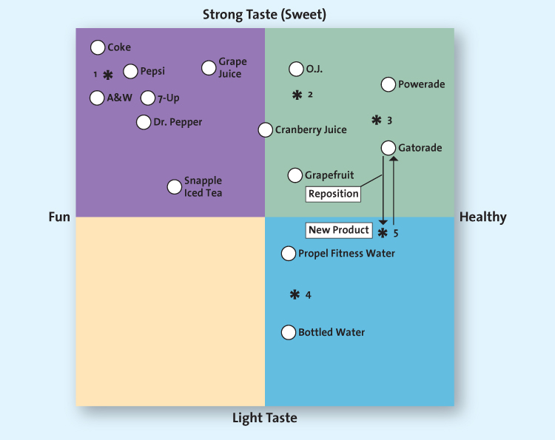

- To derive a perceptual map, marketers follow 5 steps:
- Determine consumers’ perceptions and evaluation of the product or service in relation to competitions’
- Determine their brand’s position by asking consumers a series of questions about their and competitors’ products

- Identify competitors’ positions
- When the firm understands how its customers view its brand relative to competitors’, it must study how those same competitors position themselves

- Determine consumers preferences
- The firm knows what the consumer thinks of the products or services in the marketplace and their positions relative to one another
- Must find what the consumer really wants – determine the “ideal” product or service that appeals to each market

- Select the position
- A firm could develop a new product to meet the needs of market
- It could adjust or reposition its marketing approach to sell more of their products or services to the market
- It could ignore what target market really wants and hope that consumers will be attracted to the original product or service

- Monitor the positioning strategy
- Firms must always view the first tree steps of the positioning process as ongoing, with adjustments made in step 4 as necessary

Repositioning
- Good marketers constantly re-evaluate their brand’s position to determine when to reposition it
- Companies should reposition their brands to keep up with changes in the marketplace or to put a fresh spin on their stale and stodgy brand
- Proactive companies change or inker with their positioning to keep up with market dynamics
- Brand repositioning: a strategy which marketers change a brand’s focus to target new markets or realign the brand’s core emphasis with changing market preferences
- New marketing opportunities may urge companies to reposition their brands
- Repositioning can change the quality image of the brand
- Also breathes life into old brands
  - Revitalization sometimes can result from changing the pack-aging and/or altering the characteristics of the brand
- Very costly
  - Costs may not be recovered if the repositioned brand and messages are not credible to the customers or if the firm has mistaken a fad for a long-term market trend

